How to install weblogic in Ubantu(OS)

If you have oracle-java8-installer then no need to remove java.

Firstly Remove java :-

1) sudo apt-get purge openjdk-8-jre openjdk-8-jre-headless openjdk-7-jre gcj-4.7-base gcj-4.7-jre openjdk-6-jre-headless
2) sudo apt-get autoremove openjdk-7-jre
3) java -version
4) sudo apt-get purge openjdk*
5) sudo apt-get purge openjdk*
Install Java 8 :-
1) sudo add-apt-repository ppa:openjdk-r/ppa
2) sudo apt-get update
3) sudo apt-get install oracle-java8-installer

Step 1. Open Oracle URL(http://www.oracle.com/technetwork/middleware/weblogic/downloads/index.html)

Step 2. Accept License Agreement
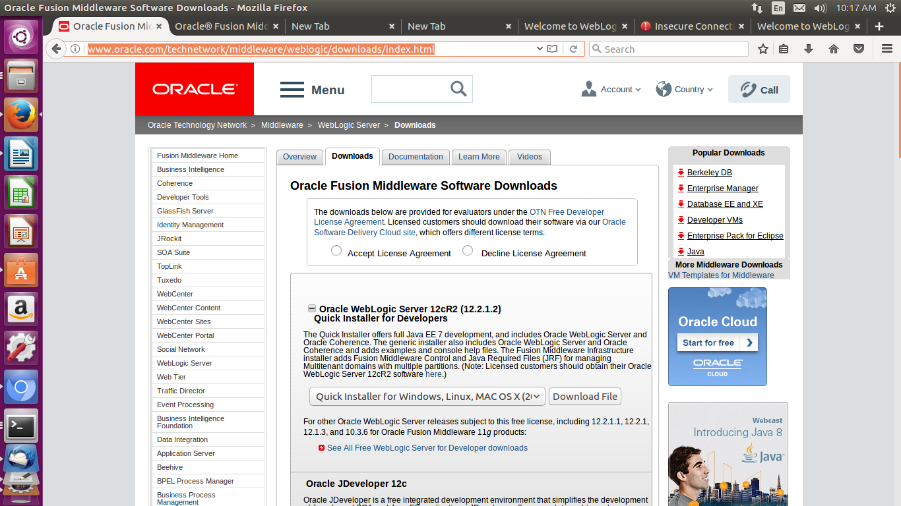

Step 3: Click on Download File button
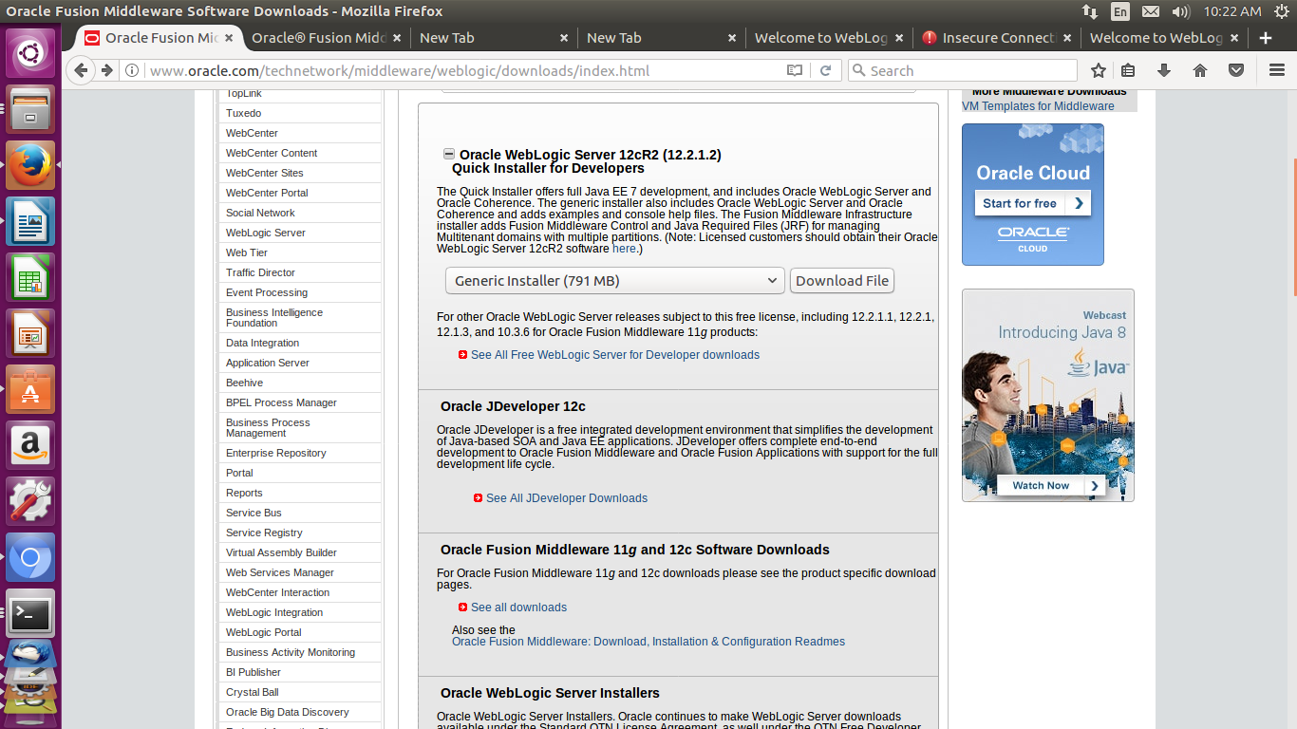
Step 4: Extract the Zip file(fmw_12.2.1.2.0_wls_Disk1_1of1.zip)

Step 5: Go to fmw_12.2.1.2.0_wls_Disk1_1of1 directory(such as: cd Downloads/fmw_12.2.1.2.0_wls_Disk1_1of1)
Please see below screenshot :-
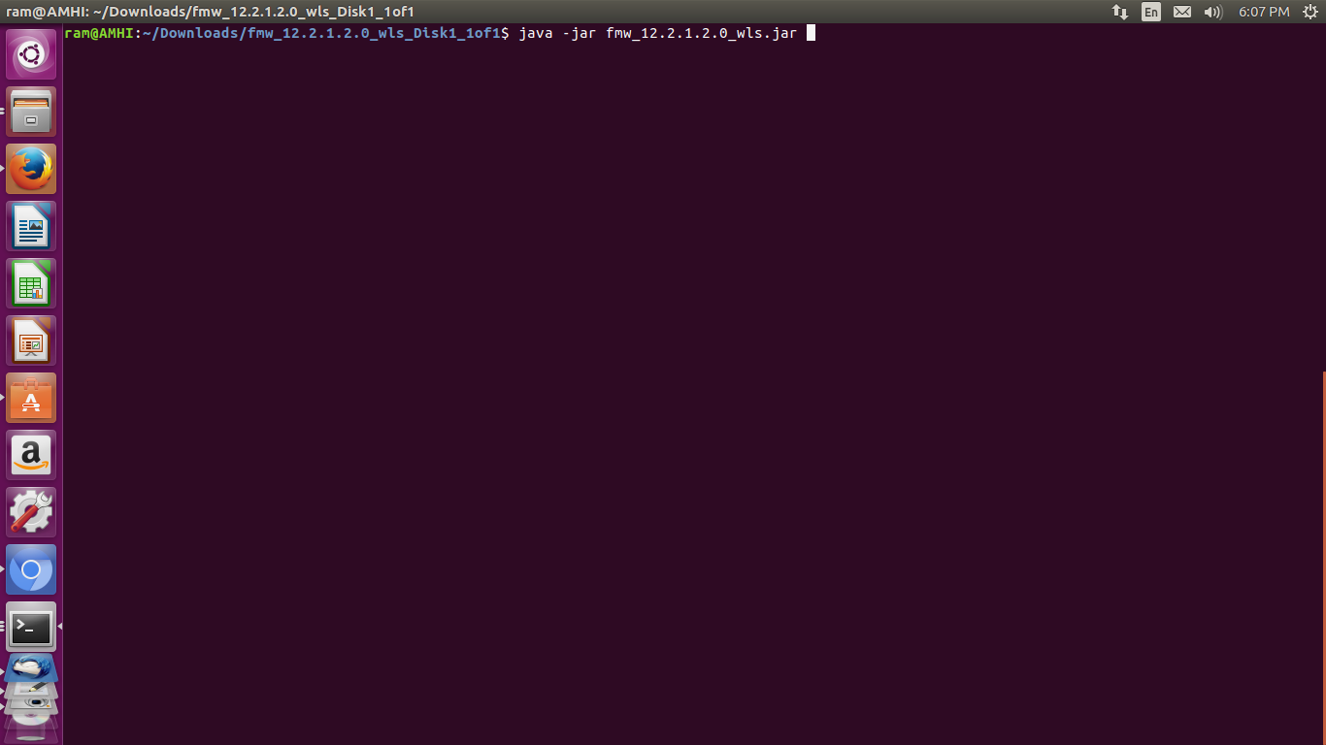

Step 6: Click on Ok button
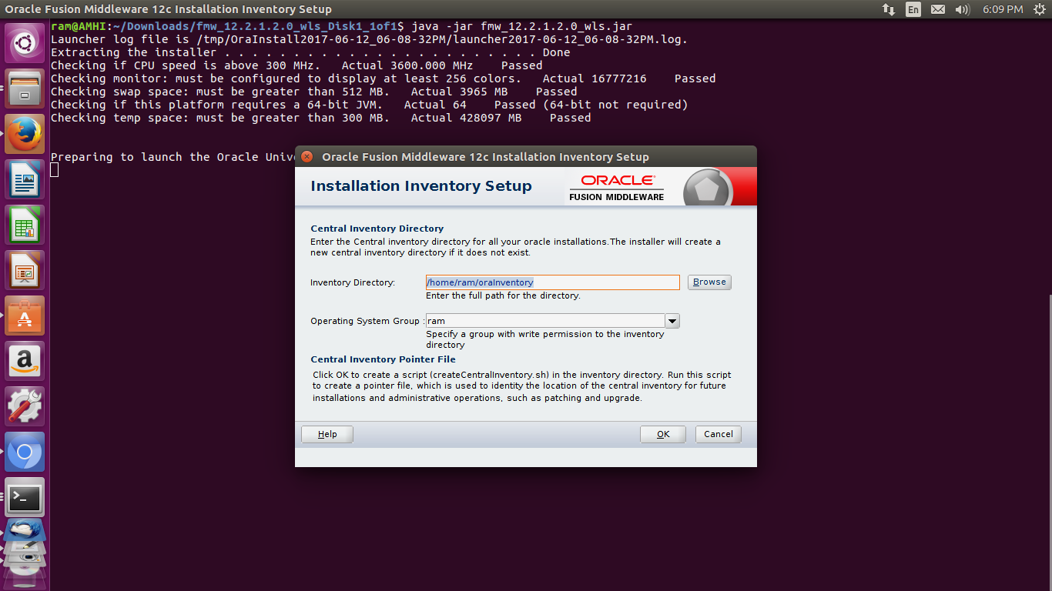

Step 7: Wait...
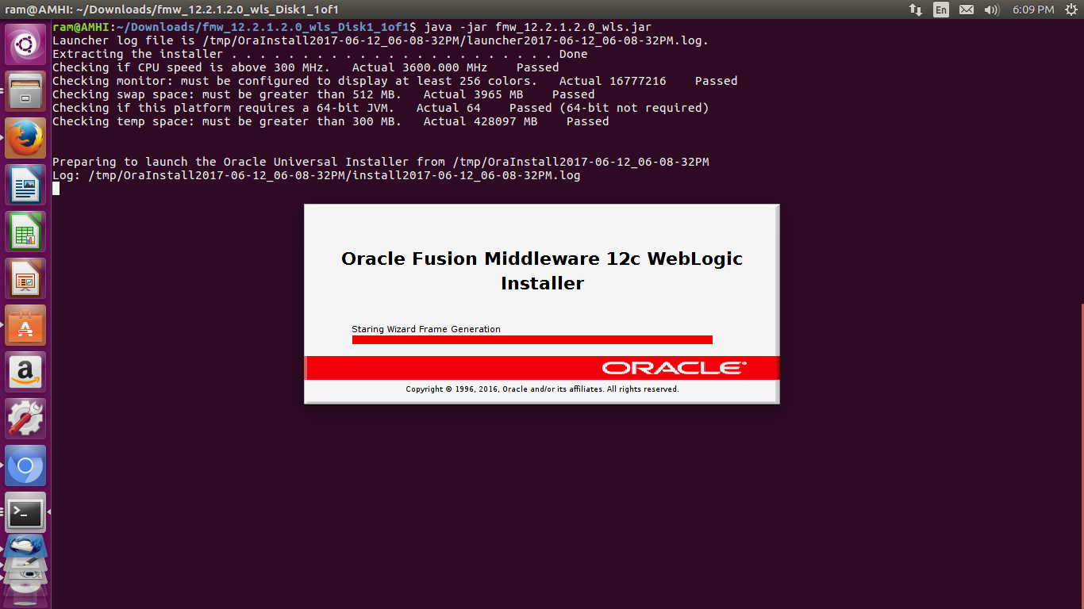

Step 8: Click on Next button
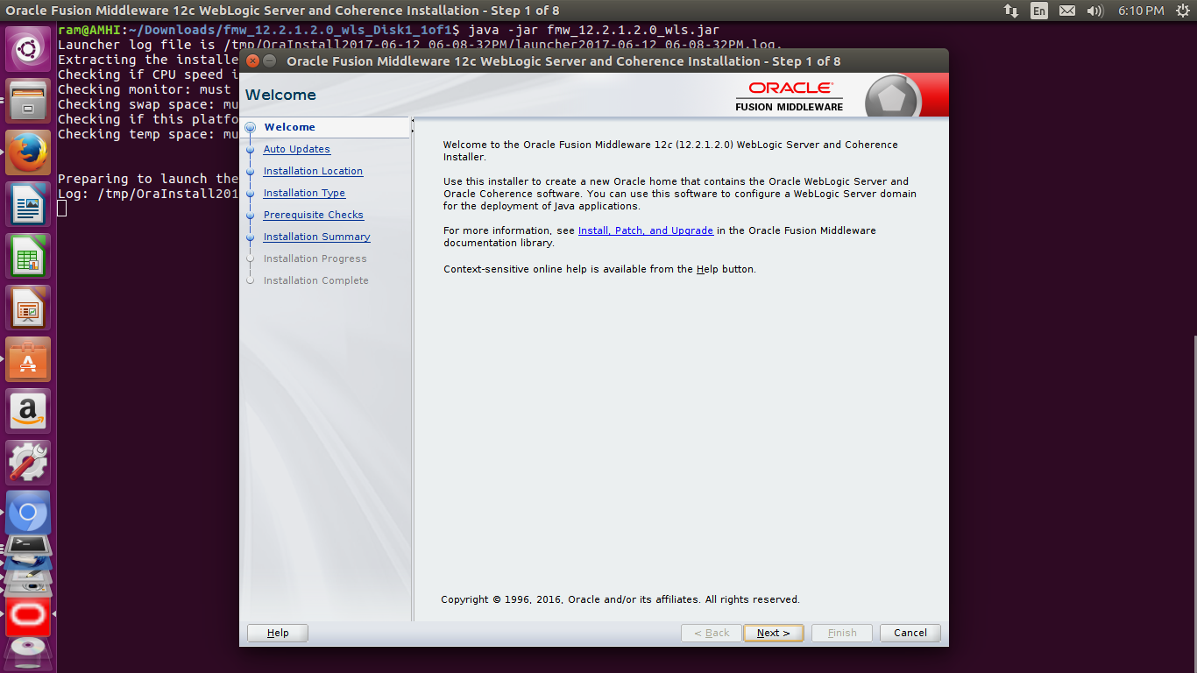
Step 9: Click on Next button
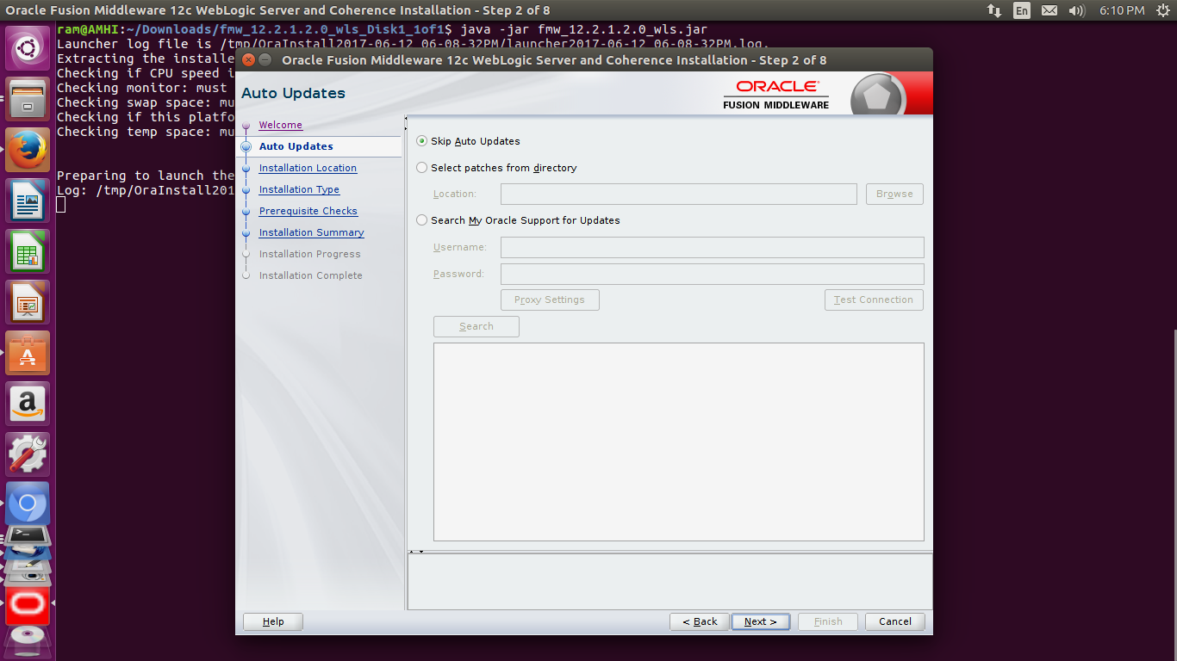

Step 10: Click on Next button
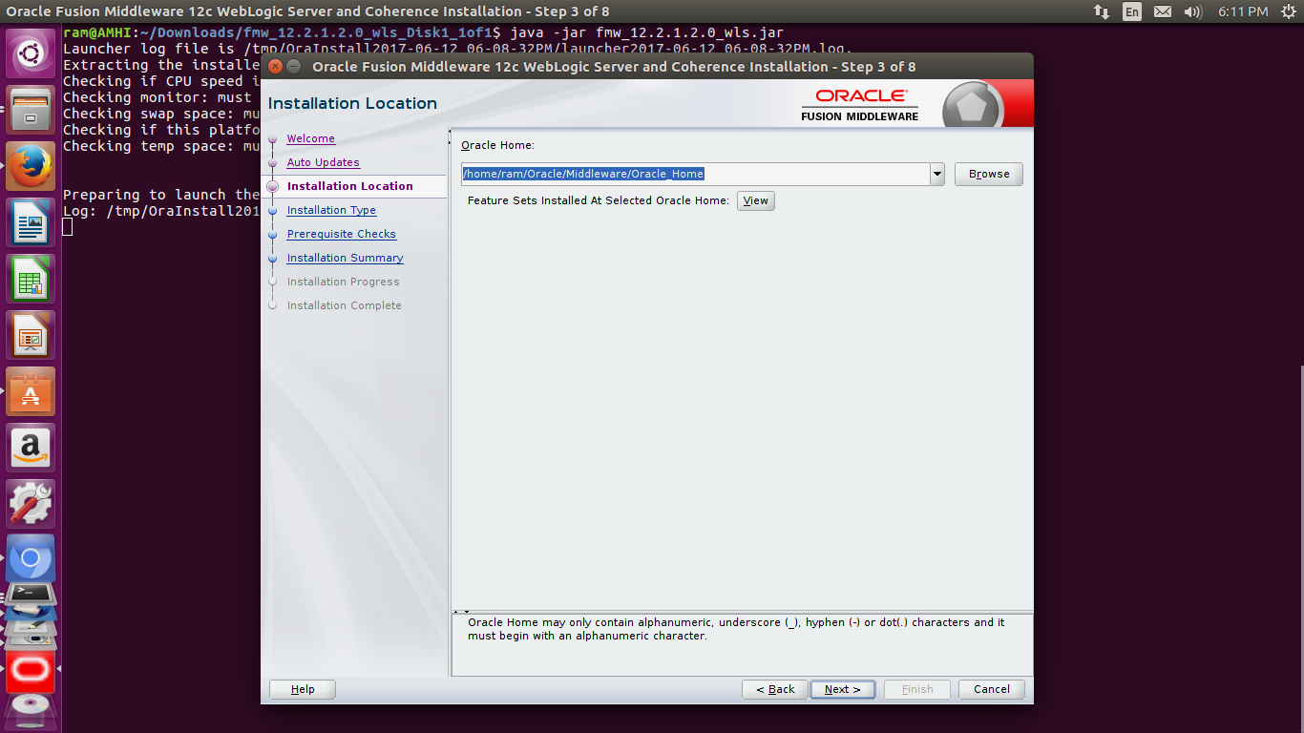
Step 11: Select Complete with Examples and Click on Next button
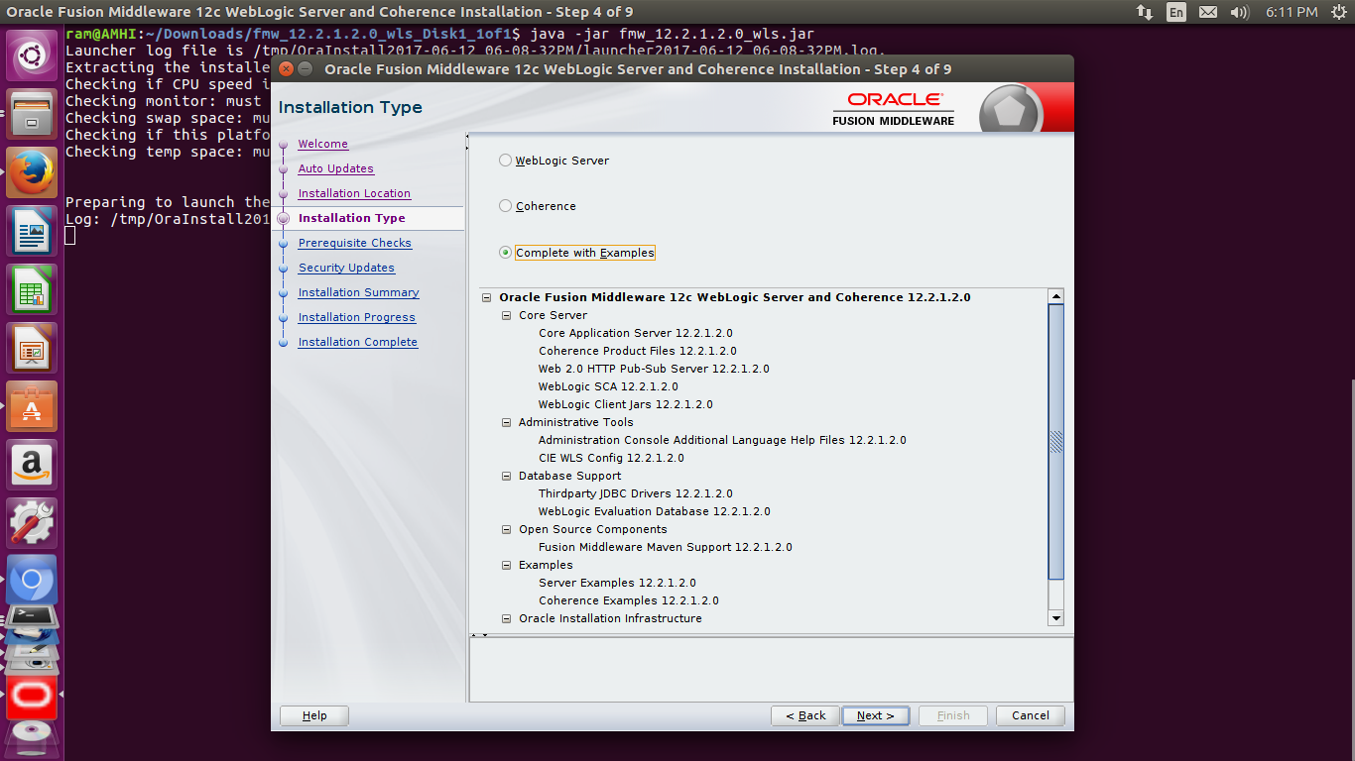

Step 12: Click on Next button
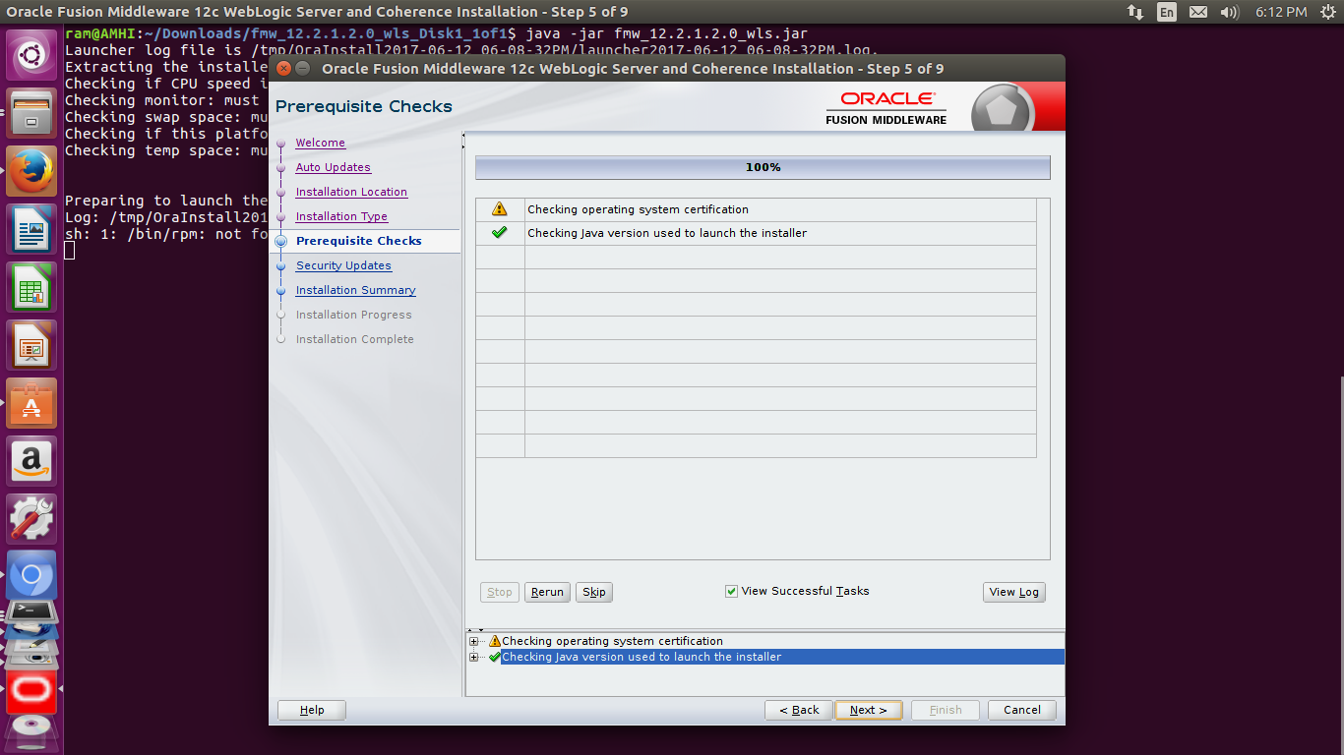
Step 13: If you want get update infromation from oracle then put details otherwise Click on Next button
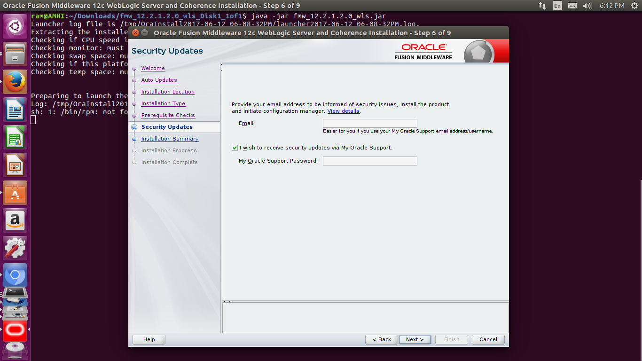

Step 14: Here is the confirmation message only
Click on Yes button
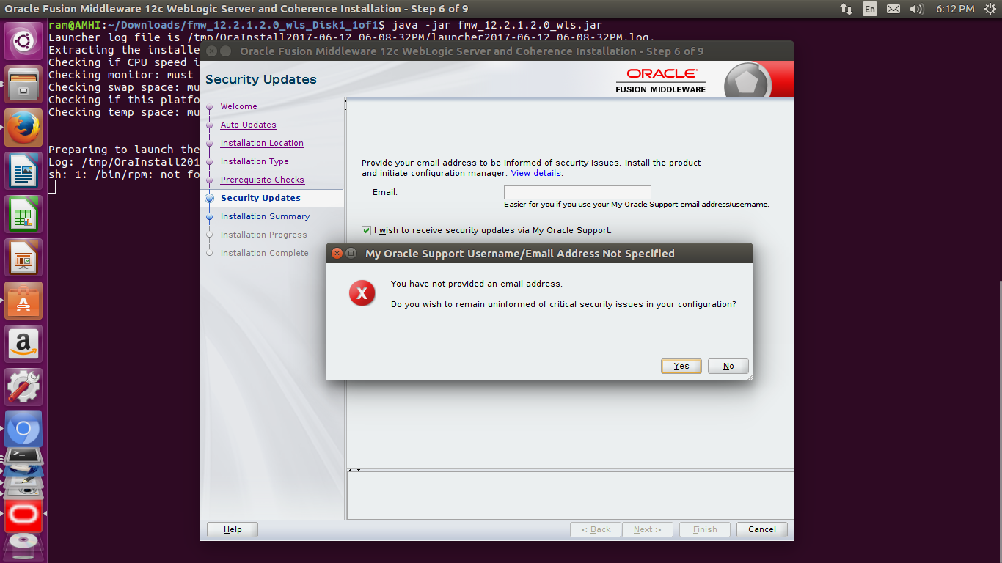
Step 15: Click on Install button
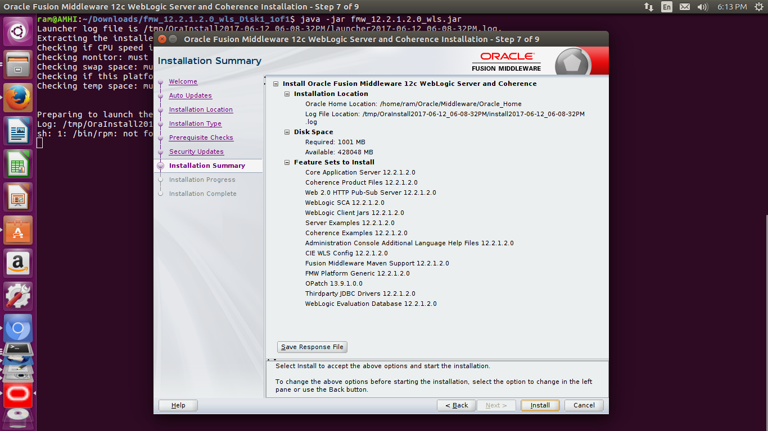

Step 16: Please wait till installation not complete
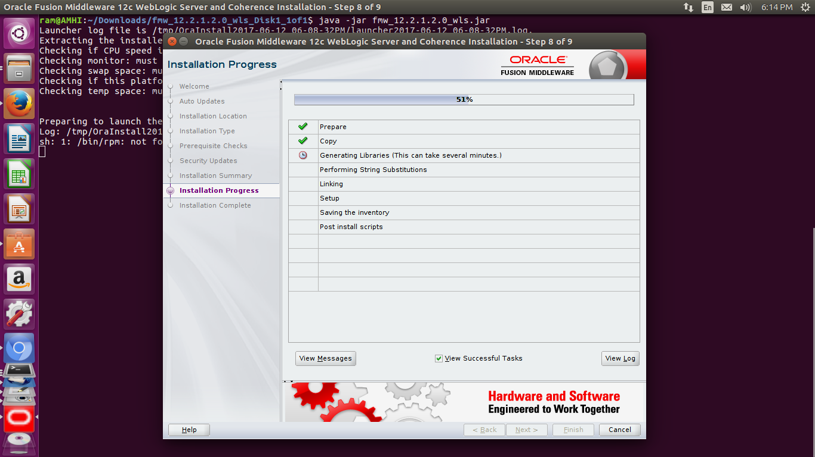
Step 17: If all installation are complete then Click on Next button
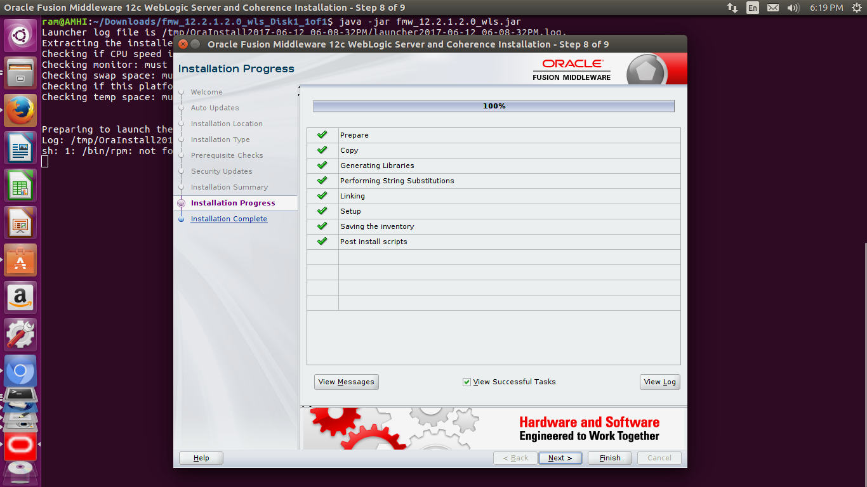

Step 18: Click on Finish button
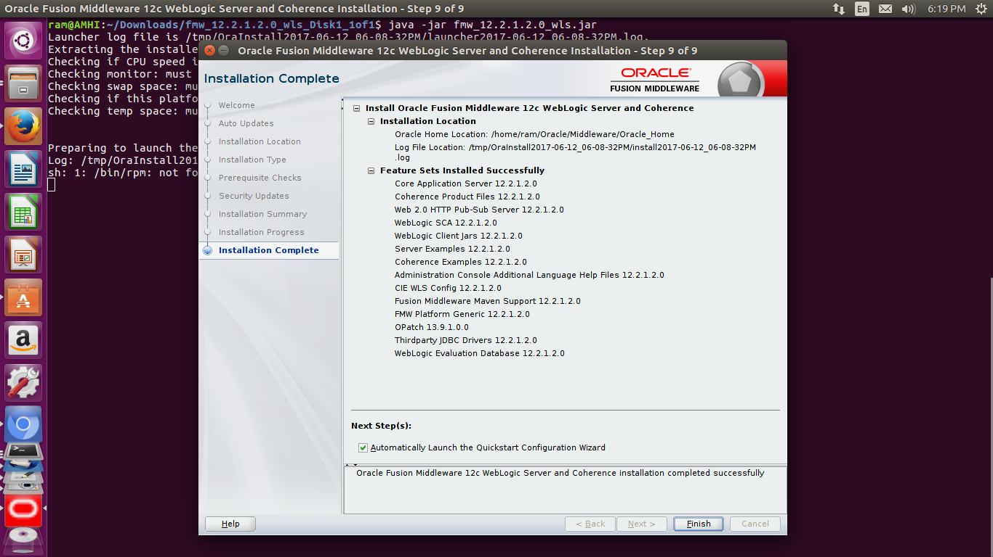
Step 19: Put the Password and Confirm Password (such as admin/admin)
If you want to change the weblogic server port then change port number 7001(such as 8081)
Port number 7001 is default for weblogic application server.
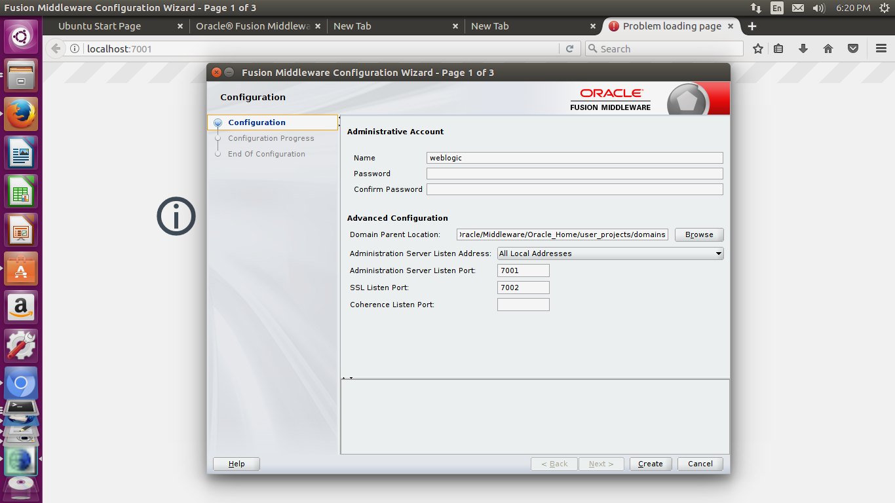

Step 20: Wait for Configuration progess
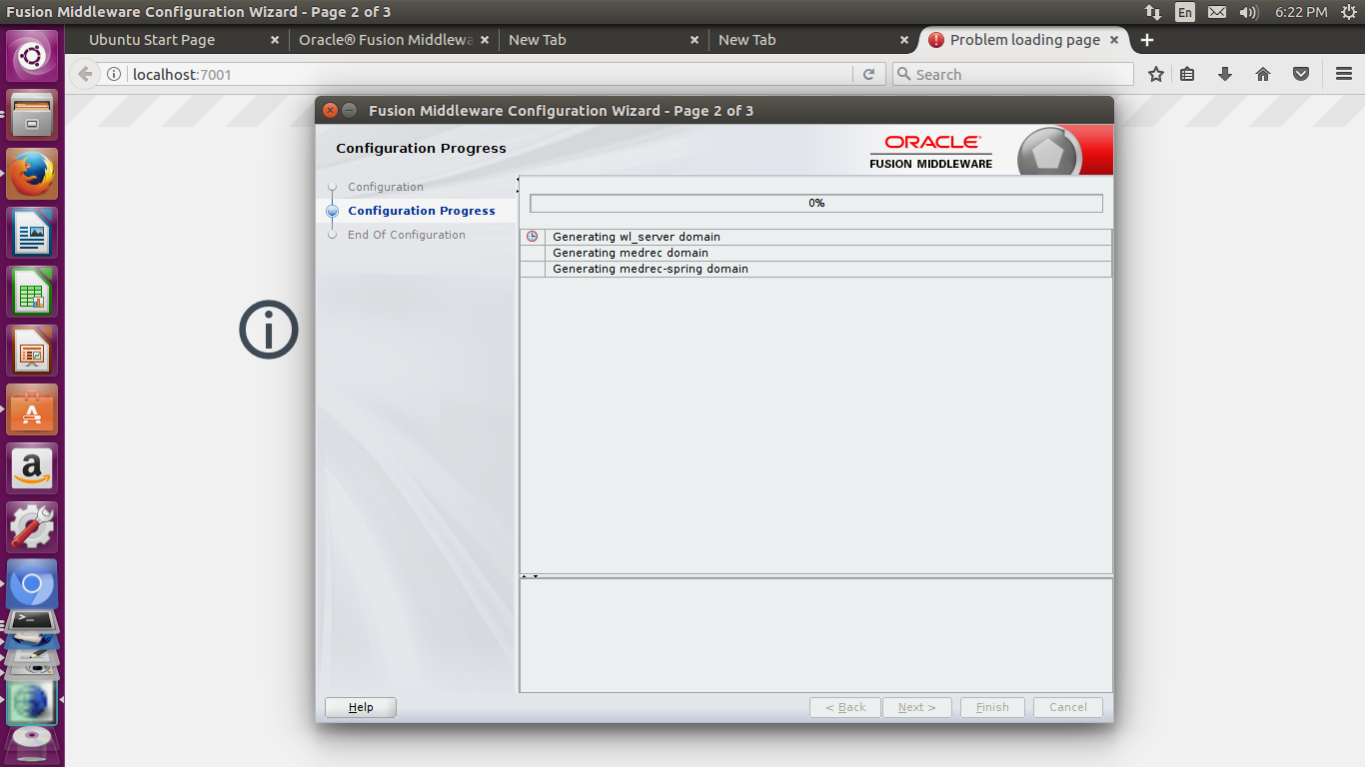
Step 21: Here is the configuration successful processed
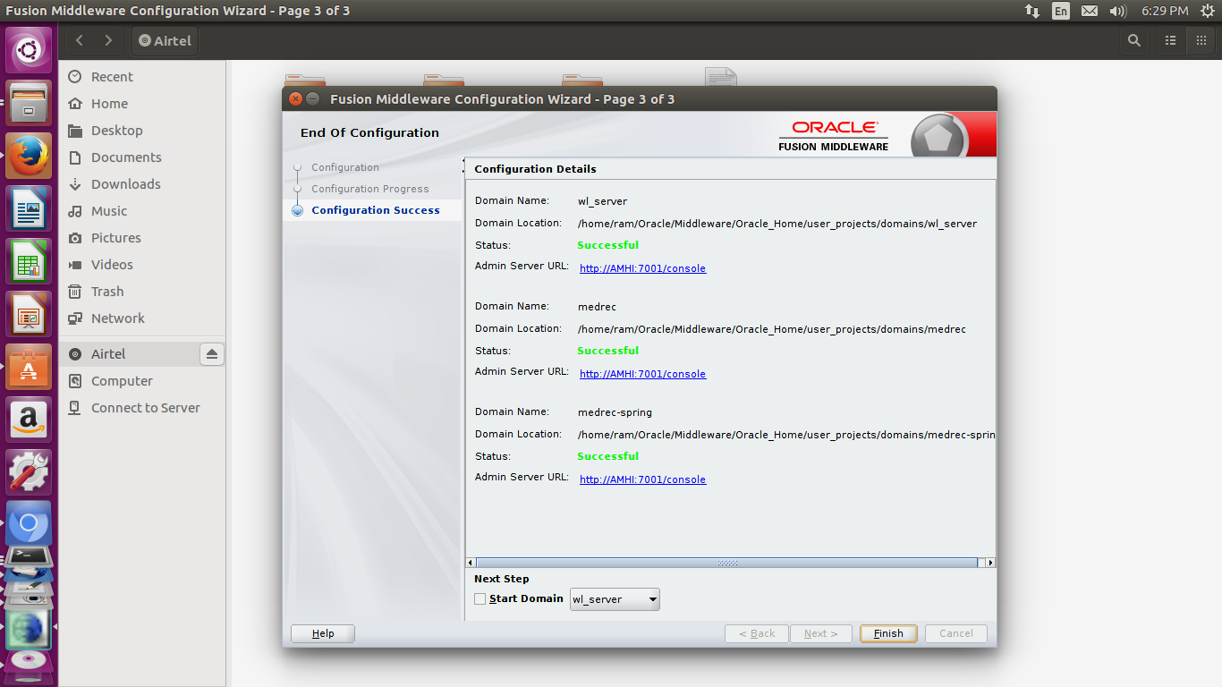

Step 22: Now you can able to start the weblogic application server
i) Go to directory (/home/ram/Oracle/Middleware/Oracle_Home/user_projects/domains/wl_server/bin)
ii) ./startWebLogic.sh
iii) Now Weblogic application server going to start
iii) According to below screenshot: -
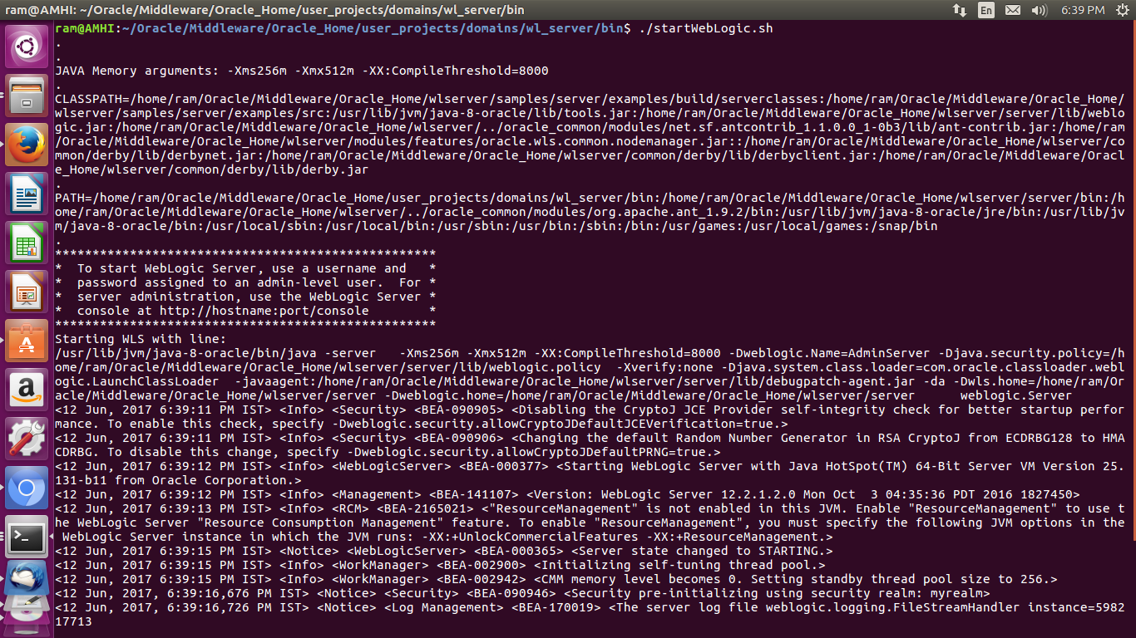
Step 23: Open the browser
Put in URL (127.0.1.1:7001/index.jsp)
Press the Enter key
Now you can see the Weblogic server home page according to below screenshot :-
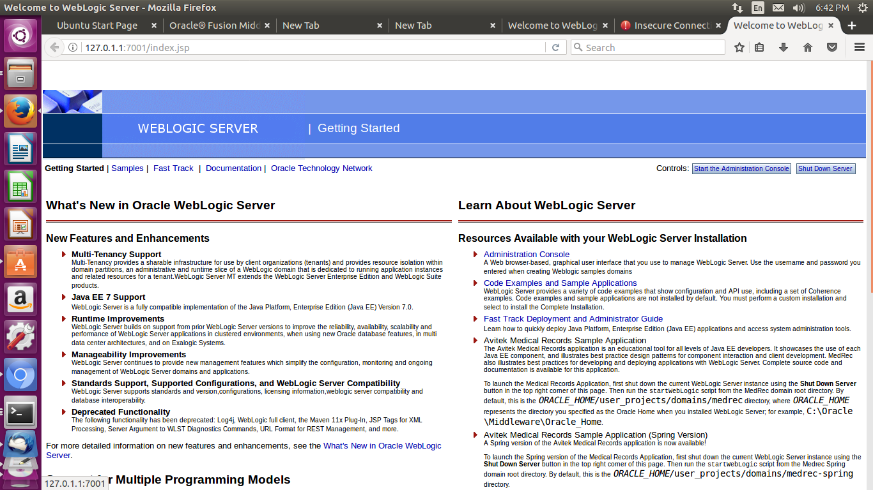

How to deploy a web Application in Weblogic

Step 1: Open URL(http://127.0.1.1:7001/console) then you Login first with username and password
Step 2: After login Click on Deployments link which link available under Doamin Structure Tab
Step 3: After that click on Install button which button available under Deployments tabled
Please see below screenshot:-
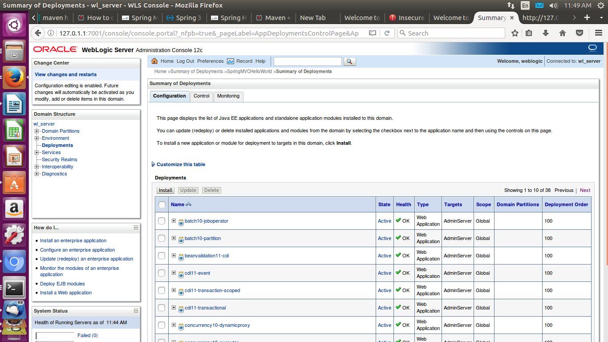

Step 3: i) After that you click on home directory
ii) Go to the directory which directory conatain .war file
iii)Select the .war file readio button
iv) Click on next button
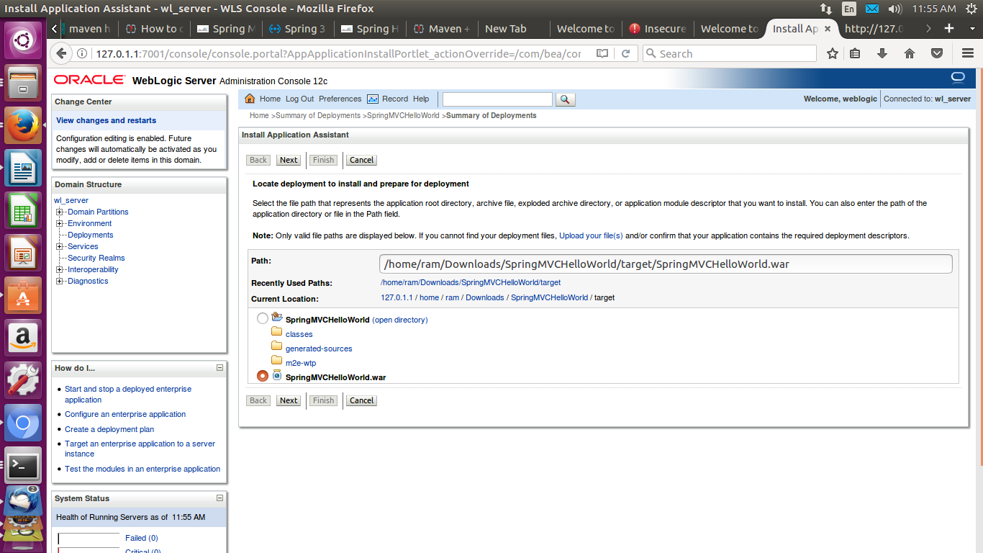
Step 4: Click on next button
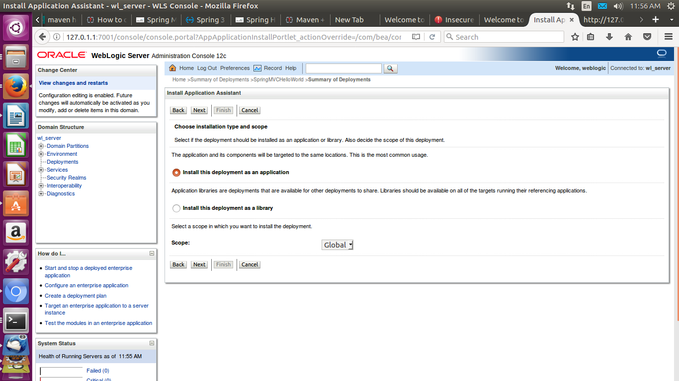

Step 5: Click on next button
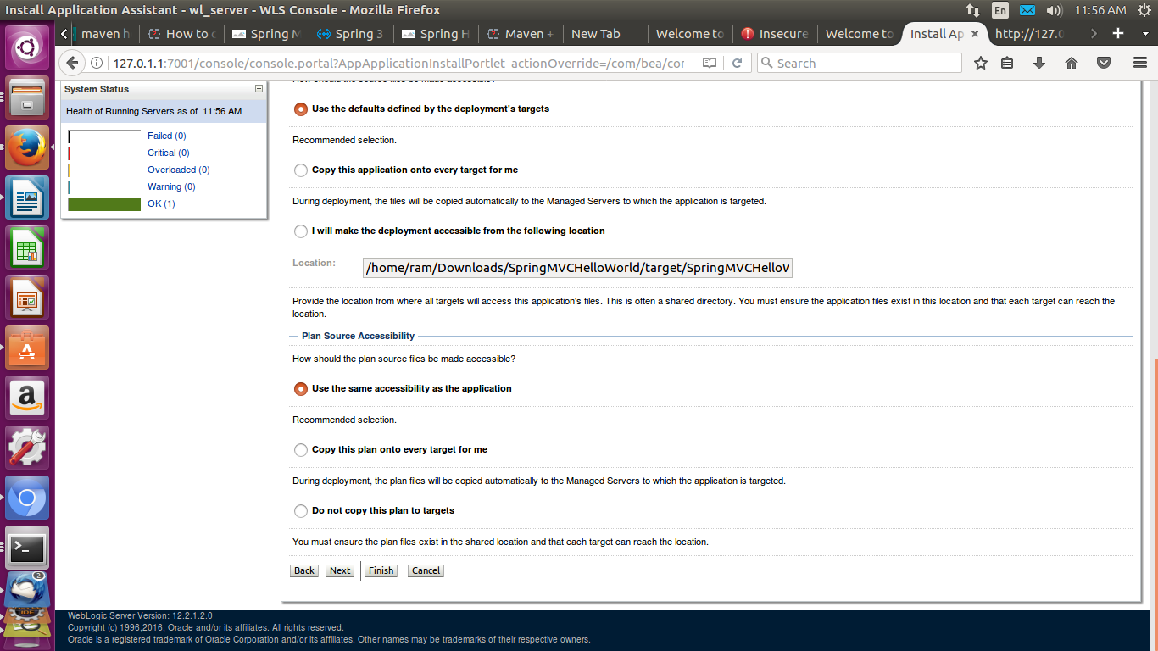
Step 6: Click on Finish button
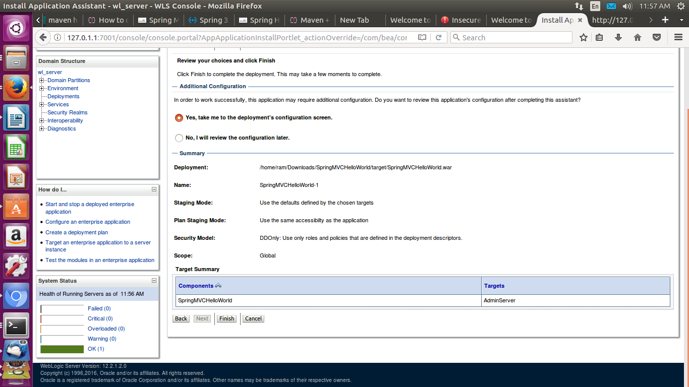

Step 7: Select the Testing Tab
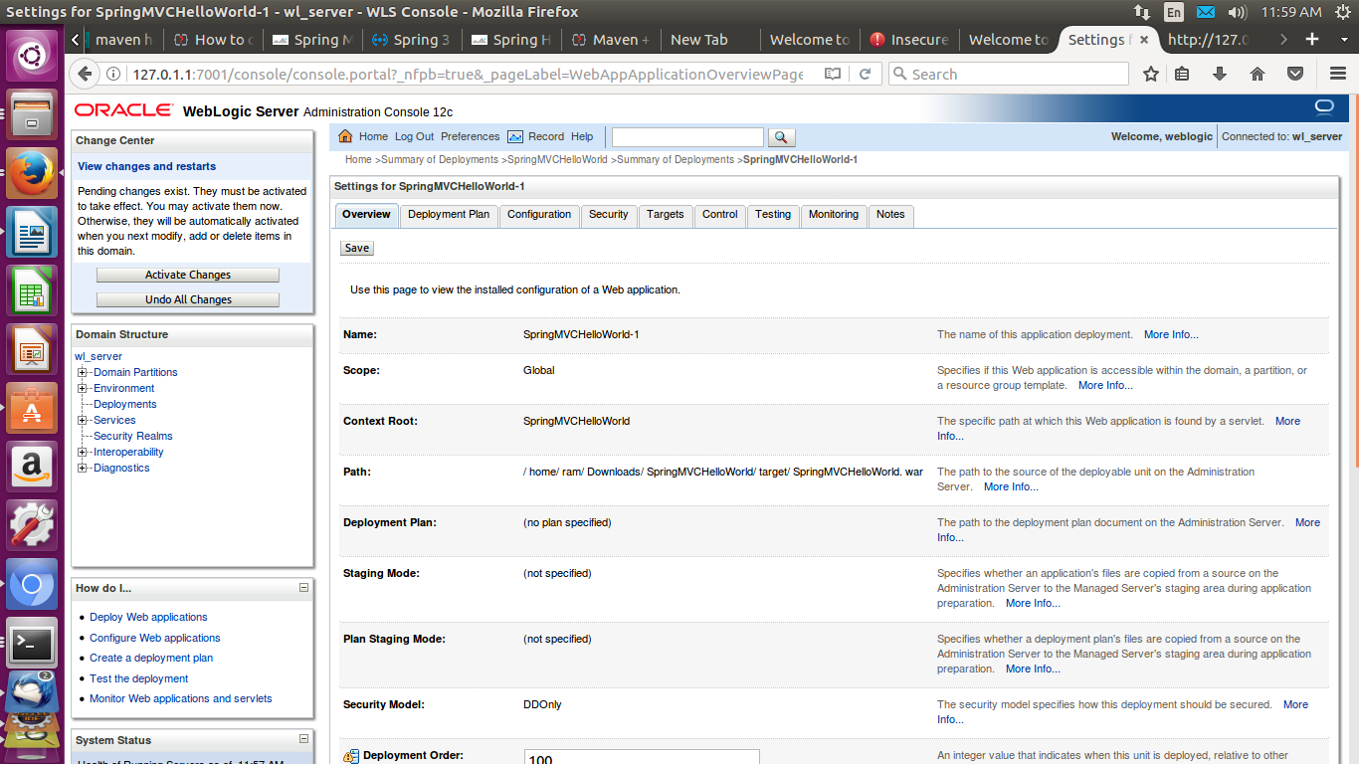
Step 8: Click on below url which url available in Test Point Table Column
http://127.0.1.1:7001/SpringMVCHelloWorld


