Date :13-05-2025

Current System
In the existing assignment submission system for Indira Gandhi National Open University (IGNOU) students submit assignments online or offline based on their specific course requirements ,
currently assignment in-charge keep manual records of submitted assignments with details including serial number,students name,enrollment number ,Program,Course code,submission date etc. manually on physical record books.

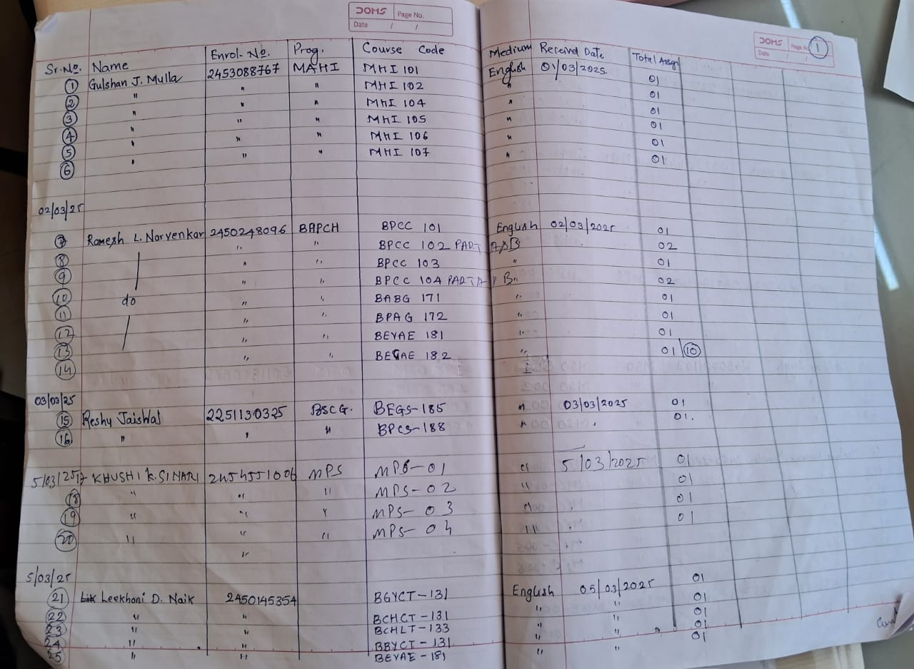

The handwritten records are transcribed into an Excel spreadsheet along with grade and marks obtained and printed when required.This process is repeated twice a year as there are two assignmets associated with each academic year.
Whenever assignment incharge need to access and retrieve the assignment details ,they have to go through the physical records,which is time consuming.

Drawbacks
- Voluminous:A substantial number of students are enrolled within IGNOU and each student has to submit assignments for their choosen course twice a year ,this amounts to considerable volume of data to be stored manually which leads to piling of record books.
- Prone to Errors:Since large amount of repetitive data is being entered manually by humans, there are chances of errors occuring such as mistakes in student details such as their names and enrollment numbers, also assignment in-charge can overlook some information details.
- Time Consuming:The manual entering and subsequent retrieval of assignment details is time consuming .Accessing a specific student or assignment information will require a physical search through the record books .Also the process of entering the assignment details into the Excel spreadsheet is again a time intensive process.

DONE BY:
Saisha Prabhu
Olivia Fernandes

