MS1 System Register Specification

Date | Version | Author | Change
2025/7/1 | v0.1 | liang.zhao | Copy from t6X and update for MS1
2025/7/16 | v0.2 | tao.hu | update for irq_ctrl & efuse_top
2025/7/16 | v0.3 | xiaoyong.ma | update ana_ctrl/pwr_ctrl/clk_ctrl
2025/7/17 | v0.4 | faying.luo | update ao_reset_ctrl/ao_sys_ctrl
2025/7/18 | v0.5 | feng.hu | update ao_pad_ctrl /ee_pad_ctrl /edp_lvds_phy_dig_top
2025/8/26 | v0.6 | liang.zhao | update some missed register
2025/8/26 | v0.7 | liang.zhao | update some missed register
2025/8/28 | v0.8 | guojin.zhang | update some register
2025/9/1 | v0.9 | liang.zhao | add aocpu register

Table of Contents

Table of Contents

Contents

1. Module address list: 10
2. AO_RESET_CTRL 11
RESETCTRL_RESET0~1 12
RESETTRL_RESET0~1_LEVEL 12
RESETCTRL_RESET0~1_MASK 12
RESETCTRL_RESET_HOLD_CYC 12
RESETCTRL_WATCHDOG_CTRL0 13
RESETCTRL_WATCHDOG_CTRL1 13
RESETCTRL_WATCHDOG_CNT 13
RESETCTRL_WATCHDOG_CLR 14
RESETCTRL_WATCHDOG_IRQ_OFFSET 14
3. AO_PAD_CTRL 15
AO_PADCTRL_PIN_MUX_REG0 17
AO_PADCTRL_PIN_MUX_REG1 17
AO_PADCTRL_PIN_MUX_REG2 17
AO_PADCTRL_PIN_MUX_REG3 18
AO_PADCTRL_GPIO_IRQ_CTRL0 18
AO_PADCTRL_GPIO_IRQ_CTRL1 18
AO_PADCTRL_GPIO_IRQ_CTRL2 20
AO_PADCTRL_GPIO_MSR_CTRL0 20
AO_PADCTRL_GPIOAO_I 21
AO_PADCTRL_GPIOAO_O 21
AO_PADCTRL_GPIOAO_OEN 21
AO_PADCTRL_GPIOAO_IEN 21
AO_PADCTRL_GPIOAO_PULL_UP 21
AO_PADCTRL_GPIOAO_PULL_DOWN 21
AO_PADCTRL_GPIOAO_DS 21
AO_PADCTRL_GPIOW_I 22
AO_PADCTRL_GPIOW_O 22
AO_PADCTRL_GPIOW_OEN 22
AO_PADCTRL_GPIOW_IEN 22
AO_PADCTRL_GPIOW_PULL_UP 22
AO_PADCTRL_GPIOW_PULL_DOWN 22
AO_PADCTRL_GPIOW_DS 22
AO_PADCTRL_TESTN_I 23
AO_PADCTRL_TESTN_O 23
AO_PADCTRL_TESTN_OEN 23
AO_PADCTRL_TESTN_IEN 23
AO_PADCTRL_TESTN_PULL_UP 23
AO_PADCTRL_TESTN_PULL_DOWN 23
AO_PADCTRL_TESTN_DS 23
AO_PADCTRL_UART_DISABLE_CTRL0 24
AO_PADCTRL_ANALOG_I 25
AO_PADCTRL_ANALOG_EN 25
AO_PADCTRL_GPIOW_CTRL0 25
AO_PADCTRL_GPIOW_CTRL1 26
4. EE_PAD_CTRL 27
EE_PADCTRL_PIN_MUX_REG0 27
EE_PADCTRL_PIN_MUX_REG1 28
EE_PADCTRL_PIN_MUX_REG2 28
EE_PADCTRL_GPIO_IRQ_CTRL0 29
EE_PADCTRL_GPIO_IRQ_CTRL1 29
EE_PADCTRL_GPIO_IRQ_CTRL2 30
EE_PADCTRL_GPIO_MSR_CTRL0 31
EE_PADCTRL_GPIOH_I 31
EE_PADCTRL_GPIOH_O 31
EE_PADCTRL_GPIOH_OEN 31
EE_PADCTRL_GPIOH_IEN 32
EE_PADCTRL_GPIOH_PULL_UP 32
EE_PADCTRL_GPIOH_PULL_DOWN 32
EE_PADCTRL_GPIOH_DS 32
EE_PADCTRL_UART_DISABLE_CTRL0 32
EE_PADCTRL_DEBUG_SEL 32
5. AO_CLK_CTRL 34
AO_CLKCTRL_OSCIN_CTRL 34
AO_CLKCTRL_RTC_BY_OSCIN_CTRL0 35
AO_CLKCTRL_RTC_BY_OSCIN_CTRL1 35
AO_CLKCTRL_RTC_CTRL 36
AO_CLKCTRL_MBIST_ATSPEED_CTRL 36
AO_CLKCTRL_SYS_CLK_CTRL0 36
AO_CLKCTRL_SYS_CLK_EN0_REG0 & AO_CLKCTRL_CLK81_GATE_CTRL 38
AO_CLKCTRL_AHB_CLK_CTRL0 38
AO_CLKCTRL_TST_CTRL0/1 39
AO_CLKCTRL_CECB_CLK_CTRL0 40
AO_CLKCTRL_CECB_CLK_CTRL1 42
AO_CLKCTRL_CLK12_24_CTRL 42
AO_CLKCTRL_PWM_CLK_(AD_)**_CTRL 43
AO_CLKCTRL_GEN_CLK_CTRL 44
AO_CLKCTRL_TIMEBASE_CTRL0 45
AO_CLKCTRL_TIMEBASE_CTRL1 46
AO_CLKCTRL_HRX_CLK_CTRL0 46
AO_CLKCTRL_HRX_CLK_CTRL1 47
AO_FIX_PLL_CTRL0 47
AO_FIX_PLL_CTRL1 47
AO_FIX_PLL_CTRL2 47
AO_FIX_PLL_STS 47
6. EE_CLK_CTRL 48
EE_CLKCTRL_TST_CTRL0/1 48
EE_CLKCTRL_VP_OPT_CLK_CTRL 49
EE_CLKCTRL_BCON_CLK_CNTL 50
EE_CLKCTRL_TX_DET_CLK_CTRL 50
EE_CLKCTRL_APB2_CLK_CTRL 51
EE_CLKCTRL_SPISG_CLK_CTRL 51
EE_CLKCTRL_PWM_CLK_(EH_)**_CTRL 52
EE_CLKCTRL_SAR_CLK_CTRL0 53
EE_CLKCTRL_TS_CLK_CTRL 53
EE_CLKCTRL_AXI_CLK_CTRL0 54
EE_CLKCTRL_CLK81_GATE_CTRL & EE_CLKCTRL_AHB_CLK_GATE_CTRL 55
EE_CLKCTRL_MBIST_ATSPEED_CTRL 55
EE_CLKCTRL_GEN_CLK_CTRL 55
EE_CLKCTRL_HRX_CLK_CTRL1 57
EE_CLKCTRL_HRX_CLK_CTRL2 57
EE_CLKCTRL_VDOUT_CLK_CTRL 58
7. AO_SYS_CTRL 59
SYSCTRL_METAL_REV0 59
SYSCTRL_METAL_REV1 59
SYSCTRL_METAL_REV2 59
SYSCTRL_CHIP_ID 59
SYSCTRL_WRITEONCE_REG0 59
SYSCTRL_WRITEONCE_REG1 59
SYSCTRL_WRITEONCE1_REG0 59
SYSCTRL_WRITEONCE_STICKY_REG0 60
SYSCTRL_WRITEONCE_STICKY_REG1 60
SYSCTRL_TIMERA_CTRL 60
SYSCTRL_TIMERA 61
SYSCTRL_TIMERE/F_CTRL 61
SYSCTRL_TIMERE/F 62
SYSCTRL_TIMERE/F_HI 62
SYSYSCTRL_ALERT_STS_STICKY 63
SYSCTRL_ALERT_ENABLE 63
SYSYSCTRL_DEBUG_REG0~4 63
SYSCTRL_STATUS_REG0~3 63
SYSCTRL_STICKY_REG0~3 63
SYSCTRL_CEC_STICKY_REG0~3 63
SYSCTRL_MSG_INDEX0~1_STICKY 63
SYSYSCTRL_BUS_CFG0 64
SYSCTRL_HDMIRXPLL_TEST_CTRL 64
SYSCTRL_SCAN_PW0 65
SYSCTRL_SCAN_PW1 65
SYSCTRL_SCAN_PW2 65
SYSCTRL_SCAN_PW3 65
SYSCTRL_TEST_MUX_SEL 65
SYSCTRL_TEST_MUX0/1/2/3/4/5 66
SYSCTRL_EFUSE_INFO0 66
SYSCTRL_EFUSE_INFO1 66
SYSCTRL_EFUSE_INFO2 66
SYSCTRL_LDO_CTRL 66
8. EE_SYS_CTRL 67
EE_SYSCTRL_BUS_CFG0 67
EE_SYSCTRL_BUS_CFG1 67
EE_SYSCTRL_NIC_CFG0 67
EE_SYSCTRL_VGD_CTRL 68
EE_SYSCTRL_SPISG_TRIG0 68
EE_SYSCTRL_OSC_RING_CTRL0 69
EE_SYSCTRL_OSC_RING_CTRL1 69
9. IRQ_CTRL 70
IIRQCTRL_IRQ_MODE0~2 71
IRQCTRL_IRQ_LATCH0~2 71
IRQCTRL_IRQ_LATCH_CLR0~2 71
IRQCTRL_IRQ_MASK0~2_AOCPU 71
RQCTRL_IRQ_INV0~2 71
IRQCTRL_SOFT_IRQ 71
10. Efuse_top 72
11. aocpu 73
AOCPU_CPU_VECTOR 73
AOCPU_CPU_CTRL0 73
AOCPU_CPU_CTRL1 73
AOCPU_STS00_BYCPU0~7 73
AOCPU_IRQ_TYPE0/1/2 74
AOCPU_TIMER_DIV 74
AOCPU_TIMER_DBG_DIV 74
12. PWR_CTRL 75
PWRCTRL_PWR_ACK0 75
PWRCTRL_ISO_EN0 75
PWRCTRL_PWR_OFF0 76
PWRCTRL_FOCRST0 76
PWRCTRL_MEM_PD0 76
PWRCTRL_MEM_PD1 76
PWRCTRL_MEM_PD2 77
PWRCTRL_MEM_PD3 77
PWRCTRL_MEM_PD4 77
13. ANA_CTRL 78
ANACTRL_HIFI_PLL_CTRL0 78
ANACTRL_HIFI_PLL_CTRL1 78
ANACTRL_HIFI_PLL_CTRL2 78
ANACTRL_HIFI_PLL_CTRL3 79
ANACTRL_HIFI_PLL_STS 80
ANACTRL_DISP_PLL_CTRL0 80
ANACTRL_DISP_PLL_CTRL1 80
ANACTRL_DISP_PLL_CTRL2 81
ANACTRL_DISP_PLL_CTRL3 81
ANACTRL_DISP_PLL_STS 82
14. edp_lvds_phy_dig_top 83
ANACTRL_TCON_PLL0_CNTL0 83
ANACTRL_TCON_PLL0_CNTL1 83
ANACTRL_TCON_PLL0_CNTL2 84
ANACTRL_TCON_PLL0_CNTL3 85
ANACTRL_TCON_PLL0_STS 85
ANACTRL_DIF_PHY_CNTL1 86
ANACTRL_DIF_PHY_CNTL2 86
ANACTRL_DIF_PHY_CNTL3 86
ANACTRL_DIF_PHY_CNTL4 86
ANACTRL_DIF_PHY_CNTL5 86
ANACTRL_DIF_PHY_CNTL6 86
ANACTRL_DIF_PHY_CNTL7 87
ANACTRL_DIF_PHY_CNTL8 87
ANACTRL_DIF_PHY_CNTL9 87
ANACTRL_DIF_PHY_CNTL10 87
ANACTRL_DIF_PHY_CNTL11 87
ANACTRL_DIF_PHY_CNTL12 88
ANACTRL_DIF_PHY_CNTL13 88
ANACTRL_DIF_PHY_CNTL14 88
ANACTRL_LVDS_TX_PHY_CNTL1 88
ANACTRL_VID_PLL_CLK_DIV 89
ANACTRL_TCON_PLL_VLOCK 89
ANACTRL_TCON_PLL0_STS 90

Module address list:
module name | size(KB) | start | end
ao_clk_ctrl | 8 | FE000000 | FE001FFF
ao_reset_ctrl | 8 | FE002000 | FE003FFF
ao_pad_ctrl | 8 | FE004000 | FE005FFF
irq_ctrl | 8 | FE00A000 | FE00BFFF
pwr_ctrl | 8 | FE00C000 | FE00DFFF
ao_sys_ctrl | 8 | FE010000 | FE011FFF
debug_i2c | 8 | FE016000 | FE017FFF
tempsensor | 8 | FE01C000 | FE01DFFF
efuse_top | 8 | FE040000 | FE041FFF
ao_cpu | 8 | FE09C000 | FE09DFFF
ee_clk_ctrl | 8 | FE300000 | FE301FFF
ee_pad_ctrl | 8 | FE302000 | FE303FFF
ee_ana_ctrl | 8 | FE304000 | FE305FFF
msr_clk | 8 | FE308000 | FE309FFF
edp_lvds_phy_dig_top | 8 | FE30C000 | FE30DFFF
ee_sys_ctrl | 8 | FE310000 | FE311FFF

Link: MS1 memory map:

AO_RESET_CTRL
This module is control module level reset which shown on diagram are “REG”.
And the control of watchdog is here also.
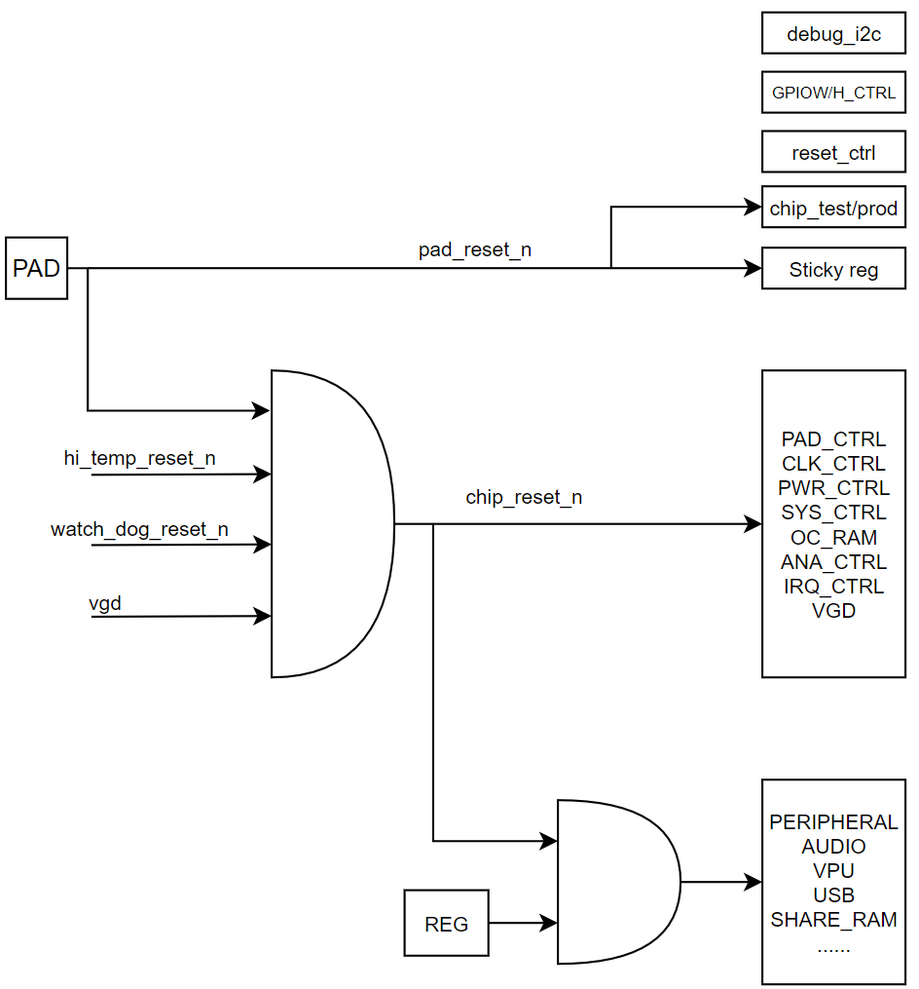
RESETn_module is low active.
RESETn_module = (~RESET_reg & RESET_LEVEL) | RESET_MASK;
If set RESET_reg = 1, will reset the module.
RESET_reg is an auto-recover register which will recover to 0 after some cycles.
If set RESET_LEVEL = 0, will keep RESETn_module as low, mean the module will keep at reset status.
If set RESET_MASK = 1, will keep RESETn_module as high, mean the module will never be reset.

Link: MS1_reset_ctrl

RESETCTRL_RESET0~1
RESET_reg, write each bit to 1 can reset related module, the reset will auto-cover to 0 by HW.
the list refer to resetctrl_reset0~1

RESETTRL_RESET0~1_LEVEL
write each bit to 0 will hold reset as 1.
the list refer to resetctrl_reset0~1

RESETCTRL_RESET0~1_MASK
write each bit to 1 will hold reset as 0.
the list refer to resetctrl_reset0~1

RESETCTRL_RESET_HOLD_CYC
Bit(s) | R/W | Default | Description
2:0 | R/W | 1 | the cycle number of auto-recover

RESETCTRL_WATCHDOG_CTRL0
Bit(s) | R/W | Default | Description
31 | R | 0 | watchdog status(RESET value)
27 | R/W | 0 | Ao_reset_n_now
26 | R/W | 0 | Sys_reset_n_now
25 | R/W | 0 | Clk_div_en
24 | R/W | 0 | Clk_en
23 | R/W | 0 | Interrupt_en
22 | R/W | 0 | Ao_reset_n_en
21 | R/W |  | Sys_reset_n_en
19 | R/W | 0 | Clk_sel;  0: cts_oscin_clk;  1: cts_sys_clk;
18 | R/W | 0 | Watchdog_en
17-0 | R/W | 0 | Clk_div_tcnt

RESETCTRL_WATCHDOG_CTRL1
Bit(s) | R/W | Default | Description
17 | R/W | 0 | Gpio_pulse
16 | R/W | 0 | Gpio_polarity
15-0 | R/W | 0 | Gpio_pulse_tcnt

RESETCTRL_WATCHDOG_CNT
Bit(s) | R/W | Default | Description
31-16 | R | 0 | Watchdog count read
15-0 | R/W | 0 | Watchdog_count set

RESETCTRL_WATCHDOG_CLR
Bit(s) | R/W | Default | Description
31:0 | W | 0 | write any value will clear watchdog status

RESETCTRL_WATCHDOG_IRQ_OFFSET
Bit(s) | R/W | Default | Description
16 | R | 0 | Watchdog irq
15:0 | W | 0 | Watchdog irq offset, make watchdog irq early than watchog rst

AO_PAD_CTRL
gpioW_0/1/2/3/4/5/8/9/gpioH_0/20 are OD 5V PAD,each OD 5V PAD include 6 register.
gpioW_6/7/10/11 are OD5Vx2_DPAUX PAD,
gpioW_12 is OD 3.3V CEC PAD.
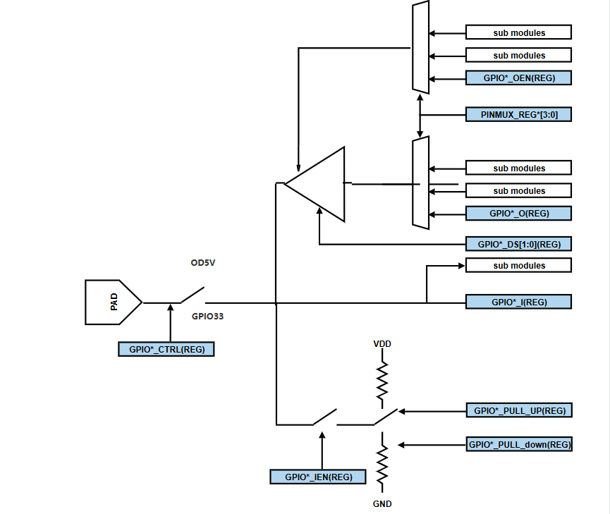
all other PAD are GPIO PAD, each GPIO PAD include 6 register:
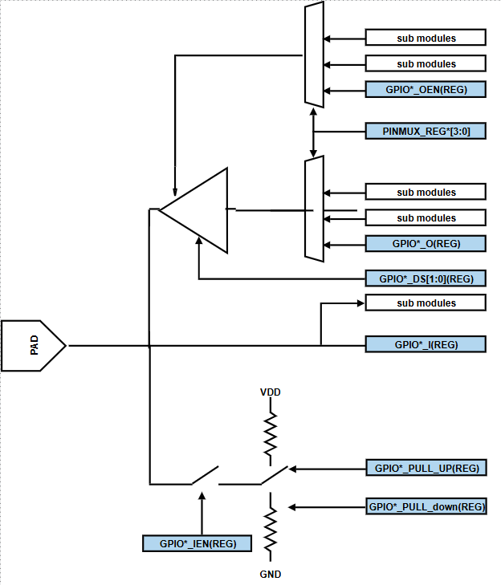
all pinmux function select option please refer to core pinmux_reg.xlsx.
Link: MS1_pinmux_register_spec.xlsx

AO_PADCTRL_PIN_MUX_REG0
Bit(s) | R/W | Default | Description
31:28 | R/W | 0 | gpioAO_7_sel
27:24 | R/W | 0 | gpioAO_6_sel
23:20 | R/W | 1 | gpioAO_5_sel
19:16 | R/W | 1 | gpioAO_4_sel
15:12 | R/W | 1 | gpioAO_3_sel
11:8 | R/W | 1 | gpioAO_2_sel
7:4 | R/W | 1 | gpioAO_1_sel
3:0 | R/W | 1 | gpioAO_0_sel

AO_PADCTRL_PIN_MUX_REG1
Bit(s) | R/W | Default | Description
31:28 | R/W | 1 | gpioAO_15_sel
27:24 | R/W | 1 | gpioAO_14_sel
23:20 | R/W | 1 | gpioAO_13_sel
19:16 | R/W | 1 | gpioAO_12_sel
15:12 | R/W | 0 | gpioAO_11_sel
11:8 | R/W | 0 | gpioAO_10_sel
7:4 | R/W | 0 | gpioAO_9_sel
3:0 | R/W | 0 | gpioAO_8_sel

AO_PADCTRL_PIN_MUX_REG2
Bit(s) | R/W | Default | Description
31:28 | R/W | 0 | gpioW_7_sel
27:24 | R/W | 0 | gpioW_6_sel
23:20 | R/W | 0 | gpioW_5_sel
19:16 | R/W | 0 | gpioW_4_sel
15:12 | R/W | 0 | gpioW_3_sel
11:8 | R/W | 0 | gpioW_2_sel
7:4 | R/W | 0 | gpioW_1_sel
3:0 | R/W | 0 | gpioW_0_sel

AO_PADCTRL_PIN_MUX_REG3
Bit(s) | R/W | Default | Description
23:20 | R/W | 0 | gpioW_13_sel
19:16 | R/W | 0 | gpioW_12_sel
15:12 | R/W | 0 | gpioW_11_sel
11:8 | R/W | 0 | gpioW_10_sel
7:4 | R/W | 0 | gpioW_9_sel
3:0 | R/W | 0 | gpioW_8_sel

AO_PADCTRL_GPIO_IRQ_CTRL0
Bit(s) | R/W | Default | Description
31 | R/W | 0 | gpio_irq_en
11:8 | R/W | 0 | gpio_edge_en[11:8]  if enable, will generate irq by fall edge or rise edge of gpio
7:4 | R/W | 0 | gpio_intr_pol[7:4]  0: rise edge;  1: fall edge;
3:0 | R/W | 0 | gpio_both_edge_en[3:0]  if enable, will generate irq by both fall edge and rise edge of gpio

AO_PADCTRL_GPIO_IRQ_CTRL1
gpio src list
# | src | # | src | # | src | # | src | # | src
 |  |  |  | 26 | gpioW_10 | 17 | gpioW_1 | 8 | gpioAO_8
 |  |  |  | 25 | gpioW_9 | 16 | gpioW_0 | 7 | gpioAO_7
 |  |  |  | 24 | gpioW_8 | 15 | gpioAO_15 | 6 | gpioAO_6
 |  |  |  | 23 | gpioW_7 | 14 | gpioAO_14 | 5 | gpioAO_5
 |  | 31 | 1’b0 | 22 | gpioW_6 | 13 | gpioAO_13 | 4 | gpioAO_4
 |  | 30 | 1’b0 | 21 | gpioW_5 | 12 | gpioAO_12 | 3 | gpioAO_3
 |  | 29 | gpioW_13 | 20 | gpioW_4 | 11 | gpioAO_11 | 2 | gpioAO_2
 |  | 28 | gpioW_12 | 19 | gpioW_3 | 10 | gpioAO_10 | 1 | gpioAO_1
 |  | 27 | gpioW_11 | 18 | gpioW_2 | 9 | gpioAO_9 | 0 | gpioAO_0

Bit(s) | R/W | Default | Description
24 | R/W | 0 | gpio_irq1  in filter clk select:  0:8M(timebase defaule freq,can set other div freq);  1:cts_sys_clk;
23:21 | R/W | 0 | gpio_irq1  in filter cycle count;  filter sel 0:this valuesets the filter selection for gpio interrupt 0. A value of 0 = no filtering.  A value of 7 corresponds to 7x3x(cycle time) of filtering.
20:16 | R/W | 0 | gpio_irq1;  source select; from gpio src list
8 | R/W | 0 | gpio_irq0  in filter clk select:  0:8M(timebase defaule freq,can set other div freq);  1:cts_sys_clk;
7:5 | R/W | 0 | gpio_irq0  in filter cycle count;  filter sel 0:this valuesets the filter selection for gpio interrupt 0. A value of 0 = no filtering.  A value of 7 corresponds to 7x3x(cycle time) of filtering.
4:0 | R/W | 0 | gpio_irq0;  source select; from gpio src list

AO_PADCTRL_GPIO_IRQ_CTRL2
Bit(s) | R/W | Default | Description
24 | R/W | 0 | gpio_irq3  in filter clk select:  0:8M(timebase defaule freq,can set other div freq);  1:cts_sys_clk;
23:21 | R/W | 0 | gpio_irq3  in filter cycle count;  filter sel 0:this valuesets the filter selection for gpio interrupt 0. A value of 0 = no filtering.  A value of 7 corresponds to 7x3x(cycle time) of filtering.
20:16 | R/W | 0 | gpio_irq3;  source select; from gpio src list
8 | R/W | 0 | gpio_irq2  in filter clk select:  0:8M(timebase defaule freq,can set other div freq);  1:cts_sys_clk;
7:5 | R/W | 0 | gpio_irq2  in filter cycle count;  filter sel 0:this valuesets the filter selection for gpio interrupt 0. A value of 0 = no filtering.  A value of 7 corresponds to 7x3x(cycle time) of filtering.
4:0 | R/W | 0 | gpio_irq2;  source select; from gpio src list

AO_PADCTRL_GPIO_MSR_CTRL0
Bit(s) | R/W | Default | Description
5 | R/W | 0 | gpio_msr enable
4:0 | R/W | 0 | source select; from gpio src list

AO_PADCTRL_GPIOAO_I
Bit(s) | R/W | Default | Description
15:0 | R

AO_PADCTRL_GPIOAO_O
Bit(s) | R/W | Default | Description
15:0 | R/W | 0xFFFF

AO_PADCTRL_GPIOAO_OEN
Bit(s) | R/W | Default | Description
15:0 | R/W | 0xFFFF

AO_PADCTRL_GPIOAO_IEN
Bit(s) | R/W | Default | Description
15:0 | R/W | 0x0 | 1：input enable；0：input disable

AO_PADCTRL_GPIOAO_PULL_UP
Bit(s) | R/W | Default | Description
15:0 | R/W | 0x242C | 1:pull up, 0:hiz

AO_PADCTRL_GPIOAO_PULL_DOWN
Bit(s) | R/W | Default | Description
15:0 | R/W | 0xDBD3 | 1:pull down, 0:hiz

AO_PADCTRL_GPIOAO_DS
Bit(s) | R/W | Default | Description
15:0 | R/W | 0x0 | 0：ds is 0;1:ds is 1

AO_PADCTRL_GPIOW_I
Bit(s) | R/W | Default | Description
12:0 | R

AO_PADCTRL_GPIOW_O
Bit(s) | R/W | Default | Description
12:0 | R/W | 0x1fff

AO_PADCTRL_GPIOW_OEN
Bit(s) | R/W | Default | Description
12:0 | R/W | 0x1fff

AO_PADCTRL_GPIOW_IEN
Bit(s) | R/W | Default | Description
12:0 | R/W | 0x0 | 1:input enable,0:input disable

AO_PADCTRL_GPIOW_PULL_UP
Bit(s) | R/W | Default | Description
12:0 | R/W | 0x0

AO_PADCTRL_GPIOW_PULL_DOWN
Bit(s) | R/W | Default | Description
12:0 | R/W | 0x0

AO_PADCTRL_GPIOW_DS
Bit(s) | R/W | Default | Description
13:0 | R/W | 0x0 | 0：ds is 0;1:ds is 1

AO_PADCTRL_TESTN_I
Bit(s) | R/W | Default | Description
0 | R

AO_PADCTRL_TESTN_O
Bit(s) | R/W | Default | Description
0 | R/W | 0

AO_PADCTRL_TESTN_OEN
Bit(s) | R/W | Default | Description
0 | R/W | 1

AO_PADCTRL_TESTN_IEN
Bit(s) | R/W | Default | Description
0 | R | 0

AO_PADCTRL_TESTN_PULL_UP
Bit(s) | R/W | Default | Description
0 | R/W | 1

AO_PADCTRL_TESTN_PULL_DOWN
Bit(s) | R/W | Default | Description
0 | R/W | 0

AO_PADCTRL_TESTN_DS
Bit(s) | R/W | Default | Description
0 | R/W | 0

AO_PADCTRL_UART_DISABLE_CTRL0
Bit(s) | R/W | Default | Description
8 | R/W | 0 | uart_A_rx disable
0 | R/W | 0 | uart_A_tx disable

AO_PADCTRL_ANALOG_I
Bit(s) | R/W | Default | Description
2 | R
1 | R
0 | R

AO_PADCTRL_ANALOG_EN
Bit(s) | R/W | Default | Description
2 | WR | 0
1 | WR | 0
0 | WR | 0

AO_PADCTRL_GPIOW_CTRL0
Bit(s) | R/W | Default | Description
31:30 | R/W | 0x2 | gpioW_6_7 aux_rxhys_sel
29:28 | R/W | 0 | gpioW_6_7 aux_rx_mode
27:25 | R/W | 0x4 | gpioW_6_7 aux_tx_trim
24:22 | R/W | 0x4 | gpioW_6_7 aux_vref_sel
21:20 | R/W | 0 | gpioW_6_7 aux_vcm_mode
19 | R/W | 0 | gpioW_6_7 aux_en_rxswap
18 | R/W | 0 | gpioW_6_7 aux_en_txswap
17 | R/W | 0 | Release;
16 | R/W | 0 | gpioW_6_7 Aux_en
15:10 | R/W | 0x3F | Release;
9 | R/W | 1 | gpioW_9 od_mode,1:set pad_od5v,0:pad_gpio33
8 | R/W | 1 | gpioW_8 od_mode,1:set pad_od5v,0:pad_gpio33
7:6 | R/W | 0x3 | Release;
5 | R/W | 1 | gpioW_5 od_mode,1:set pad_od5v,0:pad_gpio33
4 | R/W | 1 | gpioW_4 od_mode,1:set pad_od5v,0:pad_gpio33
3 | R/W | 1 | gpioW_3 od_mode,1:set pad_od5v,0:pad_gpio33
2 | R/W | 1 | gpioW_2 od_mode,1:set pad_od5v,0:pad_gpio33
1 | R/W | 1 | gpioW_1 od_mode,1:set pad_od5v,0:pad_gpio33
0 | R/W | 1 | gpioW_0 od_mode,1:set pad_od5v,0:pad_gpio33

AO_PADCTRL_GPIOW_CTRL1
Bit(s) | R/W | Default | Description
23:20 | R/W | 0 | gpioW_10_11 reg_dum
19:18 | R/W | 0x2 | gpioW_10_11 aux_rxhys_sel
17:16 | R/W | 0 | gpioW_10_11 aux_rx_mode
15:13 | R/W | 0x4 | gpioW_10_11 aux_tx_trim
12:10 | R/W | 0x4 | gpioW_10_11 aux_vref_sel
9:8 | R/W | 0 | gpioW_10_11 aux_vcm_mode
7 | R/W | 0 | gpioW_10_11 aux_en_rxswap
6 | R/W | 0 | gpioW_10_11 aux_en_txswap
5 | R/W | 0 | Release;
4 | R/W | 0 | gpioW_10_11 Aux_en
3:0 | R/W | 0 | gpioW_6_7 reg_dum

EE_PAD_CTRL
PAD are GPIO PAD, each GPIO PAD include 6 register:

all pinmux function select option please refer to core pinmux_reg.xlsx.
Link: MS1_pinmux_register_spec.xlsx

EE_PADCTRL_PIN_MUX_REG0
Bit(s) | R/W | Default | Description
31:28 | R/W | 0 | gpioH_7_sel
27:24 | R/W | 0 | gpioH_6_sel
23:20 | R/W | 0 | gpioH_5_sel
19:16 | R/W | 0 | gpioH_4_sel
15:12 | R/W | 0 | gpioH_3_sel
11:8 | R/W | 0 | gpioH_2_sel
7:4 | R/W | 0 | gpioH_1_sel
3:0 | R/W | 0 | gpioH_0_sel

EE_PADCTRL_PIN_MUX_REG1
Bit(s) | R/W | Default | Description
31:28 | R/W | 0 | gpioH_15_sel
27:24 | R/W | 0 | gpioH_14_sel
23:20 | R/W | 0 | gpioH_13_sel
19:16 | R/W | 0 | gpioH_12_sel
15:12 | R/W | 0 | gpioH_11_sel
11:8 | R/W | 0 | gpioH_10_sel
7:4 | R/W | 0 | gpioH_9_sel
3:0 | R/W | 0 | gpioH_8_sel

EE_PADCTRL_PIN_MUX_REG2
Bit(s) | R/W | Default | Description
31:28 | R/W | 0 | Release;
27:24 | R/W | 0 | gpioH_22_sel
23:20 | R/W | 0 | gpioH_21_sel
19:16 | R/W | 0 | gpioH_20_sel
15:12 | R/W | 0 | gpioH_19_sel
11:8 | R/W | 0 | gpioH_18_sel
7:4 | R/W | 0 | gpioH_17_sel
3:0 | R/W | 0 | gpioH_16_sel

EE_PADCTRL_GPIO_IRQ_CTRL0
Bit(s) | R/W | Default | Description
31 | R/W | 0 | gpio_irq_en
11:8 | R/W | 0 | gpio_edge_en[11:8]  if enable, will generate irq by fall edge or rise edge of gpio
7:4 | R/W | 0 | gpio_intr_pol[7:4]  0: rise edge;  1: fall edge;
3:0 | R/W | 0 | gpio_both_edge_en[3:0]  if enable, will generate irq by both fall edge and rise edge of gpio

EE_PADCTRL_GPIO_IRQ_CTRL1
gpio src list
# | src | # | src | # | src | # | src | # | src
 |  |  |  | 26 |  | 17 | gpioH_17 | 8 | gpioH_8
 |  |  |  | 25 |  | 16 | gpioH_16 | 7 | gpioH_7
 |  |  |  | 24 |  | 15 | gpioH_15 | 6 | gpioH_6
 |  |  |  | 23 |  | 14 | gpioH_14 | 5 | gpioH_5
 |  | 31 |  | 22 | gpioH_22 | 13 | gpioH_13 | 4 | gpioH_4
 |  | 30 |  | 21 | gpioH_21 | 12 | gpioH_12 | 3 | gpioH_3
 |  | 29 |  | 20 | gpioH_20 | 11 | gpioH_11 | 2 | gpioH_2
 |  | 28 |  | 19 | gpioH_19 | 10 | gpioH_10 | 1 | gpioH_1
 |  | 27 |  | 18 | gpioH_18 | 9 | gpioH_9 | 0 | gpioH_0

Bit(s) | R/W | Default | Description
24 | R/W | 0 | gpio_irq1  in filter clk select:  0:8M(timebase defaule freq,can set other div freq);  1:cts_sys_clk;
23:21 | R/W | 0 | gpio_irq1  in filter cycle count;  filter sel 0:this valuesets the filter selection for gpio interrupt 0. A value of 0 = no filtering.  A value of 7 corresponds to 7x3x(cycle time) of filtering.
20:16 | R/W | 0 | gpio_irq1;  source select; from gpio src list
8 | R/W | 0 | gpio_irq0  in filter clk select:  0:8M(timebase defaule freq,can set other div freq);  1:cts_sys_clk;
7:5 | R/W | 0 | gpio_irq0  in filter cycle count;  filter sel 0:this valuesets the filter selection for gpio interrupt 0. A value of 0 = no filtering.  A value of 7 corresponds to 7x3x(cycle time) of filtering.
4:0 | R/W | 0 | gpio_irq0;  source select; from gpio src list

EE_PADCTRL_GPIO_IRQ_CTRL2
Bit(s) | R/W | Default | Description
24 | R/W | 0 | gpio_irq3  in filter clk select:  0:8M(timebase defaule freq,can set other div freq);  1:cts_sys_clk;
23:21 | R/W | 0 | gpio_irq3  in filter cycle count;  filter sel 0:this valuesets the filter selection for gpio interrupt 0. A value of 0 = no filtering.  A value of 7 corresponds to 7x3x(cycle time) of filtering.
20:16 | R/W | 0 | gpio_irq3;  source select; from gpio src list
8 | R/W | 0 | gpio_irq2  in filter clk select:  0:8M(timebase defaule freq,can set other div freq);  1:cts_sys_clk;
7:5 | R/W | 0 | gpio_irq2  in filter cycle count;  filter sel 0:this valuesets the filter selection for gpio interrupt 0. A value of 0 = no filtering.  A value of 7 corresponds to 7x3x(cycle time) of filtering.
4:0 | R/W | 0 | gpio_irq2;  source select; from gpio src list

EE_PADCTRL_GPIO_MSR_CTRL0
Bit(s) | R/W | Default | Description
5 | R/W | 0 | gpio_msr enable
4:0 | R/W | 0 | source select; from gpio src list

EE_PADCTRL_GPIOH_I
Bit(s) | R/W | Default | Description
22:0 | R

EE_PADCTRL_GPIOH_O
Bit(s) | R/W | Default | Description
22:0 | R/W | 0x7F_FFFF

EE_PADCTRL_GPIOH_OEN
Bit(s) | R/W | Default | Description
22:0 | R/W | 0x7F_FFFF

EE_PADCTRL_GPIOH_IEN
Bit(s) | R/W | Default | Description
22:0 | R/W | 0x0 | 1：input enable；0：input disable

EE_PADCTRL_GPIOH_PULL_UP
Bit(s) | R/W | Default | Description
22:0 | R/W | 0x70_0100 | 1:pull up, 0:hiz

EE_PADCTRL_GPIOH_PULL_DOWN
Bit(s) | R/W | Default | Description
22:0 | R/W | 0xFEFF | 1:pull down, 0:hiz

EE_PADCTRL_GPIOH_DS
Bit(s) | R/W | Default | Description
22:0 | R/W | 0x0 | 0：ds is 0;1:ds is 1

EE_PADCTRL_UART_DISABLE_CTRL0
Bit(s) | R/W | Default | Description
8 | R/W | 0 | uart_B_rx disable
0 | R/W | 0 | uart_B_tx disable

EE_PADCTRL_DEBUG_SEL
Bit(s) | R/W | Default | Description
3:0 | R/W | 0x0 | debug out sel:  0: sel mod_usb2_drd_out[1:0];  1: sel mod_vpuhdmi_debug_bus[2:0];  2: sel ao_test_mux[15:0];  3: sel mod_acodec_debug_bus(reg_acodec_4[19:18] set1 :AU_DACL_VT ,reg_acodec_4[19:18] set2 : AU_DACR_VT );

AO_CLK_CTRL
the chip include :
- External 24Mhz crystal
- internal PLLs:
FIXPLL
Two cfg mux is a special module for dynamic switch clock frequency.
It can generate two different clock sources by two muxs and divN.
Then selected by a “glitch free mux”.
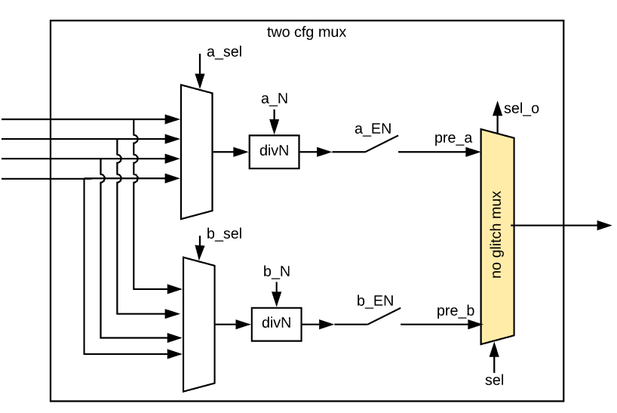

AO_CLKCTRL_OSCIN_CTRL
Osc from XTAL pad will connect all PLL and some analog modules:
And it will gated by reg_oscin_ctrl;
Bit(s) | R/W | Default | Description
21 | R/W | 1 | clock gate en;  xtal -> VX1_PLL, PIXEL_PLL
20 | R/W | 1 | clock gate en;  xtal -> HIFI_PLL, DISP_PLL
18 | R/W | 1 | clock gate en;  xtal -> USB2_phy
17 | R/W | 1 | clock gate en;  xtal -> USB2(u2drd)
0 | R/W | 1 | clock gate en;  xtal -> PLL_TOP(FIXPLL)

AO_CLKCTRL_RTC_BY_OSCIN_CTRL0
RTC clock is a low frequency clock which needn’t PLL.
it can generated by XTAL（base clk） of from PAD.
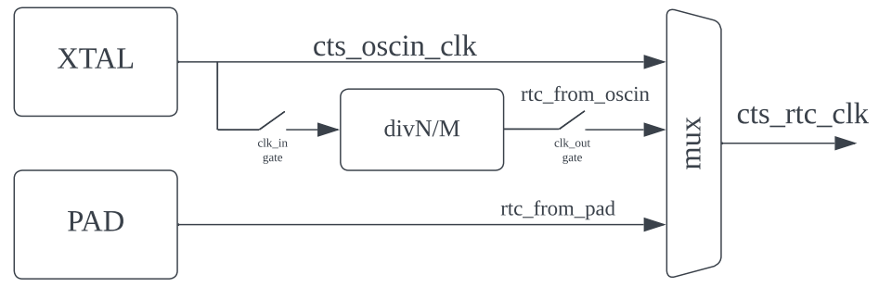
Bit(s) | R/W | Default | Description
31 | R/W | 1 | clock in gate en
30 | R/W | 1 | clock out gate en
29:28 | R/W | 0 | div_list_max
23:12 | R/W | ‘d731 | clock div N1, if you want div8, set to 7
11:0 | R/W | ‘d732 | clock div N0, if you want div8, set to 7

AO_CLKCTRL_RTC_BY_OSCIN_CTRL1
Bit(s) | R/W | Default | Description
24 | R/W | 1 | 1: force clock_out = clock_in
23:12 | R/W | ‘d10 | clock div M1, if you want div8, set to 7
11:0 | R/W | ‘d7 | clock div M0, if you want div8, set to 7

AO_CLKCTRL_RTC_CTRL
Bit(s) | R/W | Default | Description
31 | R | 0 | mux1 sel o
30 | R | 0 | mux0b sel o
29 | R | 0 | mux0a sel o
1:0 | R/W | 0 | cts_rtc_clk source select:  0: oscin;  1:rtc from oscin div(N0/N1);  2:rtc from PAD;  3:off;

AO_CLKCTRL_MBIST_ATSPEED_CTRL
Bit(s) | R/W | Default | Description
0 | R/W | 0 | 0: mbist clk will select oscine;  1: mbist clk will select cts_***_clk;

AO_CLKCTRL_SYS_CLK_CTRL0
SYS_CLK is a system level clock, most of control bus and some data bus worked on this clock domain.

Bit(s) | R/W | Default | Description
31 | R | 0 | no glitch mux sel out, if it’s not equal to sel in for long time, mean the FSM is dead because no clock in
29 | R/W | 0 | pre_b clock gate en
28:26 | R/W | 0 | pre_b source select:  0:cts_oscin_clk;  1:fclk_div2;  2:fclk_div3;  3:fclk_div4  4:fclk_div5  5:fclk_div7  6:1’b0  7:cts_rtc_clk
25:16 | R/W | 0 | pre_b div N, if you want div8, set to 7
15 | R/W | 0 | no gilitch mux sel in  0: select pre_a;  1: select pre_b;
13 | R/W | 1 | pre_a clock gate en
12:10 | R/W | 0 | pre_a source select:  0:cts_oscin_clk;  1:fclk_div2;  2:fclk_div3;  3:fclk_div4  4:fclk_div5  5:fclk_div7  6:1’b0  7:cts_rtc_clk
9:0 | R/W | 0 | pre_a div N, if you want div8, set to 7

AO_CLKCTRL_SYS_CLK_EN0_REG0 & AO_CLKCTRL_CLK81_GATE_CTRL
Each bit will enabled one user, all those bits are default enable after power up, if some bits are not defined, mean they are reserved.
Ref spec link: ms1_clk_spec

AO_CLKCTRL_AHB_CLK_CTRL0
Bit(s) | R/W | Default | Description
31 | R | 0 | no glitch mux sel out, if it’s not equal to sel in for long time, mean the FSM is dead because no clock in
29 | R/W | 0 | pre_b clock gate en
28:26 | R/W | 0 | pre_b source select:  0:cts_oscin_clk;  1:fclk_div2;  2:fclk_div3;  3:fclk_div4  4:fclk_div5  5:fclk_div7  6:fclk_div2p5  7:cts_rtc_clk
25:16 | R/W | 0 | pre_b div N, if you want div8, set to 7
15 | R/W | 0 | no gilitch mux sel in  0: select pre_a;  1: select pre_b;
13 | R/W | 1 | pre_a clock gate en
12:10 | R/W | 0 | pre_a source select:  0:cts_oscin_clk;  1:fclk_div2;  2:fclk_div3;  3:fclk_div4  4:fclk_div5  5:fclk_div7  6:fclk_div2p5  7:cts_rtc_clk
9:0 | R/W | 0 | pre_a div N, if you want div8, set to 7

AO_CLKCTRL_TST_CTRL0/1
there are 4 test source can connect to PINMUX.
each pin can select by 2bits of CLKCTRL_TST_CTRL0/1.
the test source list as blow:
TST_CLK_OUT | Select | tst_src0_clk | tst_src1 | tst_src2
25 | CTRL1[19:18]
24 | CTRL1[17:16]
23 | CTRL1[15:14]
22 | CTRL1[13:12]
21 | CTRL1[11:10]
20 | CTRL1[9:8]
19 | CTRL1[7:6]
18 | CTRL1[5:4]
17 | CTRL1[3:2]
16 | CTRL1[1:0]
15 | CTRL0[31:30]
14 | CTRL0[29:28]
13 | CTRL0[27:26]
12 | CTRL0[25:24] | fclk_div2
11 | CTRL0[23:22] | fclk_div2p5
10 | CTRL0[21:20] | fclk_div3
9 | CTRL0[19:18] | fclk_div4
8 | CTRL0[17:16] | fclk_div5
7 | CTRL0[15:14] | fclk_div7
6 | CTRL0[13:12]
5 | CTRL0[11:10]
4 | CTRL0[9:8]
3 | CTRL0[7:6]
2 | CTRL0[5:4]
1 | CTRL0[3:2]
0 | CTRL0[1:0]

AO_CLKCTRL_CECB_CLK_CTRL0
CEC_CLK always run at 32768Hz, it will generated by XTAL, but for more accuracy, it can div by two counter.
please refer to RTC_CLK for N1/N2 usage.
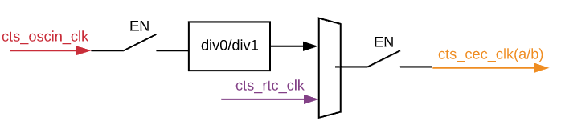
Bit(s) | R/W | Default | Description
31 | R/W | 0 | Gclk_in:0:disable clk in;1:enable clk in;
30 | R/W | 0 | Gclk_out: 0:disable clk out; 1: enable clk out;
29-28 | R/W | 0 | Div_list_max:  0:only use clk_div0;  1:use clk_div0/clk_div1 in turn;
27-24 | R/W | 0 | Reserved
23-12 | R/W | 0 | Div_tcnt1: freq_clk_div1 = freq_clk_in/div_tcnt1;
11-0 | R/W | 0 | Div_tcnt0: freq_clk_div0 = freq_clk_in/div_tcnt0;

AO_CLKCTRL_CECB_CLK_CTRL1
Bit(s) | R/W | Default | Description
31 | R/W | 0 | clk_sel for cts_cec_clk  0: cecb_clk_div  1: from cts_rtc_clk
30-25 | R | 0 | Reserved
24 | R/W | 0 | Divide_by_1:  1: clk_out = clk_in;  0: clk_out = clk_div0 or 1;
23-12 | R/W | 0 | Cycle_tcnt1  After Cycle_tcnt1 times clk_div1, clk_out will equal clk_div0;  Need set div_list_max = 1;
11-0 | R/W | 0 | Cycle_tcnt0  After Cycle_tcnt0 times clk_div, clk_out will equal clk_div1;  Need set div_list_max = 1;

AO_CLKCTRL_CLK12_24_CTRL

Bit(s) | R/W | Default | Description
19~13 | R/ | 0 | RESERVED
12 | R/W | 0 | crt_clk25_en; for CLK25M(refer to pinmux define)  set 1 :CLK25M = 2GHz/ clk25_div;  set 0 : CLK25M = 0;
11 | R/W | 0 | crt_clk24_en; for CLK12M_24M(refer to pinmux define)  set 1 :CLK12M_24M = 24M;  set 0 : CLK12M_24M = 0;
10 | R/W | 0 | clk24_div2_en; for CLK12M_24M(refer to pinmux define)  need set crt_clk24_en = 1 first;  set 1 :CLK12M_24M = 12M;  set 0 : CLK12M_24M = 24M;
7:0 | R/W | 0 | clk25_div; for CLK25M(refer to pinmux define)  if need 8, set as 7; if set 0, will div2;  etc: set 79, CLK25M = 2000MHz/80=25MHz;

AO_CLKCTRL_PWM_CLK_(AD_)**_CTRL
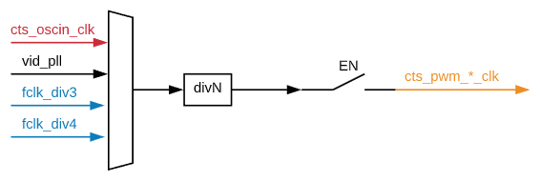
Bit(s) | R/W | Default | Description
26:25 | R/W | 0 | cts_pwm_j/h/f/d/b_clk  clk_sel:  0: osin  1: vid_pll  2: fclk_div4  3: fclk_fiv3
24 | R/W | 0 | cts_pwm_j/h/f/d/b_clk  clk_en
23:16 | R/W | 0 | cts_pwm_j/h/f/d/b_clk  div N, if you want div8, set to 7
10:9 | R/W | 0 | cts_pwm_i/g/e/c/a_clk  clk_sel:  0: osin  1: vid_pll  2: fclk_div4  3: fclk_fiv3
8 | R/W | 0 | cts_pwm_i/g/e/c/a_clk  clk_en
7:0 | R/W | 0 | cts_pwm_i/g/e/c/a_clk  div N, if you want div8, set to 7

AO_CLKCTRL_GEN_CLK_CTRL
this register can control a special “GEN_CLK” which is designed for debug/monitor some internal clock quality, especially all PLL output. “GEN_CLK” will connect to one PAD(output).
Bit(s) | R/W | Default | Description
16:12 | R/W | 0 | gen_clk source select  0: cts_oscin_clk;  1:cts_rtc_clk;  2:1’b0  3:1’b0  4: 1’b0  5: 1’b0  6: 1’b0  7: 1’b0  8: 1’b0  9: 1’b0  10:1’b0  11:1’b0  12:cts_msr_clk  13:1’b0  14:1’b0  15:1’b0  16: 1’b0  17: 1’b0  19: fclk_div2  20: fclk_div2p5  21: fclk_div3  22: fclk_div4  23: fclk_div5  24: fclk_div7  29:1’b0  31:1’b0
11 | R/W | 0 | gen_clk gate en
10:0 | R/W | 0 | gen_clk div N, if you want div8, set to 7

AO_CLKCTRL_TIMEBASE_CTRL0
Some module need a fixed frequency tick as reference like UART, the tick will generated by a count which has 3 clock sources. if XTAL changed frequency, need change this register.
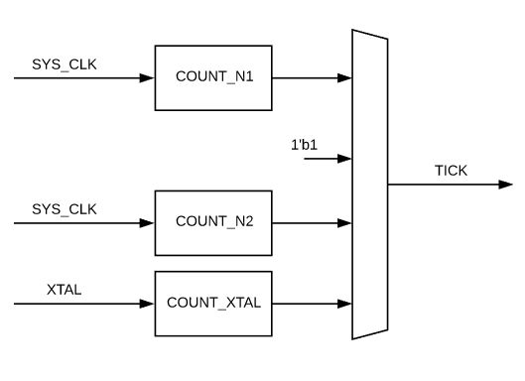
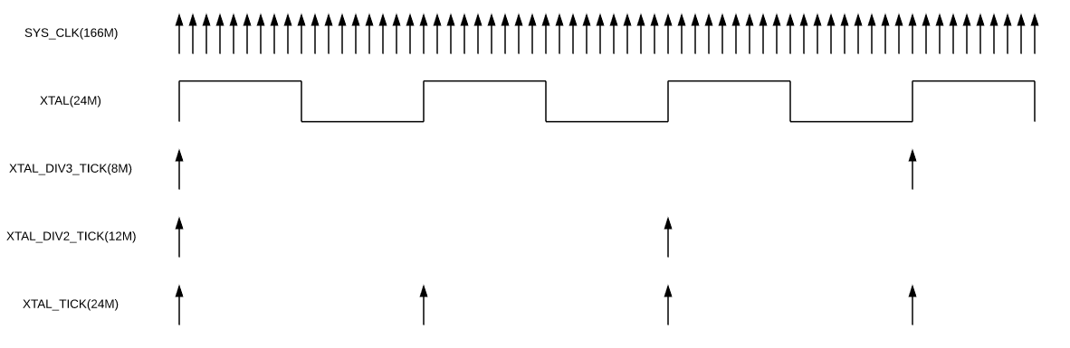
Bit(s) | R/W | Default | Description
31:24 | R/W | 0 | N1, if you want div8, set to 8
23:19 | R/W | 0 | N2, if you want div8, set to 8
18 | R/W | 0 | 1: enable xtal(24M) tick
17 | R/W | 1 | Crystal clock enable.
16 | R/W | 0 | Soft Reset
15:14 | R/W | 0 | 1MS_TICK: 0 = use (100US_TICK/10), 1 = hold to 1, 2 = use counter1, 3 = use counter 2
13:12 | R/W | 0 | 100US_TICK: 0 = use (10US_TICK/10), 1 = hold to 1, 2 = use counter1, 3 = use counter 2
11:10 | R/W | 0 | 10US_TICK: 0 = use (1US_TICK/10), 1 = hold to 1, 2 = use counter1, 3 = use counter 2
9:8 | R/W | 0 | 1US_TICK: 0 = use (Crystal/XTAL_DIV), 1 = hold to 1, 2 = use counter1, 3 = use counter 2
7:6 | R/W | 0 | XTAL_DIV3_TICK: 0 = use Crystal/3, 1 = hold to 1, 2 = use counter1, 3 = use counter 2
5:0 | R/W | 24 | XTAL_DIV, if you want div24000, set to 24

AO_CLKCTRL_TIMEBASE_CTRL1
Bit(s) | R/W | Default | Description
2 | R/W | 1 | 1: sync xtal_div3 by fall edge of xtal;
1 | R/W | 1 | 1: sync xtal_div2 by fall edge of xtal;
0 | R/W | 0 | 1: enable xtal_div2(12M) tick

AO_CLKCTRL_HRX_CLK_CTRL0
Bit(s) | R/W | Default | Description
26:25 | R/W | 0 | cts_hdmirx_2m_clkl:  0:oscin  1:fclk_div4  2:fclk_div3  3fclk_div5
24 | R/W | 0 | cts_hdmirx_2m_Clk_en
22:16 | R/W | 0 | cts_hdmirx_2m_Clk  div N, if you want div8, set to 7
10:9 | R/W | 0 | cts_hdmirx_5m_clkl:  0:hdmirx_aud_pll_clk
8 | R/W | 0 | cts_hdmirx_5m_Clk_en
6:0 | R/W | 0 | cts_hdmirx_5m_Clk  div N, if you want div8, set to 7

AO_CLKCTRL_HRX_CLK_CTRL1
Bit(s) | R/W | Default | Description
10:9 | R/W | 0 | cts_hdmirx_meter_clk sel  0:oscin  1:fclk_div4  2:fclk_div3  3:fclk_div5
8 | R/W | 0 | cts_hdmirx_meter_Clk_en
6:0 | R/W | 0 | cts_hdmirx_meter_Clk  div N, if you want div8, set to 7

AO_FIX_PLL_CTRL0
Bit(s) | R/W | Default | Description

AO_FIX_PLL_CTRL1
Bit(s) | R/W | Default | Description

AO_FIX_PLL_CTRL2
Bit(s) | R/W | Default | Description

AO_FIX_PLL_STS
Bit(s) | R/W | Default | Description

EE_CLK_CTRL

EE_CLKCTRL_TST_CTRL0/1
there are 4 test source can connect to PINMUX.
each pin can select by 2bits of CLKCTRL_TST_CTRL0/1.
the test source list as blow:
TST_CLK_OUT | Select | tst_src0_clk | tst_src1 | tst_src2
25 | CTRL1[19:18] | 1'b0 | 1'b0 | 1’b0
24 | CTRL1[17:16] | 1'b0 | 1'b0 | 1’b0
23 | CTRL1[15:14] | 1'b0 | 1'b0 | 1’b0
22 | CTRL1[13:12] | 1'b0 | 1'b0 | 1’b0
21 | CTRL1[11:10] | 1'b0 | 1'b0 | 1’b0
20 | CTRL1[9:8] | 1'b0 | 1'b0 | 1’b0
19 | CTRL1[7:6] | 1'b0 | 1'b0 | 1’b0
18 | CTRL1[5:4] | 1'b0 | 1'b0 | 1’b0
17 | CTRL1[3:2] | 1'b0 | 1'b0 | 1’b0
16 | CTRL1[1:0] | 1'b0 | 1'b0 | 1’b0
15 | CTRL0[31:30] | 1'b0 | 1'b0 | 1’b0
14 | CTRL0[29:28] | hrx20_pll_clk_test | hrx20_pll_lock_flag | 1’b0
13 | CTRL0[27:26] | fpll_pixel_clk | fpll_lock | 1’b0
12 | CTRL0[25:24] | audio_pll_clk | audio_pll_lock | 1’b0
11 | CTRL0[23:22] | tx_pixel_pll_clk | pix_pll_sts_i[31] | 1’b0
10 | CTRL0[21:20] | tcon_clk_out0 | p2p_pll0_lock_flag | 1’b0
9 | CTRL0[19:18] | vga_pll_clk | vga_pll_lock_flag | 1’b0
8 | CTRL0[17:16] | p20_usb2_ckout | usb_pll0_lock | 1’b0
7 | CTRL0[15:14] | disp_pll_clk | disp_pll_sts_i[31] | 1’b0
6 | CTRL0[13:12] | hifi_pll_clk | hifi_pll_sts_i[31] | 1’b0
5 | CTRL0[11:10] | fclk_div2 | fixpll_lock | am_ring_osc_clk_out_vpu[1]
4 | CTRL0[9:8] | fclk_div2p5 | fixpll_lock | am_ring_osc_clk_out_vpu[1]
3 | CTRL0[7:6] | fclk_div3 | fixpll_lock | am_ring_osc_clk_out_video_out
2 | CTRL0[5:4] | fclk_div4 | fixpll_lock | am_ring_osc_clk_out_top[2]
1 | CTRL0[3:2] | fclk_div5 | fixpll_lock | am_ring_osc_clk_out_top[1]
0 | CTRL0[1:0] | fclk_div7 | fixpll_lock | am_ring_osc_clk_out_top[0]

EE_CLKCTRL_VP_OPT_CLK_CTRL
Bit(s) | R/W | Default | Description
31 | R | 0 | no glitch mux sel out, if it’s not equal to sel in for long time, mean the FSM is dead because no clock in
24 | R/W | 0 | pre_b clock gate en
27:25 | R/W | 0 | pre_b source select:  0:cts_oscin_clk;  1:disp_pll_clk  2:fclk_div5;  3:fclk_div4  4:fclk_div3  5:ftx_pll_div_clk  6:vdin_clk  7:tx_pixel_pll_clk
22:16 | R/W | 0 | pre_b div N, if you want div8, set to 7
31 | R/W | 0 | no gilitch mux sel in  0: select pre_a;  1: select pre_b;
8 | R/W | 1 | pre_a clock gate en
11:9 | R/W | 0 | pre_a source select:  0:cts_oscin_clk;  1:disp_pll_clk  2:fclk_div5;  3:fclk_div4  4:fclk_div3  5:fclk_div2  6:vdin_clk  7:tx_pixel_pll_clk
6:0 | R/W | 0 | pre_a div N, if you want div8, set to 7

EE_CLKCTRL_BCON_CLK_CNTL
Bit(s) | R/W | Default | Description
9:7 | R/W | 0 | clk_sel::  0:oscin  1:cts_sys_clk  2:fclk_div5  3:fclk_div4  4:tx_pll_div_clk  5:1’b0  6:1’b0  7:1’b0
6 | R/W | 0 | clk_en
5:0 | R/W | 0 | div N, if you want div8, set to 7

EE_CLKCTRL_TX_DET_CLK_CTRL
Bit(s) | R/W | Default | Description
9:7 | R/W | 0 | clk_sel::  0:oscin  1:cts_sys_clk  2:fclk_div5  3:fclk_div4  4:1’b0  5:1’b0  6:1’b0  7:1’b0
6 | R/W | 0 | clk_en
5:0 | R/W | 0 | div N, if you want div8, set to 7

EE_CLKCTRL_APB2_CLK_CTRL
Bit(s) | R/W | Default | Description
9:7 | R/W | 0 | clk_sel::  0:oscin  1:cts_sys_clk  2:fclk_div4  3:fclk_div3  4:fclk_div5  5:1’b0  6:1’b0  7:1’b0
6 | R/W | 0 | clk_en
5:0 | R/W | 0 | div N, if you want div8, set to 7

EE_CLKCTRL_SPISG_CLK_CTRL
Bit(s) | R/W | Default | Description
9:7 | R/W | 0 | clk_sel::  0:oscin  1:cts_sys_clk  2:fclk_div4  3:fclk_div3  4:fclk_div2  5:fclk_div5  6:fclk_div7  7:1’b0
6 | R/W | 0 | clk_en
5:0 | R/W | 0 | div N, if you want div8, set to 7

EE_CLKCTRL_PWM_CLK_(EH_)**_CTRL

Bit(s) | R/W | Default | Description
26:25 | R/W | 0 | cts_pwm_j/h/f/d/b_clk  clk_sel:  0: osin  1: vid_pll  2: fclk_div4  3: fclk_fiv3
24 | R/W | 0 | cts_pwm_j/h/f/d/b_clk  clk_en
23:16 | R/W | 0 | cts_pwm_j/h/f/d/b_clk  div N, if you want div8, set to 7
10:9 | R/W | 0 | cts_pwm_i/g/e/c/a_clk  clk_sel:  0: osin  1: vid_pll  2: fclk_div4  3: fclk_fiv3
8 | R/W | 0 | cts_pwm_i/g/e/c/a_clk  clk_en
7:0 | R/W | 0 | cts_pwm_i/g/e/c/a_clk  div N, if you want div8, set to 7

EE_CLKCTRL_SAR_CLK_CTRL0
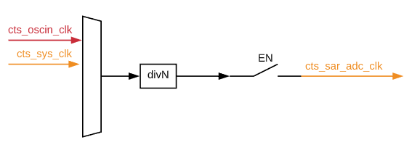
Bit(s) | R/W | Default | Description
10:9 | R/W | 0 | clk_sel:  0: osin  1: cts_sys_clkl  2:fclk_div5
8 | R/W | 0 | clk_en
7:0 | R/W | 0 | div N, if you want div8, set to 7

EE_CLKCTRL_TS_CLK_CTRL
this clock is generated for temp sensor.
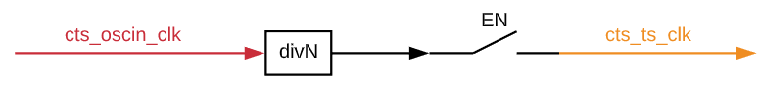
Bit(s) | R/W | Default | Description
8 | R/W | 0 | cts_ts_clk clk_en
7:0 | R/W | 18 | cts_ts_clk div N, if you want div8, set to 7

EE_CLKCTRL_AXI_CLK_CTRL0
AXI_CLK is a high speed clock for most of data bus.
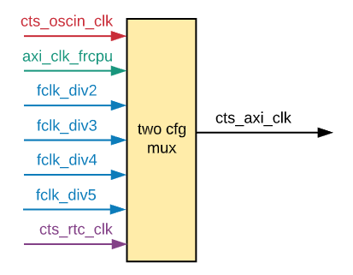
Bit(s) | R/W | Default | Description
31 | R | 0 | no glitch mux sel out, if it’s not equal to sel in for long time, mean the FSM is dead because no clock in
29 | R/W | 0 | pre_b clock gate en
28:26 | R/W | 0 | pre_b source select:  0:cts_oscin_clk;  1:fclk_div2;  2:fclk_div3;  3:fclk_div4  4:fclk_div5  5:fclk_div7  6:fclk_div2p5
25:16 | R/W | 0 | pre_b div N, if you want div8, set to 7
15 | R/W | 0 | no gilitch mux sel in  0: select pre_a;  1: select pre_b;
13 | R/W | 1 | pre_a clock gate en
12:10 | R/W | 0 | pre_a source select:  0:cts_oscin_clk;  1:fclk_div2;  2:fclk_div3;  3:fclk_div4  4:fclk_div5  5:fclk_div7  6:fclk_div2p5
9:0 | R/W | 0 | pre_a div N, if you want div8, set to 7

EE_CLKCTRL_CLK81_GATE_CTRL & EE_CLKCTRL_AHB_CLK_GATE_CTRL
Each bit will enabled one user, all those bits are default enable after power up, if some bits are not defined, mean they are reserved.
Ref spec link: ms1_clk_spec

EE_CLKCTRL_MBIST_ATSPEED_CTRL
Bit(s) | R/W | Default | Description
0 | R/W | 0 | 0: mbist clk will select oscine;  1: mbist clk will select cts_***_clk;

EE_CLKCTRL_GEN_CLK_CTRL
this register can control a special “GEN_CLK” which is designed for debug/monitor some internal clock quality, especially all PLL output. “GEN_CLK” will connect to one PAD(output).
Bit(s) | R/W | Default | Description
16:12 | R/W | 0 | gen_clk source select  clk0 : cts_oscin_clk  clk1 : cts_rtc_clk  clk2 : hifi_pll_clk  clk3 : disp_pll_clk  clk4 : vdin_clk  clk5 : tx_pll_div_clk  clk6 : tx_pixel_pll_clk  clk7 : tcon_clk_out0  clk8 : vga_pll_clk  clk9 : p20_usb2_ckout  clk10 : 1'b0  clk11 : 1'b0  clk12 : cts_msr_clk  clk13 : hrx20_pll_clk_test  clk14 : audio_pll_clk  clk15 : fpll_pixel_clk  clk16 : 1'b0  clk17 : 1'b0  clk18 : 1'b0  clk19 : fclk_div2  clk20 : fclk_div2p5  clk21 : fclk_div3  clk22 : fclk_div4  clk23 : fclk_div5  clk24 : fclk_div7  clk25 : 1'b0  clk26 : 1'b0  clk27 : 1'b0  clk28 : 1'b0  clk29 : 1'b0  clk30 : 1'b0  clk31 : 1'b0
11 | R/W | 0 | gen_clk gate en
10:0 | R/W | 0 | gen_clk div N, if you want div8, set to 7

EE_CLKCTRL_HRX_CLK_CTRL1
Bit(s) | R/W | Default | Description
26:25 | R/W | 0 | cts_hdmirx_hdcp2x_eclk clk_sel::  0:oscin  1:fclk_div4  2:fclk_div3  3:fclk_div5
24 | R/W | 0 | cts_hdmirx_hdcp2x_eclk clk_en
22:16 | R/W | 0 | Cts_hdmirx_hdcp2x_eclk  div N, if you want div8, set to 7
10:9 | R/W | 0 | cts_hdmirx_cfg_clk :clk_sel  0:oscin  1:fclk_div4  2:fclk_div3  3:fclk_div5
8 | R/W | 0 | cts_hdmirx_cfg_clk：clk_en
6:0 | R/W | 0 | Cts_hdmirx_cfg_clk  div N, if you want div8, set to 7

EE_CLKCTRL_HRX_CLK_CTRL2
Bit(s) | R/W | Default | Description
26:25 | R/W | 0 | Cts_hdmirx_acr_ref_sel::  0:oscin  1:fclk_div4  2:fclk_div3  3:fclk_div5
24 | R/W | 0 | Cts_hdmirx_acr_ref_en
22:16 | R/W | 0 | Cts_hdmirx_acr_ref_clk  div N, if you want div8, set to 7

EE_CLKCTRL_VDOUT_CLK_CTRL
Bit(s) | R/W | Default | Description
9:7 | R/W | 0 | Cts_tcon_pll_clk_sel::  0:oscin  1:tx_pll_div_clk  2:fclk_div5  3:fclk_div4  4:fclk_div3  5:fclk_div2  6:vdin_clk  7:tx_pixel_pll_clk
6 | R/W | 0 | Cts_tcon_pll_clk_en
5:0 | R/W | 0 | Cts_tcon_pll_clk  div N, if you want div8, set to 7

AO_SYS_CTRL

SYSCTRL_METAL_REV0
Bit(s) | R/W | Default | Description
31:0 | R | 0x11111111 | metal rev[31:0]

SYSCTRL_METAL_REV1
Bit(s) | R/W | Default | Description
31:0 | R | 0x11111111 | metal rev[63:32]

SYSCTRL_METAL_REV2
Bit(s) | R/W | Default | Description
11:0 | R | 0x1 | metal rev[75:64]

SYSCTRL_CHIP_ID
Bit(s) | R/W | Default | Description
31:0 | R | 0x60 | the CHIP ID

SYSCTRL_WRITEONCE_REG0
Bit(s) | R/W | Default | Description
31:0 | R/W | 0 | each bit can write to 1 only

SYSCTRL_WRITEONCE_REG1
Bit(s) | R/W | Default | Description
31:0 | R/W | 0 | each bit can write to 1 only

SYSCTRL_WRITEONCE1_REG0
Bit(s) | R/W | Default | Description
31:0 | R/W | 0 | each bit can write to 1 only

SYSCTRL_WRITEONCE_STICKY_REG0
Bit(s) | R/W | Default | Description
31:0 | R/W | 0 | each bit can write to 1 only  not reset by watchdog

SYSCTRL_WRITEONCE_STICKY_REG1
Bit(s) | R/W | Default | Description
31:0 | R/W | 0 | each bit can write to 1 only  not reset by watchdog

SYSCTRL_TIMERA_CTRL
Bit(s) | R/W | Default | Description
7 | R/W | A:1  B:0  C:0  D:0  G:0  H:0  I:0  J:0 | timer en
6 | R/W | A:1  B:0  C:0  D:0  G:0  H:0  I:0  J:0 | timer mode:  0: generate irq once;  1: generate irq periodic;
1:0 | R/W | A:0  B:0  C:0  D:0  G:0  H:0  I:0  J:0 | clk_sel:  0: cts_sys_clk;  1:1us;  2:10us;  3:100us

SYSCTRL_TIMERA
Bit(s) | R/W | Default | Description
31:16 | R | 0 | ttimer threshold
15:0 | R/W | 0 | write:  clean timer count;  set timer threshold.  irq will generate when timer count equal to threshold  read:  timer count value

SYSCTRL_TIMERE/F_CTRL
Bit(s) | R/W | Default | Description
7 | R/W | E:1  F:1 | timer en
1:0 | R/W | E:1  F:0 | clk_sel:  0: cts_sys_clk;  1:1us;  2:10us;  3:100us

SYSCTRL_TIMERE/F
Bit(s) | R/W | Default | Description
31:0 | R/W | 0 | write:  clean timer count;  read:  update timer count[63:32] to TIMER_HI  timer count[31:0]

SYSCTRL_TIMERE/F_HI
Bit(s) | R/W | Default | Description
31:0 | R | 0 | timer count[63:32]

SYSYSCTRL_ALERT_STS_STICKY
Bit(s) | R/W | Default | Description
4 | R | 0 | efuse write error
1 | R | 0 | enclave vgd1 alert
0 | R | 0 | enclave vgd0 alert

SYSCTRL_ALERT_ENABLE
Bit(s) | R/W | Default | Description
4 | R/W | 0 | write 1 only; enable efuse write error
1 | R/W | 0 | write 1 only; enable enclave vgd1 alert
0 | R/W | 0 | write 1 only; enable enclave vgd0 alert

SYSYSCTRL_DEBUG_REG0~4
Bit(s) | R/W | Default | Description
31:0 | R/W | 0

SYSCTRL_STATUS_REG0~3
Bit(s) | R/W | Default | Description
31:0 | R/W | 0

SYSCTRL_STICKY_REG0~3
Bit(s) | R/W | Default | Description
31:0 | R/W | 0 | not reset by watchdog

SYSCTRL_CEC_STICKY_REG0~3
Bit(s) | R/W | Default | Description
31:0 | R/W | 0 | not reset by watchdog

SYSCTRL_MSG_INDEX0~1_STICKY
Bit(s) | R/W | Default | Description
31 | R/W | 0 | write_en
15:0 | R/W | 0 | if write_en = 1: update index = write data [15:0];  if write_en = 0: update index = index + 1

SYSYSCTRL_BUS_CFG0
Bit(s) | R/W | Default | Description
27:4 | R/W | 0xfac688 | ahb_arbiter_pp_bits
3 | R/W | 0 | ahb_arbfix_en
2 | R/W | 0 | ahb_arbiter_changed
1:0 | R/W | 0 | ahb_arbiter_scheme

SYSCTRL_HDMIRXPLL_TEST_CTRL
Bit(s) | R/W | Default | Description
1 | R/W | 0x0 | hdmirxpll_test_ctrl

SYSCTRL_SCAN_PW0
Bit(s) | R/W | Default | Description
31:0 | R | 0x0 | pwd_recv[31:0]

SYSCTRL_SCAN_PW1
Bit(s) | R/W | Default | Description
31:0 | R | 0x0 | pwd_recv[63:32]

SYSCTRL_SCAN_PW2
Bit(s) | R/W | Default | Description
31:0 | R | 0x0 | pwd_recv[95:64]

SYSCTRL_SCAN_PW3
Bit(s) | R/W | Default | Description
31:0 | R | 0x0 | pwd_recv[127:96]

SYSCTRL_TEST_MUX_SEL
Bit(s) | R/W | Default | Description
27 | R/W | 0 | 0: ao_test_mux_pre[31:16]  1:ao_test_mux_pre[15:0]
2:0 | R/W | 0 | 0 ao_test_mux0  1 ao_test_mux1  2 ao_test_mux2  3 otp_info0  4 otp_info1  5 otp_info2  6 aocpu_test_mux0  7 aocpu_test_mux1

SYSCTRL_TEST_MUX0/1/2/3/4/5
just for debug
Bit(s) | R/W | Default | Description
31:0 | R

SYSCTRL_EFUSE_INFO0
Bit(s) | R/W | Default | Description
19:4 | R | 0X0 | otp_pll_para
3:2 | R | 0X0 | efuse_alert
1 | R | 0X0 | efuse_ft_pwd_en
0 | R | 0X0 | otp_ready

SYSCTRL_EFUSE_INFO1
Bit(s) | R/W | Default | Description
31:0 | R | 0x0 | otp_lic_0

SYSCTRL_EFUSE_INFO2
Bit(s) | R/W | Default | Description
31:0 | R | 0X0 | otp_clk_freq0

SYSCTRL_LDO_CTRL
Bit(s) | R/W | Default | Description
1 | R/W | 0x0 | vout_sel, 0: 2.5v; 1: 1.8v
0 | R/W | 0x0 | ldo_en_09, 0：ldo_out = 0v; 1: enable

EE_SYS_CTRL

EE_SYSCTRL_BUS_CFG0
Bit(s) | R/W | Default | Description
31:28 | R/W | 0 | ARQOS_vpu_top
27:24 | R/W | 0 | AWQOS_vpu_top
23:20 | R/W | 0 | ARQOS_ubs2
19:16 | R/W | 0 | AWQOS_ubs2
15:12 | R/W | 0 | ARQOS_spisg
11:8 | R/W | 0 | AWQOS_spisg
7:4 | R/W | 0 | ARQOS_video_out
3:0 | R/W | 0 | AWQOS_video_out

EE_SYSCTRL_BUS_CFG1
Bit(s) | R/W | Default | Description
31:28 | R/W | 0 | ARCACHE_vpu_top
27:24 | R/W | 0 | AWCACHE_vpu_top
23:20 | R/W | 0 | ARCACHE_ubs2
19:16 | R/W | 0 | AWCACHE_ubs2
15:12 | R/W | 0 | ARCACHE_spisg
11:8 | R/W | 0 | AWCACHE_spisg
7:4 | R/W | 0 | ARCACHE_video_out
3:0 | R/W | 0 | AWCACHE_video_out

EE_SYSCTRL_NIC_CFG0
Bit(s) | R/W | Default | Description
3 | R/W | 0xf | nic_ee vpu clock gate
2 | R/W | 0xf | nic_ee spi clock gate
1 | R/W | 0xf | nic_ee axi sram_clk clock gate
0 | R/W | 0xf | nic_ee aobus_clk clock gate

EE_SYSCTRL_VGD_CTRL
Bit(s) | R/W | Default | Description
3 | R/W | 0x0 | vgd_en
2:1 | R/W | 0x0 | vgd_lvrsel
0 | R/W | 0x0 | vgd_porsel

EE_SYSCTRL_SPISG_TRIG0
Bit(s) | R/W | Default | Description
31:0 | R/W | 0 | reg_trig_mux_en
30:7 | R/W | 1 | reg_dly_cnt
6:5 | R/W | 0 | reg_out_sel
4:0 | R/W | 0 | reg_in_sel:  [19]:gpio_i  [18:16]:line_n_i[2:0]  [15:13]:vsync_i[2:0]  [12:10]:pwm_vs_i[2:0]  [9:0]:pwm_i[7:0]

EE_SYSCTRL_OSC_RING_CTRL0
Bit(s) | R/W | Default | Description
11:10 | R/W | 0 | u_am_ring_osc_vpu_1  bit1:freq_sel, 0:low frequency;1:high frequency;  bit0:enable
9:8 | R/W | 0 | u_am_ring_osc_vpu_0  bit1:freq_sel, 0:low frequency;1:high frequency;  bit0:enable
7:6 | R/W | 0 | am_ring_osc_video_out  bit1:freq_sel, 0:low frequency;1:high frequency;  bit0:enable
5:4 | R/W | 0 | am_ring_osc_top_2  bit1:freq_sel, 0:low frequency;1:high frequency;  bit0:enable
3:2 | R/W | 0 | am_ring_osc_top_1  bit1:freq_sel, 0:low frequency;1:high frequency;  bit0:enable
1:0 | R/W | 0 | am_ring_osc_top_0  bit1:freq_sel, 0:low frequency;1:high frequency;  bit0:enable

EE_SYSCTRL_OSC_RING_CTRL1
Bit(s) | R/W | Default | Description
31 | R/W | 0 | am_ring_osc_resetn  0: all osc_ring is reset.

IRQ_CTRL
irq_ctrl include:
- collect all irq source together and sync it;
- add invert or latch if needed;
- send to different destination after masked;
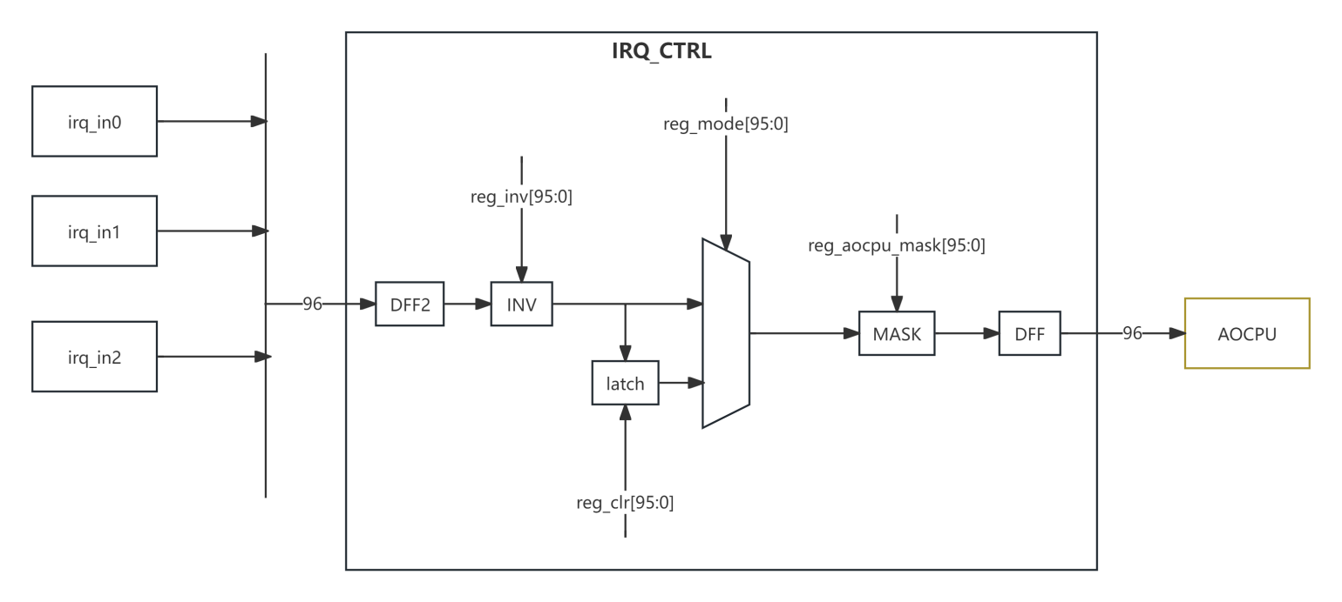

IIRQCTRL_IRQ_MODE0~2
Bits | R/W | Defaults | Description
95:0 | R/W | 0 | if set 1, will select latched irq;  if set 0, will select original irq source;

IRQCTRL_IRQ_LATCH0~2
Bits | R/W | Defaults | Description
95:0 | R | 0 | the latched irq value

IRQCTRL_IRQ_LATCH_CLR0~2
Bits | R/W | Defaults | Description
95:0 | R/W | 0 | if set 1, will keep latched irq to low

IRQCTRL_IRQ_MASK0~2_AOCPU
Bits | R/W | Defaults | Description
95:0 | R/W | all 1 | if set 0, will keep irq as low

RQCTRL_IRQ_INV0~2
Bits | R/W | Defaults | Description
95:0 | R/W | 0 | if set 1, will invert irq level

IRQCTRL_SOFT_IRQ
Bits | R/W | Defaults | Description
31:8 | R/W | 0x0 | rsv
7:0 | R/W | 0x0 | IRQ can be set by SW

irq source is:
Link: MS1_irq_source

Efuse_top
Please refer to the specific description in MS1_efuse_top_spec.docx

aocpu
aocpu is top of N205, contain configuration register.

AOCPU_CPU_VECTOR
Bits | R/W | Defaults | Description
31:0 | R/W | 0xF0000000 | N205 boot address

AOCPU_CPU_CTRL0
Bit(s) | R/W | Default | Description
[5] | R/W | 0 | nmi
[3] | R/W | 0 | override_dm_sleep
[2] | R/W | 0 | dbg_stop_at_boot
[1] | R/W | 0 | jtag_dwbypass
[0] | R/W | 0 | icache_disable_init

AOCPU_CPU_CTRL1
Bit(s) | R/W | Default | Description
[10] | R/W | 0 | gate_by_sleep
[9] | R/W | 0 | RXEV
[7:6] | R/W | 0 | n205_debug_sel
[1] | R/W | 0 | n205_i_dbg_stop
[0] | R/W | 0 | n205_pc_enable

AOCPU_STS00_BYCPU0~7
Bit(s) | R/W | Default | Description
31:0 | R/W | 0 | cpu read & write

AOCPU_IRQ_TYPE0/1/2
Bit(s) | R/W | Default | Description
31:0 | R/W | 0 | aocpu_irq_type  0: pulse  1:source direct from irq_ctrl

AOCPU_TIMER_DIV
Bit(s) | R/W | Default | Description
7:0 | R/W | 0x3

AOCPU_TIMER_DBG_DIV
Bit(s) | R/W | Default | Description
15:0 | R/W | 0x600

PWR_CTRL
defined power domain as blow：
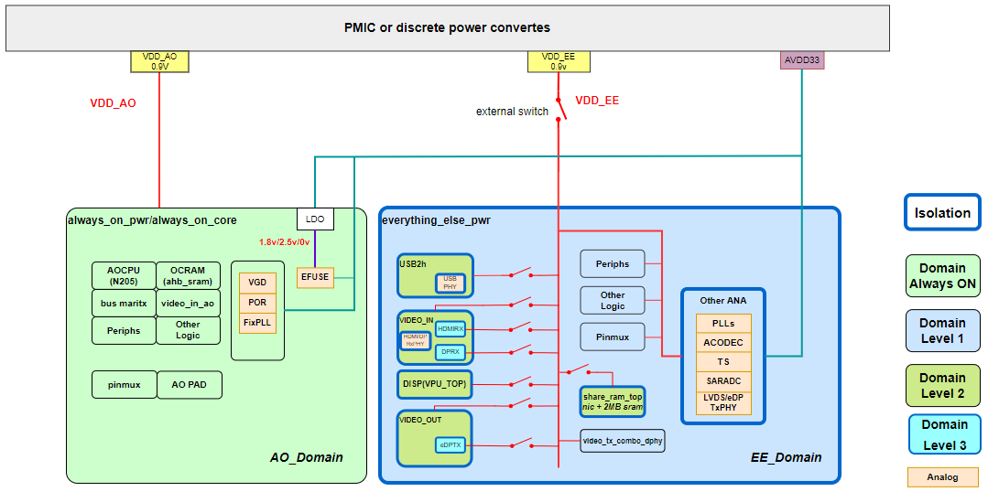

- ao_pwr work at VDD_AO, all other work at VDD_EE;
- all power control include:
PWR_OFF(wr/rd): set 1 will cut power supply;
PWR_ACK(rd): the status of power status; 1: power is off; 0: power is on;
ISO_EN(wr/rd): set 1 will isolate output;
FOCRST(wr/rd): set 1 will keep module as reset status;
MEMPD(wr/rd): set 2’b11 will power off memory; the power of memory is different path from logic;
- For module power domain, all PWR_ACK/PWR_OFF/ISO_EN/FOCRST will follow the same sequence for each bit connection, and MEMPD will connect by different sequence.

PWRCTRL_PWR_ACK0
read only, the status of each power domain.

PWRCTRL_ISO_EN0
isolation the interface of each power domain.

PWRCTRL_PWR_OFF0
power off each power domain
bit | module | default | bit | module | default
31 |  |  | 15
30 |  |  | 14
29 |  |  | 13
28 |  |  | 12
27 |  |  | 11
26 |  |  | 10
25 |  |  | 9
24 |  |  | 8 | share_ram_top | on
23 |  |  | 7 | vout_edp_top | on
22 |  |  | 6
21 |  |  | 5 | video_out | on
20 |  |  | 4 | vpu_top(display) | on
19 |  |  | 3 | dprx_link | on
18 |  |  | 2 | hdmirx_top | on
17 |  |  | 1 | video_in | on
16 |  |  | 0 | usb2_wrapper | OFF

PWRCTRL_FOCRST0
bit | module | default | bit | module | default
31 |  |  | 15
30 |  |  | 14
29 |  |  | 13
28 |  |  | 12
27 |  |  | 11
26 |  |  | 10
25 |  |  | 9
24 |  |  | 8 | share_ram_top | on
23 |  |  | 7 | vout_edp_top | on
22 |  |  | 6
21 |  |  | 5 | video_out | on
20 |  |  | 4 | vpu_top(display) | on
19 |  |  | 3 | dprx_link | on
18 |  |  | 2 | hdmirx_top | on
17 |  |  | 1 | video_in | on
16 |  |  | 0 | usb2_wrapper | OFF

PWRCTRL_MEM_PD0
Bit(s) | R/W | Default |  | Description
1:0 | R/W | 0x0 |  | video_in_ao

PWRCTRL_MEM_PD1
Bit(s) | R/W | Default | Description
19:2 | R/W | 0x0 | vpu_top(display)
1:0 | R/W | 0x3 | usb

PWRCTRL_MEM_PD2
Bit(s) | R/W | Default | Description
23:0 | R/W | 0x0 | video_out

PWRCTRL_MEM_PD3
Bit(s) | R/W | Default | Description
15:0 | R/W | 0x0 | share_ram

PWRCTRL_MEM_PD4
Bit(s) | R/W | Default | Description
24:0 | R/W | 0x0 | mem_pd_video_in

ANA_CTRL
include the register of these analog modules:
HIFI_PLL
DISP_PLL
Analog_ctrl register :MS1 PLL Application Note

edp_lvds_phy_dig_top
include the register of these analog modules:
PLL/Panel driver
Analog_ctrl register :MS1 PLL Application Note

