Employee Management System (EMS)
Product Brochure
Name: Ama Mensah-Dwumfua
Project Title: Employee Management System
Project Webpage: https://github.com/AmmaDwum/EMS_Project

Overview
The Employee Management System (EMS) is a web-based application that helps businesses manage employee information and track attendance. The system allows managers to add employees, record attendance, and generate reports. This helps organizations keep employee data organized and improve productivity.

Key Features
- Secure Login – Employees and managers log into the system using their username and password.
- Create Employee – Managers can add employee information such as name, department, and salary.
- Record Attendance – Employees can clock in and clock out and the system records the time.
- Generate Attendance Reports – Managers can generate attendance reports for selected dates.

System Screens
Login Screen – Users enter credentials to access the dashboard.
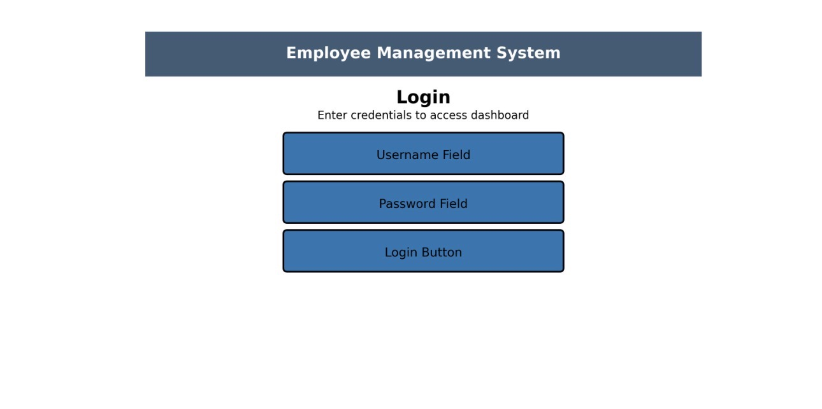
Create Employee Screen – Managers add employee details.
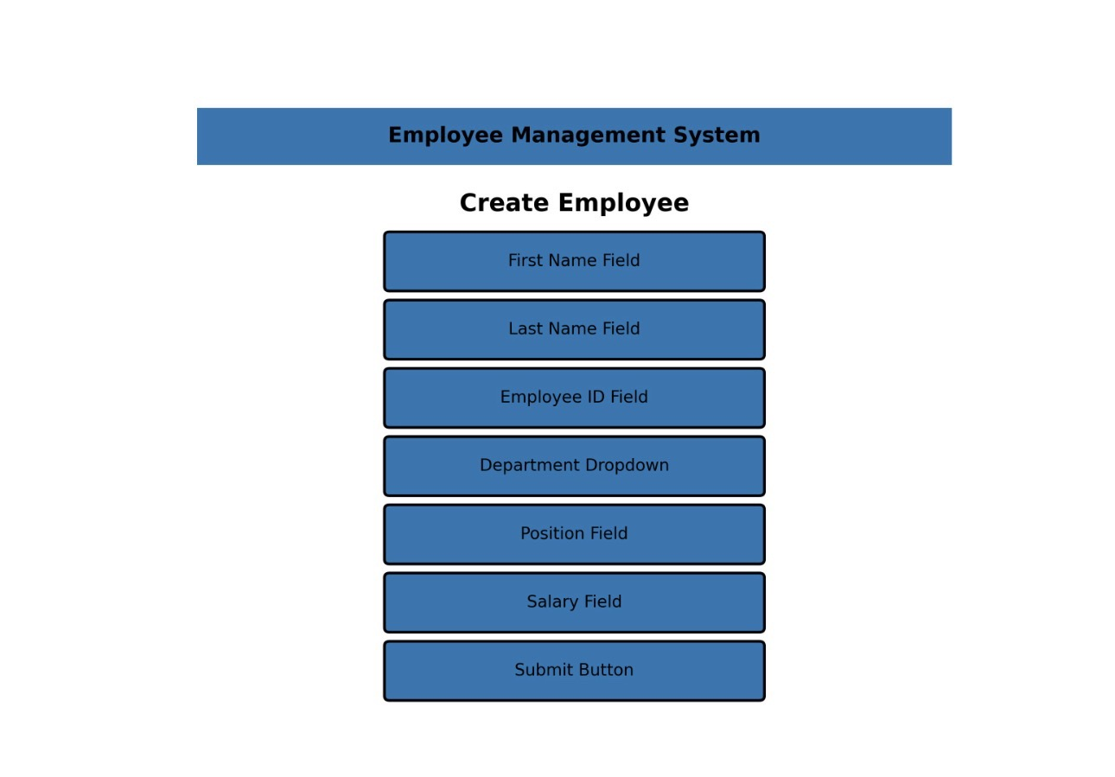
Record Attendance Screen – Employees clock in and clock out.
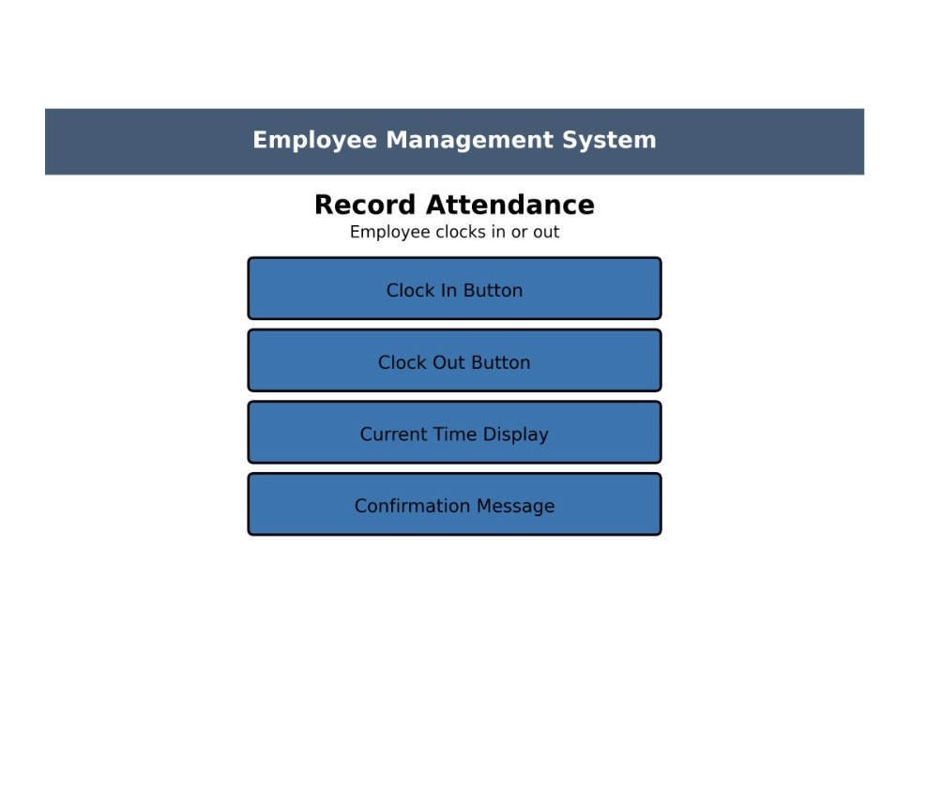
Generate Attendance Report Screen – Managers generate reports.
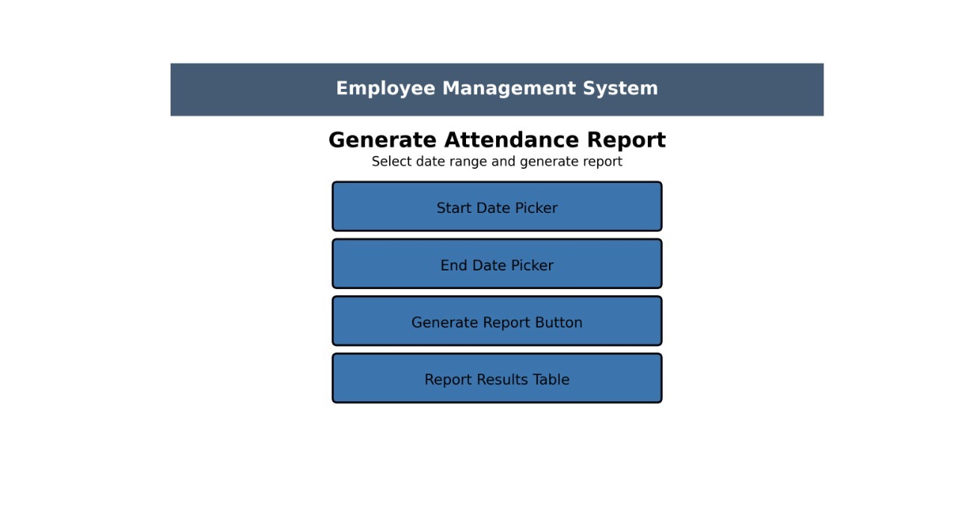

System Requirements
- Computer or laptop
- Web browser such as Chrome or Edge
- Internet connection
- Database for storing employee information

Future Improvements
Future improvements may include advanced reporting features, improved user interface design, and additional employee management tools.

