**Day 5 - Testing and Backend Refinement – Furniro**

Day 5 focuses on preparing Furniro for real-world use by thoroughly testing all backend components, optimizing performance, and ensuring the system is ready to handle user traffic. The key tasks include testing backend integrations, improving error handling, and refining processes to deliver a smooth and reliable user experience.

**Functional Deliverables for Furniro:**

All functionalities are properly working. I have checked and tested each component, including the product page, product detail page, shopping cart, and checkout, blog page, contact form, and other additional pages. These pages are fully responsive and functioning smoothly across both desktop and small screens.

**Product Listing Page:**

* Displays a list of fetched products, including images, titles, prices, and brief descriptions.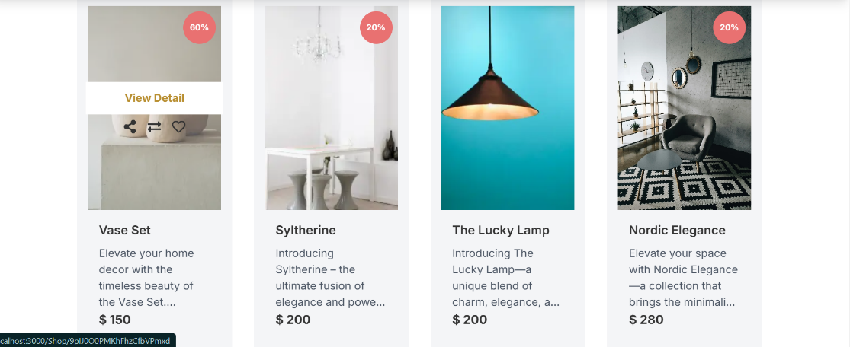

**Product Detail Page:**

* Displays detailed information about a specific product, including images, description, price, and options such as Add to Cart, Add to Wishlist, and a detailed description, Reviews & Additional Information of the furniture.



**Shopping Cart**

• When a user adds items to the cart, the selected furniture items will be displayed with details like image, name, price, and quantity.

• If no items are added, the cart will show a message: "**Your Cart is Empty**".

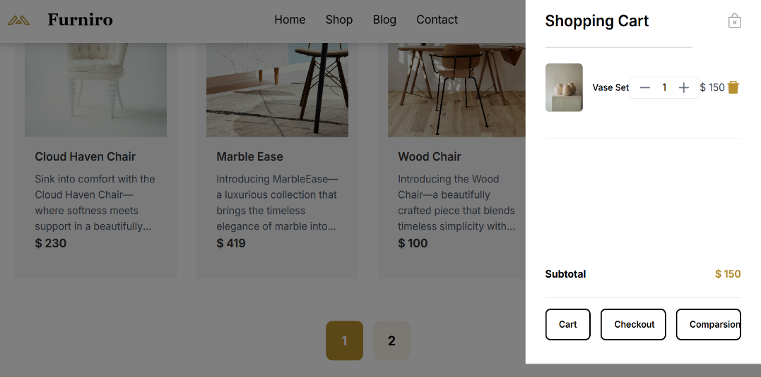

**Error Messages Set for Furniro:**

**Product Not Found:**

Displayed when a product doesn’t exist or incorrect URL.

Invalid Input: When forms are incomplete or incorrect.

**Search Error**

* Displayed when no results are found for a search query.
* Example: "**No results found for your search**".

**Storing Sensitive Information Securely:**

For enhanced security, I store all sensitive information, such as API keys, in a separate .env file.

**API Response Testing:**

I tested the API endpoint https://template6-six.vercel.app/api/products in Thunder Client, and it worked without any issues, returning a successful response with status code 200.

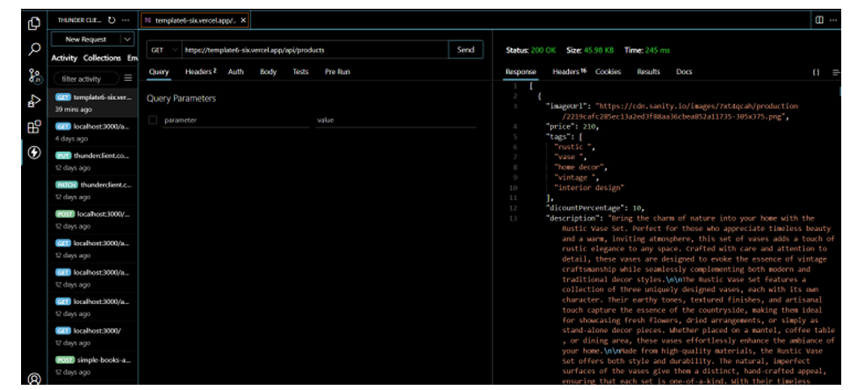

**Lighthouse Report:**

I have checked my Funiro website using Lighthouse, which provided detailed insights into performance, accessibility, and overall site quality.

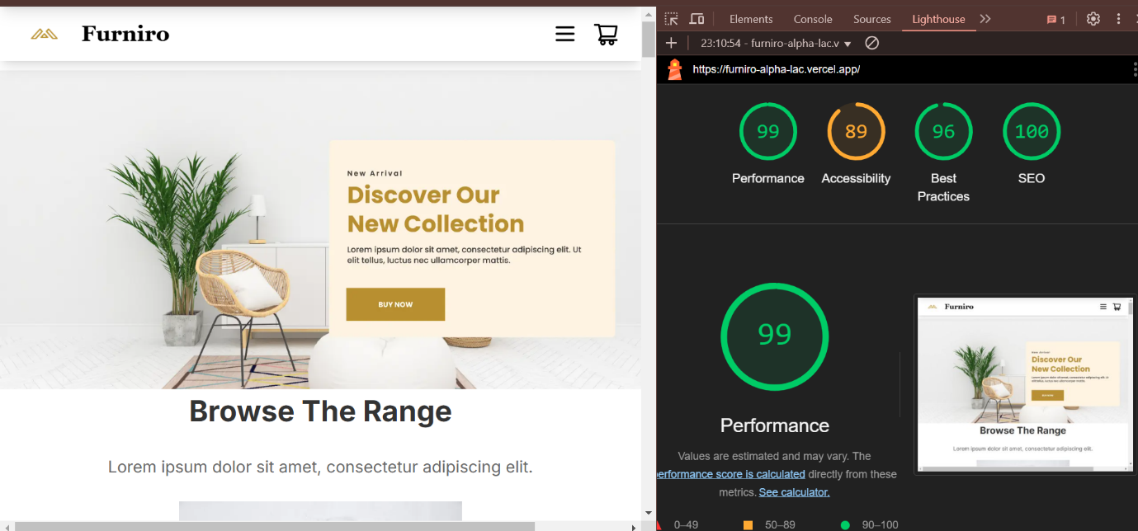

**Testing Report:**

