**EXPERIMENT 4**

**Create a simple cloud software application for Car Booking Reservation System using any Cloud Service Provider to demonstrate SaaS**

**Step 1: Create the application form.**

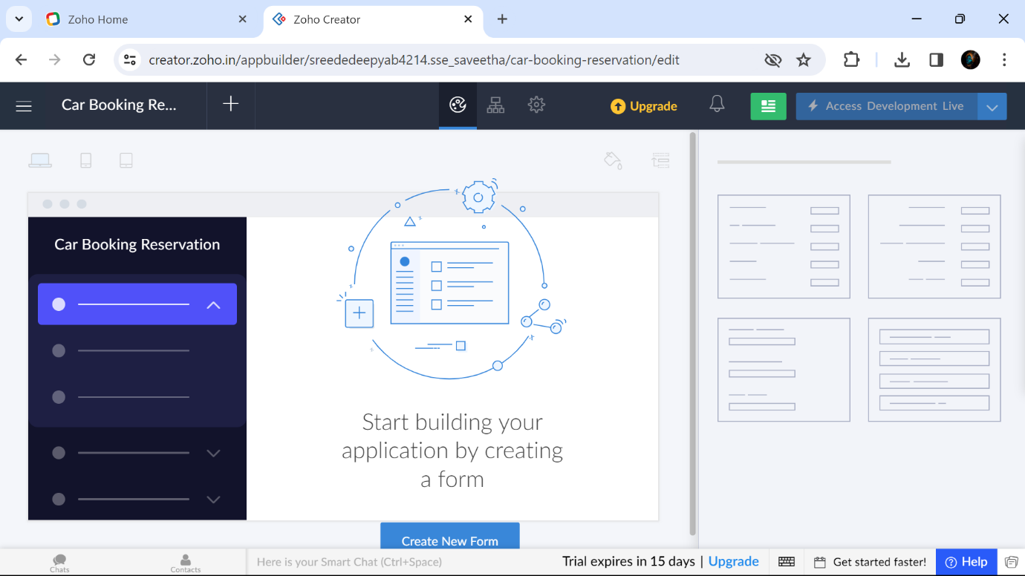

**Step2: Create Passenger scratch form.**

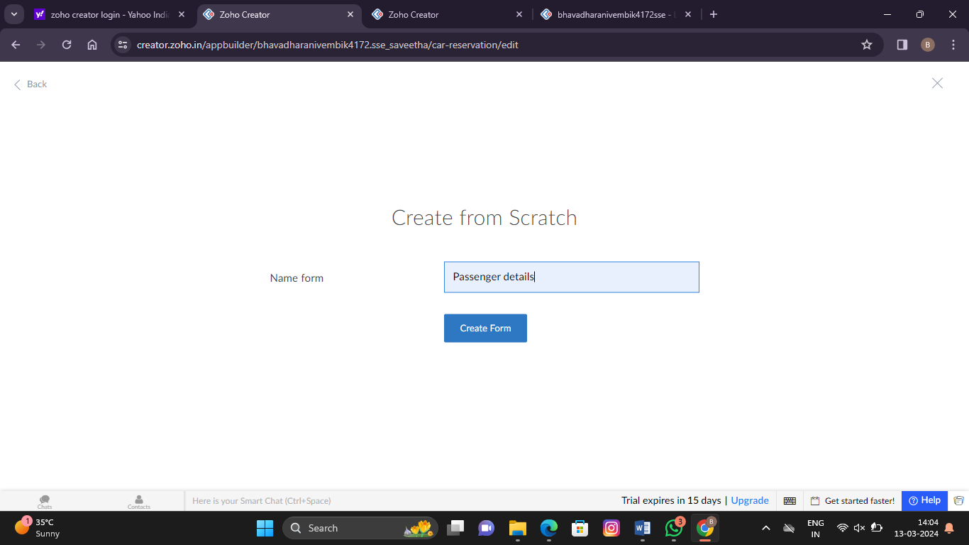

**Step 3: Create another properties.**

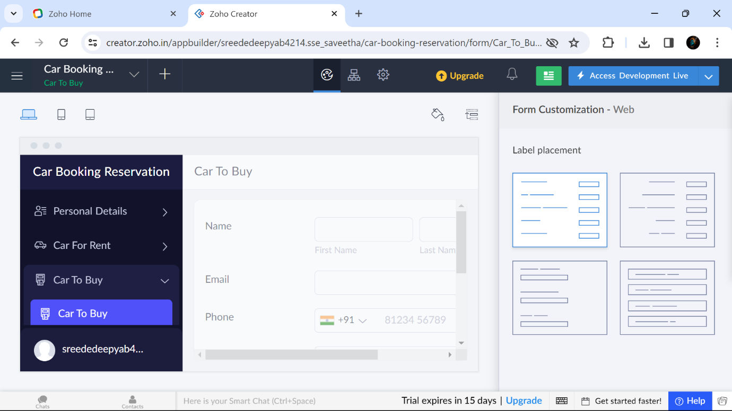

**Step 4: Create journey details form**

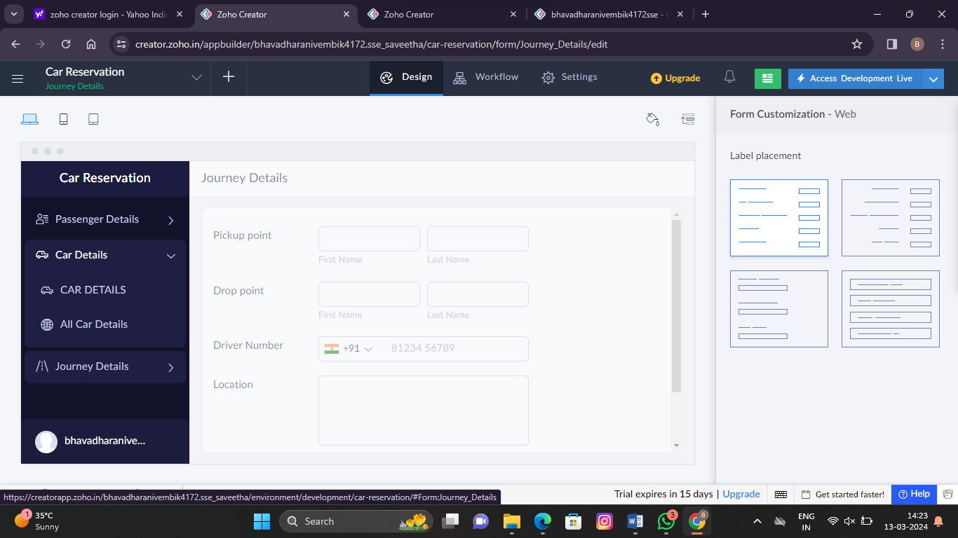

**Step 5: Create car details form**

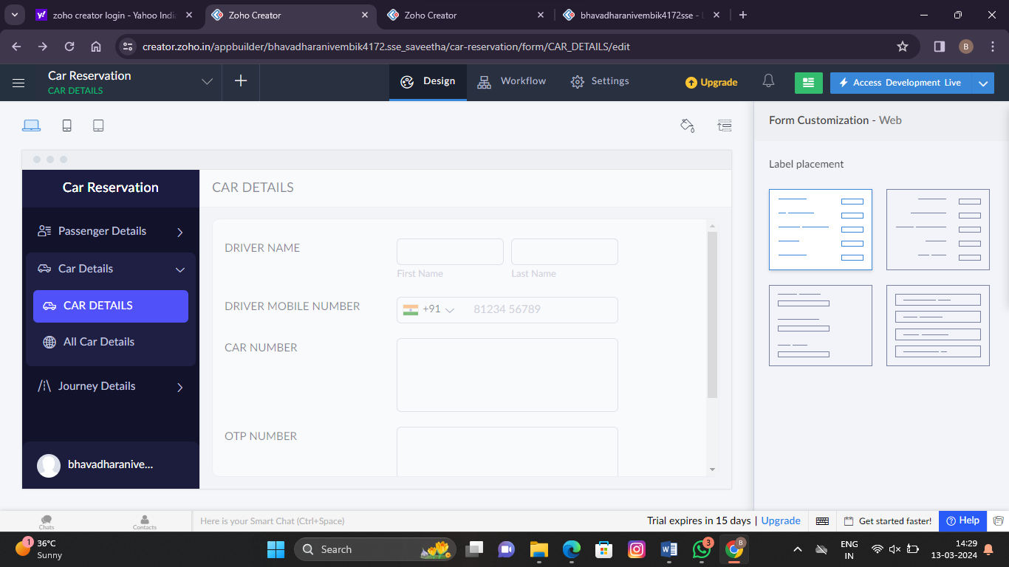

**Step 6: Display all journey details form**



**Step 7: Display all passenger details form**

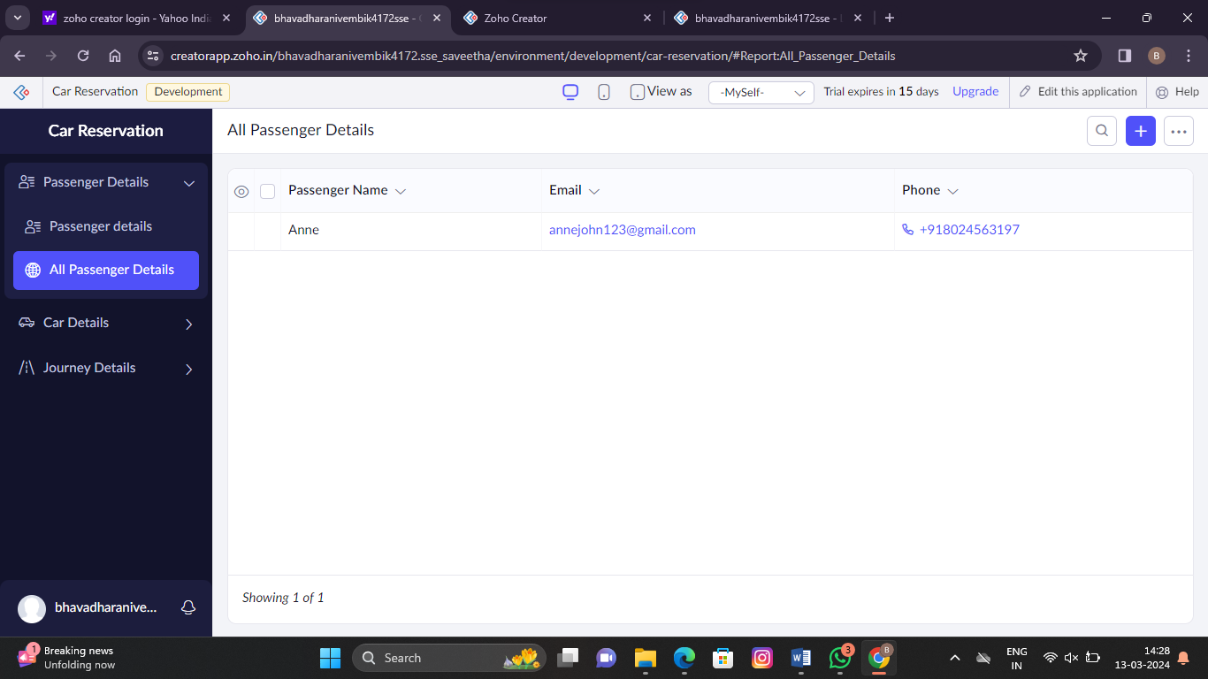

**Step 8: Display all car details form**

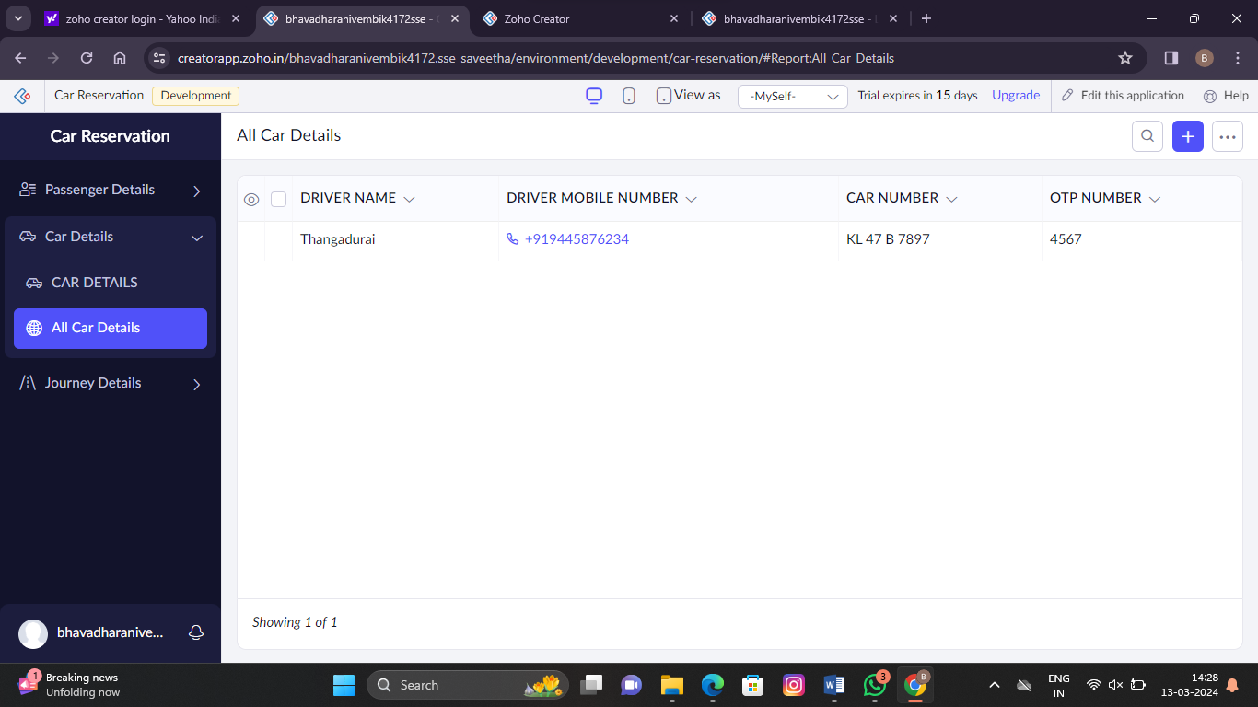

**Step 9: Final app design**

