**EXPERIMENT 2**

**Create a simple cloud software application for Flight Reservation System using any Cloud Service Provider to demonstrate SaaS.**

**Step 1: Create the application form.**

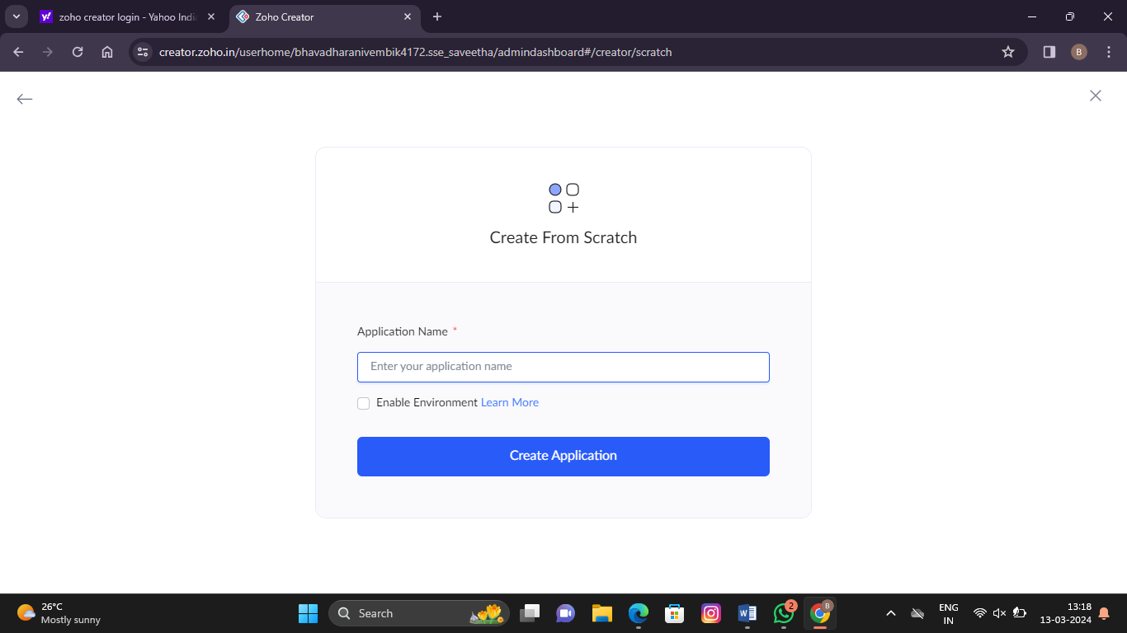

**Step 2: Create Passenger Details Form:**

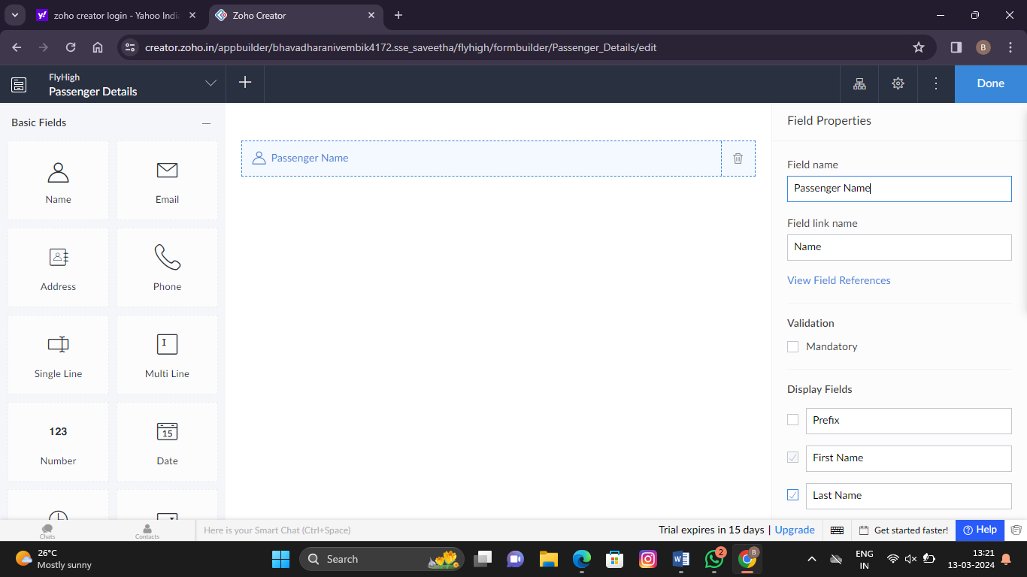

**Step 3: Create Journey Details Form:**

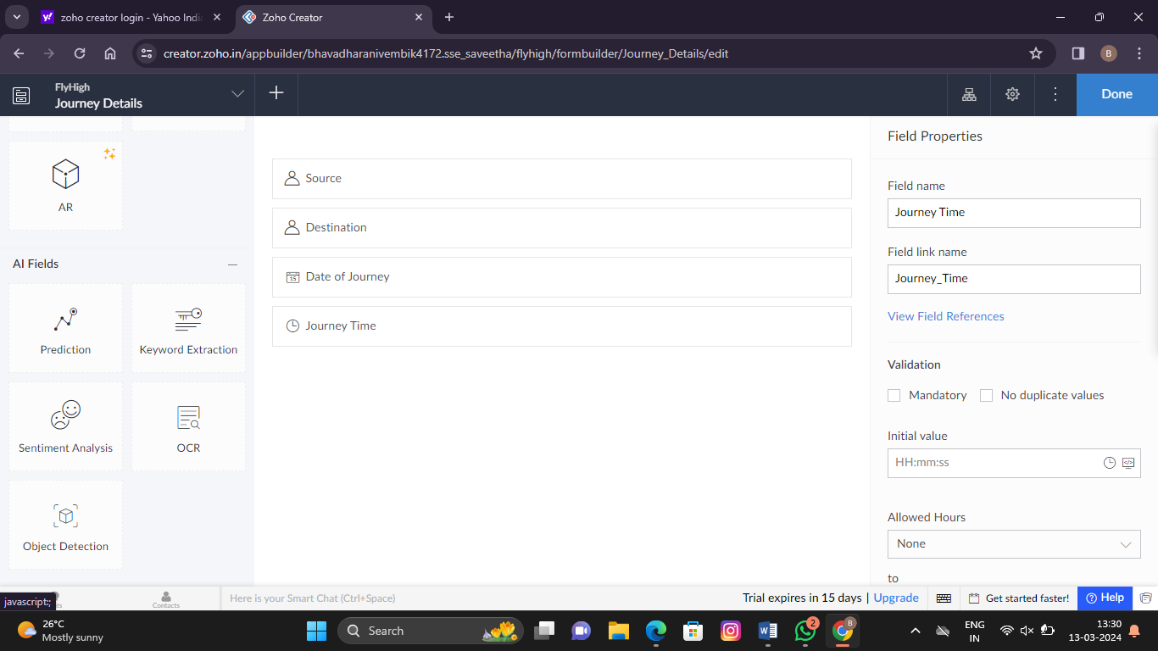

**Step 4: Create Transaction Details Form:**

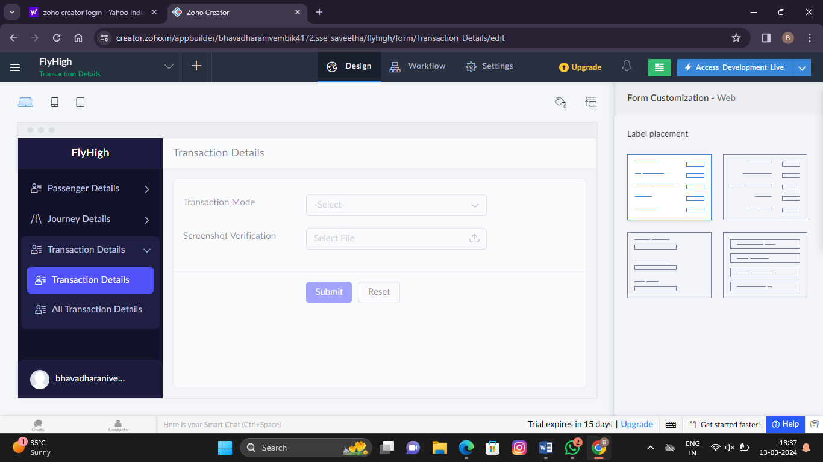

**Step 5: Display all passenger details**

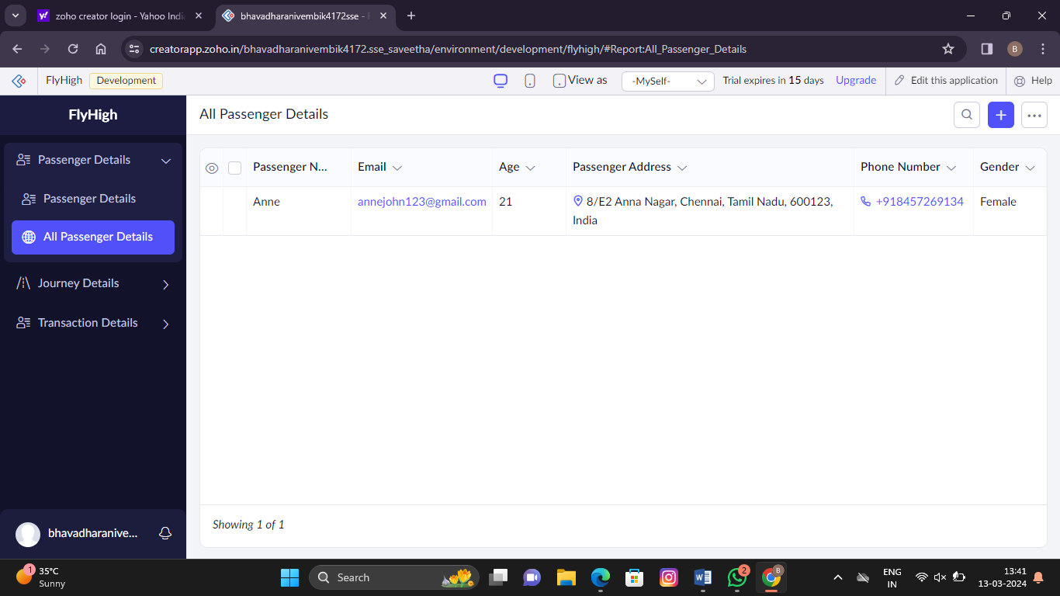

**Step 6: Display all transaction details**

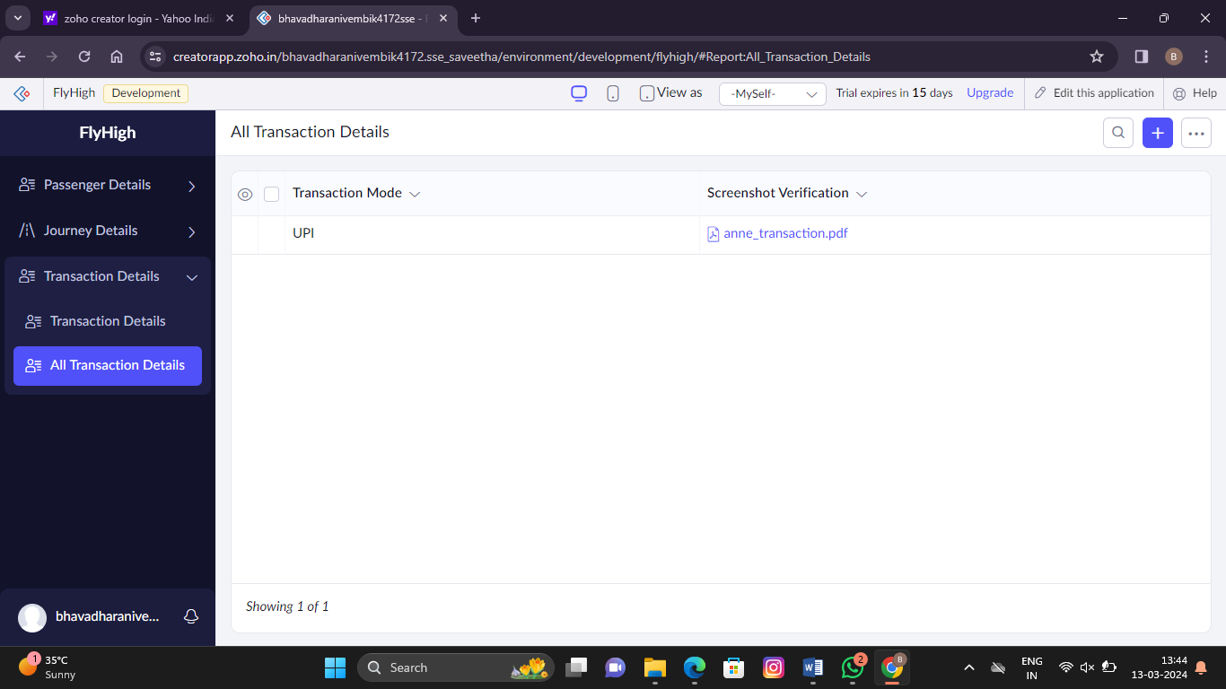

**Step 7: Final app design**

