**EXPERIMENT 9**

**Create a simple cloud software application for a Hospital information system for SIMATS Hospital using any Cloud Service Provider to demonstrate SaaS with fields of patient name, age, address, phone, email, Attender name, attender phone, doctor name, diseases, etc**

STEP 1: ENTER APPLICATION NAME

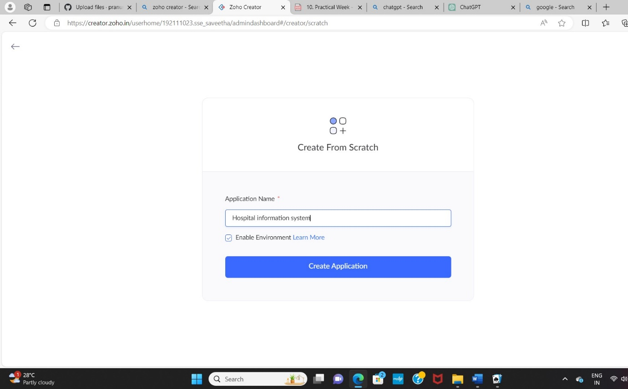

STEP 2: CREATED NEW APPLICATION

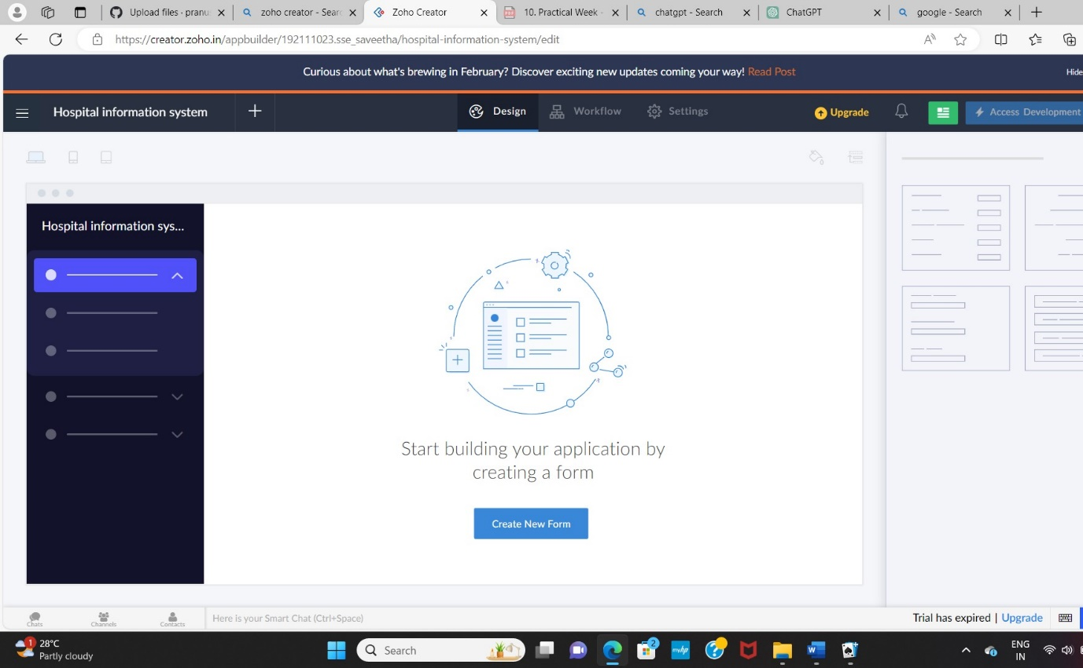

STEP 3: Select from Scratch and Create form as login.

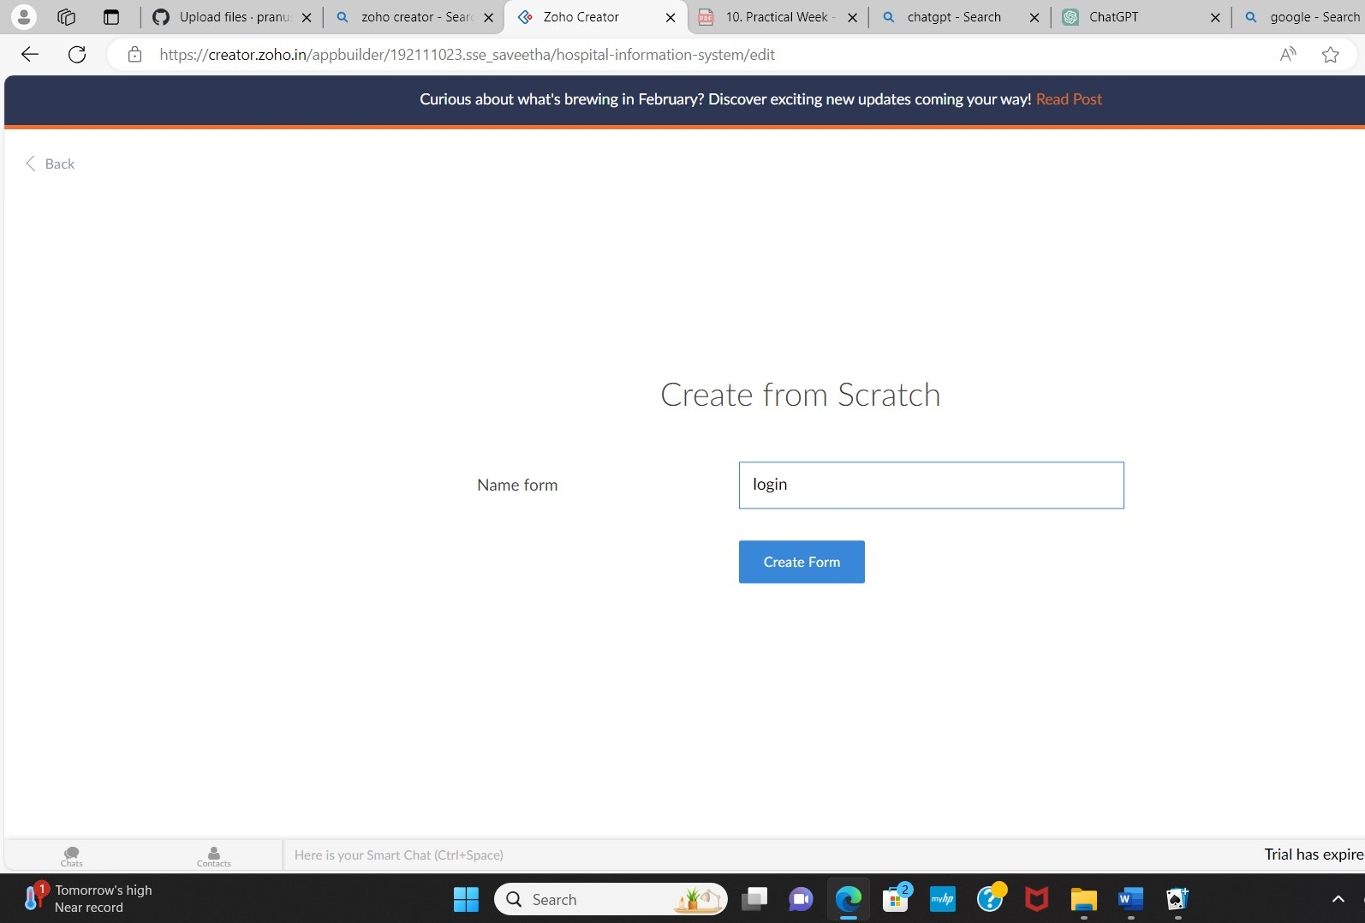

STEP 4: The form has been created as login.

Choose the fields.

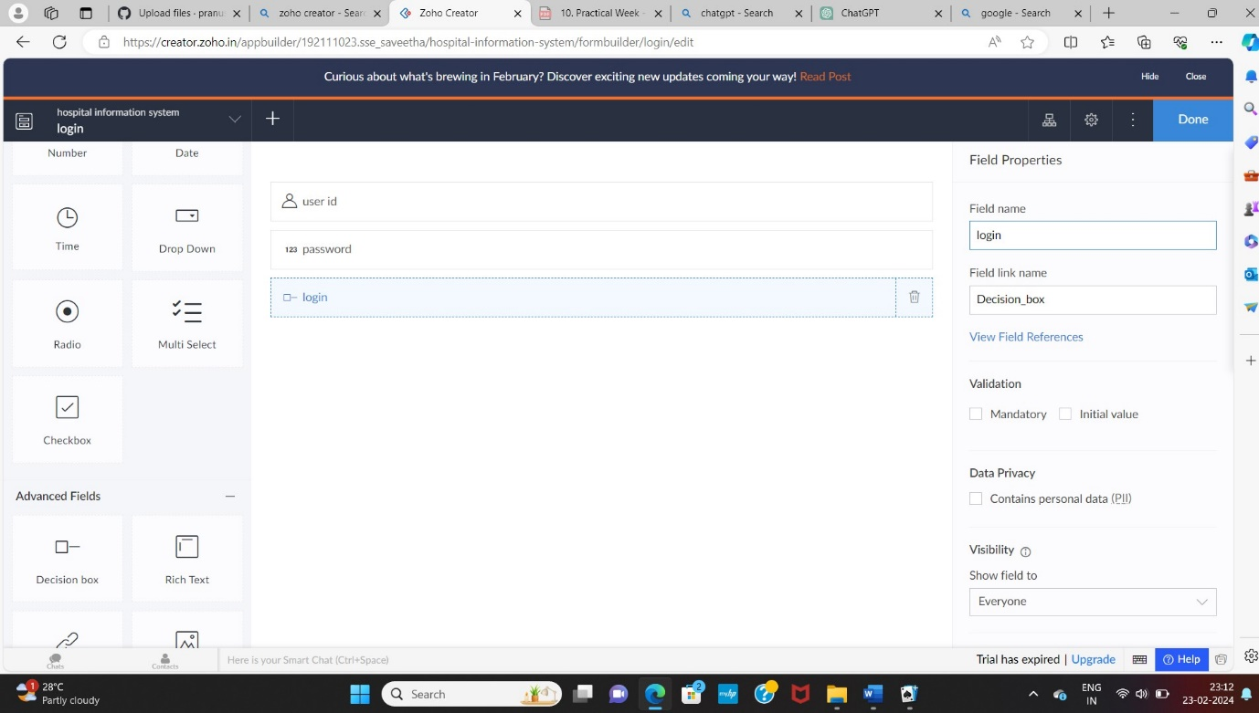

STEP 5: Click Access Development Live and enter the details to access.

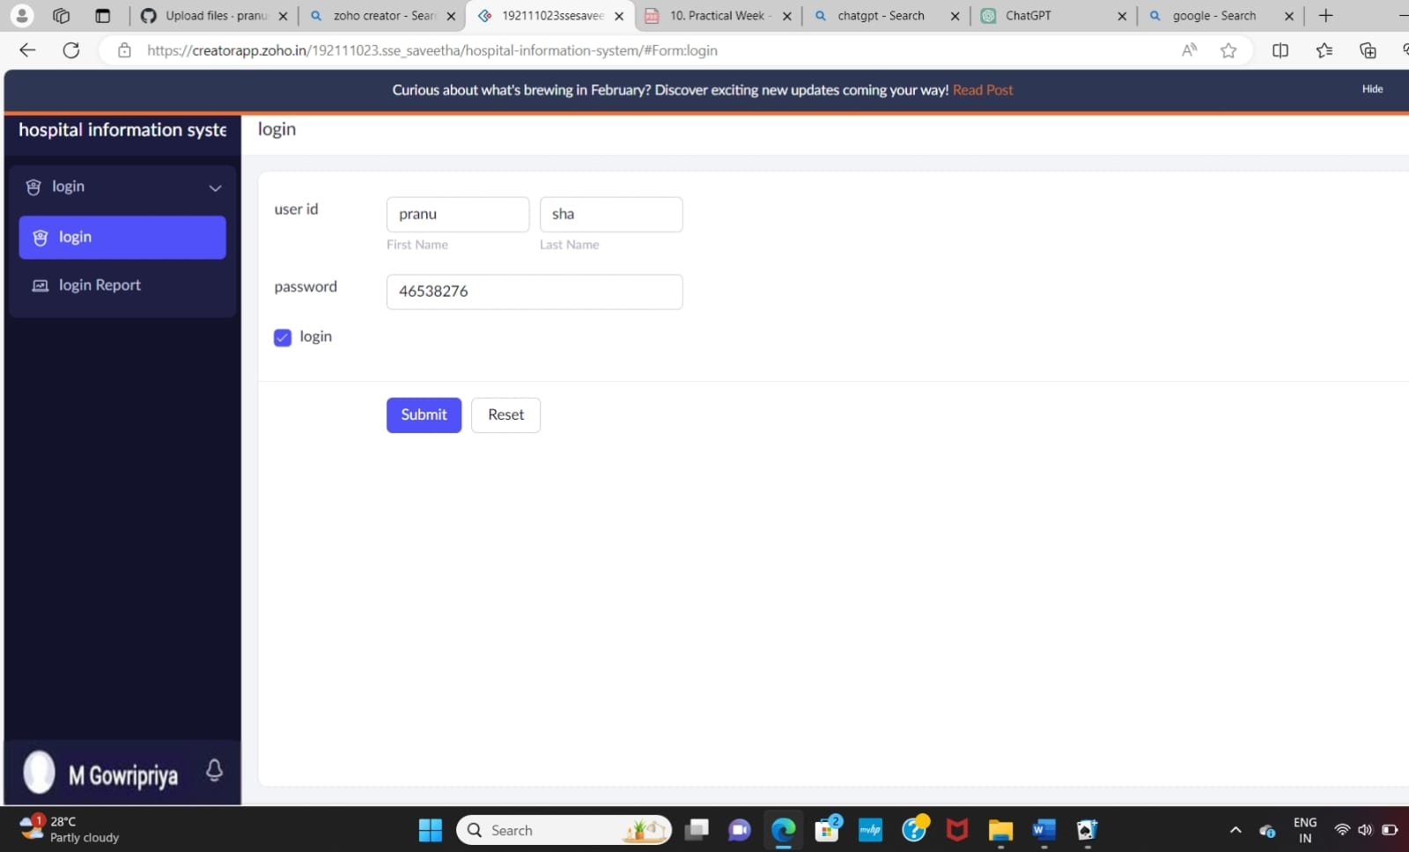

STEP 6: The report has been registered in the login report.

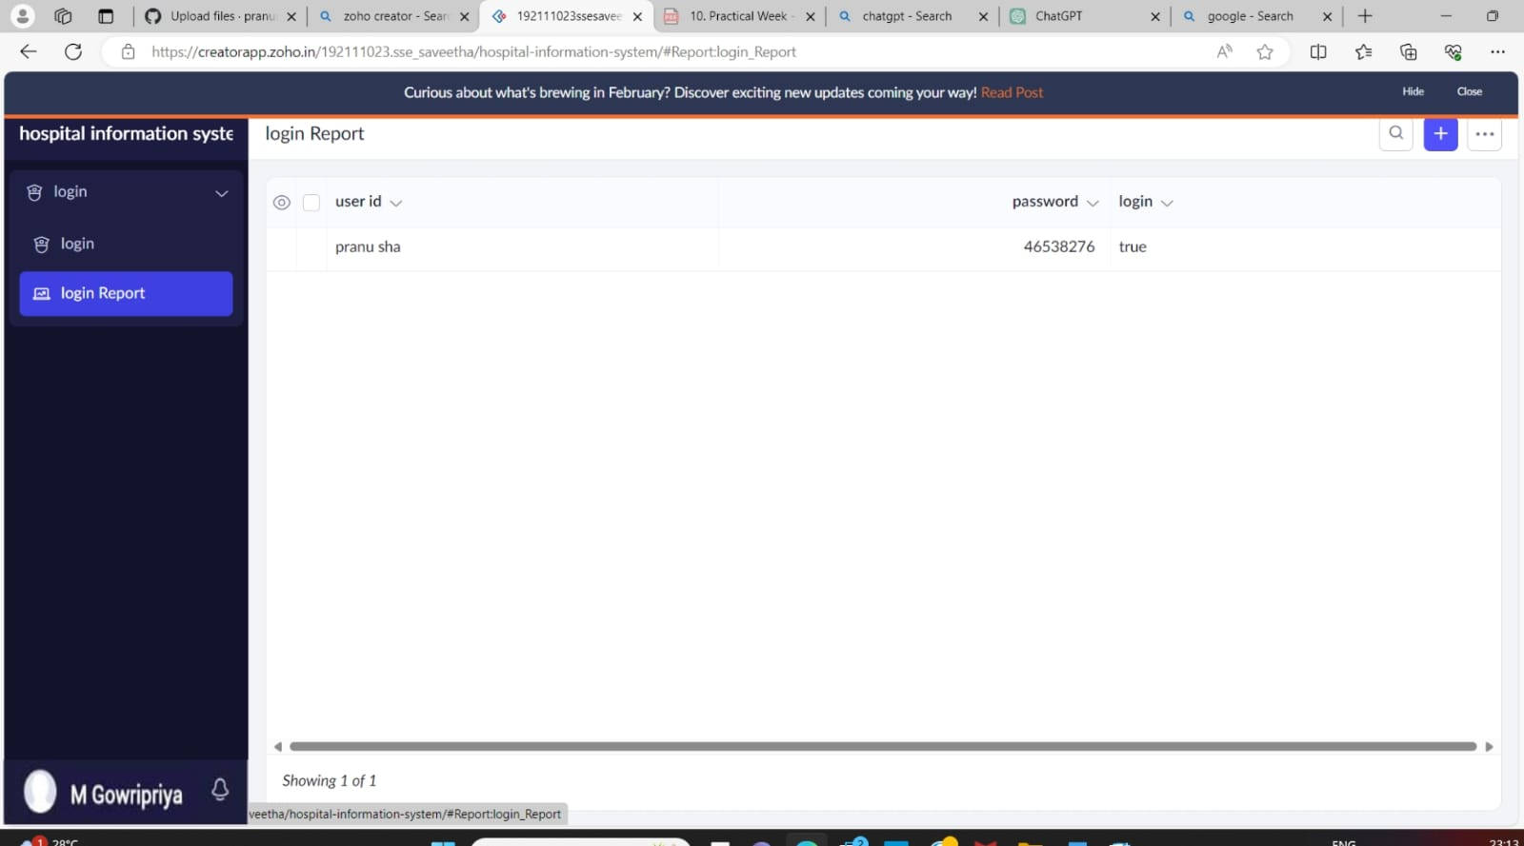

STEP 7: Select from Scratch and Create a form as Apollo hospitals.

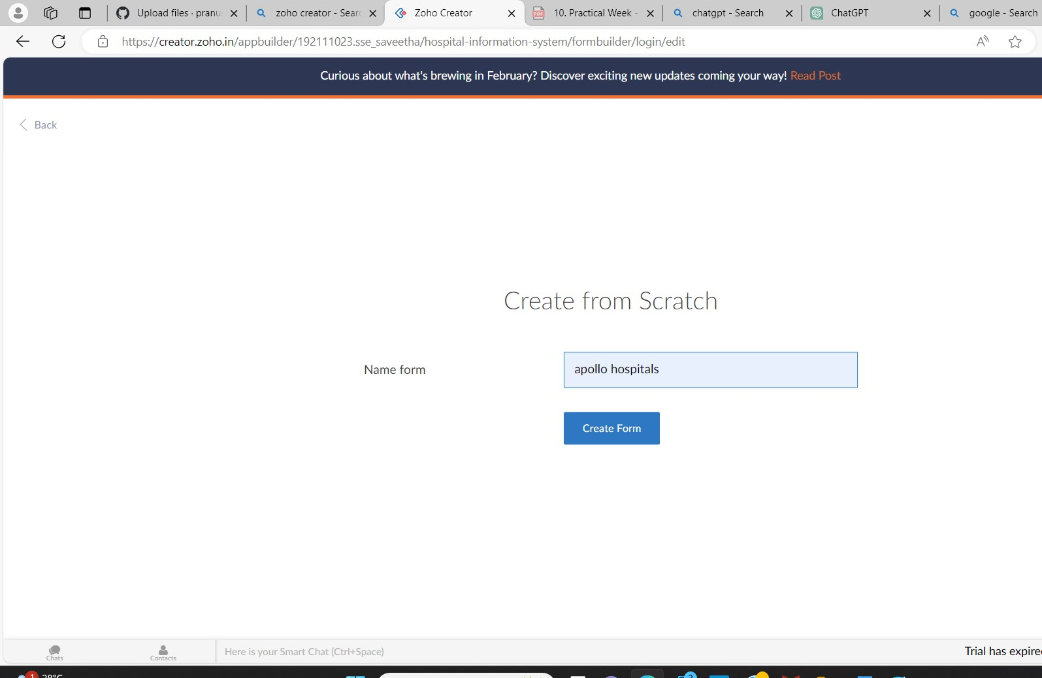

STEP 8: The form has been created as SIMATS hospital.

Choose the fields.

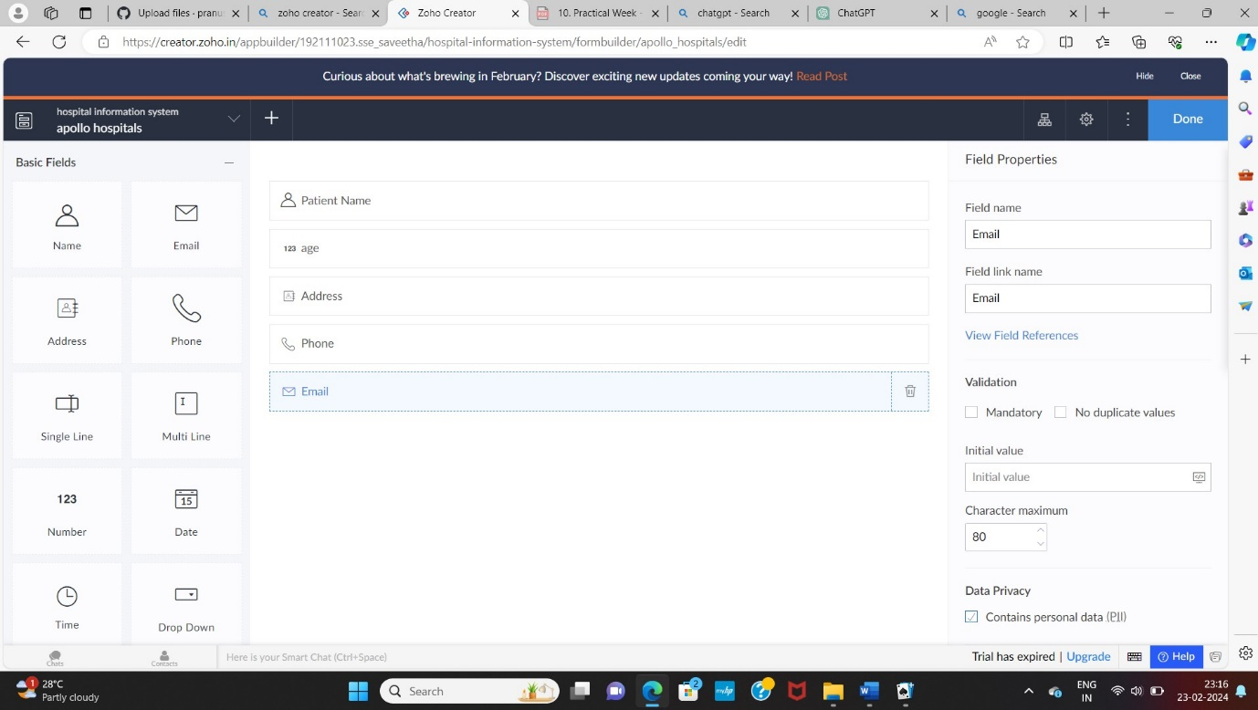

STEP 9: Click Access Development Live and enter the details to access.

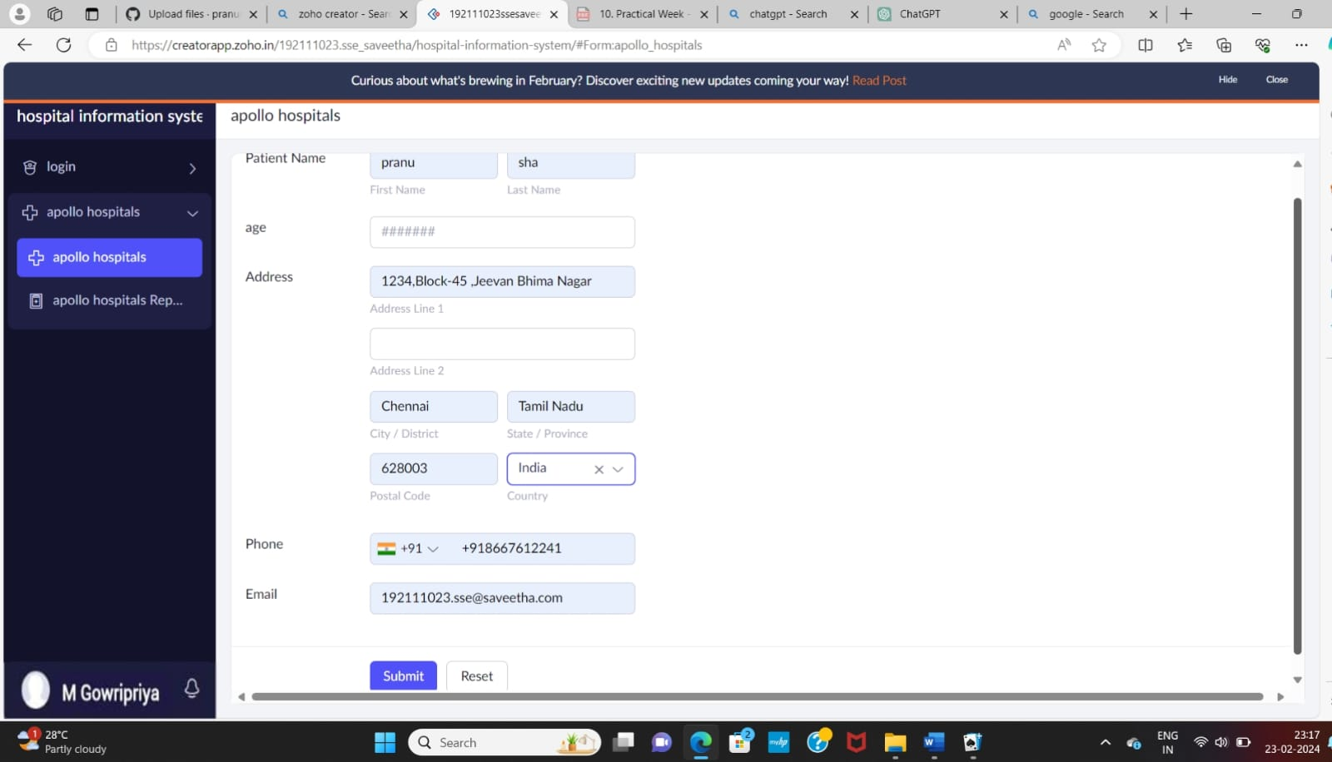

STEP 10: The report has been registered in the apollo hospital report.

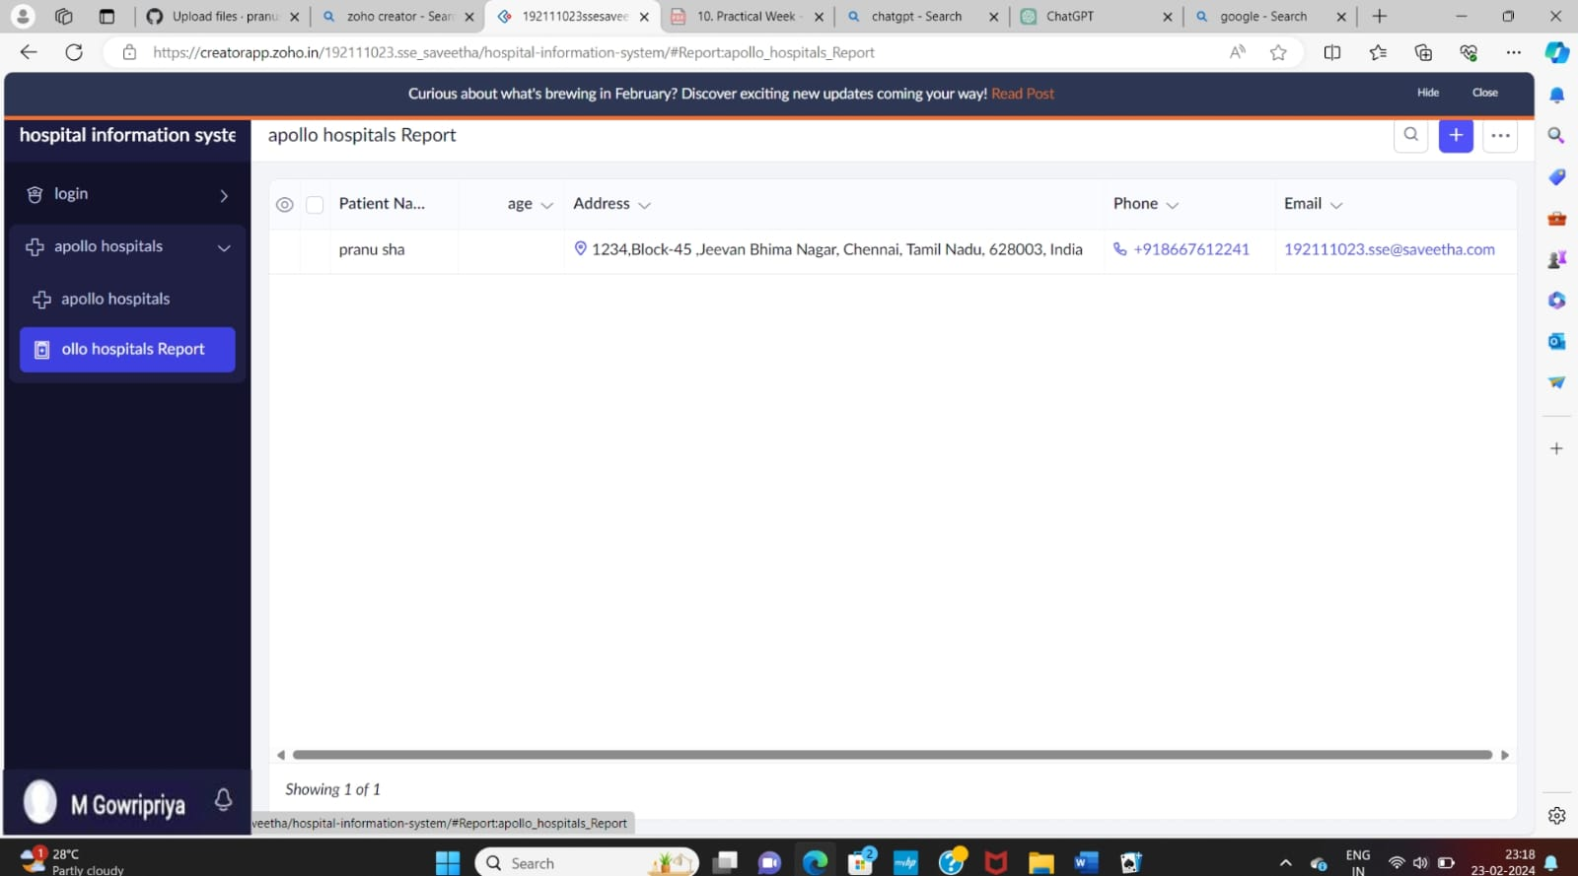

STEP 11: Select from Scratch and Create form an attender form.

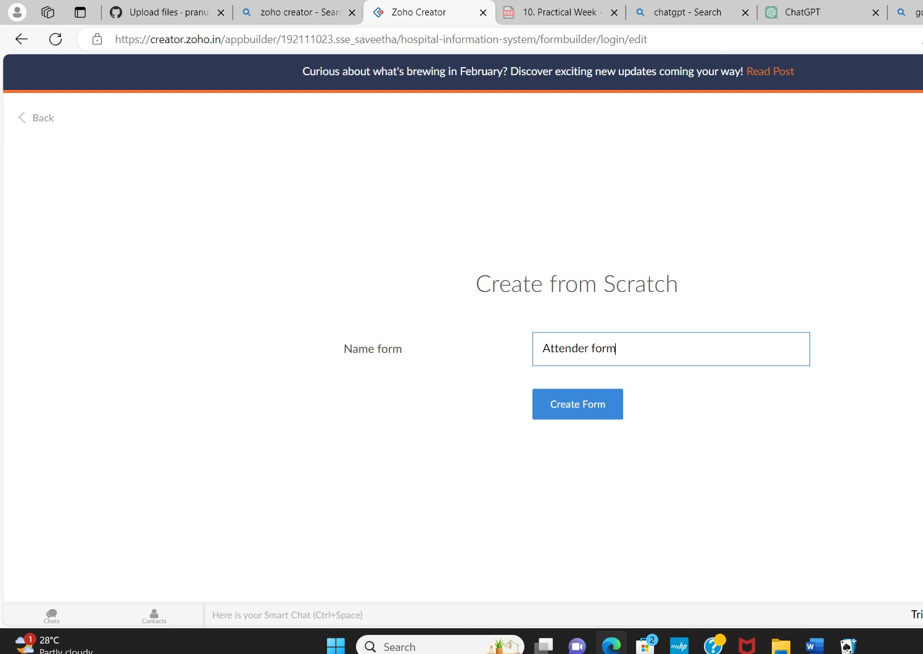

STEP 12: The form has been created as attendee form.

Choose the fields.

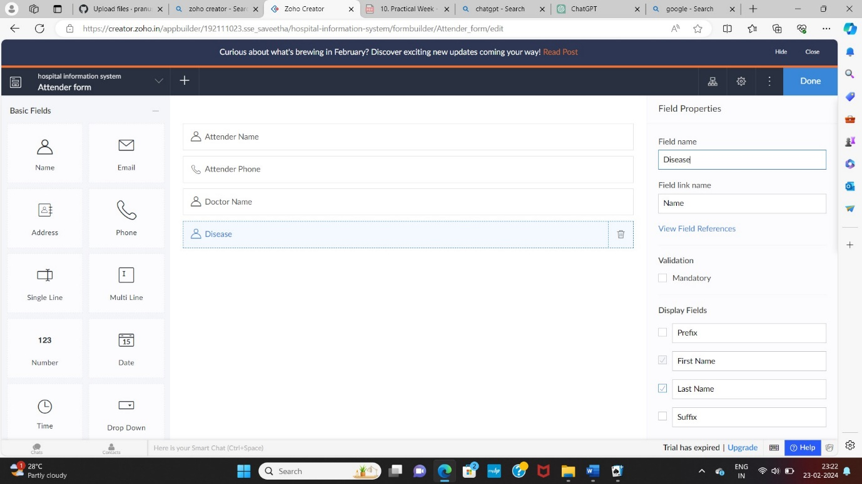

STEP 13: Click Access Development Live and enter the details to access.

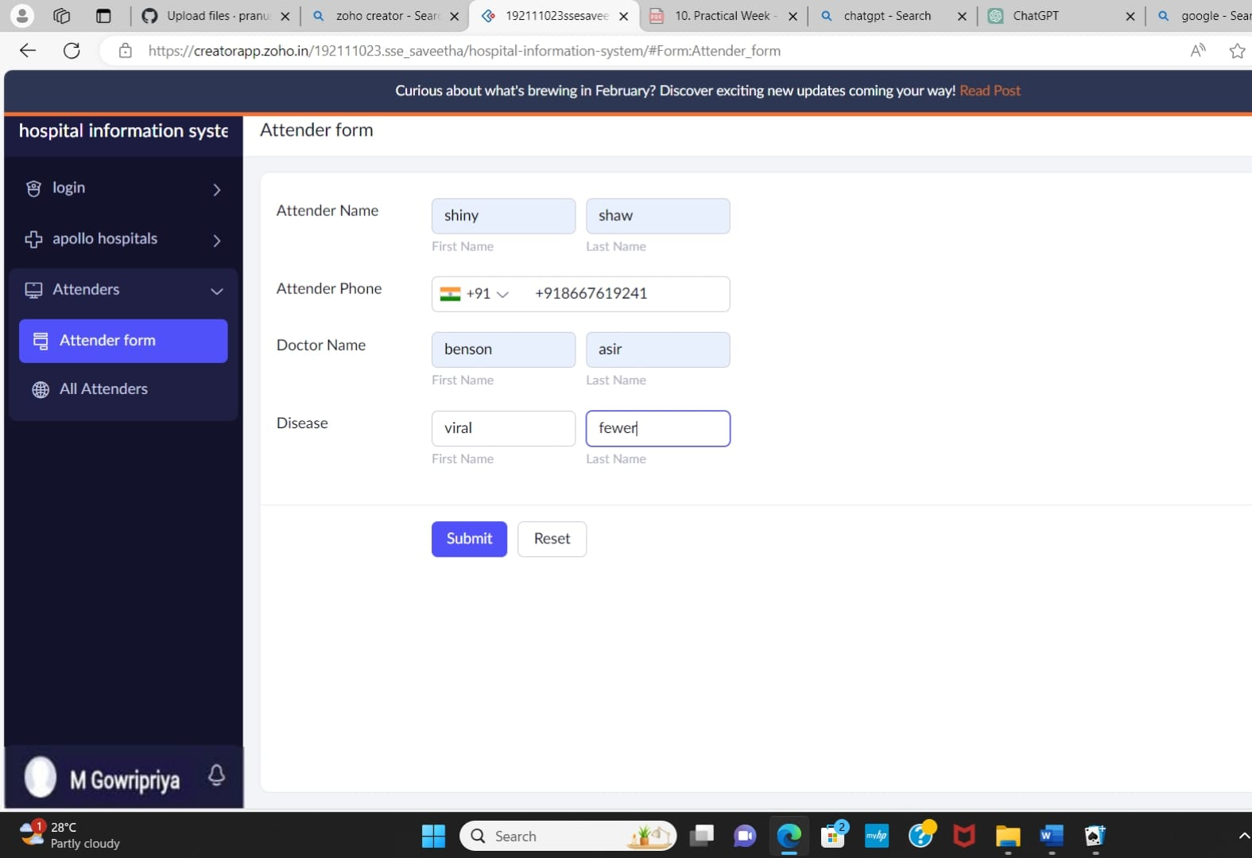

STEP 14: The report has been registered in the attendee form report.

