**EXPERIMENT 4**

**Create a simple cloud software application for Library book reservation system for SIMATS library using any Cloud Service Provider to demonstrate SaaS include the necessary fields such as Title of the book, author, publications, Year, edition, no of copies, Rack no, status (taken/returned) etc**

**Step 1: Create library application**

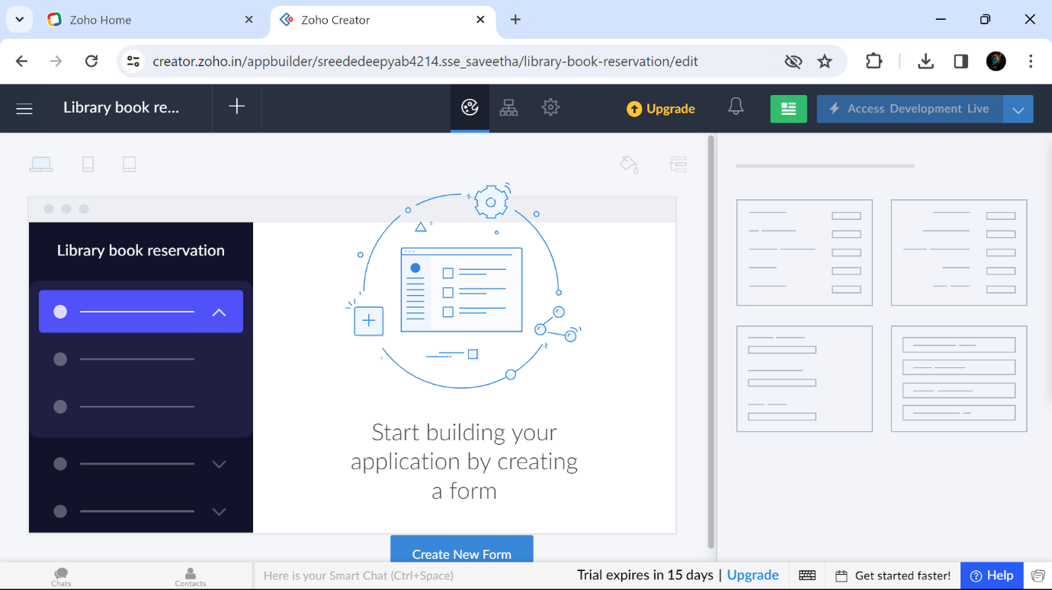

**Step 2: Create personal details form**

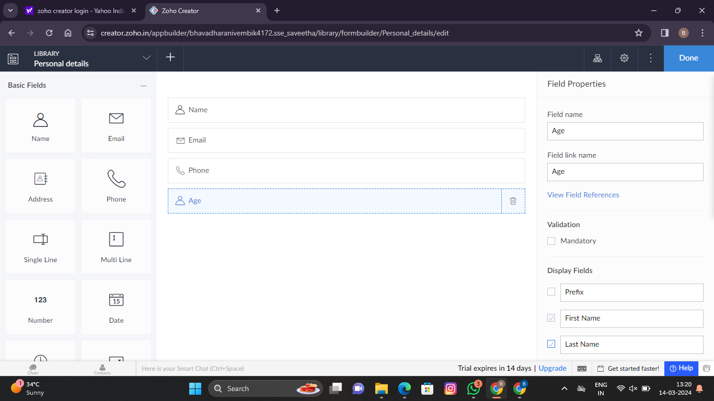

**Step 3: Create About Book details form**

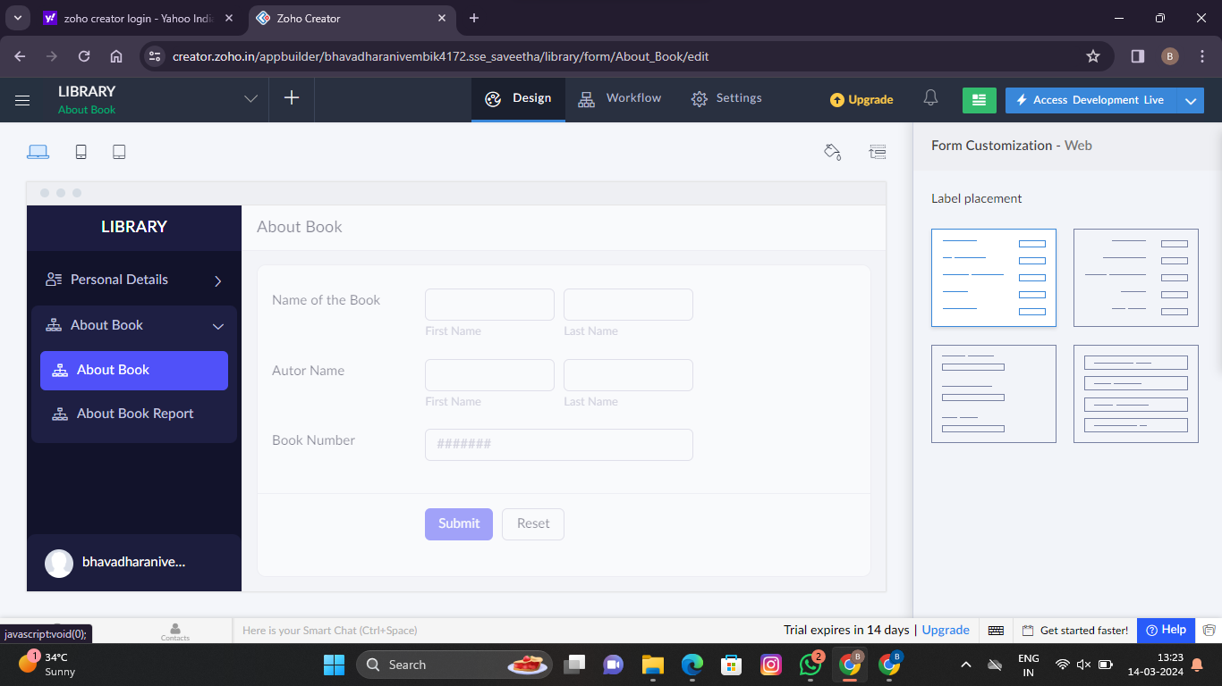

**Step 4: Create Staff details form**

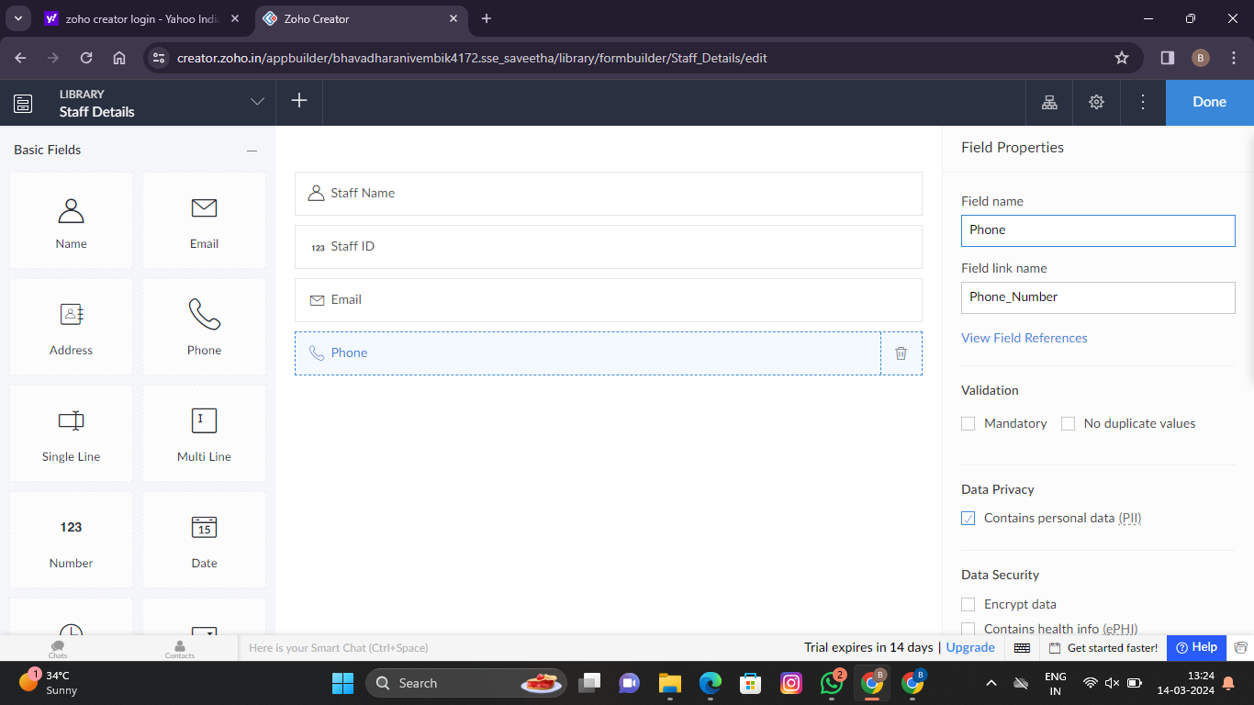

**Step 5: Enter Personal Details form**

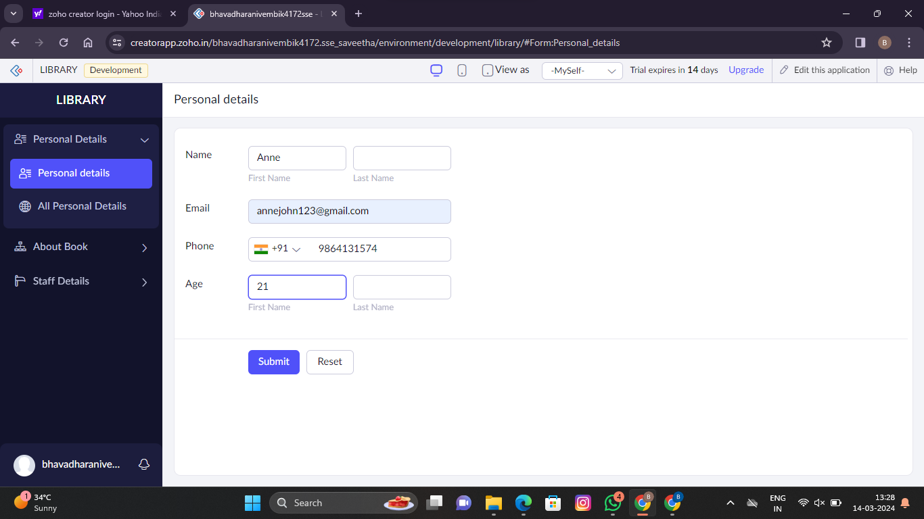

**Step 6: Enter About Book Details form**

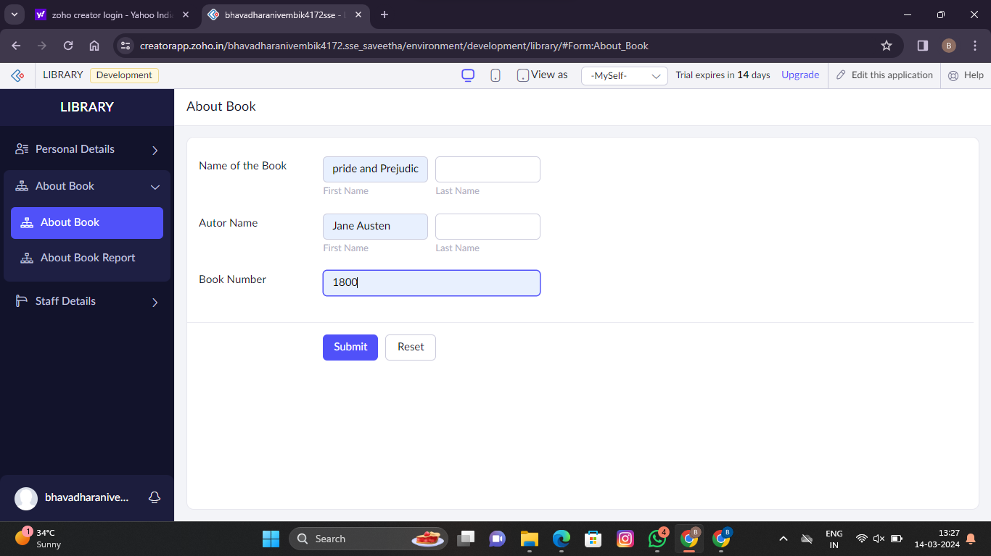

**Step 7: Display All Personal Details Form**

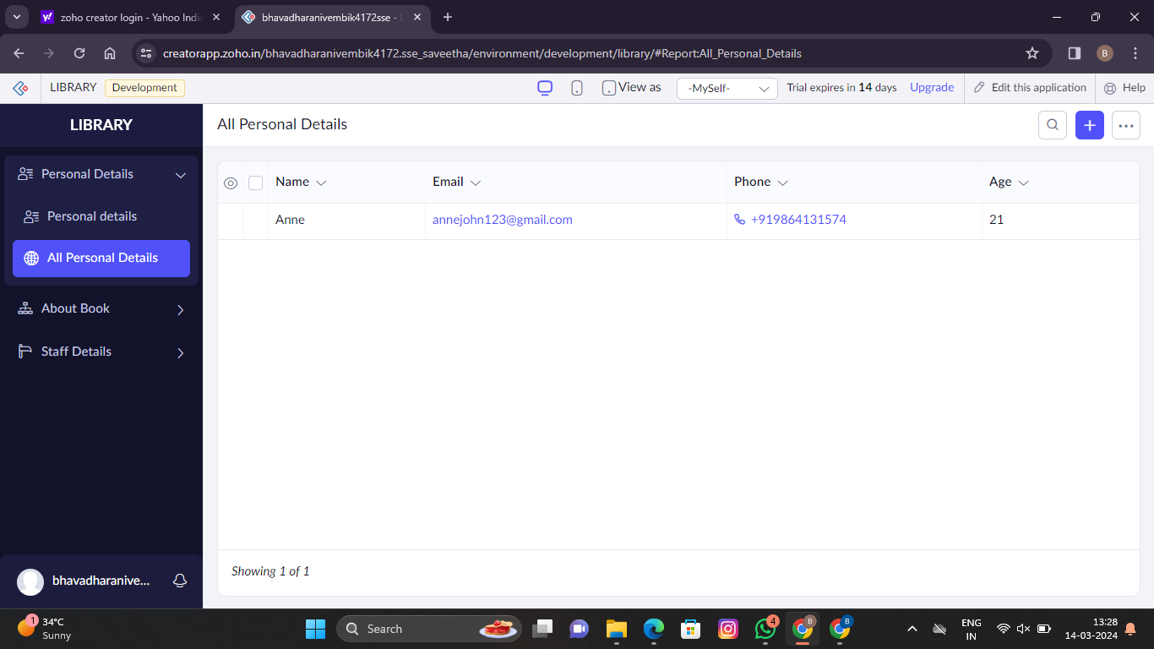

**Step 8: Display All About Book Details Form**

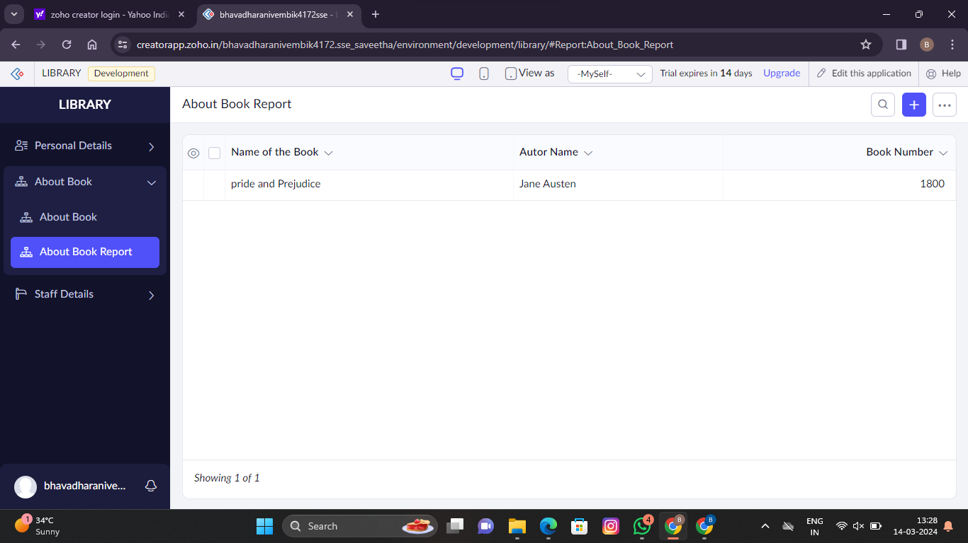

**Step 9: Display All Staff Detail Form**

