**EXPERIMENT 6**

**Create a simple cloud software application for Payroll Processing System using any Cloud Service Provider to demonstrate SaaS include the necessary fields such as Name of the employee, experience in present org , over all experience, basic pay, HRA, DA, TA, net pay, gross pay etc**

Step 1: Create payroll application form

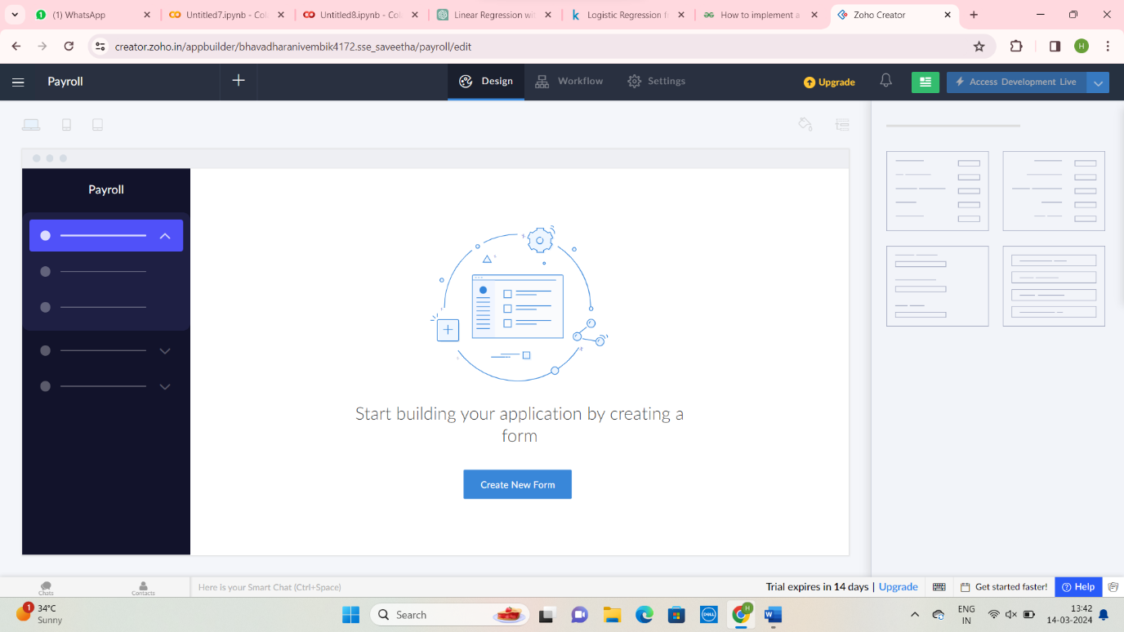

Step 2: Enter the payroll application

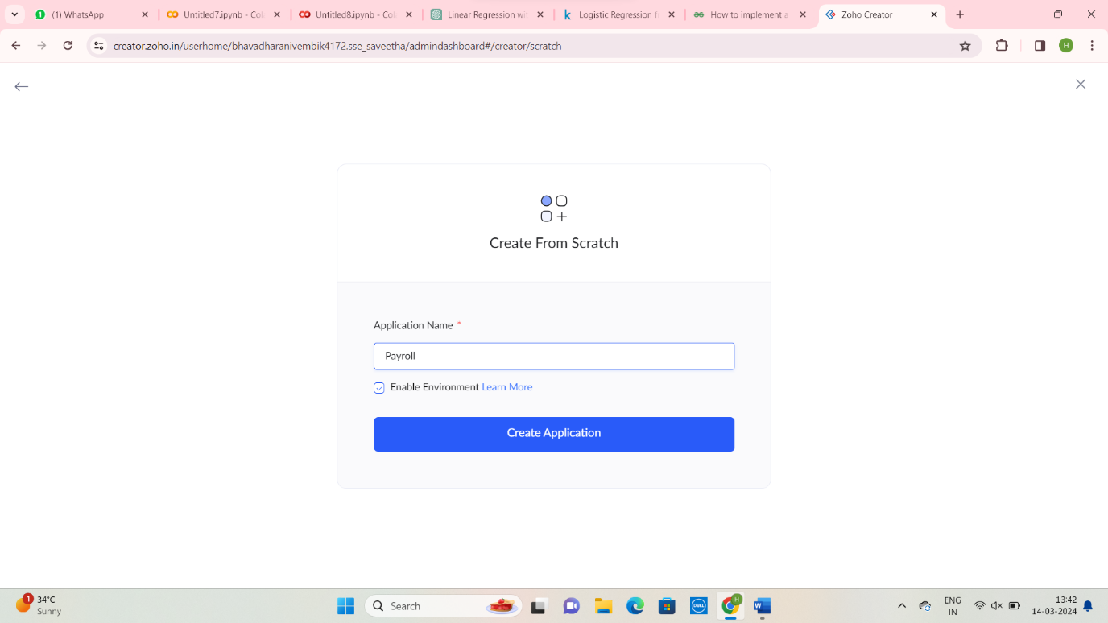

Step 3: Create Employee Details form

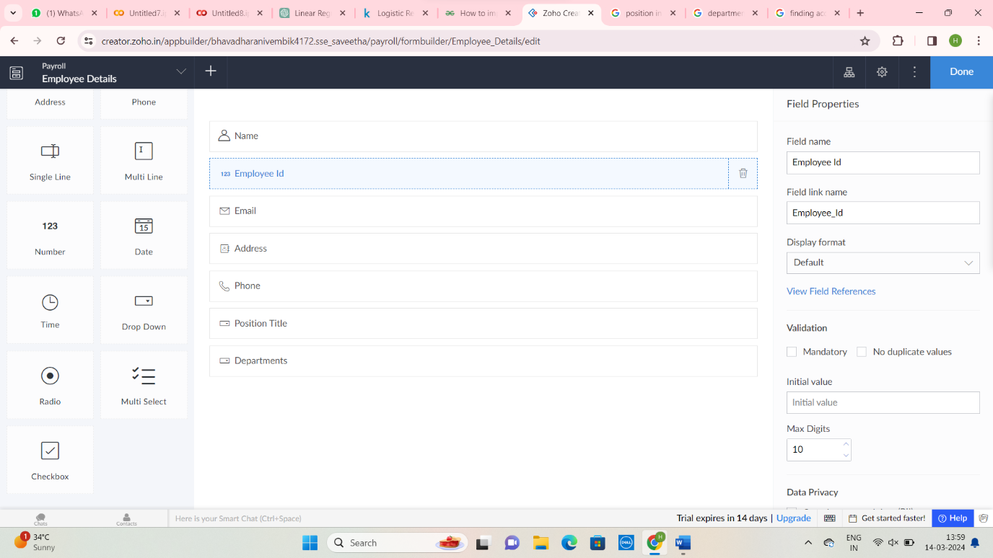

Step 4: Give Organization details for payroll application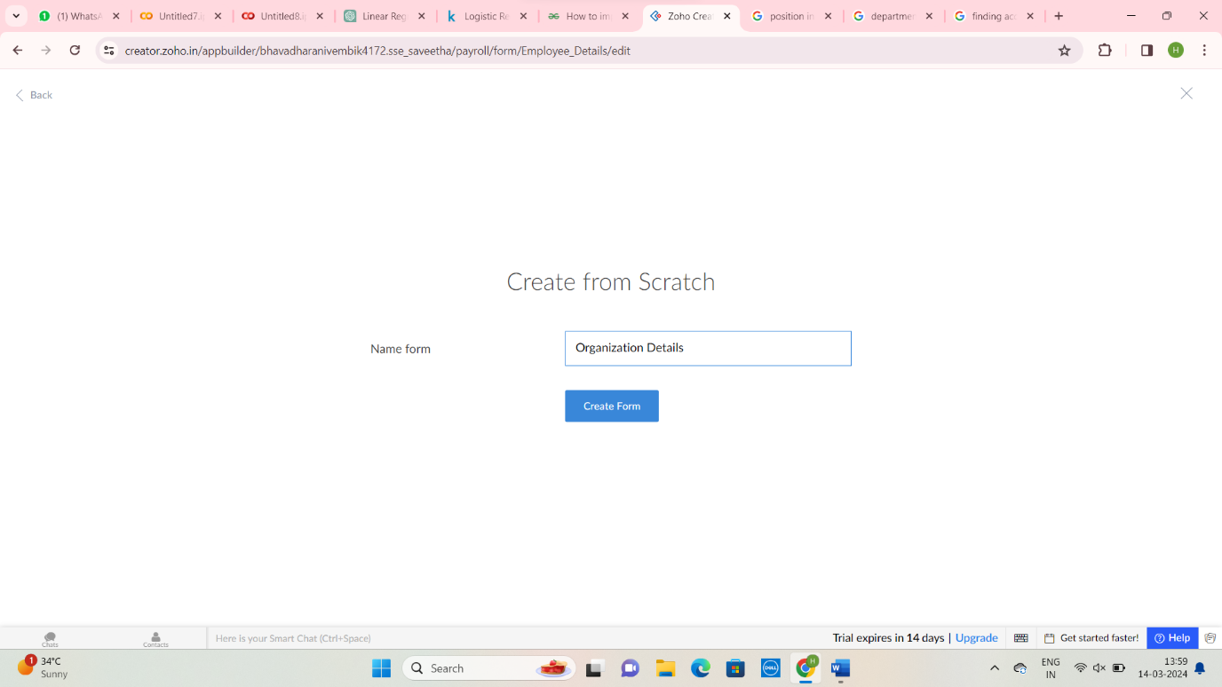

Step 5: Create Organization Details for payroll applications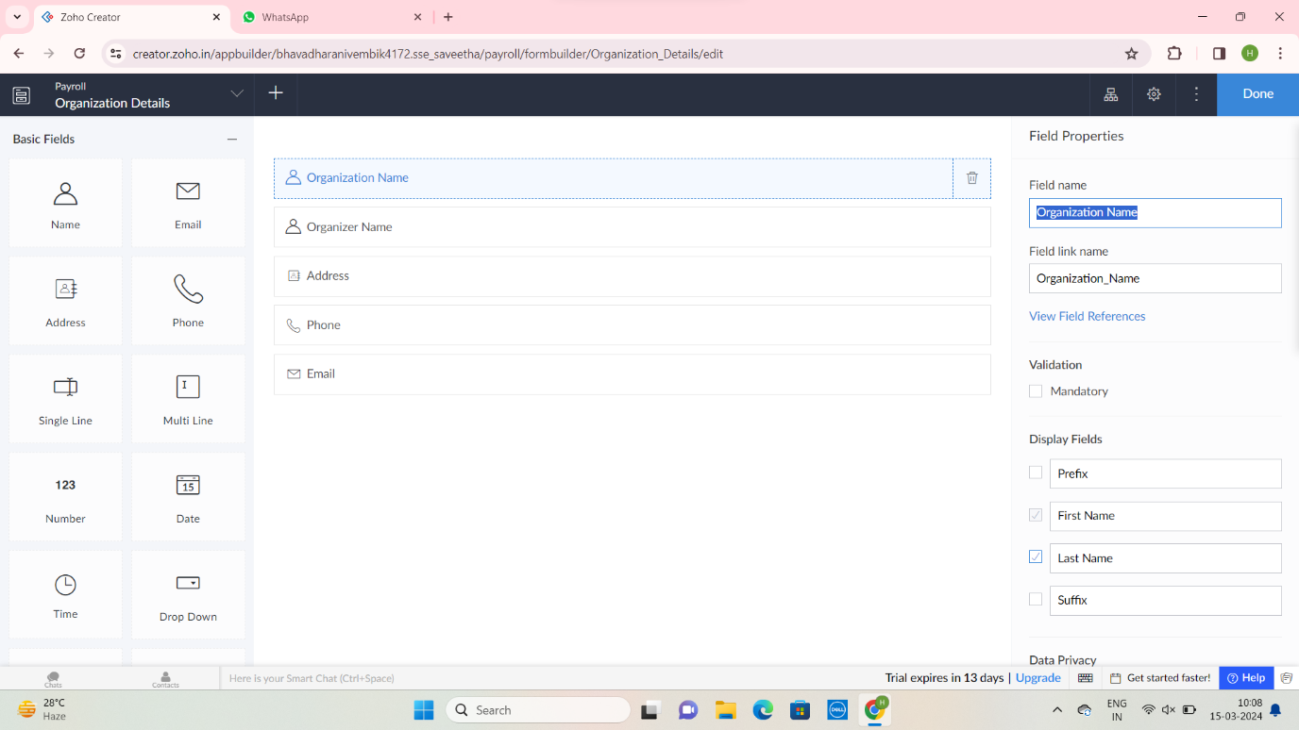

Step 6: Create Payment Details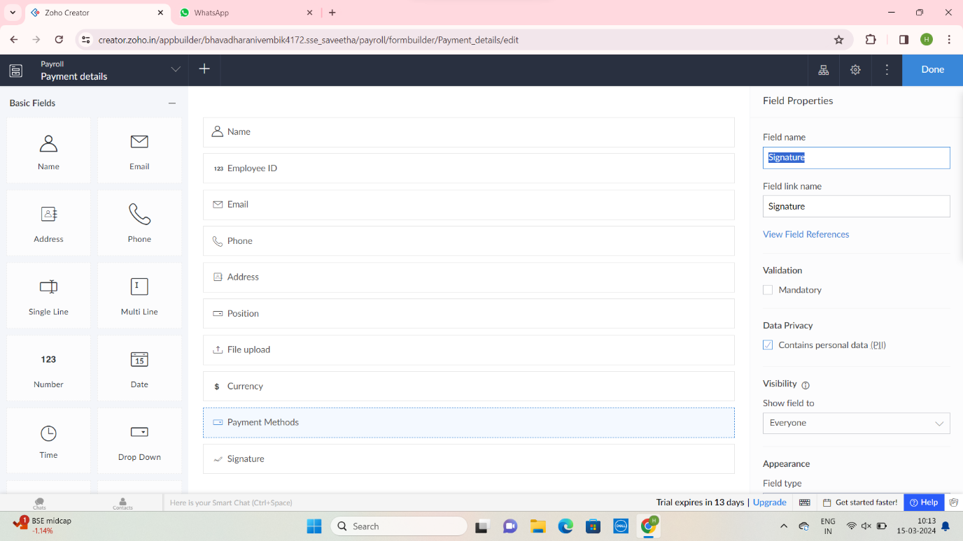

Step 7: Enter payment details for payroll application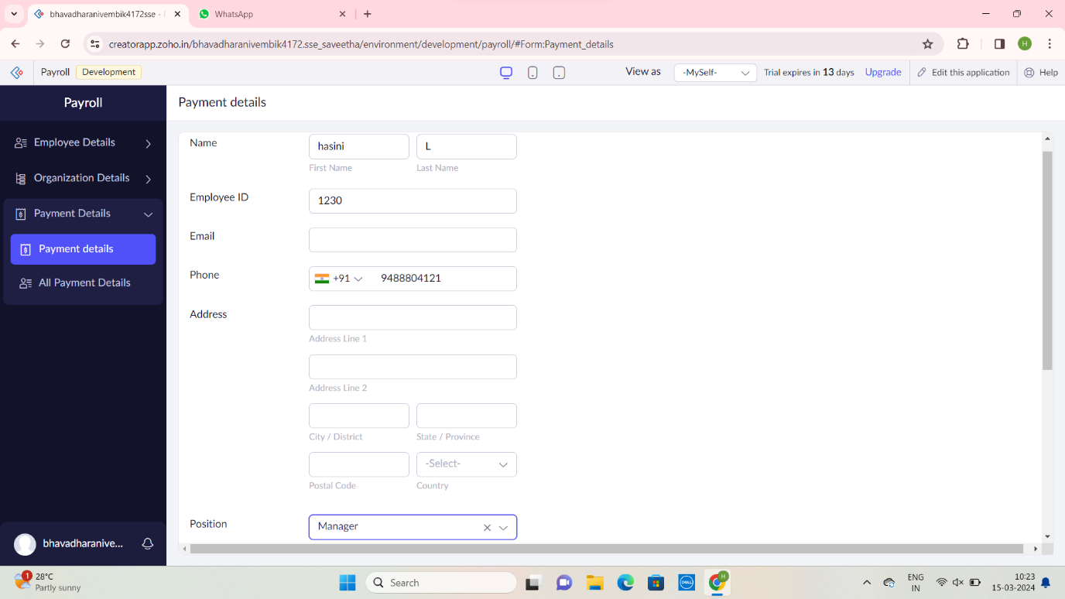

Step 8: Enter Organization details for payroll applications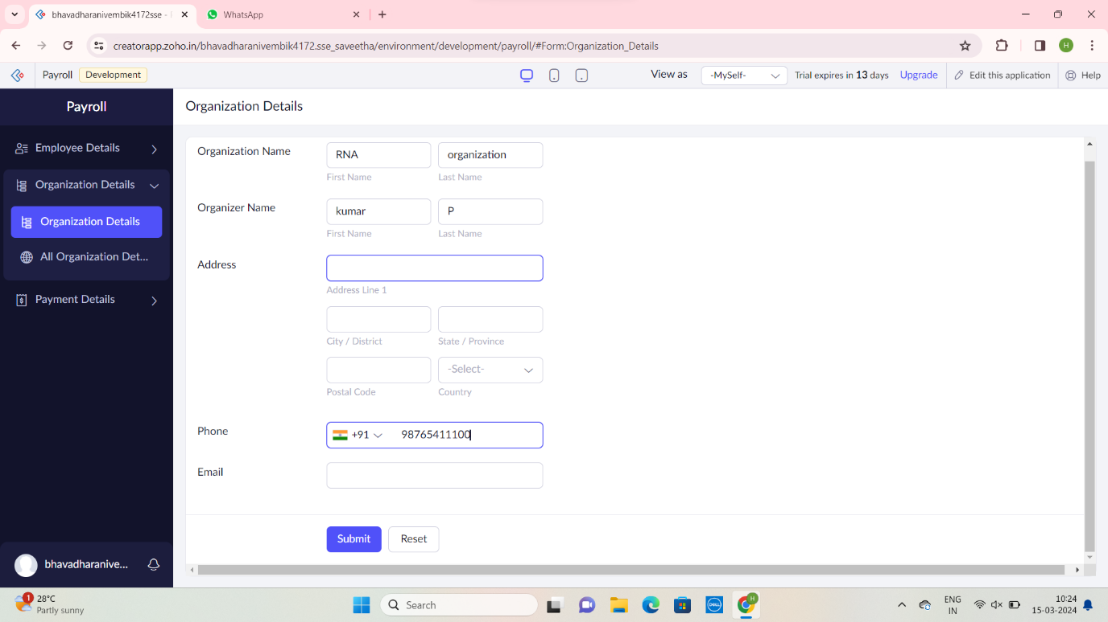

Step 9: Display All Employee Details for Payroll Application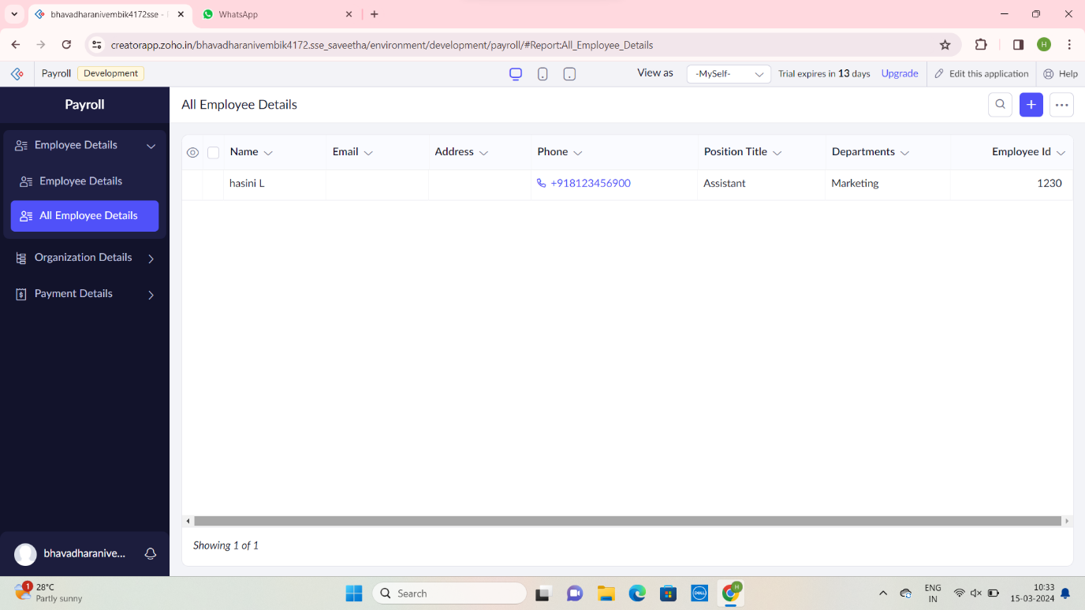

Step 10: Display all Organization Details for payroll applications 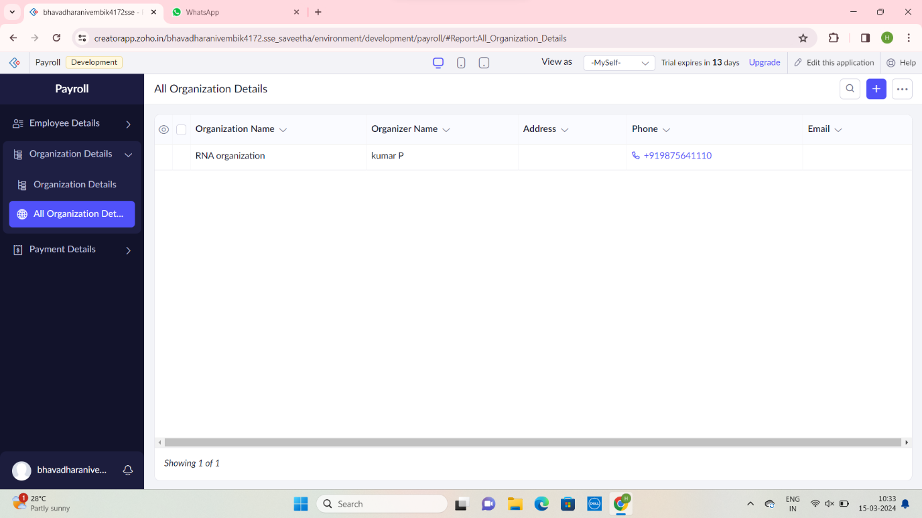

Step 11: Display all Payment Details for Payroll applications

