**EXPERIMENT 2**

**Create a simple cloud software application for Property Buying & Rental process (In Chennai city) using any Cloud Service Provider to demonstrate SaaS include the necessary fields such as Buy, Rent, commercial, Rental Agreement , Rental Agreement, Area, place, Range, property value etc**

**Step 1: Create Buyer Details Application**

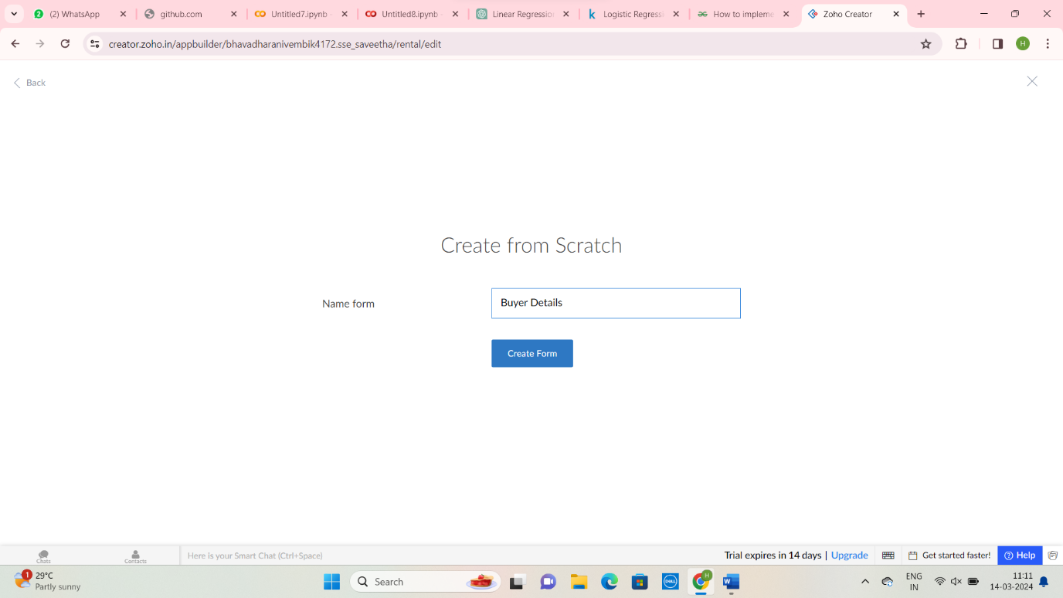

**Step 2: Create Buyer Details Form**

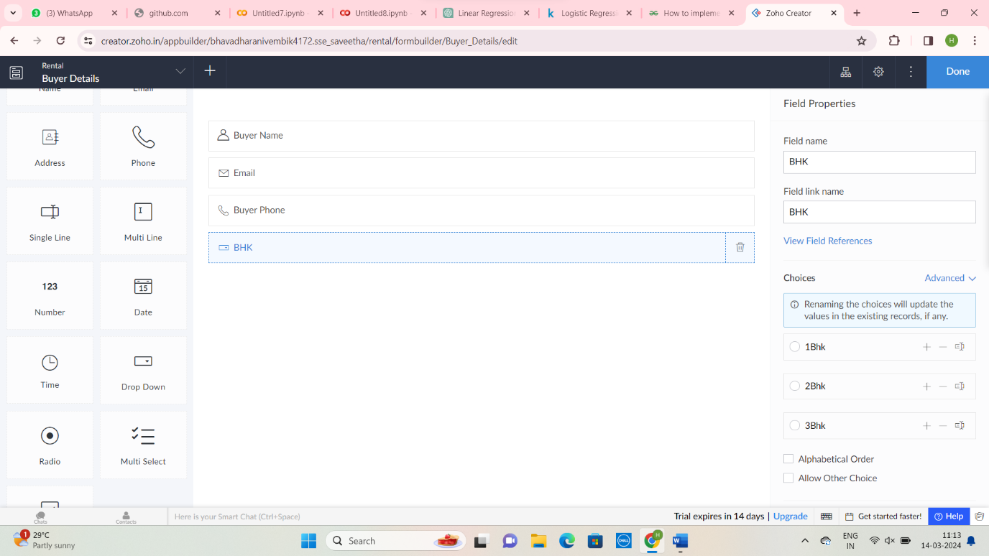

Step 3: Create Owner Details Form

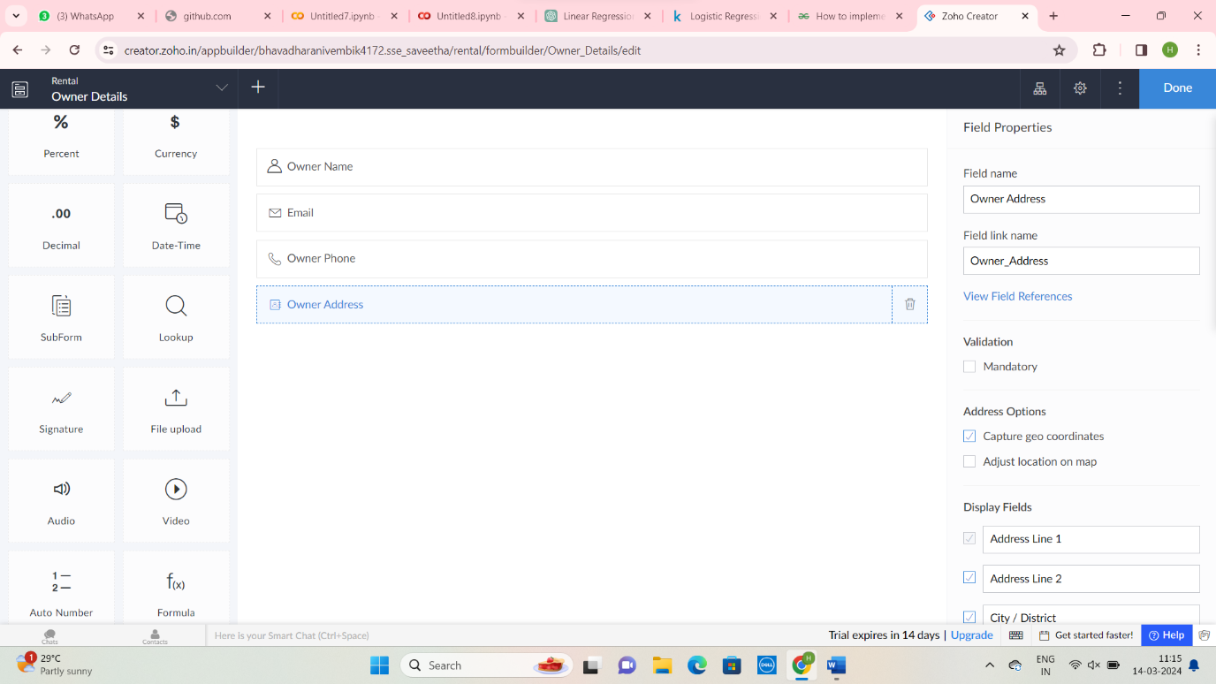

Step 4: Create House Details Applications:

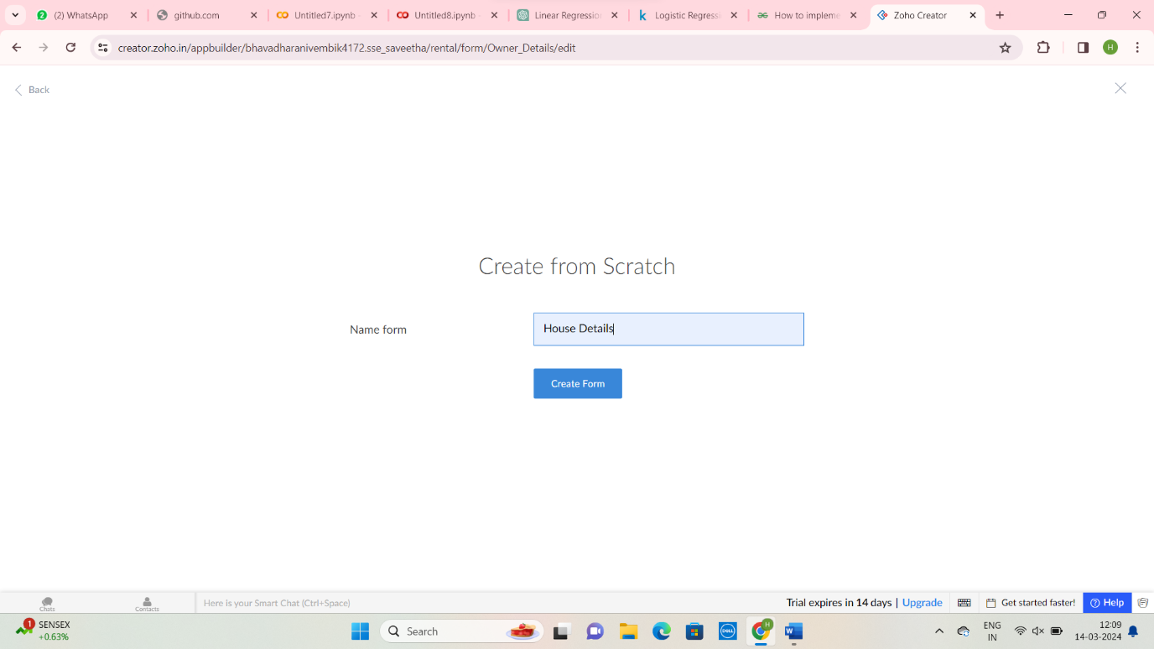

Step 5: Create House Details Form

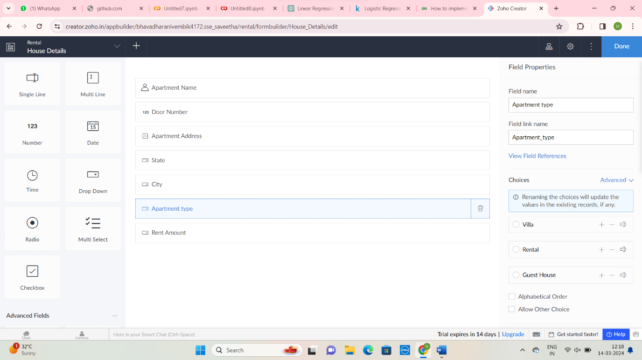

Step 6: Enter Buyer Details Forms

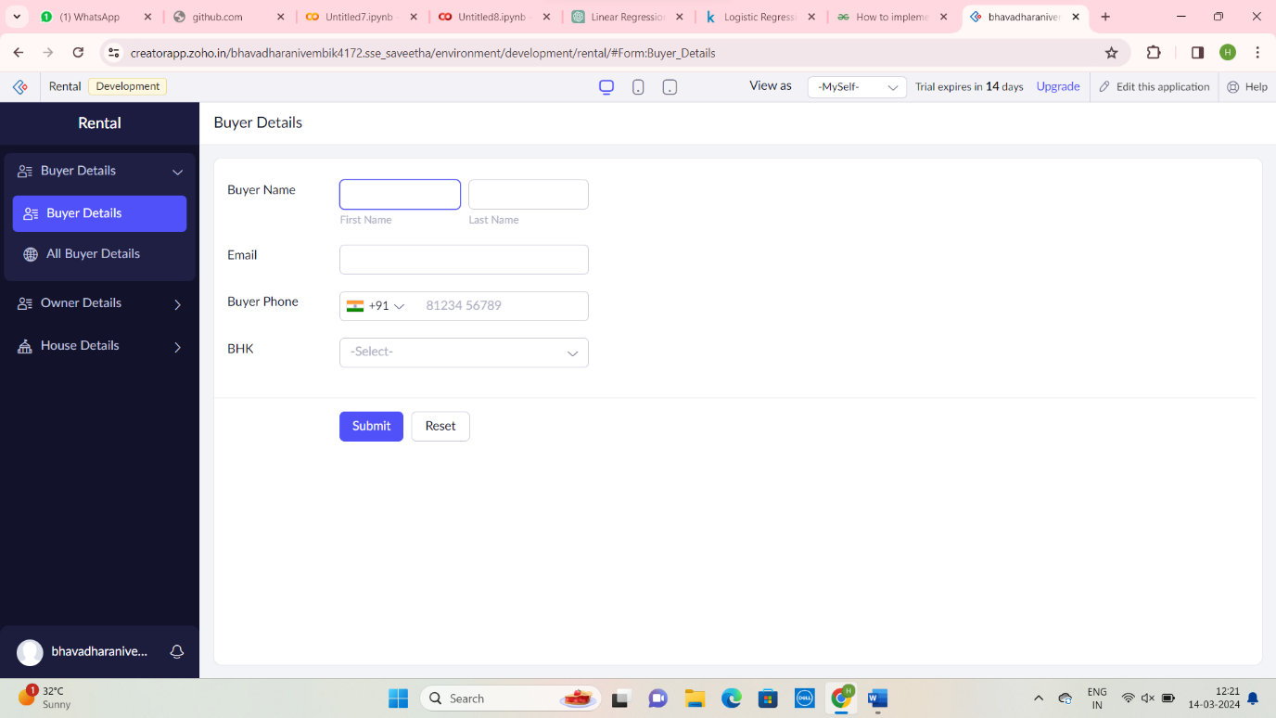

Step 7: Enter Owner Details Form:

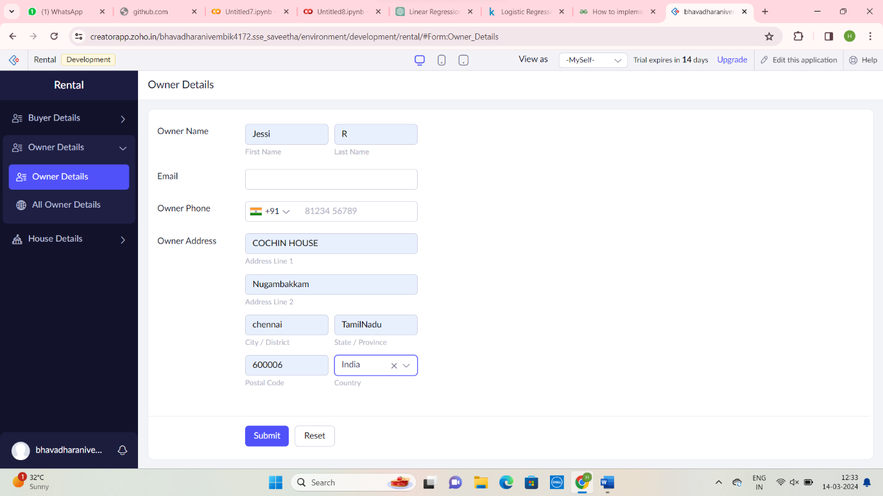

Step 8: Enter House Details Form: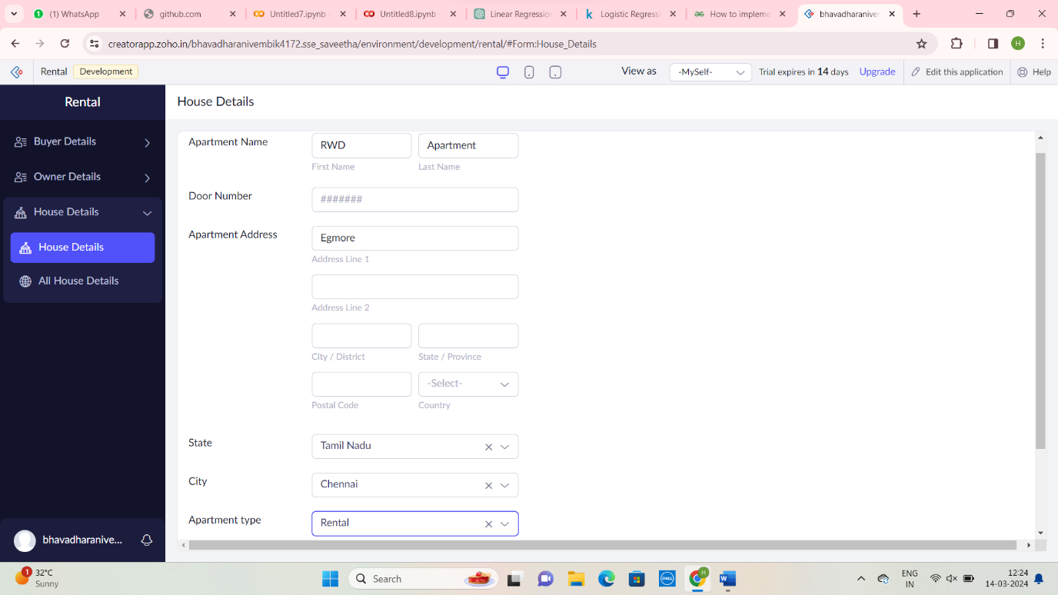

Step 9: Display All Buyer Details

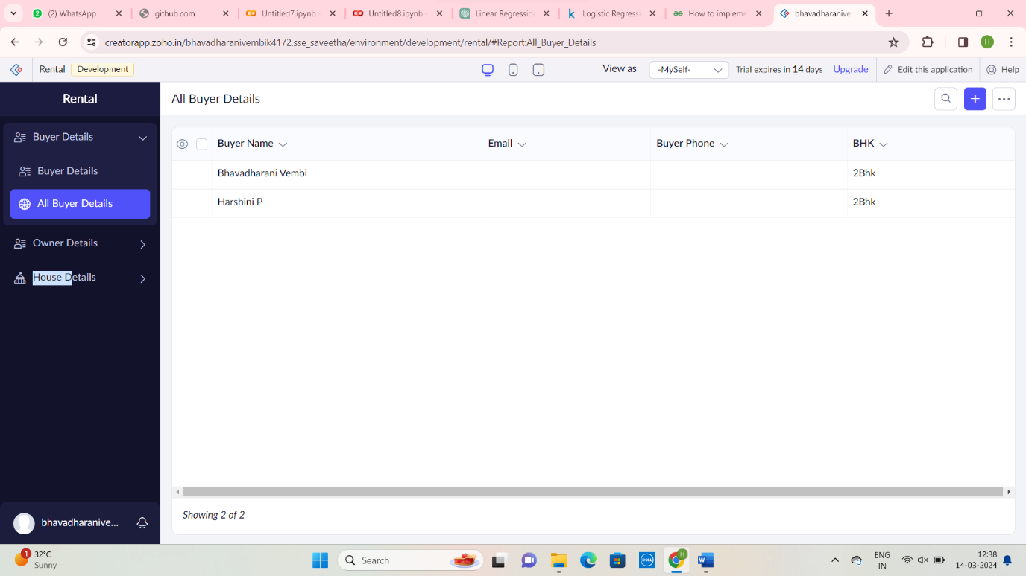

Step 10: Display Owner Details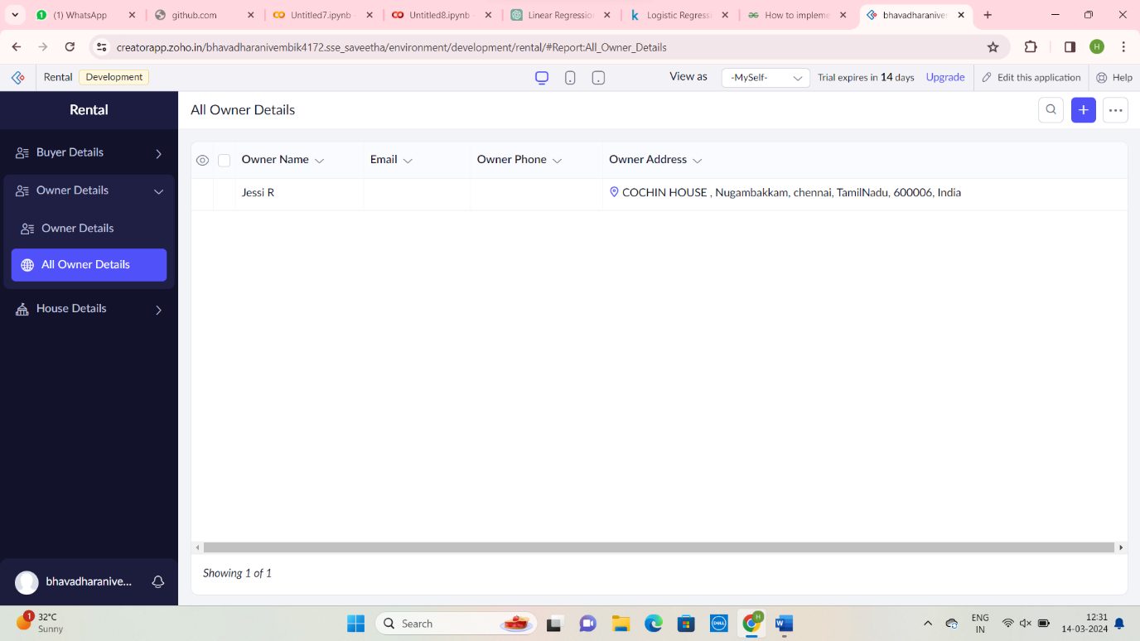

Step 11: Enter House Details Form