***AI-Driven Inventory Optimization and Personalized Recommendation Platform***

***Name – Amman Chhetri***

***Abstract:***

AI, the technology mirroring human intelligence in machines, has transformative potential in inventory management. These AI-powered systems replicate human thinking and behaviour, handling learning, reasoning, problem-solving, perception, and language skills. Their ability to analyse vast data sets, predict, automate tasks, and make critical decisions can revolutionize inventory processes, enhancing efficiency, accuracy, and profitability.

In today's dynamic business landscape, managing inventory poses complex challenges. Global expansion necessitates real-time inventory tracking and precise "available-to-promise" status. Retailers, amid fierce competition and the omnichannel paradigm, prioritize seamless inventory management to meet customer demands.

Balancing operational smoothness with avoiding excess stock is pivotal. Effective inventory control demands foresight, strategic planning, and the ability to resolve urgencies calmly. Mismanagement can lead to inefficiencies and financial setbacks, highlighting the importance of mastering inventory optimization for resource allocation, timely orders, and high customer satisfaction while ensuring financial stability.

AI disrupts traditional inventory practices through predictive forecasting. By leveraging historical data, market dynamics, and trends, AI delivers accurate demand forecasts. This empowers businesses not just to maintain ideal stock levels but also to adapt proactively to changing preferences and market shifts.

Inventory management involves supervising and regulating an entire inventory, including aspects like acquiring, storing, and distributing goods. Effective inventory management involves carefully balancing the supply of items with demand, ensuring that the right quantity of goods is available at the right time and in the right location while minimizing costs and optimizing operational efficiency.

Key aspects of inventory management include:

* **Demand forecasting:** Predicting future demand for products to ensure that enough inventory is on hand to meet customer needs without excessive overstocking.
* **Ordering and reordering:** Determining when and how much to order or reorder to maintain optimal inventory levels while avoiding stockouts or excessive carrying costs.
* **Inventory tracking:** Monitoring the movement of items in and out of inventory, tracking quantities, locations, and changes in status.
* **Stock optimization:** Striking a balance between carrying enough inventory to fulfil orders and minimizing excess stock that ties up capital and incurs storage costs.
* **Supply chain coordination:** Collaborating with suppliers and distributors to ensure punctual and precise delivery of goods while minimizing lead times.
* **Cost management:** Managing costs associated with holding inventory, including storage costs, holding costs, and the cost of capital tied up in inventory.
* **Risk management:** Mitigating risks associated with stockouts, overstocking, changes in demand, and supply chain disruptions.
* **Data analysis:** Utilizing data and analytics to make informed decisions, improve demand forecasting, optimize inventory levels, and identify opportunities for improvement.

Inventory management plays a pivotal role in achieving operational efficiency, customer satisfaction, and financial stability for businesses across various industries, including [manufacturing](https://www.leewayhertz.com/ai-use-cases-in-the-manufacturing/), retail, distribution, and [e-commerce](https://www.leewayhertz.com/ai-use-cases-in-retail-and-e-commerce/). Effective inventory management practices help businesses balance supply and demand, reduce carrying costs, minimize stockouts, and improve overall business performance.

1. **Problem Statement –**

The problem addressed in this report is the need for businesses to optimize their inventory management and enhance customer engagement. Businesses often struggle with accurately predicting future demand for products or services and efficiently managing their inventory levels. Additionally, they strive to provide personalized recommendations to customers to enhance their experience and drive customer engagement.

1. **Market/Customer/Business Need Assessment –**

Through market research and customer feedback, it has been identified that businesses face challenges in optimizing inventory management, resulting in stockouts or excess inventory. This leads to increased costs, operational inefficiencies, and, ultimately, lost revenue. Customers also express the desire for personalized product recommendations to enhance their shopping experience, discover relevant items, and increase satisfaction and loyalty.

1. **Target Specifications and Characterization –**

The target customers for this AI-driven platform are businesses across various industries, including retail, e-commerce, and hospitality. The platform should cater to both small and large businesses and be scalable to handle increasing volumes of data and customers. It should integrate seamlessly with existing inventory management systems and e-commerce platforms while providing real-time insights and actionable recommendations to improve inventory management and customer engagement.

The target audience and customers for inventory optimization and personalized recommender systems can vary depending on the industry and application. Here are a few examples:

* 1. **Retailers and E-commerce Platforms:** 
     + Target Audience: Retailers, online marketplaces, e-commerce platforms.
     + Customers: Online retailers, brick-and-mortar stores, e-commerce platforms, multi-channel retailers.
  2. **Manufacturing Companies:** 
     + Target Audience: Manufacturing companies, production facilities. >
     + Customers: Companies involved in production, factory managers, supply chain management teams.
  3. **Logistics and Supply Chain Management:** 
     + Target Audience: Logistics companies, supply chain management teams.
     + Customers: Supply chain managers, logistics managers, distribution centres.
  4. **Wholesalers and Distributors:**
     + Target Audience: Wholesalers, distributors, suppliers.
     + Customers: Wholesale distributors, suppliers, B2B companies, distribution centres.
  5. **Service-Based Businesses:** 
     + Target Audience: Service-based businesses with inventory needs (e.g., hospitality industry, healthcare).
     + Customers: Hotels, restaurants, healthcare facilities, service providers with inventory management requirements.
  6. **Personalized Recommendation Platforms:** 
     + Target Audience: Online marketplaces, media streaming platforms, recommendation engine developers.
     + Customers: Online marketplaces, media streaming platforms, app developers, content platforms.

1. **External Search –**

Gone through different sources of information and found this helpful links –

* <https://rapidops.medium.com/11-ways-ai-inventory-management-boosts-efficiency-and-profitability-b011e4abdb02>
* <https://www.intelligencenode.com/blog/10-ways-inventory-management-software-increases-sales-profit/>
* <https://www.leewayhertz.com/ai-in-inventory-management/>
* <https://www.linkedin.com/pulse/how-ai-based-recommendation-systems-transforming-e-commerce-mori-w4h9f/>

1. **Benchmarking Alternate Products –**

Here are a few alternative products in the field of inventory optimization and personalized recommender systems:

1. **Oracle Retail Inventory Optimization Suite:**

Pros:

* + - Comprehensive inventory management solution.
    - Advanced forecasting capabilities.
    - Intuitive user interface.

Cons:

* + - High licensing and implementation costs.
    - Complex setup and configuration.

1. **IBM Watson Commerce:**

Pros:

* + - Robust inventory optimization capabilities.
    - Integrated AI and machine learning capabilities.
    - Scalable and capable of handling large datasets.

Cons:

* + - Steep learning curve for customization and implementation.
    - Requires technical expertise for setup and maintenance.

1. **Amazon Personalize:**

Pros:

* + - Powerful recommendation engine.
    - Deep integration with Amazon Web Services (AWS).
    - Ability to leverage large-scale customer data.

Cons:

* + - Limited customization options.
    - Primarily focused on e-commerce applications.
    - Costly for high-volume usage.

So, while creating our own inventory optimization and Personalized recommender System we should ensure to keep the below points as the key factor, based on our benchmarking analysis, identify areas where you can differentiate your product of inventory optimization and personalized recommender system. This might include adding unique features, improving scalability, enhancing customization options, or focusing on specific industry verticals.

1. **Functionality**: Assessing the features and capabilities of each product to identify strengths and weaknesses in terms of inventory optimization and personalized recommendations.
2. **Scalability**: Considering the ability of the product to handle large datasets and adapt to growing business demands.
3. **Customization**: Evaluating the level of customization and flexibility offered by each product to meet specific business requirements.
4. **User** **Experience**: Considering the user interface, ease of use, and accessibility of the product for different user roles and it should be understandable by people with no education background.
5. **Implementation** **and Costs**: Evaluating the complexity and costs associated with implementing and maintaining each solution.
6. **Business Model –**

There are several potential monetization strategies for this inventory optimization and personalized recommendation system that we can used, here are a few ideas to consider –

* + - * **Licensing or Subscription Model:** Offer your app as a licensed software or subscription-based service. Users would pay a recurring fee or a one-time fee to access and utilize your app's functionalities.
      * **Commission or Revenue Sharing:** Partner with retailers or businesses and earn a commission or a percentage of the revenue generated through your app. This can be based on the increased sales or cost savings resulting from your inventory optimization and recommendation algorithms.
      * **Premium Features:** Provide a basic version of your app for free and offer additional premium features or advanced analytics to users who are willing to pay. This can include advanced reporting capabilities, real-time notifications, or customizability options.
      * **Data Analytics and Insights:** Collect anonymized data from your app users and leverage it to provide valuable insights or market intelligence to businesses. You can offer data analytics reports, trend analysis, or predictive modelling to help businesses optimize their inventory and make informed decisions.
      * **White Labelling or Customization:** Allow businesses to customize and rebrand your app as their own, catering to their specific needs. Charge a licensing fee or set-up fee for providing the white-labelled solution.
      * **Consultancy and Integration Services:** Offer professional services such as consulting, implementation, and integration support to assist businesses in implementing your app effectively. Charge a fee for these services based on the scope of work.
      * **Collaborations and Partnerships:** Collaborate with complementary service providers or platforms to enhance the functionality of your app. Establish revenue-sharing partnerships to monetize the combined offering.
      * **Advertising:** Incorporate non-intrusive advertisements within your app, either as banners, sponsored content, or relevant product recommendations. Ensure that the ads align with the user experience and don't compromise the app's usability.

We can also make this recommender System, available to only those members which have taken our premium Subscription, Baisc Members can only use the Optimization model for their inventory, that too with only some limited features

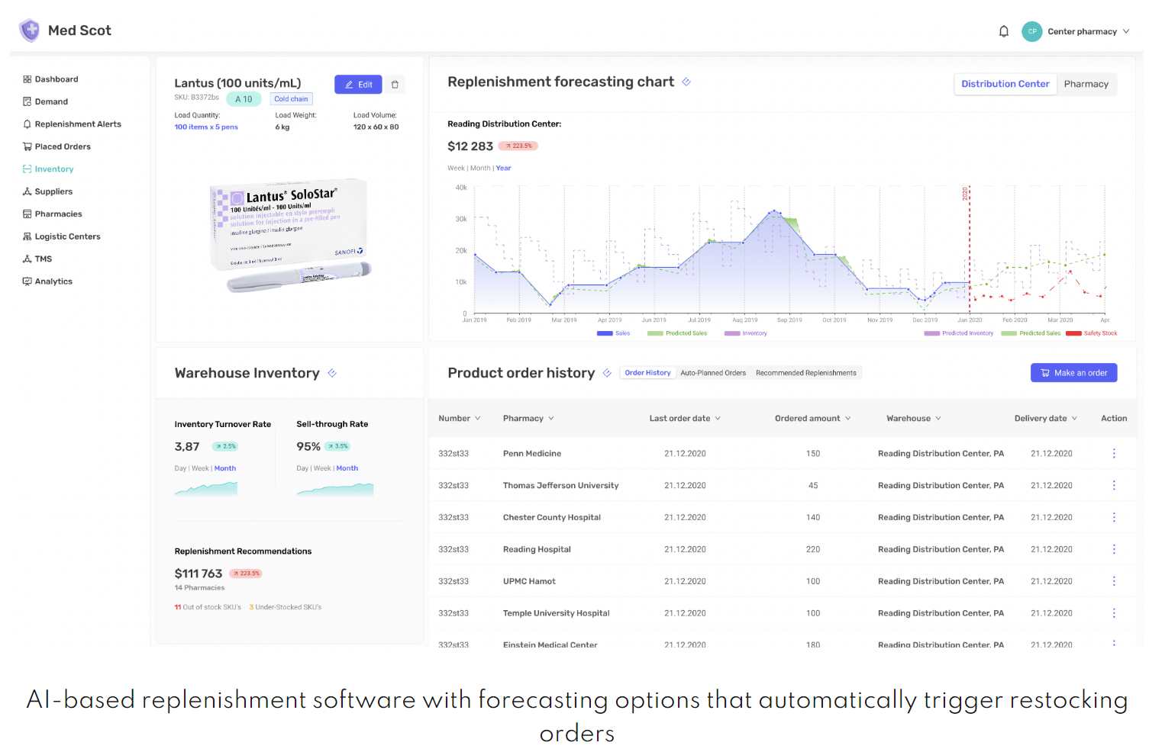

1. **Concept Development –**

This will solely depend upon once business needs. For the particular type of business we will collect its historical data, customer reviews, current market trends, seasonal requirements etc.

We will be requiring various items for this system for different aspects –

**Inventory Management**:

* Time Series Forecasting: Techniques such as ARIMA (Autoregressive Integrated Moving Average) or SARIMA (Seasonal ARIMA) are used to forecast demand patterns and predict future inventory needs.
* Optimization Algorithms: Linear programming or integer programming models can be employed to optimize inventory levels based on factors like holding costs, ordering costs, lead time, and demand variability.
* Reinforcement Learning: RL algorithms can be used to learn optimal inventory replenishment policies through continuous interaction with the inventory system, taking into account factors like stockouts, sales patterns, and costs.

**Personal Recommendation System**:

* Collaborative Filtering: This approach recommends items based on the preferences and behaviours of similar users. It can be implemented using techniques like user-based filtering or item-based filtering.
* Content-Based Filtering: This technique recommends items based on their attributes and characteristics. It involves analysing user preferences and matching them with the attributes of items.
* Matrix Factorization: This method applies dimensionality reduction techniques like Singular Value Decomposition (SVD) or Alternating Least Squares (ALS) to identify latent factors and provide recommendations.
* Deep Learning: Neural network architectures, such as Convolutional Neural Networks (CNNs) or Recurrent Neural Networks (RNNs), can be used to capture complex patterns in user behaviour and provide personalized recommendations.

1. **Final Product Prototype –**

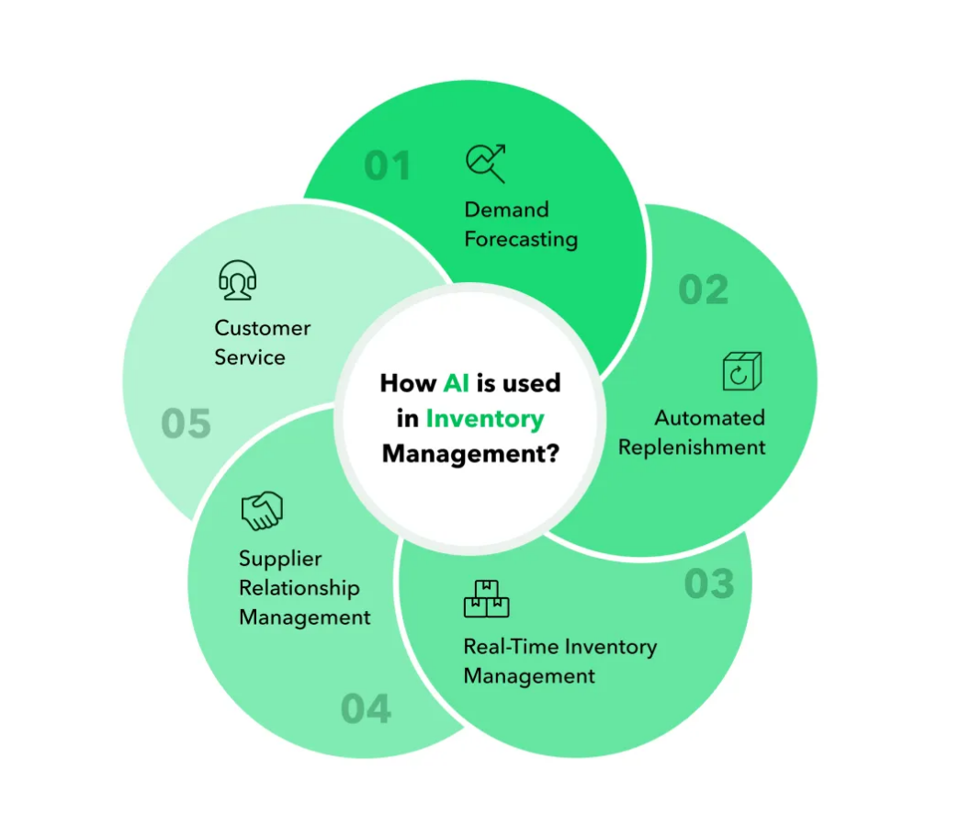

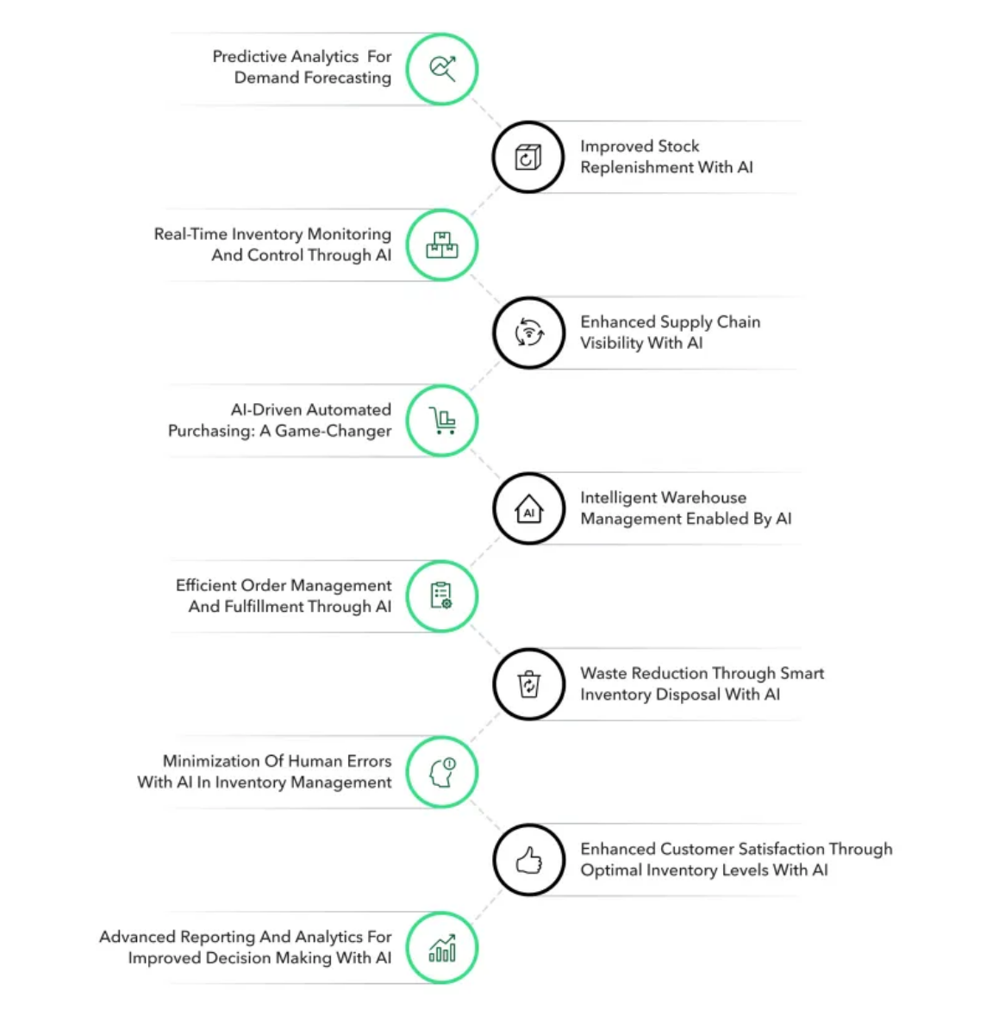

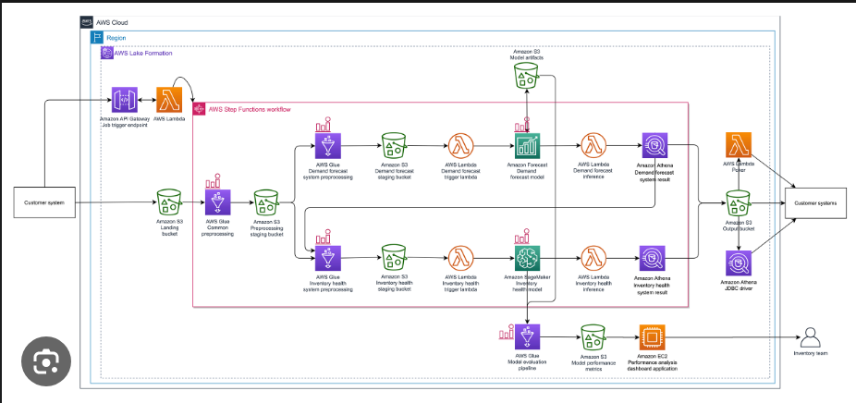

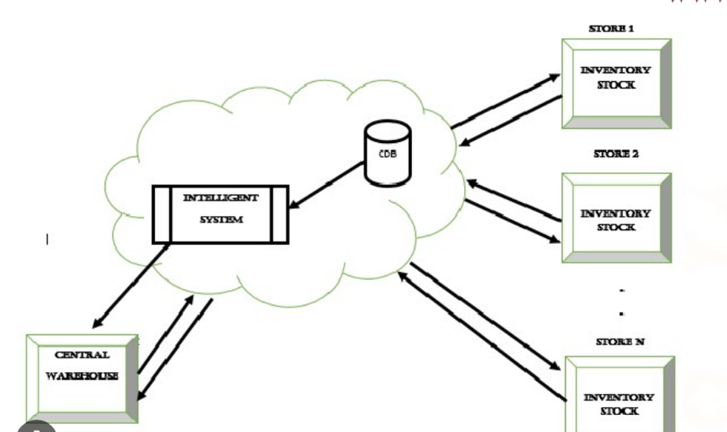

1. **Product Details –**

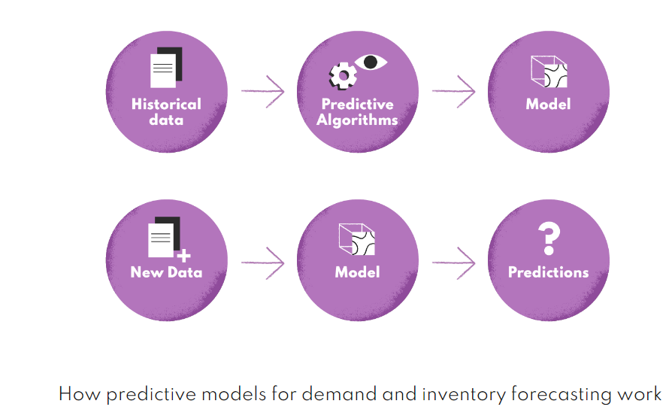

**– How does it work?**

* + - The system utilizes historical sales data and customer preferences to analyse trends and recommend optimal inventory levels.
    - It employs machine learning algorithms to predict future demand and identify patterns to optimize stock replenishment.
    - Through collaborative filtering techniques, it recommends suitable products based on customer behaviour and preferences.

**– Data Sources:**

* + - Primary data sources include historical sales data, customer order history, and product attributes.
    - External data sources, such as market trends, competitor analysis, and economic indicators, can be used to enhance recommendations.

**– Algorithms, frameworks, software etc. needed:**

* + - Popular algorithms such as demand forecasting (e.g., ARIMA, exponential smoothing) and classification algorithms (e.g., k-nearest neighbors) can be employed.
    - Frameworks such as TensorFlow, scikit-learn, or PyTorch can be used for machine learning implementation.
    - Software tools like Python, R, or SQL are utilized for data processing, analysis, and modelling.

**– Team required to develop:**

* + - A cross-functional team is necessary, including data scientists/statisticians, software developers, and domain experts (if specific industry knowledge is required).
    - Data scientists will be responsible for building and fine-tuning the predictive models.
    - Software developers will handle the implementation and integration of the system into existing infrastructure.

**– What does it cost?**

* + - Costs include data acquisition, storage, and processing.
    - Expenses related to software licenses, hardware infrastructure, and cloud services should be considered.
    - Ongoing maintenance, monitoring, and periodic updates should also be factored into the cost estimation.

1. **Code Implementation –**

Demonstrating code for some basic functions and utilities that will be act as a base for the development of this project:

**Inventory Management –**

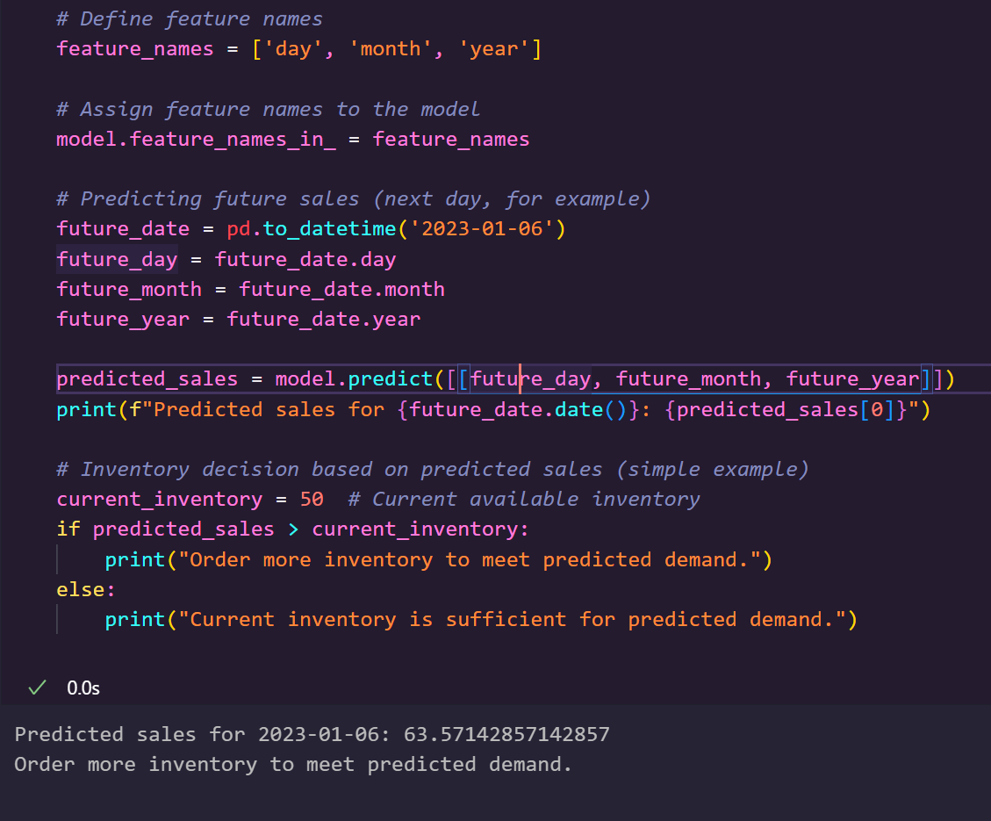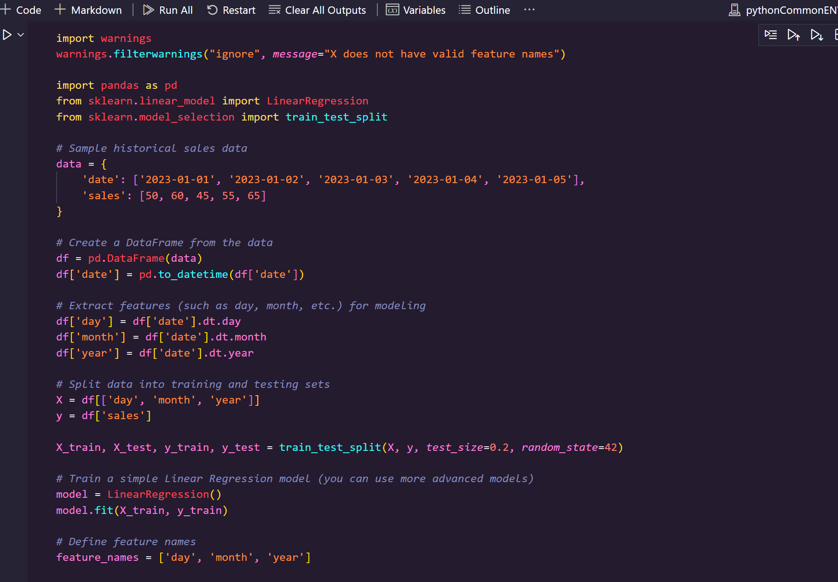

**Recommender System using Surprise – (We can create our own function also) -**

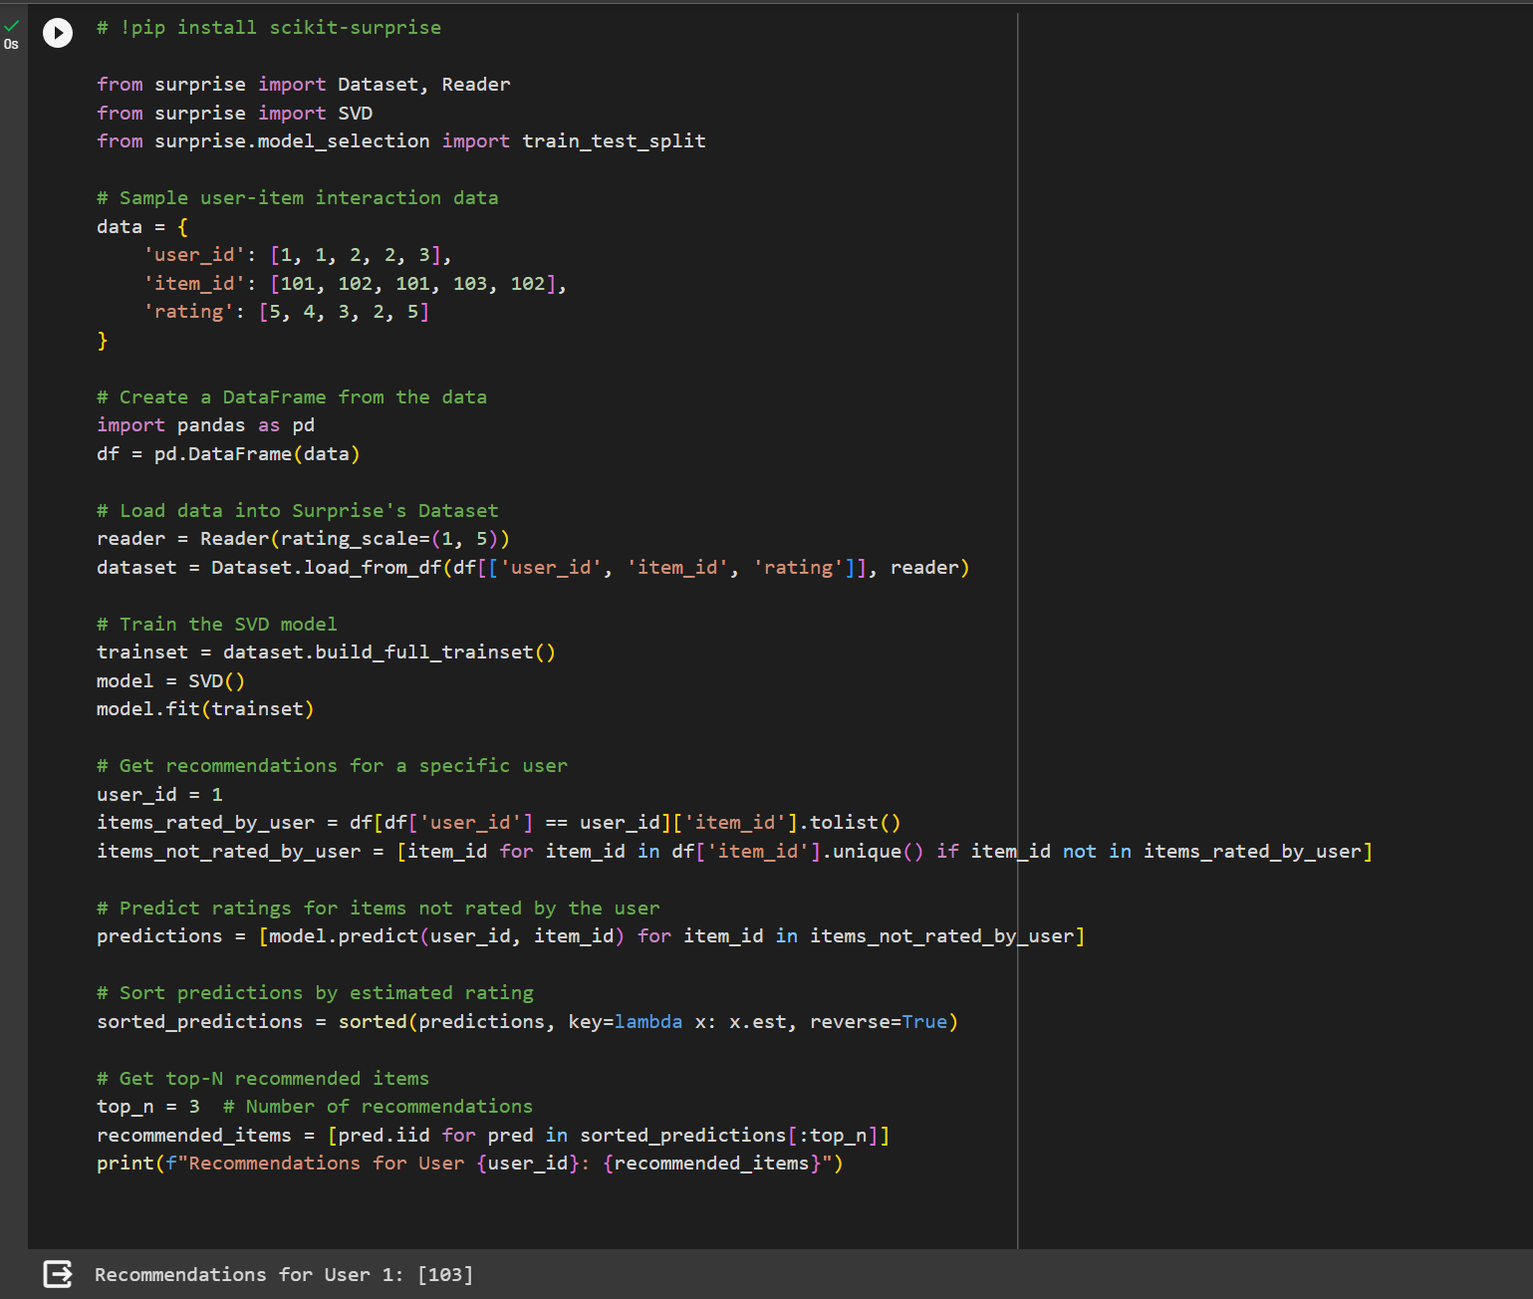

**Financial Equation -**

Here I have listed the factors that I think will decide the equation the inventory management and optimization –

1. **Season effect** - represents the impact of seasonal variations on demand.
2. **Current** **market** **demand** - refers to the current need for the product in the market.
3. **Market** **price** - is the price at which the product is being sold. (if some existing product is there)
4. **Current** **stock** **levels** - indicate how much inventory is currently in stock.
5. **Ease** **of** **availability** - is how easily the product can be sourced.
6. **Reusability** **factor** - represents how easily the product can be reused or repurposed.
7. **Lead** **time** - is the time it takes between ordering and receiving inventory.
8. **Carrying** **cost** - is the cost incurred to hold inventory in stock.
9. **Profit** **margin** - is the difference between the selling price and the cost of the product.
10. **Forecast** **accuracy** - indicates how accurate the AI system is in predicting future demand.
11. **Customer** **satisfaction** - is the level of satisfaction customers experience with the product availability.

**Optimal Inventory Level** = [ {(Seasonal Effect) * (Current Market Demand) * (Market Price) – Current Stock Level } ] / [ { (Ease of availability) + (Reusability Factor) + (Lead Time) + (Carrying Cost) + (Forecast Accuracy) + (Customer Satisfaction) – (Profit margin)} ]

Here, are some small implementation we can perform –

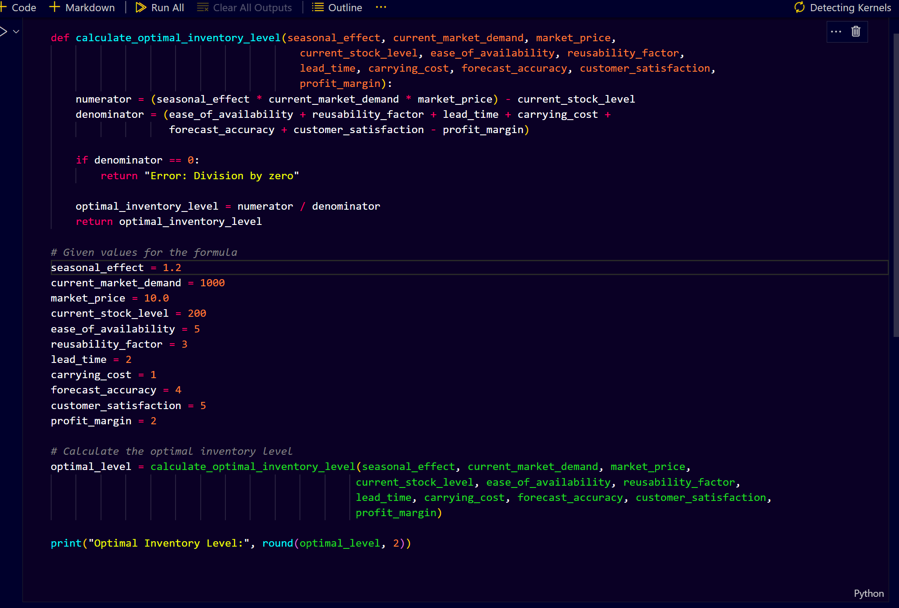

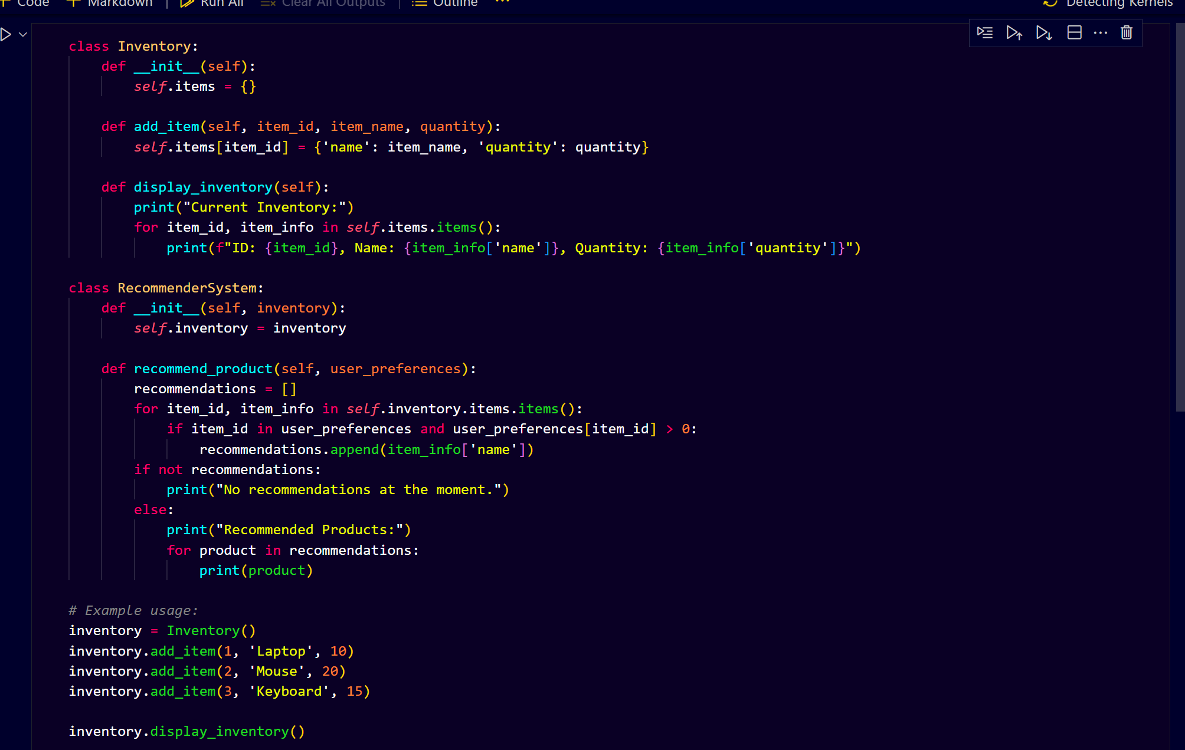

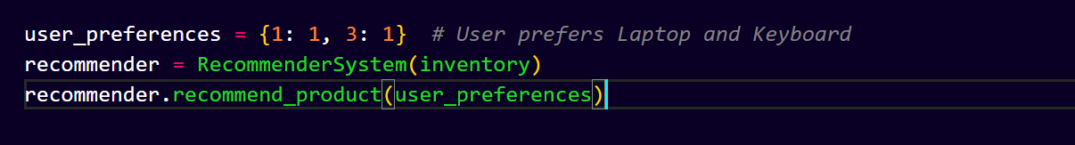

**NOTE** - You can use this as a base reference to build your product