**Market Segmentation:**

**Analysing Electric vehicle Market of India using Segmentation Analysis for an Electric Vehicle Startup**

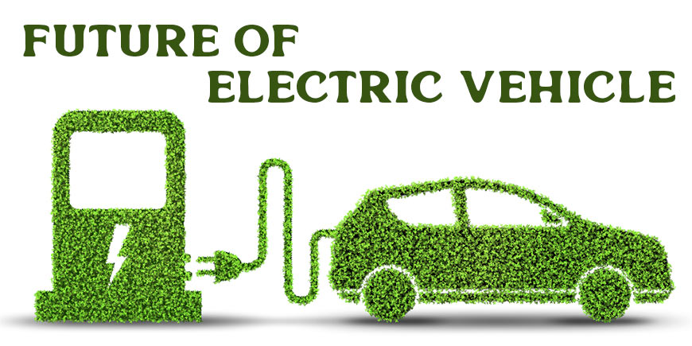

**Overview:**

**Benefits of Electric Vehicle:**

Modern life cannot exist without transportation, but the conventional combustion engine is rapidly becoming antiquated. Vehicles powered by gasoline or diesel emit a great deal of pollution, and fully electric vehicles are rapidly taking their place. Fully electric cars (EVs) are significantly better for the environment and have no exhaust emissions. The revolution in electric vehicles is here.

1. **Lower Running Cost:**

An electric vehicle has substantially lower operating costs than a comparable gasoline or diesel vehicle. Instead of utilizing fossil fuels like gasoline or diesel to charge their batteries, electric vehicles use electricity. Because electric vehicles are more energy-efficient and power is more expensive, charging an electric car is more affordable than filling it up with gasoline or diesel for your needs. Using electric vehicles can be more environmentally friendly when renewable energy sources are used. Installing renewable energy sources, like solar panels, at home can help down the cost of electricity even more when charging.

1. **Lower Maintenance Cost:**

In contrast to internal combustion vehicles, electric vehicles have significantly fewer moving components, which results in extremely cheap maintenance costs. Electric automobiles require less maintenance than traditional gasoline or diesel vehicles. As a result, maintaining an electric car has very little annual expense.

1. **Zero Tailpipe Emissions:**

Because electric vehicles emit no tailpipe emissions, driving one can help one lower their carbon footprint. By selecting renewable energy sources for your home's electricity, you can further lessen the environmental impact of charging your automobile.

1. **Tax and Financial Benefits:**

Compared to gasoline or diesel vehicles, electric vehicle registration fees and road tax are lower. Depending on the state you live in, the government offers different regulations and incentives. Click below to learn more about incentives for electric vehicles.

<https://e-amrit.niti.gov.in/electric-vehicle-incentives>

1. **Easier to Drive:**

Electric cars are really convenient to drive and don't have gears. There are only three controls: steer, brake, and accelerate. Simply plug your car into a public or home charger when you need to charge it. Because they are silent as well, electric cars lessen the noise pollution that conventional cars cause.

1. **Convenience of Chargin at Home:**

Consider yourself at a crowded gas station at rush hour, running out of time to get to work. An electric car is a simple solution to these issues. Just leave your car plugged in for four to five hours at home before you intend to leave. It is quite convenient to arrange your trips ahead of time if you can find a charger where you park at home. What happens if you ever forget to plug in your computer? Then, if you are riding a two-wheeler on the road, you may readily enlist the aid of rapid chargers or even battery changing services.

1. **No Noise Pollution:**

Because there is no engine inside an electric car, they may operate quietly. There is no noise if there is no engine. You have to look into your instrument panel to see if the electric motor is on because it runs so quietly. Because electric vehicles are so silent, their manufacturers have to incorporate fake sounds to ensure pedestrian safety.

**Top 25 Electric Cars**

| **MODEL** | **PRICE** |
| --- | --- |
| Tata Nexon EV | Rs. 14.74 Lakh |
| MG Comet EV | Rs. 7.98 Lakh |
| Tata Tiago EV | Rs. 8.69 Lakh |
| Mahindra XUV400 | Rs. 15.99 Lakh |
| Hyundai Ioniq 5 | Rs. 45.95 Lakh |
| Kia EV6 | Rs. 60.95 Lakh |
| BYD Atto 3 | Rs. 33.99 Lakh |
| Volvo XC40 Recharge | Rs. 57.90 Lakh |
| Citroen eC3 | Rs. 11.61 Lakh |
| MG ZS EV | Rs. 22.88 Lakh |
| Audi e-tron GT | Rs. 1.70 Crore |
| Volvo C40 Recharge | Rs. 62.95 Lakh |
| Jaguar I-Pace | Rs. 1.20 Crore |
| Hyundai Kona Electric | Rs. 23.84 Lakh |
| BYD e6 | Rs. 29.15 Lakh |
| Lotus Eletre | Rs. 2.55 Crore |
| Tata Tigor EV | Rs. 12.49 Lakh |
| BMW i7 | Rs. 2.03 Crore |
| MINI Cooper SE | Rs. 53.00 Lakh |
| BMW i4 | Rs. 72.50 Lakh |
| Porsche Taycan | Rs. 1.61 Crore |
| BMW iX1 | Rs. 66.90 Lakh |
| BMW iX | Rs. 1.21 Crore |
| Mercedes-Benz EQB | Rs. 74.50 Lakh |
| Porsche Taycan Cross Turismo | Rs. 1.82 Crore |

**Market Overview:**

Electric vehicle (EV) adoption in India has been on the rise, with sales growing by 82% in March 2023 compared to the previous year. Overall sales increased by 157% from FY2022 to FY2023. The electric two-wheeler market is seeing significant growth, with over 1 lakh EVs sold every month in H2 FY2023.

India has seen a constant rise in EV adoption since 2021 and the upward trajectory has continued through 2023 as well.  
Vahan data indicates that on a year-on-year basis, EV sales grew by 82 percent in March 2023 with **1,39,789** units sold in comparison to **77,128** EVs sold in March 2022. Overall sales grew by a whopping 157 percent, from 4,58,746 in FY2022 to **11,80,597** in FY2023. This was further encouraged with an increase in the number of models being offered in the electric two-wheeler and 4-wheeler brands ranging between the affordable and luxury segments. With the bulk of the EV sector being driven by sales of electric two-wheelers, India saw over 1 lakh EVs being sold every month in H2 FY 2023, MoRTH data shows.

**Graphical Analysis of EV-Market of India –**

We observe that in the last 10 years the sales of Electric vehicle have increased by approximately 174%, That too we observe the huge increase in the sales of 2-Wheelers Electric Vehicle

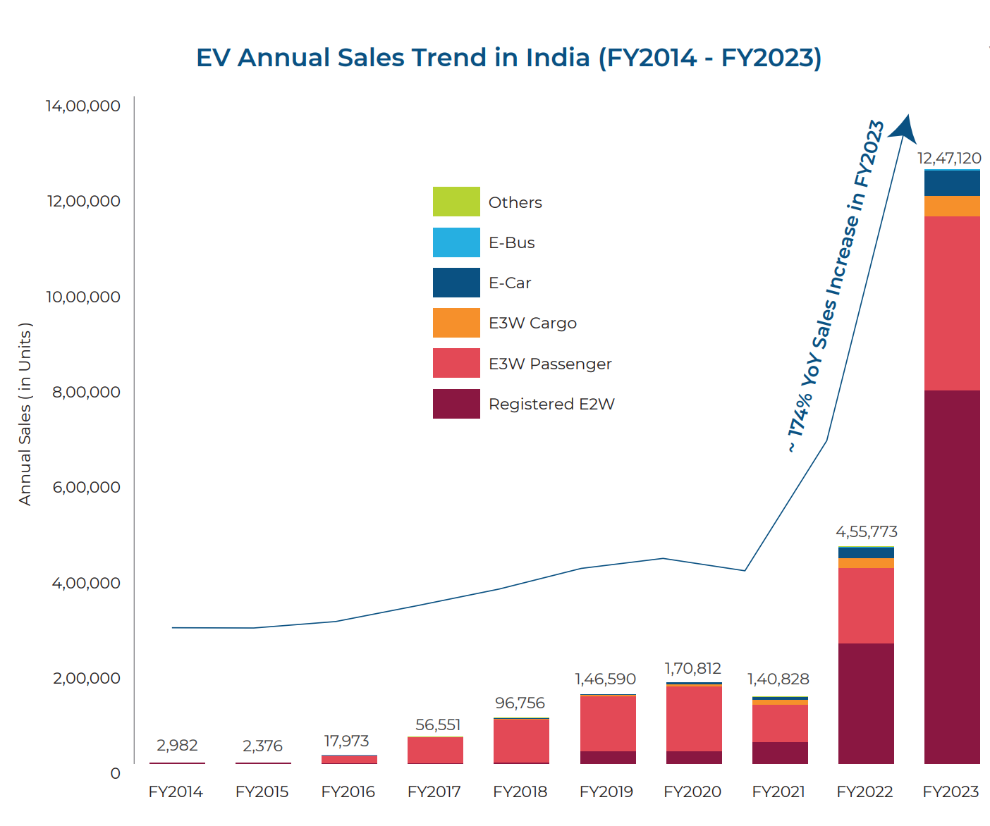

Again 2-Wheeler Electric vehicle has the highest sales and registration.

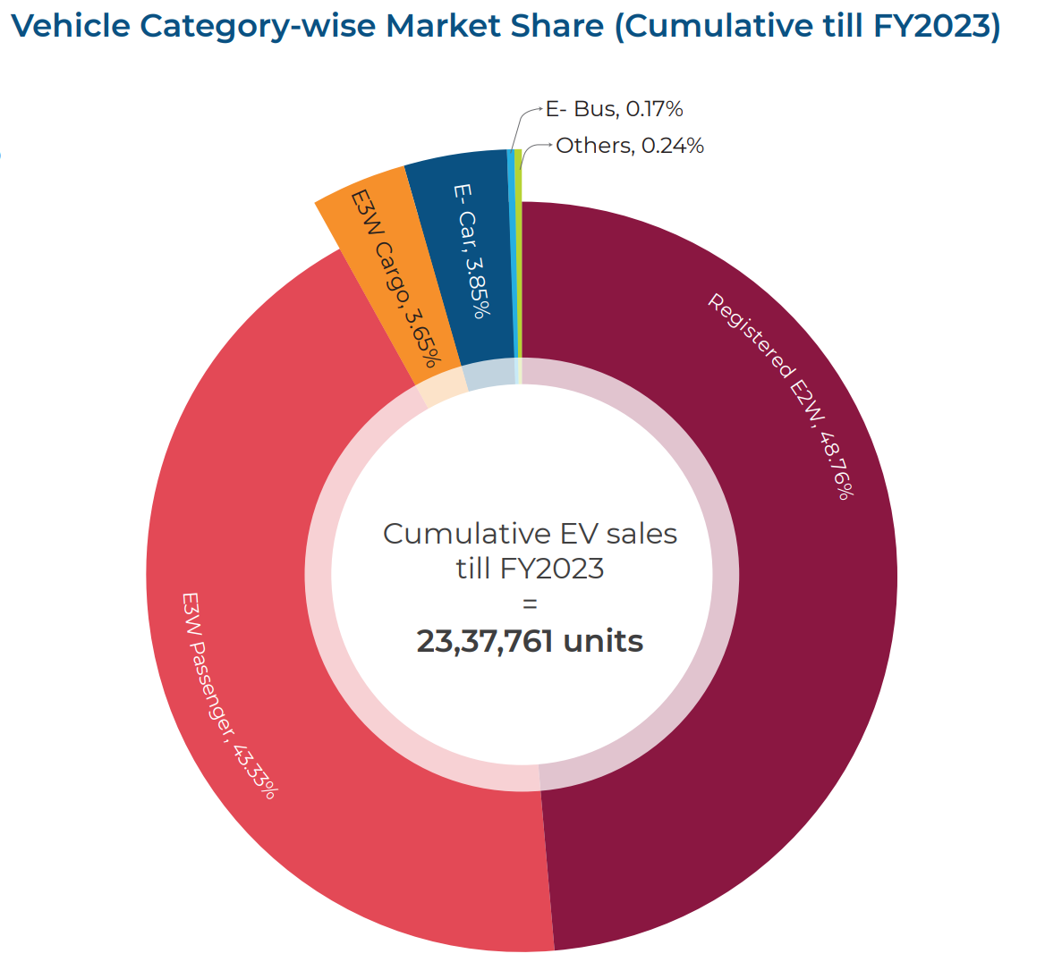

Uttar Pradesh, Maharashtra and Delhi are the top places with highest Electric Vehicles Sales till the end of year 2023, and have high chances to remain at the top as well.

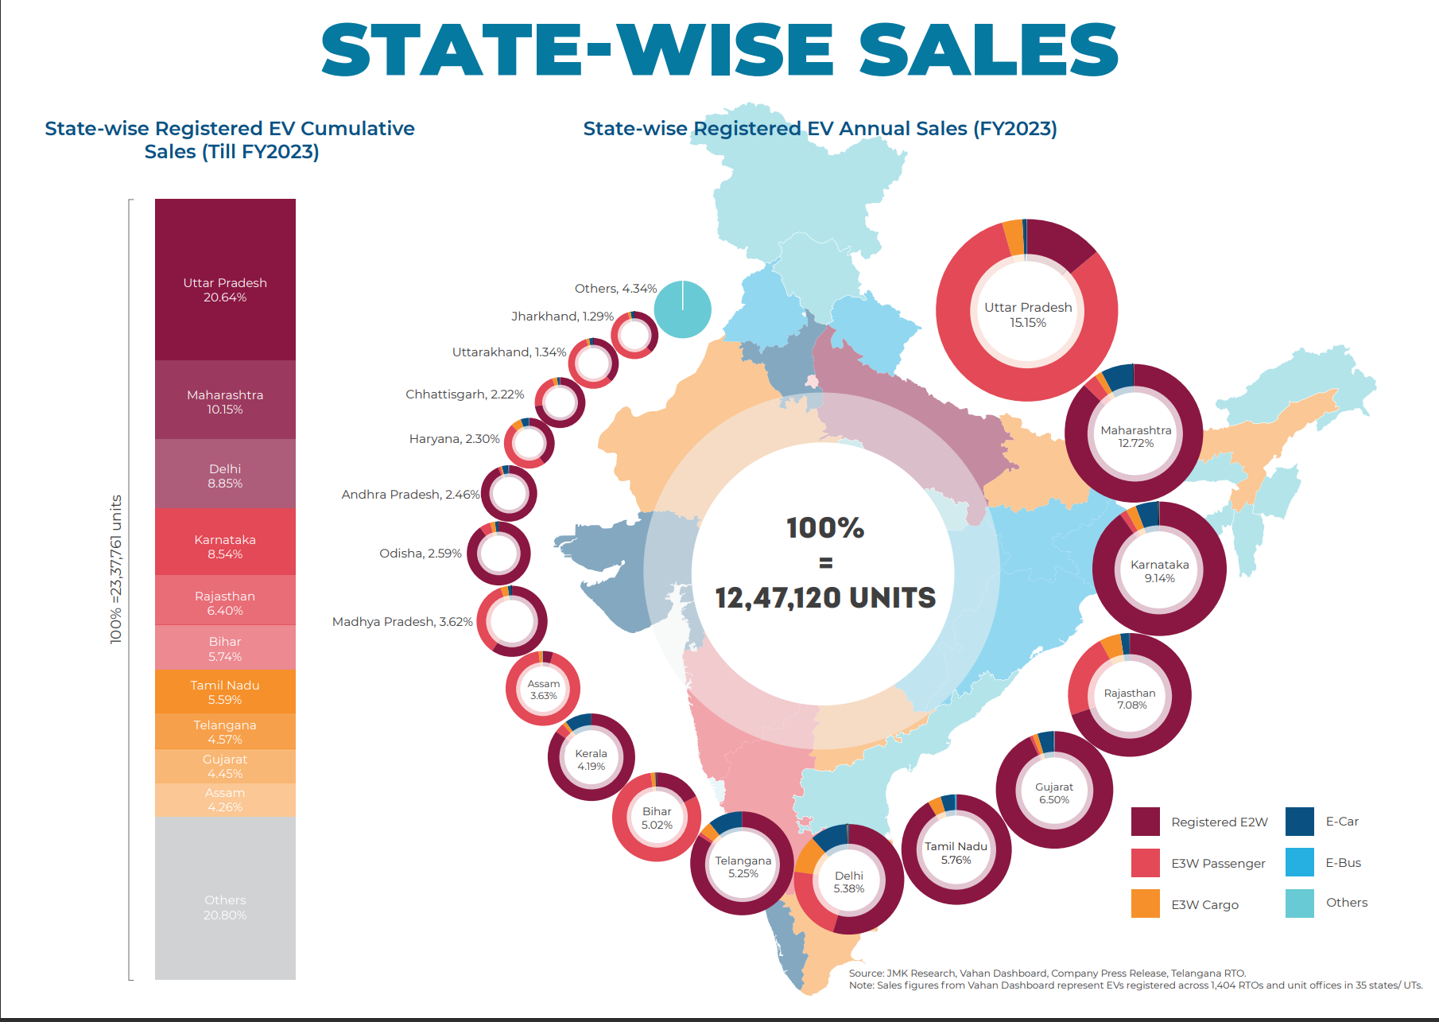

Uttar Pradesh, Bihar and Assam have the highest sales of 3-Wheelers

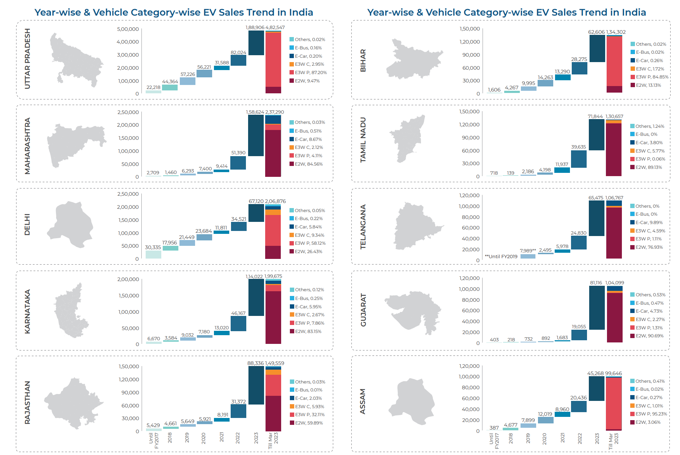

**Key Players registered for the Electric Vehicle (2-Wheelers) in India:**   
**Conclusion –**

1. Ola Electric, Hero Electric and Okinawa Autotech are the strongest competitors in the EV market for 2 wheelers right now
2. If we divide the 2-Wheeler category into sub-categories of High Speed and Low Speed Vehicle then the High-Speed vehicle wins by a huge margin on the basis of yearly sale

On an annual basis, the sales for E2W segment recorded an increase of 210% in FY2023 over sales in FY2022. Ola Electric, Hero Electric, and Okinawa Autotech were the top 3 E2W players in FY2023, accounting for more than ~45% market share in registered vehicle category sales.

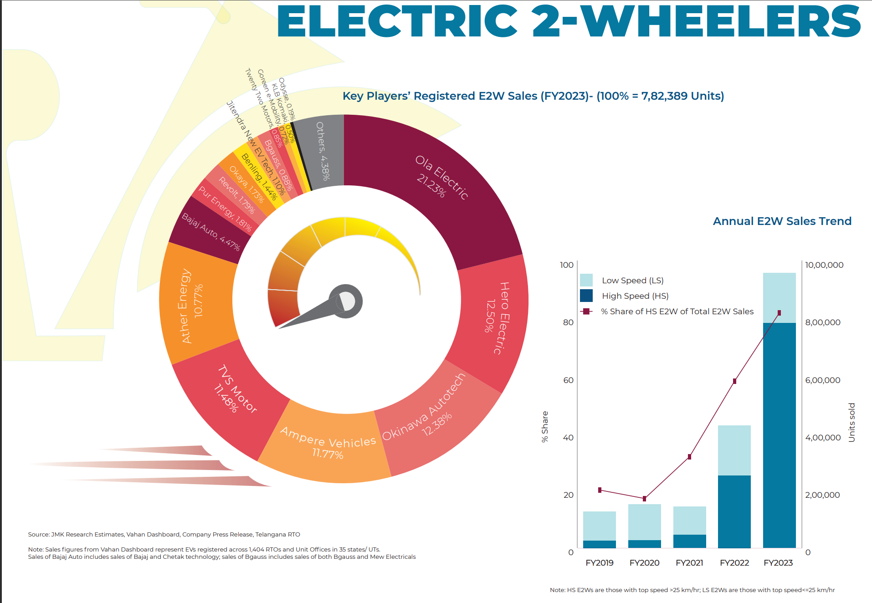

Among all the sub-categories of 3-Wheelers in India like E-Rickshaw (Passenger), E-Rickshaw (Cart), E3W(Goods), E3W(Personal) etc., E-Rickshaw(passenger) sales is around 86%

On a yearly basis, the combined sales of both passenger and cargo (registered) E3Ws in FY2023 recorded an increase of 126% over sales in FY2022. Mahindra & Mahindra, YC Electric Vehicle, and Saera Electric were the top 3 E3W players in FY2023 with shares of 8.95%, 7.34%, and 5.46% respectively.

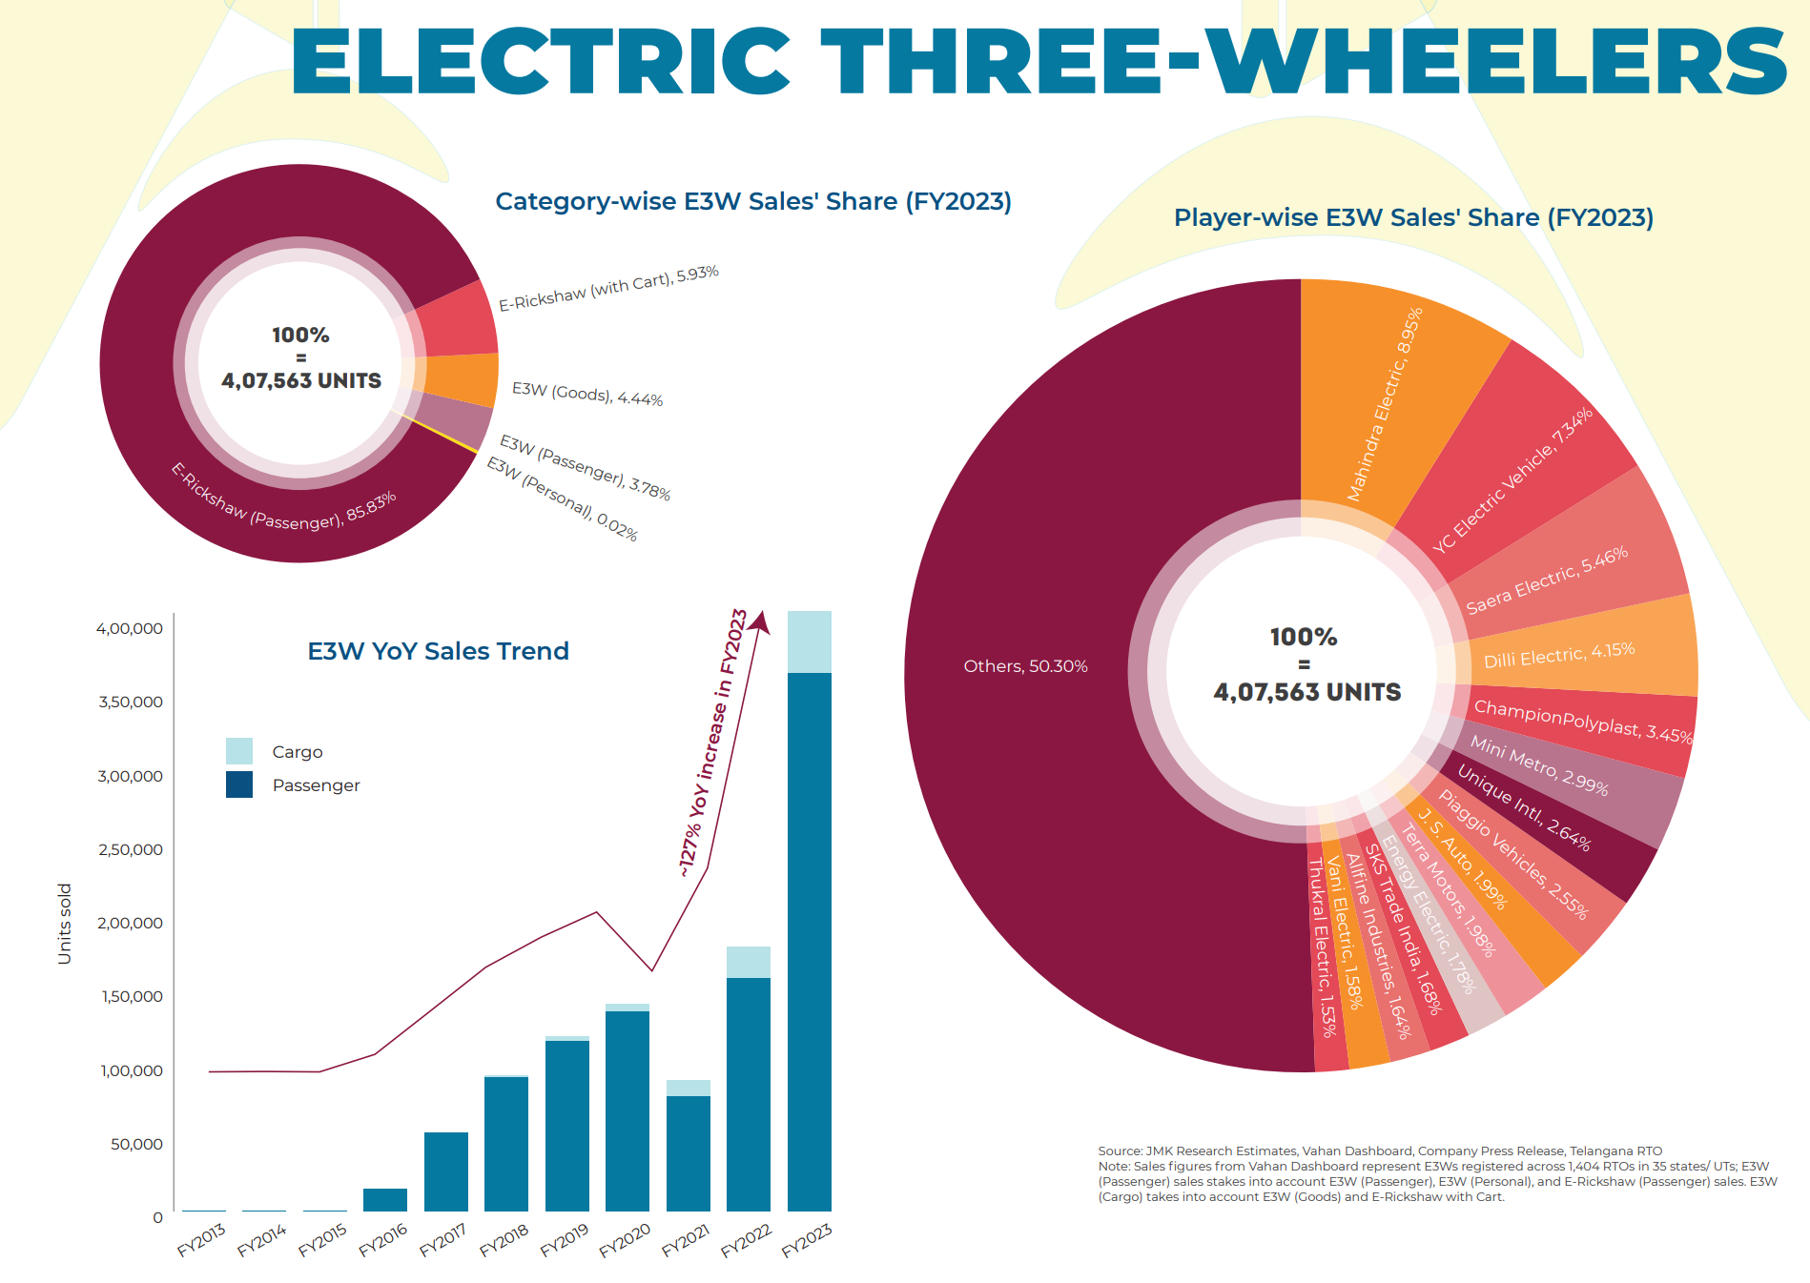

In the year 2023 the Tata Motors holds the highest percentage of total sales of there Electric Cars with more than 43,000 units sold

On a yearly basis, E-Car sales registered an increase of more than 150% in FY2023 over FY2022 sales. Tata Motors was the top E-Car player, accounting for more than 75% of the entire market share, followed by MG Motor which accounted for 10% of the market share.

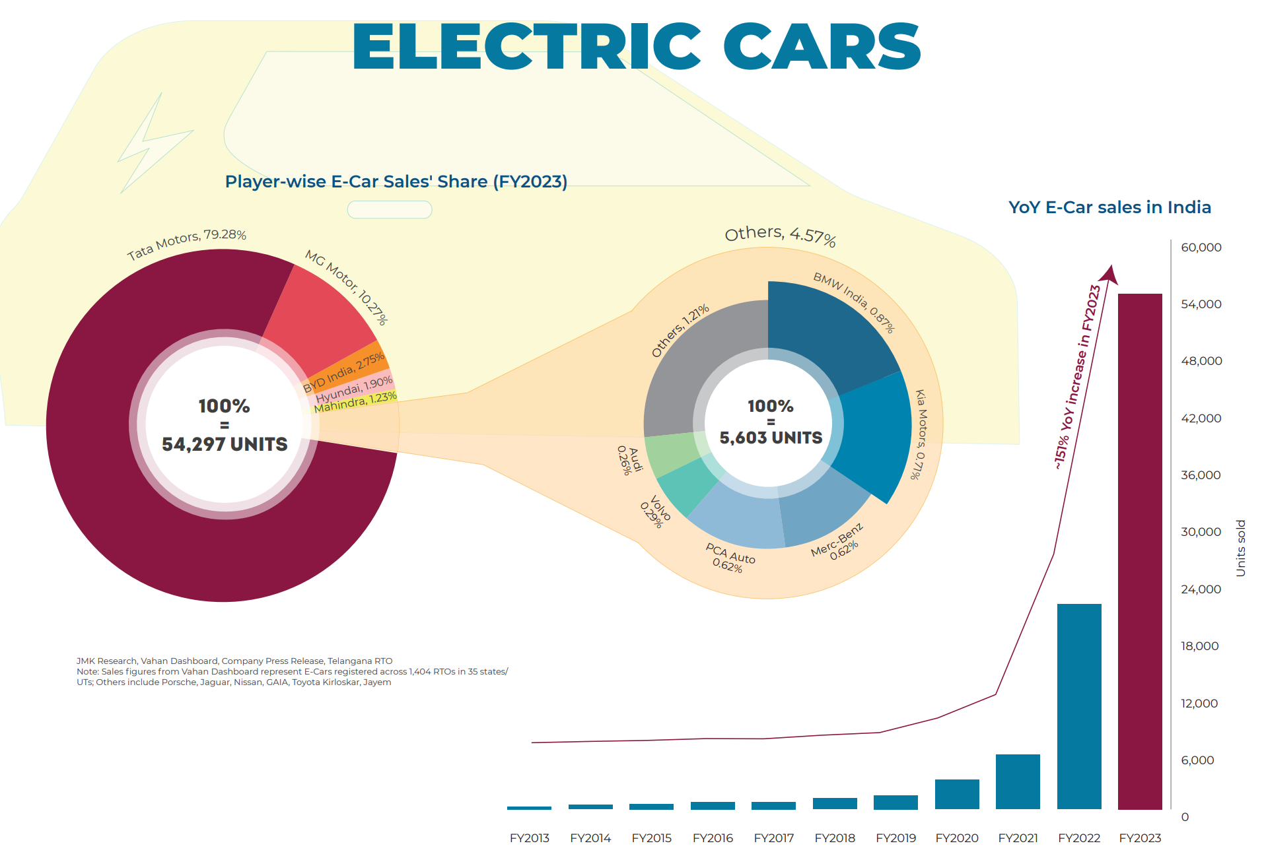

**Player-wise E-Bus Sales’ Share (FY 2023):**

On an annual basis, E-Bus sales witnessed a jump of 62% in FY2023 over sales in FY2022. PMI Electro Mobility, Olectra Greentech, and Switch Mobility (Ashok Leyland) were the top 3 E-Bus players accounting for 74% of the total E-buses sold in FY2023.

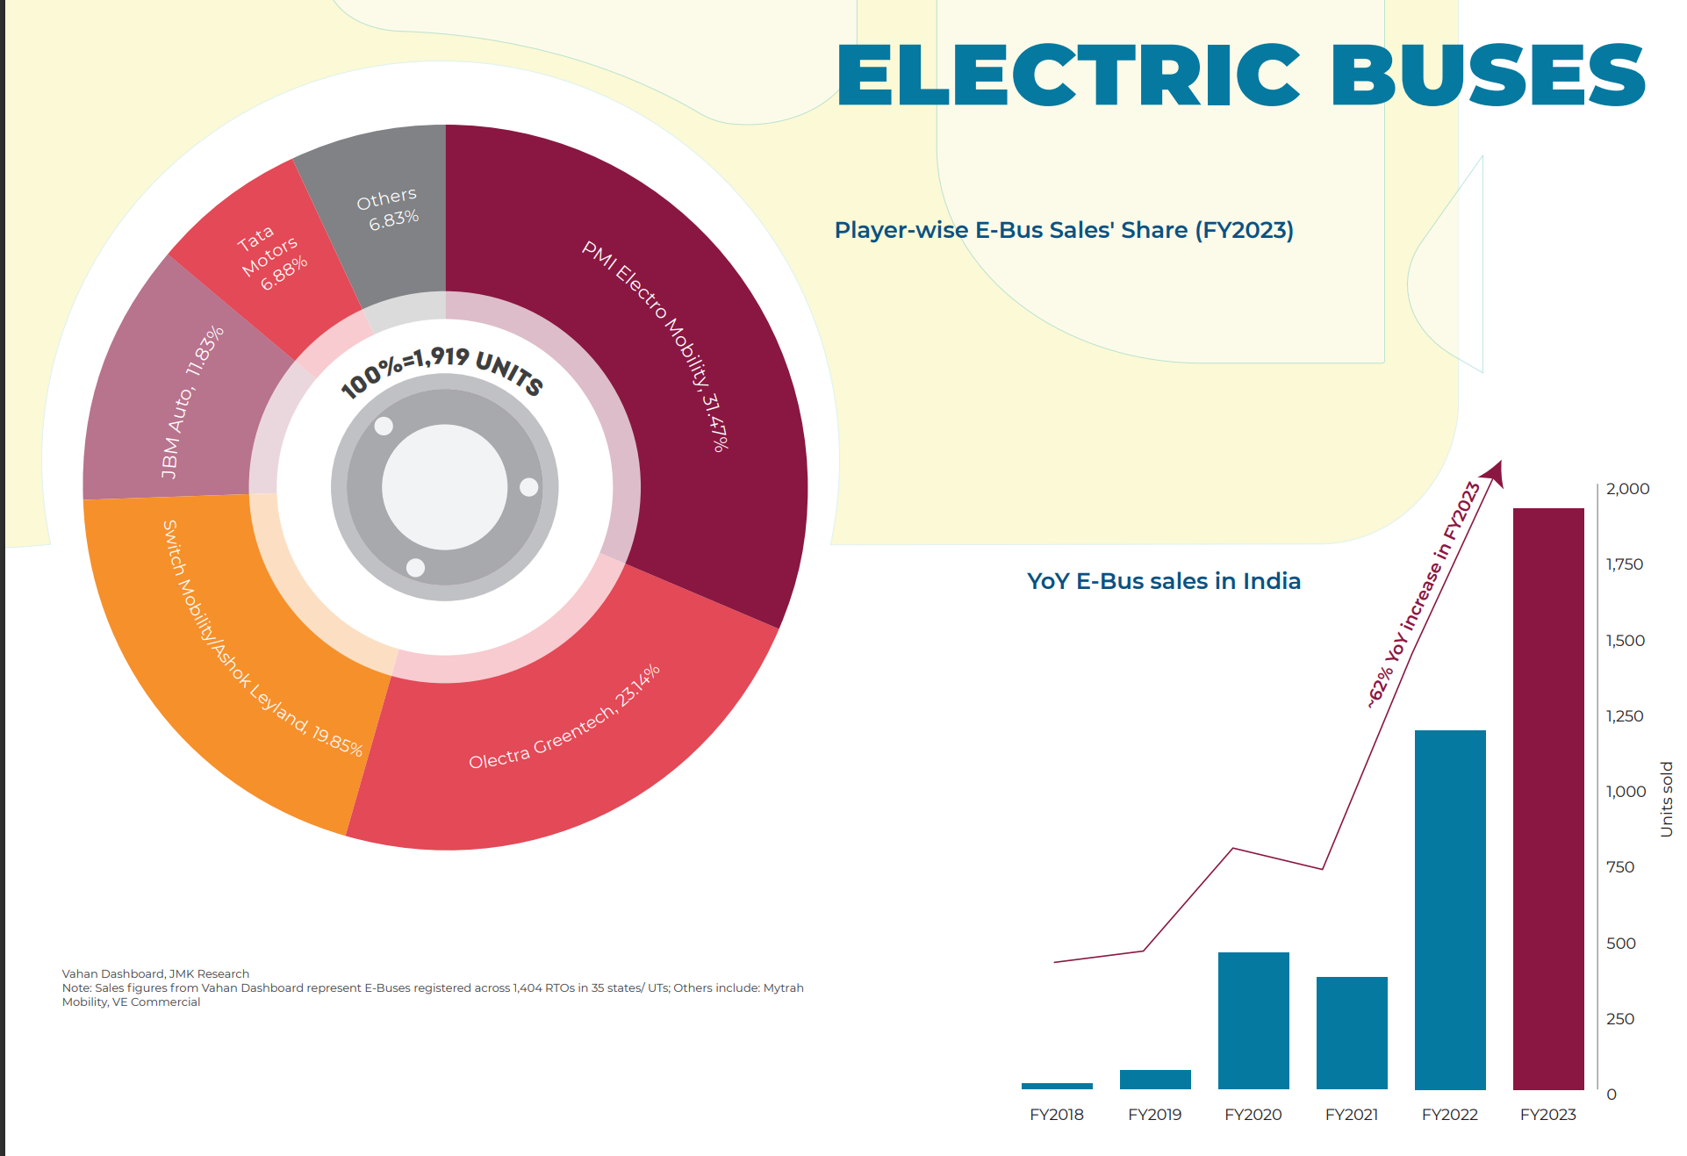

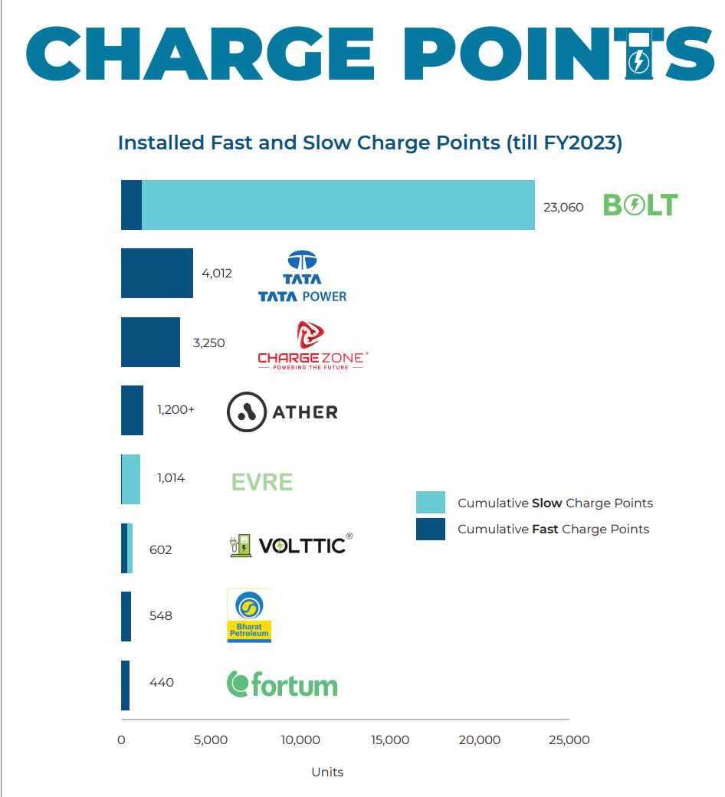

1. Slow charge points include AC001 charge points; Fast charge points include DC001 (30/60 kW)/ AC Level II/CCS (50/60kW), and combo charge points.

2. Tata Power has not shared breakup of charge point numbers into slow and fast ones. Tata Power has an installed network of 4,012 Public, Captive, and Bus Charge points. Excludes 39,000+ Home chargers (for private use).

3. BOLT's charge point count includes public charge points only and excludes private (home) charge points.

**Various factors on which the analysis of the EV Market depend –**

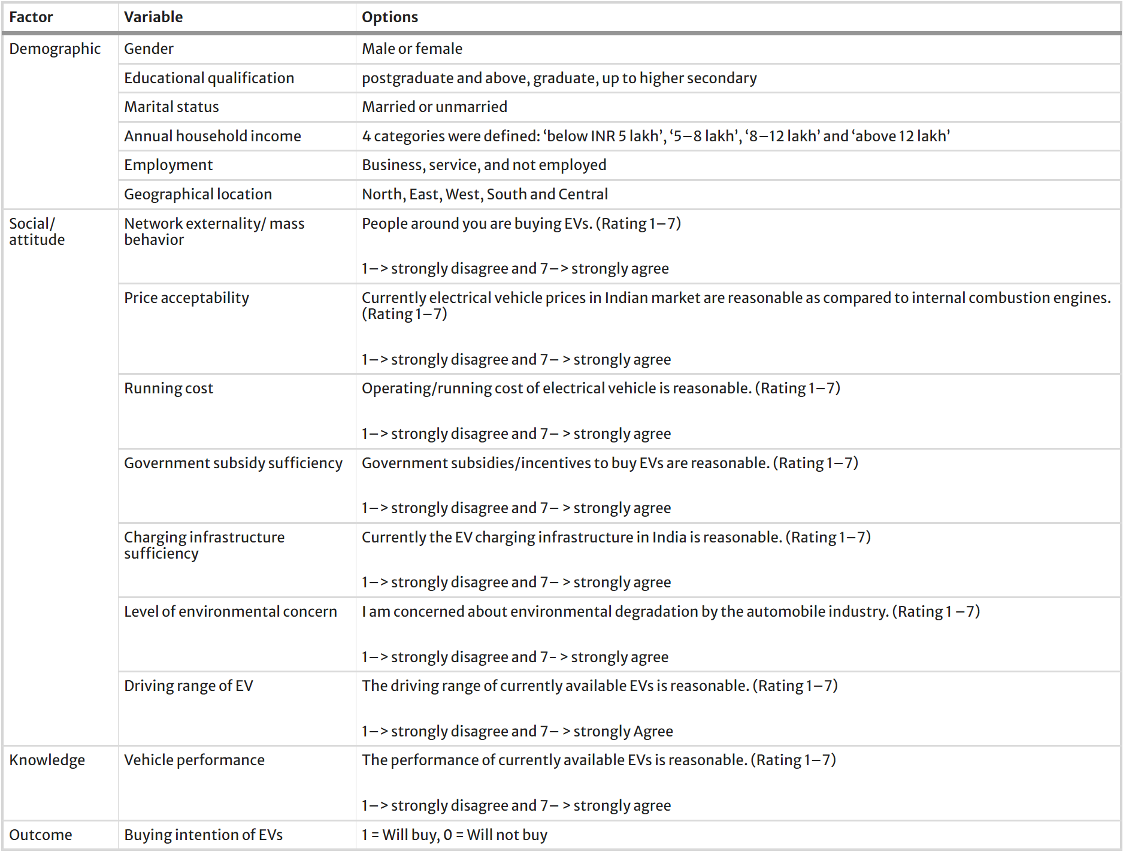

There can be several other factors like vehicle specifications (number of seats, cost of vehicle, servicing cost, etc), depends upon geographical data like location (Location like Bengaluru, Chennai Delhi, Gurugram and other tech cities have higher chance of getting electric cars first), pollution level (Highly polluted locations may adapt to electric vehicles sooner than other regions).

**Code Implementation –**

https://github.com/AmmanChhetri/EV-Market-Segmentation.git

Reference - JMK Research & Analytics

* <https://link.springer.com/article/10.1007/s12626-022-00109-9>
* How electric Car’s work - <https://afdc.energy.gov/vehicles/how-do-all-electric-cars-work>
* https://www.google.com/