Campaign Analysis & Security Awareness Report
Internee.pk Phishing Awareness Simulation
Tool: GoPhish | Controlled Test Environment

3.1 Objective
The objective of Phase 03 is to analyze the results of the controlled phishing-awareness simulation conducted using GoPhish. The analysis focuses on email delivery, opening, link interaction, data submission, and reporting behavior.

3.2 Campaign Results
Metric | Result | Percentage
Emails Sent | 1 | 100%
Emails Opened | 1 | 100%
Links Clicked | 1 | 100%
Data Submitted | 0 | 0%
Emails Reported | 0 | 0%

3.3 Metric Calculations
- Open Rate = 1 / 1 × 100 = 100%
- Click Rate = 1 / 1 × 100 = 100%
- Submission Rate = 0 / 1 × 100 = 0%
- Report Rate = 0 / 1 × 100 = 0%

3.4 Observations
- The simulated email was successfully delivered to the controlled test account.
- The test recipient opened the email.
- The recipient interacted with the simulated training link.
- No password or sensitive information was submitted.
- The test recipient did not report the simulated email during this single-recipient exercise.

3.5 Security Awareness Findings
The controlled exercise demonstrates the importance of recognizing common phishing indicators before interacting with an email or its links.
- Verify unexpected links before opening them.
- Check the sender email address carefully.
- Be cautious with urgent, unusual, or unexpected requests.
- Never enter passwords or other sensitive information through unexpected email links.
- Report suspicious messages to the appropriate security or awareness team.

3.6 Safety and Privacy
- No real credentials were collected.
- No passwords, MFA codes, or OTPs were requested.
- No malware or executable files were distributed.
- No account compromise was attempted.
- The landing page provided security-awareness guidance after the interaction.

3.7 Recommendations
- Use an approved employee or test-user list for future authorized exercises.
- Increase the number of controlled participants when appropriate so that results are more representative.
- Measure reporting behavior in addition to email opening and link-click activity.
- Provide short phishing-awareness training after each simulation.
- Repeat awareness simulations periodically to observe changes in user behavior.

3.8 Evidence Checklist
Evidence 01: GoPhish dashboard
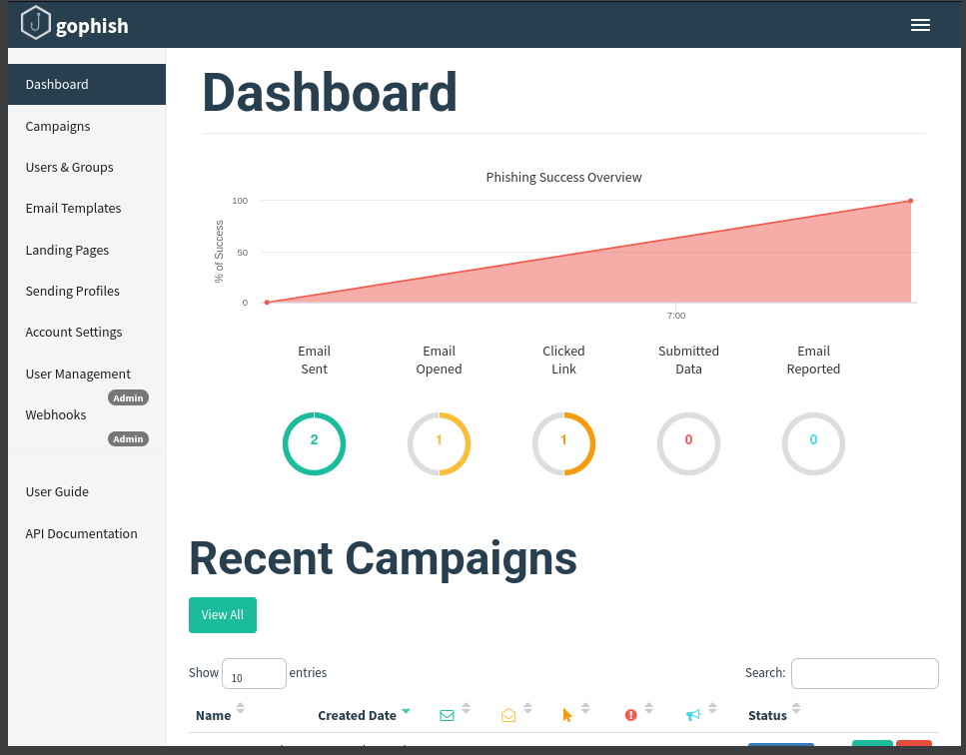
Evidence 02: Users & Groups — Internee-Phishing-Test
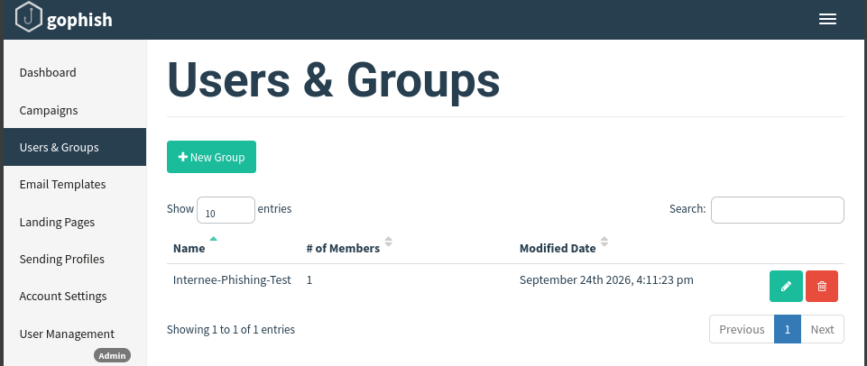
Evidence 03: Email Template — Internee Security Awareness Test
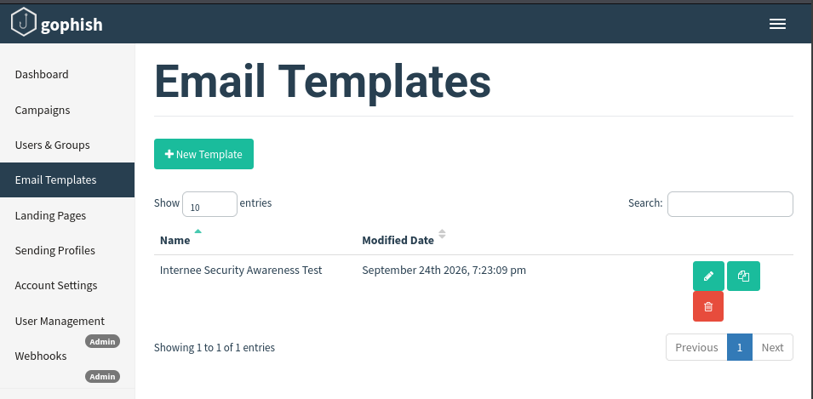
Evidence 04: Landing Page — Internee Security Awareness Training Page
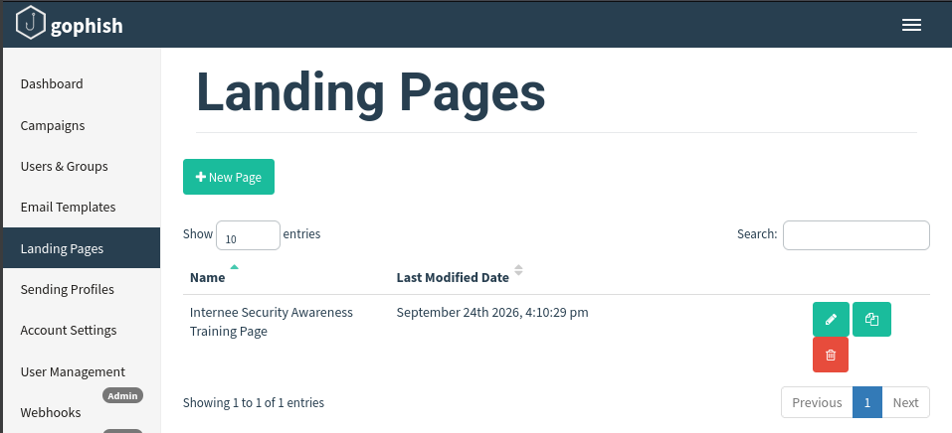
Evidence 05: Sending Profile — Internee Test SMTP
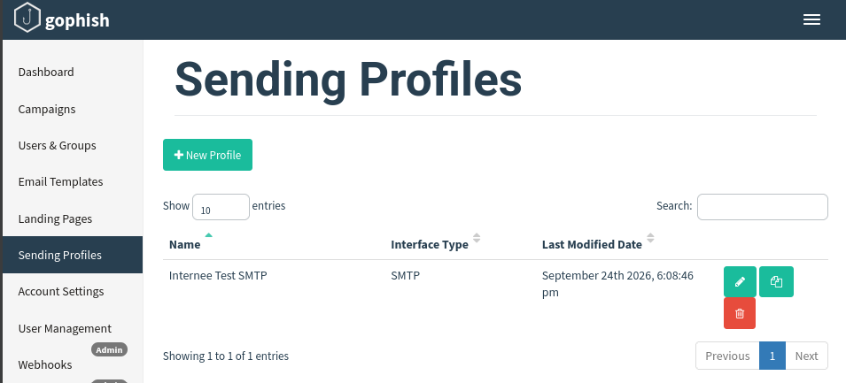
Evidence 06: Send Email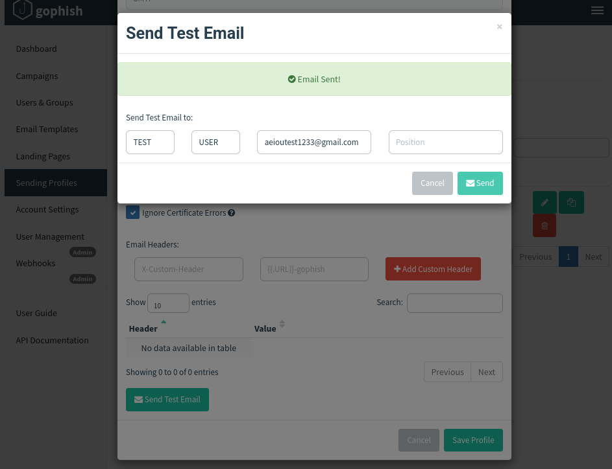

Evidence 07: Final campaign results showing 1 sent, 1 opened, 1 clicked, 0 submitted, and 0 reported
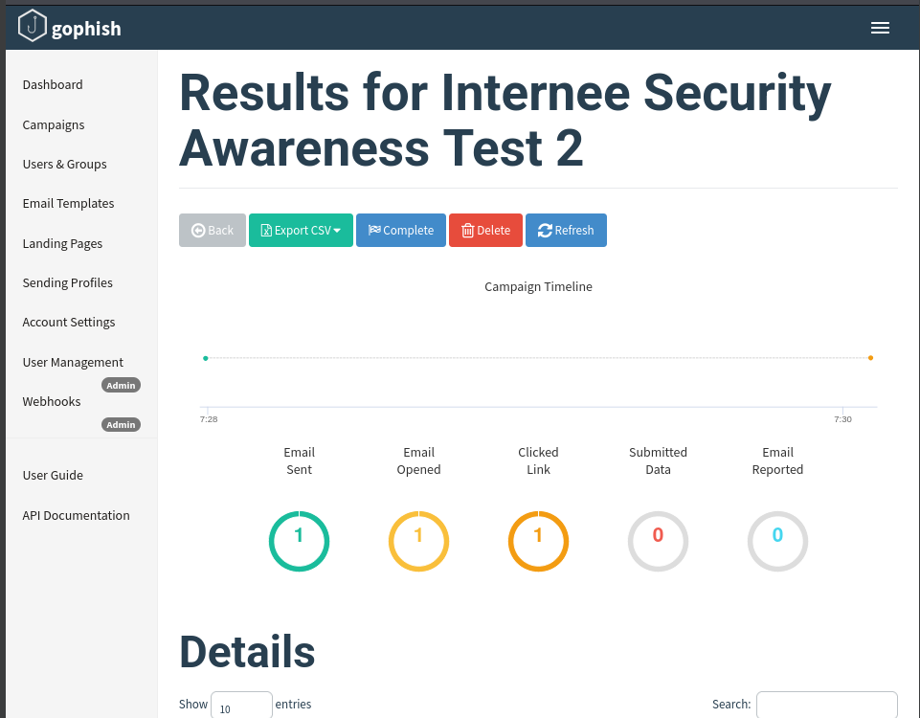

3.9 Result Interpretation
The test showed successful delivery and interaction with the simulated phishing message. The absence of submitted data is important because the exercise was designed as a safe awareness simulation and did not request or collect passwords or other sensitive information. Because only one controlled test account participated, the percentages should not be treated as representative of the entire Internee.pk team.

3.10 Phase 03 Conclusion
I analyzed the controlled phishing-awareness simulation conducted with GoPhish. The test email was delivered and opened, and the simulated training link was clicked. No sensitive information was submitted. The results provide practical evidence of user interaction with a simulated phishing message and can be used to support future security-awareness training.

