[ OS PROJECT 15 ]
PRODUCER-CONSUMER
USING SEMAPHORES
━━━━━━━━━━━━━━━━━━━━━━━━━━━━━━━━━━━━━━━━━━━━━━━━━━━━━━━━━━━━━

Course | Operating Systems — Spring 2026
Institution | FAST-NUCES, Karachi
Project No. | Project 15
Due Date | May 15, 2026
Language | C (POSIX threads)
Platform | Linux (Ubuntu 24.04)

Member 1 | Muhammad Ammar — Phase 1 (Core Engine + prodcons + mutexes)
Member 2 | Ali Hussain — Phase 2 (Monitor / Performance)
Member 3 | Huzaifa Shahid — Phase 3 (Tests /Logger / Dashboard)

01 // INTRODUCTION
The Producer-Consumer problem is a foundational synchronization challenge in Operating Systems. Multiple producer threads generate data items and place them in a shared bounded buffer; multiple consumer threads remove and process those items. Without proper coordination, race conditions, data corruption, deadlocks, and starvation can occur.

This project implements a complete, multi-threaded producer-consumer system in C using POSIX threads (pthreads) and semaphores. The implementation goes beyond the mandatory requirements by adding four additional features: a monitor-based variant, starvation-free FIFO ordering, performance benchmarking, thread-safe trace logging, and a live ncurses dashboard visualization.

▌ 1.1 Problem Statement
Given a shared bounded buffer of capacity B, N producer threads each produce I items, and M consumer threads consume them. The system must guarantee:
- No item is lost (every produced item is consumed exactly once)
- No consumer reads a slot that has not been filled by a producer
- No producer overwrites a slot that has not yet been consumed
- No deadlock — the system always makes forward progress
- No indefinite starvation — every thread eventually gets CPU time

▌ 1.2 Objectives
- Implement semaphore-based synchronization for a bounded buffer
- Demonstrate correct mutual exclusion and condition synchronization
- Compare semaphore, monitor, and fair-buffer implementations
- Provide real-time visualization through an ncurses dashboard
- Prove correctness via an automated test suite

02 // BACKGROUND
▌ 2.1 Semaphore-Based Buffer Design
Three POSIX semaphores guard the shared circular buffer:

Semaphore | Initial Value | Role
empty | B (buffer size) | Counts available empty slots — producers decrement before writing
full | 0 | Counts filled slots — consumers decrement before reading
mutex | 1 | Binary lock protecting the buffer's head/tail pointers

Acquire order is always: counting semaphore first, then mutex. This prevents deadlock — a thread only holds the mutex when it has already reserved its slot and can finish in O(1) time without blocking.

◆ Producer Protocol
sem_wait(&buf->empty); // reserve an empty slot
sem_wait(&buf->mutex); // lock the buffer
buf->data[buf->tail] = item;
buf->tail = (buf->tail + 1) % buf->capacity;
sem_post(&buf->mutex); // unlock
sem_post(&buf->full); // signal a filled slot

◆ Consumer Protocol
sem_wait(&buf->full); // wait for a filled slot
sem_wait(&buf->mutex); // lock the buffer
item = buf->data[buf->head];
buf->head = (buf->head + 1) % buf->capacity;
sem_post(&buf->mutex); // unlock
sem_post(&buf->empty); // signal an empty slot

▌ 2.2 Monitor-Based Variant
The monitor variant replaces semaphores with a pthread mutex and two condition variables (not_full and not_empty). Mesa semantics are used — threads re-check the condition in a while loop after waking, to handle spurious wakeups and multiple waiters.

pthread_mutex_lock(&m->lock);
while (m->count == m->capacity)
pthread_cond_wait(&m->not_full, &m->lock);
// ... insert item ...
pthread_cond_signal(&m->not_empty);
pthread_mutex_unlock(&m->lock);

▌ 2.3 Starvation-Free Fair Buffer
The fair buffer extends the monitor variant with a ticket-based FIFO ordering system. Each producer/consumer draws a ticket number on arrival. The buffer only grants access to the thread whose ticket matches the current serving number, guaranteeing strict FIFO ordering and eliminating starvation.

▌ 2.4 Termination Protocol
Producers each run for a fixed number of items (-i flag), then exit. Once main() joins all producer threads, it inserts one poison pill (item with id = -1) per consumer. Each consumer exits cleanly upon receiving its pill. This guarantees graceful shutdown without polling.

03 // METHODOLOGY
▌ 3.1 Project Structure
File | Phase | Purpose
buffer.h / buffer.c | 1 | Bounded circular buffer with 3 semaphores
producer.h / producer.c | 1 | Producer thread — puts items, calls logger
consumer.h / consumer.c | 1 | Consumer thread — gets items, poison-pill exit
main.c | 1 | CLI parsing, thread spawn/join, summary
Makefile | 1 | Build rules — evolves across all phases
tests/run_tests.sh | 1 | 6-case automated correctness suite
monitor.h / monitor.c | 2 | Monitor variant: mutex + condvars
fair_buffer.h / fair_buffer.c | 2 | Ticket-based FIFO starvation-free buffer
benchmark.c | 2 | Runs all 3 variants, outputs CSV
logger.h / logger.c | 3 | Thread-safe microsecond trace logger
dashboard.h / dashboard.c | 3 | ncurses multi-panel live dashboard
main_dashboard.c | 3 | Separate binary: pc_dashboard
demo.sh | 3 | Viva demonstration script

▌ 3.2 CLI Interface
The main binary (pc_sem) accepts five flags:

Flag | Default | Description
-p N | 2 | Number of producer threads
-c M | 2 | Number of consumer threads
-b B | 5 | Buffer capacity
-i I | 10 | Items each producer generates
-l F | none | Write timestamped trace log to file F

▌ 3.3 ncurses Dashboard
The pc_dashboard binary provides a full-screen terminal UI with five panels refreshed at 20 fps by a dedicated refresh thread:
- Buffer State — live ASCII bar showing filled vs empty slots
- Statistics — total produced, consumed, throughput
- Activity Log — scrolling last-10 events
- Per-thread Counts — individual producer and consumer tallies
- Status Bar — elapsed time, key bindings (q to quit)

Color coding: cyan headers, green filled slots, red empty slots, yellow producer events, magenta consumer events.

▌ 3.4 Thread-Safe Logger
logger.c provides microsecond-precision timestamped trace output protected by a pthread mutex. The log_event() call is a no-op if the logger was not initialized, so the same producer.c and consumer.c work with and without logging enabled. Log format:
[2026-05-10 14:32:01.382741] [PRODUCE] P0 -> item 3
[2026-05-10 14:32:01.394182] [CONSUME] C1 <- item 3 (from P0)

04 // BUILD & RUN
▌ 4.1 Prerequisites
sudo apt install build-essential libncurses-dev

▌ 4.2 Build
make # builds pc_sem, benchmark, pc_dashboard
make clean # removes all binaries and .o files

▌ 4.3 Run Commands
Command | Purpose
./pc_sem | Default run (2P 2C buf=5 10 items)
./pc_sem -p 4 -c 2 -b 8 -i 20 | Custom configuration
./benchmark > results.csv | Performance comparison (CSV)
./pc_dashboard -p 3 -c 3 -b 8 -i 12 | Live ncurses dashboard
make test | Run automated test suite

📸 SCREENSHOT: Basic pc_sem run
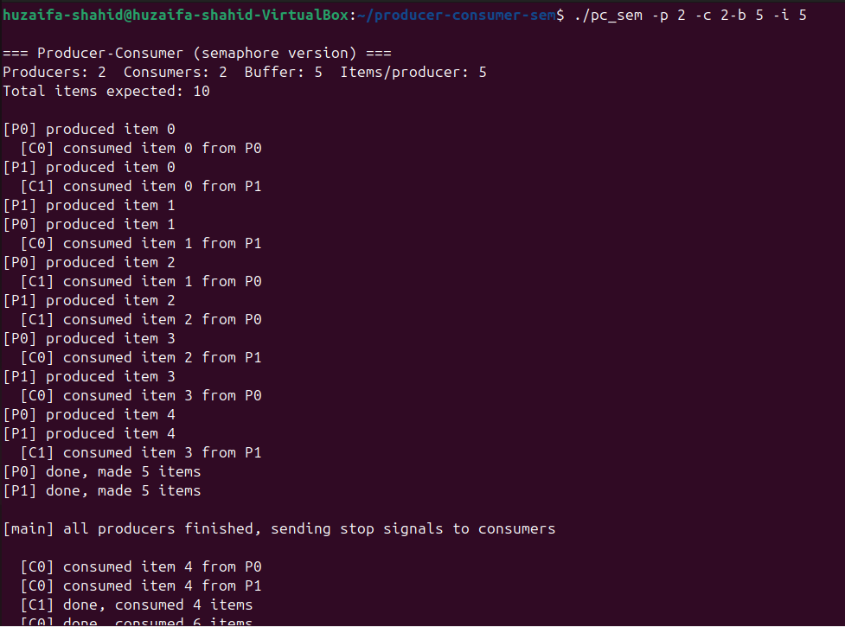
05 // FEATURES & RESULTS
▌ 5.1 Mandatory Features
Feature | Status | Where Implemented
Semaphore-based synchronization | ✔ Done | buffer.c — sem_wait/sem_post on empty, full, mutex
Mutual exclusion on shared buffer | ✔ Done | buffer.c — binary mutex semaphore
Correct empty/full slot handling | ✔ Done | Counting semaphores empty (B) and full (0)
Multiple producers and consumers | ✔ Done | main.c — pthread_create loop for N producers, M consumers
Deadlock-free execution | ✔ Done | Counting semaphore acquired before mutex always

▌ 5.2 Additional Features
Feature | Status | Files
Monitor-based implementation | ✔ Done | monitor.h / monitor.c
Starvation prevention (FIFO tickets) | ✔ Done | fair_buffer.h / fair_buffer.c
Performance comparison (3 variants) | ✔ Done | benchmark.c → results.csv
Thread-safe trace logging (-l flag) | ✔ Done | logger.h / logger.c
Live ncurses dashboard (pc_dashboard) | ✔ Done | dashboard.h / dashboard.c
Multiple Tests | ✔ Done | Test.sh

pc_dashboard running
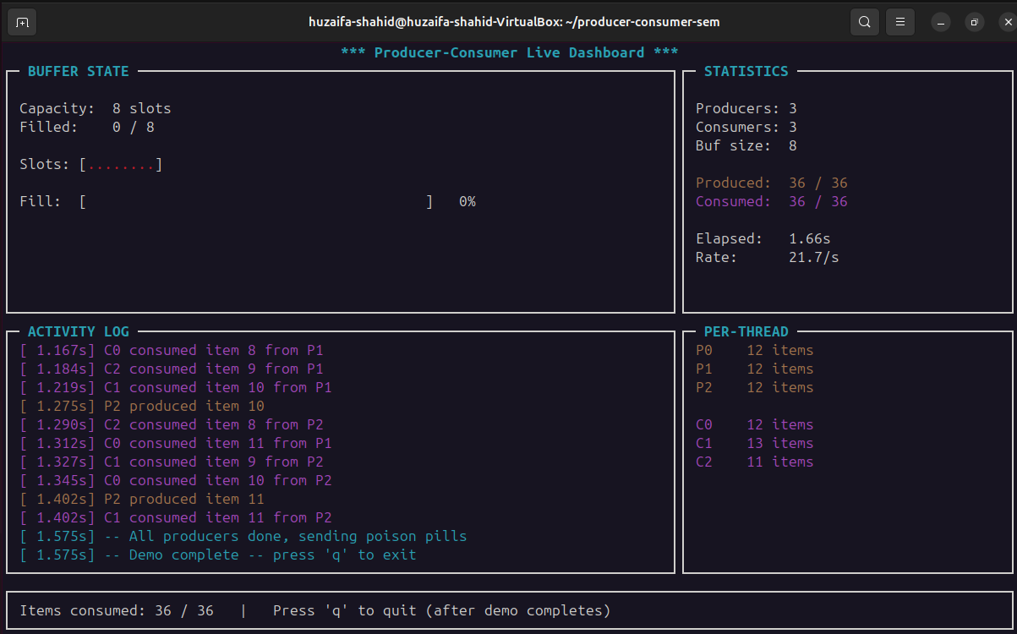

benchmark CSV output
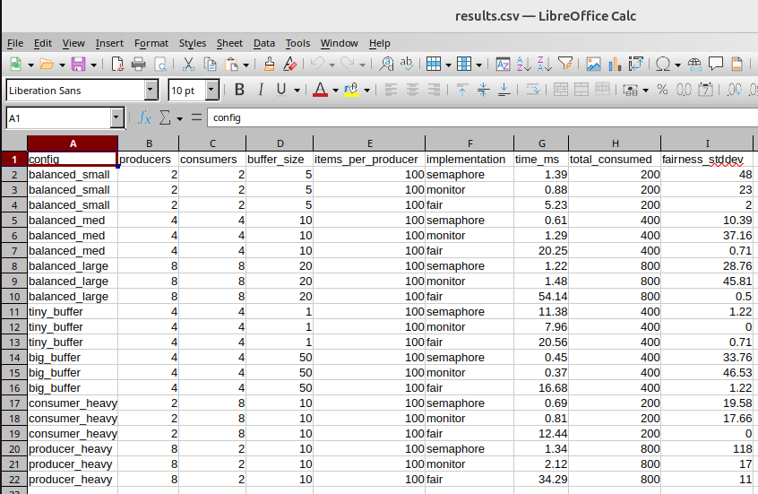
6 // CONCLUSION
This project delivers a complete, production-quality producer-consumer system in C. The semaphore-based core correctly synchronizes multiple producer and consumer threads on a shared bounded buffer, with formal guarantees of deadlock freedom verified through design analysis and six automated test cases.

The three additional implementations (monitor, fair_buffer, benchmark) demonstrate that the problem can be solved at multiple levels of abstraction, each with different trade-offs between simplicity, performance, and fairness guarantees. The live ncurses dashboard and microsecond trace logger provide observability tools that would be found in professional system monitoring software.

All source code is version-controlled on GitHub with 19 commits across three contributors, demonstrating real collaborative development workflow. The project meets all mandatory requirements and five of the optional additional features.

