**My dream computer**

*I dream of owning a computer that can meet my needs and wishes. I would love to own a superb computer that will enable me to have a smooth experience in my study and playing games*

* The computer parts are :

* **Hard drive**
* **SSD drive**
* **CPU**
* **Memory**
* **GPU**
* **Motherboard**
* **CASE**
* **MONITOR**

Hard drive :

**WD hard drive 8TB**

**It’s really good hard drive**

***WD******Purple****3.5"" SATA****6Gb/s 8TB****5400rpm .*

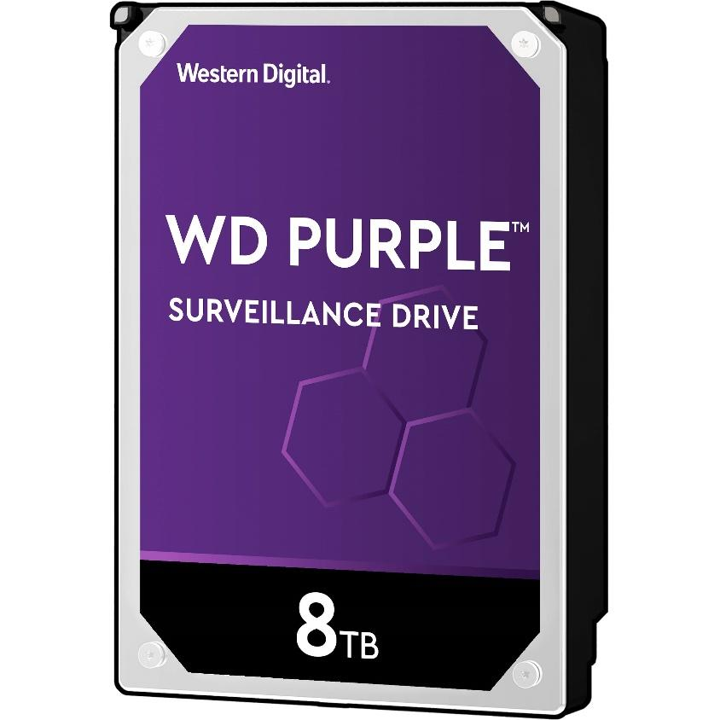

SSD drive :

**My solid state drive, type M.2**

**AORUS Gen4 SSD 1TB**

* Interface: PCI-Express 4.0 x4, NVMe 1.3
* Total Capacity: 1000GB*
* Sequential Read Speed : up to 5000 MB/sec
* Sequential Write speed : up to 4400 MB/sec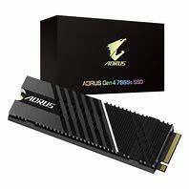

**CPU :**

**My CPU, type intel**

**I 9 13900k**

24 cores and 32 threads.

The base clock frequency of the CPU is 3000 MHz,

but due to Turbo Boost technology, it can perform up to 5400 MHz.

The size of the L3 cache is 36 MB.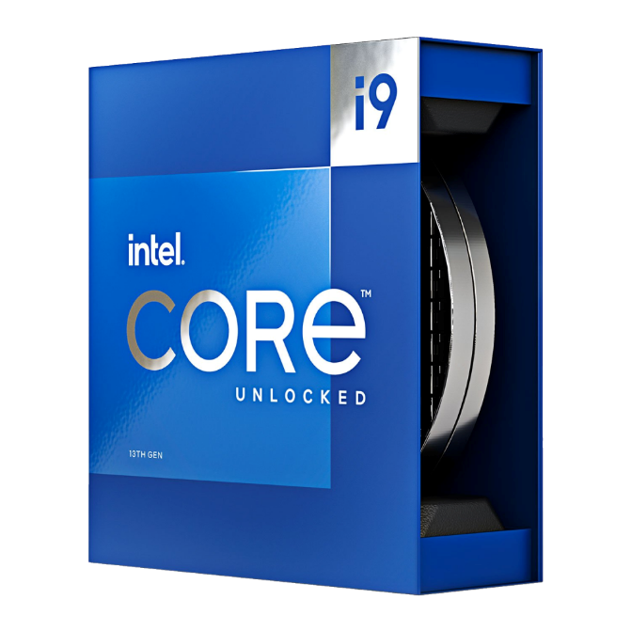

**Memory :**

**Corsair VENGEANCE RGB DDR5 64GB**

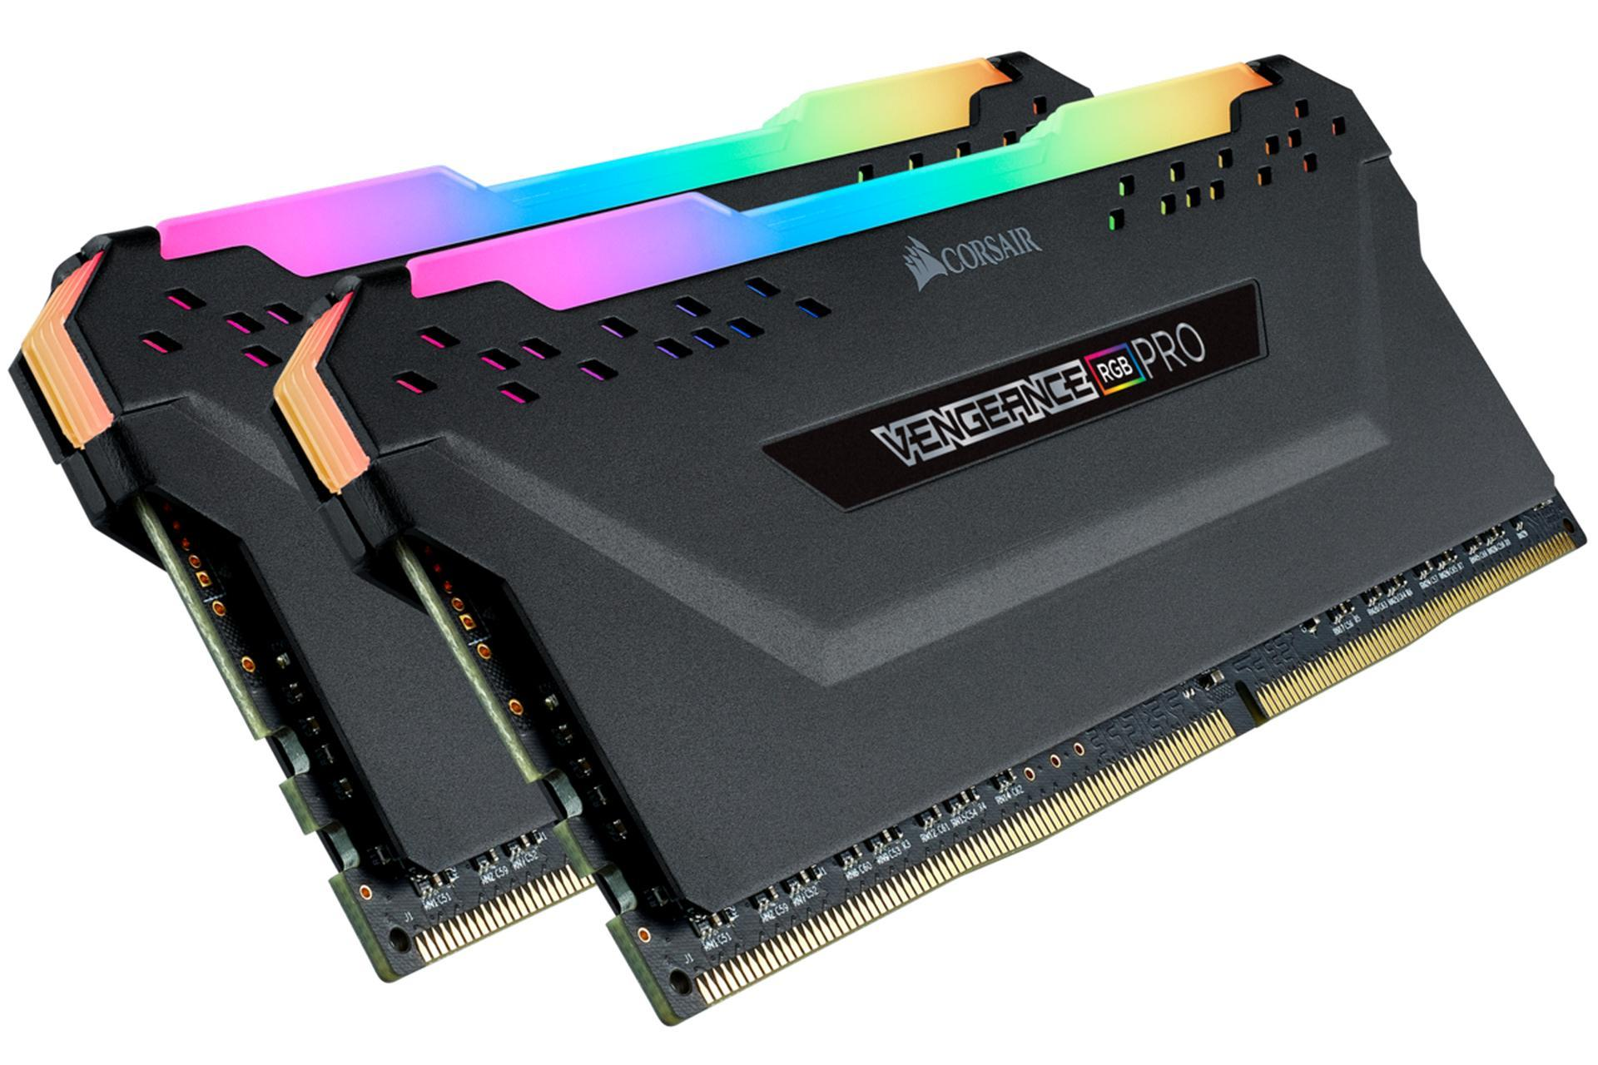

**GPU :**

**RTX 4080 16GB**

The RTX 4080 is a high-end graphics card from Nvidia that is expected to use the AD103 GPU and 16GB of GDDR6X memory. It will have**9,728 CUDA cores** and a boost clock of around 2.5 GHz. The memory bus will be 256-bit and the memory bandwidth will be 736 GB/s . The TDP will be 320W. There will not be a 12GB model as previously rumored. There might be a new Titan card with 24 Gbps GDDR6X and 48GB of VRAM.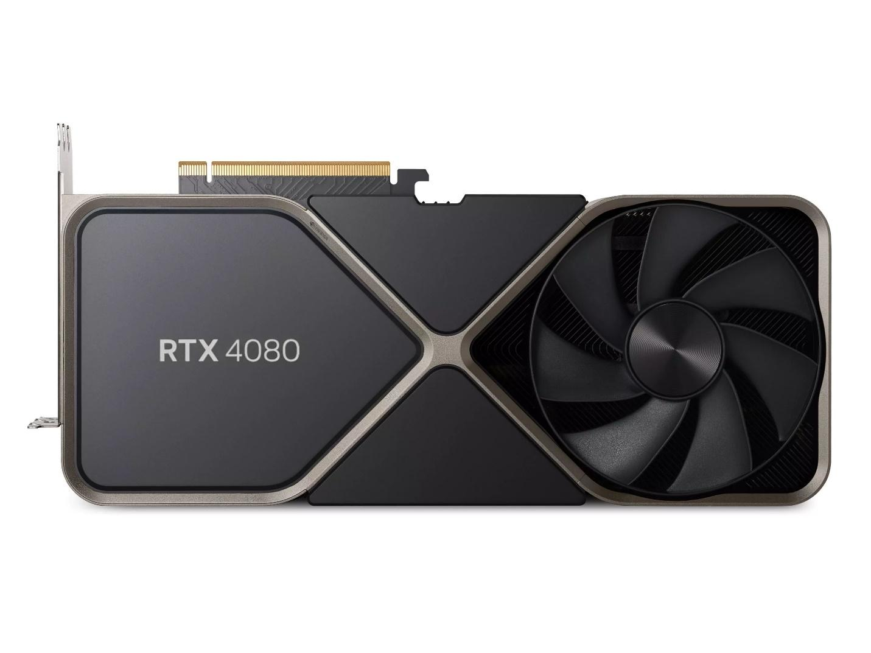

**Motherboard :**

**Z690 AORUS MASTER**

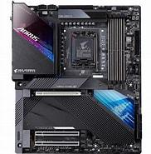

**CASE :**

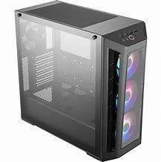

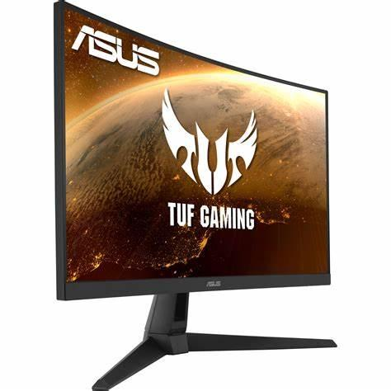

**MONITOR :**

BUNDLES

