Question 1:

1. select name from client_master;

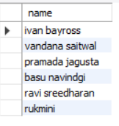

1. select * from client_master;

1. select name,city from client_master;

1. select description from product__master;

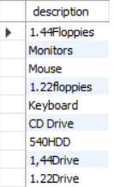

1. select name from client_master where city="bombay";

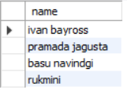

1. select salesman_name from sales_master where sal_amt=3000;

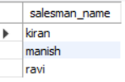

Question 2:

1. update client_master set city="bombay" where client_no="C00005”;

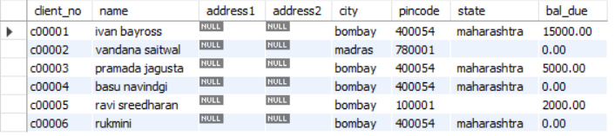

1. update client_master set bal_due=1000 where client_no ="C00001";

1. update product__master set cost_price = 950.00 where description="1.22Floppies";

1. update sales_master set city="Mumbai";

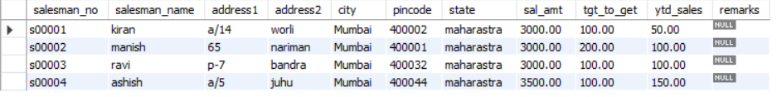

Question 3:

1. delete from sales_master where sal_amt=3500;

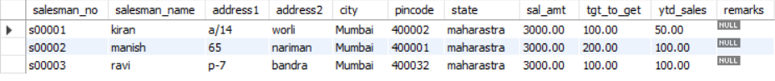

1. delete from product__master where Qty_on_hand=100;

1. delete from client_master where state="tamil nadu";



Question 4:

1. alter table client_master add(telephone numeric(10));

1. alter table product__master modify sell_price numeric(10,2);

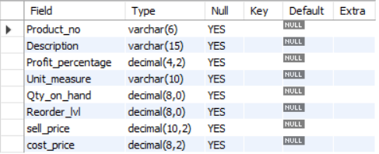

Question 5:

1. drop table client_master;
2. alter table sales_master rename to sman_mast;

