Lab 3 — Requirements in Linear
Name: Ammar Mohamed Fathy
Student ID: 1620240474
Application: Facebook (feature: React to a post)
Linear project: https://linear.app/ammar-mohamed74/project/1620240474-facebook-post-workflow-e42ada21eea2/overview
Lab 3 Specification (Linear document): https://linear.app/ammar-mohamed74/document/lab-3-specification-35c3de2473b3
Implementation issue: AMM-32 — https://linear.app/ammar-mohamed74/issue/AMM-32/build-the-reaction-action
Test issue: AMM-33 — https://linear.app/ammar-mohamed74/issue/AMM-33/run-the-reaction-tests

Lab 3 Specification

1. Feature and WRSPM
The feature is React to a post: a user attaches one reaction to a published Facebook post, changes it, or removes it, and the post shows how many reactions it has. It extends Lab 2 (project: 1620240474 Facebook Post Workflow) and continues its numbering (R1, R2, Q1 exist already).
Actors: User (the person reacting, one of the sample users); Application Server (applies the rules and stores data).
In scope: reacting to a Published post, removing a reaction, showing counts per reaction type. Out of scope: notifications, reactions on comments, custom emoji, showing who reacted, real accounts.
Key terms
Term | Meaning in this specification
Published post | A post whose status is Published (Lab 2 state diagram). Rejected and Draft posts are not Published.
Reaction type | One of exactly three values: Like, Love, Haha.
Reaction | One stored record (postId, userId, reactionType). A user has zero or one Reaction per post.
Reaction count | The number of stored Reactions of one type on one post.
Select | The user clicks a reaction button on a post.

W: World assumptions
ID | Assumption | Who can confirm | What fails if false
W1 | Users expect that selecting the reaction they already hold removes it, as in the real Facebook behavior observed in Lab 1. | TA or peer tester, by comparing with the real application. | Users read the removal as a bug and re-click, so counts look unstable and S3 does not match what users want.
W2 | The sample-user selector identifies the acting user correctly on every request. | Project owner (me), checked in the test environment. | One reaction per user per post cannot be enforced; counts are wrong and S1 to S3 cannot be tested.

R: Requirement
R3: A user can express exactly one reaction to a published post and see the post's reaction counts match what users have chosen.
Source: Lab 1 Workflow 2 (approved scope). The stakeholder need is a class assumption: I act as product owner, with the TA as the reviewing stakeholder.

S: Specification
- S1 (success). When a user selects reaction type T on a Published post, if the user has no stored Reaction on that post, the system must store one Reaction (postId, userId, T) and show the count of T on that post increased by 1.
- S2 (refusal). When a user selects a reaction type on a post, if the post does not exist or is not Published, the system must store no Reaction, leave all counts unchanged, and show the message "Post is not available".
- S3 (repeated request). When a user selects reaction type T on a post, if the user already holds a Reaction of type T on that post, the system must delete that Reaction and show the count of T decreased by 1.
The case "user holds type X and selects a different type Y" is not covered by S1 to S3; it is recorded as open decision OD1 in section 4.

P and M: Program and machine
- Program (P): a Reaction Service component inside the Application Server from the Lab 2 system sketch. It checks the post, reads the user's existing Reaction, then stores or deletes it and returns the new counts.
- Machine (M): the course/local test environment on my laptop, running the Application Server with the Stored Data component. Programming language, framework, and database are undecided.
- How S and W support R: S1 makes a new choice appear in the count, S3 lets the user withdraw it, and S2 stops reactions on posts that are not visible. With W2, every Reaction belongs to one known user, so a user never has more than one Reaction per post by S1 and S3. With W1, users understand the removal in S3, so what they see matches what they chose, which is R3. The different-type case stays open (OD1), so R3's "exactly one reaction" is fully met only once OD1 is decided.

2. Clear and testable rules
Every rule in S1 to S3 follows "When [event], if [condition], the system must [observable response]" and carries one obligation. Each response is something a tester can see on screen or read in stored data.
Exact states and wording
Vague wording avoided | Exact replacement
"valid post" | A post with status Published.
"update the count" | The number shown next to reaction type T changes by exactly 1 in the same screen, without a page reload.
"error message" | The exact text "Post is not available".
"one reaction" | At most one stored Reaction per (postId, userId) pair.
"fast" | See Q2.

Q2 (measurable quality target). With sample data and 20 concurrent sample users in the course test environment, each selecting a reaction on a different Published post once, 95% of select requests finish within 1 second. Finished means the Reaction is stored and the new count is displayed. Test data: 20 sample users, 20 Published sample posts, 0 existing reactions at the start.
Bad draft, correction, and reason
 | Text
Bad draft | "Reactions must work properly and update fast when a user clicks twice."
Correction | S3: "When a user selects reaction type T on a post, if the user already holds a Reaction of type T on that post, the system must delete that Reaction and show the count of T decreased by 1." Speed moved to Q2 (95% within 1 second).
Reason | "Properly", "fast", and "clicks twice" gave no expected result; the correction names the event, the exact condition, one observable response, and a number a tester can measure.

3. Work connected to the specification
Two new Linear issues carry the feature into work. Both link to the "Lab 3 Specification" document and cite S rule IDs. In Linear they are AMM-32 and AMM-33.
 | Implementation issue | Test issue
Title | Build the reaction action | Run the reaction tests
Linear ID | AMM-32 | AMM-33
Lifecycle / Status | Implementation / Todo | Testing / Todo
Owner | Ammar Mohamed Fathy | Ammar Mohamed Fathy
Cites | S1, S2, S3, Q2; requirement R3 | S1, S2, S3, Q2; requirement R3
Blocked by | AMM-6 (design, Done) and AMM-7 (create-post, so Published posts exist) | AMM-32
Related to | AMM-5, Lab 3 Specification | AMM-9, Lab 3 Specification

Acceptance criteria (in AMM-32)
- AC1 (S1): Given a Published post and a user with no Reaction on it, when the user selects Like, then one Reaction (postId, userId, Like) is stored and the Like count shows 1 more than before.
- AC2 (S2): Given a post that does not exist or is not Published, when the user selects any reaction, then no Reaction is stored, no count changes, and the message "Post is not available" is shown.
- AC3 (S3): Given a user who holds Like on a post, when the user selects Like again, then that Reaction is deleted and the Like count shows 1 less than before.

Test cases (in AMM-33)
Test | Covers | Input data | Steps | Expected result | Result
T4 | AC1 / S1 | Sample user Ali; Published post P1 with Like count 0 and no reaction from Ali | 1. Choose Ali as current user. 2. Open P1. 3. Select Like. 4. Repeat steps 1 to 3 on fresh posts for Love and Haha. | One Reaction (P1, Ali, Like) is stored; P1 shows Like count 1. The same holds for Love and Haha on their own posts. | Not run
T5 | AC2 / S2 | Sample user Ali; (a) post ID that does not exist; (b) post P2 with status Rejected | 1. Choose Ali. 2. Send a Like request for (a). 3. Repeat for (b). | For both: no Reaction stored, counts unchanged, message "Post is not available". | Not run
T6 | AC3 / S3 | Sample user Ali holding Like on P1 (Like count 1) | 1. Choose Ali. 2. Open P1. 3. Select Like again. | The Reaction is deleted; P1 shows Like count 0. | Not run
T7 | Q2 | 20 sample users, 20 Published posts, 0 reactions | 1. Each user selects Like on a different post at the same time. 2. Record the time until the count is displayed. | At least 19 of 20 requests (95%) finish within 1 second. | Not run

Real dependencies
- AMM-32 is blocked by AMM-6 (design) and AMM-7 (create post). Reactions cannot be built or tried without Published posts.
- AMM-33 is blocked by AMM-32. Tests need the working action.
- AMM-9 (Lab 2 tests) stays separate: it covers R1, R2, Q1, while AMM-33 covers R3, Q2.
- AMM-32 and AMM-33 stay open (Todo) until the work is done and the tests are actually run.

4. Review and revision
Saif Ali reviewed the specification and added a comment in Linear on AMM-32.
Field | Entry
Reviewer | Saif Ali, 15/10/2026
Review comment in Linear | Missing case: S1 allows Like, Love, and Haha, but T4 only tests Like, so Love and Haha are never checked. Comment recorded in AMM-32 (Linear).
Change made to the specification | T4 now repeats the success test for Like, Love, and Haha.
Reason | S1 covers every reaction type, so an untested type could fail without anyone noticing.
Reply posted in Linear | Yes, reply recorded in AMM-32.

Open decisions
ID | Decision | Owner | Review date
OD1 | When a user holds type X and selects a different type Y, should the system replace X with Y (the Lab 1 behavior) and add a rule S4? Candidate S4: "When a user selects reaction type Y on a Published post, if the user holds a Reaction of a different type X, the system must replace X with Y and show the count of X decreased by 1 and the count of Y increased by 1." | Ammar Mohamed Fathy | 2026-10-22 (proposed)
OD2 | Which programming language, framework, and database store the reactions (P and M are undecided). | Ammar Mohamed Fathy | 2026-10-22 (proposed)

Status
AMM-32 and AMM-33 remain open. All test results are Not run until the tests are actually executed.

Linear Evidence (Screenshots)
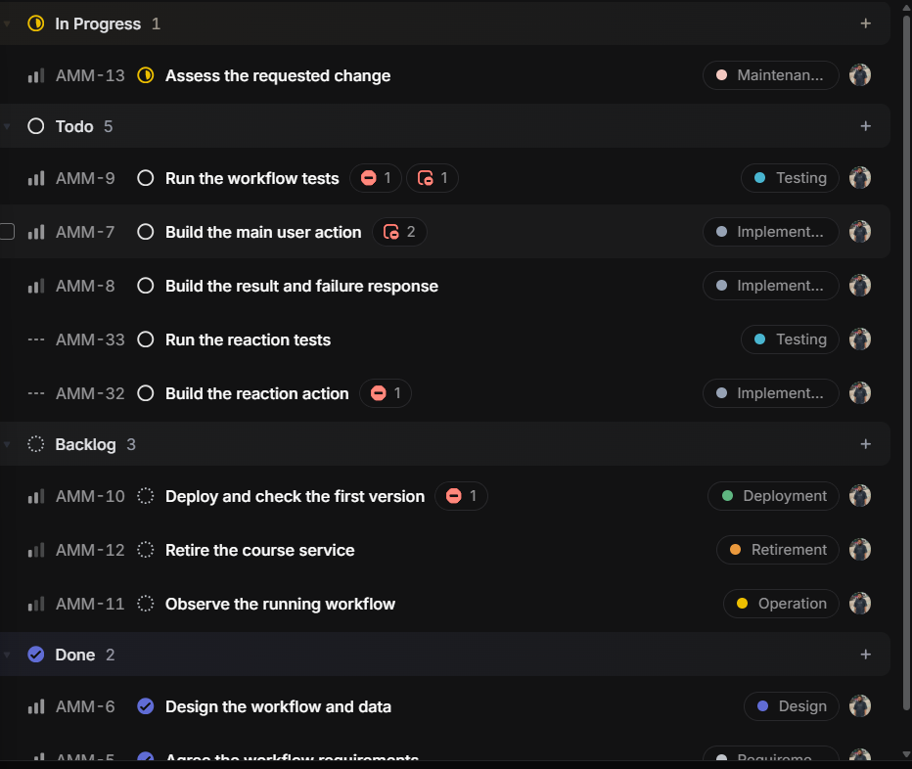
Screenshot 1 — Project board: AMM-32 and AMM-33 in Todo
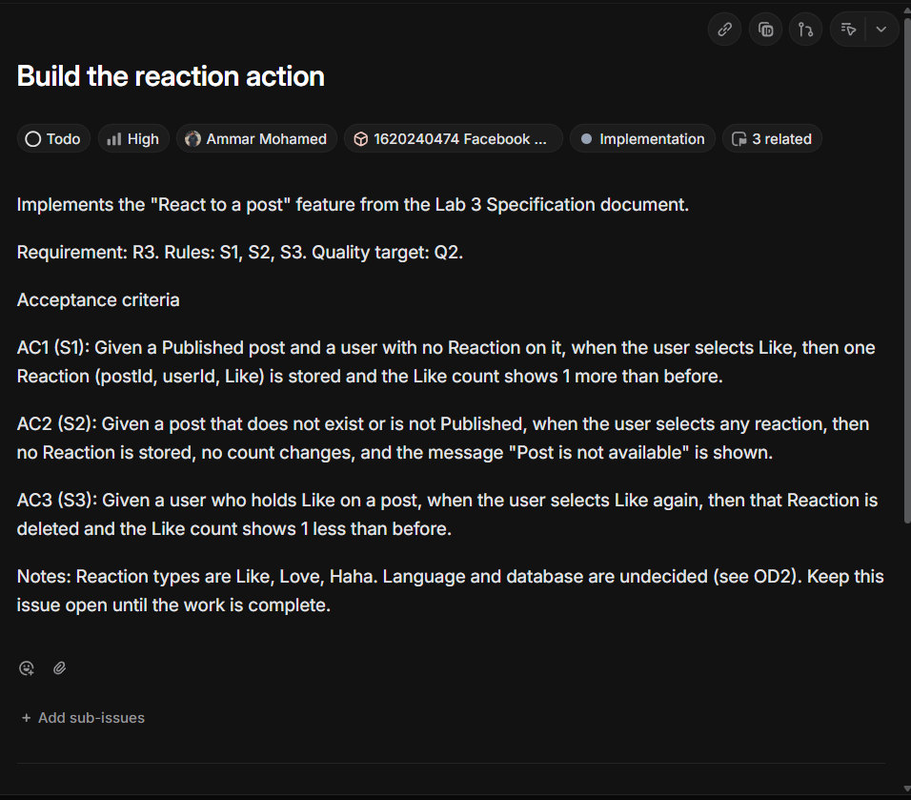
Screenshot 2 — AMM-32: implementation issue with acceptance criteria AC1–AC3
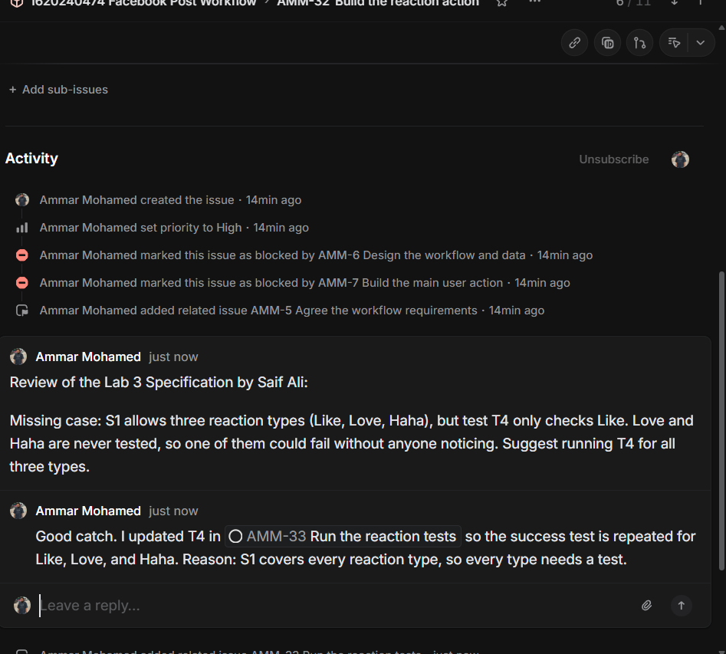
Screenshot 3 — AMM-32: dependencies (blocked by AMM-6, AMM-7; related AMM-5), review comment and reply
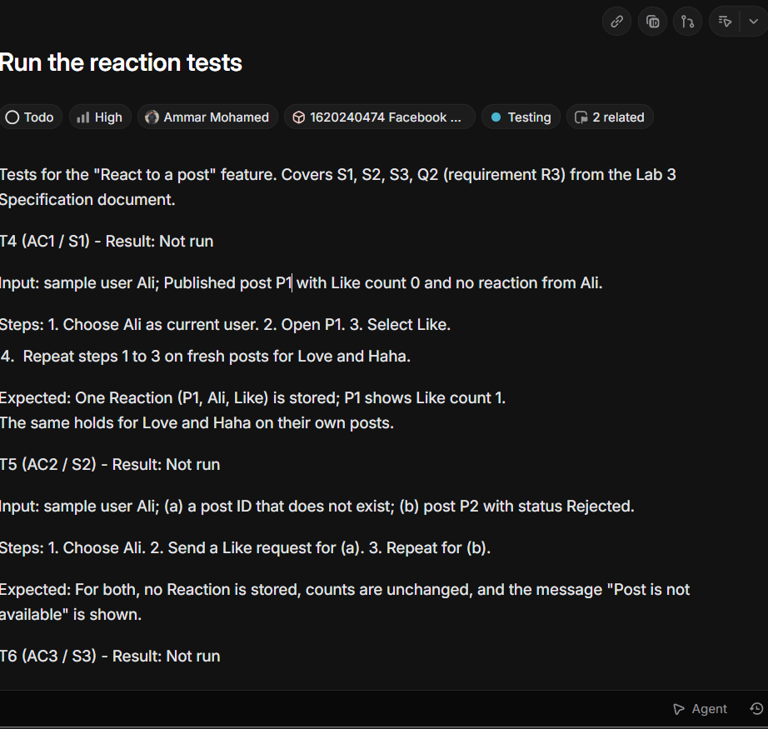
Screenshot 4 — AMM-33: test issue with T4–T7, Result: Not run

