

Foresight

Learning Website

**Presented by**

**Haitham Hashem Al-Shalabi: 31801001132**

**Abdullah Waleed Awad: 31801001026**

**Ammar Khalid Abd-Alqader: 31801001033**

**Supervisor: Dr. Hamzah Al-Dabbas**

Submitted in Partial Fulfillment of the Requirements for bachelor's degree in computer science

**Prince Abdullah Bin Ghazi Faculty of Information technology**

**Al-Balqa' Applied University Salt- Jordan**

**01/06/2022**

**ACKNOWLEDGMENT**

In The Beginning, we would like to thank the Dean of the College of Prince Abdullah bin Ghazi ***Dr. Khalaf Khtattenh*** , Deputy Dean ***Dr. Abdalaziz Al-Hammouri*** and all teaching staff there.

And finally, our thanks and appreciation to ***Dr.Hamzah Al******Dabbas ,***

project supervisor,

who gave us a hand to build our project systematically until it finished.

**DECLARATION**

**I hereby certify that this material, which I now submit for assessment on the program of study leading to the award of Bachelor of Science in *(Computer Science )* is entirely my own work, that I have exercised reasonable care to ensure that the work is original, and does not to the best of my knowledge breach any law of copyright, and has not been taken from the work of others save and to the extent that such work has been cited and acknowledged within the text of my work.**

**Signed: Haitham Hashem Al-Shalabi, Abdullah Waleed Awad, Ammar Khalid Abd-Alqader**

**Student No.: 31801001132, 31801001026, 31801001033**

**Date: 01-06-2022.**

**Abstract**

In these times, you can access any piece of information you want, and you can do it very fast. Due to the wide spread of fast internet and the huge number of websites and apps you can easily pick whatever you want from wherever you want. The only problem here is the info you often find is incomplete, wrong or simply is not valid anymore (outdated).

Therefore, in this project, we will talk about a website programmed to make it easier for students and users to access the latest content in various branches of any subject you are looking for like the latest technologies in programming, latest trends in improving your health and the mathematics section. Our vision is to make sure we deliver complete and valid information for our users. Many means will also be used that enhance user experience by providing a discussion sector where users can post the problems and the community will provide the answers. In the feature we can add a whole section dedicated entirely to BAU students where they can find their lectures recorded and uploaded for them to access anytime.

**TABLE OF CONTENTS**

# LIST OF FIGURES 8

# LIST OF TABLES 9

# LIST OF ACRONYMS/ABBREVIATIONS 9

1. **CHAPTER.1 INTRODUCTION 10**

# Introduction 11

1. **CHAPTER.2 PLANNING PHASE 13**

# Introduction to planning phase 14

# Business profile 16

# Foresight Mission 16

# Foresight Vision 16

# Foresight Core Values 16

# Foresight Services 17

# Current system description 19

# Scope of the system 20

# System Requirement 20

# Functional Requirements 21

# Non-Functional Requirements 22

# Technical limitation 22

# Economic constraints 23

# Shortage of time 23

# Pert diagram 24

# Feasibility study 25

# Economic feasibility study 25

# Technical feasibility 26

# Operation feasibility 26

# Schedule feasibility 26

# S.W.O.T Analysis 27

# Strength 27

# Opportunity 27

# Threats 27

1. **CHAPTER.3 ANALYSIS PHASE 28**

# Introduction to analysis phase 29

# Analysis Methodology 30

1. **CHAPTER.4 DESIGN PHASE 32**

# UML and Description 33

# Modeling with Enterprise Architect 33

# Class Diagram 35

# Use Case Diagram 36

# Sequence Diagram 37

* + - 1. **user Login 37**
      2. **user Screen 38**
      3. **Add user 39**

# Collaboration (State Diagram) 40

* + - 1. **user Activity 40**
      2. **Add user… 41**
      3. **user login 42**

1. **CHAPTER.5 USER MANUAL 43**

# Introduction 44

# Hardware Requirements 44

# Software Requirements 44

# Figures of the project 45

1. **CHAPTER.6** **REFERENCES** **63**

# REFERENCES 64

**List of figures**

**Figure 1-1: SDLC Phases 12**

**Figure 1-2: Pert Diagram for The Project 25**

**Figure 1-3: Tasks of the project… 26**

**Figure 1-4: Waterfall for The Project… 27**

**Figure 1-5: Foresight Class Diagram 36**

**Figure 1-6: Foresight Use Case Diagram 37**

**Sequence Diagrams:**

**Figure 1-7: Foresight (user Login) 38**

**Figure 1-8: Foresight (user Screens) 39**

**Figure 1-9: Foresight (add user) 40**

**Collaboration (State) Diagrams:**

**Figure 1-10: Foresight (add user) 42**

**Figure 1-11: Foresight (user Login) 43**

**Figures of the Project:**

Figure 1-12: Splash Screen 46

Figure 1-13: Login Screen 47

Figure 1-14: Register Screen 48

Figure 1-15: Reset Password Screen 50

Figure 1-16: Reset Password by Email Screen 51

Figure 1-17: User Homepage Screen Section1 52

Figure 1-18: User Homepage Screen Section2 53

Figure 1-19: User Homepage Screen Section3 54

Figure 1-20: User Homepage screen Contact us 55

Figure 1-21: User Categories cards 56

Figure 1-22: User Categories Details Page 57

Figure 1-23: User Profile Settings 58

Figure 1-24: User About us Page 59

Figure 1-25: Favorite Page/Before 60

Figure 1-26: Favorite Page/After 61

Figure 1-27: 404 Page 62

Figure 1-28: Footer & Navigation Bars 63

**LIST OF TABLES**

**Table 1-1: Time Schedule for the project 25**

**Table 1-2: Tasks of the project 27**

**Table 1-3: Describing table of Admin/user Login 38**

**Table 1-4: Describing table of Admin/user Screens… 39**

**Table 1-5: Describing table of add user 40**

**LIST OF ABBREVIATIONS**

**ABBREVIATION Definition of Abbreviation**

**SDLC** System Development Life cycle

**IT_Tools** Information Technology Tools

**OOA Methodology** Object Oriented Analysis Methodology

**UML** Unified Modeling Language

**DFD** Data Flow Diagram

**BAU** Al-Balqa’a Applied University

**CHAPTER ONE**

Introduction



**Introduction**

**Foresight** is a website mainly directed to our learning enthusiast to deliver an easier way to access specific fields based on student’s ambition. We created this website because we had trouble finding certain courses in certain areas. We noticed students in our college struggling to gather information from different sites. Even with the most famous websites including stack overflow & Udemy the difficulties were finding the correct answer on stack overflow and high price courses on Udemy. Our vision is to gather the most useful and free courses found on the internet in one place.

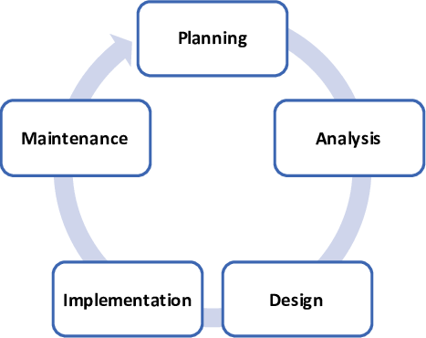

Figure 1-1: SDLC phases

Work began on the system with the **Planning Phase**, and the purpose of their study is to establish a clear vision of the nature and extent of system problems in common Websites. We started asking for important information that helped us identify

the system specifications (**system's requirements**) and found out the system's mechanism. Preparation of the feasibility study, implementation plan, and evaluation of this study is carried out through the planning phase to know how to display courses, show course details, and all features in each phase of the project.

All system requirements and specifications are prepared in **Analysis Phase**, the next phase of system development life cycle (**SDLC**). We preferred using analysis methodology called "object -oriented analysis methodology" (**OOA methodology**), which mainly used class diagram, use case diagram, and other types of diagrams that are used in this methodology.

The new version of Website presented in **Design & Development Phase**, in which team members working in a special UX-UI design tools called “**Figma**” & “**Adobe XD**”, the famous IDE for we development VScode (Visual Studio Code) based on “**HTML/CSS/SASS/JAVASCRIPT**” as a programming language,” **Git & GitHub”** as a version control system, and “**Firebase**” for store data and host application. The Website consists of set of different capabilities, which mainly build the design & development phase. We took into consideration the major steps and activities that are used to build design phase, such as input design, output design, control design, and access layer design, which the Website requires when displaying courses.

The final phase of building our project was **Implementation Phase**, in which all system specifications, needs, and requirements are mixed to build the final system. This phase is made up of seven different activities started by coding and ended by systems maintenance. During this phase, the system built and evaluated its performance in other activities in this phase, enhanced by IT-tools that made the system interfaces more flexible, and user's friendly of users.

"*After Foresight goes through main phases in SDLC, the new model of the system becomes more efficient, reliable, user's friendly, and the developers can maintain it in easy way.***"**

**CHAPTER TWO**

Planning Phase



**Introduction to planning phase**

System's Development Life Cycle (SDLC) is one of the most common and important concepts that are used in Business Environment. This concept can present as a closed cycle that presents a set of different phases that are used to build your own system.

SDLC built mainly from the following phases:

* Planning phase.
* Analysis phase.
* Design phase.
* Implementation phase.
* Operation, support, and security phase.

Each of these phases has its own activities that are very important to complete the final and functional phase, aims to build your system successfully. You must note that the first phase is planning phase, in this case, the system's analysts start to evaluate the proposed project and determine its feasibility.

The main activities that will be covered in this phase:

* **Business profile**: consists of mission, vision, and core values, services, and organization's structure chart.
* **Current business description** includes the history of the current system, current system description, and its difficulties.
* **Problem's definitions**: includes the major problems that face the current system, nature and discussion of each problem.
* **System's scope**: talks in summary about the essential services that are provided by the current system.
* **System's requirements**: presents the major requirement of the current system, either functional or non-functional requirements.
* **Strategic planning and SWOT analysis**: provides the main factors that affect the system on one hand, and the strategies to develop the system on the other hand.
* **Feasibility study**: evaluates the system's feasibility: technical, operation, and economic feasibility.
* **Implementation plan**: short plan that presents the major phases, that uses to build project infrastructure, with estimated time and cost.

*"Some of the previous activities will present in more details in the next phases of this project, mainly, the project built from the following phases: planning, analysis, design, implementation, and testing."*

**Business Profile**

**Foresight Mission:**

We aimed to utilize our resources, distinguished management, and knowledge towards achieving the following:

* + Make it easier for people to acquire information in various fields.
  + Ensure that the courses can be accessed effortlessly and completely free
  + Collect the best free courses that are scattered throughout the internet and group them in one place

**Foresight Vision:**

We seek to establish a culture of excellence and creativity locally and regionally, to make searching for free and new courses for people more efficient and time saving among people.

**Foresight Core Values:**

* + Provide a stable and easy website to use.
  + Provide a website that is easy to use and has a lot of features.
  + Provide a website that ensures work to be done with precision, organization and quality.
  + Provide an online website to be accessed from anywhere and anytime.
  + Provide a stable and up-to-date website.

**Foresight Services:**

***Foresight*** presents different services for the users and the different stakeholders. It provides the following services:

1. **Login Screen**

Used to enter the Homepage screen by entering verified email and password.

1. **Register Screen**

Used to add new users to the website by entering new email, password, and user details.

1. **Forget Password Screen**

Used when the user forgot his password by entering his verified email then an email will be sent to the user email that allows the user to change his password.

1. **Sending Emails**

An email that is sent automatically when a new email needs to be verified or when changing the user password.

1. **Homepage Screen**

This is the main screen inside the website that shows the base content of the project. The Homepage has cards that show the main categories of our project

1. **Categories Screen**

This screen shows the content of each category, each category contains various subcategories containing the course that is displayed based on user choice in an easy and User-friendly way to make it more appealing.

1. **Details Screen**

This screen shows the description of the chosen course and displays the details about it (course length, tutor details, practices, reviews).

1. **Contact us Screen**

A screen that is used when the user finds a problem with the website (technical, educational, personal) or if the user needs more details.

1. **About us Screen**

A screen that displays the vision and ambition of the developers to let the users know the purpose of the project.

1. **Profile Screen**

A screen that displays the users details for future features (Username, email, mobile number).

1. **Favorite Screen**

A screen that shows the Wishlist for a specific user.

1. **Onboarding Screen**

A screen aimed to introduce what an app does to a user and of course how to use it.

**Current System Description:**

The current system lacks a wide range of interactive services (interactive means, filling form applications for the following components: **Create course, adding tutors**). Most of these services are manual, so it takes a lot of time, effort and human resources.

**Scope of The System:**

The new Website (Foresight) offers a variety of computerized services, which solve most of the problems of the current system, as follows:

1. **A new User**

Added to the system by registration and verification.

1. **A new Course**

Added to the system through adding a courses /event screen by admins.

1. **Taking information about students**

Through registration, this information is stored in the user database.

1. **Real-time database**

The courses and events are updated at the same time for all users.

**System Requirements:**

Requirement can be a description of what a system must do. This type of requirement specifies something that the delivered system must be able to do. Another type of requirement specifies something about the system itself; how well it performs its functions.

Such requirements are called 'non-functional requirements'; Examples of such requirements include availability, testability, maintainability, and ease-of-use.

A collection of requirements defines the characteristics or features of the desired system. A 'good' list of requirements generally avoids saying how the system should implement the requirements, leaving such decisions to the system designer. Describing how the system should implement is known as implementation bias. In software engineering, the same meaning of requirements applies, except that the focus of interest is the software itself. Requirements classified into the following types:

1. Functional requirements.
2. Non-functional requirements.

**Functional Requirements:**

Functional requirements define the internal workings of the software, that is, the calculations, technical details, data manipulation and processing and other specific functionality that show how the use cases are to be satisfied. They are supported by non-functional requirements, which impose constraints on the design or implementation such as performance requirements, security, quality standards, or design constraints.

As defined in requirements engineering, functional requirements specify specific behaviors of a system. This should contrast with non-functional requirements, which specify overall characteristics such as cost and reliability. Software requirements must be clear, correct, unambiguous, specific, and verifiable.

The major requirements that Foresight includes are as follows:

If the user does not have an electronic account with (Foresight), the user must create an account, as follows:

1. Set up Email
2. Set up Password
3. Input Full Name.

**Non-functional Requirements:**

In systems engineering and requirements engineering, non-functional requirements are requirements, which specify criteria that are used to judge the operation of a system, rather than specific behaviors. This should contrast with functional requirements that specify specific behavior or function. Typical non-functional requirements are reliability, scalability, and cost.

Non-functional requirements are called "constraints", "quality attributes" and "quality of service requirements". SM includes the following non-functional requirements:

1. Full-automated system
2. Increase system reliability
3. Increase system performance
4. Build user friendly interface

These requirements, either functional or non-functional, will be discussed in detail when talking about requirements structuring in the second and third phase (Analysis and Design).

**Technical limitations:**

This type of restriction depends on how students, instructors or stakeholders can work and interact with information technology, to measure their ability to adapt to the computer and its trends. In this case, we should increase the capacity of employees to work with IT tools, by enabling staff to be able to use the new system (how to publish and edit the courses or categories).

**Economic constraints:**

Economic constraints are directly related to the main operations used by Foresight to enhance system performance, as each of these operations has its own cost to be accomplished.

These include:

1. System maintenance.
2. Re-engineering the system.
3. System development.
4. Support system.
5. Installation system.

**Shortage of time:**

This limitation relates directly to the time required to complete this process in the system.

You can go back and see the main services provided by the system, each one of them needs a period to be completed, for example: adding a new lecture or course, we can also see time or schedule constraints in many system situations.

**Pert diagram**

**Table 1-1: Time schedule for the project**

|  |  |  |  |  |
| --- | --- | --- | --- | --- |
| Activity ID | Activity | Duration | Start | Predecessors |
| A | Select Work Team | 2 days | Mon 01/11/2021 | None |
| B | Select the Project idea | 6 days | Wed 03/11/2021 | A |
| C | Write a proposal for the project | 4 days | Tue 09/11/2021 | B |
| D | Feasibility study | 2 days | Sat 13/11/2021 | B |
| E | Write the functional requirement  and nonfunctional requirement | 5 days | Mon 18/11/2021 | C |
| F | Architectural design defines the  subsystem, block diagram | 4 days | Sat  23/11/2021 | E |
| G | start phase analysis of the system | 2 days | Mon 27 /11/2021 | F |
| H | write a data dictionary | 3 days | Wed 29/11/2021 | G |
| I | start design phase use ER and  DFD | 9 days | Thu 01/12/2021 | H |
| J | implement the system using  VScode and Firebase | 22 days | Sat 10/12/2021 | I |
| K | write a final document of the  project | 5 days | Sat 01/01/2022 | J |
| L | present the project with  Complement Documentation | 1 day | Sat 06/1/2022 | K |

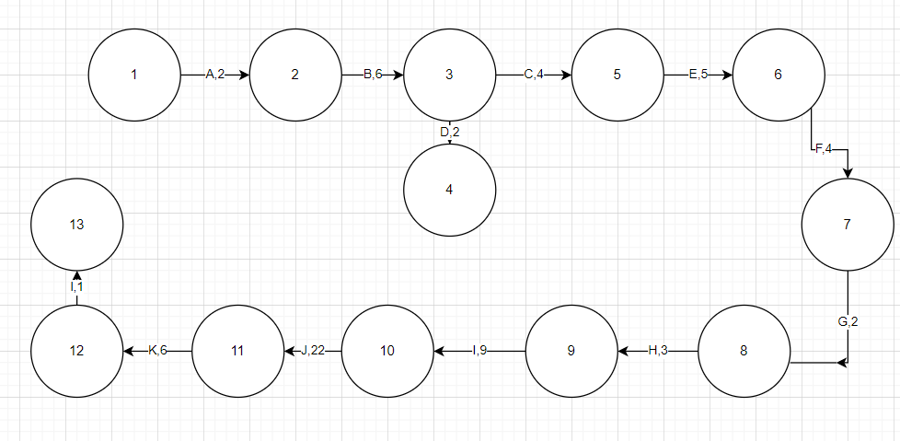

**Figure 1-2: Pert diagram for the project.**

The number of activities is: 13 Event: from 1to **13**

Critical Path: 1-2-3-4-5-7 **- 8** -9-10-11-12-13 **(59 Days)**.

Critical Activity: A, B, C, E, F, G, H, I, J, K

**Feasibility study:**

**Feasibility** study is a preliminary study undertaken before the real work of a project starts to ascertain the likelihood of the project's success. It is an analysis of possible alternative solutions to a problem and a recommendation on the best alternative. It, for example, can decide whether an order processing be carried out by a new system more efficiently than the previous one. A feasibility study could be used to test a new working system, which could be used because:

* The current system may no longer suit its purpose.
* Technological advancement may have rendered the current system redundant.
* The business is expanding, allowing it to deal with extra workload.
* Customers are complaining about the speed and quality of work the business provides.
* Competitors are now winning a big enough market share due to an effective integration of a computerized system.

Economic feasibility study:

This involves questions such as whether the firm can afford to build the system, whether its benefits should substantially exceed its costs, and whether the project has higher priority and Profits than other projects that might use the same resources. This also includes that whether the project is in the condition to fulfil all the eligibility criteria and the responsibility of both sides in case there are two parties involved in performing any project.

1. The system Economically Feasibility.
2. Hardware, Software and Others.

Technical Feasibility:

1. Accuracy.
2. Reliability.
3. Security.

Operation Feasibility:

1. Sufficient support for the Donors and Hospitals.

1. Work property if it is being developed and implemented.

3. Easy to maintain.

**Schedule feasibility:**

Our system can be accomplished in time.

**Table 1- 2: Tasks of the project**

|  |  |  |
| --- | --- | --- |
| Activity | Duration | Start |
| Task A | 2 | 01 – Oct |
| Task B | 6 | 03 – Oct |
| Task C | 4 | 09 – Oct |
| Task D | 5 | 13 – Oct |
| Task E | 4 | 18 – Oct |
| Task F | 2 | 23 – Oct |
| Task G | 3 | 27 – Oct |
| Task H | 9 | 29 – Oct |
| Task I | 22 | 01– Dec |
| Task J | 5 | 10 – Dec |
| Task K | 1 | 06 – Dec |

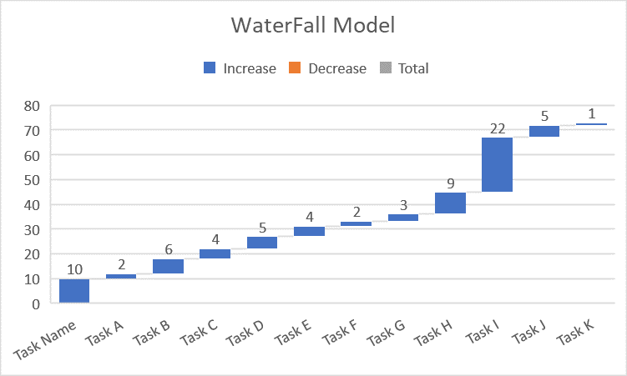

**Figure 1- 4: Waterfall for the project**

**S.W.O.T. Analysis:**

Strength:

* Easy to interact with the system.
* Ability to take the report in a short time.
* Ability to give the reports quickly.
* Automate the saving into the data to the database.

Opportunity:

* It’s adapting to be used in the Jordanian Universities.
* The web page of Strategic Management System can be used from phones, computers, and

anywhere connected to the Internet. Threats:

a system can be a threat factor if it doesn't have any security or maintenance techniques or if it doesn't gain compliance with its users because of any reason.

**CHAPTER Three**

Analysis Phase



**Introduction to Analysis Phase:**

The second important phase that our project used is the analysis phase, in which the overall objectives of the system in this phase is to understand the proposed project, to ensure that it will support the business requirements. The analysis phase involves end users and IT specialists working together to gather, understand, and document the business requirements for the proposed system. The main activities that this phase includes:

* + **Requirement modeling**: involves fact-finding to describe the current system, and to identify the major requirements of the new system such as outputs, inputs, processes, performance, and security techniques.
  + **Data and Process modeling:** describes how to represent graphically system data and processes using object -oriented analysis methodology.
  + **Development Strategies:** the operation of selecting the best development path is an important decision that requires companies to consider three key topics: the impact of the internet, software outsourcing options, and in-house software development alternatives.
* When talking about analysis phase, we must know that we have a set of different analysis techniques, the major techniques can be classified into the following types:
  + **Structured analysis methodology:** this technique is mainly based on using something called data flow diagram to describe the major activities and data flow through the system processes.
  + **Object oriented methodology:** this type of analysis is based on using objects that may present a person, machine or something else.
* Another concept that we must know in this important phase is team-oriented methods that describe the way that is used to develop and analysis the system. There are two main methods:
  + **Joint Application Development (JAD):** a popular fact-finding method that brings users into the development process as active participation.
  + **Rapid Application Development (RAD):** team-based technique that speeds up information system development and produces a functioning information system. **"**Analysis phase needs strong analytical and interpersonal skills to build an accurate model of the new system. Analytical skills mean the ability to identify the problem, evaluate elements, and develop a useful solution. Interpersonal skills mean the ability to communicate effectively with your team members on one hand, and the end users on the other hand."

**Analysis Methodology:**

In this project, we chose object-oriented methodology to analyze the system, whole system

Object oriented analysis is considered one of the most common techniques to analyze the system requirements, this process or method based on using objects, O- O analysis commonly used in real world business application. The main result of using this method is a set of software objects that represent actual system users, things, transactions and events which are allocated in the current system.

The most common language that is used in object-oriented analysis is UML that stands for Unified Modeling Language. It uses a set of different concepts that come from object-oriented programming languages. There are a set of different examples of them such as:

* Classes.
* Inheritance.
* Objects.
* Messages.
* Methods.
* Abstraction.
* Encapsulation.
* Polymorphism.

The fundamental idea behind an object-oriented (OO) language is object decomposition, breaking the complex software system down into its various objects, combining the data and the functions that operate on the data into a single unit, the object. Objects are discussed and built by modeling real-world instances. A typical OO system consists of several cooperating objects, each of which may or may not collaborate with other objects to achieve some tasks for the user. Real- world objects display the characteristic of high cohesion; they maintain a single theme or focus, in true, and software objects modeling real world objects.

Because of using this technique for analyzing our system requirements we must use the following parts of UML diagrams:

* Use case diagrams.
* Class Diagram.
* Sequence diagrams and Machine state diagrams.

**CHAPTER Four**

Design Phase



**UML and Description**

Visual modeling has one communication standard: the Unified Modeling Language (**UML**). The **UML** provides a smooth transition between the business domain and the computer domain. Using the UML, all members of a design team can work with a common vocabulary, minimizing miscommunication and increasing efficiency.

Visual modeling captures business processes by defining the software system

requirements from the user’s perspective. This streamlines the design and development process. Visual modeling also defines architecture by providing the capability to capture the logical software architecture independent of the software Language. This method provides flexibility to your system design since the logical Architecture can always be mapped to a different software language. Finally, with Visual modeling, you can reuse parts of a system or an application by creating Components of your design. These components can then be shared and reused by different members of a team allowing changes to be easily incorporated into already existing development software.

**Modeling with Enterprise Architect**

**Enterprise Architect** is the visual modeling software solution that lets you create, analyze, design, view, modify, and manipulate components. You can graphically depict an overview of the behavior of your system with a use-case diagram. **Enterprise Architect** provides the collaboration diagram as an alternative to a use-case diagram. It shows object interactions organized around objects and their links to one another. The state chart diagram provides additional analysis techniques for classes with significant dynamic behavior. A state chart diagram shows the life history of a given class, the events that because a transition from one state to another and the actions that result from a state change. Activity diagrams provide a way to model a class operation or the workflow of a business process.

**Enterprise Architect** provides the notation needed to specify and document the system architecture. The logical architecture is captured in class diagrams that contain the classes and relationships that represent the key abstractions of the system under development. The component architecture is captured in component diagrams that focus on the actual software module organization within the development environment. The deployment architecture is captured in deployment diagrams that map software to processing nodes—showing the configuration of run-time processing elements and their software processes

There are a set of concepts that are used in UML as follows:

* **Use Cases**: represent the major functional requirements of your system.
* **Class Diagrams**: show the static structure of data and the operations that act on the data.
* **State Diagrams**: represent dynamic models of how objects change their states in response to events.
* **Sequence Diagrams**: represent dynamic models of interaction that happen between objects.

1. Class Diagram

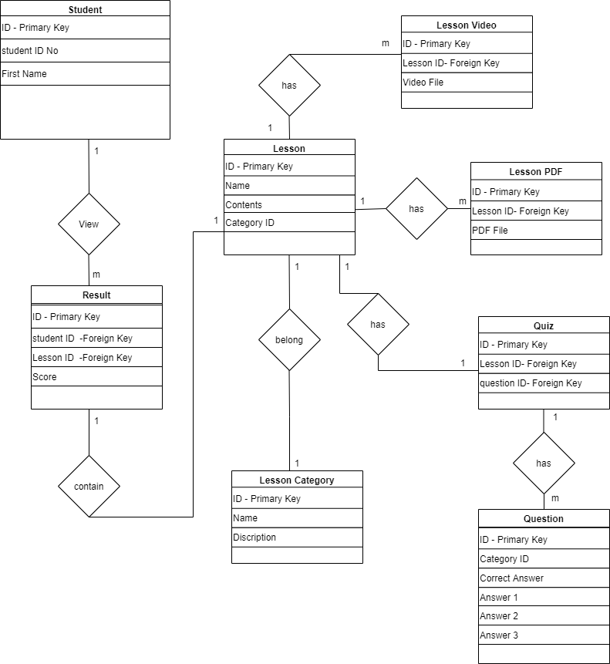

**Figure 1-5: Foresight Class Diagram**

1. Use Case Diagram

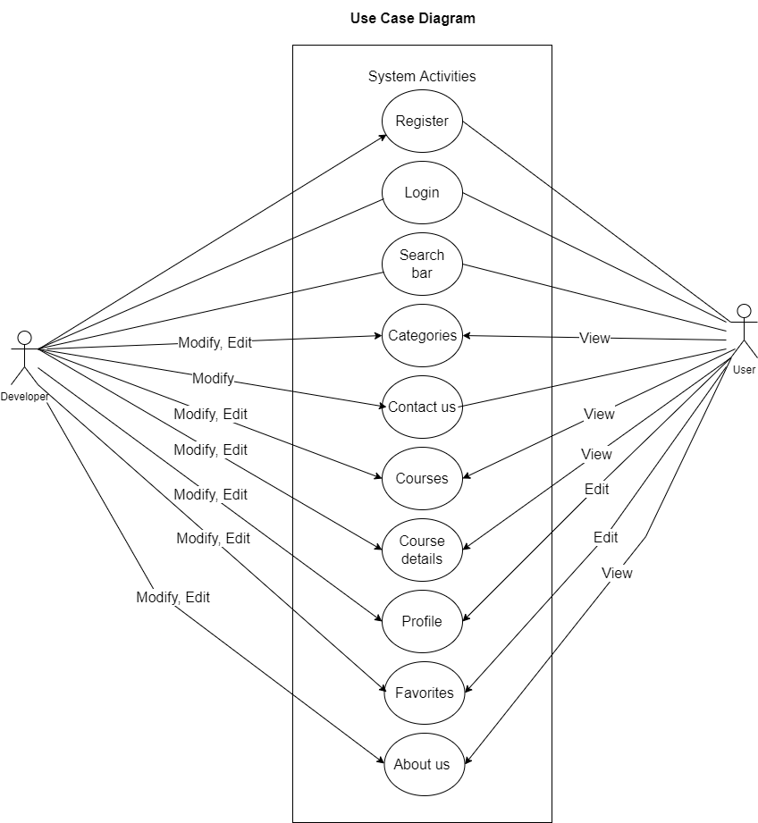

**Figure 1- 6: Foresight Use Case Diagram**

1. Sequence diagrams:
   1. user Login:

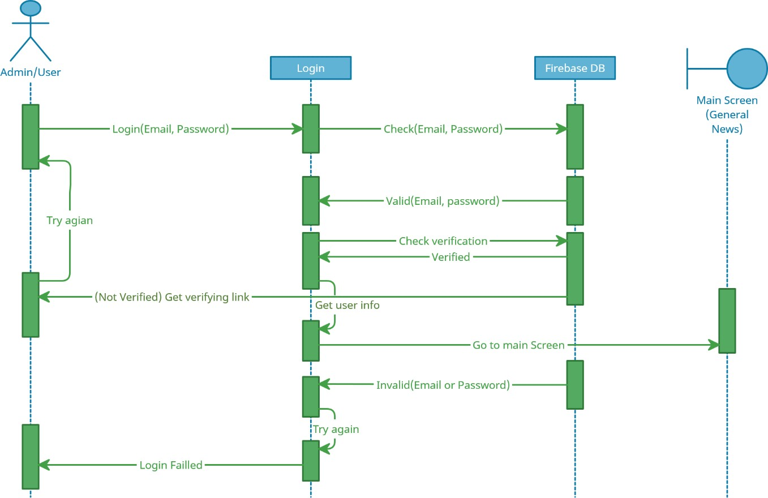

**Figure 1- 7: Foresight (user Login)**

|  |
| --- |
| **Sequence diagram Number:** 1 |
| **Sequence diagram Name:** Login |
| **Brief Description:** Enable the admin/user to login to the program |
| **Actors:** Admin/user |
| **Frequency of Execution:** This process is executed whenever the admin/user enters his password and email correctly |
| **Scalability:** Multi data can be added at once |
| **Primary Path:**   1. The admin/user enters the password and email 2. The control verifies the password and email and sends it to the Firebase (DB) 3. The database verifies the password and opens the account and sends a verify message to the interface |

**Table 1- 3: Describing Table of Admin/user Login**

* 1. User Screens

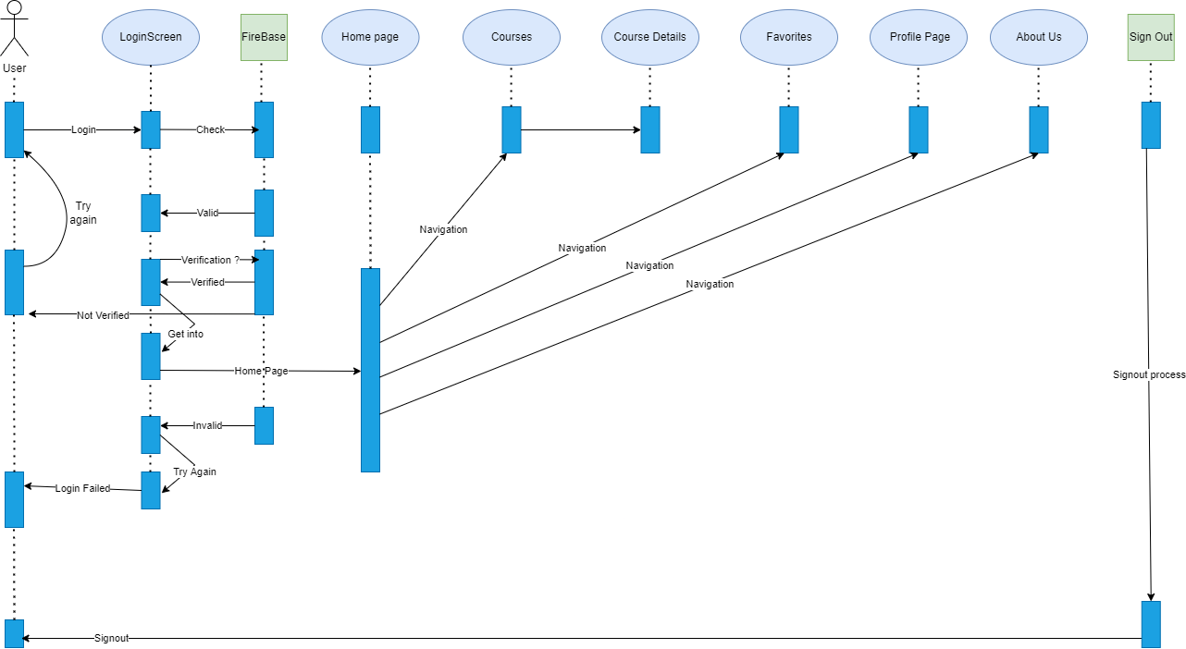

**Figure 1- 8: Foresight (user Screens)**

|  |
| --- |
| **Sequence diagram Number:** 2 |
| **Sequence diagram Name:** Admin/user Screens |
| **Brief Description:** Enable the admin/user to visit any Admin Screen |
| **Actors:** Admin/user |
| **Frequency of Execution:** This process is executed whenever the admin/user enters his password and email correctly and goes to any Admin/user Screen |
| **Scalability:** Multi data can be added at once |
| **Primary Path:**   1. The admin/user enters the password and email 2. The control verifies the password and email and sends it to the Firebase DB 3. The Firebase DB verifies the password and opens the account and sends a verified message to the interface, and enables admin/user to go to Admin/user Screen |

**Table 1 -4: Describing Table of Admin/user Screens**

* 1. Add users

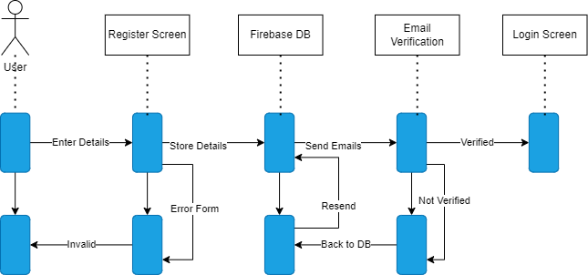

**Figure 1- 9: Foresight (Add user)**

|  |
| --- |
| **Sequence diagram Number:** 3 |
| **Sequence diagram Name:** add user |
| **Brief Description:** Register to add new students to Foresight |
| **Actors:** User |
| **Frequency of Execution:** This process is executed whenever the new User enters his details |
| **Scalability:** Multi data can be added at once |
| **Primary Path:**  1.The New user enters his info  2.Store in Firebase DB and send verification email 3. Verify and go to login screen to sign in |

**Table 1- 5: Describing Table of add user**

1. Collaboration (State Diagram)
   1. Add User

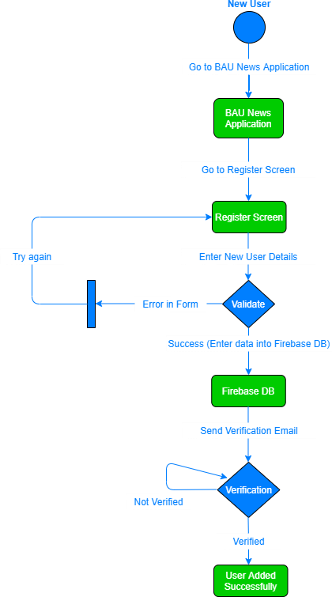

**Figure 1- 10: Foresight (Add User)**

* 1. New User

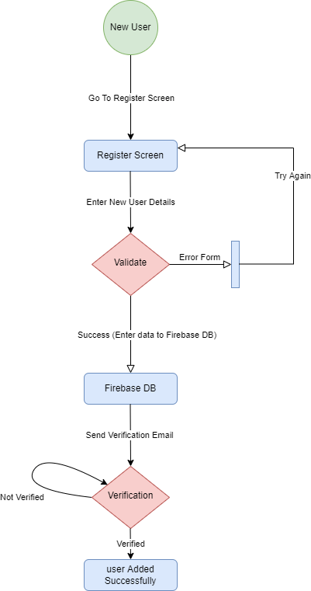

**Figure 1- 11: Foresight (add user)**

* 1. Login

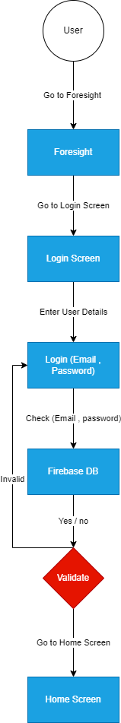

**Figure 1- 12: Foresight (User Login)**

**CHAPTER Five**

User Manual



**Introduction**

**Foresight** is a website. This website is characterized by its user- friendly interfaces. It is divided into screens according to the user who will deal with it.

**Website** is a collection of web pages and related content that is identified by a common domain name and published on at least one web server

**Hardware Requirements:**

1. Any device capable of connecting to the Internet.
2. Internet access provider.

**Software Requirements:**

1. Web Browsers (Google Chrome, etc.).

**Figures of the project**

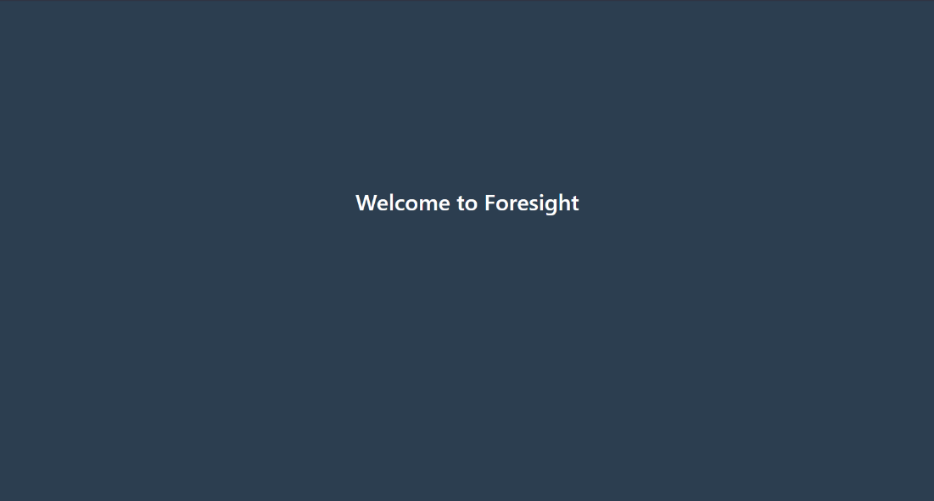

# Figure 1-13: Splash Screen

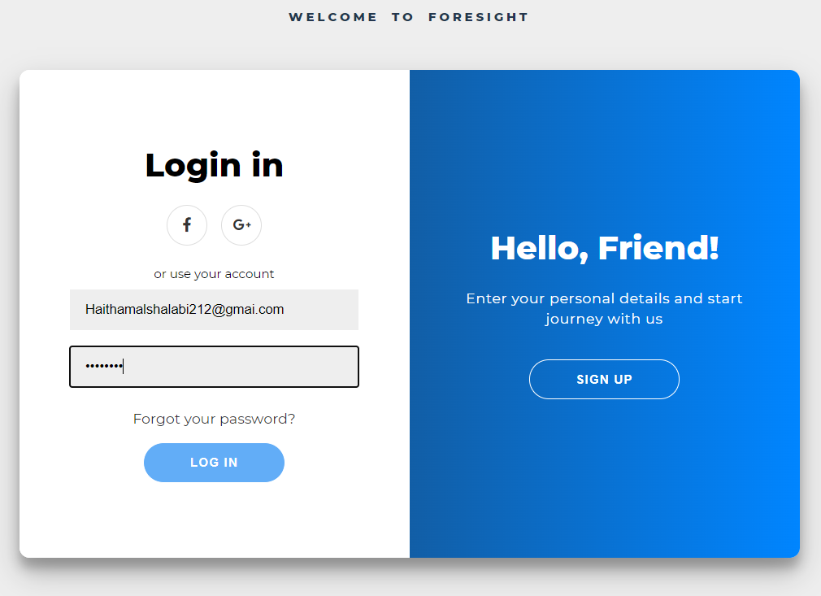

# Figure 1-14: Login Screen

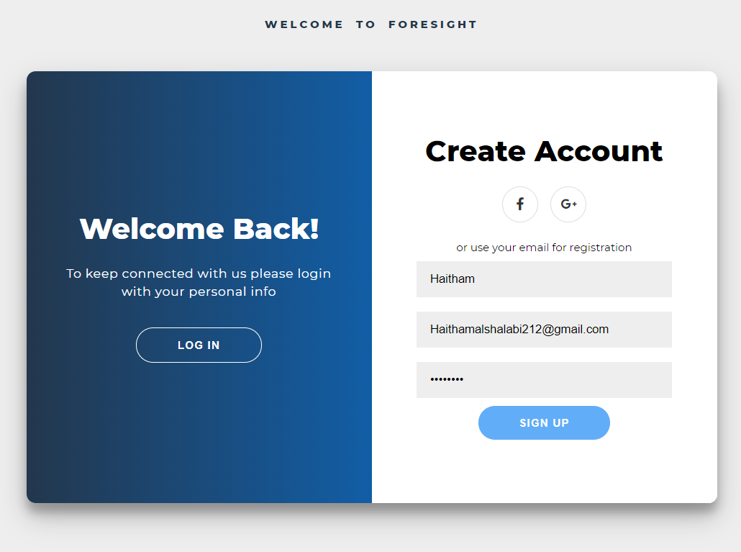

# Figure 1-15: Register Screen

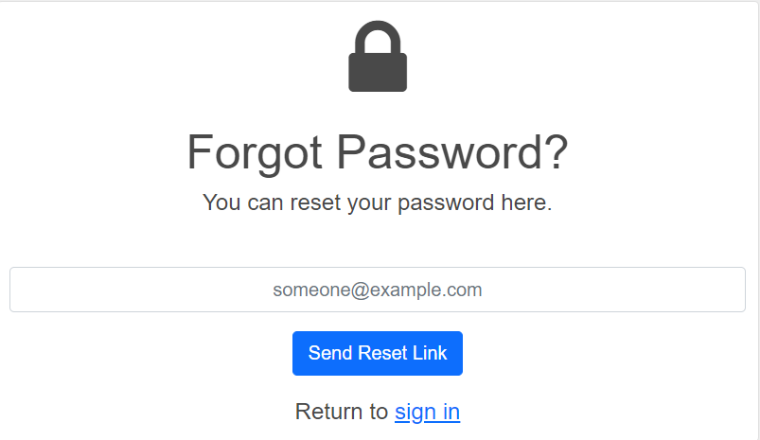

# Figure 1-16: Reset Password Screen

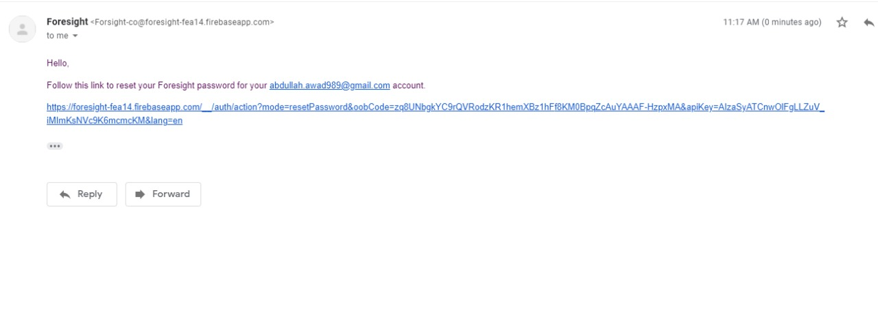

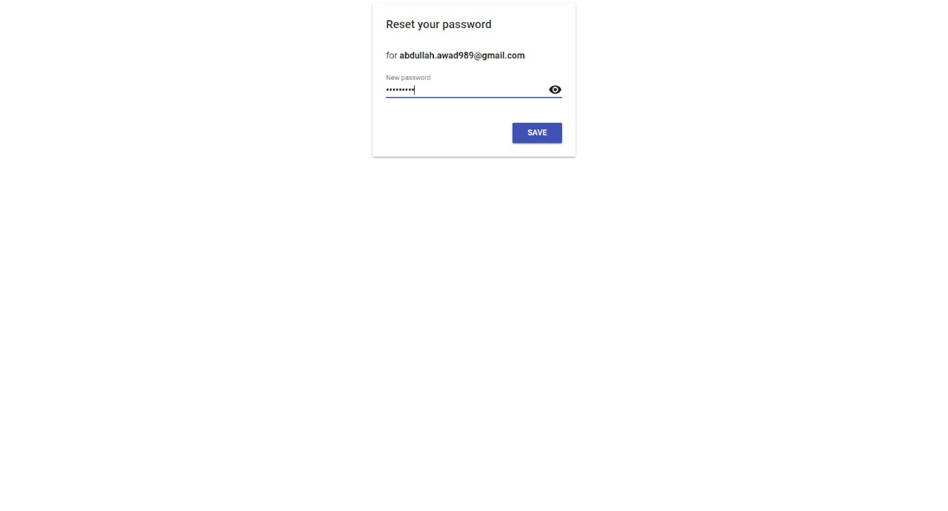

**Figure 1-17: Reset Password by Email Screens**



# Figure 1-18: User Homepage/Section1

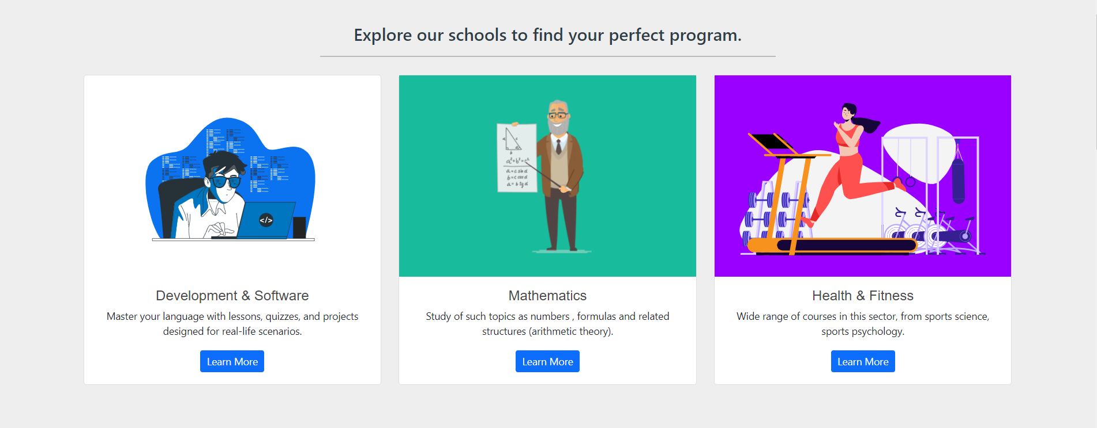

# Figure 1-20: User Homepage/Section2

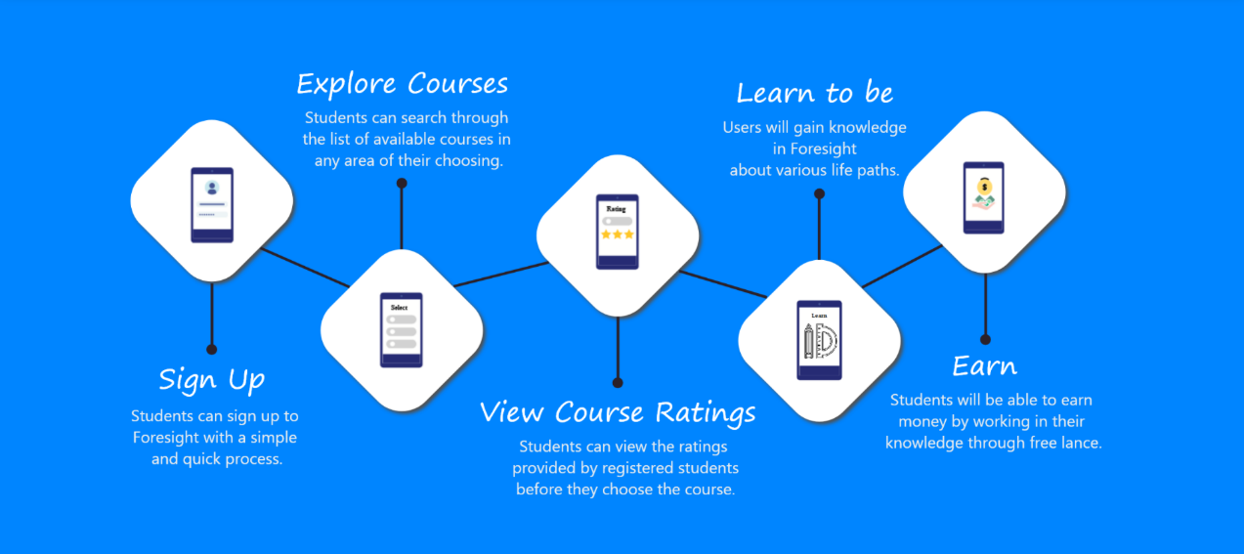

# Figure 1-21: User Homepage/Section3

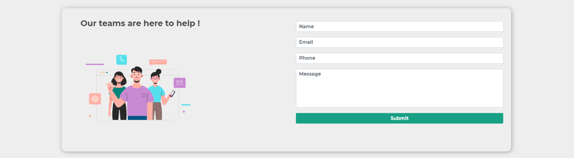

# Figure 1-22: User Homepage/Contact Us

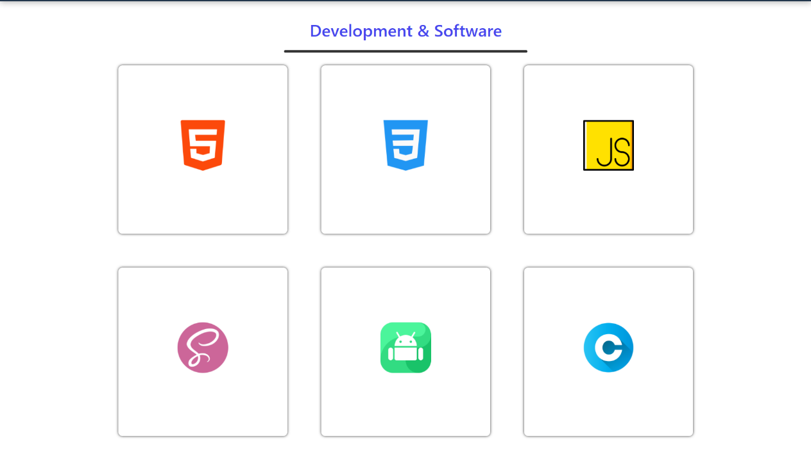

# Figure 1-23: User Categories-Page

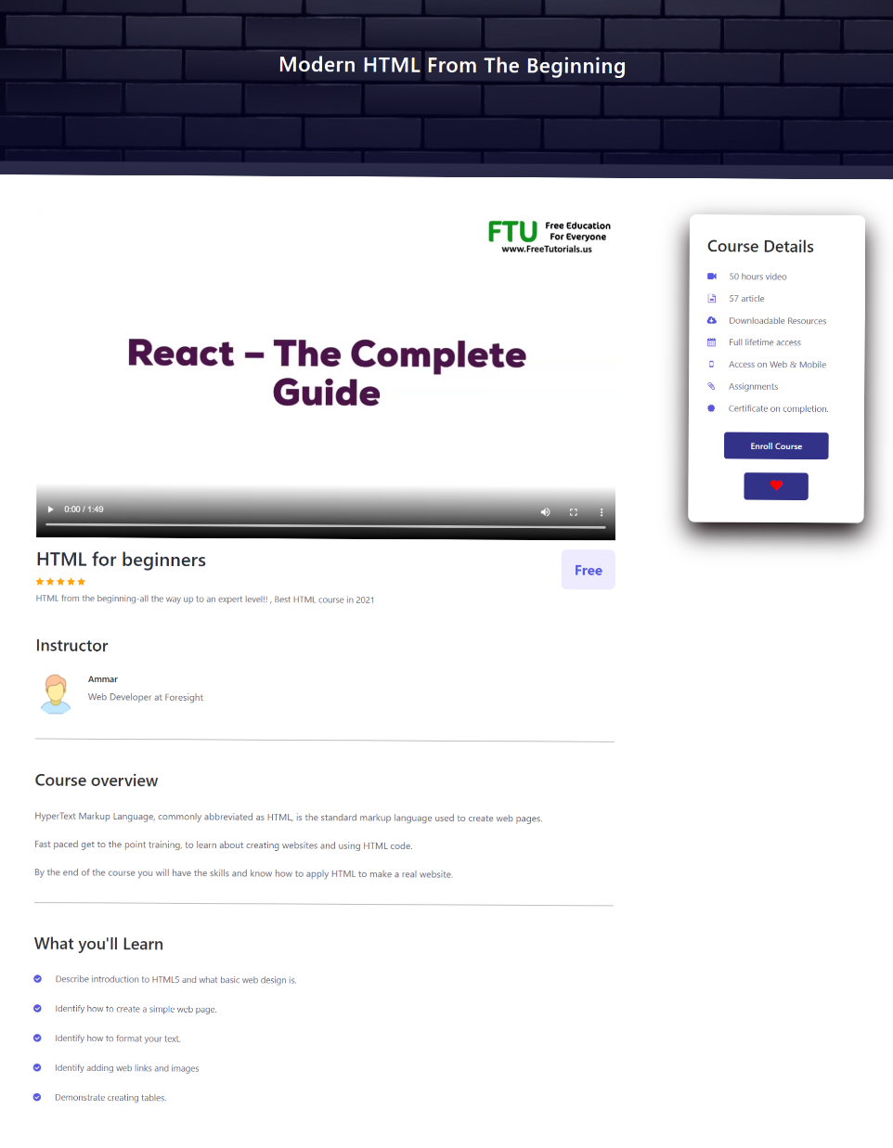

# Figure 1-24: User Categories Details-Page

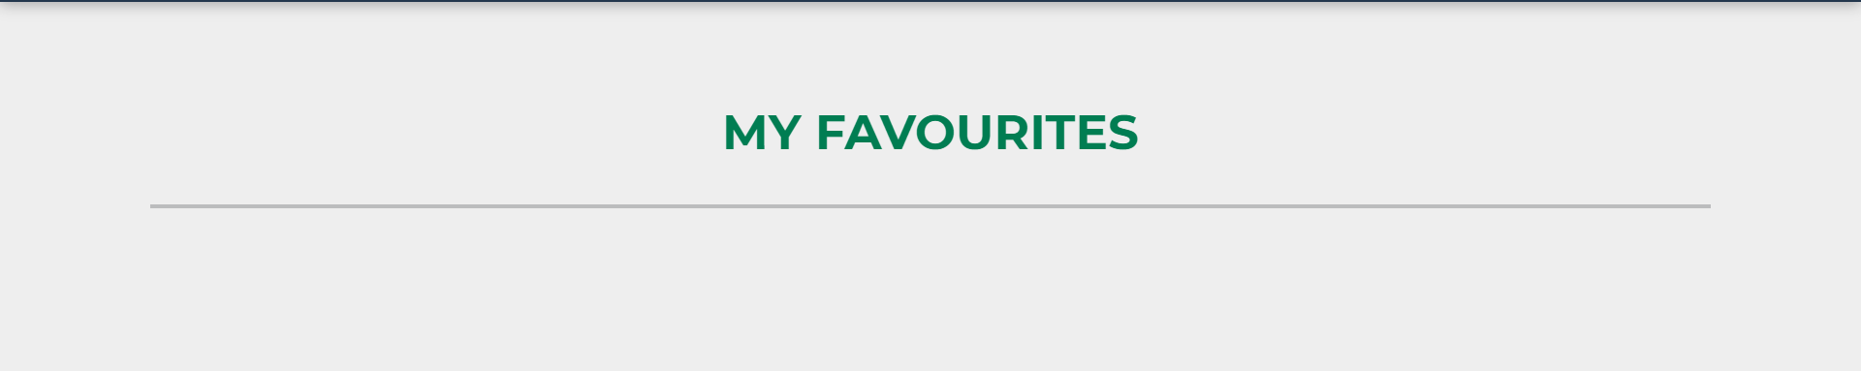

# 

# Figure 1-25: Favorites Screen / Before

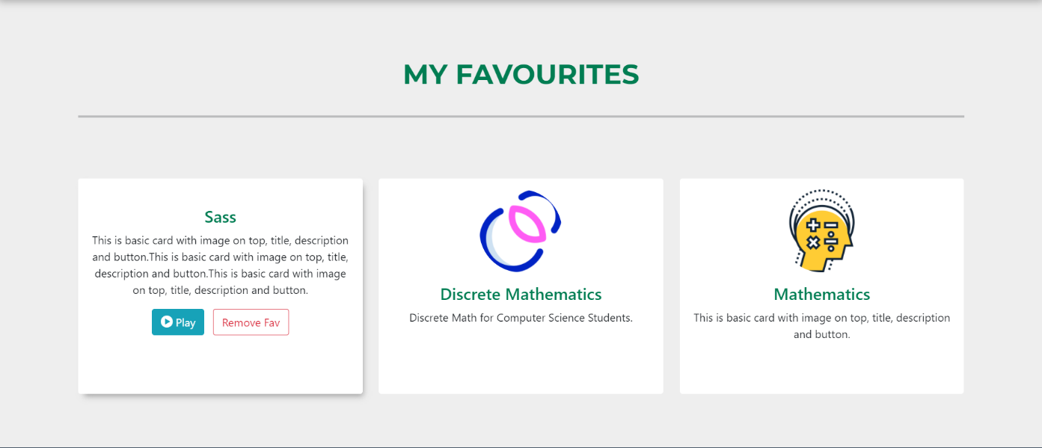

# 

# Figure 1-26: Favorites Screen / After

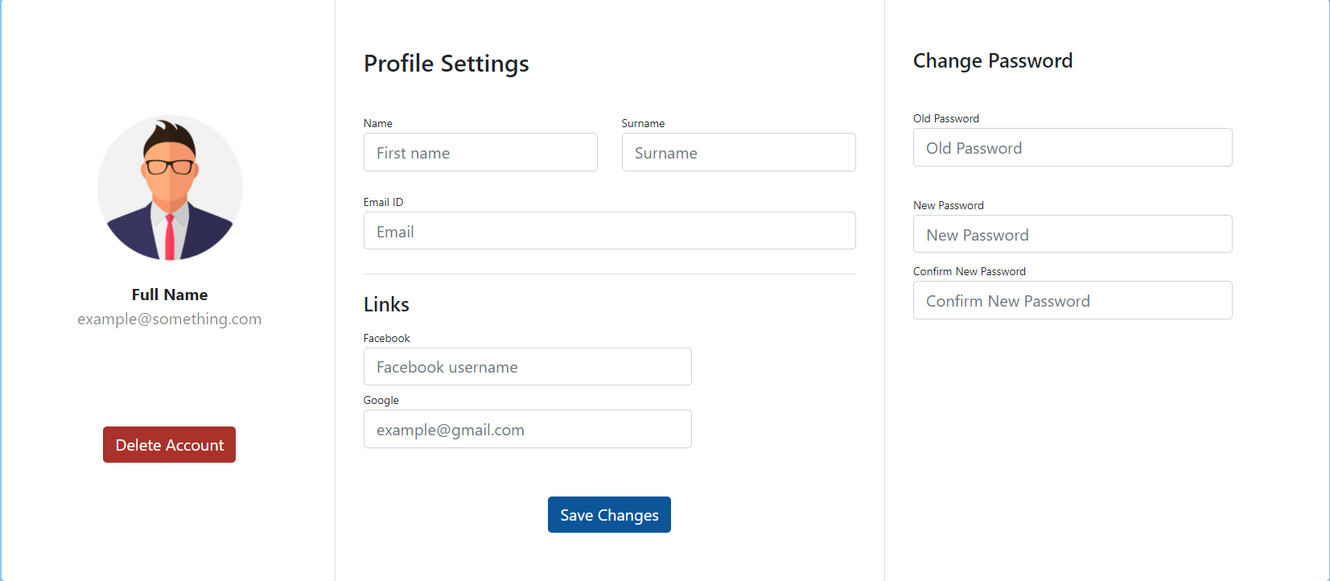

# Figure 1-27: User Profile Screen

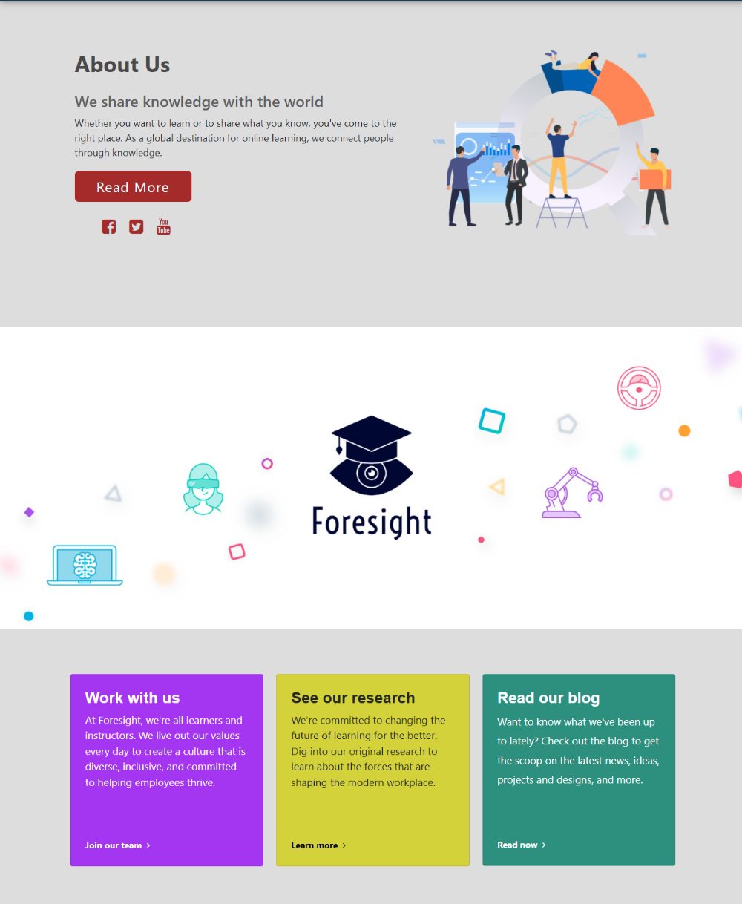

# Figure 1-28: User About Us Screen

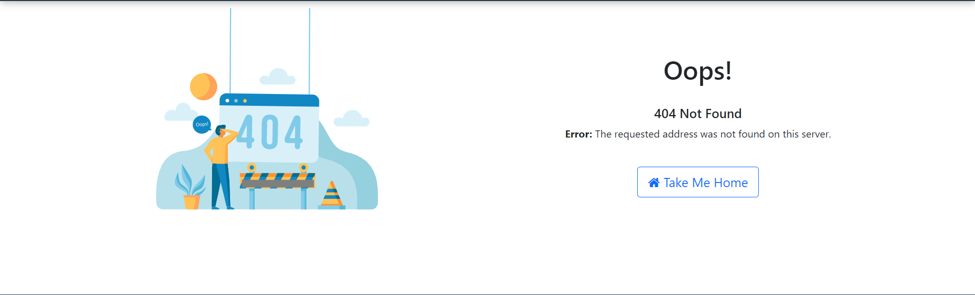

# Figure 1-29: User 404 Screen



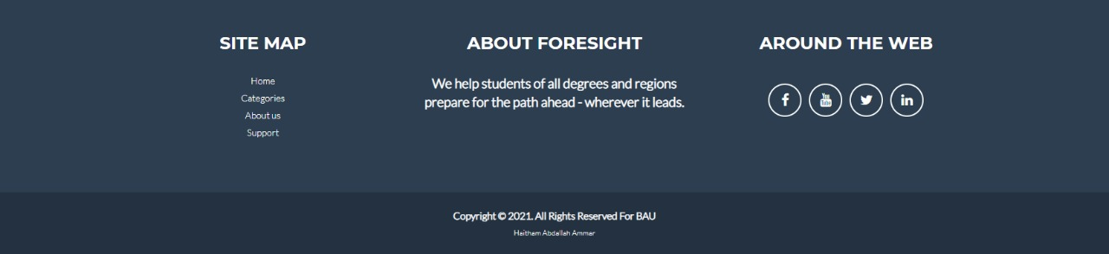

# Figure 1-30: Navigation Bar / Footer

**CHAPTER SIX**

References



**References:**

**Gather information**

Udemy

Google

Udacity

**Support**

Dr. Hamzah Al-Dabbas Project **supervisor**

**SDLC "System Development Life Cycle"** Tutorialspoint <https://www.tutorialspoint.com/sdlc/>

**Pert Diagram & Gantt Chart**

Wikipedia.org <https://en.wikipedia.org/wiki/Program_evaluation_and_review_technique>

**UML Diagrams**

Tutoralspoint <https://www.tutorialspoint.com/uml/uml_standard_diagrams.htm>

[Derek Banas](https://www.youtube.com/channel/UCwRXb5dUK4cvsHbx-rGzSgw) [https://www.youtube.com/watch?v=OkC7HKtiZC0&list=PLGLfVvz_LVvQ5G-LdJ8RLqe-](https://www.youtube.com/watch?v=OkC7HKtiZC0&list=PLGLfVvz_LVvQ5G-LdJ8RLqe-ndo7QITYc) [ndo7QITYc](https://www.youtube.com/watch?v=OkC7HKtiZC0&list=PLGLfVvz_LVvQ5G-LdJ8RLqe-ndo7QITYc)

**Other Sites that helped:**

[Stack Overflow - Where Developers Learn, Share, & Build Career](https://stackoverflow.com/) [GitHub: Where the world builds software · GitHub](https://github.com/)

Documentation| Firebase (google.com)