Week 5 - Testing



**Class: Ei2c**

**Group members: Yogesh, Amar, Ibhraim, Suman**

Date: 29-05-2016  
Version 1.0

Contents

Introduction 3

Overview assignment(s) week 5 3

The plan 4

The project 5

# Introduction

Last week you and your group started working on the project by setting up the development environment and creating the starting projects. Hopefully you also spend some time discussing what you as a group are going to do (the requirements). If so it should mean that you already have a good idea of how your robot and (remote) application is going to function.

This week we’re going to make sure that what has been envisioned for the deliverables are being realized. After that you will also start the implementation of the deliverables.

The structure of this week’s practical will be as following:

* Brainstorm about test cases;
* Write the test plan;
* Start working on the project.

## Overview assignment(s) week 5

**Deliverable:** This document with the test plan. One group member will send it to the teacher.  
**Deliverable per:** All Students.  
**Deadline:** Before week 6.

# The plan

With last week’s practical your group had to decide what is going to be created as deliverables for the project. At the end of this course you should have a bug free robot and Windows Form application. One of the ways to ensure this is by creating a test plan at the start of the project and use it when the deliverables are ‘done’.

For this reason you can use the table below to specify tests. The test should be written in such a way that any fellow classmate can perform it. Be sure to also test monkey behaviour and exceptions that can occur!

NOTE: Make sure there are **at least** 10 test cases!

|  |  |  |  |  |  |
| --- | --- | --- | --- | --- | --- |
| Nr | Purpose | Effected deliverable(s) | Actions to undertake/test data | Expected result | Actual result |
| 1 | Find path to follow |  | Get colour detected (e.g. White) via colour lens. It will pass some integer value (e.g. 6 ) until it gets same colour | Automatic forward moving over same colour |  |
| 2 | Connection Test |  | - Select a port Click on connect  If connected, others buttons like disconnect will be visible otherwise Displays message - " Cannot connect to port and try again" | Connection via Bluetooth to robot. |  |
| 3 | Detect object to pick up | Use of ultrasonic sensor | - Ultrasonic sensor produces sound and receives the reflected sound waves from the object (i.e, ball) and calculates the distance to travel | Move towards object |  |
| 4 | Ball Pick Up | Use of touch sensor | - After travelling distance calculated by ultrasonic sensor, touch sensor will touch ball | Pick Up ball automatically. |  |
| 5 | Drop off | Colour sensor | Whenever, the Robot is moving with ball picked up, at the end of the path(i.e, Change in path colour), the robot will start dropping off ball | Ball drop automatically |  |
| 6 | Show Message |  | Whenever, robot changes its action, it should send message to windows application | Monitor what robot is doing |  |
| 7 | Send Message | Windows form application | - write something in Input message textbox and click send message button  - it sends message to robot via bluetooth | Message will be shown in the brick |  |
| 8 | Read Message |  | - Click on Read message  - Last send message will popout in output listbox. | Message will be shown in output list box. |  |
| 9 | Movement Test (Monkey Test) | Colour Sensor | - Put the robot in contact with different colour (e.g. Green colour)  - it send different integer to brick | The Robot should be in idle position. It should not move. |  |
| 10 | Monkey Test for Pickup | Touch sensor | - If touch sensor does not touch ball  - Robot should not start pick-up | Robot should not start pick -up |  |

# The project

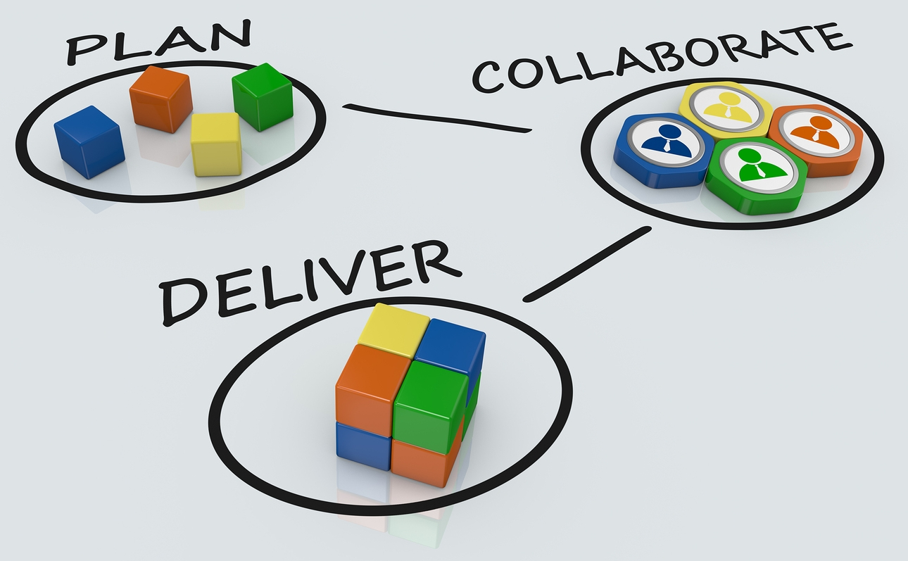Now we’re done with writing all the documentation for this project and it’s time to start working on the project.

When working as a group we have the following tips for you:

* It’s important to use the appropriate tool(s) for developing applications;
* Think in small blocks so you can split up the work ;
* Communication is key. Regularly meet (in real life) with other group members so you all know what work is being done;
* Make agreements and honor them;
* Respect each other and their opinions;
* Most important: learn from each other and have fun!

You have until Friday of week 7 to develop and test the deliverables. This means at the end of week 7 you’re going to deliver/show your teacher the following:

* The working Lego Mindstorms robot;
  + The delivery process should be started from a Windows form application;
  + It should automatically follow a track (see Appendix A for an example), pick-up and drop-off the product;
    - Optional: automatically stop at the start/stop position;
  + It should be possible to pause the delivery process;
  + Whatever you can think of, related to the robot and delivery process, to impress the other groups and teacher
* The C# Windows Form application;
  + Connect to the robot;
  + Start and pause the delivery process;
  + See the status of the delivery process;
  + Whatever you can think of, related to the form application, to impress the other groups and teacher.