Homework 2

Ammar Kothari

CE 661

1. Question 1
   1. NWU is a right handed system
   2. The determinant of C is 1. This is expected since this matrix is a rotation about x.
   3. The point will be reflected in y and z but not change in x. The point in the NWU frame is (11.521, 215.633, -108.617).
2. Question 2
   1. 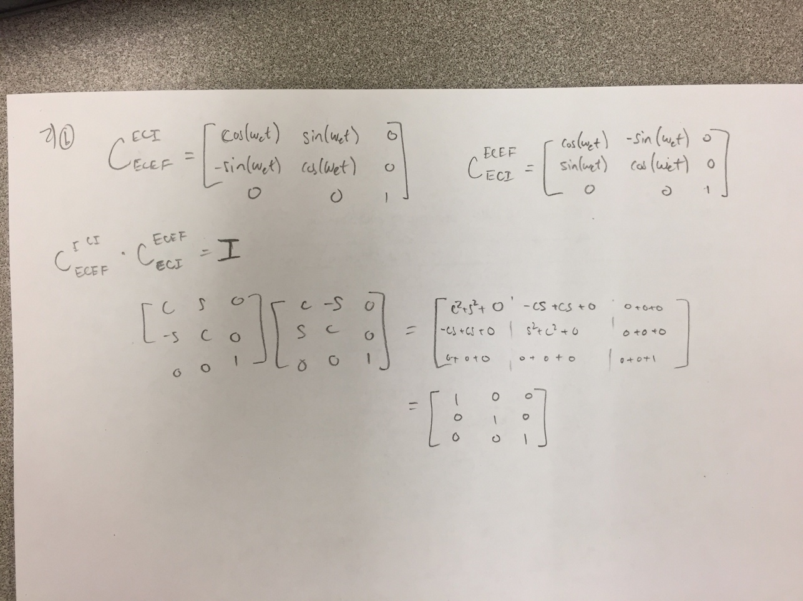
3. Question 3
   1. Quaternion = [0.0427 0.0303 0.7070 0.7053]
4. Question 4 – yes the matrix satisfies the definition of a rotation matrix.
   1. A-1 = AT
   2. det(R) = 1
   3. rank(A) = 3 (I think this is covered by the previous two statements)
5. Question 5
6. Point in frame 2 = [3.6863, 5.0151]. Multiple by a rotation matrix that has theta = 30.