CE661 - HW4

Ammar Kothari

1. Question 1
   1. Orthometric height

|  |  |  |  |
| --- | --- | --- | --- |
| Latitude | Longitude | N | Error (95%) |
| 44 33 54.59871 | 123 16 22.06612 | -22.680 | 0.042 |

* 1. Orthometric height is based on the earth geoid. It is an approximation based on measurements of the mean sea level which should reflect the earth’s gravitational field. In comparison, the ellipsoid height approximates the earth as an ellipsoid and gives the height from the surface of that ellipsoid.

Orthometric height is more reflective of an important feature of the earth than some approximation, which the ellipsoid height is. The distance from an equipotential gravity field has more general meaning than the distance from the idealized ellipsoidal shape that the earth resembles.

Is the issue only in how satellite values are converted to relative earth measurements like height? The earths gravitational field should not significantly affect GPS positioning relative to the ECE. The challenge seems to be how to define a zero height that accurately reflects what people are interested in measuring.

[1] <http://www.esri.com/news/arcuser/0703/geoid1of3.html>

1. Currently, the government is in the process of adding civil signs L2C, L5, and L1C. L1C/A will continue to broadcast.

Dual band receivers that use L2C and L1C/A will be able to do ionospheric correction to make better measurements. L2C also provides “faster signal acquisition, enhanced reliability, and greater operating range”[2]. Additionally, the higher signal strength will allow for better signal reception when there are occlusions and indoors.

L5 is meant for “safety-of-life transportation and other high-performance applications”[2]. These signals are intended for use with aviation vehicles. L5 has higher signal strength, a large bandwidth, and advanced signal type compared to L1C/A. These features result in increased accuracy and more robust signals. L1C/A, L2, and L5 can be used in combination to achieve high accuracy.

L1C signal is structured in a way to allow for cooperation with other nations. GPS, Galileo, QZSS, and BeiDou are all adopting L1C type signals. This signal is targeted at improving signal for mobile devices in cities.

[2] <https://www.gps.gov/systems/gps/modernization/civilsignals/>

1. Approximate travel times of signal between satellite and receiver, assuming the speed of the signal is 299,792.458 km / s
   1. GPS: 20,180 km 🡪 0.067s
   2. Galileo: 23,222 🡪 0.077s
   3. GLONASS: 19,130 km 🡪 0.064s
2. What are the various DOP parameters?

Parameters are dimensionless measures of error.

* 1. Geometric: 2.69 - error in the distance from the satellite
  2. Position: 1.77 – error in the location position provided by the measurement
  3. Horizontal: 1.71 – error in the lateral (east and north) position provided by the measurement
  4. Vertical: 0.43 – error in the height position provided by the measurement
  5. Time: 2.03 – error in the estimation of the time difference between the receiver clock and the satellite clock.

1. The PRN code from the file corresponds to SV 14. Below is the cross correlation plot showing what shift corresponds to the two signals have the maximum correlation.
   1. 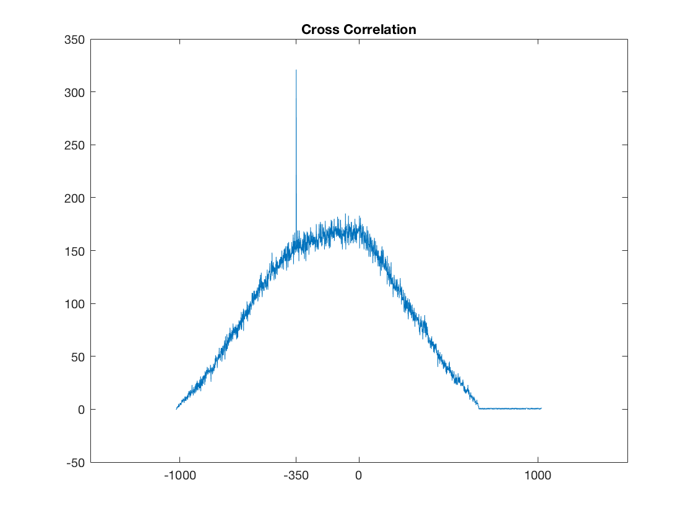
   2. The shift is 350 bits. If the frequency is 1.023 Mhz then the shift corresponds to a .003s delay? That is shorter than how long it takes for the signal to reach earth from the satellites. How do you go from shift to time? I looked online and my best guess is that the C/A code is simply used to guess the general clock offset by assuming a distance and correcting it based on the PRN auto-correlation. This information can be used to do correlation with the P-code which is much longer and should allow for a much more accurate estimation of the time delay.