HW6: Kalman Filtering
CE661

1.
a. What are the effects of adjusting Q and R? What values do you feel provide the best
results? Illustrate your answer with screenshots.
Increasing the values of Q corresponding to noise in the height transition doesn’t have much effect. Increasing Q for the velocity transition makes the estimate less smooth. Decreasing Q for the velocity transition makes the estimate smoother but track poorer. Adding cross terms to Q affects the estimate without affecting the velocity tracking.
Reducing R doesn’t seem to have much effect. The system still tracks the measurement closely. Increasing R makes the system explode or oscillate around some central path.

Q = [0.5, 0; 0, 0.0]; R = 01;
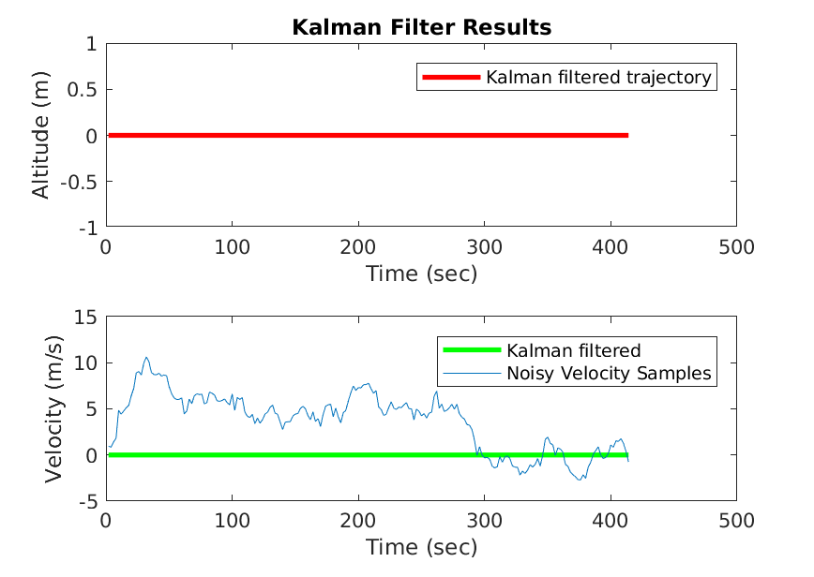

Q = [0.5, 0; 0, 0.5]; R = 01;
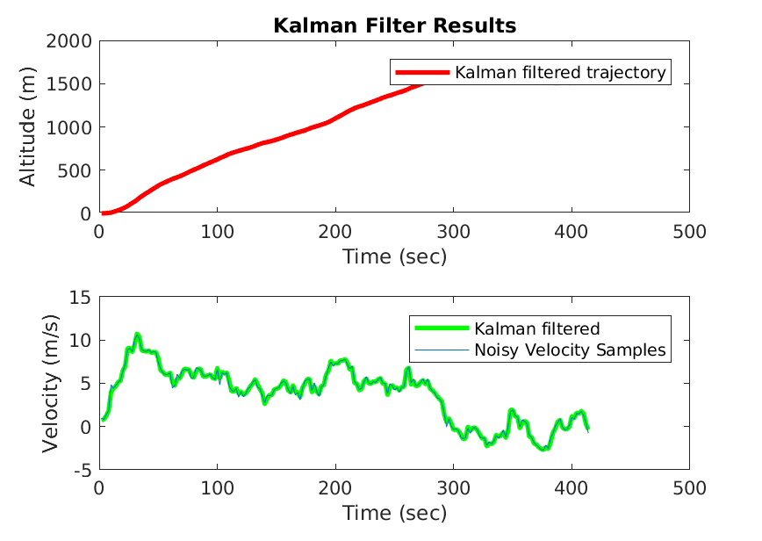

Q = [0.5, 0; 0, 0.9]; R = 01;
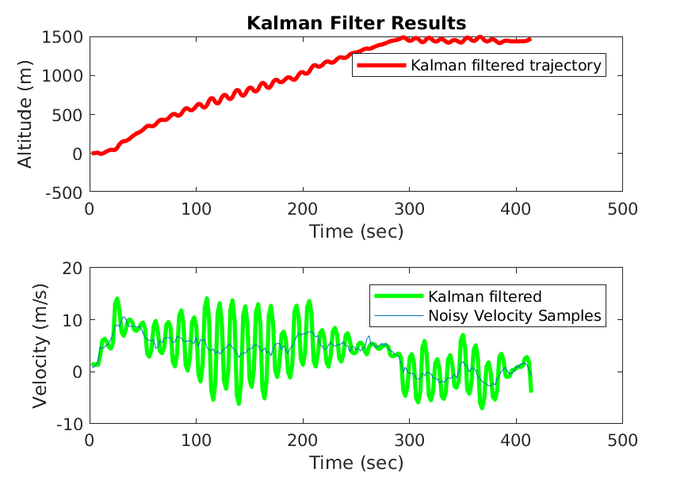

Q = [10, 0; 0, 0.5]; R = 01;

Q = [0.5, 0; 0, 0.5]; R = 3;
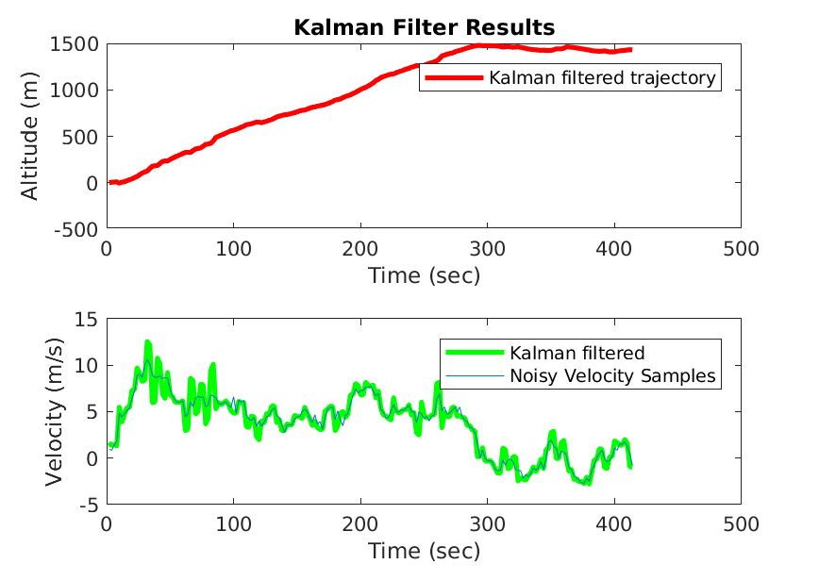

Q = [0.5, 0; 0, 0.5]; R = 1e-3;
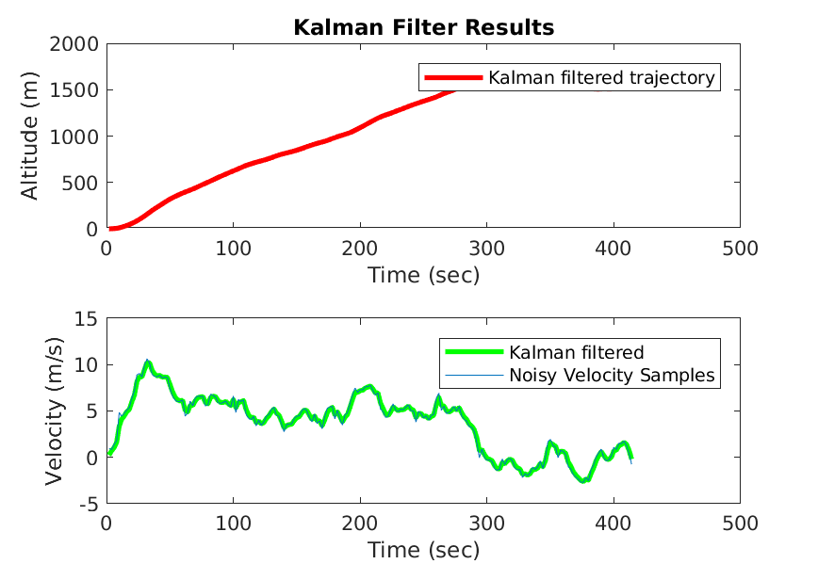

Q = [0.5, 10; 10, 0.5]; R = 1;
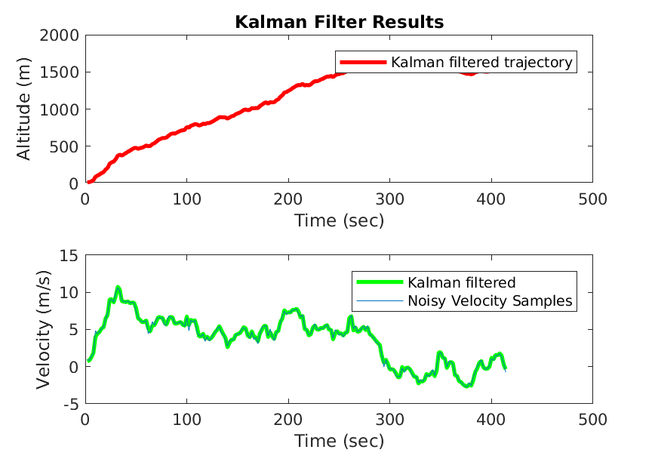

All of the paths plotted on top of each other.

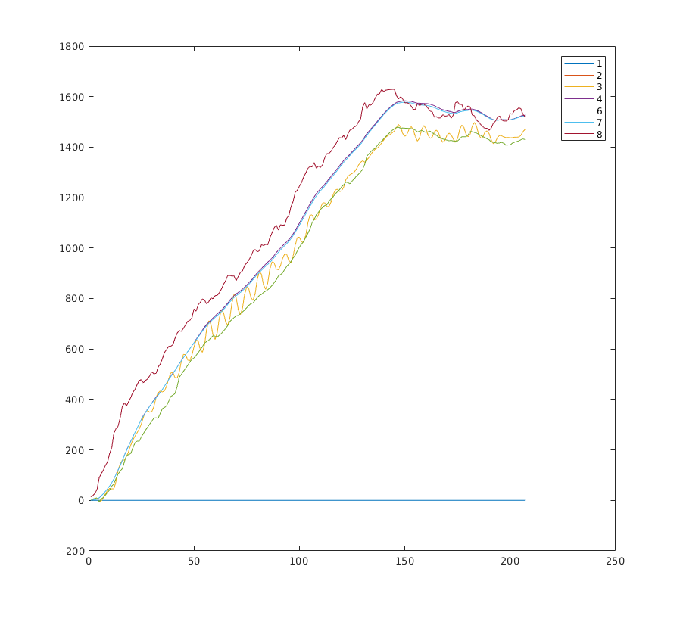

b. Say you are unable to obtain satisfactory performance by adjusting Q and R. What would be the next step(s) in modifying or enhancing your Kalman filter?

The next step would be to change the transition matrices to better capture how the state changes and how the measurement corresponds to the state.

2.
a. What are the dimensions (number of rows by number of columns) of the Φ and H?

Φ will have dimensions 6x6
H will have dimensions 3x6

b. What are the Φ and H matrices? (You don’t have to write any MATLAB code for this

Φ = H =

