Diatom Robotics Controls Challenge

Ammar Kothari

## Goal

Design an algorithm that can separate out each phase of the gait based on sensor information from an accelerometer and Gyroscope on the foot.

## Questions

The question pdf lists the MPU 6500 on the image. In the text, the IMU is described as having a 2 axis gyroscope. The MPU 6500 is a 3 axis gyroscope. I assumed that the gyroscope had sensors for all 3 axis and each was functional.

## **Assumptions**

Gyroscope was an MPU 6500.

Accelerometer was set to the highest resolution sensing - +/-0.2g

Gyroscope was set to highest resolution sensing - +/- 250 degrees/s

When data starts streaming from the sensor, the foot is in mid-stance.

Gaits always follow the same order (midstance can only occur immediately before heel-off)

## **Approach**

I started by doing some research on gaits for humans and understanding each phase. I found an article that gave a quick summary and provided some relevant details for extracting each phase [2]. The following image helped me understand what was happening for each phase.

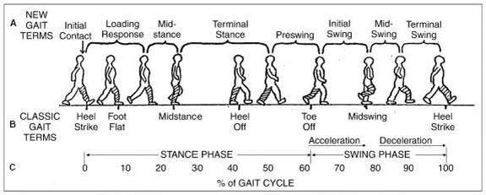

The output of the algorithm will be used by a control system. Since the control system will likely be running online, the algorithm should be able to determine the phase locally and not after an entire gait has completed.

Since the gait is assumed to follow the same order every time, for a given reading, the classification is either the current phase or the subsequent phase. Additionally, the following criteria were used to determine the phases:

Heel Strike – Change from negative acceleration to positive acceleration

- The foot is decelerating (in the y direction) as it touches the ground. Once contact occurs, the toes begin to rotate towards the ground. This causes the toes to accelerate forward faster than before.

Foot Flat: Negative Y rotation

- During the foot flat phase, the foot pronates (rotates towards the center of the body) to help support the load [2]. This can be sensed as a negative rotation around the Y axis.

Mid Stance: Minimal Movement (all readings less than some limit)

- During midstance, the foot should be stationary as it is fully supporting the load of the body.

Heel Off: Rotation around -X axis

- As the weight transfers to the other leg, and the center of mass continues to move forward, the heel begins to lift. This causes the foot to rotate forward.

Toe Off: Rotation around X axis has become small and the Z acceleration is greater than zero

- As the foot is no longer supporting the weight of the body, the whole foot moves upward in order to clear the ground. The foot also stops rotating.

Mid-Swing: large overall acceleration (primarily in Y, but also some in Z)

- The foot is no longer in contact with the ground. It is accelerated forward in order to be in position for the next heel strike.

## **Results**

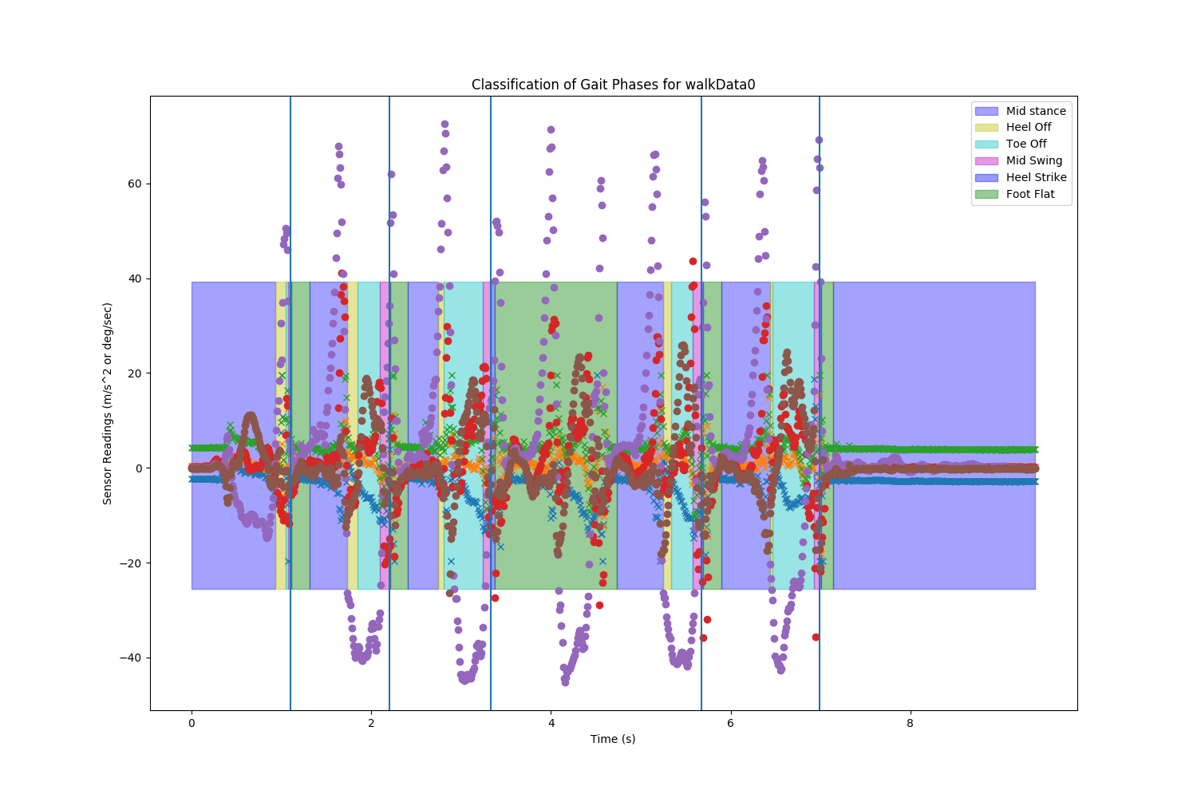

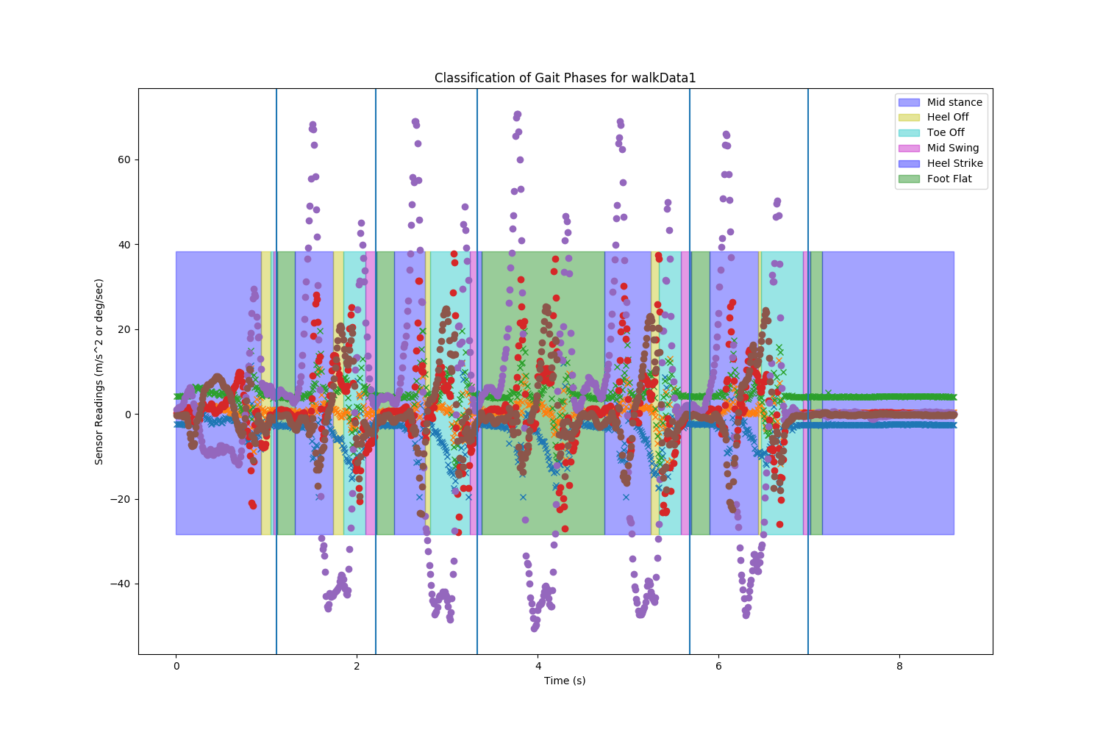

The different colored boxes represent different phases of the gait. Circles represent Gyroscope readings and Xs represent Accelerometer readings. The vertical lines represent the start of the gait (heel strike).

## **Discussion**

One issue with the algorithm is that not every step is captured. Six steps were captured in the data, but only 5 are classified. The middle stride in both datasets fails to be detected. Further tuning is required to better segment each phase. Foot flat phase is maintained throughout the next stride because the only other classification from this state can be mid-stance. Once the following mid-stance phase is missed, the classification only changes when the next mid-stance phase occurs.

## Challenges

Since an accelerometer and gyroscope only were used, significant drift and noise which makes tracking the pose of the foot difficult. As a result, large changes in readings that would be outside of the effect of noise and not subject to drift were considered.

Another challenge was the lack of ground truth. Although this data was collected from a person, no video or labeling for the gait was provided. I used my understanding of gait kinematics and dynamics to interpret the data. However, my interpretation may be incorrect. With a ground truth, the interpretation and implementation can properly be assessed in relation to the desired labeling.

## Alternative Approaches and Future Improvements

One improvement is to use better error checking or a probabilistic approach. For example, if there is an estimate for how long each phase should last, as that limit is exceeded, the algorithm can remove the subsequent phase restriction. This will allow classification to recover even if a phase was missed.

Another idea is to use a Kalman Filter to determine the pose of the foot. A better state estimate might allow for more accurately determining when mid-swing and mid-stance are occurring. The improved state estimate can be used with signals from the raw sensory input to improve classification.

A learning based approach to classification would be use a recurrent neural network. If a sufficient amount of labeled data could be captured, the network could be trained to determine the phase based on sensory input. However, if this is to be used with people, proving the accuracy of the algorithm to ensure safety of the user would be critical.

## Resources

1. MPU 6500 Datasheet - <https://www.invensense.com/wp-content/uploads/2015/02/MPU-6500-Datasheet2.pdf>

2. <https://www.quora.com/What-are-the-motions-during-the-stance-phase-of-walking-gait>

3. Searched for Python syntax as needed