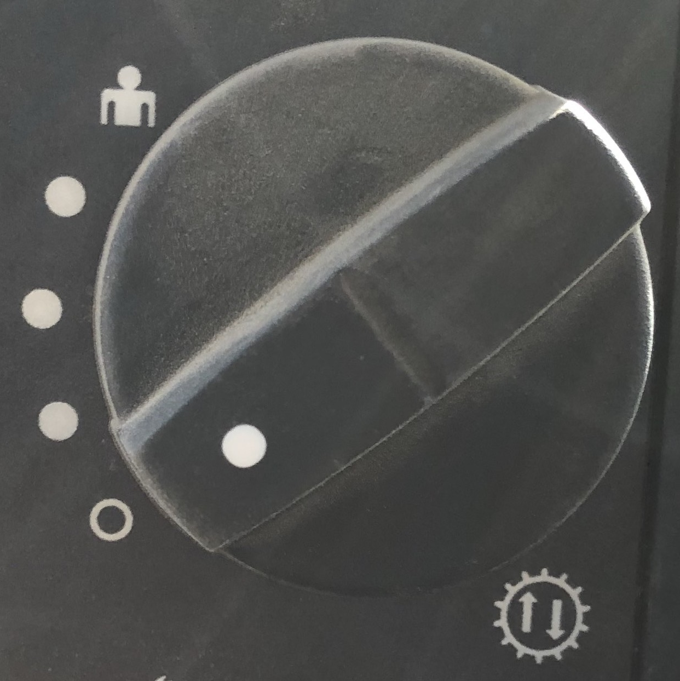
Auto-shift knob: It allows for a variety of settings to the machine automatically switches into certain gears.
Mode: 2F-1R
Mode: 2F-2R
Mode: 1F-2R
Mode: Independent
Mode: Unison
When driving manually, in Modes 1F-2R, 2F-2R, and 2F-1R any time the direction is changed to F or R the gear is set to a specific gear regardless of what it was before. In unison, both gears change together – change into 3rd in forward, when you switch into reverse you are in 3rd in reverse. In independent, you can set the forward and reverse gear independently.

When driving autonomously, we seem to switch into Unison mode when the knob is in Independent mode. Is there a CAN message or way from software to change the mode. Or is there a way to detect which mode we are in?

I can work around it, but I think it would be useful if we can get this information some how.

