12/17/2025
How will the database be structured?

Company name, Date Applied, Platform (Handshake, LinkedIn), Job Position, URL, Notes

12/18/2025
I think I will choose MySQL over SQLite.

What I should do:
1) Write down functional requirements <-- remembered I want to mark jobs as ACCEPTED, REJECTED, IN PROGRESS, NO RESPONSE
2) Layout the UI
3) Design the database
4) Code the app

FUNCTIONAL REQUIREMENTS
- Allow user to create a job tracker
- Allow user to edit job tracker info
- Allow user to delete job tracker info
- Allow user to set status of job tracker
- Set status accepted
- Set status rejected
- Set status interviewing or in-contact
- Set status in progress (or waiting)
- if job date is not past the expected decision date
- Set status no response
- if job date is past the expected decision date

- Allow user to select job filters
- Filter company
- Filter job field: software engineering, computer engineering, electrical
- Filter job type: full-time, part-time, internship
- Filter date applied range

- Allow user to click URLs to go to company's job application/status page

- System sorts job tracker info by date
- System displays # of jobs applied in a specified time period
- Time period of current month
- Time period of past month from today
- Time period of current year
- Time period of today
- Time period of specific day
- Time period of current week
- Time period of specific week

LAYOUT THE UI
Pages
- Create job tracker
- View job trackers
- View job applying statistics, maybe download data page?

DATABASE DESIGN
- In jobapp-db-diagram.drawio

12/21/2025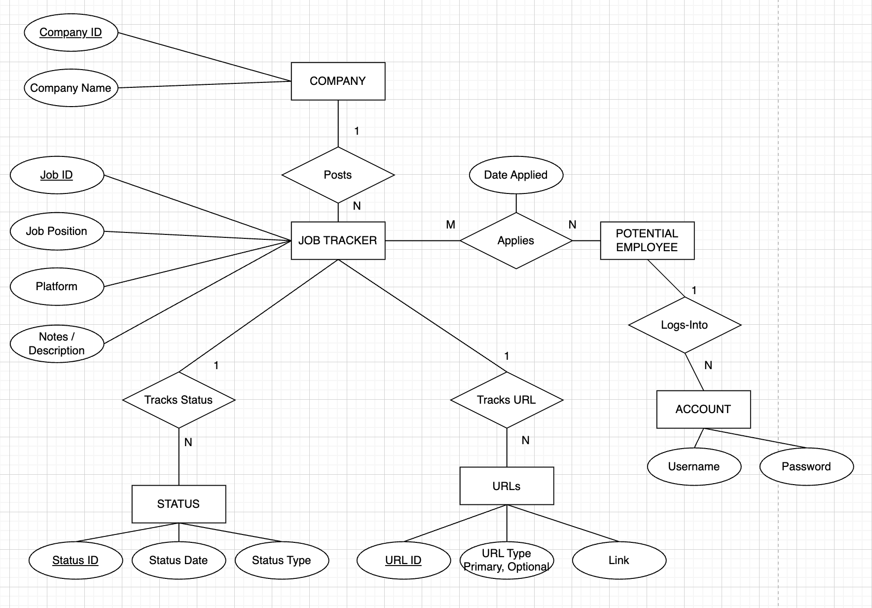

Database ER Diagram currently looks like this.

Should I connect ACCOUNT to the URL? Or to the COMPANY? I want to see what account is associated to what company.
What if I just had username as my email instead of email+company? Then I would need a different way to distinguish accounts if they have different passwords.

Do I need to reconsider the platform attribute of JOB TRACKER. If I find it through Handshake, but end up going to the company website, should I just have it as the company name instead?

I added the relationship degrees (1:N, M:N). I didn’t add the single/double line though.

Each company can post multiple job listings, but each job is not listed by multiple companies.

For the most part, for the applications I have done, each company uses one type of application portal. So, I think the account login information should be connected to the company and potential employee??? But I stuck on whether it should connect to the job listing and URL. Well the job listing is connected to the company already and URL is connected to job listing.

Now that there is some SQL (was it DDL or DML???) for the database, how do I populate my database?

For the app, I want to use the frontend HTML/JS to send the data as a form to my Python APIs. The Python code should open a connection to the MySQL server and perform operations.
- First create the APIs
- Next create Python code to test APIs
- Then create the “Create Job Tracker” UI page
- Afterwards, create a page to “View Job Trackers”
12/25/2025 – 5:53pm
Previously, I wrote DDL for the database, Data Definition Language. Now, I need to write the queries – also known as DML, Data Manipulation Language.

A good place to start is reviewing how to write SQL queries.
I could take a look at CH6 & CH7 slides.

CH6 Slide 29: Start of “Basic Retrieval Queries in SQL
https://www.w3schools.com/python/python_mysql_where.asp
^ about %s to prevent sql injection

Need to learn how to get HTTPS Method input / POST Method in FastAPI
Break 6:08pm Return 6:15pm

https://fastapi.tiangolo.com/
https://fastapi.tiangolo.com/async/ ← looks interesting to read. Learning about concurrency and async / await

https://fastapi.tiangolo.com/tutorial/first-steps/#path
A path refers to last part of URL starting from first /
Path aka “endpoints” or “routes”

POST: to create data.
GET: to read data.
PUT: to update data.
DELETE: to delete data.

For endpoint /api/account/username-availability:
I guess I want to read data from database. So even though I am sending username to API, I should still make GET method.

I am not looking for Path Parameters (http://127.0.0.1:8000/items/foo), nor Query Parameters (http://127.0.0.1:8000/items/?skip=0&limit=10), I am looking for how to work with Request Body

https://fastapi.tiangolo.com/tutorial/body/
A request body: data your client sends the API.
A response body: data your API sends the client.

They usually use Pydantic to make Request bodies. Here is how to do without.
https://fastapi.tiangolo.com/tutorial/body-multiple-params/#singular-values-in-body

6:49pm Need to see how to send a request body in javascript.
Break at 7:04pm Return 7:40pm
TypeError: Failed to execute 'fetch' on 'Window': Request with GET/HEAD method cannot have body.
at checkUsernameExists (create_account.js:32:28)
at HTMLInputElement.<anonymous> (create_account.js:11:5)

GET method cannot have body, so have to use POST

create_account.js:32 Fetch API cannot load localhost:8000/api/account/username-availability. URL scheme "localhost" is not supported.
checkUsernameExists @ create_account.js:32
(anonymous) @ create_account.js:11Understand this error
create_account.js:18 Success! Passwords match.
create_account.js:47 TypeError: Failed to fetch. URL scheme "localhost" is not supported.
at checkUsernameExists (create_account.js:32:28)
at HTMLInputElement.<anonymous> (create_account.js:11:5)

Can’t have localhost ← using VSCode Live Server

Back at 11:35pm
How to encrypt/hash a password in JS?
Google says use bycrypt and NOT to encrypt on client side.

Needed to downgrade bycrypt to support version of passlib since I have python 3.11 (this issue took a while)
Need to increase VARCHAR(20→100) to store HASHED PASSWORDs
Finished 1:30am 12/26/2025
12/26/2025 – Friday 10:49am
Build “Create JobTracker” UI.
Build sign-in page. How to manage user login session?

11:41am – The sign-in API is working. Everytime I hash the login password, although it is the same password, the hash changes. That’s why we need to just send the plain password and just verify it with the hash in the database.

12/31/2025 – Wednesday 4:48pm
Work on the “Create Job Tracker” page today
End 5:43PM Made HTML and JS page

