Study Station

Study station is an android application that helps the university student:

* Share his learning process among other students in an easy fast way
* Get additional resources to study from other student’s notes
* Revising his notes in an organized way
* Asking questions and get answers in an organized way
* Take the challenge to be a moderator in some topics
* Share any other self-study courses to students

**The problem**

It is frequently happen that the student don’t understand some points from the doctor, so he resort to TA, but what if he still don’t understand the point ?  
Sometimes he want another student to illustrate it to him.  
In another hand, if the student illustrate some points to others he make sure that he get the point and it help him to keep the info in his mind longer.  
This is the core of “Study Station” based on and this is the main problem it solves.

Study station ER Diagram 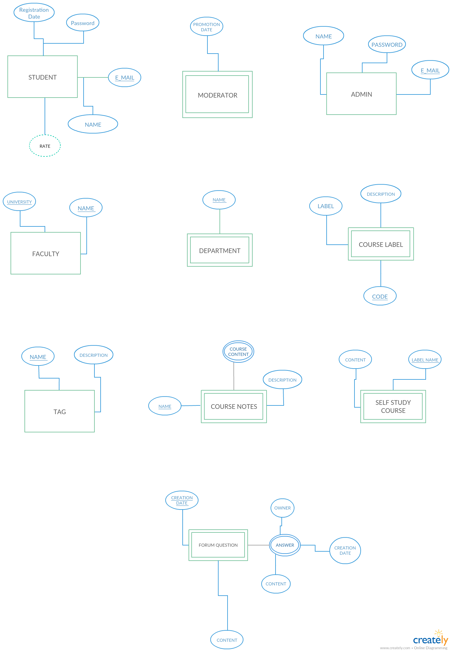

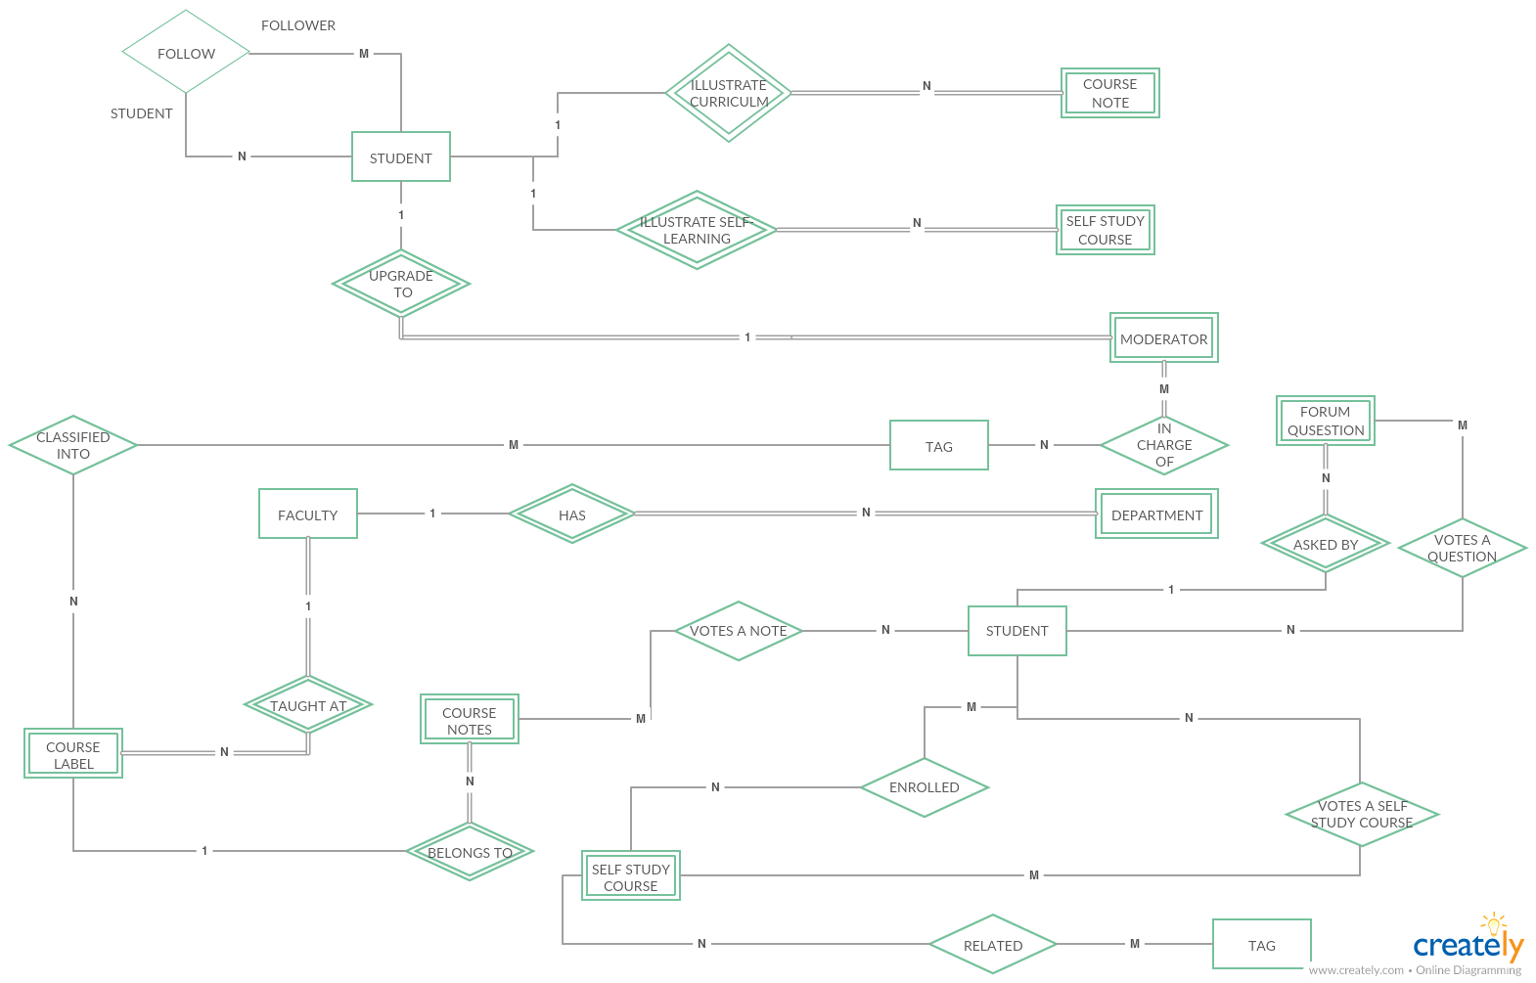

The relations

Any weak entity has an underlying attribute

This attribute is a partial key

(We can’t make a dash line)

Clarification of ER Diagram

**Entities:**

* ***Student***:  
  contain the info of one user
  + Name: appearance name that will appear to other students
  + Email: the educational email of student (it should be like username@%faculty%.%university%.edu.%country) such as  
    ammaralsayed@eng-st.cu.edu.eg
  + Followers: all students this student follow (read user & functionality)
  + Rating: a derived attribute indicates the power of this student.  
    Calculated from number of courses he made and the number of votes in each course
  + Notes_Playlist: multi valued attribute contain all the playlists of notes this student made ( a one playlist contain one or more videos – read this entity below )
  + Self-studied-course: multi valued attribute contain all the self-studied courses this student made
* ***Moderator***: contain the info of one moderator, any moderator should be a student
  + Promotion-date: the date this student promoted to a moderator
  + Related-topic: identify the tags this moderator is responsible for (Read the tag entity)
* ***Tag***: categorize the questions, courses and the moderators. This facilitates the search and introduce more controls on contents according to users
  + Name: the name of this tag, it could be like “c++” “machine-learning”
  + Description: the description of this tag, it could be like “c++ is a famous programming language developed by…”
* ***Question***: form question where any student can ask or answer
  + Votes: number of up votes to this question, this indicate if this question is helpful or not
  + Owner: the student made this question
  + Answer: the answers to this question( it has an owner and the content).
* ***Course-label:*** this entity contain the info of one specific course exists in one faculty to allow the student to refer their notes to(one course-label can exists in more departments)
  + Label: the name of the course in this faculty, such as “Math1”, note that this course exist in more department in the same faculty “CMP” and “biomedical”.
  + Description: a description of this course, this can contain the instructor or any additional information can be added like course contents.
  + Code: the code of the course label, it will identify the course label (primary key)
* ***Faculty:*** this can also be included as the domain of the email (the educational email determine the faculty and the university)
* ***Notes_playlist:*** this entity is a playlist refer to existing course label. When the student made a new playlist and say this is the subject.  
  such as, student “ammar” make a notes playlist and refer it to course label “Math1”.  
  when the student want to illustrate a course in its department he will find it in the course label list (the moderators is responsible of editing this list while courses differs)
  + Course-content: YouTube links or any links that identify the actual playlist content
* **Self-study_course:** this entity is free to the student, this course say that he illustrates some points or whole course he took outside the curriculum of department.

**Relations:**

* **Votes_self_study**: this relation is because at any time we want to know the courses this student vote it up ( if he enter many times later he should find it marked).
* **Enrolled**: identify which self-studied courses he takes or took.

Users & Functionality

* Student: highest
  + Login / Sign up
  + Update personal information as name, password and etc.
  + Uploading Notes and Videos: the student explain a certain subject related to a course label in a department in the faculty using videos or notes.
  + Asking questions and answer others in forms which helps in sharing knowledge between them and the tags facilities the accessing of question related to specific topic.
  + Making self-study courses: the student explain various subjects using videos and showing them in playlists related to the students and that subjects is not related to specific course.
  + Follow other students: find the profiles of students that the student follow effectively and know the followers that follow him through followers list.
  + search for students
  + view other students profiles : Also view their courses , votes and courses
  + Rate courses made by other students
  + search by tag
* **Moderator:** each moderator is a student and has these more functionalities
  + modify courses list : delete or add courses (course label )from course list in any faculty
  + modify courses contents: the course content as videos or notes related to the topic he responsible for
  + Search students.
  + View student’s profile.
  + handle question tags : each moderator handle a number of tags contents questions and videos
  + Sign up/log in.
  + Update personal information.
* **Admin:** can access the whole databases
  + ban students: due to violation of rules
  + Adding or deleting moderators.
  + Sign up/ log in.
  + Update personal information.
  + show the most active students : active students is the students who upload the largest number of content
  + handle the tags for each moderator
  + show the number of questions in the form daily
  + calculate statistics about the app : as the number of students , questions and etc