

**Community-scale Online Network Analysis of Social Data Streams**

**Progress Report (or Final Report) for**

**ENGR 498 Global Design Project II Synthesis**

**Ammar Raşid**

**Assoc. Prof. Ahmet Bulut**

**College of Engineering**

**İstanbul Şehir University**

**28/05/2018**

# 

# **Abstract**

The project is about building a web-based application that collects, analyzes and visualizes Sehir social networks. Our motivation is to render the story of Sehir community in an interactive and insightful manner. The project utilizes Natural Language Processing, Network Analysis and Data Visualization to draw insightful conclusions based on contextually rich data. Organizational intelligence and social computing are at the core of what this project provides for social, management and computational studies.

# **Abbreviation**

Adaptive Online Clustering (AOC)

Latent Dirichlet Allocation (LDA)

Natural Language Processing (NLP)

Bag of Words (BOW)

JavaScript Object Notation (JSON)

# **Acknowledgements**

I would like to express my gratitude for the kind support I have got from:

Prof. Ferhat Kentel, Prof. Mustafa Özel, Prof. Mehmet Akif Kayapınar, Abdurrahman Abodakika, Selma Slocum and Somaya Gamal.

Table of Contents

Abstract 2

Abbreviation 2

Acknowledgements 2

Introduction 5

A BAD Demonstration: Towards Big Active Data 6

FlashView: An Interactive Visual Explorer for Raw Data 8

Adaptive online event detection in news streams 10

Microblogs Data: Twitter 12

Generic Social Media: Facebook 13

Spark Streaming 14

System Overview 14

Scrapper 15

Analyzer 15

Visualizer 17

Evaluation 18

Social Sciences aspects 20

Contextual Insights 20

Affiliation Network and Closures 20

21

Homophily 22

Conclusion 23

References 24

# **Introduction**

The amount of high-throughput data made available in the past decade coinciding with an exponential increase in the computational power has provided researchers with the opportunity to make holistic analysis without taking data out of their contexts. The sheer visualization of community networks has the potential of revealing latent problems in early stages and predicting others before they take place. Operational Intelligence (OI) leverages fully contextual data and social networks to observe, analyze and make prudent decisions. Analyzing the common interest, demands, objections and other sentiments-related trends of the mass are manifested in the political application of OI. The motivation for our project is to crawl social media data of members of Sehir community (Students and staff), integrating them with structured data from university’s database (e.g. field of study) and analyzing the community in holistic manner. One caveat though is that we do not brainstorm the tools available to us and look for problems to apply them too, but rather we seek advice and guidance from social science departments regarding the problems that they think are likely to happen or phenomena worth studying. We aim to have an online system, continuously collecting and integrating contextual data and keeping track of the evolution of the community network. A system with this momentum once ready is passed through an interactive visualization pipeline. Observation and analysis are a recurrent cycle forming the core of our system.

Background and Literature Review

## A BAD Demonstration: Towards Big Active Data

(Jacobs, et al., 2017). summarized three key requirements for an effective ‘Big Active Data’ analysis system; First and foremost, significant importance of data could only be detected and analyzed in the entirety of the data context and their relationships to other data items. Second, data should be ‘enrichable’ using other relevant data to make up for important absent information. Third and Last, active data should both be processed on the fly, thus the name, and also in retrospective manner as the evolution of the data in a time-line per se has a significant value. Their proposed BAD system is mostly an extension to Event Condition Action (ECA) rules and Triggers in that it overcomes their two key limitations. First, in contrast to ECA where when event E happens, action A is performed, BAD provides optimizable way of detecting complex events of interests. Second, BAD scales to a degree required for Big Data that hasn’t been achieved by previous implementations of Triggers or ECA rules . They extended Apache AstrexDB with a new feature they called Channels. Channels are versions of queries that are instantiated with parameters and executed continuously starting at their creation.

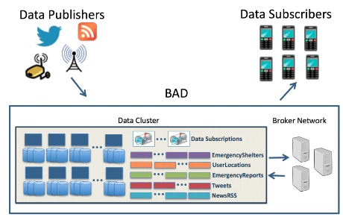

Figure 1 Big Active Data (BAD) System Overview

They also introduced a BAD Broker Network coordinate the data flow between the data cluster and the client. BAD Broker Network consists of Broker Coordination Service and BAD broker nodes. Brokers, as the name suggests, act as mediators between the client (handled by a client-facing part) ,for handling client registration, managing subscriptions and delivering results for those subscriptions, and the data cluster, for handling interactions with the Asterix backend (handled by Asterix-facing part). The common ground between our project and this work is the ‘Big Active’ data, as their work scales to the large number of subscribers, though the number is not mentioned, while maintaining the feasibility of the system and not compromising any of the three key requirements they summarized for effective Big Active Data systems. However, we are not really into data subscribers and notifications. What matters for us is crawling the published data. In contrast to their work, we focus only on data published by individuals in a specific community, i.e. Sehir Community.

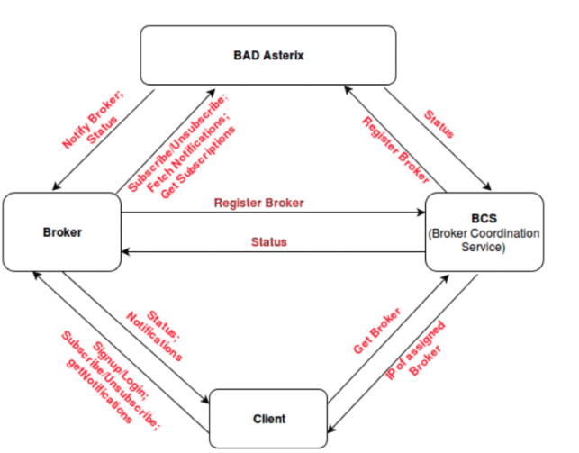

Figure 2 Broker Data Flow

## FlashView: An Interactive Visual Explorer for Raw Data

In order to query big data in near-real-time speed in continuous manner, a trade off between loading speed or querying speed; processing and indexing raw data takes significantly long time, but once the data is loaded and indexed, querying is almost instantaneous. On the other hand, we could skip the data-loading step to save the time consumed in this bootstrapping step, but then queries would suffer from tediously slow performance. (Pang, Wu, Chen, Chen, & Shou, 2017). address this dilemma by introducing FlashView- an interactive visual explorer for raw data made to help analysts get initial acquaintance with the data they are given to analyze. The key point in providing a real-time response for data aggregation, without loading the data but rather manipulating raw data files directly, is leveraging approximate query processing techniques. Since FlashView provides fast but accuracy-compromised queries, an error metric and bound had to be specified. FlashView executes queries on randomly selected samples from the data and uses Hoeffding Inequality to estimate the bounds for the approximation.

Equation 1 Hoeffding Inequality

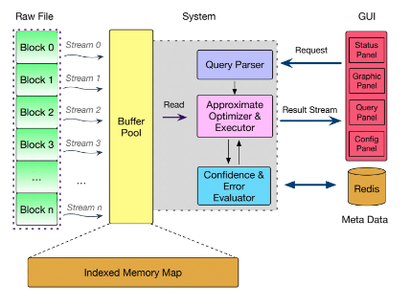

Figure 3 FlashView Architecture

The interesting component in their paper to our project is how they regulate the Data Flow in SQL trees. They use caching to keep track of active queries, so that if a subsequent query depends on one of the active queries, the later query could branch out from the active query directly and not from the root query.

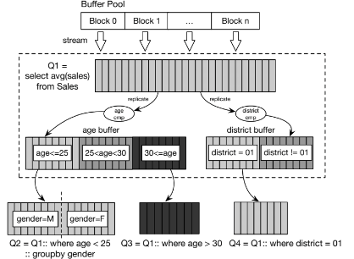

Figure 4 Data Flow of SQL Tree

## Adaptive online event detection in news streams

Though the scarcity of big contextual data had been the main hindrance facing analysts couple of decades ago, the amount of these data is growing in an overwhelmingly rapid way. Big data are not just overwhelming for analysts but also to Data Management Systems (DMS); keeping record of big contextual data over long timelines and applying machine learning models on the top of that could be thwarted by poor performance in querying speed and full-patch variations of machine learning models. (Hu, Zhang, Hou, & Li, 2017) address the problem of event detection through capturing news stream data and feeding them to single-pass online clustering model, yet with some intermediary processing of the data, making their method significantly faster than standard single-pass online clustering and even with higher Normalized Mutual Information (NMI) and F1 scores. The method this paper provides is pertaining to our project in that it processes time-sliced textual (unstructured) data streams while maintaining feasible performance speed and accuracy. There are two main keys to the significant superiority of the method proposed in this paper over the standard single-pass online clustering algorithm. First, before applying single-pass online clustering , they use K-means clustering to cluster similar words based on their skip-gram word embeddings.

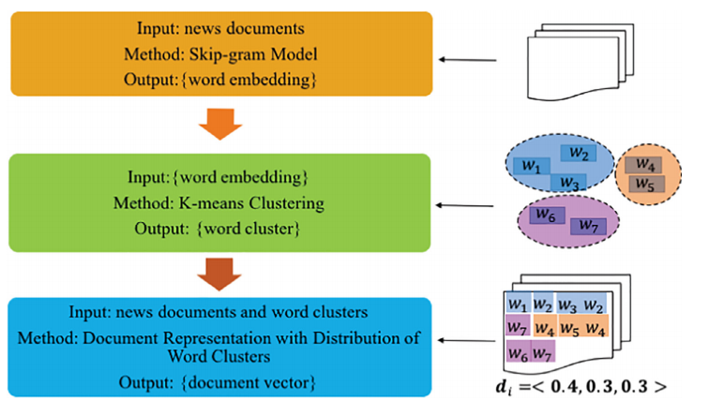

Figure 5 Process of document representation

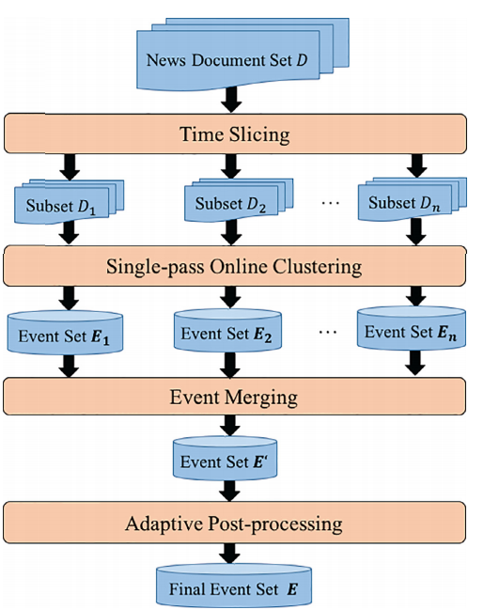Second, after obtaining document vectors from the distribution of word clusters, they slice the documents set to subsets of similar time period. Having relevant subsets of data, they parallelize the single-pass online clustering on each of the subsets (time periods).

Figure 6 Process of adaptive online clustering method

In order to polish the precision of the clustering algorithm -eliminate the noise associated with similar news documents belonging to different events- they use variance to determine which clusters are ‘high-quality’ (i.e. with low variance) and which are not based on a threshold parameter δ. They use F1 and NMI scores as metrics for the recall-precision performance assessment. Adaptive online event detection has the momentum of capturing, not only events from news streams, but also trends and networks from micro blogs (e.g. Twitter) and flattening the evolution of these trends and networks over a time-line.

## Microblogs Data: Twitter

Microblogs such as Twitter provide invaluable data in significant amounts and rich contexts. Not only that, but also Twitter has an open-source API for developers to access and analyze these data. Such versatile data have been used for many types of analyses. Just to name a few, (Lekha R. Nair, 2005) have used data streams from Twitter for job search using machine learning categorization algorithms based on hashtags and Spark Streaming for real time data collection. (Marcus, et al., 2011) in MIT CS-AI Lab built two systems for programmers upon Twitter API- TweeQL and SQL-Like stream processor that provides streaming semantics and user-defined functions for extracting and aggregating tweet-embedded data. And for end-users, they build TwitInfo- a timeline-based visualization of events in the tweet stream linked to raw tweet text, sentiment analysis and even maps. (Jin, Zhu, Jin, & Arora, 2014) opted to visualize the ‘SentimentRiver’ where the balance between positive and negative sentiments is visualized as a ‘current’ of three layers, each representing a sentiment –positive, neutral and negative.

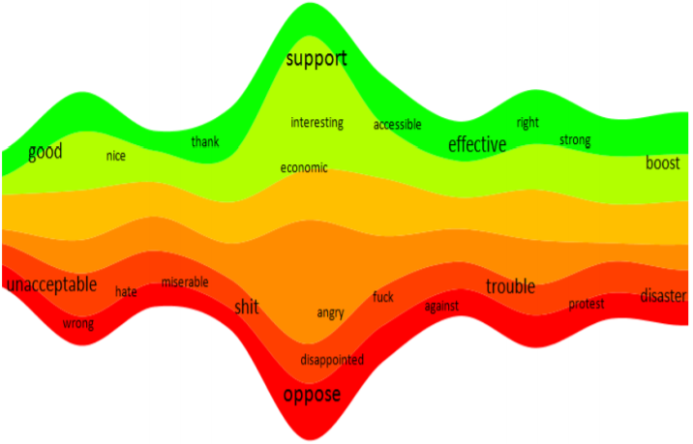

Figure 7 SentimentRiver with labels

One of the main challenges facing Twitter-based analyses is the sparsity of publicly available tweets in specific area and Twitter users mostly do not share information about their locations. (Wei, Sankaranarayanan, & Samet, 2017), utilize geotagging procedures to estimate the location for unknown-location users by examining the publicly-known locations of their friends on Twitter, and thus eliminating the aforementioned challenge. They use TwitterStand, a news tweet processing system that collects tweets and classifies them as news or not that was developed by them, to aggregate news tweets into clusters, determine their geographical focus and display them on an accessible map-query interface.

## Generic Social Media: Facebook

Although Facebook has the potential of providing even more valuable data than twitter, especially for friend-friend relationship networks. In fact, Twitter as a microblog is not used for casual social ‘posts’ as much as Facebook and, therefore, Facebook with features like, likes, comments, shares, events, pages and groups provides richer context for community-scale analysis. However, Twitter is far more ‘opensourced’ than Facebook. (Chen, et al., 2016), gave an overview of the system Facebook use in realtime data processing. They identified five design-related decisions regulating ease of use, performance, fault-tolerance, scalability and correctness.

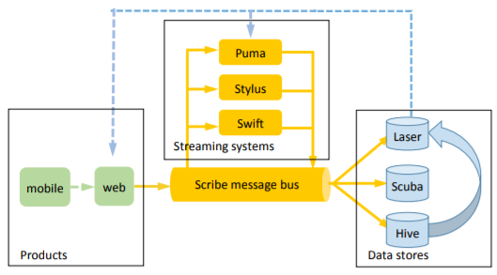

Figure 8 Realtime data processing system overview

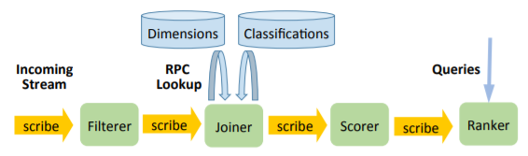

Figure 9 Computing “trending” events with a streaming application

## Spark Streaming

Spark is an opensource computing-cluster that has a long list of applications including machine learning (MLlib), network analysis and visualization (GraphX) and realtime data collection and analysis (Kafka and Spark Streaming).

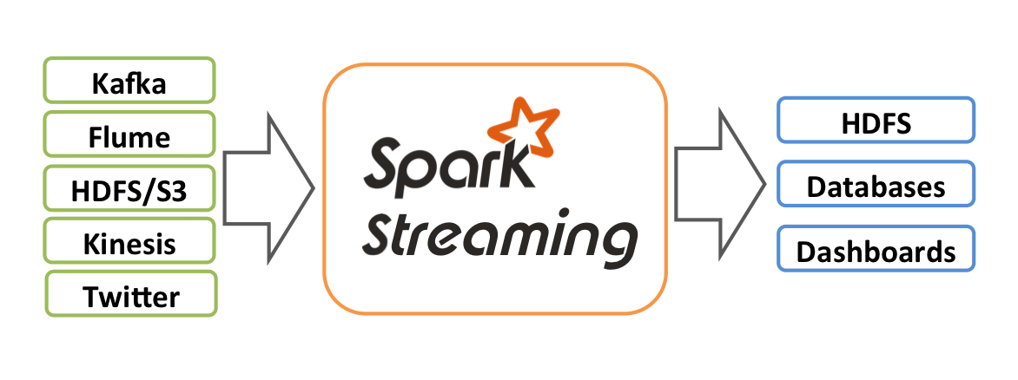

Figure 10 Overview of data flow in Spark Streaming

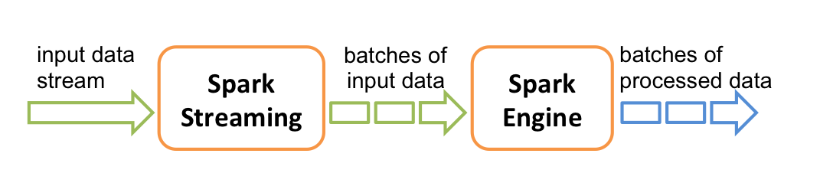

Figure 11 Overview of Spark Streaming application pipeline

## System Overview

Our system has three main components; Scrapper, Analyzer and Visualizer.

Figure 12 System Workflow

### Scrapper

For Twitter, Şehir official Twitter accounts are used as root nodes for our crawler to get the accounts of their followers and the followers of their followers. The collected Twitter accounts are then classified as Şehir account if they match a Şehir Gmail contact with at least 85% similarity. Twitter Streaming and Spark Streaming APIs are used to continuously collect tweets posted by accounts classified as Şehir accounts.

For Facebook, Şehir’s community groups are used as pools of Facebook accounts. Posts and shares are not allowed for API-based crawling.

Augmenting Twitter users with their groups membership in Facebook is done by merging Twitter users Data frame with Facebook users Data frame on their *sehir_matches* (the Şehir Gmail contact name of that account).

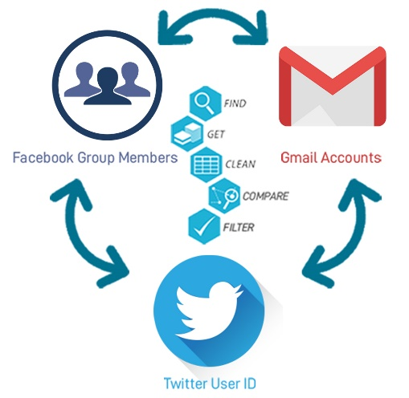

Figure 13Augmenting Twitter Network with Facebook Groups

### Analyzer

For Twitter connections, a network is constructed. In network, two nodes and have a directed edge between them if user is following user on Twitter. Networkx and SnapPy libraries are used for augmenting the network nodes with the following metrics: Betweenness, eigenvector centrality, closeness centrality, degree, in degree, out degree, parity, *pagerank* and corresponding community –calculated by Girvan–Newman community detection algorithm-. On a network level, modularity and network in, out and undirected diameters are calculated along with the average of the aforementioned node-level metrics.

We construct another network where we first download the timelines of sehir twitter accounts captured by our Scrapper. Downloaded tweets are fed to the Adaptive Online Clustering (AOC) class. AOC class implements adaptive online clustering algorithm to cluster tweets based on the cosine similiarities of their vector representations. A tweet is representated using BOW algorithm by taking the average of word2vec representation of words in that tweet. In network , two nodes and have an undirected edge between them if user and user have tweets in the same cluster. The weight of edge is the number of clusters both user and user have tweets in.

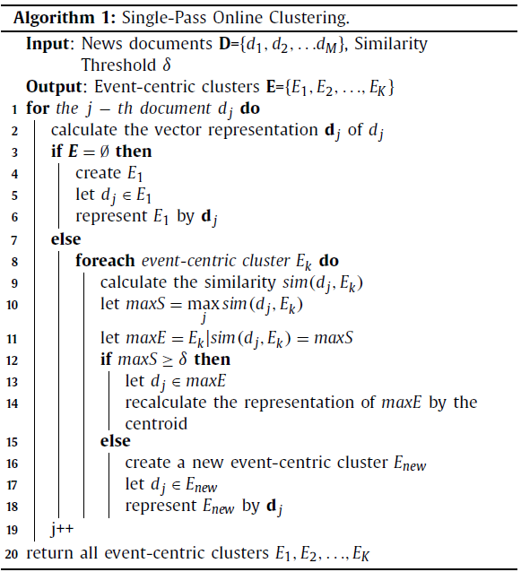

Algorithm 1 Single-Pass Online Clustering

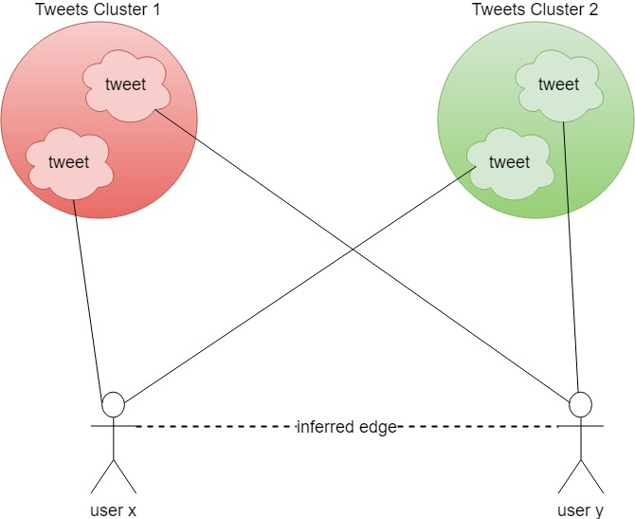

Figure 14 Users connections inference based on tweets clusters

### Visualizer

Django framework is used to put together a dynamic interactive visualization. Networks constructed by the Analyzer are passed to Django templates as JSON responses. Django’s *Views Functions* filter the network as specified by the user interaction with the filtering widgets. Users can filter the network by the node-level metrics added by the Analyzer. Sizes of the nodes are defined by a node-level metric customizable by the user.

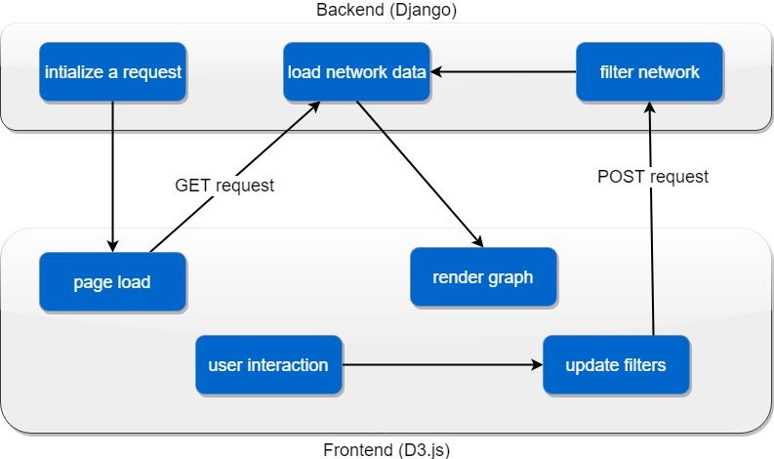

Figure 15 Backend-Frontend interaction mechanism for dynamic interactive visualization

# Evaluation

Having setup the foundation for collecting Sehir accounts timelines from twitter, constructing a network of the social media accounts and visualizing the networks with interactive visualization tools, our focus at this stage of the project is to construct more sophisticated networks of the latent connections of Social Media accounts. We are deploying the project as a web-based application where we show the various networks of Sehir community and report the networks’ centrality, homogeneity, modularity and many other metrics describing the structure of the community network. Fruitful insights require rich interactive visualization experience. We have applied the framework depicted in Figure 15 on twitter connections network defined in Analyzer.

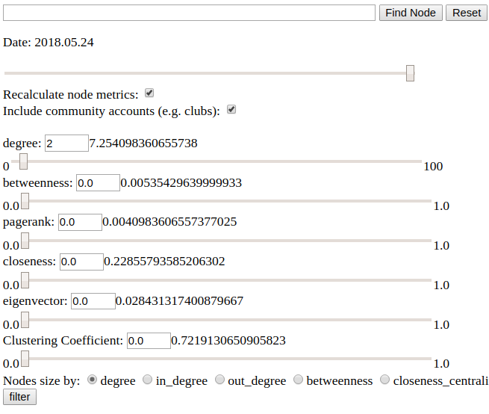

Figure 16 Filtering widgets and the average of node-level metrics

Users can filter nodes by their Degrees, Betweenness, Pagerank, Closeness, Eigenvector centralities and Clustering Coefficient. User can also choose which metric to be used as a relative indication of nodes’ sizes, in addition to in-degree, out-degree and followers count. The timeline scroll can be used to access the network at different dates as it is being augmented regularly by our Scrapper. In order to ease searching for specific nodes in the network, the search bar provides searching by name or screen name. The set of nodes selected by the searching query are highlighted with higher opacity and bigger sizes, other nodes will have much lower opacity and the graph automatically zooms on one of the selected nodes.

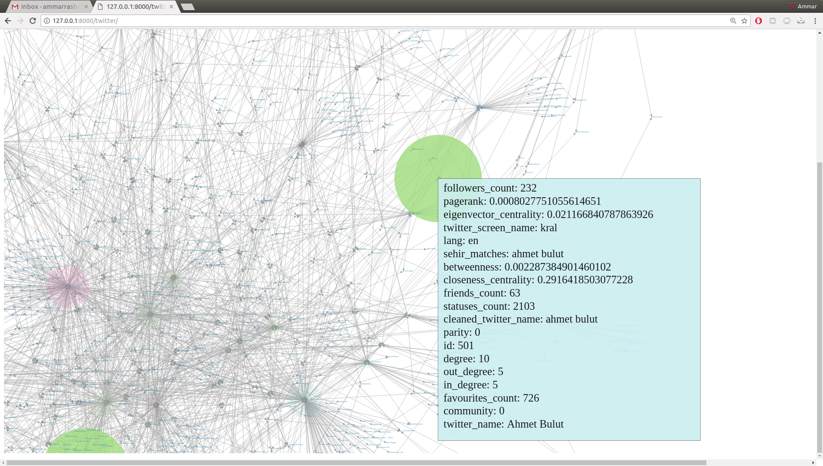

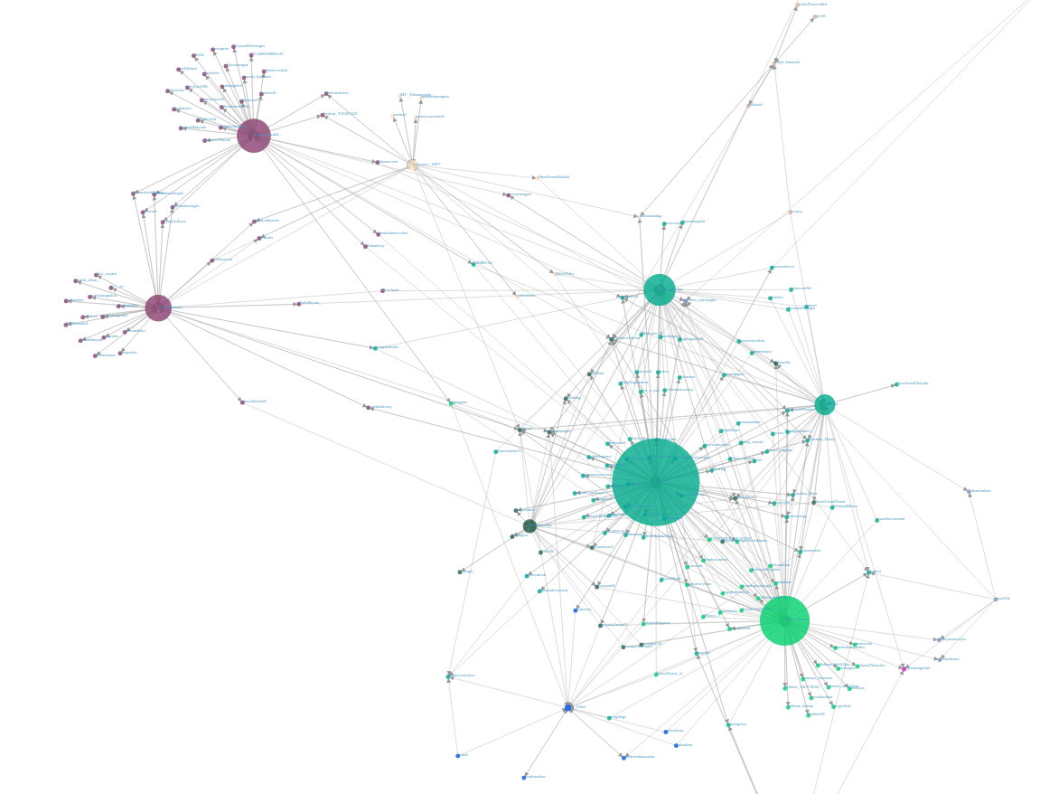Figure 17 Node-level metrics

Figure 18 Sample of Twitter user-to-user follows networks. Colors indicate the community calculated for that node by Girvan–Newman community detection algorithm. The size of a node relatively indicates its degree (customizable).

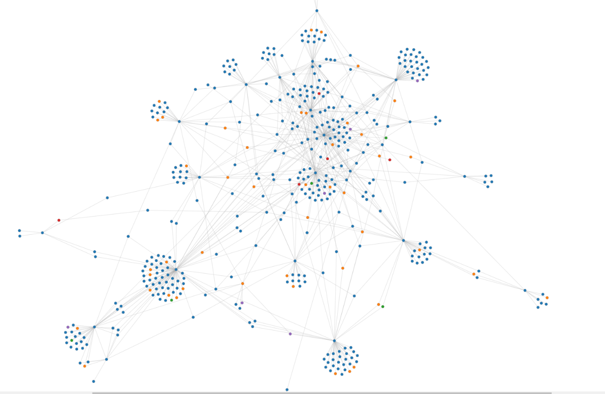

Figure 19 Twitter follows Networks Augmented with Facebook Group Membership. Colors correspond to Facebook Groups

## Social Sciences aspects

Lest we should become a “hammer” with the well-known analysis computational tools and everything becomes “nails” for us, we sought cooperation from Social Sciences faculty. We believe that, though providing the right answers is important, asking the right questions is far more important. Therefore, it is not a reversed logic to directly look for applications for the analysis tools we have in hand, but rather we should look for the issues shouting to be addressed and then look for the right means of addressing them. With the help of a philosophy-major student, we have conducted meetings with professors from sociology and political science departments who in turn, including the philosophy student as well, have shared valuable insights about how a community-scale analysis should consist of, what information are important to collect, what theories and methods relate to our goal and what challenges are likely to face us.

## Contextual Insights

### Affiliation Network and Closures

We have considered official organizational accounts, such as Sehir University or Sehir Cycling as ‘foci’ nodes. We then monitored the evolution of the network over dates. Our approach in measuring the social influence within the affiliation network is based on monitoring the formation of new closures; membership closures, focal closures and triadic closures.

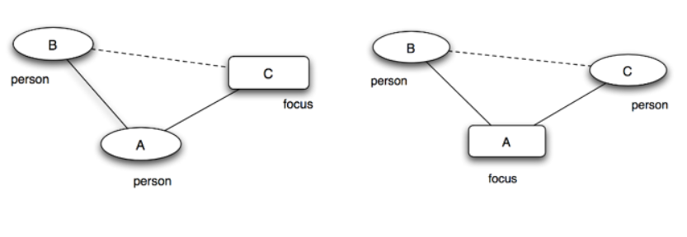

Figure 20 Membership closure (right) indicating social influence. Focal closure (left) indicating selection

## 

Figure 21 Affiliation network. Blue big nodes are the 'foci' nodes. The one in the centre is Şehir University twitter account

### Homophily

Homophily is the tendency of individuals to have bonds with others who are similar to them. We opted to measure homophily in Şehir network to study how the context surrounding the network is driving link formation and fundamentally governing the structure of the network. We have chosen language to be the contextual factor for homophily measurement as language proved the best accessibility to contextual relevance ratio. We have found that the probability of a link between two users speaking different languages in the network is slightly higher than the heterogeneity fraction norm. That can be considered as an evidence for cross-cultural ambience in Şehir and refute the argument that language barrier in Şehir is significantly hindering cross-cultural integration.

# Conclusion

The relational structure of fully contextual social data is a loud yet subtle story of the society it represents. Sehir’s story is embodied in the network’s we construct, analyze and temporally monitor, of direct and latent connections. Our approach in constructing the social networks is interdisciplinary and welcoming for everyone willing to have his or her voice in Sehir mosaic. We believe this project has the potential of bringing together an interdisciplinary team and providing important insights for social, management and computational studies.

# **References**

Chen, G. J., L. Wiener, J., Iyer, S., Jaiswal, A., Lei, R., Simha, N., . . . Yilmaz, S. (2016). Realtime Data Processing at Facebook. *International Conference on Management of Data* (pp. 1087-1098). California, USA: Facebook Inc.

Hu, L., Zhang, B., Hou, L., & Li, J. (2017). Adaptive online event detection in news streams. *Knowledge-Based Systems*, 105-112.

Jacobs, S., Sarwar Uddin, M., Carey, M., Hristidis, V., J. Tsotras, V., Venkatasubramanian, N., . . . Li, Y. (2017). A BAD Demonstration: towards Big Active Data. *Proceedings of the VLDB Endowment*, 1941-1944.

Jin, H., Zhu, Y., Jin, Z., & Arora, S. (2014). Sentiment Visualization on Tweet Stream. *JSW*, 2348-2352.

Lekha R. Nair, D. S. (2005). Streaming Twitter Data Analysis Using Spark. *Journal of Theoretical and Applied Information Technology*, 349-353.

Marcus, A., S. Bernstein, M., Badar, O., R. Karger, D., Madden, S., & C. Miller, R. (2011). Processing and Visualizing the Data in Tweets. *ACM SIGMOD*, (pp. 21-27). NY, USA.

Pang, Z., Wu, S., Chen, G., Chen, K., & Shou, L. (2017). FlashView: An Interactive Visual Explorer for Raw Data. *Proceedings of the VLDP Endowment*, 1869-1872.

Wei, H., Sankaranarayanan, J., & Samet, H. (2017). Finding and Tracking Local Twitter Users for News Detection. *International Conference on Advances in Geographic Information Systems* (p. 4). NY, USA: DOI: 10.1145/3139958.3141797.