Computer Networks (CSC3275) - Lab Final Project Report
Project Title: Multi-Client Chat Application using Socket Programming
Submitted By: Ammar Shahzad
Instructor: Sir Babar Imran
Course: Computer Networks Lab (CN-L)

1. Introduction
Modern computer networks rely heavily on client-server communication models. For this final lab project, a "Multi-Client Chat Application" was developed using Java Socket Programming. The application demonstrates the practical implementation of networking fundamentals, establishing real-time, bidirectional communication between multiple clients and a central server over a Local Area Network (localhost).

2. Objectives
The primary objectives of this project, aligned with Course Learning Outcome (CLO-5), were to:
- Design and implement a robust Client-Server architecture.
- Utilize TCP sockets for reliable data transmission.
- Manage concurrent client connections using multithreading.
- Implement user authentication with encrypted passwords.
- Provide interactive data exchange features (Broadcast and Private Messaging).
- Ensure fault tolerance through proper error handling and thread-safe logging.

3. System Architecture
The application follows a centralized Client-Server Architecture and is structured into four main Java classes:
- Server.java: The core engine that listens on Port 5000, accepts incoming connections, and maintains a thread-safe ConcurrentHashMap of active users and database credentials.
- ClientHandler.java: Implements the Runnable interface. A new instance is spawned for every connected client to handle authentication, parse input commands, and route messages independently without blocking the main server.
- Client.java: The client-side application. It utilizes two threads: the main thread reads user input from the console to send to the server, while a background "daemon" thread continuously listens for incoming server messages.
- Security.java: A utility class dedicated to hashing passwords using the SHA-256 algorithm and validating user inputs.

4. Protocols and Ports Used
- Protocol: TCP (Transmission Control Protocol) - Chosen to ensure reliable, ordered, and error-checked delivery of chat messages.
- Port: 5000
- Host: Localhost (127.0.0.1)

5. Detailed Feature Explanation

5.1. Multi-Client Handling (Concurrency)
The server supports multiple clients simultaneously using Multithreading. When a client connects, the server accepts the Socket and passes it to a new Thread(ClientHandler). This ensures that if one client is typing slowly or has a high latency, it does not delay the message delivery for other connected clients.

5.2. User Authentication & Security
To prevent unauthorized access, clients must authenticate before joining the chat.
- Mechanism: The server prompts for a username and password. The client is granted a maximum of 3 login attempts before the connection is forcefully closed.
- Encryption: Passwords are not stored or compared in plain text. The Security.java class uses Java's built-in MessageDigest to convert entered passwords into SHA-256 hashed hex strings before comparing them against the database.
- Duplicate Prevention: The server checks the ConcurrentHashMap to ensure a user cannot log in from two terminals simultaneously.

5.3. Data Exchange Functionalities
The application successfully implements the required data exchange features:
- Text Messaging (Default): Standard text entered by a user is captured and routed by the server.
- Broadcast Messaging: By typing /broadcast <message>, or simply typing text, the server iterates through all active sockets and pushes the message to everyone except the sender.
- Private Messaging: Users can type /pm <username> <message>. The server parses this string, looks up the target username in the active clients map, and routes the message exclusively to that specific user's output stream.

5.4. Error Handling and Stability
- Graceful Disconnects: If a user types /quit, the client breaks the loop, and the server safely removes the user from the active list, broadcasting a departure notification.
- Deadlock Prevention: If the server crashes, the client's receiving thread detects a null input, notifies the user, and triggers System.exit(0) to prevent the terminal from hanging.
- Input Validation: Blank or null messages are rejected by the server to prevent spam and socket buffer errors.

5.5. Logging and Monitoring
A thread-safe logging mechanism is implemented in Server.java. Using the synchronized keyword, the log() method ensures that concurrent message events do not corrupt the file. The server writes connection times, IP addresses, authentication successes/failures, and all sent messages to an external server.log file.

6. Screenshots & Demonstration
1. Server Startup and Client Connections
(The server listening on port 5000, and two clients successfully authenticating)
2. Broadcast and Private Messaging
(Demonstration of User A sending a broadcast, and User B sending a /pm back)
3. Error Handling and Security
(Demonstration of a failed login attempt or the duplicate login error)
4. Server Log Monitoring
(Screenshot of the generated server.log file showing IP addresses and timestamps)

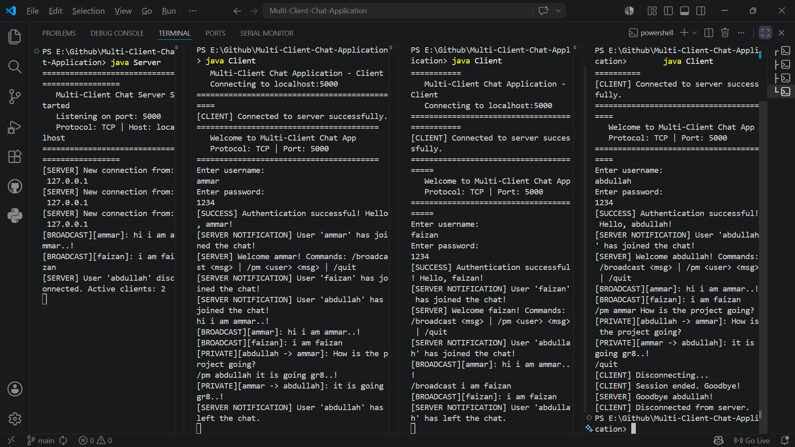

7. Challenges Faced & Solutions
- Thread-Safe Logging: Initially, concurrent messages caused FileWriter collisions. This was resolved by adding the synchronized modifier to the logging method, ensuring sequential file I/O operations.
- Client Terminal Hanging: When the server was terminated abruptly, the client application remained stuck waiting for console input (Scanner.nextLine()). This was fixed by making the receiving thread forcibly call System.exit(0) upon detecting a server-side disconnect.
- Concurrency Exceptions: Utilizing a standard HashMap for active users posed a risk of ConcurrentModificationException during broadcast iterations if a user disconnected simultaneously. Upgrading to a ConcurrentHashMap successfully resolved this thread-safety risk.

8. Testing Results
- Connection Test: Clients successfully connected to 127.0.0.1:5000.
- Authentication Test: Correct credentials (e.g., ammar / 1234) granted access; incorrect credentials incremented the attempt counter and disconnected after 3 tries.
- Routing Test: Broadcasts reached all clients. Private messages (/pm) only appeared on the sender's and target's terminals. Invalid /pm targets returned a server error to the sender.
- Load/Concurrency Test: Three clients running simultaneously successfully sent messages without blocking each other.


9. How to Run the Application (for teacher use)
To run this application on a local machine, please follow these steps:
Step 1: Compile the Code
- Open a terminal or command prompt in the directory containing the project files.
- Run the command: javac *.java
Step 2: Start the Server
- In the same terminal, start the server: java Server
- The server will indicate it is listening on port 5000.
Step 3: Connect Clients
- Open a new, separate terminal for each client connection.
- Run the command: java Client
- Log in using any of the predefined testing credentials:
  - User 1: ammar | Password: 1234
  - User 2: abdullah | Password: 1234
  - User 3: faizan | Password: 1234
Step 4: Test Functionalities
- Type standard text and press Enter to broadcast to all users.
- Type /pm <username> <message> to send a private message (e.g., /pm ammar Hello!).
- Type /quit to gracefully disconnect a client.

10. Conclusion
The Multi-Client Chat Application project successfully demonstrates the core principles of network programming. By utilizing Java's Socket and ServerSocket classes alongside Multithreading, the application effectively manages concurrent connections. The integration of SHA-256 encryption, thread-safe collections, and robust error handling ensures a secure, stable, and highly functional client-server architecture, completely fulfilling the criteria set forth in the CSC3275 lab requirements.

