**Databases**

[NoSQL vs. SQL: Important Differences & Which One Is Best for Your Project – Link](https://www.upwork.com/resources/nosql-vs-sql)

**The Relational Database**

a collection of data items with pre-defined relationships between them. These items are organized as a set of tables with columns and rows.

A FOREIGN KEY is a field (or collection of fields) in one table, that refers to the PRIMARY KEY in another table.

Types of Database Relationships:

A transaction is a very small unit of a program and it may contain several lowlevel tasks. A transaction in a database system must maintain ACID properties:

Atomic : operations are executed or none.

Consistent : must remain in a consistent state after any transaction

Isolated : one transaction are being executed

Durable : hold all its latest updates even if the system fails or restarts

SQL

CRUD operations in SQL

CREATE , READ , UPDATE , DELETE

ER Diagram

-------------

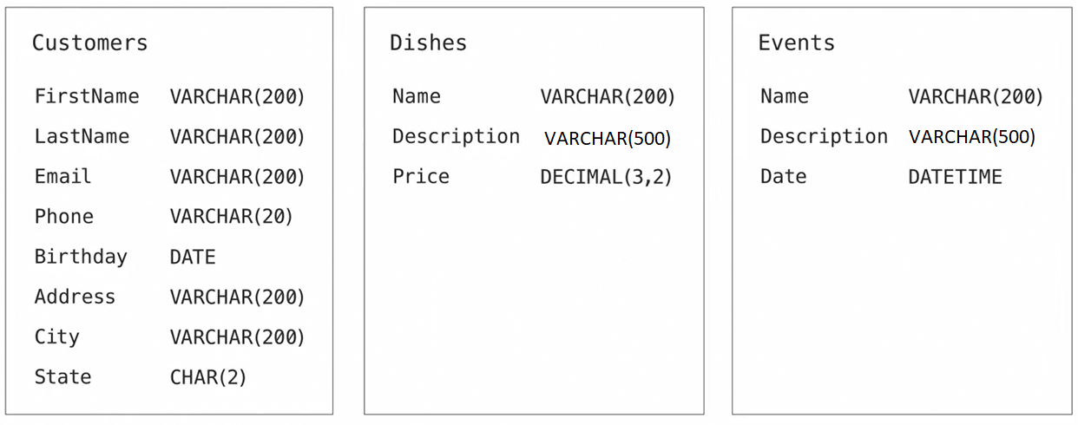

NULL is represent absence of a value

**Relationships**

Types:

- One to One

- One to Many

- Many to Many

- One to Many  
EX. Dishes & Customers  
 Customers & Reservations

- Many to Many  
EX. Orders & Dishes  
 Customers & Events

- One to One  
not frequently used , usually use for security reasons like hide some information from some people (as Denormalization)

Some DB rules:

* **Normalization**  
   is the process of organizing the data in the database.

Ex. for not applying 1NF

And

-- We solve that like this:

We probably face problem like this

So..

EX.

has composite key (Name+Date)

and (Location) just rely on Name, So..

-------------

Pros of Denormalization:-

1. Retrieving data is faster since we do fewer joins
2. Queries to retrieve can be simpler(and therefore less likely to have bugs), since we need to look at fewer tables.

Cons of Denormalization:-

1. Updates and inserts are more expensive.
2. Denormalization can make update and insert code harder to write.
3. Data may be inconsistent . Which is the “correct” value for a piece of data?
4. Data redundancy necessitates more storage.

Some SQL queries

[SQL Cheat Sheet](https://www.sqltutorial.org/sql-cheat-sheet/)

Indexes are used to quickly locate data without having to search every row in a database table every time a database table is accessed.  
A database table can have one or more indexes associated with it.

A transaction is a unit of work that you want to treat as "a whole." It must either happen in full or not at all.

A stored procedure is a set of SQL statements with an assigned name, which are stored in a relational database management system (RDBMS) as a group, so it can be reused and shared by multiple programs.

EX.

In normal case we have something like that:

And hacker make that:

Some software options:

NoSQL ones

