
UNIVERSITY OF OKARA
Department of Computer Science & IT
RESEARCH SYNOPSIS
Towards Trustworthy XAI: Evaluating Explanation Stability in Concept-Drift-Adaptive Intrusion Detection for Lightweight IoT Devices in Critical Infrastructure
Submitted in partial fulfillment of the requirements for the degree of
MS Computer Science
Submitted by
Ammara Ali Ahmed
Registration No: FA25W-MSCS-032
Session: 2025-2027
Email: ammara.ali56@gmail.com
Contact: 03086142265
Supervisor
Ms. Ifrah Pervaz

RESEARCH SYNOPSIS
Towards Trustworthy XAI: Evaluating Explanation Stability in Concept-Drift-Adaptive Intrusion Detection for Lightweight IoT Devices in Critical Infrastructure

1. Introduction / Background
The rapid expansion of Internet of Things (IoT) deployments in critical infrastructure sectors — energy, water, healthcare, and industrial control systems — has significantly increased the cyberattack surface of these environments. Intrusion Detection Systems (IDS) are a core defense mechanism, and modern IDS increasingly adopt adaptive, machine-learning-based approaches that can update their models in response to concept drift, i.e., changes in network traffic patterns and attack behavior over time. Alongside this, Explainable AI (XAI) techniques such as SHAP and LIME have been integrated into IDS to make model decisions interpretable to security analysts, supporting trust and operational decision-making.
However, while adaptive IDS and XAI have each advanced independently, their intersection — specifically, whether explanations remain consistent and trustworthy as the underlying model adapts to concept drift — remains largely unexamined. This research addresses that intersection.

2. Problem Statement
As adaptive IDS models retrain or update themselves to cope with concept drift, the explanations they generate for their predictions may shift even when the underlying threat classification remains conceptually similar. This instability undermines analyst trust and can compromise the reliability of XAI as a tool for validating IDS decisions in high-stakes critical infrastructure environments, where incorrect or inconsistent explanations can lead to delayed or misdirected incident response.

3. Literature Review
Base Paper 1: Drago, S., Lorusso, M., Ferraro, P., De Paola, A., & Lo Re, G. (2026). "Online Framework for Intrusion Detection Systems with Explainable Concept Drift Detection and Adaptation Phases." CEUR Workshop Proceedings, Vol. 4198. This paper proposes an online, unsupervised, explainability-driven concept-drift detector for IDS that adapts model behavior over time while minimizing labeling costs. It provides explainability of the drift's impact and shows how the model's decisions evolve, but does not formally measure whether the explanations themselves remain stable and consistent across successive adaptation cycles.
Base Paper 2: Alqahtani, A., Alakeel, F., & Abuhaimed, L. (2026). "XAI-Driven Intrusion Detection for Internet of Things Networks." Sensors, 26(17), Article s26175437. This study systematically evaluates LIME and SHAP explanations for IoT IDS across three benchmark datasets (CICIoT2023, TON_IoT, Edge-IIoTset), explicitly assessing explanation stability, local fidelity, and attribution agreement. However, the evaluation is performed on static, non-adaptive models — it does not consider how these stability properties change once the model must adapt to concept drift.
3.1 Supporting Literature
That this gap is real is confirmed by two recent reviews. Souto et al. (2026) looked at 71 studies published between 2016 and 2026 and concluded that explanation stability is ‘rarely investigated’. They list it as one of the minimum metrics that future work should report, and they also point out that incremental learning and XAI are rarely combined in the same system. Khare et al. (2026) make a similar point in stronger words. They ask future studies to report ‘temporal stability before and after drift adaptation’, measured through rank correlation or top-k overlap of feature attributions when the model faces drift and retraining.
Some studies do measure explanation stability, but not under drift. Pacheco and Pedroso (2026), for example, report top-10 Jaccard similarity above 0.7 and Spearman correlation above 0.8. The problem is that these numbers come from cross-validation folds on stationary 5G data, using a glass-box model. There is no SHAP or LIME involved, and no adaptation cycle at all. Munilla and Khammas (2026) compare SHAP and LIME on IoT datasets by checking top-k feature overlap before and after DeepFool adversarial attacks. Their comparison is solid, but an attack is a different stressor than drift. Stability under attack does not tell us about stability across drift adaptation.
On the deployment side, Alsubaei (2026) shows that XAI can run on small devices. Their quantized model is only 367 KB and runs on a Raspberry Pi 4 in 42 ms and on a Jetson Nano in 18 ms. But the model itself is static. It never deals with drift. Ebrahimi et al. (2025) also work with a lightweight 1D-CNN and use SHAP to cut down the feature set, but their SHAP and LIME plots are only for illustration. Nobody measures explanation quality there. The closest match in scope is Al Rawajbeh et al. (2025): an adaptive online ensemble, ADWIN and Page-Hinkley drift detectors, SHAP explanations, all running on a Raspberry Pi 5. Even they never measure whether explanations stay stable across adaptation cycles.
Keshk et al. (2023) show what the field normally does: a static LSTM explained with SHAP, ICE, PDP and PFI on standard datasets. No drift handling, no stability measurement. If we put all ten studies side by side (Table 1), we see that every pair of our three dimensions is covered somewhere. Drift adaptation plus lightweight IoT? Covered. Stability measurement plus IoT data? Covered. But all three together in one study? That cell is empty. Figure 1 makes this visible: the middle of the diagram has nothing in it, and that empty middle is exactly the gap this thesis works on.
Table 1: Comparison of the ten selected studies — IDS model, drift handling, XAI method, stability measurement, and the gap each leaves open.
# | Paper (citation) | IDS model | Drift handling | XAI / Explainer | Stability measured? | Gap (what is missing)
1 | Drago et al., 2026 (ITASEC & SERICS, CEUR) — BASE PAPER 1 | Adaptive (incremental update after drift alarm) | Own UME_CDD detector (δ-score from feature-importance change → KSWIN); ADWIN/KSWIN baselines | SHAP + own unsupervised permutation importance | NO — explanation change used as the alarm; no Jaccard/Kendall across retrainings | Closest work but inverted: change = trigger; stability across adaptation never measured
2 | Alqahtani et al., 2026 (Sensors, MDPI) — BASE PAPER 2 | Static (soft-voting ensembles) | Explicitly out of scope (future work) | SHAP + LIME | YES (partial) — LIME run-to-run top-7 Jaccard 0.21–0.53 on frozen model | No drift/adaptation dimension; stability = run-to-run noise, not across updates
3 | Souto et al., 2026 (Internet of Things, Elsevier) | Review (71 studies, 2016–2026) | n/a (review) | Various | Defines it; finds it ‘rarely investigated’; minimum future metric | Review only — no experiment; calls for stability-under-drift evaluation
4 | Al Rawajbeh et al., 2025 (IoT, MDPI) | Adaptive (online ensemble) | ADWIN + Page–Hinkley detectors; re-weighting on alarm | SHAP (illustrative plots) | NO | Scope twin with everything except the one measurement: stability across adaptation
5 | Khare et al., 2026 (IJAICET, review) | Static baselines | ADWIN/Page–Hinkley named, never executed | SHAP/LIME (prescriptive) | NO — but prescribed: ‘temporal stability before and after drift adaptation’ | Prescription only; no experiment
6 | Pacheco & Pedroso, 2026 (Computer Networks, Elsevier) | Static EBM + batch retraining | Own shape-function distance metric | Intrinsic glass-box EBM (no SHAP/LIME) | YES — top-10 Jaccard >0.7 + Spearman >0.8 across CV folds on stationary data | Wrong condition (static folds); no post-hoc explainers; no adaptation cycles
7 | Munilla & Khammas, 2026 (Sensors, MDPI) | Static (RF/DNN/CNN/LSTM) | None | SHAP + LIME | YES — top-k overlap before vs after DeepFool perturbation | Stressor is adversarial input, not drift/adaptation
8 | Alsubaei, 2026 (J. Cloud Computing, Springer) | Static (‘adaptive’ = curriculum training) | None | LIME (feature pruning + illustrative) | NO — ‘stability’ = training convergence | Deployment paper: proves XAI+edge can coexist; nothing on drift or stability
9 | Ebrahimi et al., 2025 (Cybersecurity, SpringerOpen) | Static 1D-CNN | None | SHAP + LIME (illustrative) | NO | Lightweight + SHAP side of topic, but nothing on explanation quality
10 | Keshk et al., 2023 (Information Sciences, Elsevier) | Static LSTM | None | SHAP + ICE + PDP + PFI (illustrative) | NO | Classic static anchor: documents standard practice the thesis moves beyond

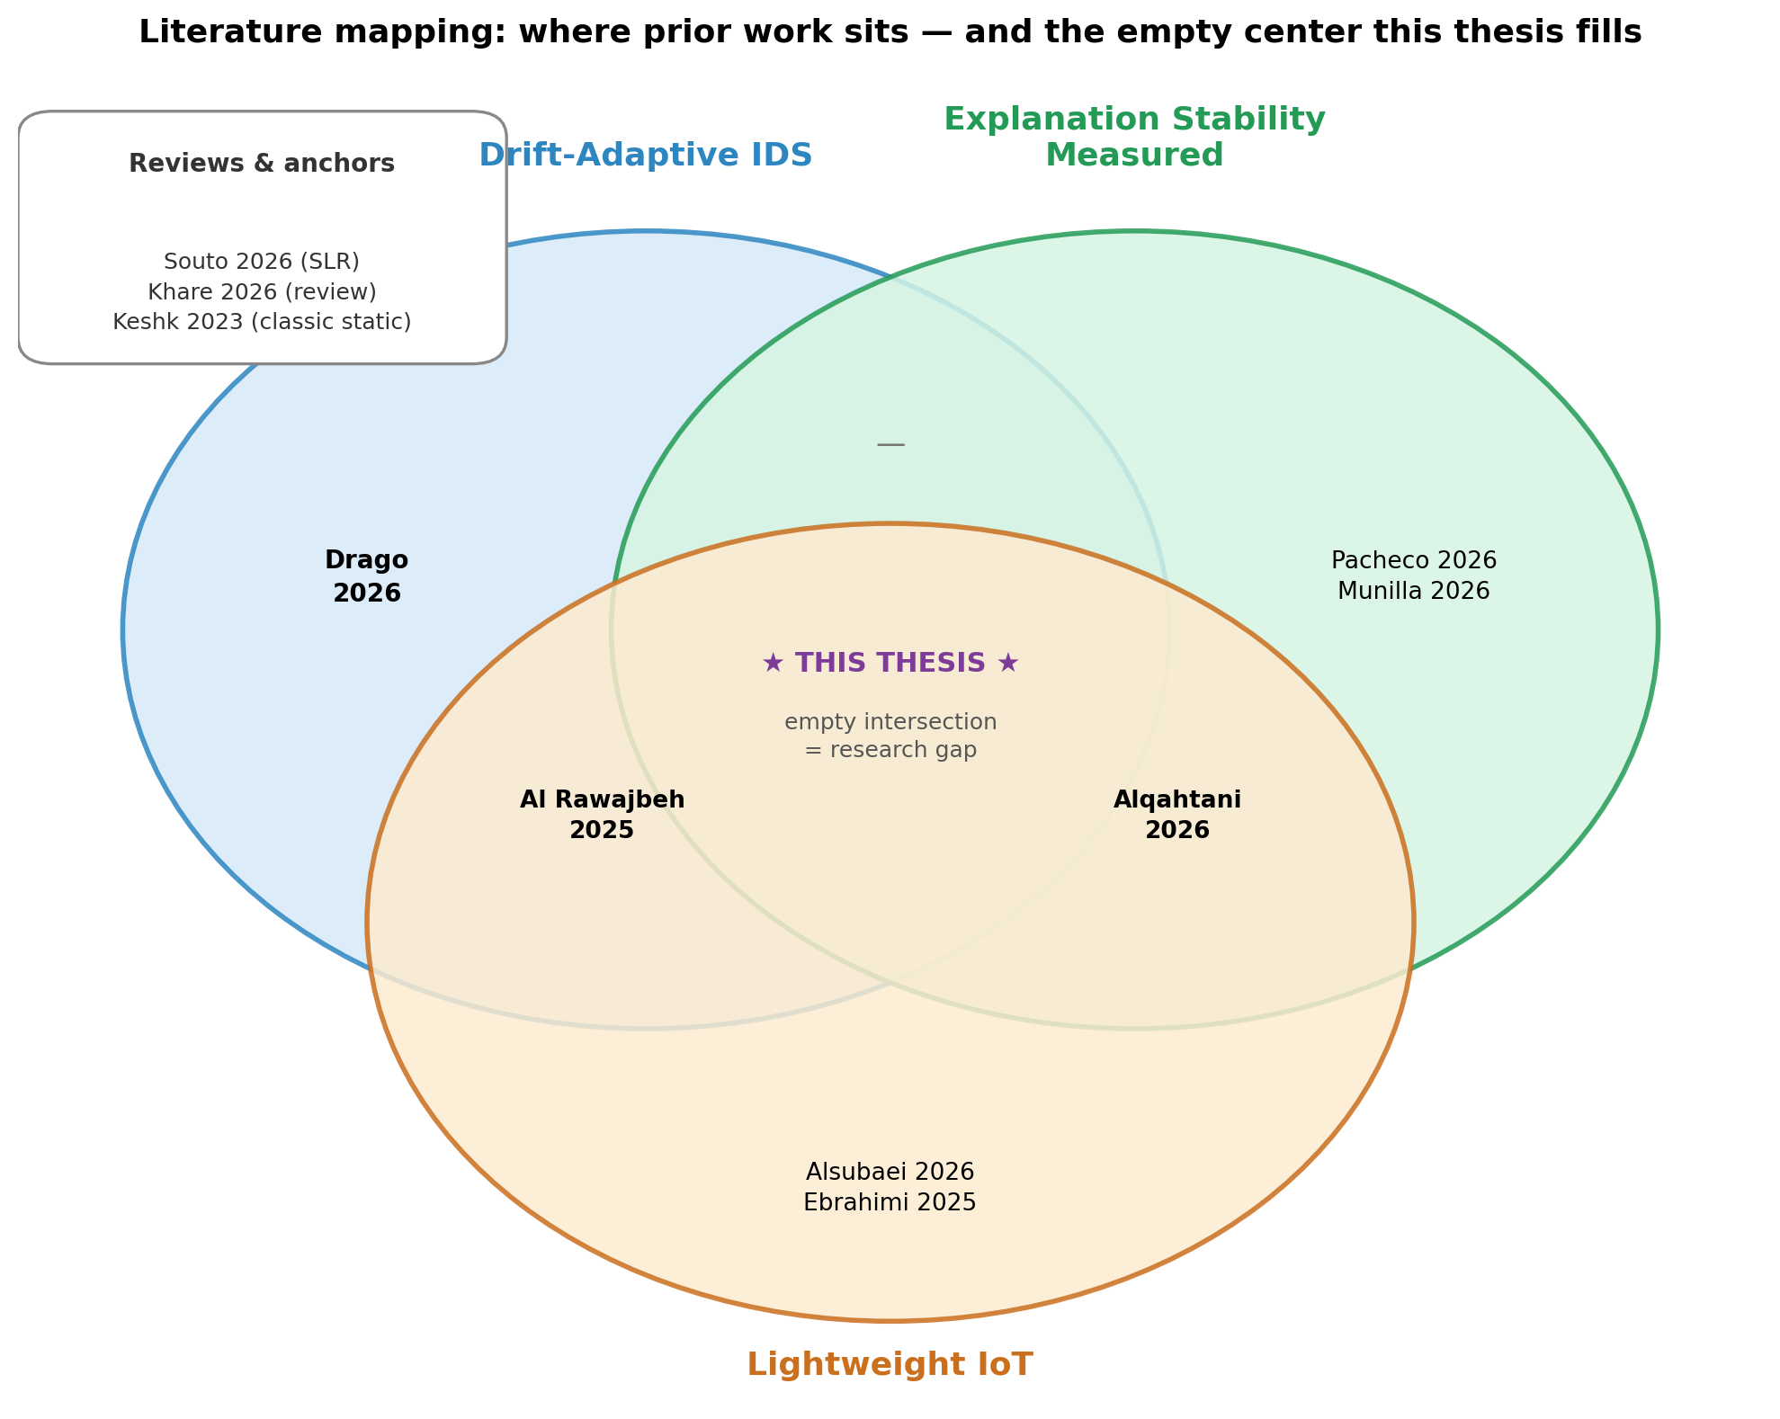
Figure 1: Mapping of the ten reviewed studies across the three dimensions of the research problem — drift-adaptive IDS, measured explanation stability, and lightweight IoT. No prior work occupies the intersection of all three; the empty center is the research gap addressed by this thesis.

4. Research Gap
Drago et al. establish an adaptive, drift-aware IDS framework with explainability support, but do not evaluate the stability of the explanations produced as the model updates. Alqahtani et al. establish a rigorous methodology for evaluating explanation stability (via LIME/SHAP), but only for static, non-adaptive models. No existing work combines these two threads: formally evaluating explanation stability within a concept-drift-adaptive IDS. This is the gap this research addresses, with specific relevance to critical infrastructure IoT, where explanation reliability directly affects incident-response decisions.

5. Research Questions
RQ1: How does explanation stability in adaptive IDS models change as the model updates in response to concept drift?
RQ2: Which XAI method (e.g., SHAP, LIME) produces more stable explanations across concept-drift adaptation cycles in an IoT IDS context?
RQ3: Is there a measurable relationship between explanation instability and degradation in IDS detection performance?

6. Objectives
To design and implement an adaptive IDS pipeline for critical infrastructure IoT that detects and adapts to concept drift.
To adapt and apply quantitative metrics (e.g., Kendall's τ rank correlation, top-k Jaccard similarity) for measuring explanation stability across model adaptation cycles.
To empirically evaluate and compare the stability of multiple XAI methods under concept drift, and analyze their relationship with detection performance.

7. Proposed Methodology
The study will use a publicly available IoT intrusion detection dataset (e.g., CICIoT2023 or a critical-infrastructure-relevant IDS dataset) and simulate concept drift by partitioning data into sequential time windows, following an approach similar to Drago et al. An adaptive classifier (e.g., an online/incremental learning model such as a Hoeffding Tree or incremental random forest) will be monitored with a drift detector (e.g., ADWIN) and updated incrementally — retrained on recent windows whenever drift is flagged. At each adaptation step, XAI methods (TreeSHAP and LIME, following the evaluation protocol used by Alqahtani et al.) will generate feature-attribution explanations, which will be compared across steps using stability metrics (Kendall's τ rank correlation of feature importance and top-k Jaccard similarity). Results will be analyzed to identify patterns between drift magnitude, explanation stability, and detection accuracy.

8. Significance / Expected Contribution
This research will contribute a novel evaluation framework for explanation stability in adaptive IDS, bridging a gap between two active but separate research threads. Findings will support more trustworthy deployment of XAI-enabled adaptive IDS in critical infrastructure IoT, aligning with Pakistan's national priorities around critical infrastructure protection and cybersecurity under the Prevention of Electronic Crimes Act (PECA) 2016.

9. References
Drago, S., Lorusso, M., Ferraro, P., De Paola, A., & Lo Re, G. (2026). Online Framework for Intrusion Detection Systems with Explainable Concept Drift Detection and Adaptation Phases. CEUR Workshop Proceedings, 4198.
Alqahtani, A., Alakeel, F., & Abuhaimed, L. (2026). XAI-Driven Intrusion Detection for Internet of Things Networks. Sensors, 26(17), s26175437.
Souto, A. M., et al. (2026). Explainable intrusion detection for the internet of things: a systematic literature review. Internet of Things, Elsevier.
Al Rawajbeh, M., et al. (2025). Trustworthy Adaptive AI for Real-Time Intrusion Detection in Industrial IoT Security. IoT, MDPI.
Khare, A., Agrawal, G., & Wadhvani, R. (2026). Trustworthy and Adaptive Intrusion Detection for Imbalanced IoT Traffic. IJAICET.
Pacheco, E. J., & Pedroso, C. M. (2026). Operational lifecycle of interpretable multi-plane intrusion detection in 5G networks. Computer Networks, Elsevier.
Munilla, J., & Khammas, R. M. (2026). Evaluation of Explainable AI in IoT Intrusion Detection Systems Under DeepFool Adversarial Conditions. Sensors, MDPI.
Alsubaei, F. S. (2026). Luminous defense: XAI-driven adaptive security for critical IoT infrastructures. Journal of Cloud Computing, Springer.
Ebrahimi, F., et al. (2025). Intrusion detection in the internet of things using convolutional neural networks: an explainable AI approach. Cybersecurity, SpringerOpen.
Keshk, M., et al. (2023). An explainable deep learning-enabled intrusion detection framework in IoT networks. Information Sciences, Elsevier.

