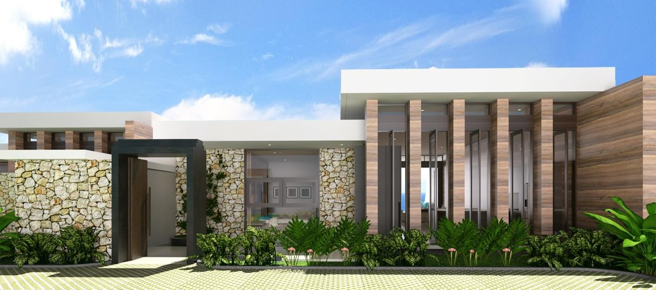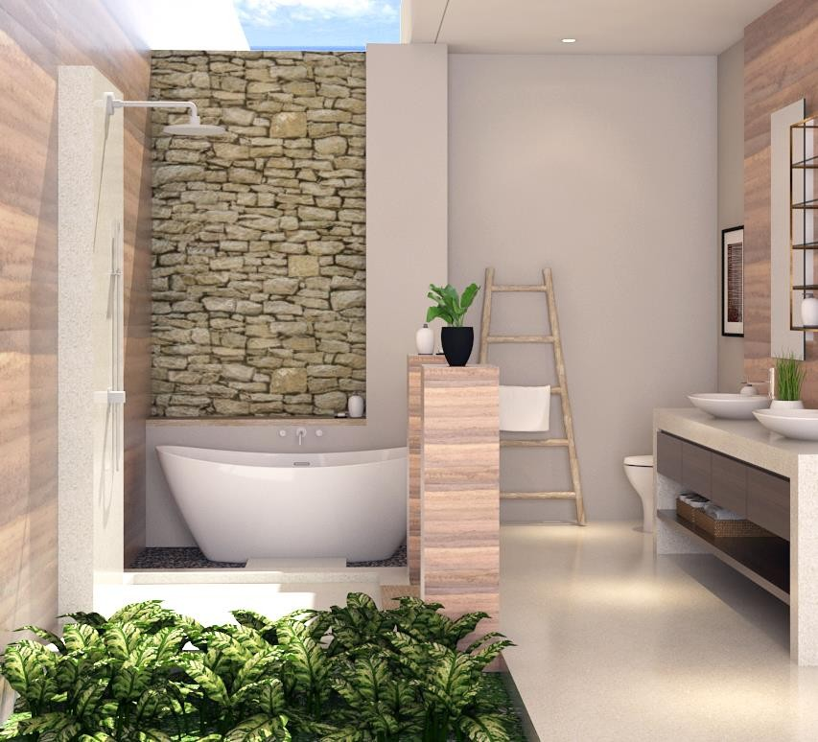

TERM SHEET



Project :

Property :

Villa B & C

# OFFER SUMMARY

|  |  |
| --- | --- |
| **FINANCE SUMMARY** | |
| Total Loan Amount | 7,288,125,000 |
| Finance Rate (p.a.) | 3.0% |
| Initial Monthly Int. | 18,220,312 |

|  |  |
| --- | --- |
| **MONTHLY PAYMENT SUMMARY** | |
| Payment Periods | 120 |
| Principal Amort. | 60,734,375 |
| Amort. + Interest | 78,954,687 |
| (Lease) | -32,500,000 |
| Net Repayment | 46,454,687 |

|  |  |
| --- | --- |
| **LEASE SUMMARY** | |
| Guaranteed Lease (yield/%) | 6.0% |
| Guaranteed Lease (IDR/yr) | 390,000,000 |



|  |  |
| --- | --- |
| **PRICING SUMMARY** | |
| Price (IDR) | 6,500,000,000 |
| Fees & Taxes (%) | 15.0% |
| Fees & Taxes (IDR) | 975,000,000 |

|  |  |
| --- | --- |
| **PURCHASE SUMMARY** | |
| Total Price (IDR) | 7,475,000,000 |
| Deposit (%) | 2.5% |
| Deposit (IDR) | 186,875,000 |

|  |  |  |
| --- | --- | --- |
|  |  |  |
|  | MONTHLY |  |
| PAYMENT  **IDR 46,454,687** | | |
|  |  |  |
|  |  |  |

EFFECTIVE

PURCHASE PRICE

**IDR 2,984,546,094**

PAYMENT

PERIODS

**120**

|  |  |
| --- | --- |
| **Effective Purchase Price Calculation** |  |
| Purchase Price (IDR) | 7,475,000,000 |
| Net Repayment Total | 4,490,453,906 |
| Effective Purchase Price | 2,984,546,094 |

Finance SUMMARY

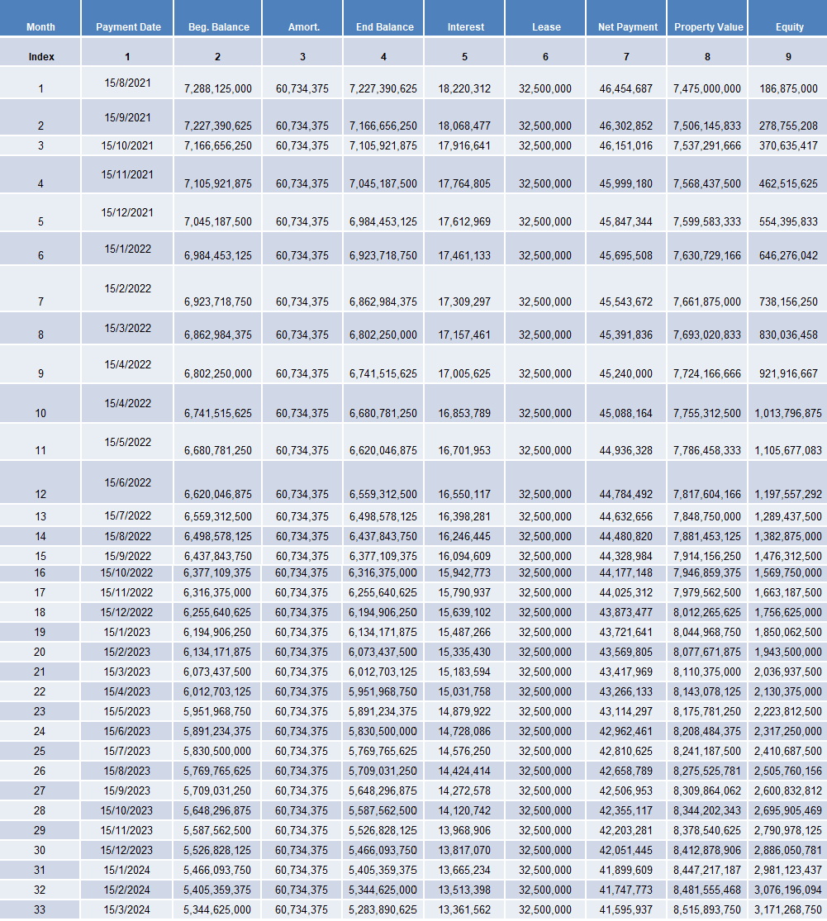



Finance SUMMARY

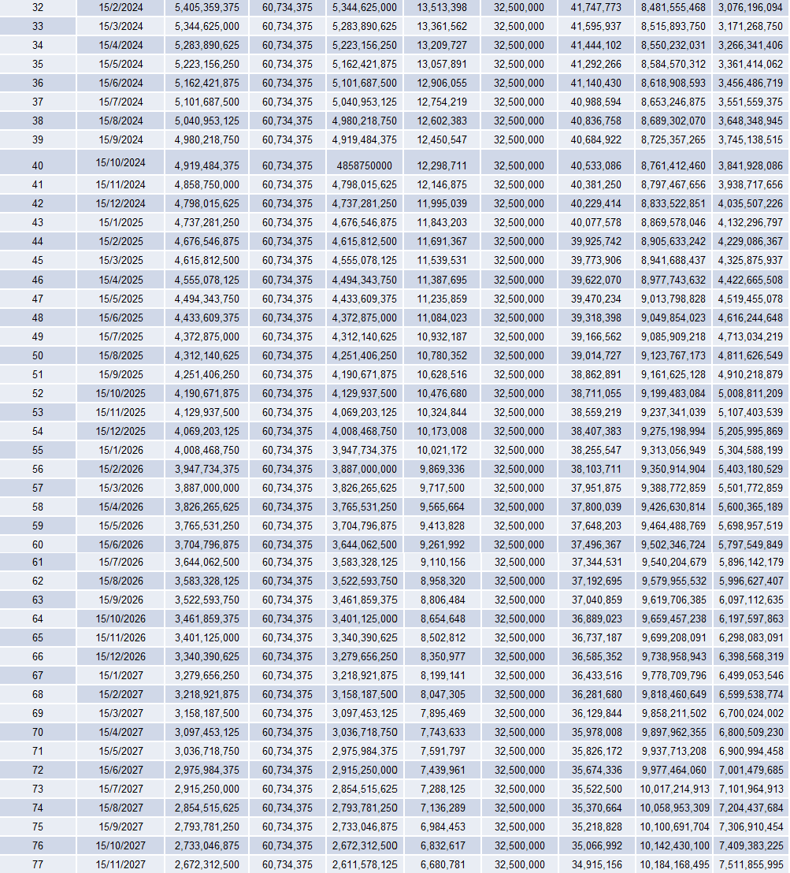



Finance SUMMARY

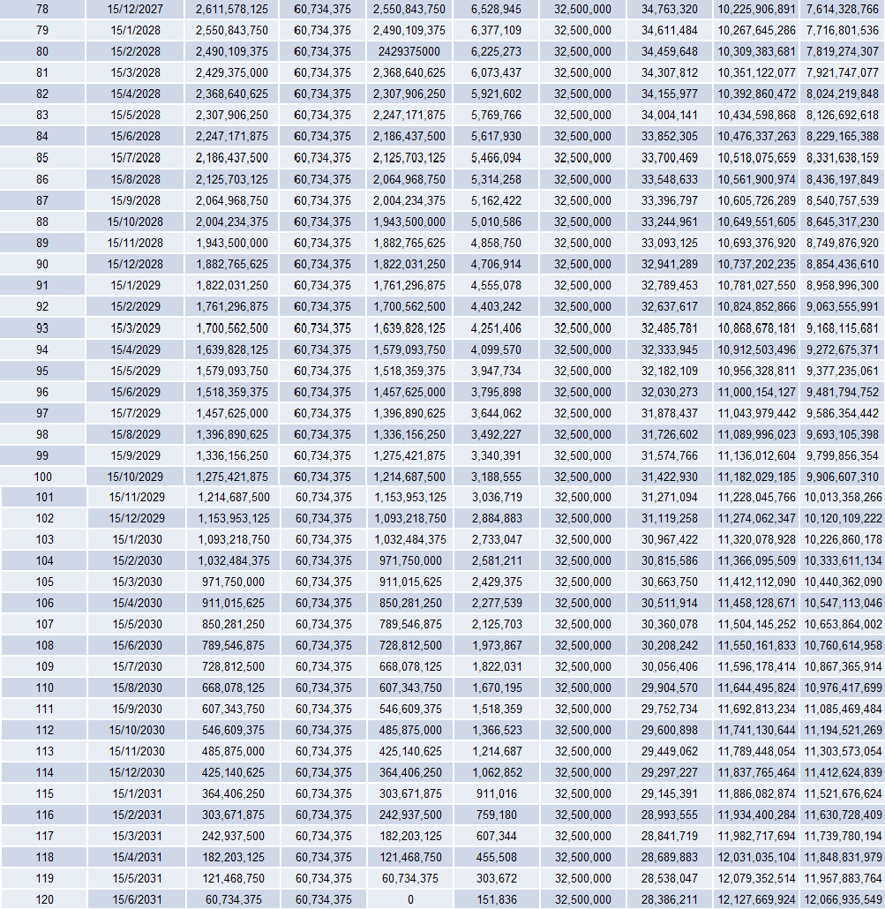



**Frequently Asked Questions**

Got questions? Find answers to some of our most frequently asked questions below:

## How does Briix guarantee that my property will generate returns?

While it’s impossible to guarantee that any property will generate returns, our Briix Property Leases mean that Briix will lease the property directly from you. This guarantees you fixed income, irrespective of how the property performs.

## How does Briix make money from the Fixed Lease Agreements? What’s in it for you?

Briix employs the same strategies an investment bank would when trading any securities, like stocks or bonds. Through a thorough analysis process, Briix forecasts earnings for each property and takes a position that the lease amount is less than the expected earnings. The difference between the lease amount and actual revenue is the profit/loss.

**If Briix thinks my property will earn more than the lease value, shouldn’t I just lease the property directly?** By leasing directly, you do have the opportunity to earn more revenue than the fixed lease agreement, but you also take on significantly more risk and could potentially not earn anything. By investing with Briix, that risk is substantially reduced.

## Does Briix guarantee property financing?

Yes. Briix guarantees finance across all properties on our platform to a maximum Loan to Value Ratio of up to 95% which means you can purchase a property with as little as 5% cash deposit.

## How can Briix offer such competitive mortgage rates in International markets?

Briix is backed by Australian Private Equity firm, First Guardian Capital. We choose to lend at this rate because we see the opportunity to disrupt inefficient mortgage practices in our target markets, and because we see the value in our strategic property investments. Our money, our rates of lending – and our Briix members are the beneficiaries!

**Does Briix guarantee leasing and / or finance for properties not on the Briix Platform?**

No, Briix does not provide leasing or finance on properties that are not on our platform.

**Why not?**

It’s all down to risk. Briix has invested significant resources to have a very detailed understanding of every property on our Platform. This level of analysis allows us to absorb the risks involved in guaranteeing leasing and finance for our customers.

## I’ve got concerns about investing in property overseas. How does Briix help me understand the risks involved?

It takes a lot of time and resources to properly understand the risks involved with international property investment. At Briix, it’s our job to understand the risks involved in the markets we invest in. To ensure secure, stable investments, we work with the world’s leading legal firms and property consultants to create and manage the infrastructure required to invest safely in each market that we participate in.

**I’m investing in a property that isn’t completed yet. Am I still eligible for my 6% rental returns?**

Yes! As soon as you have signed all your legal documentation and have paid your deposit, your loan repayment schedule begins and you will start receiving your 6% rental returns, netted off against your mortgage repayments.

**What if I need or want to sell my property before the term of my lease is up?**

If you can find an interested party, we can assign ownership to this party under the exact same lease and financing terms.

**I’ve come into some money, and I’d like to pay down some of my principal. Can I?**

Yes. If you’d like to pay down your principal faster, our Briix team will restructure your loan repayment schedule so that you can start earning rental yield even faster.

**What if something happened to Briix? Is my property protected?**

Absolutely! If, in the extremely unlikely event that something ever effected Briix’s ability to own the property or service its debt, then the title transfers immediately to the legal entity that Briix has established for you, and of which you are a director. Any remaining mortgage payments are null and void.

**What happens after I have repaid my loan in full? How do I lease out my property?**

There are a number of options. You can continue to utilise the SIWA management company to lease at a fixed return. You can take on management of the property yourself and take on both the risks and the rewards. Or, you can retire and live in your dream home!

**I think I have found a Briix property I want to invest in. What do I do now?**

One of our Briix Team Members will be in touch within two days to answer any questions and complete the steps to property ownership. They’ll confirm all the terms of your ownership and share all documentation digitally, for your review.

Once you’re ready to go, we’ll arrange for an in-person meeting to finalise everything and close on your new investment property. If you’re unable to meet in person, we’re happy to arrange a digital signing with one of our representatives.

Signature Page



This material (the “Term Sheet”) is being provided to you at your request and is for your internal use only. It has been prepared by Briix Pty Ltd (“Briix") and does not constitute research or investment advice.

By Signing this agreement the “Purchaser” declares that they have read the information in full and have understood the contents to the best of their ability and agree to proceed towards a legal and binding documentation process. This agreement is NOT a legal or binding document, but rather an “Expression of Interest” in the transaction stated within.

Real Estate transactions carry risks, which may in some cases be substantial and may even equal or exceed the entire principal invested, and therefore certain transactions may be inappropriate or unsuitable for certain investors.

If this material contains “forward-looking” information, this information is based upon certain assumptions about future events or conditions and is intended only to illustrate hypothetical results under those assumptions (not all of which are specified herein). Actual events or conditions may differ materially from those assumed herein. In addition, not all relevant events or conditions may have been considered in developing such assumptions. Accordingly, actual results will vary and the variations may be material. You should understand such assumptions and evaluate whether they are appropriate for your purposes. Past performance is not a guide to future performance.

Unless otherwise stated herein, any securities described herein have not been and will not be registered under the U.S. Securities Act of 1933, and may not be offered or sold within the United States or to, or for the account or benefit of, any U.S. person, except pursuant to an exemption from or in a transaction not subject to the Securities Act and applicable U.S. state securities laws.

Name :

Title :

Name :

Title :

{{t:s;r:y;o:“Customer”;w:100;h:15;}}