Semester Project: Global Air Quality Analysis

Course: CSC380 Introduction to Data Science
Submitted by: Ammar Ahmad
Date: December 28, 2025

1. Executive Summary
This project presents a comprehensive data science lifecycle analysis on a global air quality dataset containing 10,000 records. The primary objective was to clean, analyze, and build predictive models for the Air Quality Index (AQI) based on various pollutants and meteorological factors. The implementation follows professional software engineering standards, utilizing Clean Architecture and modular design. Eleven different machine learning algorithms were evaluated, demonstrating high predictive accuracy.

2. Problem Statement
Air pollution is a major global health risk. Understanding the relationship between different pollutants (PM2.5, NO2, etc.) and meteorological factors (Temperature, Humidity) is crucial for predicting air quality and taking proactive measures. This project aims to bridge the gap between raw environmental data and actionable insights through statistical analysis and machine learning.

3. Methodology

3.1 Data Preprocessing & Cleaning
To ensure data quality, several preprocessing steps were implemented:
• Missing Value Handling: Utilized linear interpolation for numerical gaps and median imputation for residual NAs.
• Outlier Detection: Applied Interquartile Range (IQR) method to cap extreme values in pollutant data.
• Feature Scaling: Standardized numerical features using StandardScaler to ensure model convergence.
• AQI Categorization: Binned AQI values into 'Good', 'Moderate', 'Unhealthy', and 'Hazardous' categories based on international standards.

3.2 Software Architecture
The project is built using Clean Architecture to ensure modularity and low coupling:
• Domain Layer: Core logic for AQI categorization.
• Use Cases: Specialized modules for data cleaning, temporal analysis, and feature engineering.
• Infrastructure: Data loading modules and Machine Learning model factory.
• Presentation: Interactive (Plotly) and static (Seaborn) visualization components.

4. Experimental Results

4.1 Exploratory Data Analysis (EDA)
Detailed EDA revealed significant correlations between pollutants and meteorological factors. Temporal analysis identified seasonal cycles in air quality, while a comparative country study highlighted the most affected geographical regions.
Figure 1: Distribution of AQI Categories
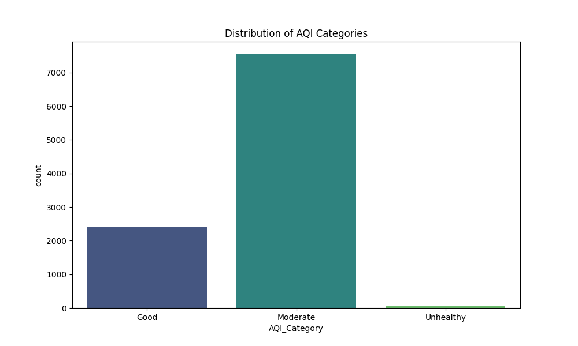

4.2 Model Performance
Eleven different models were trained and cross-validated. The results are summarized below:
Model | MSE | R2 Score
Linear Regression | ~0.00 | 1.00
Ridge Regression | ~0.00 | 1.00
ElasticNet | 0.04 | 0.99
SVR | 0.25 | 0.99
Gradient Boosting | 1.60 | 0.99
Random Forest | 4.77 | 0.98
KNN | 5.02 | 0.98
Decision Tree | 18.52 | 0.92

5. Conclusion and Recommendations
The study concludes that particulate matter (PM2.5 and PM10) are the primary drivers of AQI. Meteorological factors like temperature significantly influence pollutant concentration cycles.

5.1 Health Recommendations
• Environmental monitoring should be intensified during identified peak pollution months.
• Public health advisories should be automated based on the predictive models developed in this study.
• High-pollution regions identified in the comparative study require targeted emission control policies.

