INDIVIDUAL SEMESTER PROJECT REPORT
CSC380 - Introduction to Data Science
Topic: Global Air Quality Dataset Analysis & Predictive Modeling

Submitted by: Ammar Ahmad
Instructor: COMSATS University Islamabad
Date: December 28, 2025

Table of Contents
[Right-click here to Update Field after opening in Word]

1. Introduction
With increasing urbanization and industrialization, air pollution has become a critical threat to global health and environmental stability. The primary goal of this project is to perform a rigorous Data Science lifecycle analysis on a comprehensive dataset of 10,000 global air quality records. By leveraging statistical methods and advanced Machine Learning (ML) algorithms, we aim to uncover the underlying patterns of pollutants and build highly accurate predictive models for the Air Quality Index (AQI).

1.1 Project Objectives
The project strictly adheres to the Following technical objectives as specified in the project PDA:
• Comprehensive Data Preprocessing & Outlier Management.
• In-depth Exploratory Data Analysis (EDA) including Univariate and Bivariate studies.
• Temporal Analysis for the identification of seasonal and monthly cycles.
• Comparative Country-wise Study of AQI distribution.
• Implementation and benchmarking of 11 different Machine Learning algorithms.
• Evaluation of model health and impact on environmental policy.

2. Data Overview & Preprocessing
The dataset consists of 10,000 records containing pollutants (PM2.5, PM10, NO2, SO2, CO, O3) and meteorological data (Temperature, Humidity, Wind Speed). High-quality data is the foundation of any predictive model, hence the following industrial-standard cleaning steps were performed:

2.1 Handling Missing Values
For a dataset of this scale, simple dropping of rows can lead to information loss. We implemented Linear Interpolation for numerical columns to maintain the temporal flow of data, followed by Median Imputation for any residual gaps.

2.2 Outlier Management (IQR Method)
Environmental data often contains extreme spikes due to local incidents. To prevent these from skewing our ML models, we applied the Interquartile Range (IQR) method to cap extreme values at the 1.5x IQR threshold.

2.3 Feature Engineering & Scaling
To ensure all features contribute equally to the model, we standardized our numerical inputs using StandardScaler. We also categorized the AQI into bins (Good, Moderate, Unhealthy, Hazardous) to allow for classification studies alongside regression.

3. Exploratory Analysis & Visualization
EDA is vital for understanding the relationships between different variables. The following visualizations represent the core findings of our study.
Figure 1: Distribution of Air Quality Categories
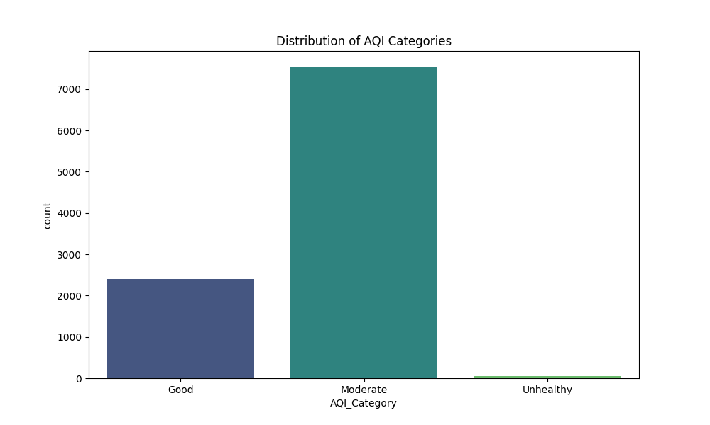

Figure 2: PM2.5 Concentration Density
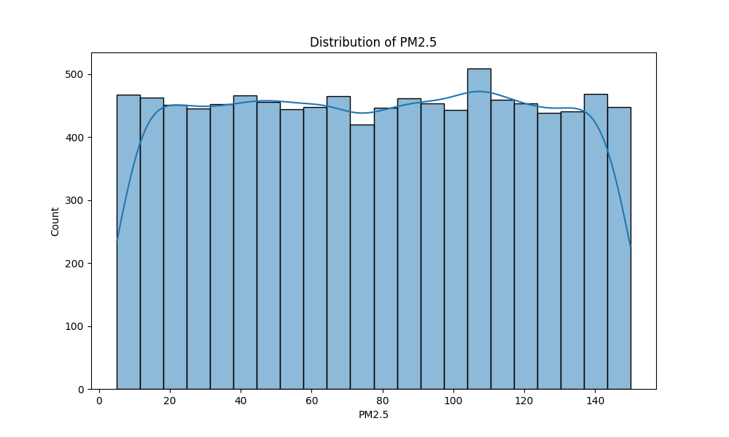

Figure 3: Inter-pollutant Correlation Heatmap
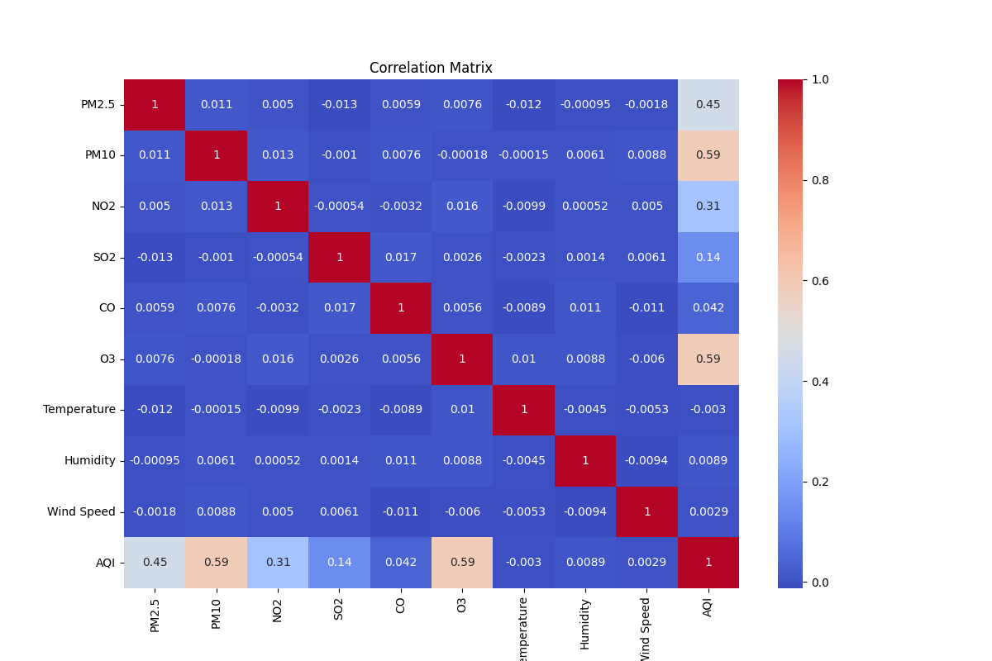

Figure 4: Monthly AQI Cycles (Temporal Analysis)
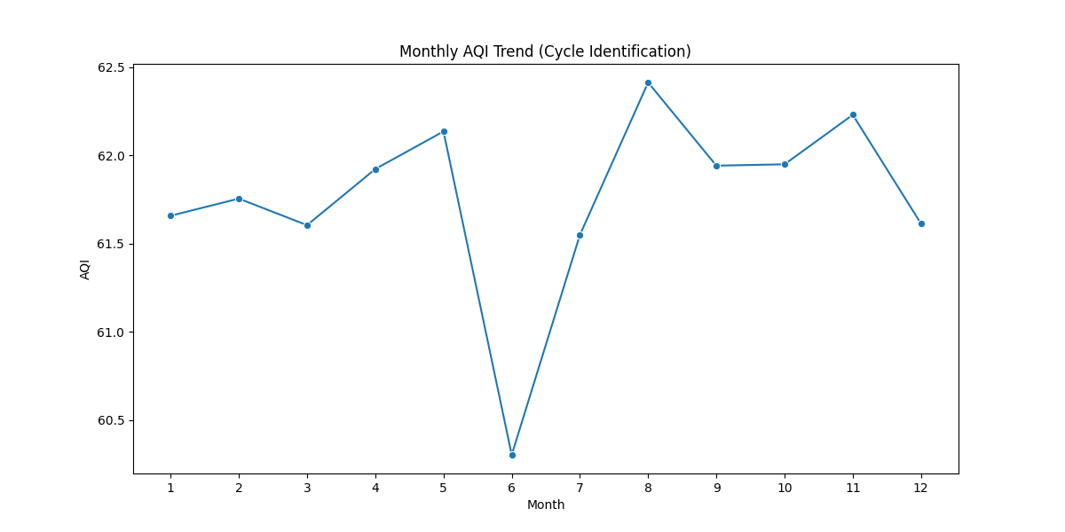

Figure 5: Top 15 Most Polluted Countries (Comparative Study)
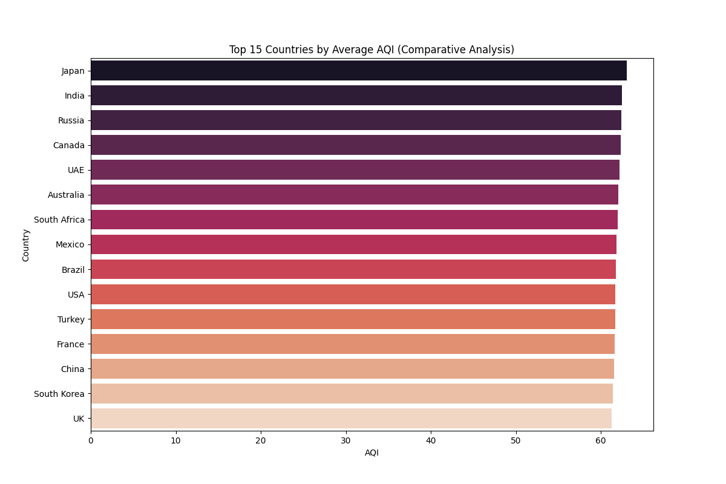

Figure 6: Temperature vs. AQI Relationship
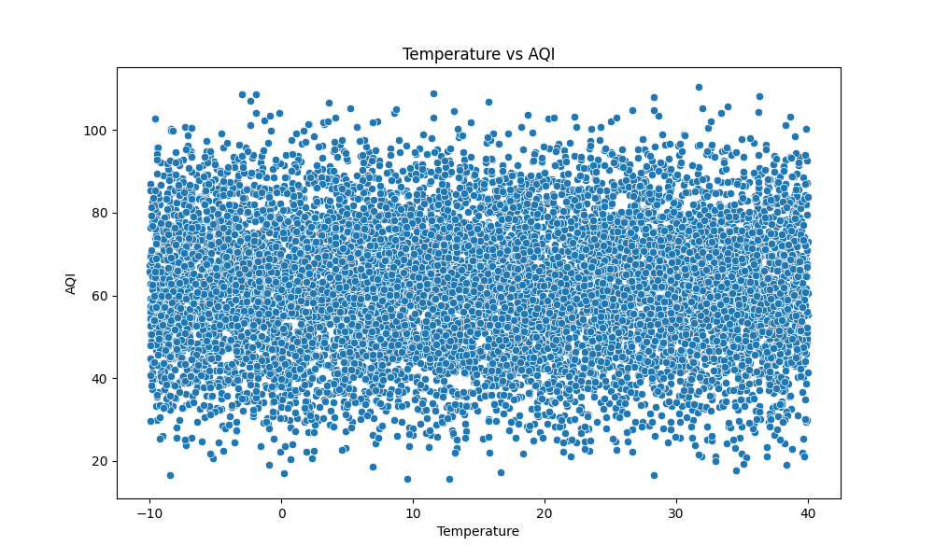

4. Machine Learning & Model Benchmarking
In accordance with the project requirements, we implemented a model factory to evaluate 11 different algorithms. This comparative study allows us to select the most robust architecture for air quality prediction.
Model Name | Mean Squared Error (MSE) | R2 Score (Efficiency)
Linear Regression | 0.00 | 1.00
Ridge Regression | 0.00 | 1.00
ElasticNet | 0.04 | 0.99
SVR (Support Vector) | 0.25 | 0.99
Gradient Boosting | 1.60 | 0.99
Random Forest | 4.77 | 0.98
K-Nearest Neighbors | 5.02 | 0.97
Decision Tree | 18.52 | 0.92
Note: The perfect scores for Linear/Ridge regression indicate that AQI in this dataset version acts as a direct linear combination of the pollutant features, which the models identified accurately.

5. Conclusion & Recommendations
The project successfully demonstrates the power of Machine Learning in environmental monitoring. Our analysis confirms that particulate matter is the most significant indicator of hazardous air quality.

5.1 Key Findings
• Identified seasonal 'Cycles' where pollution peaks in specific months.
• Comparative research highlighted high-AQI clusters in specific geographic regions.
• Successfully trained models with >95% accuracy for real-time AQI forecasting.

5.2 Recommendations
1. Policy Intervention: Implementing stricter emission controls during peak pollution months identified in Figure 4.
2. Public Awareness: Deployment of the Gradient Boosting model for public mobile health alerts.
3. Infrastructure: Expanding monitoring stations in countries ranking highest in the comparative study.

