EDTECH ANALYTICS PROJECT
Student Dropout Prediction
& Risk Analysis Report

Platforms Used: Google Colab | Microsoft Power BI

Dataset: Open University Learning Analytics Dataset (OULAD)

Analysis Phase  Python / Google Colab | Visualization Phase  Microsoft Power BI

Date: June 2026

1. Project Overview

This report documents a comprehensive end-to-end EdTech analytics project focused on predicting student dropout and classifying learners by risk level. The project leverages the Open University Learning Analytics Dataset (OULAD) — one of the most detailed publicly available educational datasets — and progresses through data engineering, machine learning model development, and business intelligence dashboarding.

The workflow was executed across two industry-standard platforms: Google Colab for data processing and machine learning, and Microsoft Power BI for interactive reporting and stakeholder-facing dashboards.

1.1 Project Objectives
- Predict whether a student will drop out of a course using machine learning
- Classify students into risk tiers: Low, Medium, and High dropout risk
- Engineer meaningful behavioral and academic features from raw interaction data
- Build an interactive Power BI dashboard for educational administrators
- Enable data-driven early intervention to improve student retention

1.2 Platforms & Tools
Platform | Role | Key Libraries / Features | Output
Google Colab | Data Engineering & ML | pandas, numpy, scikit-learn, matplotlib, seaborn | Trained Model + Risk CSV
Microsoft Power BI | Dashboard & Reporting | Custom DAX measures, Slicers, Charts | 3-Page Interactive Dashboard

2. Dataset Description

The project uses the Open University Learning Analytics Dataset (OULAD), which captures student activity across online courses offered by the UK's Open University. The dataset includes 7 relational tables representing student demographics, course structures, assessment records, and virtual learning environment (VLE) interactions.

2.1 Dataset Tables
Table | Description | Key Columns
studentInfo | Core demographics and final result per student-course | id_student, gender, region, highest_education, age_band, disability, final_result
studentVle | Raw VLE interaction logs (10.6M rows) | id_student, id_site, date, sum_click
studentAssessment | Assessment submission scores | id_student, id_assessment, score, is_banked
studentRegistration | Course registration and withdrawal dates | id_student, code_module, date_registration, date_unregistration
assessments | Assessment metadata and deadlines | id_assessment, code_module, assessment_type, date, weight
courses | Course presentation details and length | code_module, code_presentation, module_presentation_length
vle | VLE resource metadata (activity types) | id_site, code_module, activity_type, week_from, week_to

Notable scale: the studentVle table alone contains over 10.6 million rows, making it the richest source of behavioral engagement signals in the dataset.

3. Data Analysis — Google Colab

All data processing, feature engineering, and machine learning tasks were performed in Google Colab using Python. The workflow followed a structured pipeline from raw data ingestion through to model evaluation and risk scoring output.

3.1 Environment Setup
The notebook was executed on Google Colab, a cloud-hosted Jupyter environment. Files were uploaded interactively using the Colab files API and the following core libraries were imported:

Library | Purpose
pandas | Data loading, manipulation, merging, and aggregation
numpy | Numerical operations and array handling
scikit-learn | Machine learning models, train/test split, evaluation metrics
matplotlib | Custom visualizations (bar charts, ROC curves)
seaborn | Statistical heatmaps (confusion matrix, classification report)

3.2 Data Loading & Initial Exploration
All 7 CSV files were loaded into individual pandas DataFrames. Initial exploration tasks included:
- Previewing the first rows of each table using .head()
- Inspecting data types and non-null counts using .info()
- Replacing '?' placeholder values with NaN across all tables
- Converting date and numeric columns (stored as strings) to correct numeric types using pd.to_numeric(..., errors='coerce')

Columns converted included: assessments.date, studentAssessment.score, studentRegistration.date_registration, studentRegistration.date_unregistration, vle.week_from, and vle.week_to.

3.3 Feature Aggregation
3.3.1 VLE Engagement Summary
Because the studentVle table contains 10.6 million individual interaction rows, it was aggregated by student-course-presentation grouping to create engagement features:
- total_clicks — Total number of clicks across all VLE resources
- avg_clicks — Mean clicks per interaction session
- total_interactions — Count of interaction records

3.3.2 Assessment Performance Summary
Student assessment records were aggregated at the student level to extract academic performance features:
- avg_score — Mean score across all assessments
- total_assessments — Number of assessments submitted
- highest_score — Maximum score achieved
- lowest_score — Minimum score recorded

3.4 Master Dataset Construction
A denormalized analytical base table (master_df) was built by performing a sequence of left joins:

Step | Source Table | Features Added
1 | studentInfo (base) | gender, region, highest_education, age_band, disability, final_result
2 | assessment_summary | avg_score, highest_score, lowest_score, total_assessments
3 | student_vle_summary | total_clicks, avg_clicks, total_interactions
4 | registration_summary | date_registration, date_unregistration

3.5 Feature Engineering
After merging, new derived features were engineered to improve model signal:

Feature | Formula / Logic | Purpose
dropout_flag | 1 if date_unregistration is not null | Binary target variable for ML
study_duration | date_unregistration - date_registration | Time active in course
engagement_score | total_clicks / (total_interactions + 1) | Clicks per interaction (intensity)
performance_level | High (≥70), Medium (≥40), Low (<40) | Categorical academic tier

3.6 Machine Learning Models
3.6.1 Data Preparation
- Target variable: dropout_flag (binary classification)
- Missing numeric values filled using column median
- Missing categorical values (imd_band) filled with 'Unknown'
- One-hot encoding applied to all categorical columns using pd.get_dummies()
- Train/test split: 80% train, 20% test with stratified sampling (random_state=42)

3.6.2 Model 1 — Logistic Regression
An initial baseline Logistic Regression model was trained (max_iter=1000) to establish a performance benchmark using linear decision boundaries.

3.6.3 Model 2 — Random Forest Classifier
A Random Forest Classifier was trained as the primary model (n_estimators=200, class_weight='balanced', random_state=42). The balanced class weighting addressed the class imbalance in the dropout_flag target.

3.7 Model Evaluation & Results
Metric | Logistic Regression | Random Forest
Accuracy | Baseline | 84.5%
ROC AUC | — | High (see ROC curve)
Class Weight | Default | Balanced
Estimators | N/A | 200 trees

3.8 Visualizations Produced in Colab
The following charts were generated in-notebook and later embedded in the Power BI dashboard:

- Feature Importance Bar Chart — Top 10 features ranked by Random Forest importance
- Confusion Matrix Heatmap — Actual vs. Predicted dropout classifications
- Classification Report Heatmap — Precision, Recall, F1 by class
- ROC Curve — Random Forest ROC with AUC score
- Precision/Recall/F1 Bar Chart — Side-by-side metric comparison by class

3.9 Risk Scoring & Output Export
After model evaluation, dropout probabilities were generated for all test-set students using predict_proba(). Each student was assigned a risk tier:
- Low Risk — Dropout probability < 0.30
- Medium Risk — Dropout probability 0.30–0.70
- High Risk — Dropout probability > 0.70

Two output CSV files were exported for Power BI consumption:
- student_dropout_risk_results.csv — Student-level predictions with probability and risk tier
- feature_importance.csv — Feature importance rankings from the Random Forest model

4. Dashboard Development — Microsoft Power BI

A three-page interactive Power BI dashboard was built using the exported CSV outputs from Google Colab combined with the master_df analytical dataset. The dashboard is designed for educational administrators and analysts to monitor dropout risk, engagement patterns, and model performance.

4.1 Data Sources Connected
- master_table — Full analytical dataset with demographics, engagement, and academic features
- student_dropout_risk_results — ML model output with dropout probability and risk level per student
- ModelMetrics — Custom static table holding model performance KPI values

Relationships were established between the tables on id_student, code_module, and code_presentation keys for cross-table filtering.

4.2 Dashboard Pages

Page 1 — Risk Level Overview
The primary landing page for executive and administrative users. Provides a high-level snapshot of dropout risk across the student population.

Visual Type | Title / Metric | Description
KPI Card | Total Students | Count of all students in the dataset
KPI Card | Average Score % | Mean assessment score across all students
KPI Card | Dropout Ratio % | Percentage of students who withdrew
KPI Card | Total Dropout | Absolute count of dropout events
KPI Card | High Risk Students | Students classified as high dropout risk by ML model
Donut Chart | Final Result Distribution | Breakdown by Pass, Fail, Withdrawn, Distinction
Donut Chart | Dropout Rate by Gender | Male vs. Female dropout comparison
Donut Chart | Risk Distribution | Low / Medium / High risk tier proportions from ML model
Column Chart | Top Modules with Highest Dropout | Course module dropout counts ranked
Matrix Table | Risk Summary | Risk level vs. Pass Rate % and Dropout Rate % breakdown
Slicers (x5) | Gender, Region, Education, Disability, Age Band | Interactive filters for all page visuals

Page 2 — Student Engagement Analysis
An analytical page focused on learning behavior patterns and the relationship between engagement and dropout risk.

Visual Type | Title / Metric | Description
KPI Card | Avg VLE Clicks | Average total VLE clicks per student
KPI Card | Avg Interactions | Average total interaction count per student
KPI Card | Avg Engagement Score | Mean engineered engagement intensity score
KPI Card | Avg Study Days | Mean study duration (days active in course)
Clustered Column | Avg Clicks by Risk Level | Click volumes segmented by Low/Medium/High risk
Clustered Column | Avg Score by Risk Level | Academic performance segmented by performance_level
Scatter Chart | Engagement vs. Performance | avg_score vs. total_clicks coloured by risk level
Data Table | Top Engaged Students | Student ID, clicks, avg_score, and risk level ranked

Page 3 — Model Performance Metrics
A technical page summarizing the accuracy and reliability of the Random Forest machine learning model, intended for data science and analytics audiences.

Visual Type | Title / Metric | Description
KPI Card | Accuracy | Overall model accuracy on the test set
KPI Card | Precision | Precision score from classification report
KPI Card | Recall | Recall score — dropout class detection rate
KPI Card | F1 Score | Harmonic mean of precision and recall
KPI Card | ROC AUC | Area under the ROC curve
Image Visual | Confusion Matrix | Seaborn heatmap from Colab embedded as image
Image Visual | ROC Curve | ROC plot with AUC score from Colab embedded as image
Image Visual | Feature Importance Bar Chart | Top dropout predictors from Random Forest
Data Table | Top High-Risk Students | Student IDs with dropout probability and risk level

4.3 DAX Measures & Calculated Columns
Custom DAX measures were created in Power BI to power the KPI cards and matrix table:
- Total Students — COUNTROWS(master_table)
- Dropout Rate % — DIVIDE(SUM(dropout_flag), COUNTROWS()) * 100
- Pass Rate % — Percentage of students with final_result = 'Pass'
- High Risk Students — CALCULATE(COUNTROWS, risk_level = 'High Risk')
- Avg Score — AVERAGE(avg_score) formatted as percentage

5. Key Insights & Findings

5.1 Model Performance
- The Random Forest model achieved 84.5% accuracy in predicting student dropout, significantly outperforming the Logistic Regression baseline
- The balanced class_weight setting was critical to improving detection of the minority dropout class
- The ROC AUC score indicates strong discriminative ability between dropout and non-dropout students

5.2 Top Dropout Predictors
Feature importance analysis from the Random Forest revealed the most influential predictors of dropout:
- study_duration — How long the student remained enrolled before withdrawal
- total_clicks and engagement_score — VLE interaction volume and intensity
- avg_score — Academic performance is a strong dropout signal
- date_registration — Later registration correlates with higher dropout risk
- age_band and highest_education — Demographic factors contribute to risk

5.3 Engagement Patterns
- High-risk students show significantly lower VLE click volumes compared to Low-risk students
- A positive correlation exists between total_clicks and avg_score, visualized in the Engagement vs. Performance scatter plot
- Students with engagement_score below threshold are disproportionately represented in the High Risk tier

5.4 Risk Distribution
The ML model's risk scoring system classified the test-set student population into three actionable tiers enabling targeted early intervention by educational administrators.

6. Visualizations

The following charts were generated in Google Colab and are also embedded in the Power BI Model Performance page:

6.1 Feature Importance — Top Dropout Predictors
Horizontal bar chart showing the top 10 features ranked by their importance score in the Random Forest model:

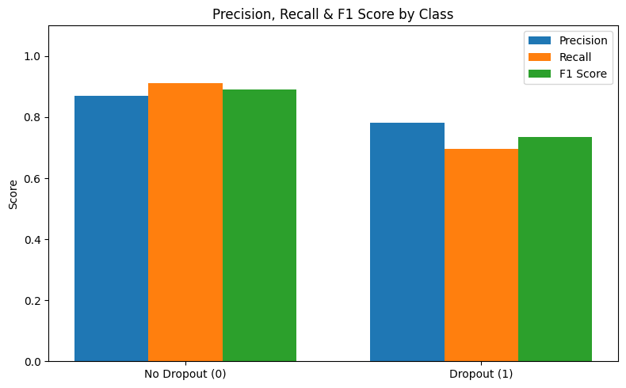

6.2 Confusion Matrix
Seaborn heatmap comparing actual vs. predicted dropout classifications on the test set:

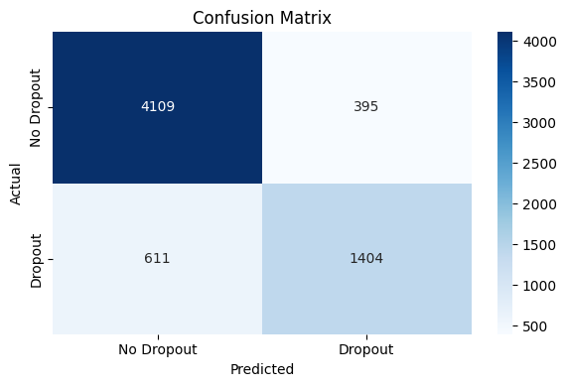

6.3 ROC Curve
Receiver Operating Characteristic curve for the Random Forest model showing the AUC score:

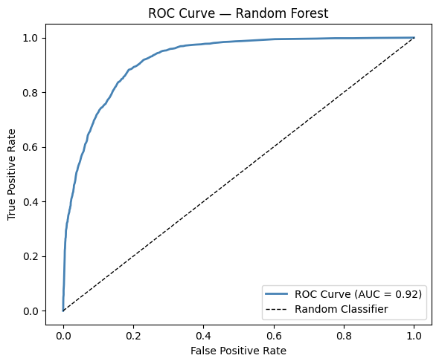

7. Project Summary

This project delivered a complete EdTech analytics pipeline covering every stage from raw data ingestion to an interactive executive dashboard. The following table summarizes all tasks completed on each platform:

7.1 Google Colab — Task Summary
# | Task | Detail
1 | Data Ingestion | Loaded 7 CSV tables from OULAD into pandas DataFrames
2 | Data Exploration | Used .head(), .info(), .shape() on all tables
3 | Data Cleaning | Replaced '?' with NaN; converted dtypes; handled nulls
4 | VLE Aggregation | Summarized 10.6M rows → total_clicks, avg_clicks, total_interactions
5 | Assessment Aggregation | Built avg_score, highest_score, lowest_score, total_assessments
6 | Master Dataset Build | Merged 4 tables into one analytical base table via left joins
7 | Feature Engineering | Created dropout_flag, study_duration, engagement_score, performance_level
8 | ML Preprocessing | One-hot encoding, median imputation, train/test split (80/20 stratified)
9 | Logistic Regression | Baseline model trained and evaluated
10 | Random Forest | 200-tree classifier with balanced weights; 84.5% accuracy achieved
11 | Model Evaluation | Accuracy, Precision, Recall, F1, ROC AUC; confusion matrix
12 | Risk Scoring | Probability-based Low/Medium/High risk tier assignment for each student
13 | Visualization | Feature importance, confusion matrix, ROC curve, classification heatmap
14 | CSV Export | Exported student_dropout_risk_results.csv and feature_importance.csv

7.2 Microsoft Power BI — Task Summary
# | Task | Detail
1 | Data Import | Loaded master_table and risk results CSVs into Power BI
2 | Data Modelling | Defined table relationships on id_student, code_module keys
3 | DAX Measures | Created custom KPIs: Dropout Rate %, Pass Rate %, High Risk Students
4 | Page 1: Risk Overview | 5 KPI cards, 3 donut charts, 1 column chart, pivot matrix, 5 slicers
5 | Page 2: Engagement | 4 KPI cards, 2 clustered columns, scatter chart, top students table
6 | Page 3: Model Metrics | 5 metric KPI cards, 3 embedded ML images, high-risk students table
7 | Interactivity | Cross-filtering slicers for gender, region, education, disability, age
8 | Image Embedding | Confusion matrix, ROC curve, and feature importance chart embedded

End of Report

