Week 2 report of Internship

Ammar Akram
Name

DVS-8041
ID

Machine Learning
Domain

Ofiice
Devsphere

09/09/2026
Date

DEVSPHERE AI & ML INTERNSHIP

Data Visualization:
1. Project Overview:
This project focuses on visualizing student performance data using Python. The dataset was explored through different charts to make the information easier to understand and identify useful patterns in student performance.
2. Objective:
The main objective was to create clean and meaningful visualizations using Matplotlib and Seaborn. Three different types of charts were created: a bar chart, a line chart, and a pie chart.
3. Dataset:
The project uses the Student Performance Mathematics dataset containing information about students and their academic performance.
The dataset contains 395 student records and 33 columns. The main grade columns used for visualization were:

- G1 — First-period grade
- G2 — Second-period grade
- G3 — Final grade
The dataset was loaded and analyzed using Pandas before creating the visualizations.

4. Tools and Technologies:
- Python
- Pandas
- Matplotlib
- Seaborn
- Jupyter Notebook

5. Visualizations:
5.1 Average Final Grade by Gender:
A bar chart was created to compare the average final grade (G3) of female and male students.
Purpose:
To see whether there is a noticeable difference in average final performance between the two groups.
Figure 1: Average Final Grade by Gender:
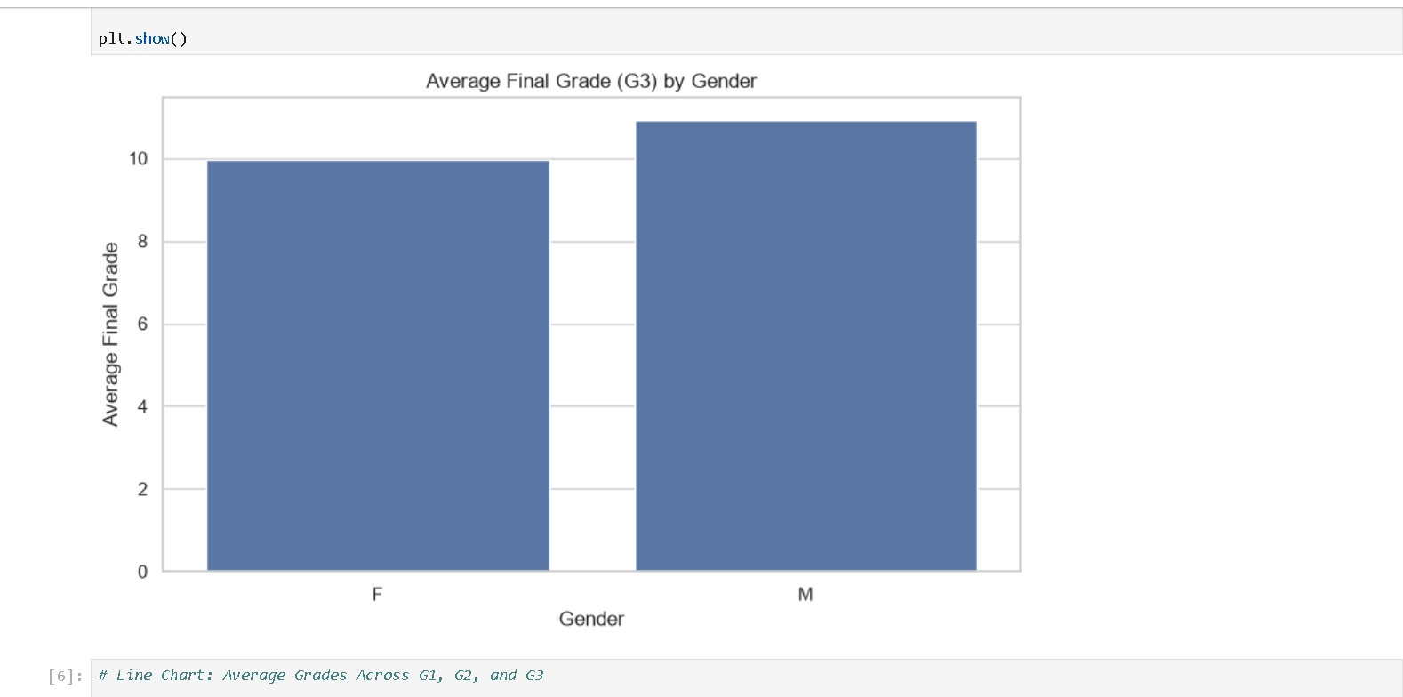
The chart shows a small difference between the average final grades of the two groups. This indicates that gender alone does not show a major difference in final academic performance in this dataset.

5.2 Average Grades Across G1, G2, and G3:
A line chart was used to show the average grades across the first period, second period, and final grade.
Purpose:
To observe the overall change in student performance across the three grading periods.
Figure 2: Average Student Grades Across G1, G2, and G3:
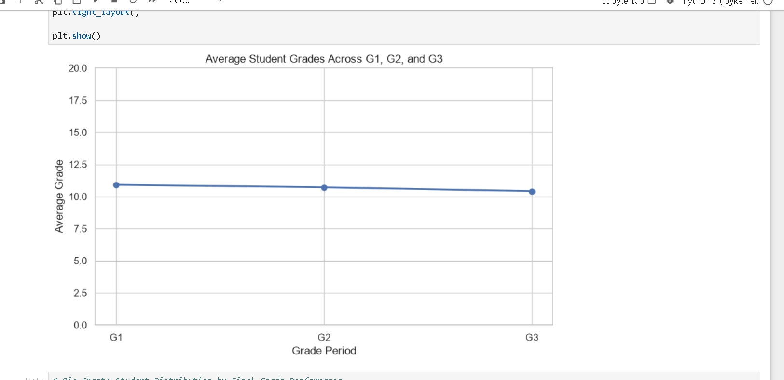

The line chart provides a clear view of the overall grade trend and makes it easier to compare the average values of G1, G2, and G3.

5.3 Student Distribution by Final Grade Performance:
A pie chart was created by grouping students according to their final grade:
- High: 15–20
- Medium: 10–14
- Low: 0–9

Purpose:
To understand how students are distributed across different final-performance levels.
Figure 3: Student Distribution by Final Grade Performance:
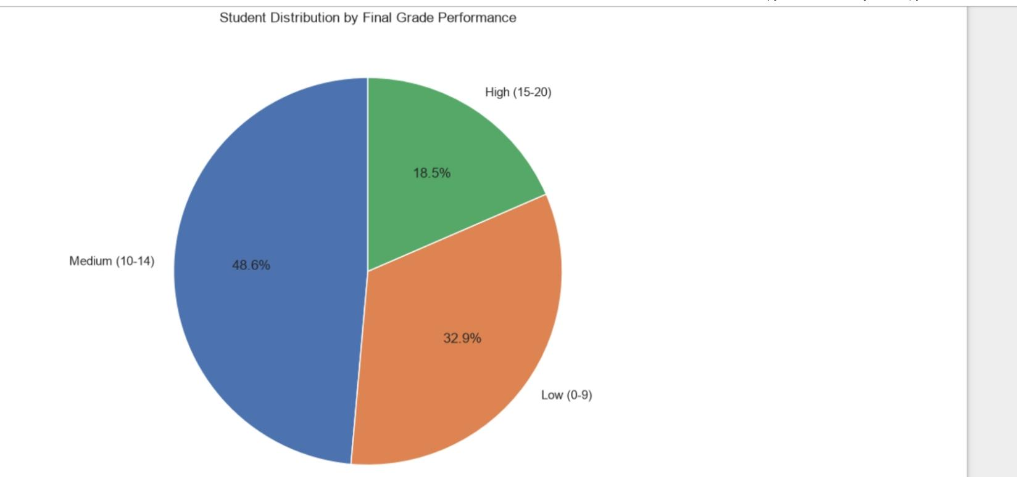
The chart provides a quick overview of the most common performance level among the students and shows the proportion of students in each group.

6. Key Insights:
The visualizations provide several useful observations:
- The average final grades of female and male students are relatively close.
- G1, G2, and G3 provide a useful view of the overall academic performance trend.
- The final-grade groups show how students are distributed across different performance levels.
- Visualizations make patterns in the dataset easier to understand than looking at raw numerical data alone.

7. Conclusion
This project successfully converted student performance data into clear and understandable visualizations. Using Matplotlib and Seaborn, bar, line, and pie charts were created with appropriate titles and labels.
The visual analysis made it easier to compare student performance, observe grade trends, and understand the distribution of final grades. This task also provided practical experience in presenting data in a simple and meaningful way.

