Week 3 report of Internship

Ammar Akram
Name

DVS-8041
ID

Machine Learning
Domain

Ofiice
Devsphere

16/09/2026
Date

DEVSPHERE AI & ML INTERNSHIP

WEEK 3 — SUPERVISED LEARNING: REGRESSION

1. Project Overview:
As part of Week 3 of the DevSphere AI & Machine Learning Internship, a supervised machine learning regression model was implemented using the Student Performance Mathematics dataset.
The objective of the project was to train a Linear Regression model to predict a student's final grade (G3) using their first-period grade (G1) and second-period grade (G2).
The project demonstrates a complete regression workflow, from loading and preparing the dataset to model training, prediction, evaluation, visualization, and model saving.

2. Dataset
Student Performance Mathematics Dataset
Dataset file: student-mat.csv
Records: 395 students
Columns: 33
The model uses the students' earlier academic performance to predict their final grade.

3. Machine Learning Method:
Supervised Learning — Regression
The problem is treated as a supervised regression task because the target variable, G3, is a numerical grade.
The selected inputs were:
Features: G1, G2
Target: G3
The overall workflow was:
Dataset → Feature Selection → Train/Test Split → Linear Regression → Predictions → Evaluation → Visualization → Saved Model

4. Train/Test Split
The dataset was divided into training and testing portions using an 80/20 split.
- Training samples: 316
- Testing samples: 79
- Random state: 42

The training data was used to learn the relationship between G1, G2, and G3.
The testing data was kept separate and used to evaluate the model on previously unseen records.

5. Linear Regression Model:
The selected algorithm was Linear Regression from Scikit-learn.
The model learns coefficients representing the relationship between the input grades and the final grade.
The learned model follows the form:
G3 = Intercept + (Coefficient × G1) + (Coefficient × G2)
After training, the model was used to predict the final grades of the 79 testing samples.

6. Model Predictions:
The trained model successfully generated predictions for the test dataset.
- The prediction results compare:
- Actual G3 — the student's real final grade
- Predicted G3 — the grade estimated by the trained model

This provides a direct way to examine how closely the regression model predicts the actual final grades.
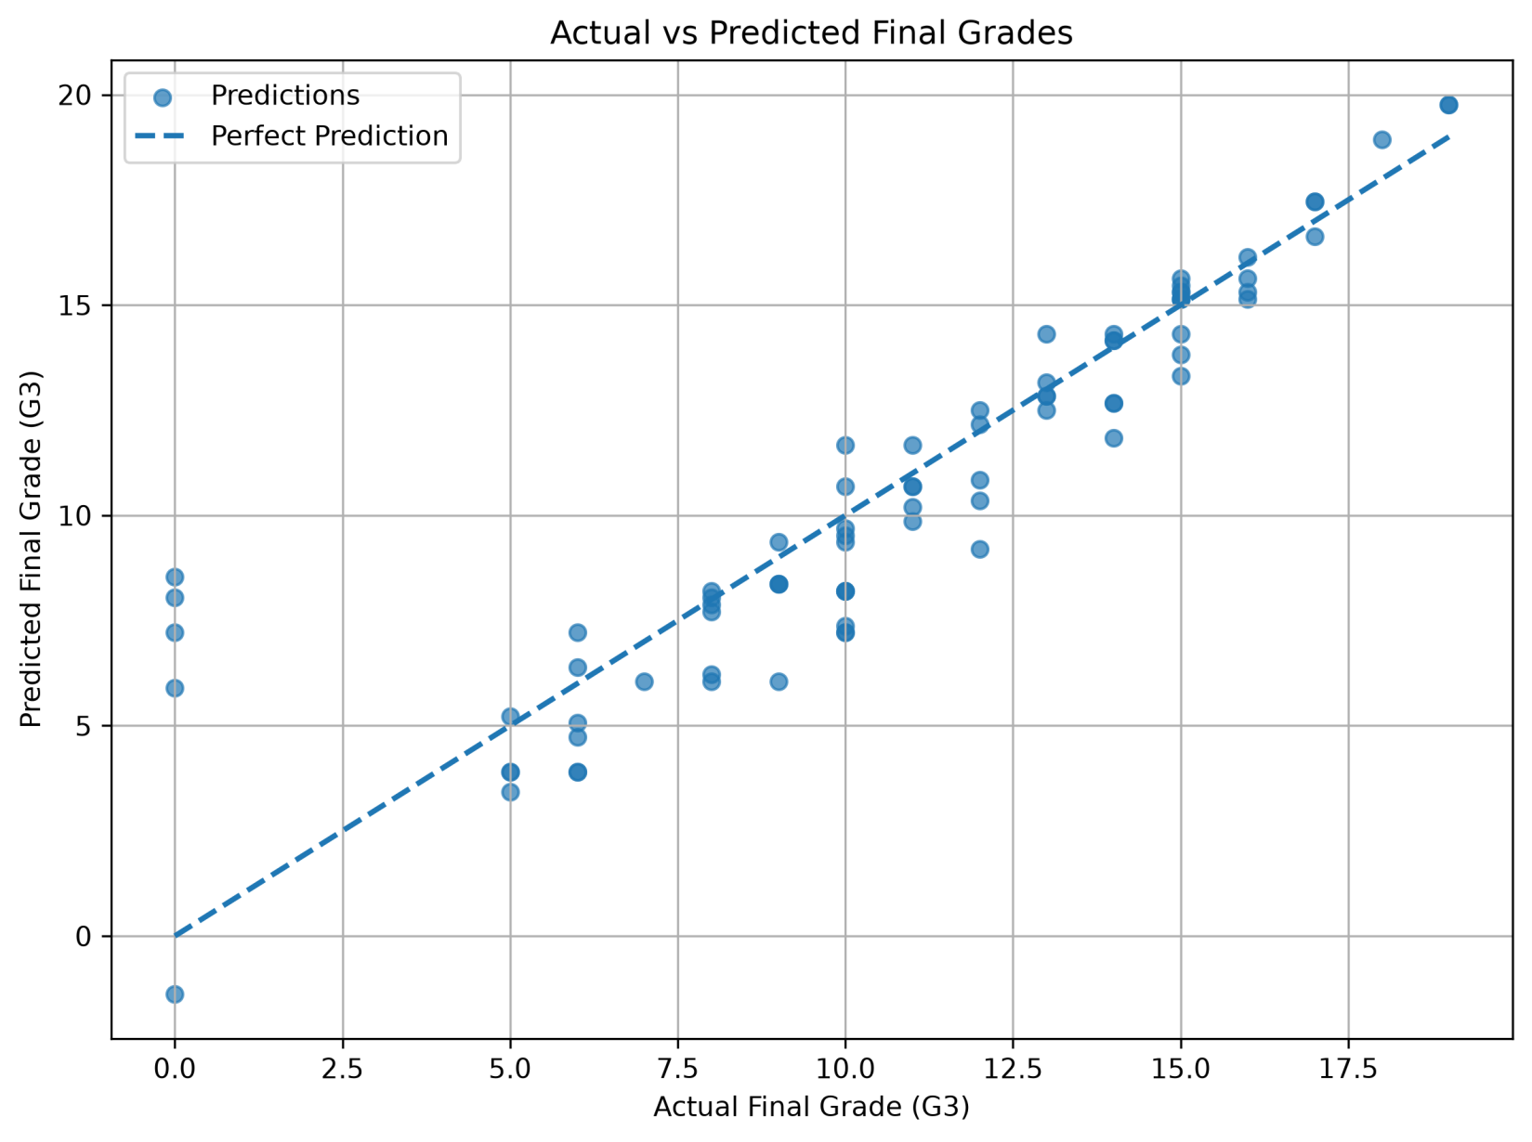
7. Model Evaluation:
The regression model was evaluated using four standard metrics:
- Mean Absolute Error (MAE)
- Measures the average absolute difference between the actual and predicted grades.
- Mean Squared Error (MSE)
- Measures the average squared prediction error.
- Root Mean Squared Error (RMSE)
- Measures prediction error while expressing it on the same general scale as the target variable.
- R² Score
- Measures how well the model explains the variation in the final grade.
The exact metric values were calculated directly by the trained model and are displayed in the completed Jupyter Notebook.

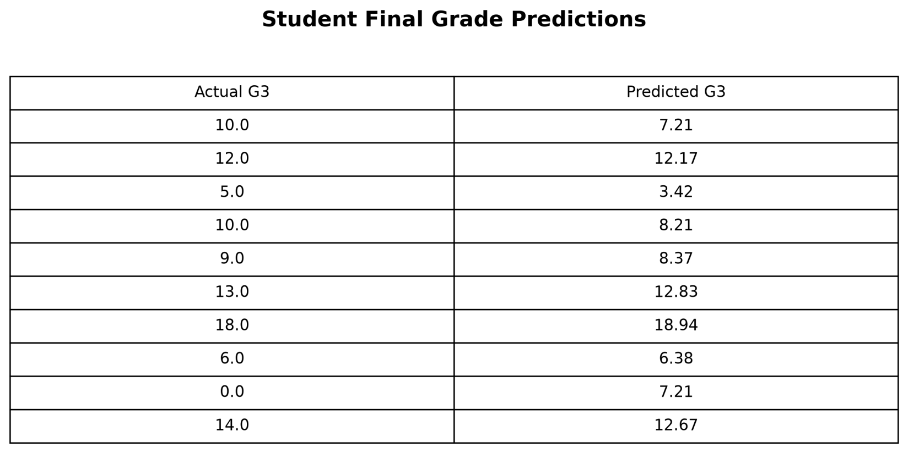
8. Actual vs Predicted Visualization
An Actual vs Predicted Final Grades scatter plot was created to visually compare the model's predictions with the actual final grades.
The diagonal reference line represents perfect prediction. Predictions closer to this line indicate closer agreement between the predicted and actual values.

9. Model Saving:
After training, the Linear Regression model was saved as a Pickle file so that it can be reused without training the model again.
Saved model:
linear_regression_student_grade_model.pkl
This makes the trained model available for future prediction tasks or integration into another application.

- 10. Technologies Used:

- Python — Machine learning implementation
- Pandas — Dataset loading and manipulation
- NumPy — Numerical operations
- Matplotlib — Data visualization
- Scikit-learn — Linear Regression and model evaluation
- Jupyter Notebook — Experimentation and documentation
- Pickle — Model serialization

11. Conclusion:
The Week 3 DevSphere AI & ML Internship task was successfully completed by implementing a supervised learning regression solution using Linear Regression.
The model used G1 and G2 as input features to predict the final grade G3. The complete workflow included dataset preparation, train/test splitting, model training, prediction generation, performance evaluation, visualization, and model saving.
The resulting project provides a working and reusable regression model and demonstrates the fundamental workflow required for building supervised machine learning regression solutions.

