Human Pose Estimation and Rule-Based Activity Classification
Project Report
Course Topic: Pose Detection, Joint Angle Analysis, and Activity Classification

1. Learning Objective
The objective of this project is to design a complete computer vision pipeline capable of detecting human body poses, analyzing body joint geometry, smoothing noisy detections, computing joint angles, and classifying activities using a rule-based system.

2. Scenario
A human activity recognition system was developed using a pre-trained pose estimation model. The system processes video frames, extracts body keypoints, computes important joint angles, and classifies activities such as standing and squatting. The pipeline was evaluated against manually labeled ground truth annotations.

3. Tools and Technologies Used
- Python
- OpenCV
- MediaPipe Pose
- NumPy
- Matplotlib
- Gaussian Smoothing Filter

4. Methodology

Pose Detection & Pre-processing
Each video frame was processed using the MediaPipe Pose model to detect body landmarks such as shoulders, hips, knees, elbows, and ankles. Detected keypoints contained small frame-to-frame fluctuations (jitter), therefore a Gaussian smoothing filter with window size W=7 was applied to stabilize the coordinates.

Skeleton Visualization
The detected keypoints were connected to form a skeleton overlay on the original frames. This helped visualize body posture and movement over time.

Joint Angle Computation
Three major joint angles were selected for analysis: knee angle, hip angle, and elbow angle. Angles were calculated using geometric relationships between three connected keypoints.

Activity Transition Analysis
Joint angles were plotted over time to observe posture changes. A major transition was detected around frame 90 where the activity changed from standing to squatting.

Rule-Based Activity Classification
Threshold-based rules were designed using joint angles. If knee and hip angles remained near extended posture values, the activity was classified as Standing. When the joint angles changed significantly toward bent posture ranges, the activity was classified as Squatting.

5. Joint Angle Formula
Joint angles were computed using the cosine rule between three body keypoints. For points A, B, and C, the angle at point B was calculated as:
θ = arccos ( (BA · BC) / (|BA| × |BC|) )
Where BA and BC are vectors formed between the connected joints.

6. Raw vs Smoothed Joint Angles
The graph below compares raw knee angle values with Gaussian-smoothed values. The smoothing filter successfully reduced jitter while preserving the transition dynamics.
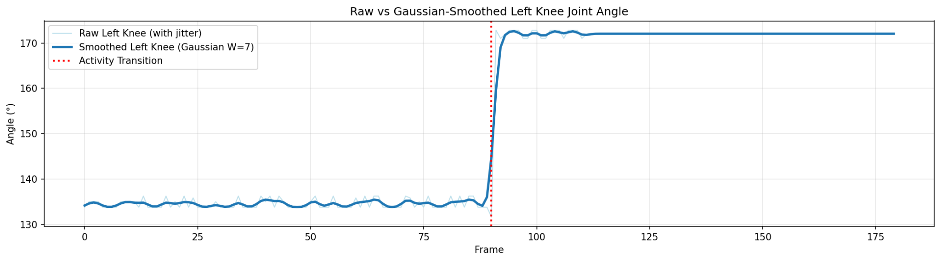

7. Joint Angle Analysis Over Time
The following plots show knee, hip, and elbow angles over time. The transition between standing and squatting is clearly visible around frame 90.
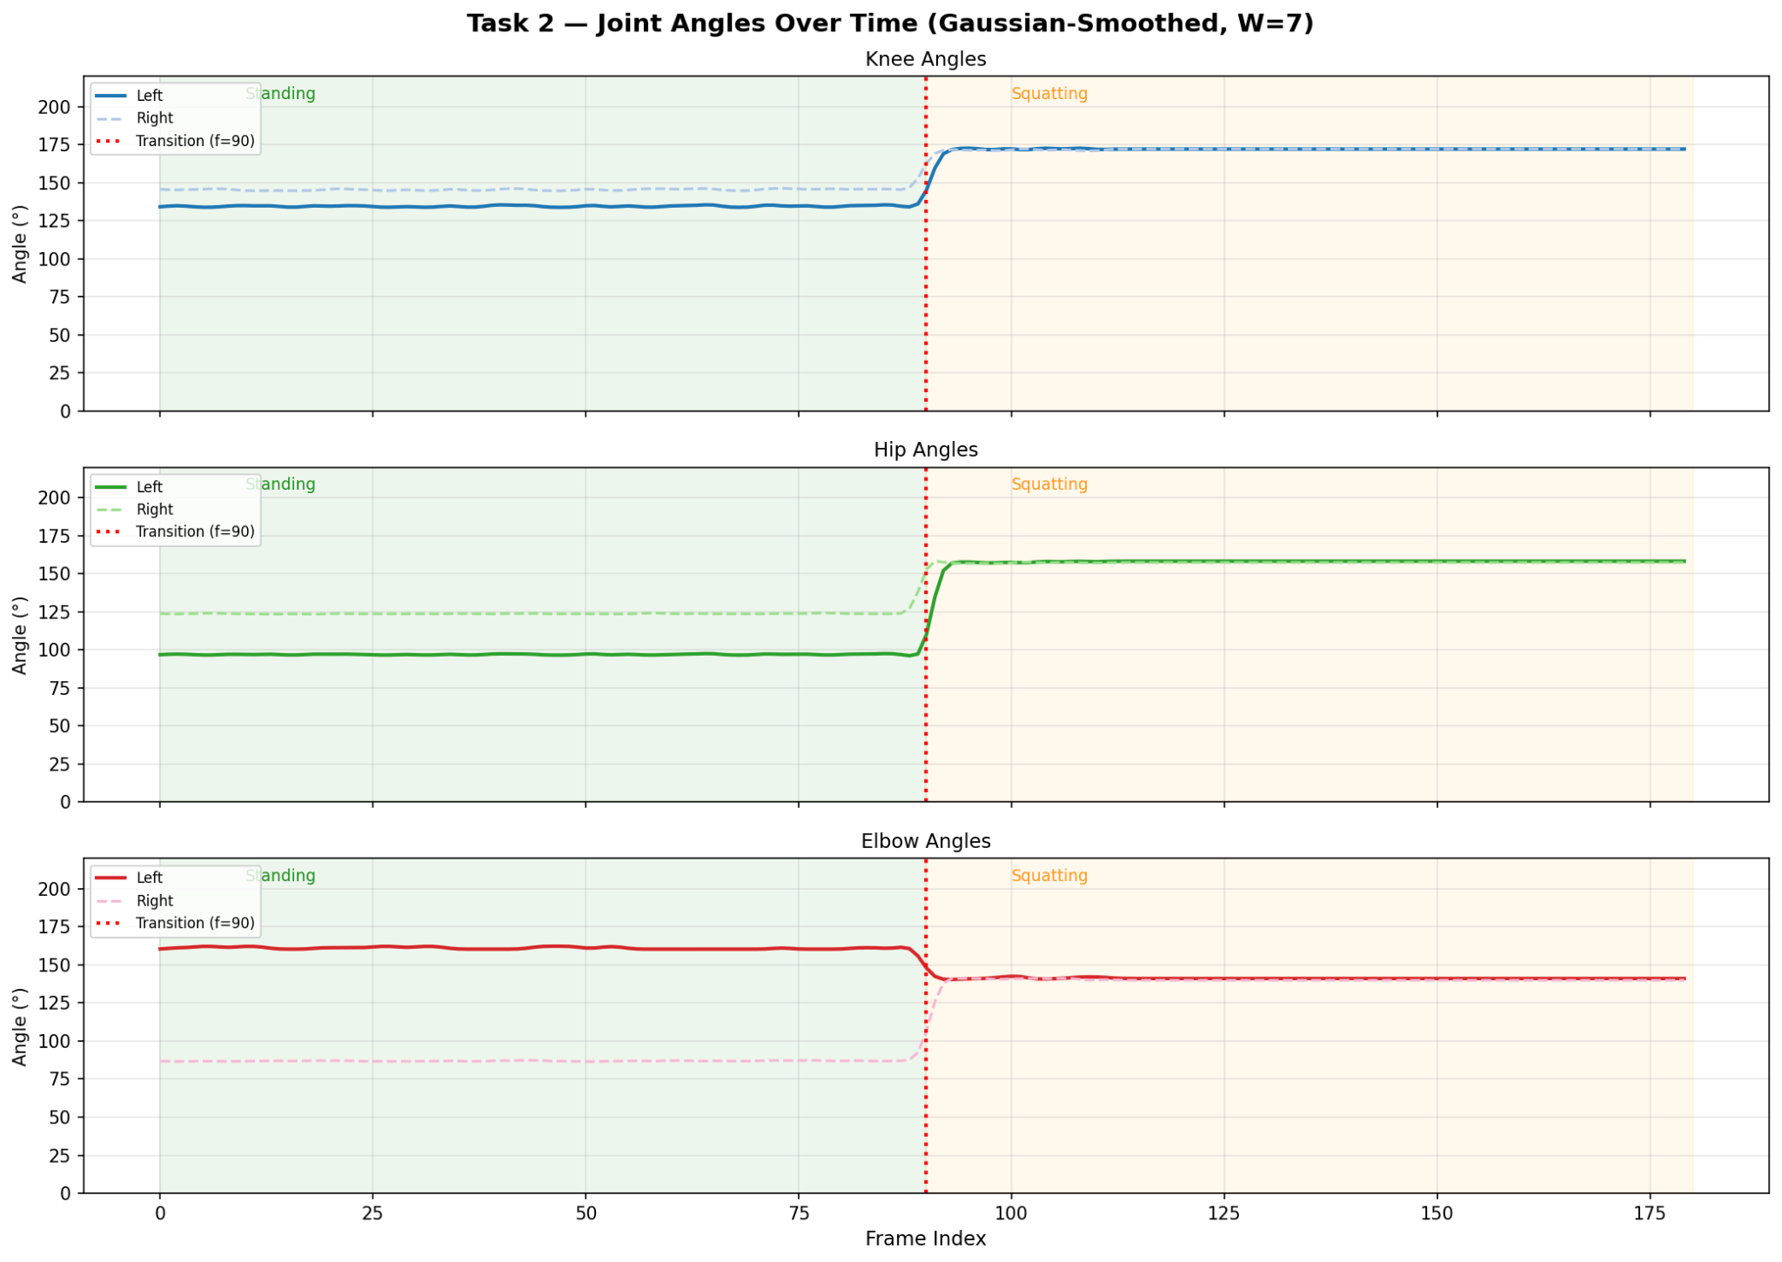

8. Activity Classification Timeline
The graph below compares ground truth labels with predicted activity labels. The classifier accurately identified most frames.
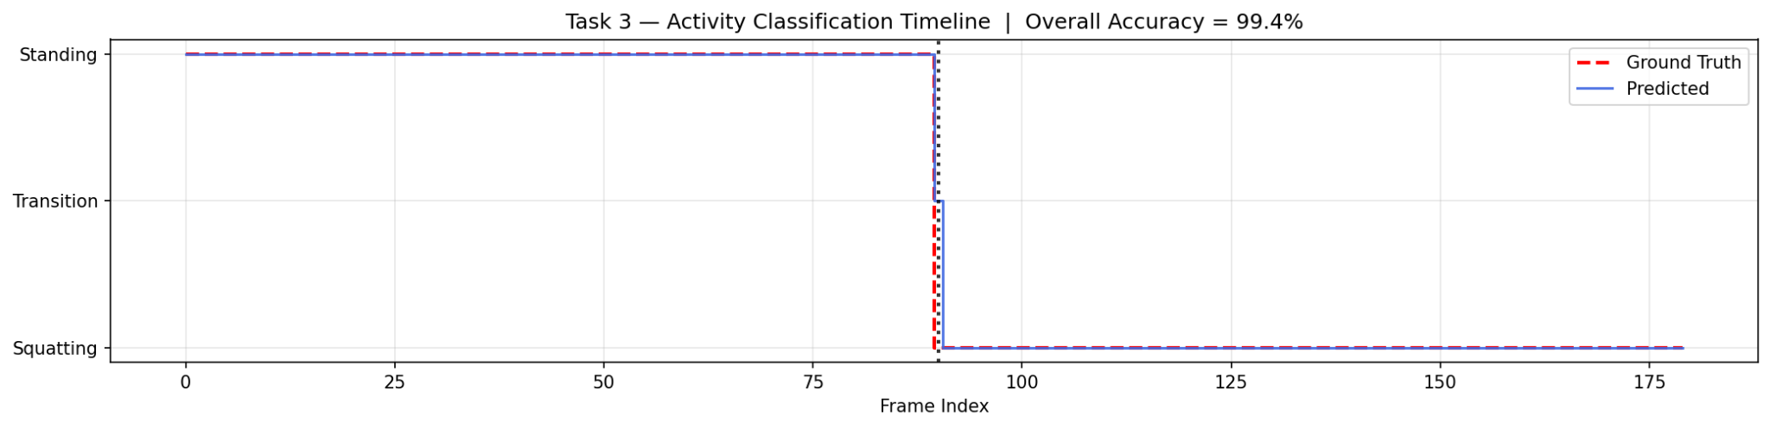

9. Results and Discussion
- The Gaussian smoothing filter effectively reduced keypoint jitter.
- Joint angle plots clearly represented posture changes across frames.
- A transition between standing and squatting was identified near frame 90.
- The rule-based classifier achieved an overall accuracy of approximately 99.4%.
- Minor classification errors occurred only during the transition frames due to rapid posture change.

10. Challenges Faced
- Pose estimation jitter caused unstable angle values before smoothing.
- Transition frames were difficult to classify because body posture changes rapidly.
- Different camera angles and visibility conditions can affect pose estimation accuracy.

11. Conclusion
This project successfully demonstrated a complete human activity recognition pipeline using pose estimation and rule-based classification. Body keypoints were extracted using MediaPipe Pose, joint angles were computed and analyzed over time, and activities were classified with high accuracy. The system proved that simple geometric rules combined with pose estimation can achieve reliable human activity recognition without requiring deep learning model training.

12. Future Improvements
- Extend the system to classify more activities such as sitting, walking, and arm raising.
- Replace the rule-based classifier with machine learning or deep learning models.
- Perform real-time webcam-based activity recognition.
- Improve robustness under occlusion and complex backgrounds.

