Exercise 1: Connecting your files to Venus

For this exercise I have mounted the local labs folder with venus RISCV online simulator as shown in the figure below
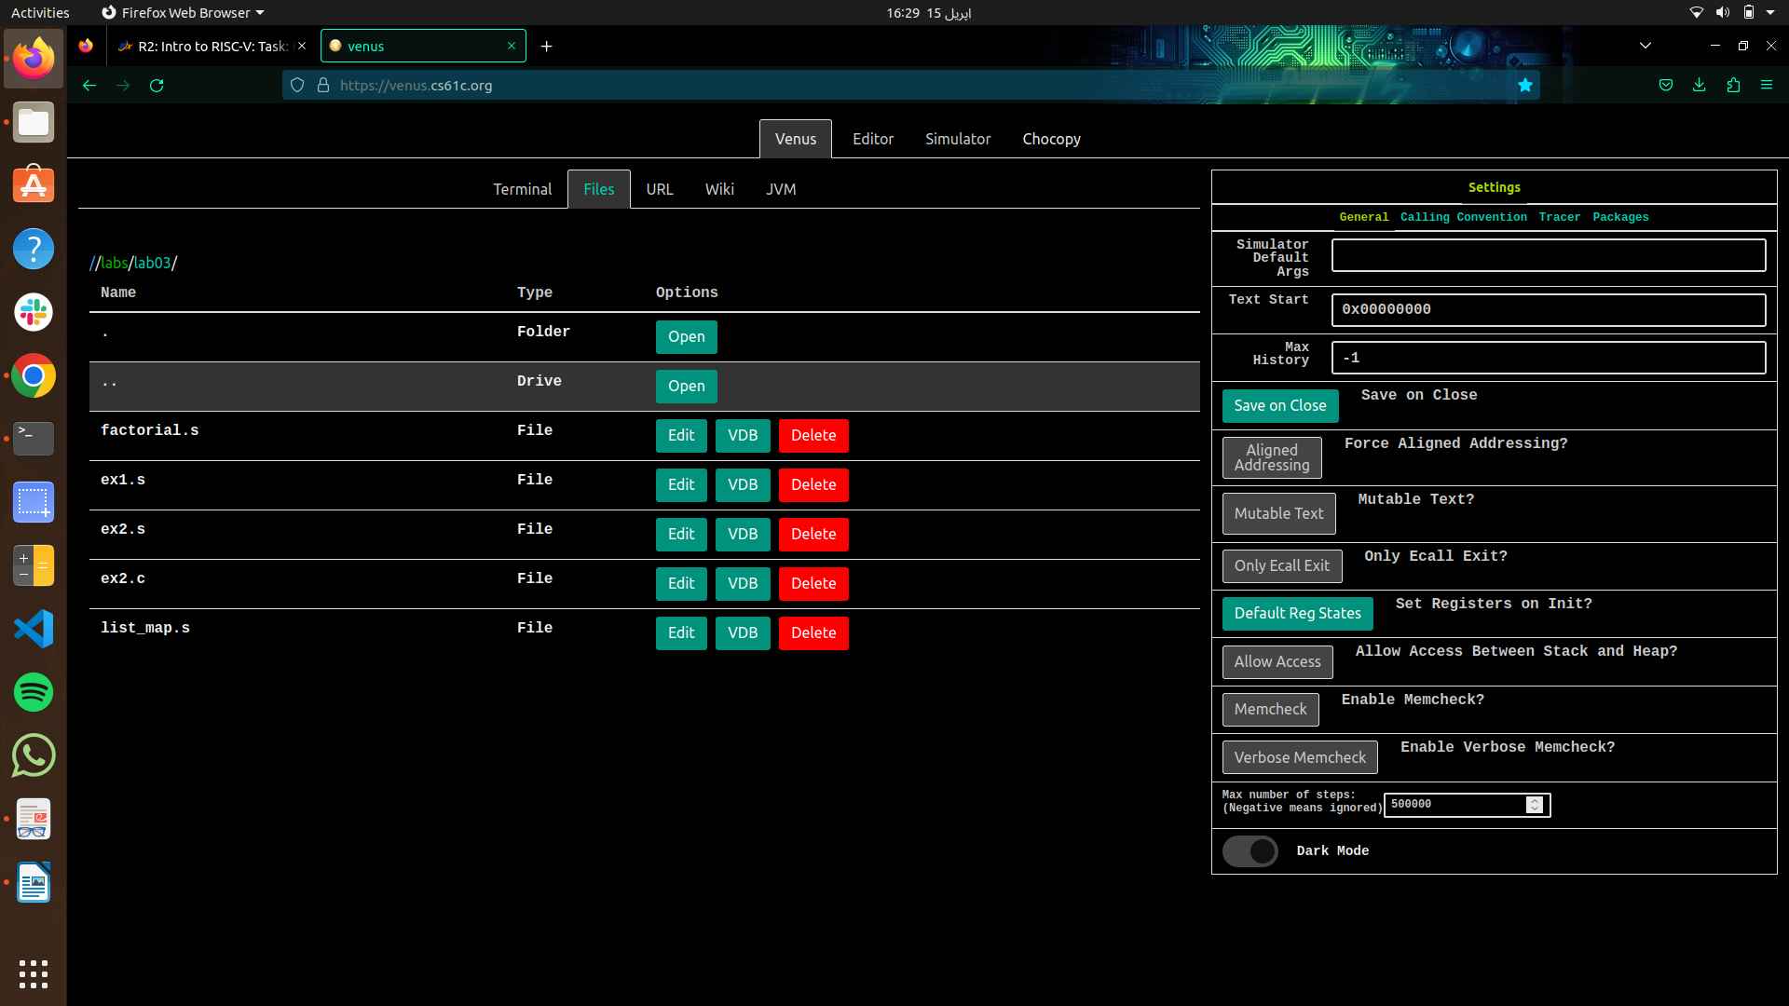
Exercise 2: Familiarizing yourself with Venus

1. What do the .data, .word, .text directives mean (i.e. what do you use them for)?

The .data section is used to define initial data values for the program. It includes declarations of variables and arrays that will be used by the program. The data stored in this section is located in the initialized data segment of memory, which is a region of memory that contains global and static variables initialized by the programmer.

The .word directive is used to allocate space in memory to hold a series of 32-bit words. It is commonly used to initialize arrays of integers. For example, the line .word 2, 4, 6, 8 initializes an array of four 32-bit integers with the values 2, 4, 6, and 8.

The .text section is used to define the executable code for the program. This is where the instructions that make up the program are stored. The code stored in this section is located in the text segment of memory, which is a read-only region of memory that contains the program instructions.

Overall, these directives allow us to specify how the program's code and data are organized in memory, and allow the program to efficiently access and manipulate the stored data.

2. Run the program to completion. What number did the program output? What does this number represent?

The program output after running the code was 34. This number represents the 9th number in the Fibonacci sequence, which is calculated by the program.

In this program, the fib label implements a loop that calculates the nth Fibonacci number, where n is the value of the n variable initialized in the .data section. When n is 9, the loop calculates and stores the 9th Fibonacci number (which is 34) in register t0. The program then prints out the value in t0 using a system call, which is the final output of the program.

3. At what address is n stored in memory? Hint: Look at the contents of the
registers.

We can see that when we loaded the address of n in t3 using la t3, n the address of n which was 0x10000010 was stored in x28(t3), as shown in the snapshot below

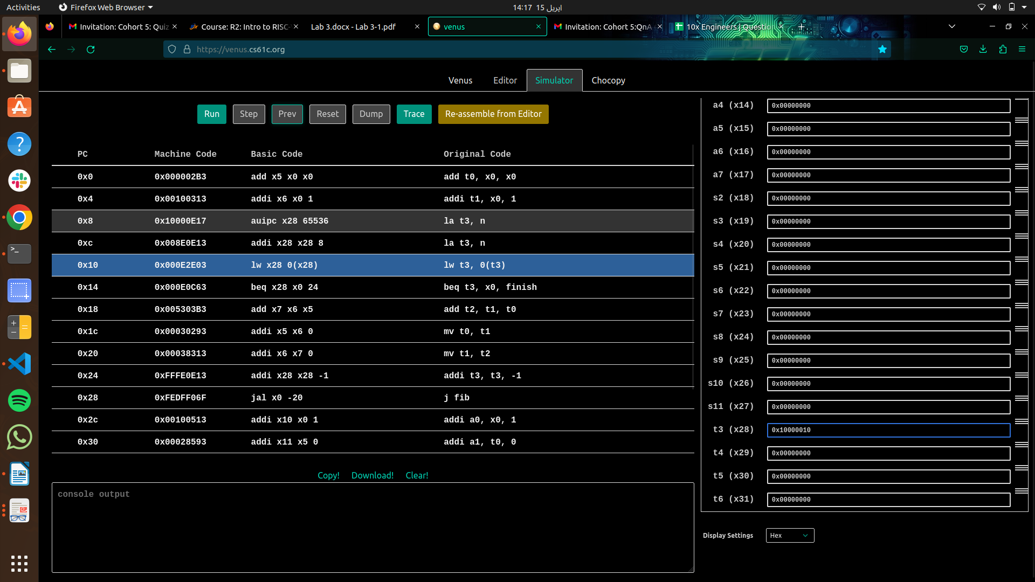

4. Without actually editing the code (i.e. without going into the "Editor" tab), have the program calculate the 13th fib number (0-indexed) by manually modifying the value of a register. You may find it helpful to first step through the code. If you prefer to look at decimal values, change the "Display Settings" option at the bottom

In order to do this when we have the value 9 stored in t3. I have manually changed that value to 13 as shown in the snapshot below

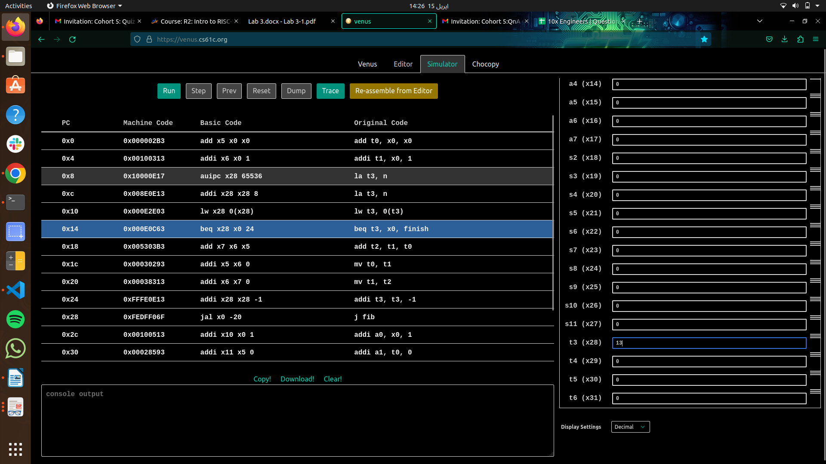
Then after changing the value to 13. I have pressed the run button to complete the execution of the program and result obtained was 233 which is the 13th number in the Fibonacci sequence.
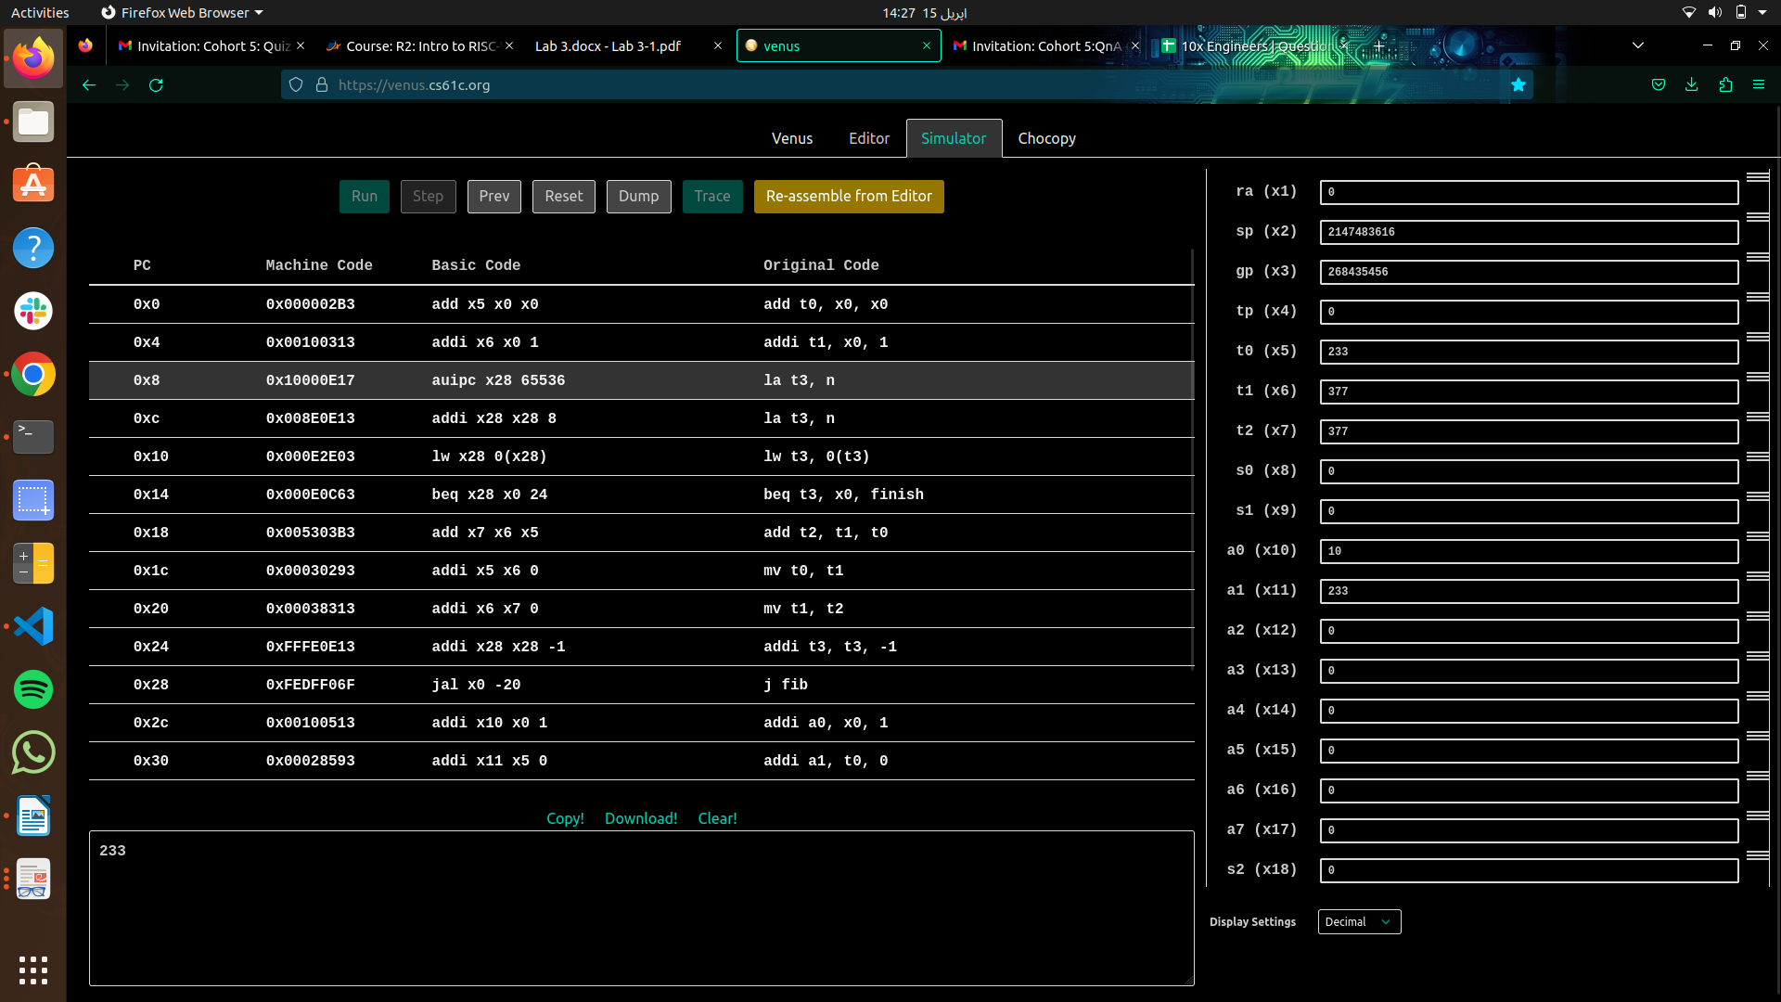

Exercise 3: Translating from C to RISC-V

Action Item

Find and identify the following components of this assembly file, and be able to explain how they work.

1. The register representing the variable k:

In the assembly code, the variable k was implemented using the register t0(x5), which was initialized to zero at the beginning of the main() function and incremented in the loop.

2. The register representing the variable sum:

In the assembly code, the variable sum was implemented using the register s0(x8). In the begin and end prologue of the main function, the value of s0 has been saved onto the stack indicating that s0 will be used for storing local variables within the function. It has been used in the loop of the main and the also after the loop terminates, the final value of s0 represents the sum of all elements in dest. This value is returned from the main function as the result.

3. The registers acting as pointers to the source and dest arrays

In the assembly code, the register acting as pointer to the source and dest arrays are s1(x9) and s2(x18) respectively. The instruction la s1, source loads the address of the source array into the register s1. Similarly, the instruction la s2, dest loads the address of the dest array into the register s2.

4. The assembly code for the loop found in the C code. -

The assembly code for the loop found in C code is as follows
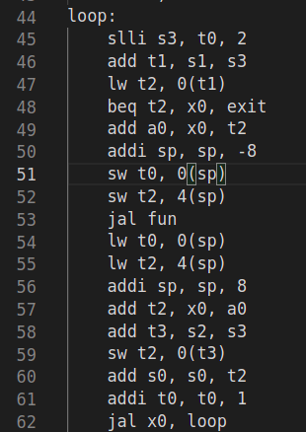

In this loop the register t0 is used as a loop counter, s1 and s2 as pointers to the source and dest arrays, respectively. It iterates over the source array until it reaches the end-of-array which has 0. For each iteration, it loads the current element of the source array into a temporary register, passes it to the fun function to compute the corresponding value, stores the result in the current position of the destination array, and updates the sum variable with the computed value. Finally, the loop continues to the next element of the source array until it reaches the end-of-array.

5. How the pointers are manipulated in the assembly code

The pointers to the source and dest arrays are manipulated using arithmetic operations on registers, specifically the "slli" instruction to shift the loop counter left by 2 bits (equivalent to multiplying by 4) and adding the result to the base address of the arrays. This calculates the memory address of the current element being accessed in the arrays, which is used to load or store data using load and store instructions.

Exercise 4: Factorial

In this exercise, you will be implementing the factorial function in RISC-V. This function takes in a single integer parameter n and returns n!. A stub of this function can be found in the file factorial.s.

The factorial code written for this exercise is as follows:

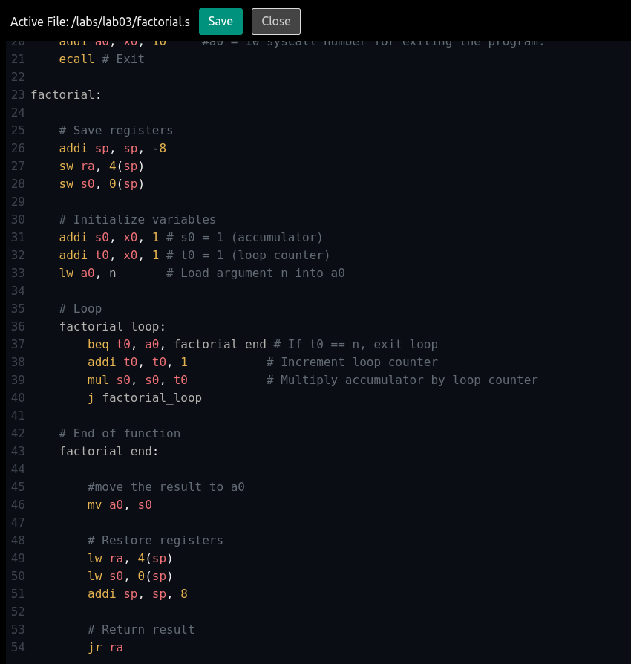

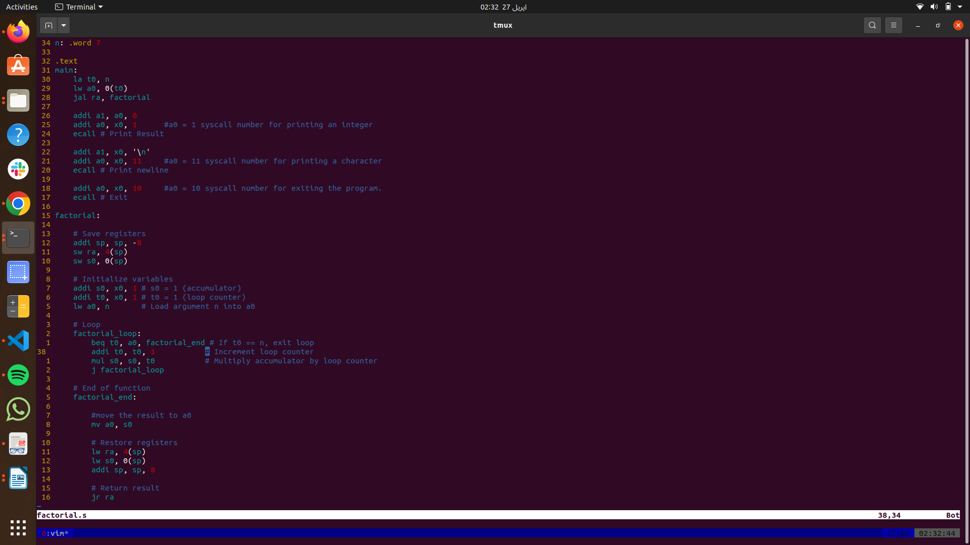

Terminal Output and Testing using Venus for different value’s of n

- For n = 3! (6)

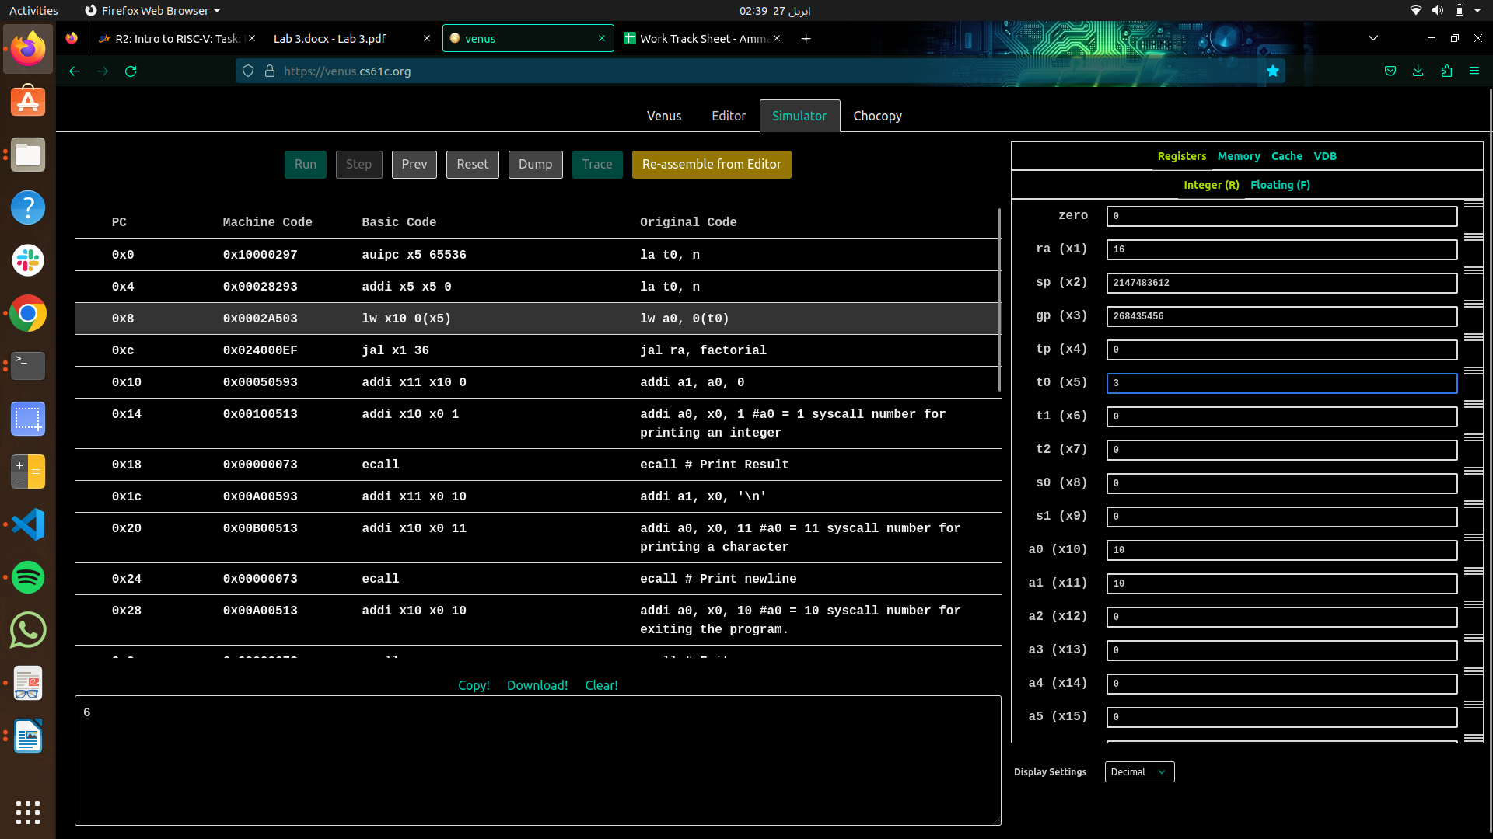

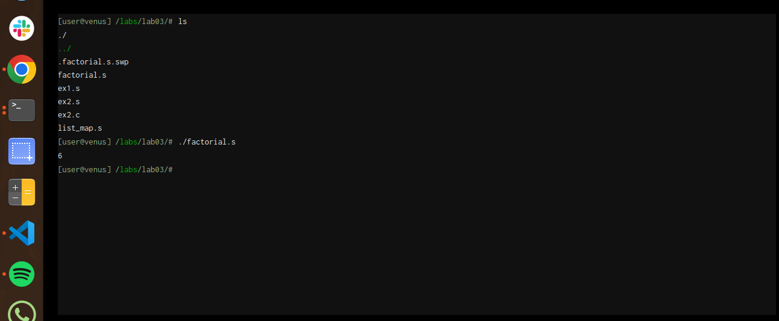
- For n = 7! (5040)

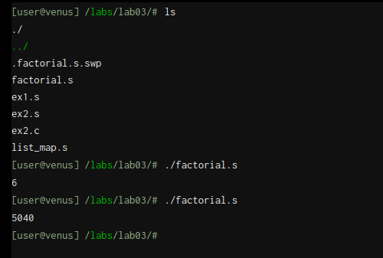
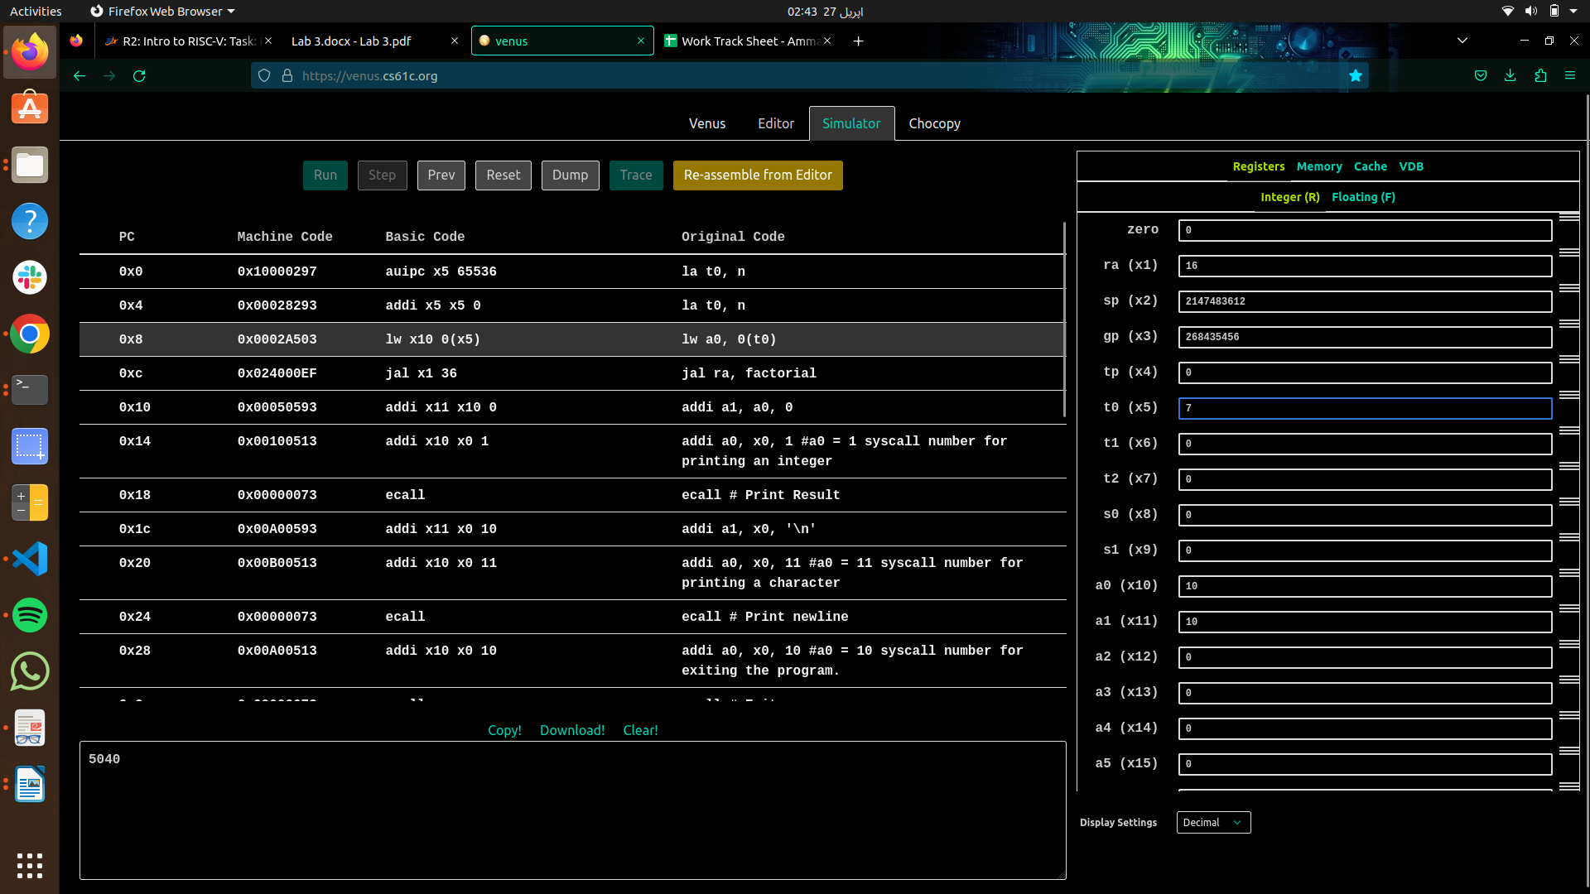

- For n = 8! (40320)

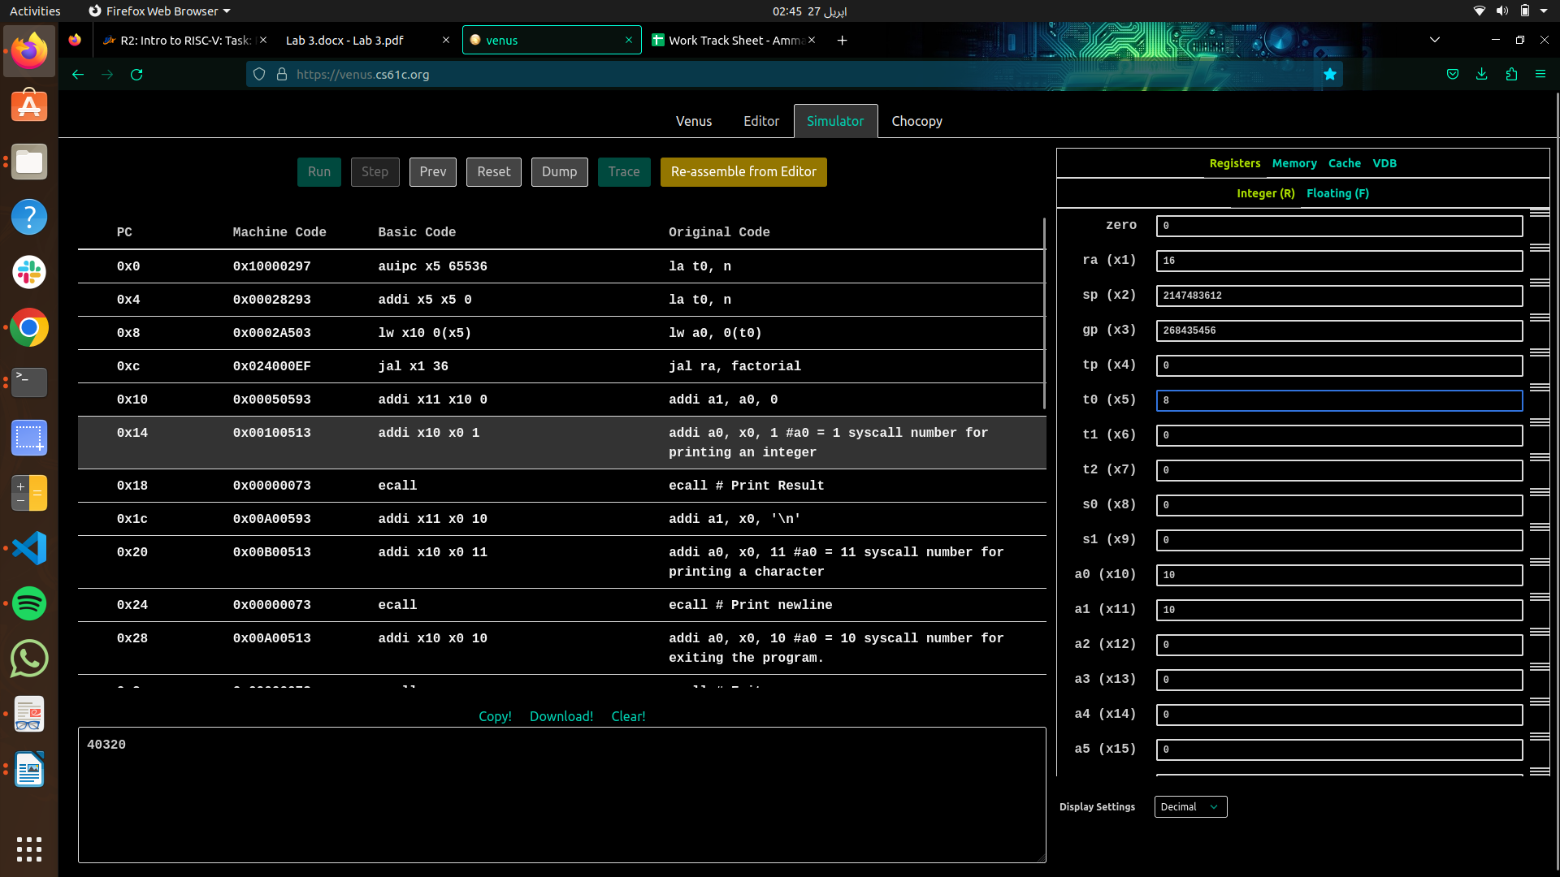
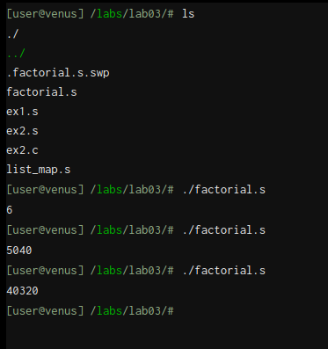

Exercise 5: RISC-V function calling with map

This exercise uses the file list_map.s.In this exercise, you will complete an implementation of map on linked-lists in RISC-V.Our function will be simplified to mutate the list in-place, rather than creating and returning a new list with the modified values.

The screenshots of the code with the necessary changes and the comments added is attached below

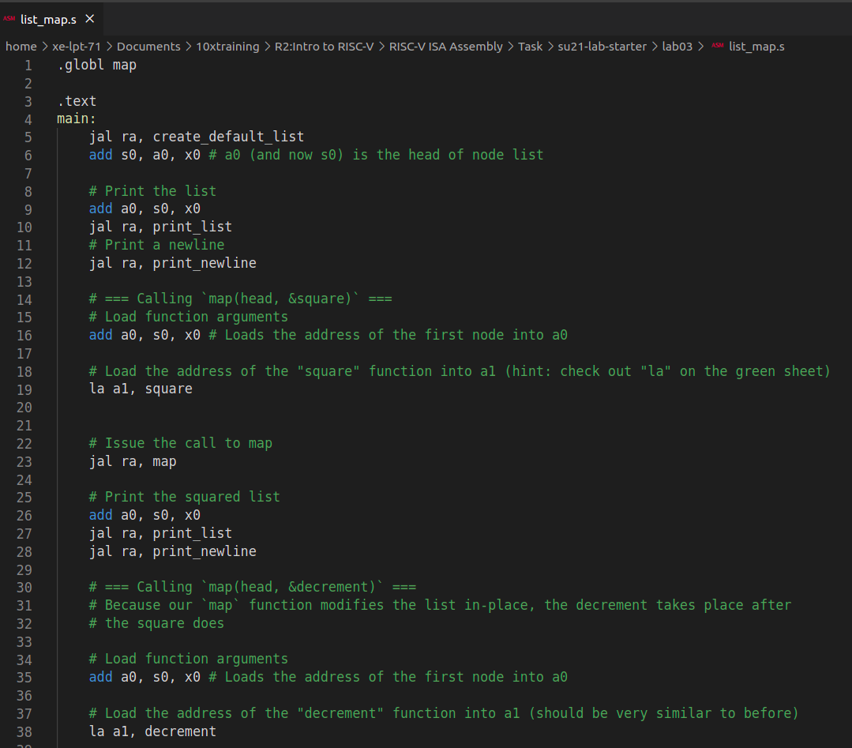

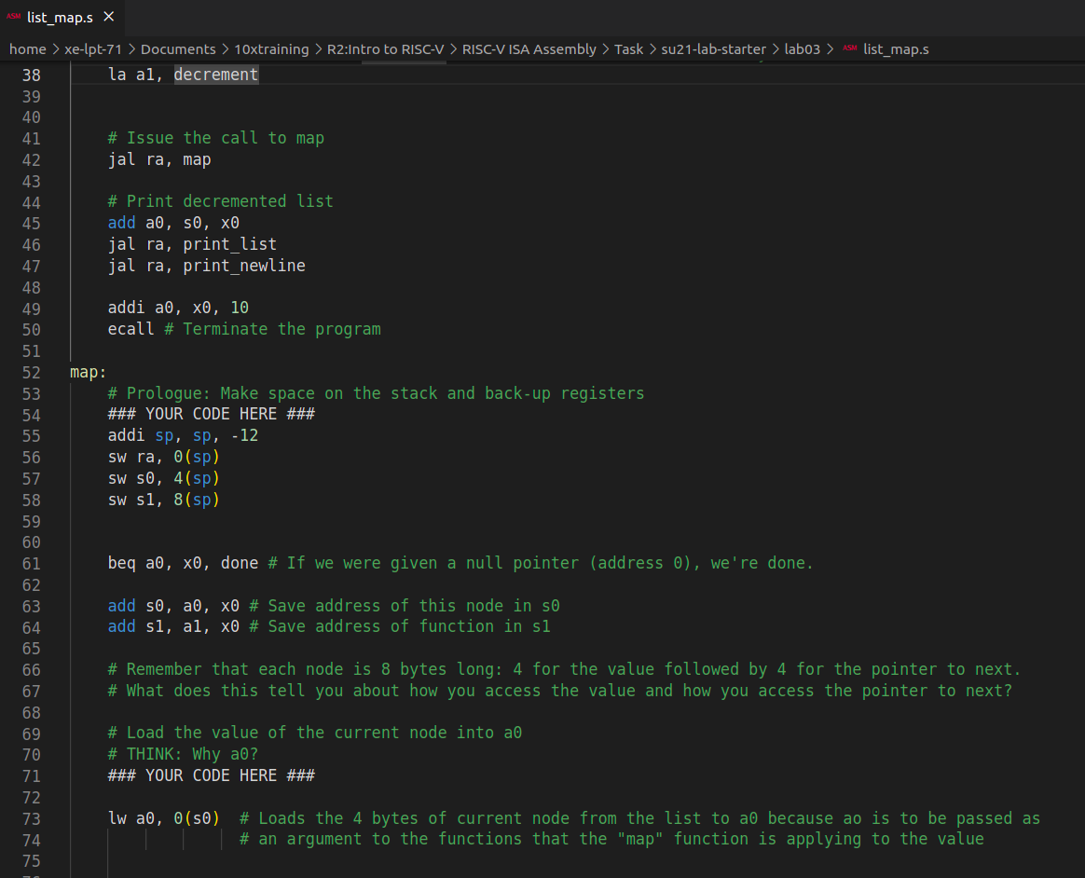
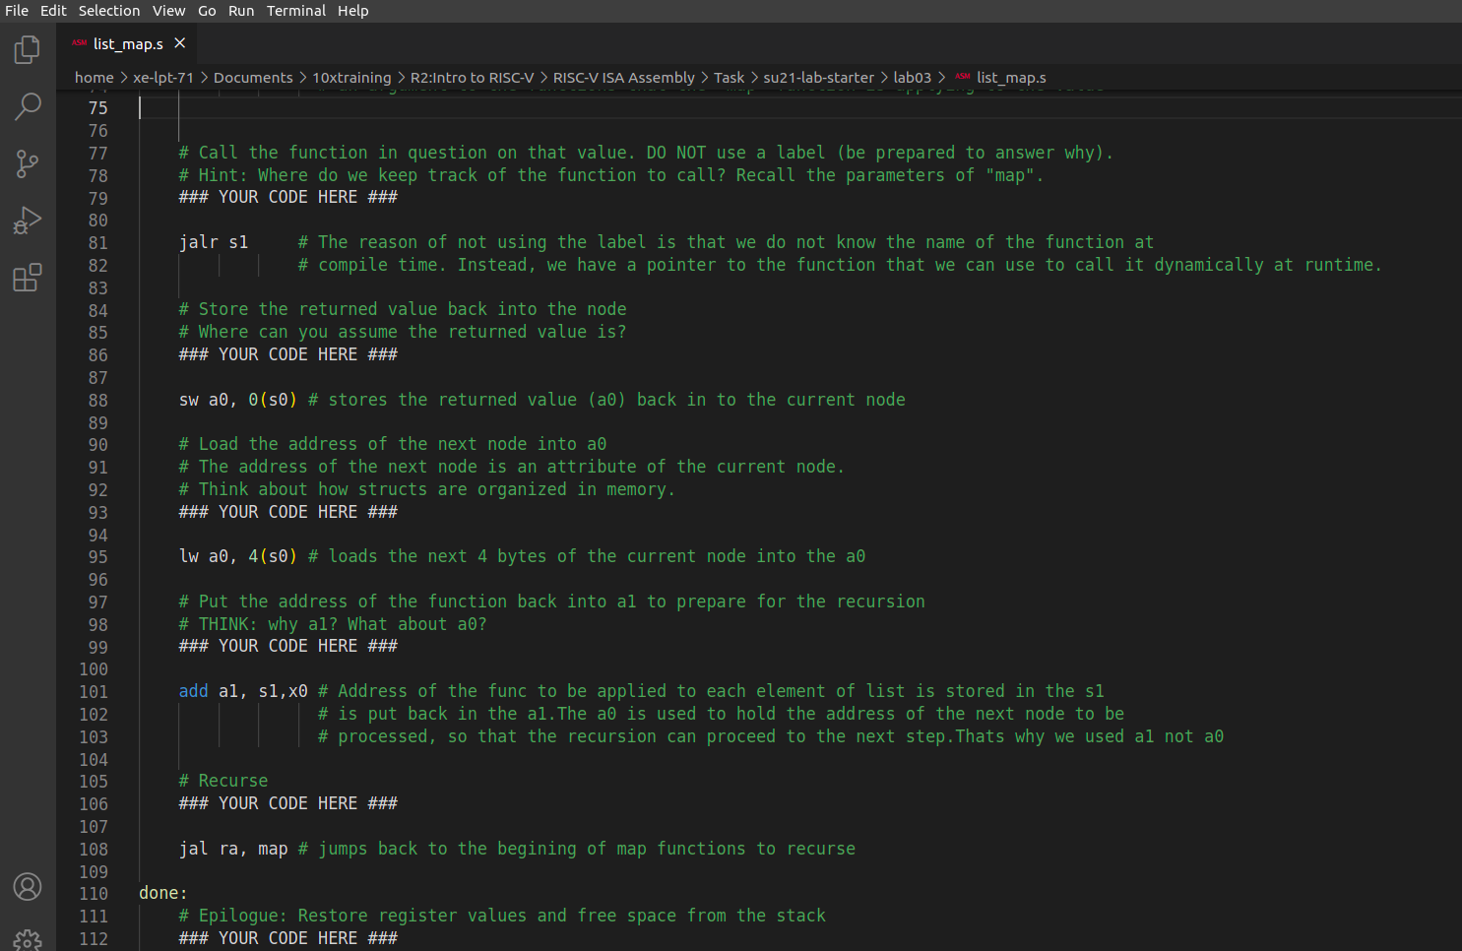
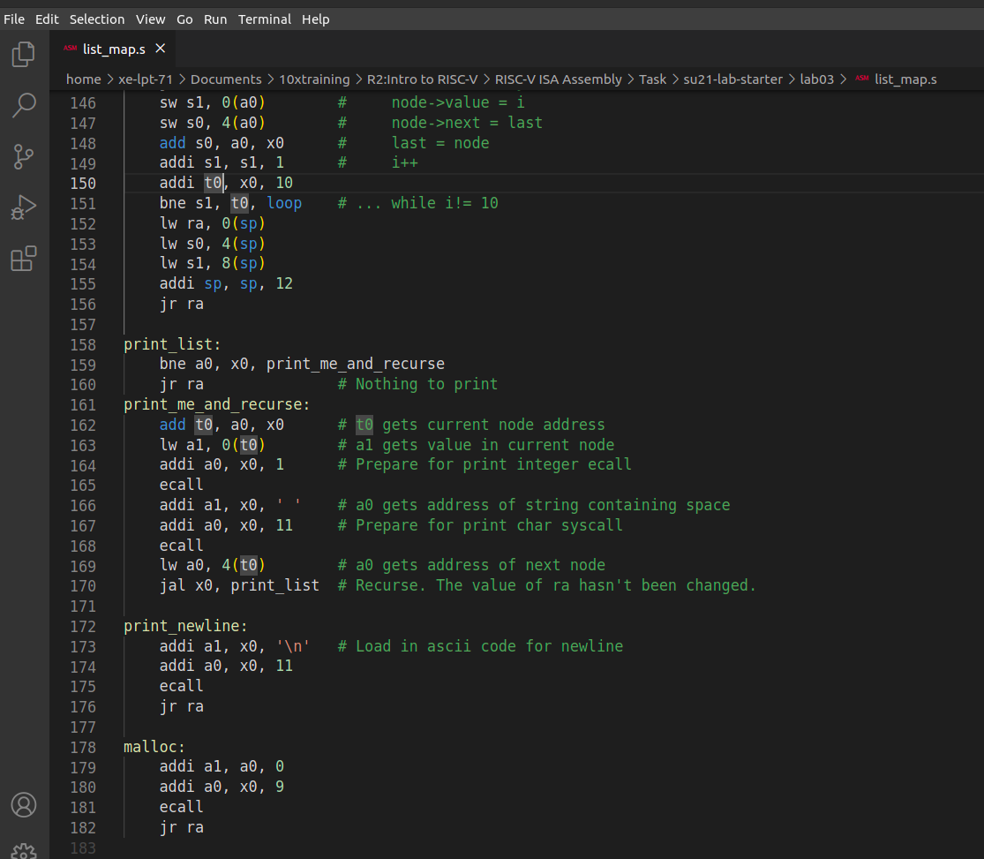
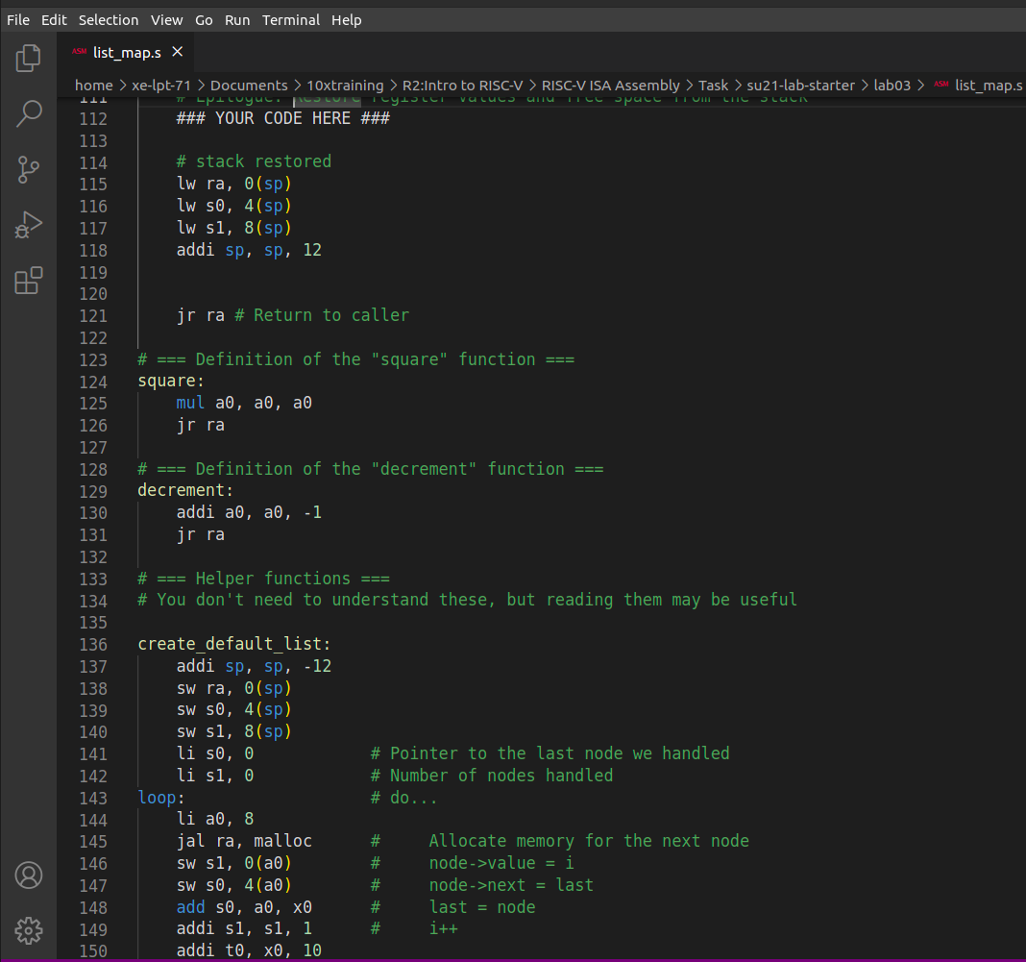
Terminal Output and Testing using Venus

