Task 1 : Set up for cache visualizations

1. Venus setup

The venus RISCV simulator was setup successfully the output of venus setup is shown below

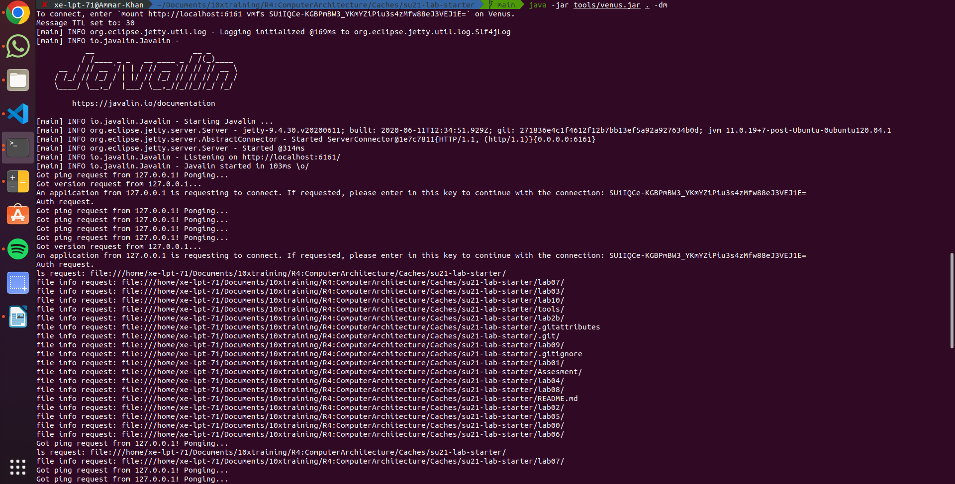
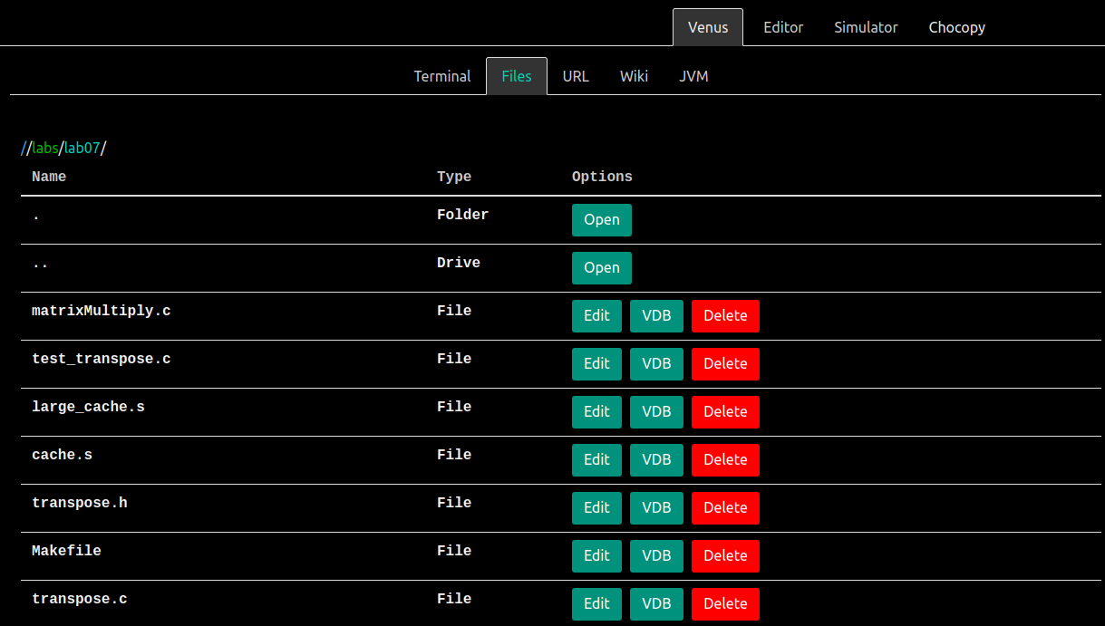

2. The output of running cache.s

I have set the the parameters as shown below
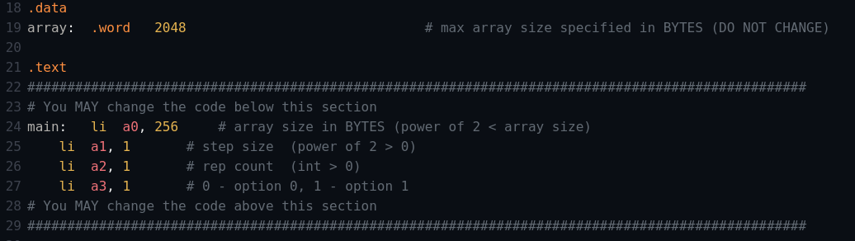

Since, the array size is 256B, which contains 64 words in it,the step size I have set is 1 which will be multiplied by 4 i.e, the step size is of one word. The value of rep count set is 1 which means it will be be executed only once unless the condition is false, and option 1 is selected which will have two cache access read and write so for this code the total number of access would be 128, 64 for read and 64 for write but when the first time read will occur the value would not be present in the cache and there would be cache miss. After that the value would be stored in the cache and next time when write operation would occur the value would be already present in the cache and cache hit would occur. So there would be of 128 cache access out of which there would be 64 cache hit and 64 cache misses. Hit rate and miss rate would be 50%. The result got from the venus RISCV simulator is as expected.

