Task: C Arrays, Pointers, Strings

Forked Repo Link: https://github.com/Ammarkhan561/su21-lab-starter.git

Exercise 1
PART 1 and 2

1. Implement the num_occurances and compute_nucleotide_occurrences function in the exercise 1

The following snapshot is showing the code for the num_occurances and compute_nucleotide_occurrences in the exercise 1

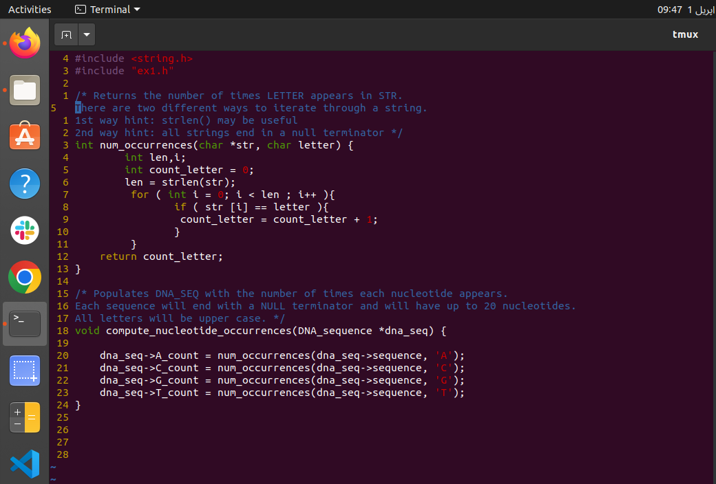
Fig 1. “Code for the Exercise 1”

The output is shown as follows:

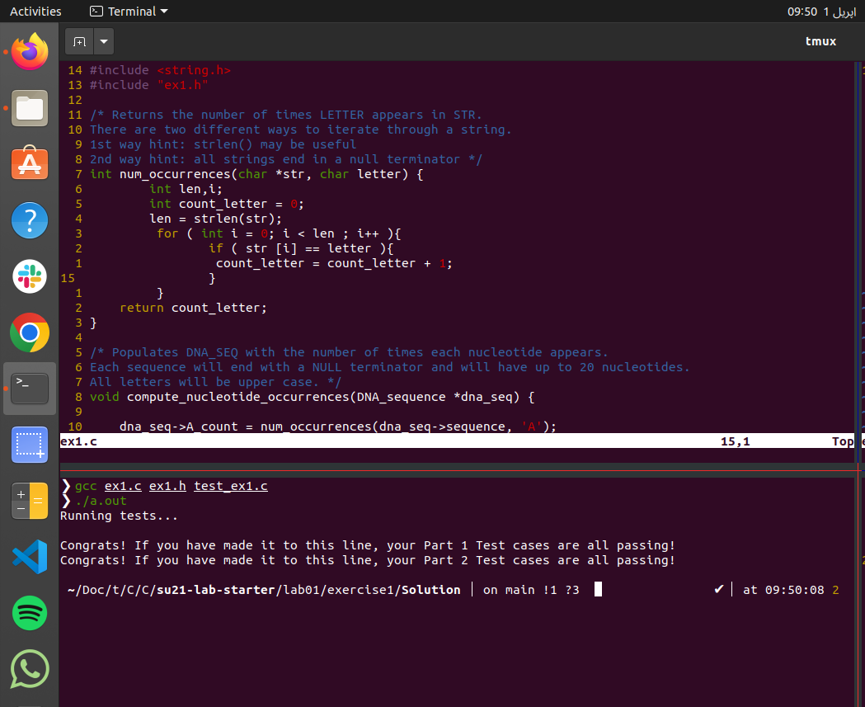
Fig 2. “Output of the Exercise 1”

2. Think of a scenario that is not tested by the current test cases. Create one
additional test case to test this scenario.

I have added a new test in num_occurrence which is

int num_x = num_occurrences ( str, ' ');
assert(num_x == 1);

that check the number of spaces as well in the given string

Similarly for the compute_nucleotide_occurrences function I have added a new test which is

DNA_sequence dna_seq_3;
strcpy(dna_seq_2.sequence, "ABCDGGTT");
compute_nucleotide_occurrences(&dna_seq_2);
assert(dna_seq_2.A_count == 1);
assert(dna_seq_2.C_count == 1);
assert(dna_seq_2.G_count == 2);
assert(dna_seq_2.T_count == 2);

that has a character “B” in it which is ambiguous nucleotide and it’s count is expected to be zero after running this test.

The output of the program after running this test is shown in the figure attached below

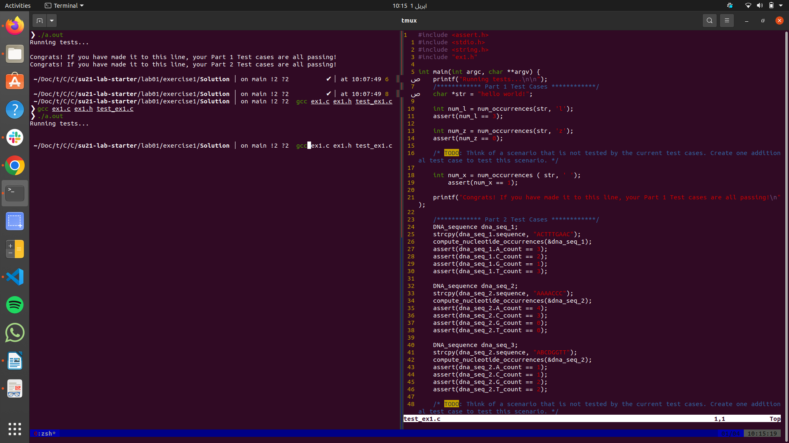
Fig 3. “Output after adding new test”

Exercise 2

Learning Goals: Get familiar with basic GDB commands

Part 1: Compiler Warnings

The following snapshot below is showing the result of the compilation of the code after removing all the four error’s

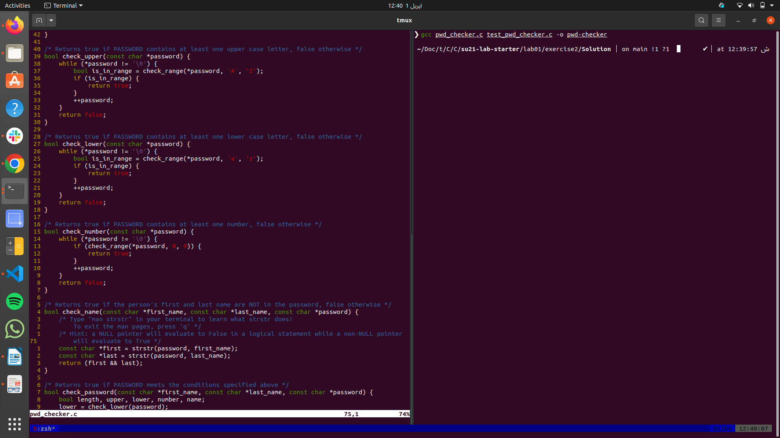
Fig 4. “Resolved Compilation Erros”

Part 2: Assert Statements

The following screenshot is showing that the compilation failed because check_lower is not working fine because the assert(lower) statement was false

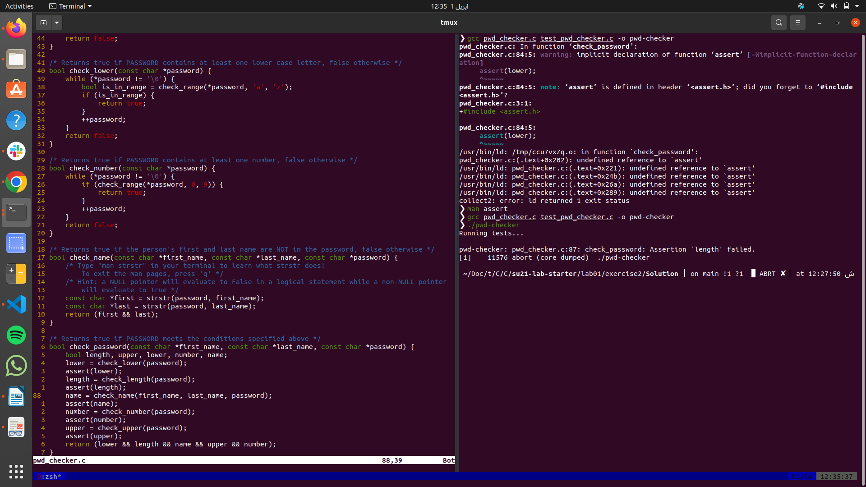
Fig 5. “Issue in assert(lower)”

Part 3: Intro to GDB: start, step, next, finish, print, quit
What is GDB?

Initially there was a error in the check_length and the check_name function after debugging it using GDB debugger the corrected version of the these two functions is showed in the following snapshot

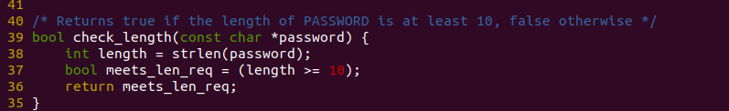
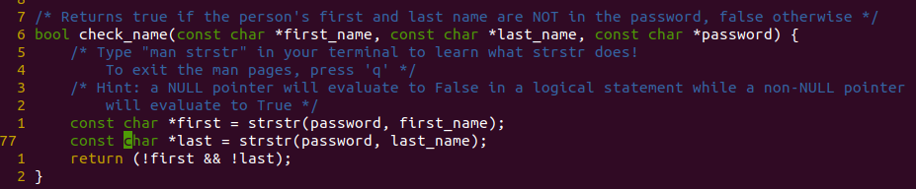
Fig 6 “Resolved check_name & check_length”

The output obtained after debugging these function is as follows

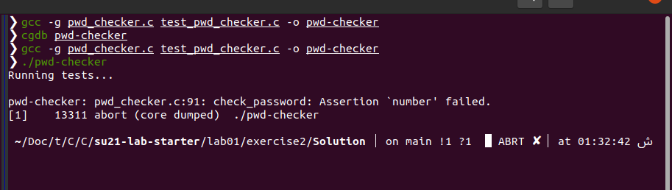
Fig 7“Output after Resolved check_name & check_length”

Part 4: Intro to GDB: break, conditional break, run, continue

Since check_upper was not working properly for that the check_range was modified as shown in the snapshot below
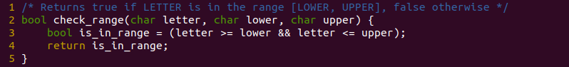
After making the required changes in the check_upper the final output with all the tests passed is shown in the snapshot below

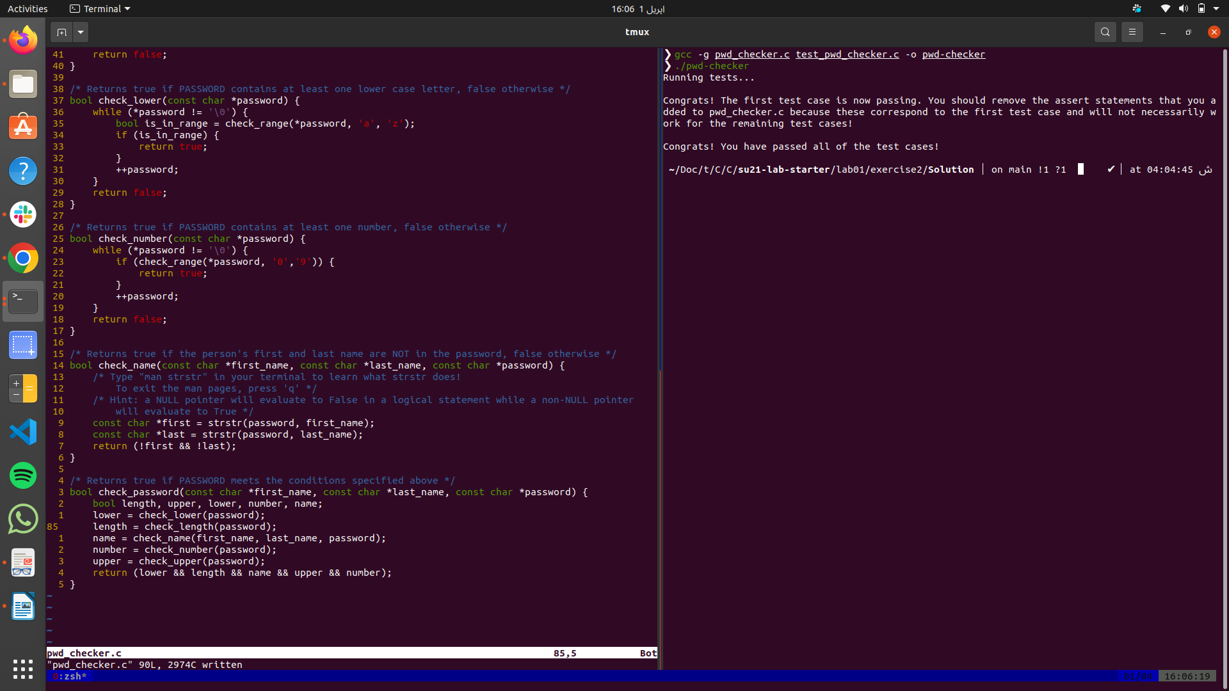
Fig 8“All tests passed”

Exercise 3
How to find segfaults

There was a segmentation fault in the function reverse_list after debugging it and removing the error that was online 58.The first segmentation fault is cleared and the first test has been passed now but now there is another segmentation fault in the add_to_back function

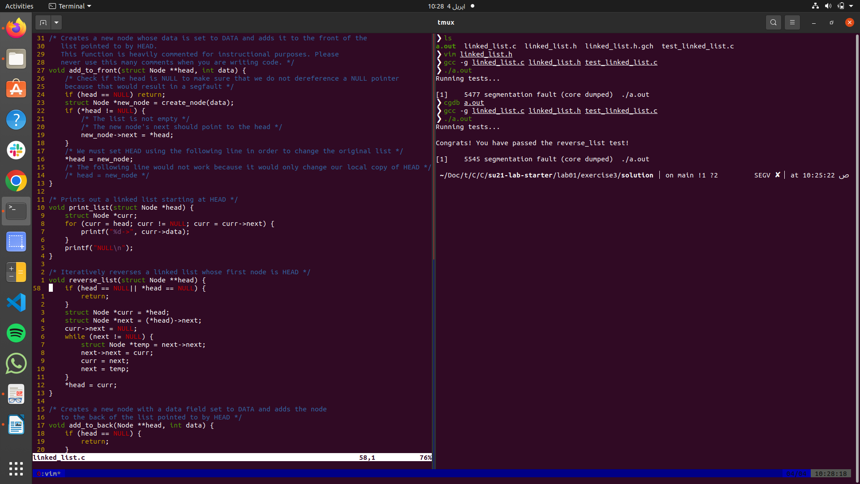
Fig 9“Reverse_list Segmentation Fault Cleared”

After debuging the add_to_back function the updated function is

/* Creates a new node with a data field set to DATA and adds the node
to the back of the list pointed to by HEAD */
void add_to_back(Node **head, int data) {
if (head == NULL) {
return;
}
Node *new_node = create_node(data);
Node *prev = NULL; //
for (Node *curr = *head; curr != NULL; curr = curr->next) {
prev = curr;
}
if ( prev == NULL){
*head = new_node;
}
else{
prev->next = new_node;
}
}
and the output obtained after making these changes are as follows:

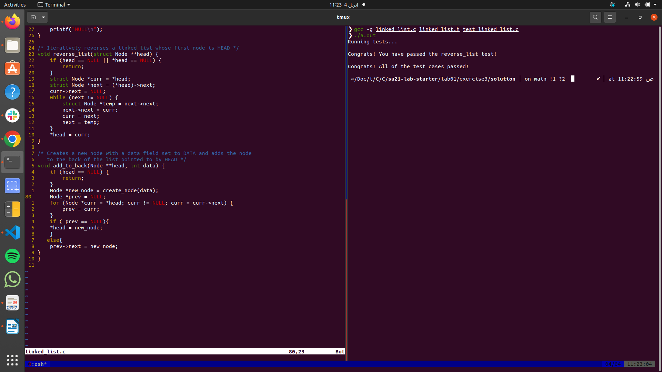
Fig 10“Output of linked list tests passed”

Exercise 4

The code that is written for this task and its output is as follows

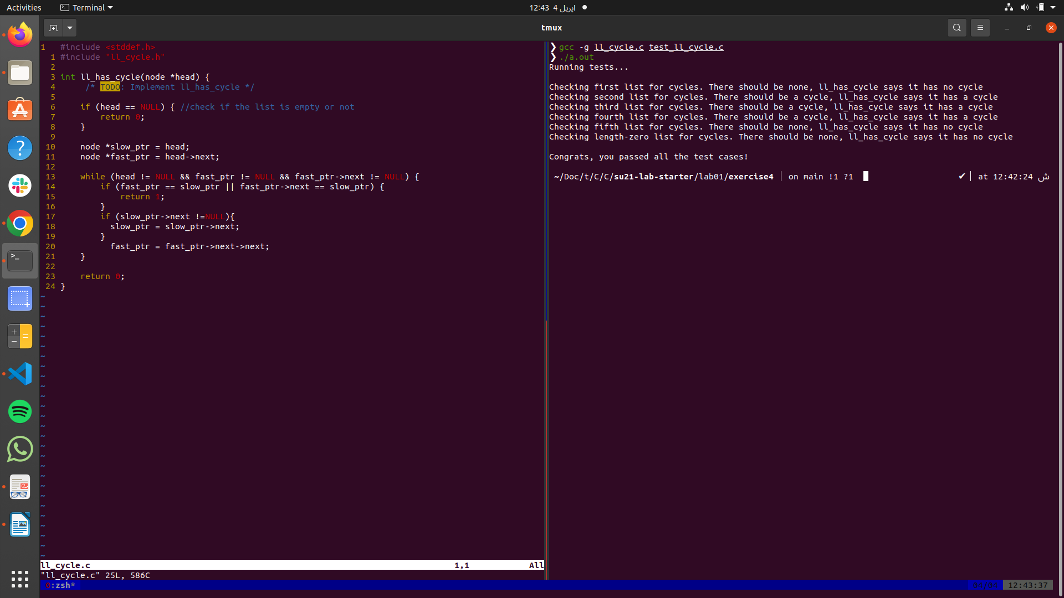
Fig 11“Exercise 4 tests passed”

