Lab 2b
C Structures, Inline Functions

Github Repo Link: https://github.com/Ammarkhan561/su21-lab-starter.git

Structures

Q. Write a program to store and print the name, ID, and age of a student using
structures.

The code that is written for this task is as follows:
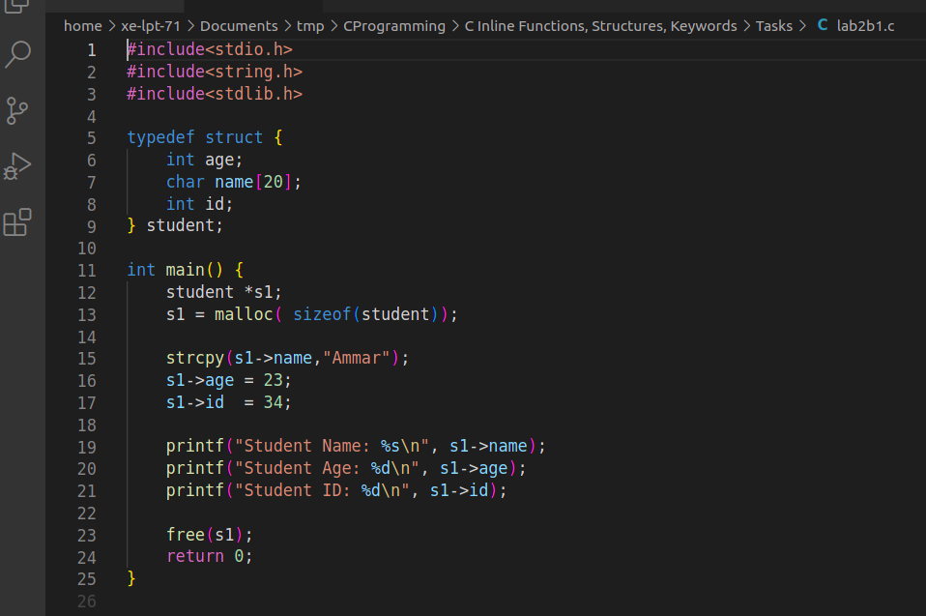
Fig 1. “Using Structures”

The output obtained after running this code is
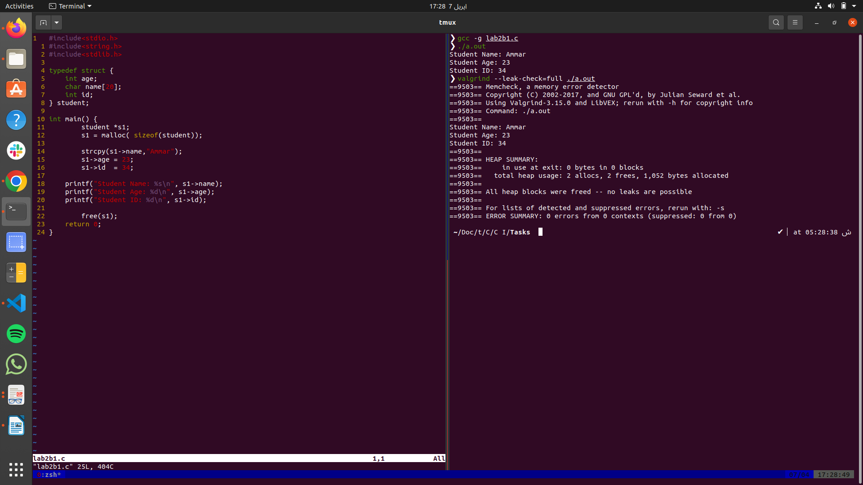
Fig 2. “Output using Structures”

Inline Function

Q. Write a program that returns an integer value by using a static inline function

The code that is written for this task is as follows:
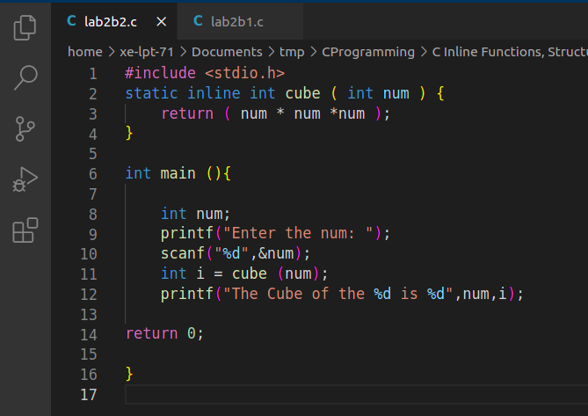

The output obtained after running this code is

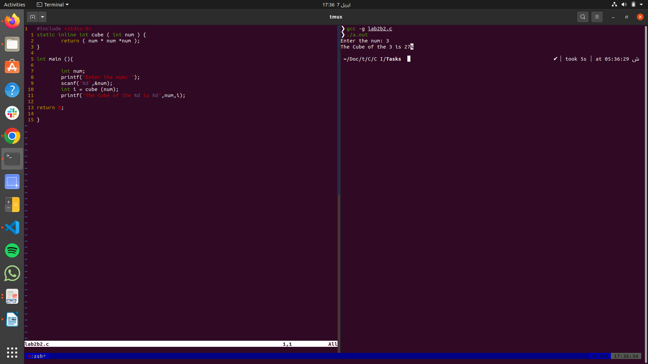
Fig 3. “Output using Static Inline Function”

