Task 2

Bit manipulation Exercise 1

Write a C program and declare this array of integers: 12, 12, 14, 90, 14, 14, 14. Then write a function that takes an array as input and returns the only odd-occurring element.

The code written for this task is

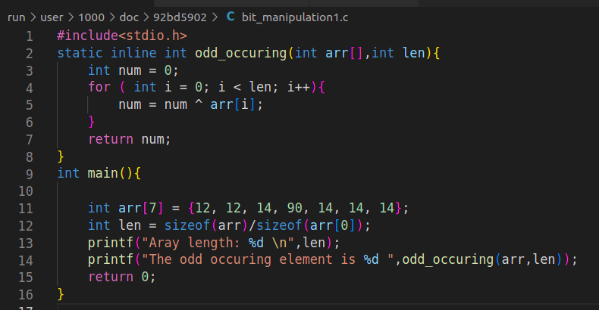
Fig 1. “code for add_occuring”

The output obtained after running this code is

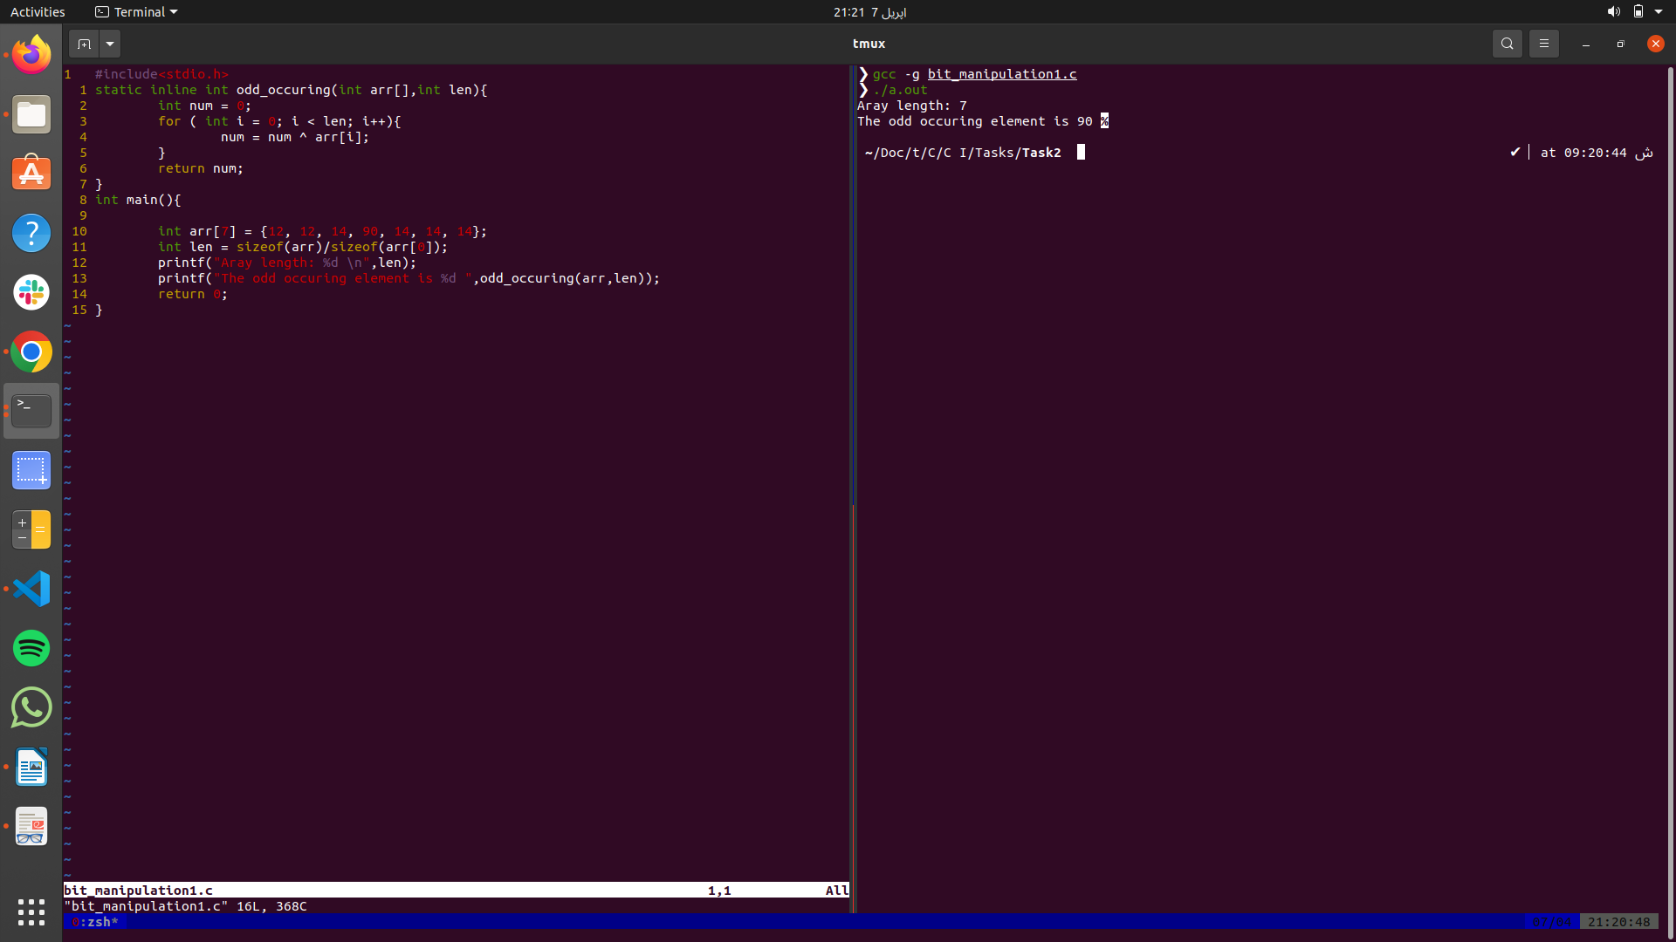
Fig 2. “Outpput of code for add_occuring”
updated version of code that takes the array from the user and display the odd occuring number

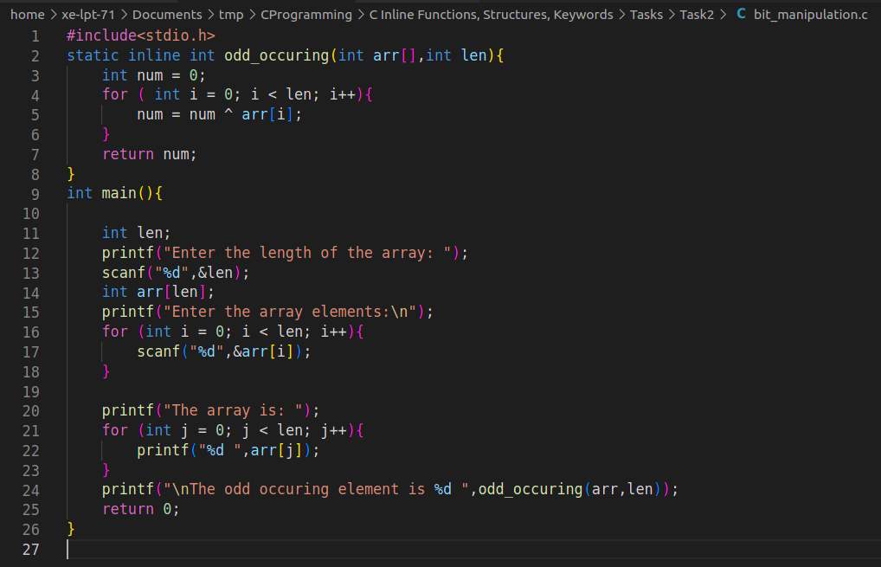
Fig 3. “updated code for add_occuring”

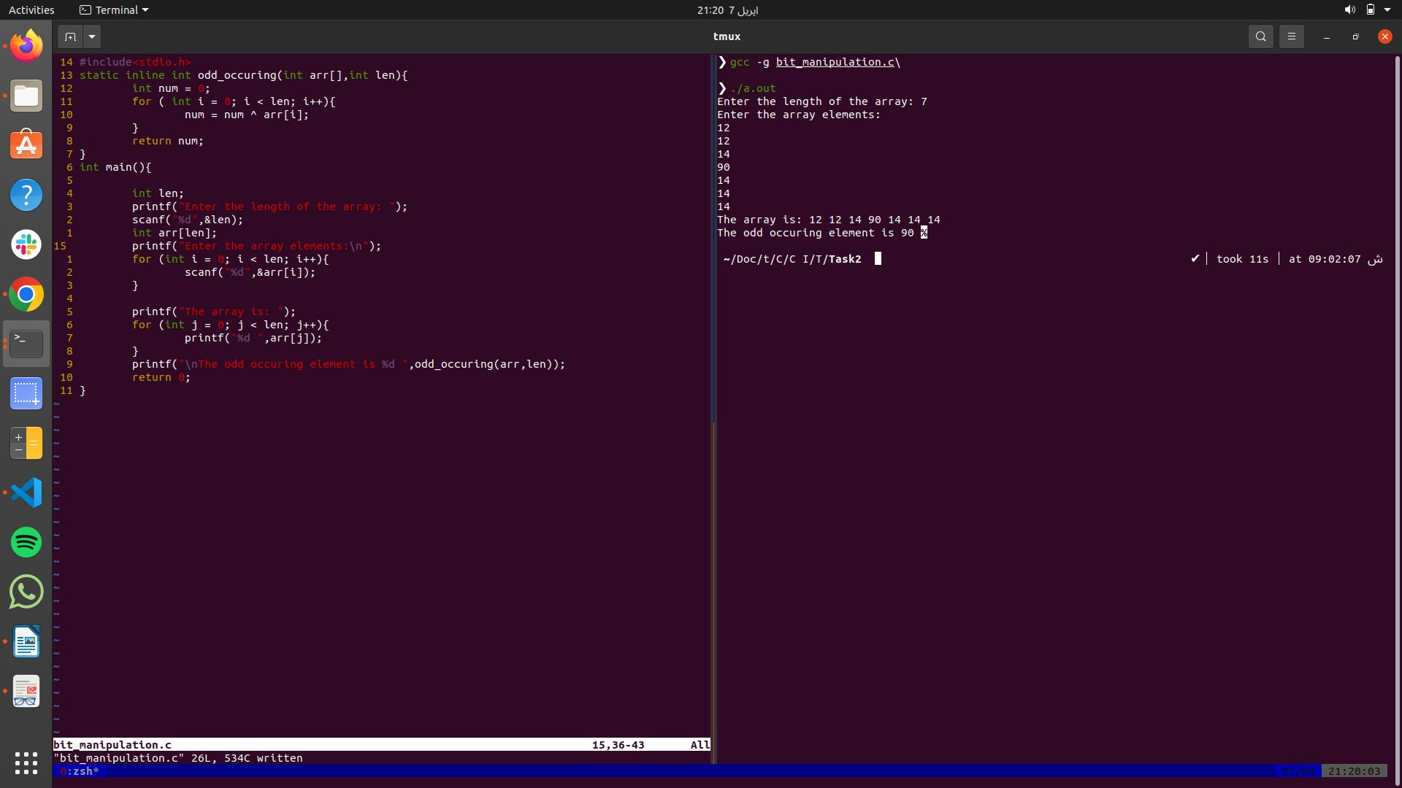
Fig 4. “Output of updated code for add_occuring”

