Lab 4 RISC-V Functions, Pointers

Objective: Practice debugging RISC-V assembly code
Write RISC-V functions that use pointers

Exercise 1: Write a function without branches

Action Item

1. Implement the function in discrete_fn.s in RISC-V, with the condition that your code may NOT use any branch and/or jump instructions!
2. Save your corrected code in discrete_fn.s. Make sure you have it saved locally!
The code written for this task is as follows

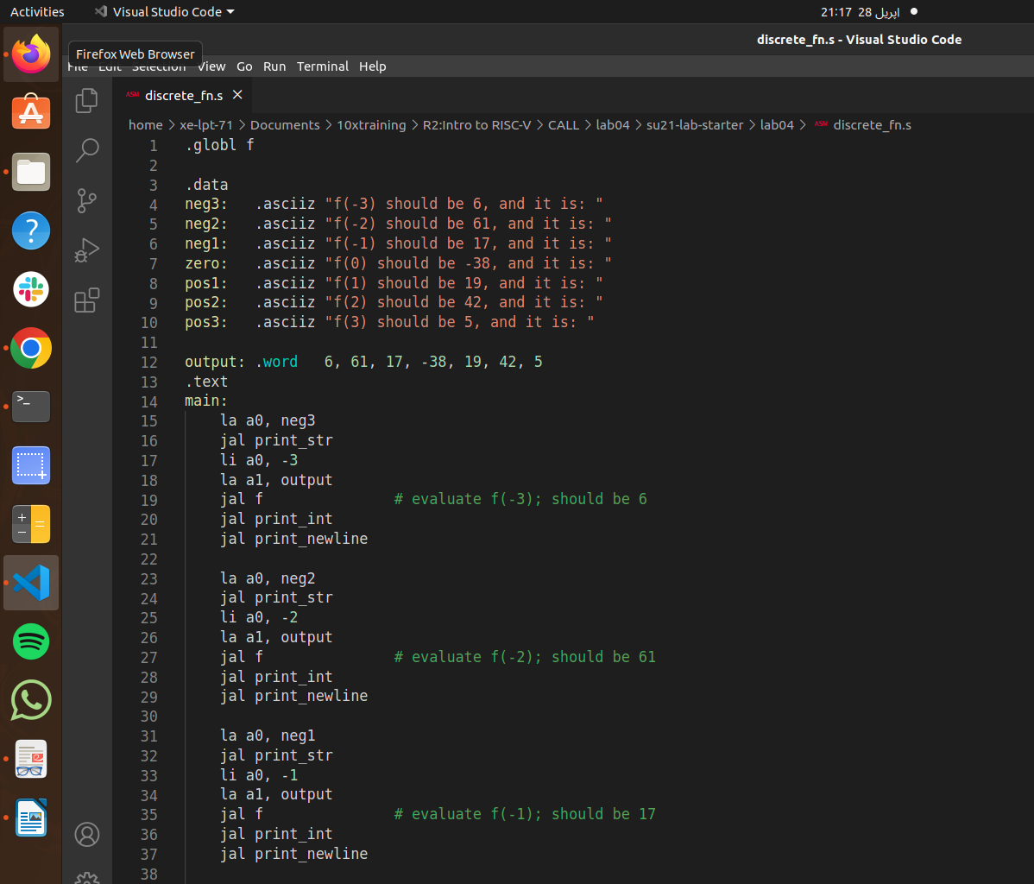
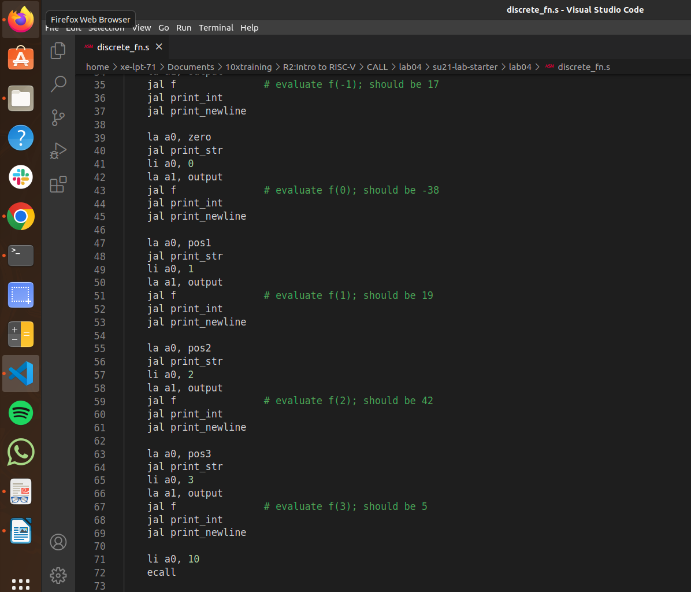
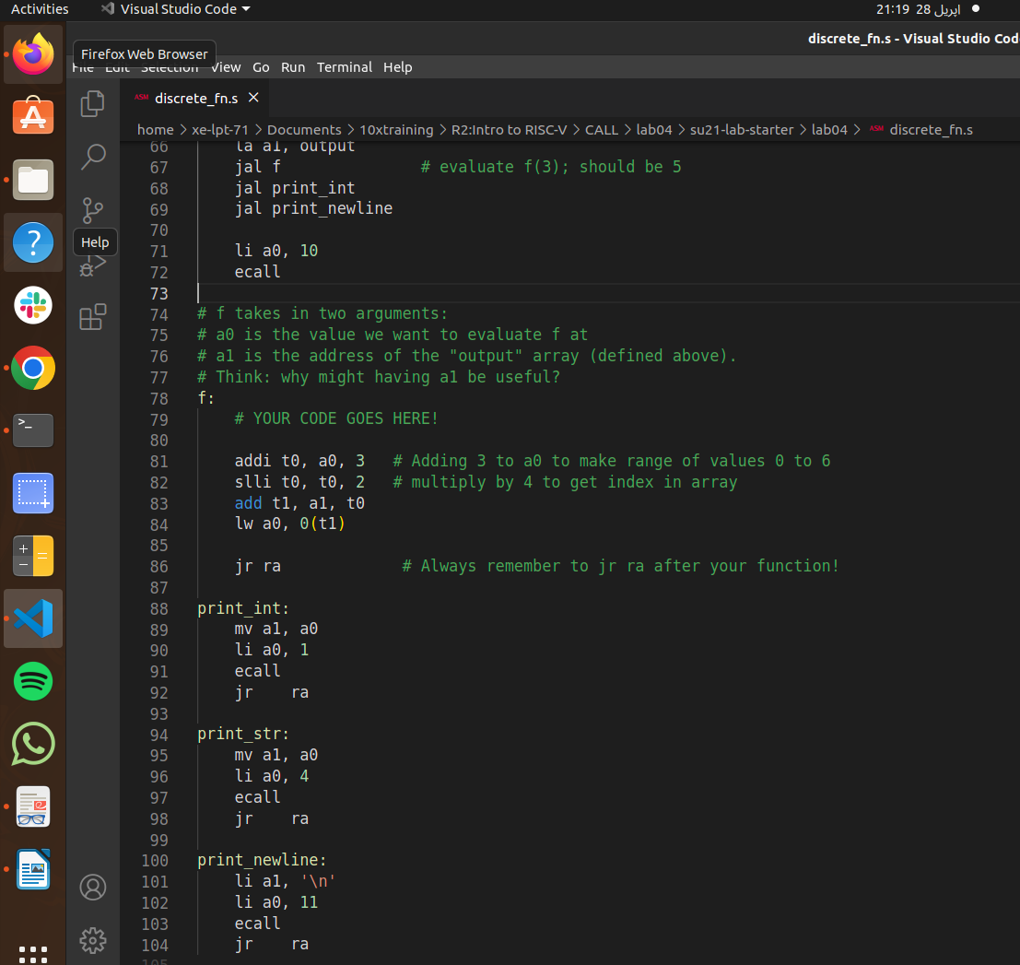
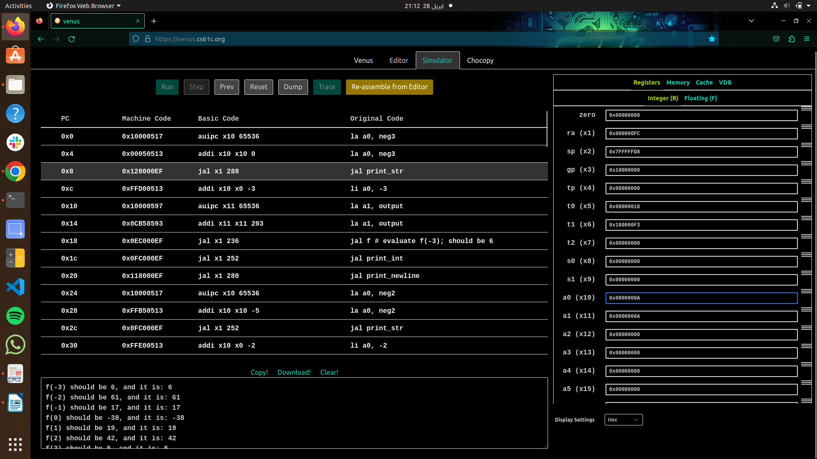
The output obtained after making the required changes in function f is as follows

Exercise 2: Calling Convention Checker

Before fixing the calling conventions errors

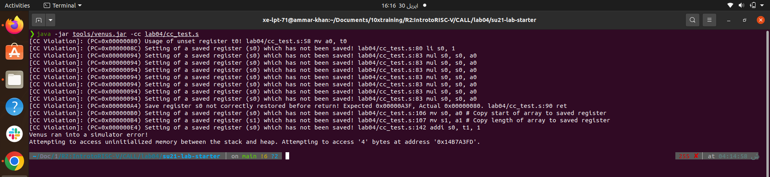

After fixing the calling convention the updated code is as follows

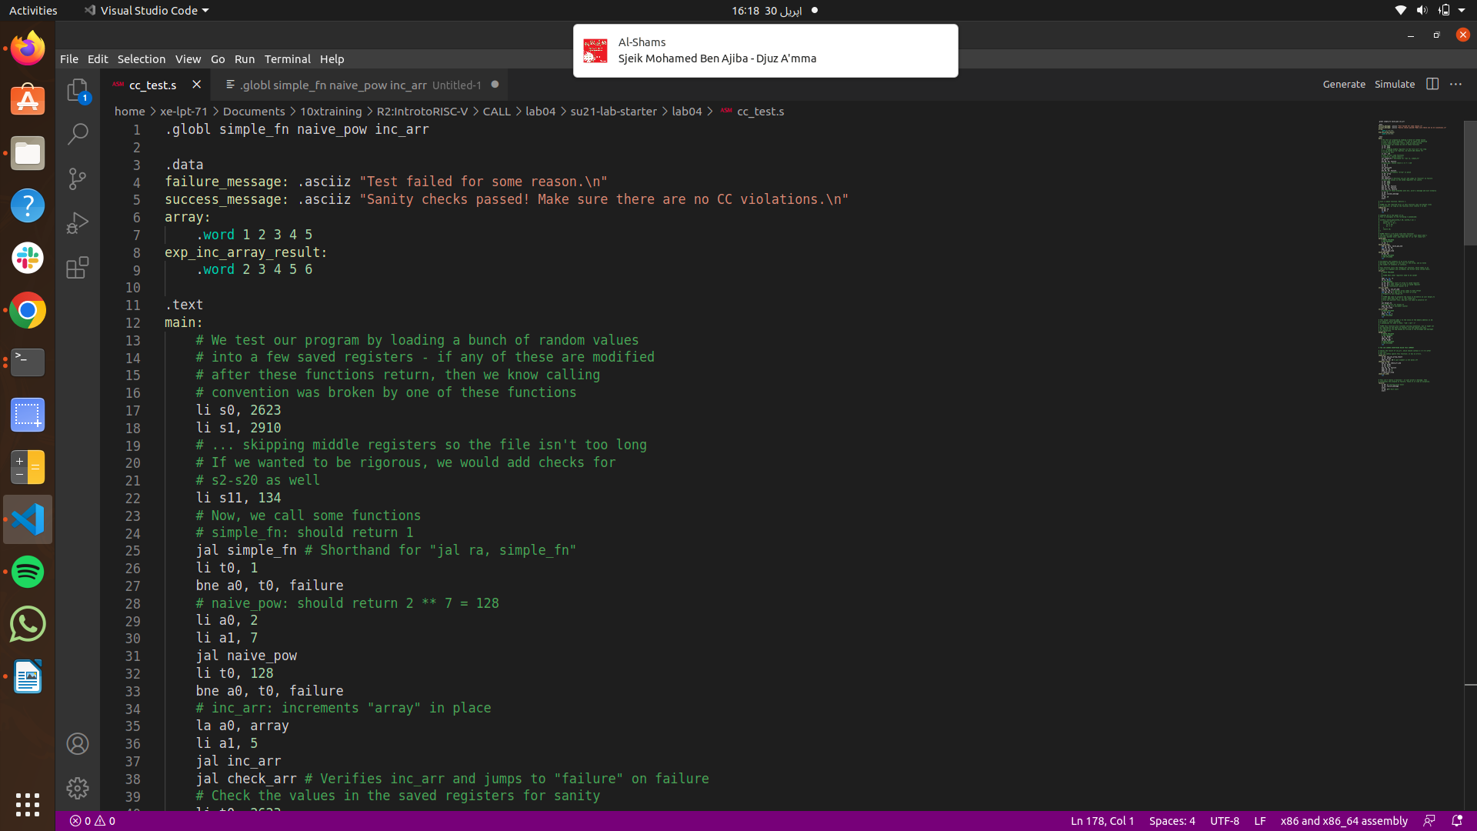
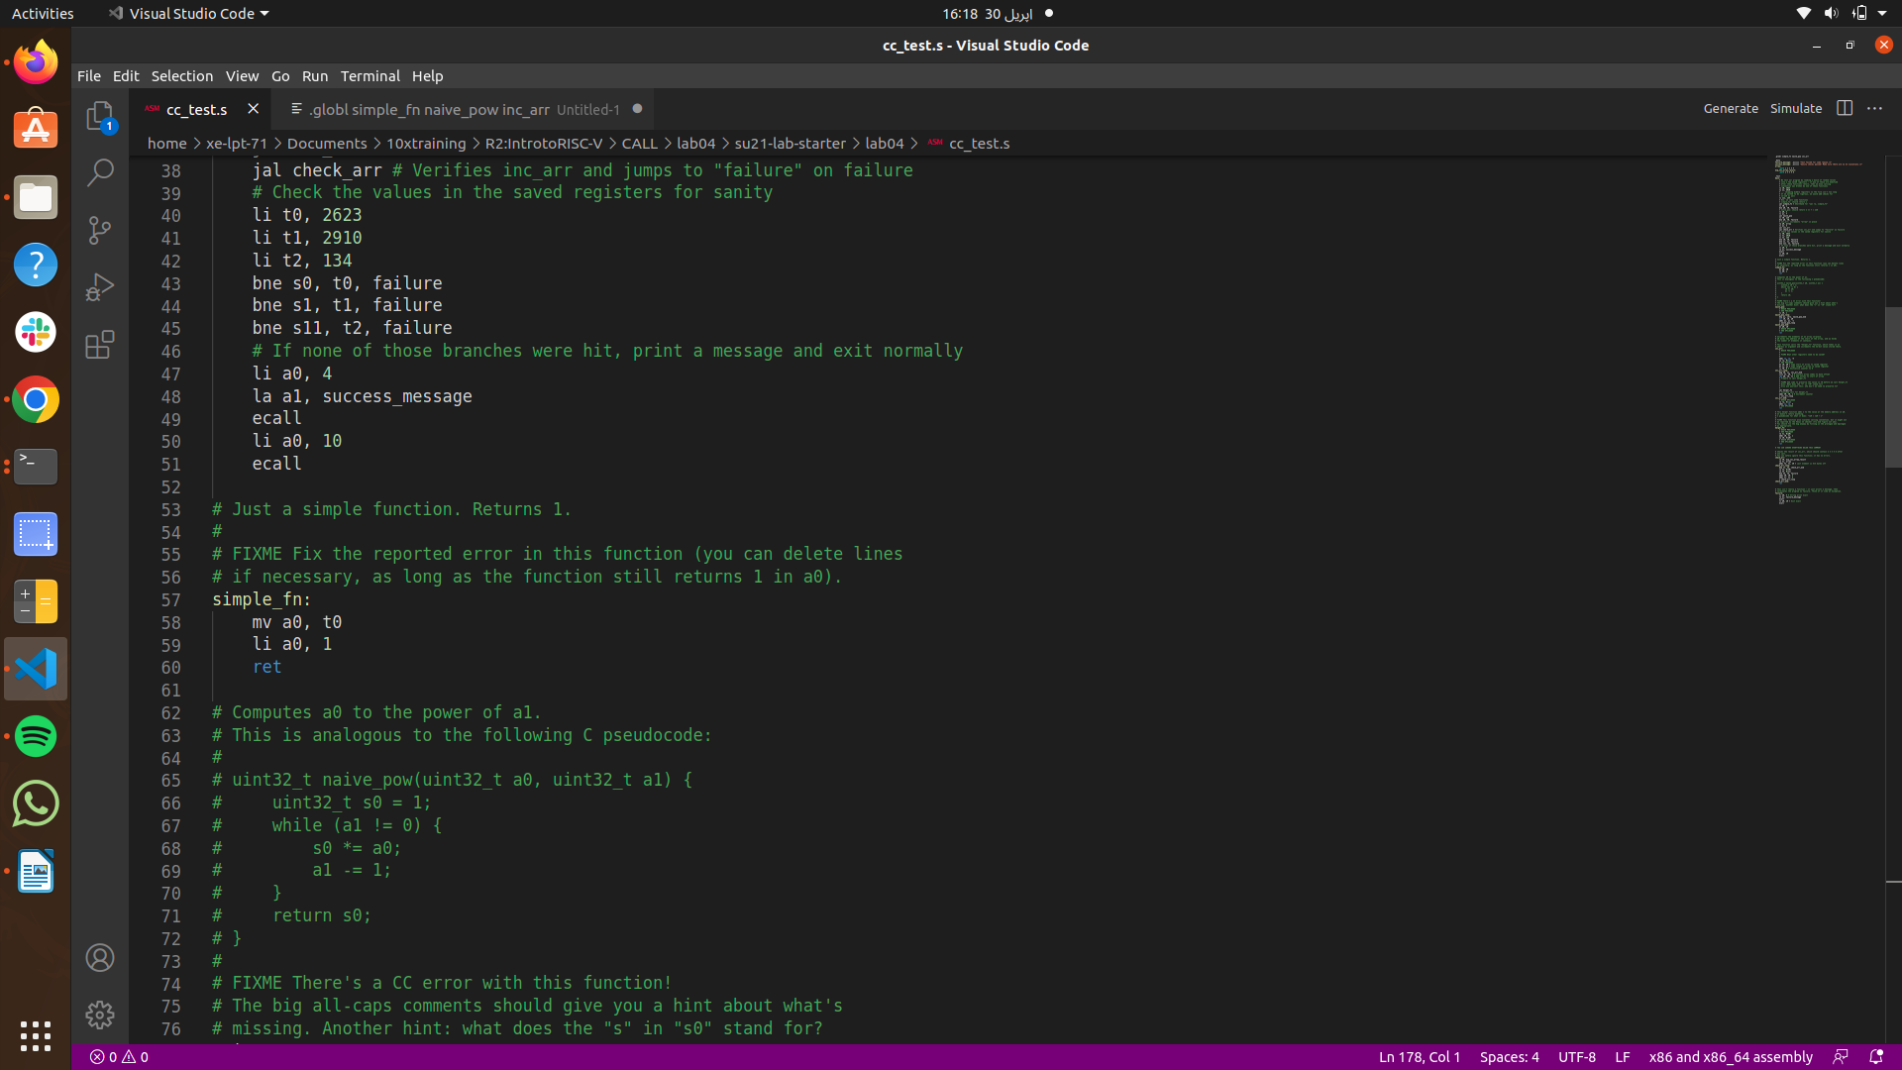

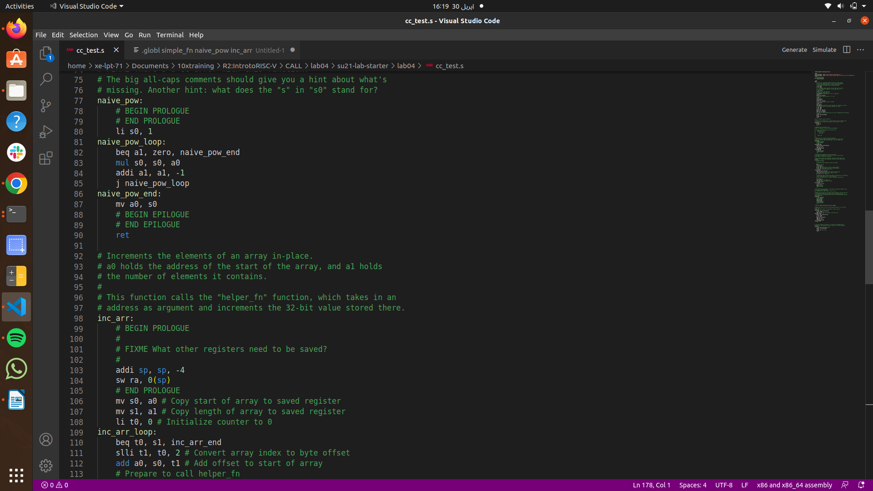

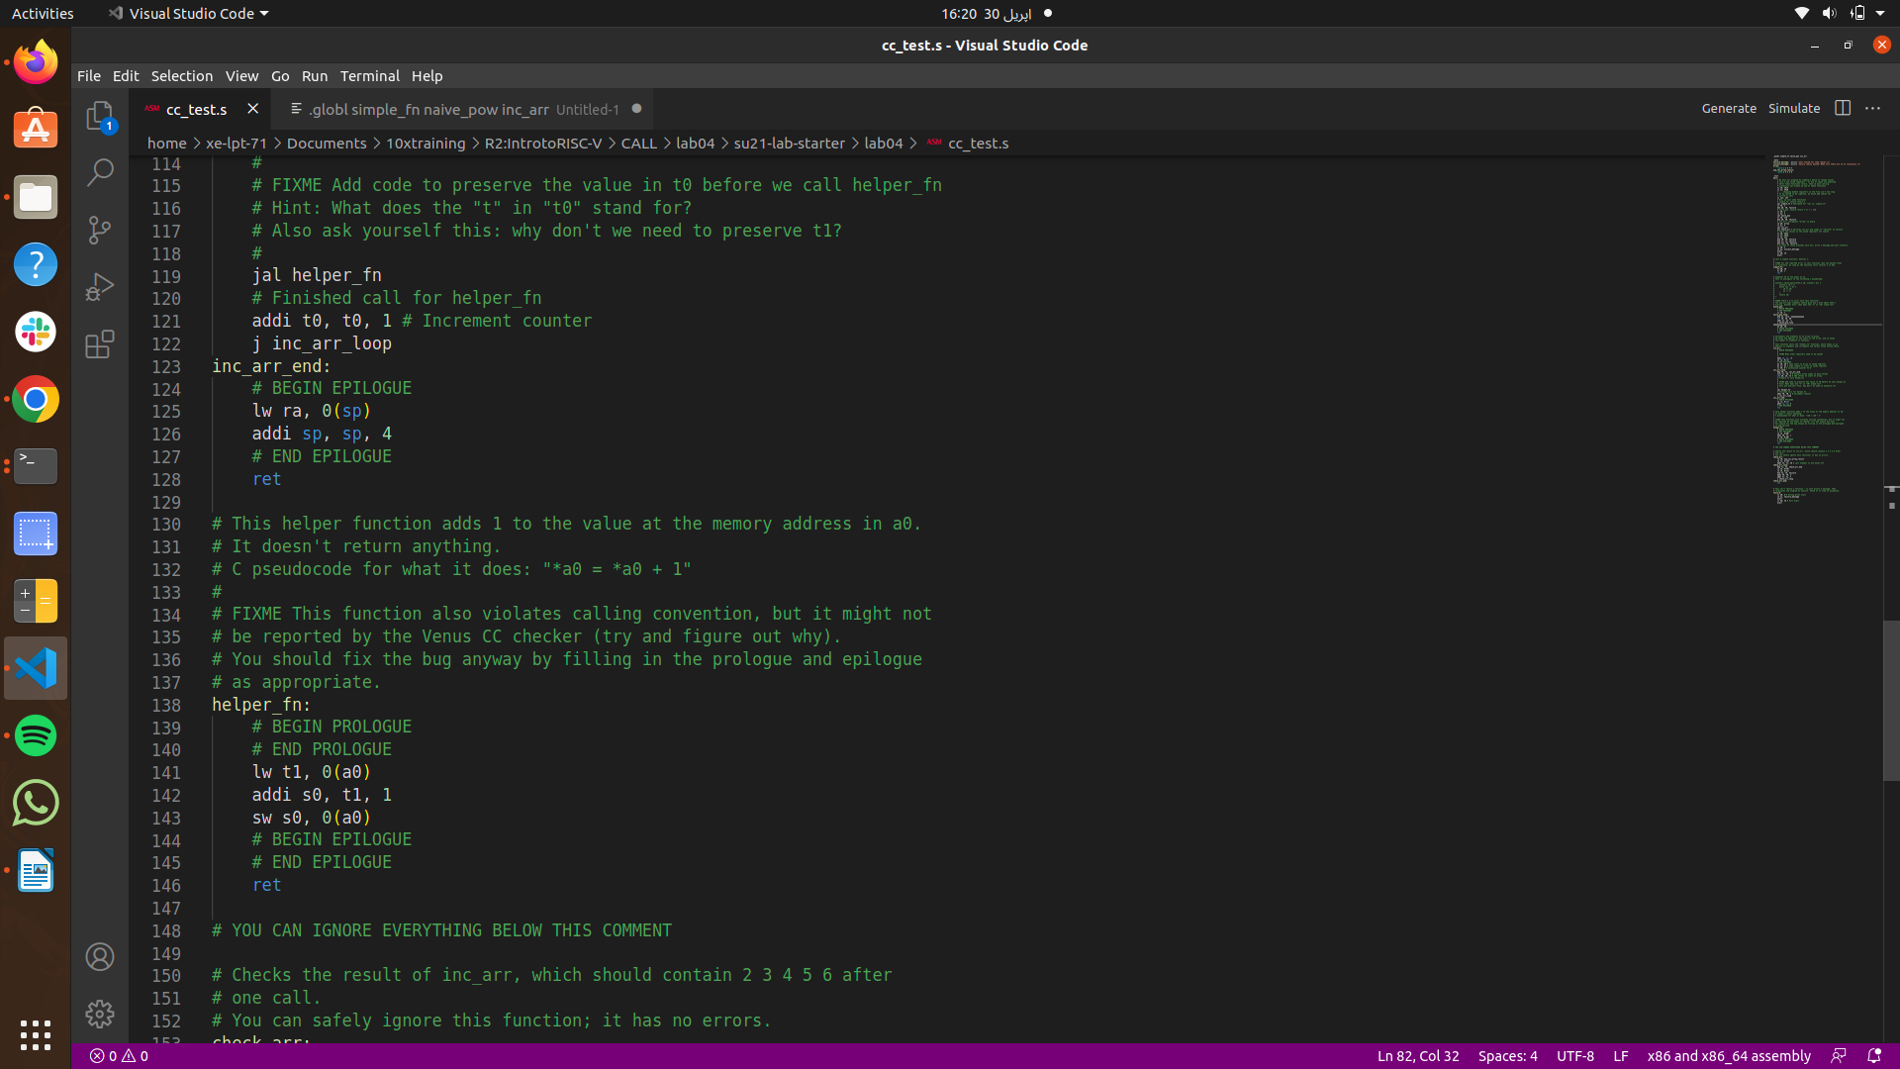

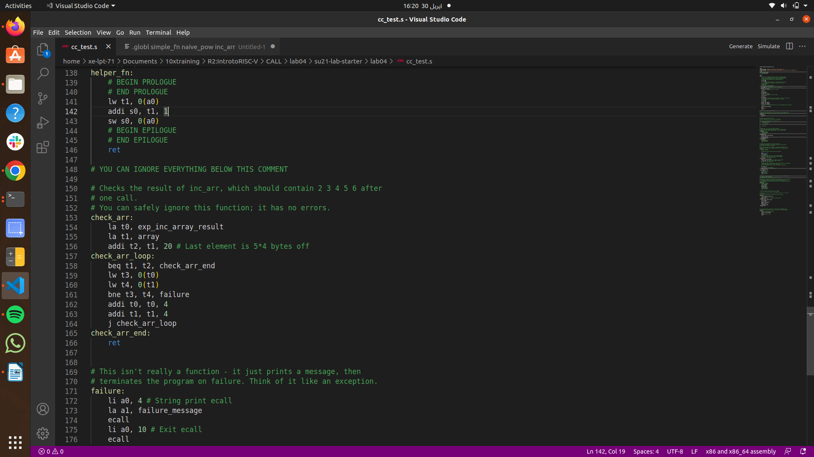
The output after fixing the calling convention errors
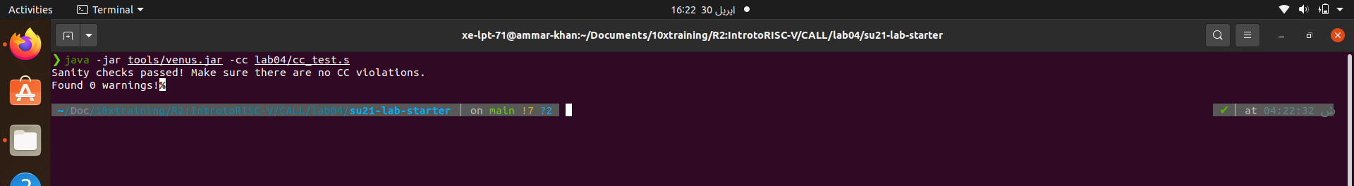
Testing on VENUS
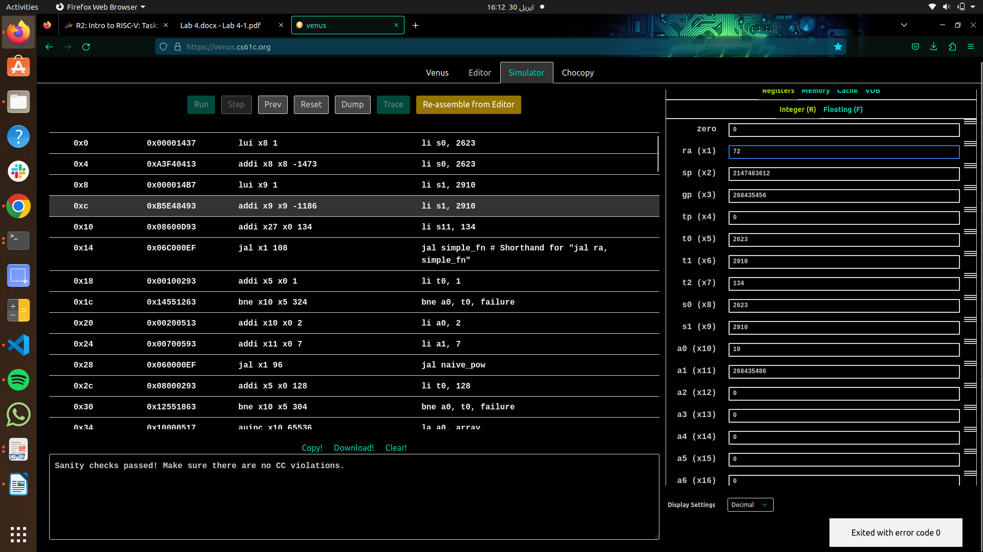

Action Items

- What caused the errors in simple_fn, naive_pow, and inc_arr that were reported by the Venus CC checker?

In the simple_fn we were loading the value of t0 in a0 but the in the t0 we never stored some value so the garbage value was being loaded in the a0 and was returned but in the naive_pow and inc_arr functions the s0 s1, or s11 was being used in the functions but their previously stored values was not preserved on to the stack theses were the errors that the Venus cc checker reported.

- In RISC-V, we call functions by jumping to them and storing the return address in the ra register. Does calling convention apply to the jumps to the naive_pow_loop or naive_pow_end labels?

No, the calling convention does not apply to jumps to the naive_pow_loop or naive_pow_end labels because they are not function calls. They are simply labels within the same function where control flow is directed to with unconditional jumps.
In RISC-V, the calling convention is only relevant for function calls where control is passed to another function and then returned to the original function.

- Why do we need to store ra in the prologue for inc_arr, but not in any other function?
In the inc_arr function, the ra register needs to be saved in the prologue because the function calls another function helper_fn using a jal instruction.Since the helper_fn function modifies the register ra in its prologue, it needs to be restored to its original value before returning to the inc_arr function.

On the other hand, other functions do not call any other functions, so there is no need to save the ra register in those functions.

- Why wasn't the calling convention error in helper_fn reported by the CC checker?
(Hint: it's mentioned above in the exercise instructions.)

The calling convention error in helper_fn was not reported by the Venus CC checker because helper_fn was never called directly by main, only by inc_arr. Since inc_arr is the only function that calls helper_fn, it is responsible for ensuring that the calling convention is followed. As a result, the Venus CC checker does not check helper_fn for calling convention violations.

Exercise 3: Debugging

The function map before making any change in it is as shown below
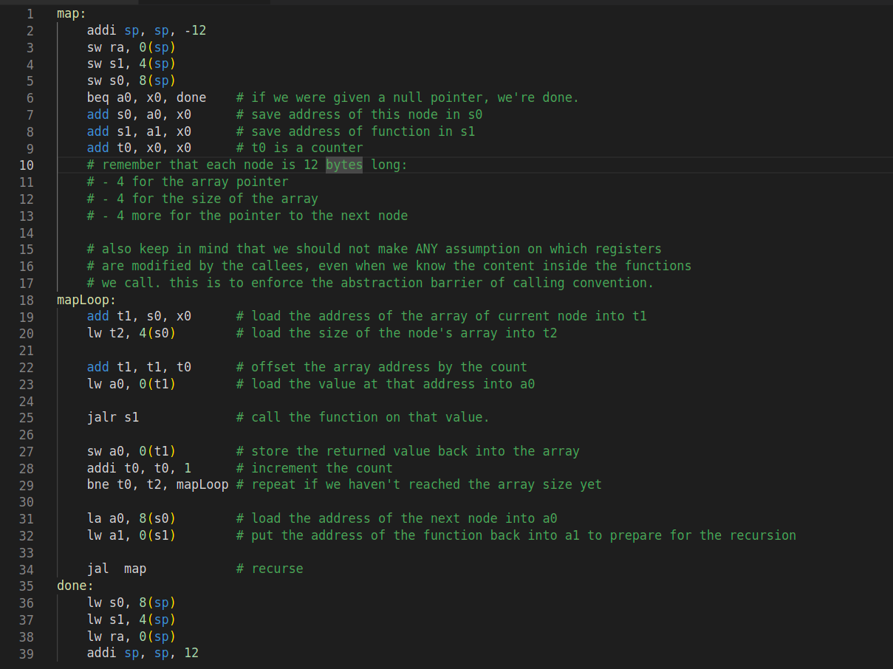
Action Item

1. Find the six mistakes inside the map function in megalistmanips.s.

- In the map label (line 2) the stack space allocated was of 12 bytes but we need actually 16 bytes since each node is of 12 bytes (- 4 for the array pointer - 4 for the size of the array - 4 more for the pointer to the next node) we need to save these 12 bytes plus the return address on the stack. Total of 16 bytes required.

- In the mapLoop label (line 19 ) we have to load the address of the array of current node into t1. So in order to load the address into t1 we should use lw instead of add Instruction.

- In the mapLoop label (line 22) we have to offset the array address by the count but here we are just adding the count to the address and not adding the offset at all.

- In the mapLoop label (line 27 ) we are storing the returned value back into array at 0(to) but when jalr s1 was called then the temporary register t1 which was previously holding the address of the array has been changed to the result calculated in the mystery function (refer to the snapshot below). So after the execution of the jalr s1 the value of temporary register was changed.

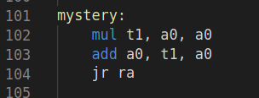

- In the mapLoop label (line 31) we have to load the address of next node in a0 so instead of using the la here which takes the label as an input we should use lw instructions here. In line 32 we have to put the address back into a1 here so instead of loading the value at that addrees which would be a garbage we should just use mv instructions to copy the address back into a1

- In the done label the stack space deallocated should be of 16 bytes rather than 12 bytes and at the end the it should return back to function. So ret instructions should be added at the end.

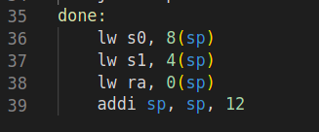

After resolving the above bugs the updated code for the map function is as follows
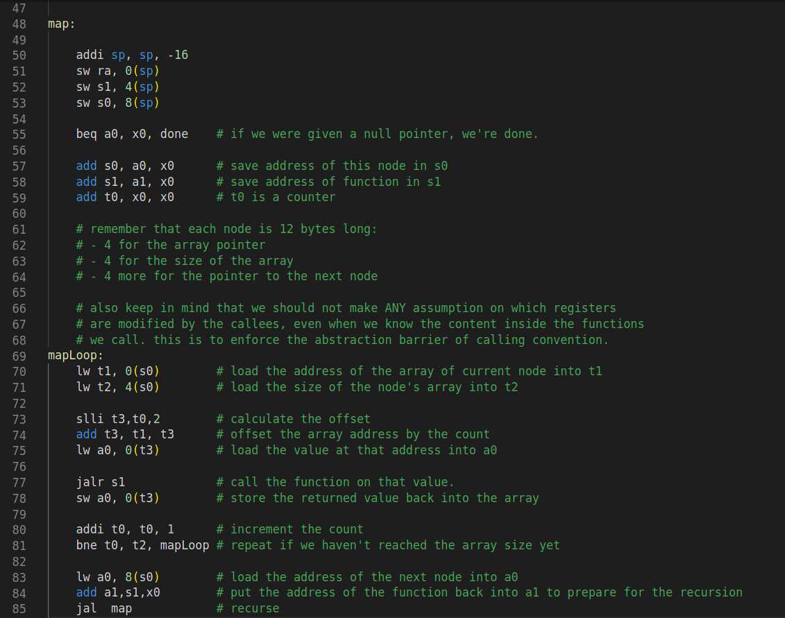
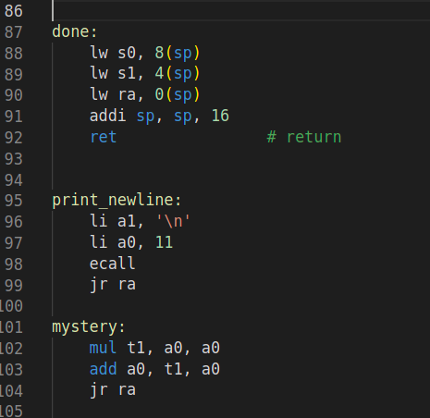

Terminal Output of the code
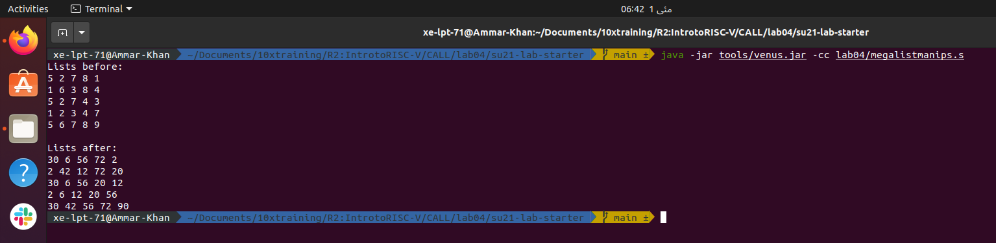
Venus Output
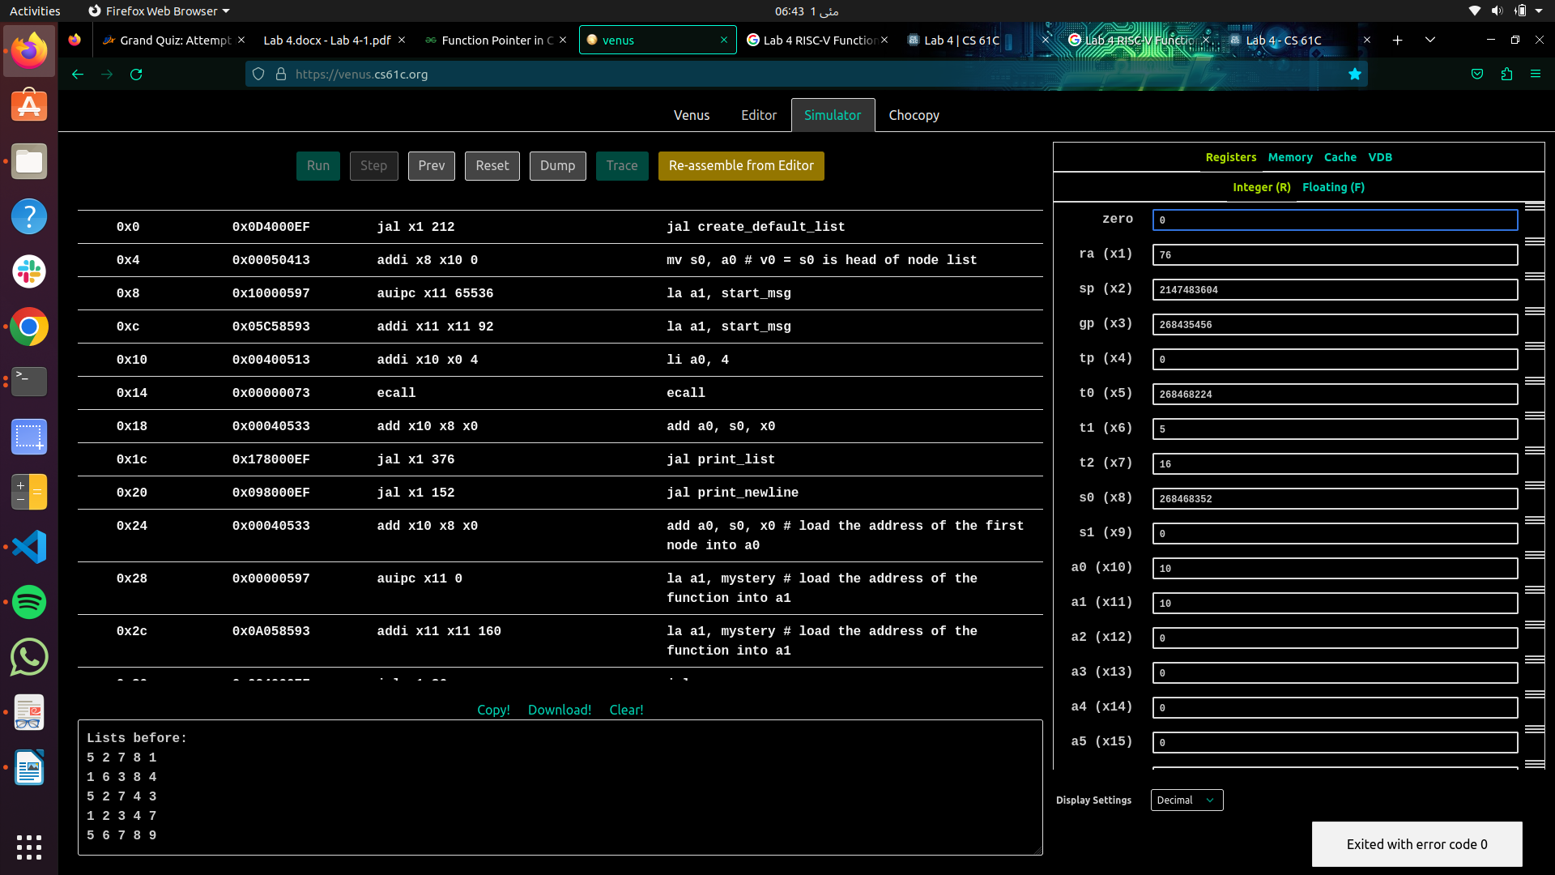
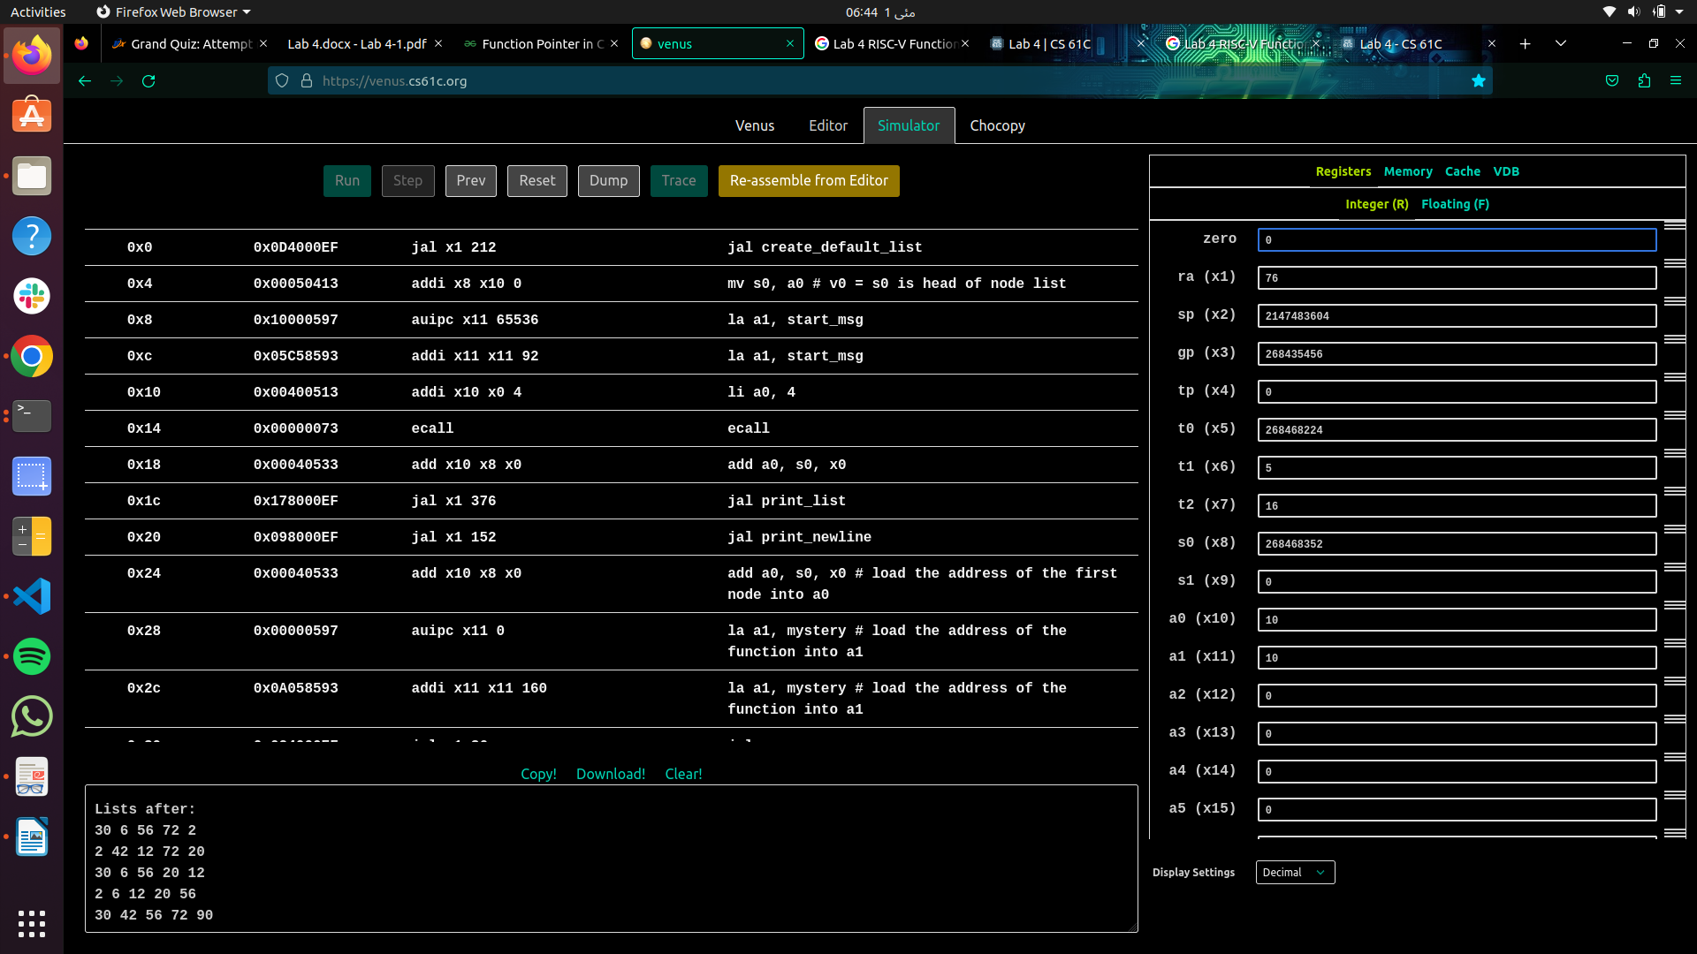
2. For this exercise, we are requiring that you don't use any extra save
registers in your implementation. While you normally can us the save
registers to store values that you want to use after returning from a function (in this case, when we're calling f in map), we want you to use temporary registers instead and follow their caller/callee conventions. The provided map implementation only uses the s0 and s1 registers, so we'll require that you don't use s2-s11.

Yes! I have not used any saved register other than s0 and s1 but I have used a temporary register t3 to preserve the value of t1 when jalr s1 was called as shown in the above snapshot of the updated code of map function.

3. Make an ordered list of each of the six mistakes in the
megalistmanips_answers.txt file , and the corrections you made to fix them.

Mistake 1: The stack space allocated should be of 16 bytes rather than 12 bytes in the map function

Solution 1: In order to solve this issue I have allocated a space of 16 bytes of stack to preserve the values of the save register and the same amount of space was deallocated when we return from the map function
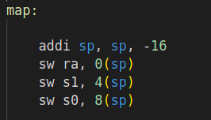

Mistake 2: In order to load the address of the array of current node into t1 add Instruction was used which just load the value which s0 contains into t1 not the address of the array was loaded

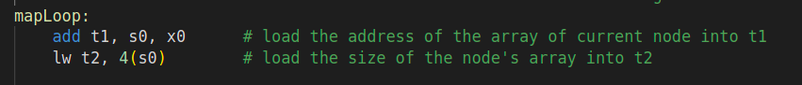

Solution 2: In order to solve this issue I have used the lw instructions to load the address of the array in t1 as shown in the snapshot below

Mistake 3: In Order to add the offset of the count in the array address the add instructions was used which just adds the count to the current address not the offset.
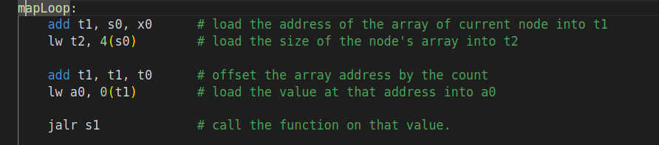
Solution 2: In order to solve this issue I have used the slli instruction first to calculate the offset by 4 bytes ( left shifted the count by 2) of the count and then this offset was added in the current address of the array using temporary register t3.

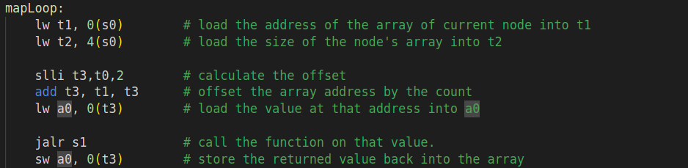

Mistake 4: As t1 holds the address of the array of current node but when jalr s1 is called in the mystery function the value of t1 was changed to the return value since we did not preserve the contents of t1 and when the sw was used to store the return value back into array the t1 is not holding the address of the array anymore.
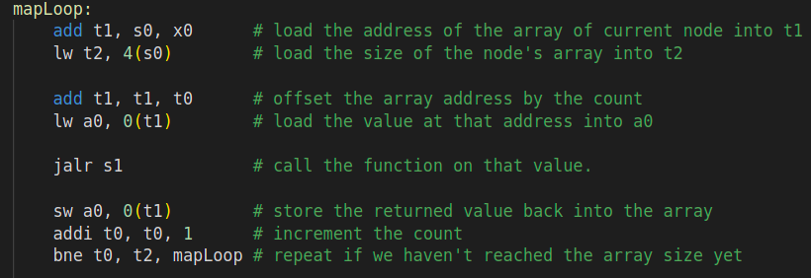
Solution 4: In order to solve this issue I have used another temporary register t3 which contains the address of the array after the offset was added in the array. In this this issue was resolved.
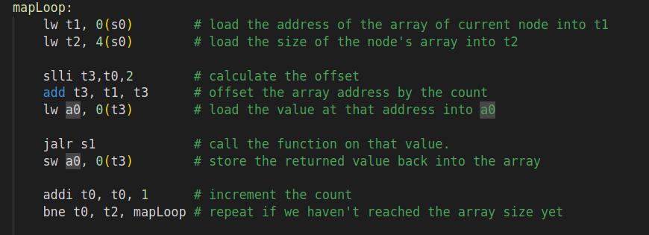
Mistake 5: In order to load the address of the next node into a0 the la instruction was used rather than lw and similary in order to put the address of the function back into a1 the lw instruction was used which loads the garbage value.

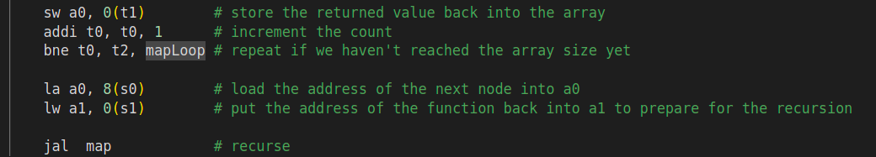
Solution 5: In order to solve this issue I have lw instruction to load the address of the next node back into a0 and add instruction to just copy the contents of s1 into a1
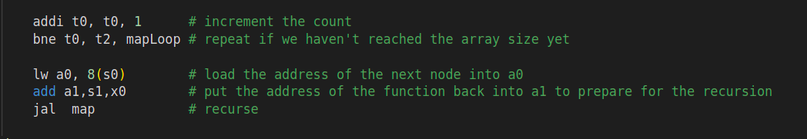

Mistake 6: Since we allocated the 16 bytes of memory on to the stack so need to deallocate that much memory rather than 12 bytes and the function should return back to next instruction.

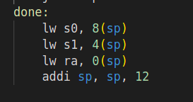

Solution 6: In order to solve this issue I have added the ret instruction and the deallocated space of the stack of 16 bytes rather than 12 bytes
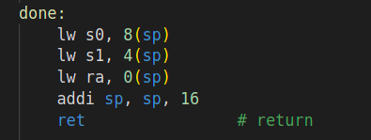

4. Save your corrected code in the megalistmanips.s file. Use the -cc flag to run a basic calling convention check on your code locally:

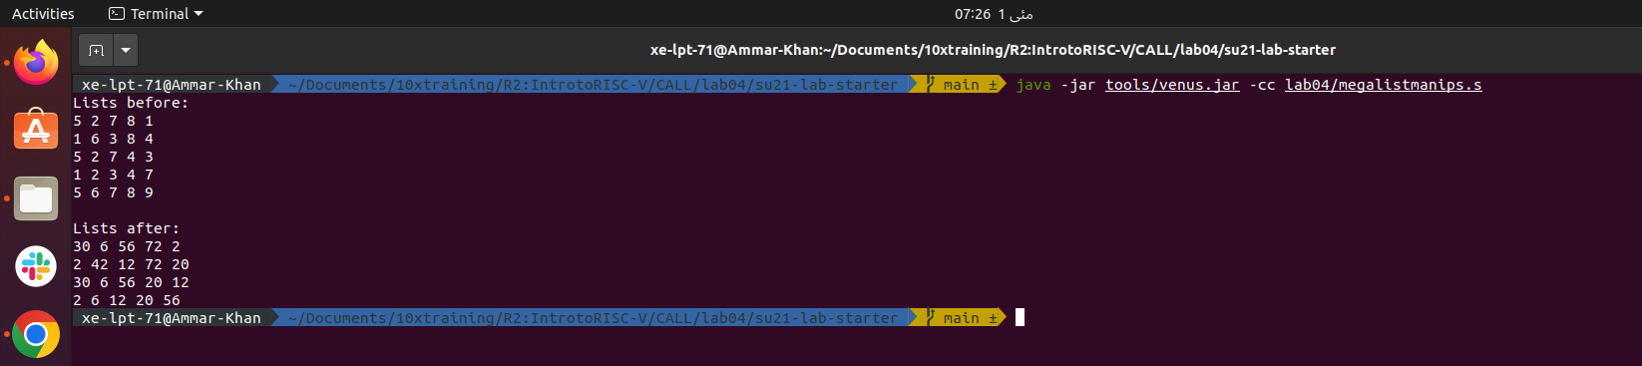
java -jar tools/venus.jar -cc lab04/megalistmanips.s

Exercise 4: Finding and solving the bugs

Action items

1. Find the bugs in four of the five accumulators

- accumulatorone: In this accumulator the s0 register was not saved onto the stack before it was used and so the value of s0 was not preserved.

- accumulatortwo: The stack pointer is incremented by four in the prologue, and decremented by four in the epilogue. This breaks the stack of the caller.

- accumulatortwo: This accumulator is correct there is no issue in it.

- accumulatorfour: The function relies on t2 being set to zero before running. Otherwise, it returns t2 plus the desired sum.

- accumulatorfive: The function doesn't check if the first element is zero. As such, it fails to provide the correct result if the first element is zero, and if the second element is nonzero.

2. For each broken accumulator, write a test that fails on the broken one, but passes the correct implementation.

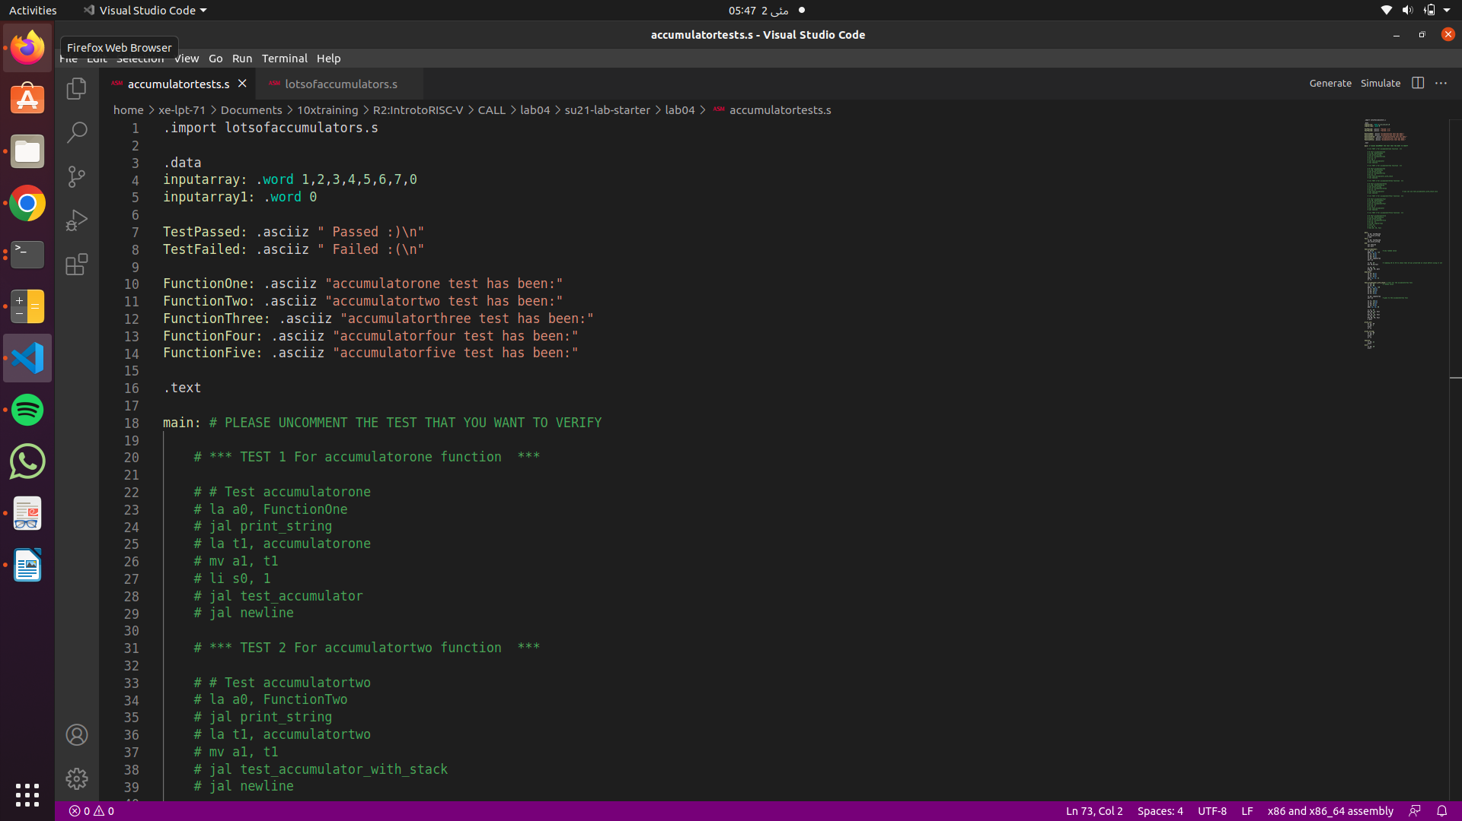
The code written in order to test these different functions is as follows:

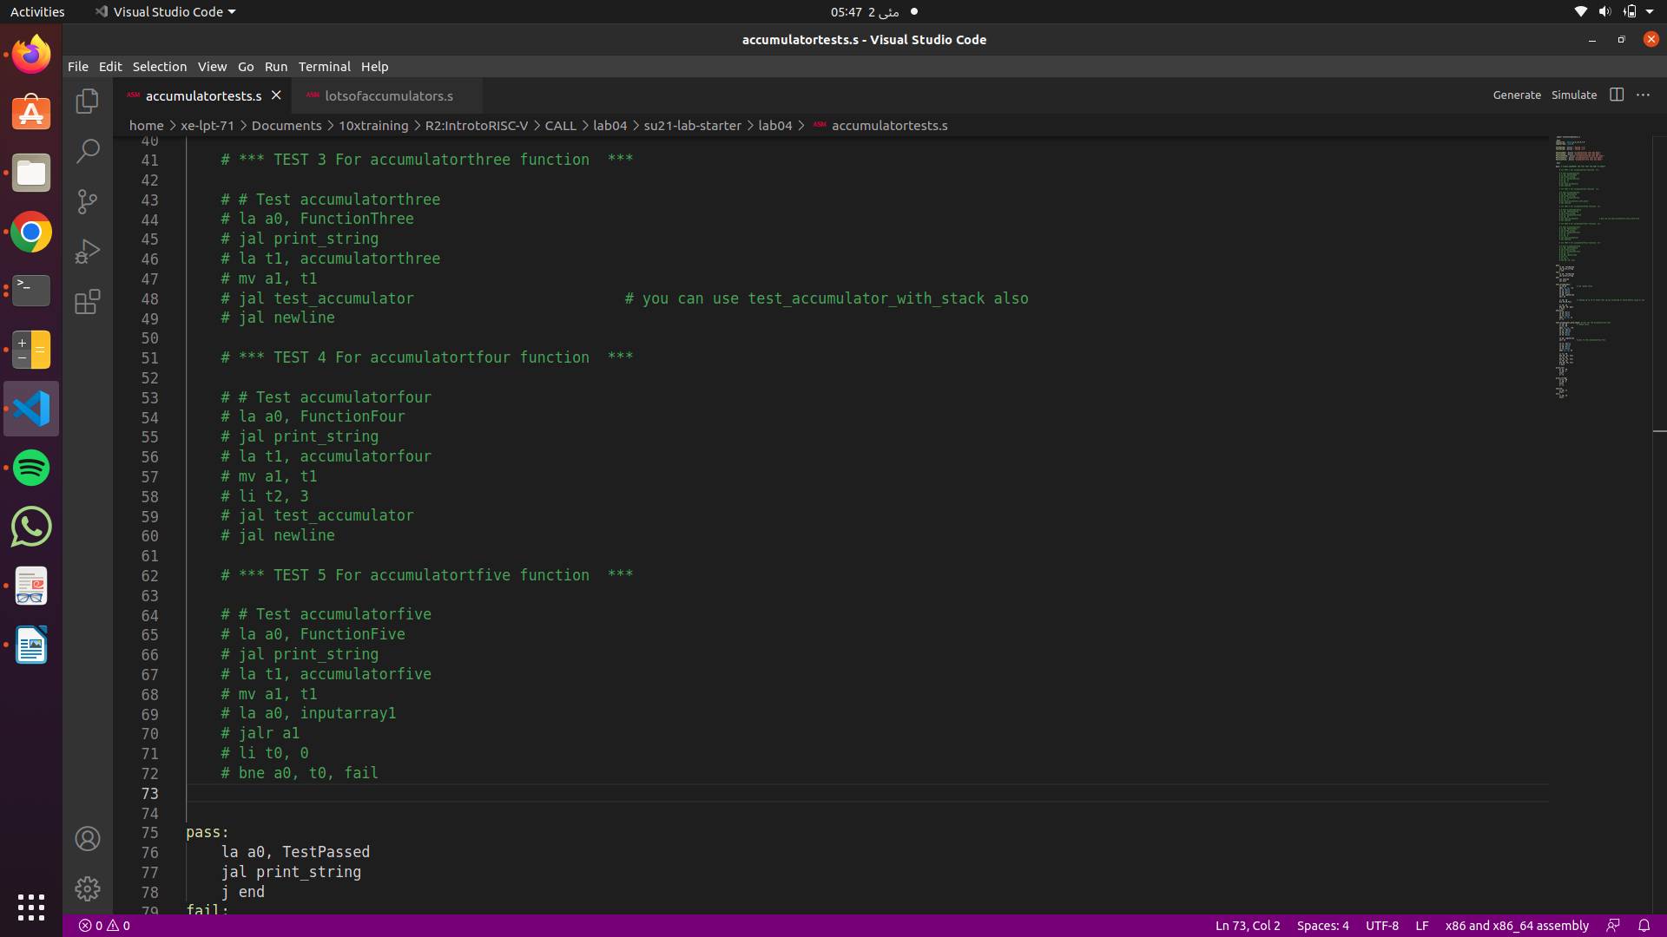

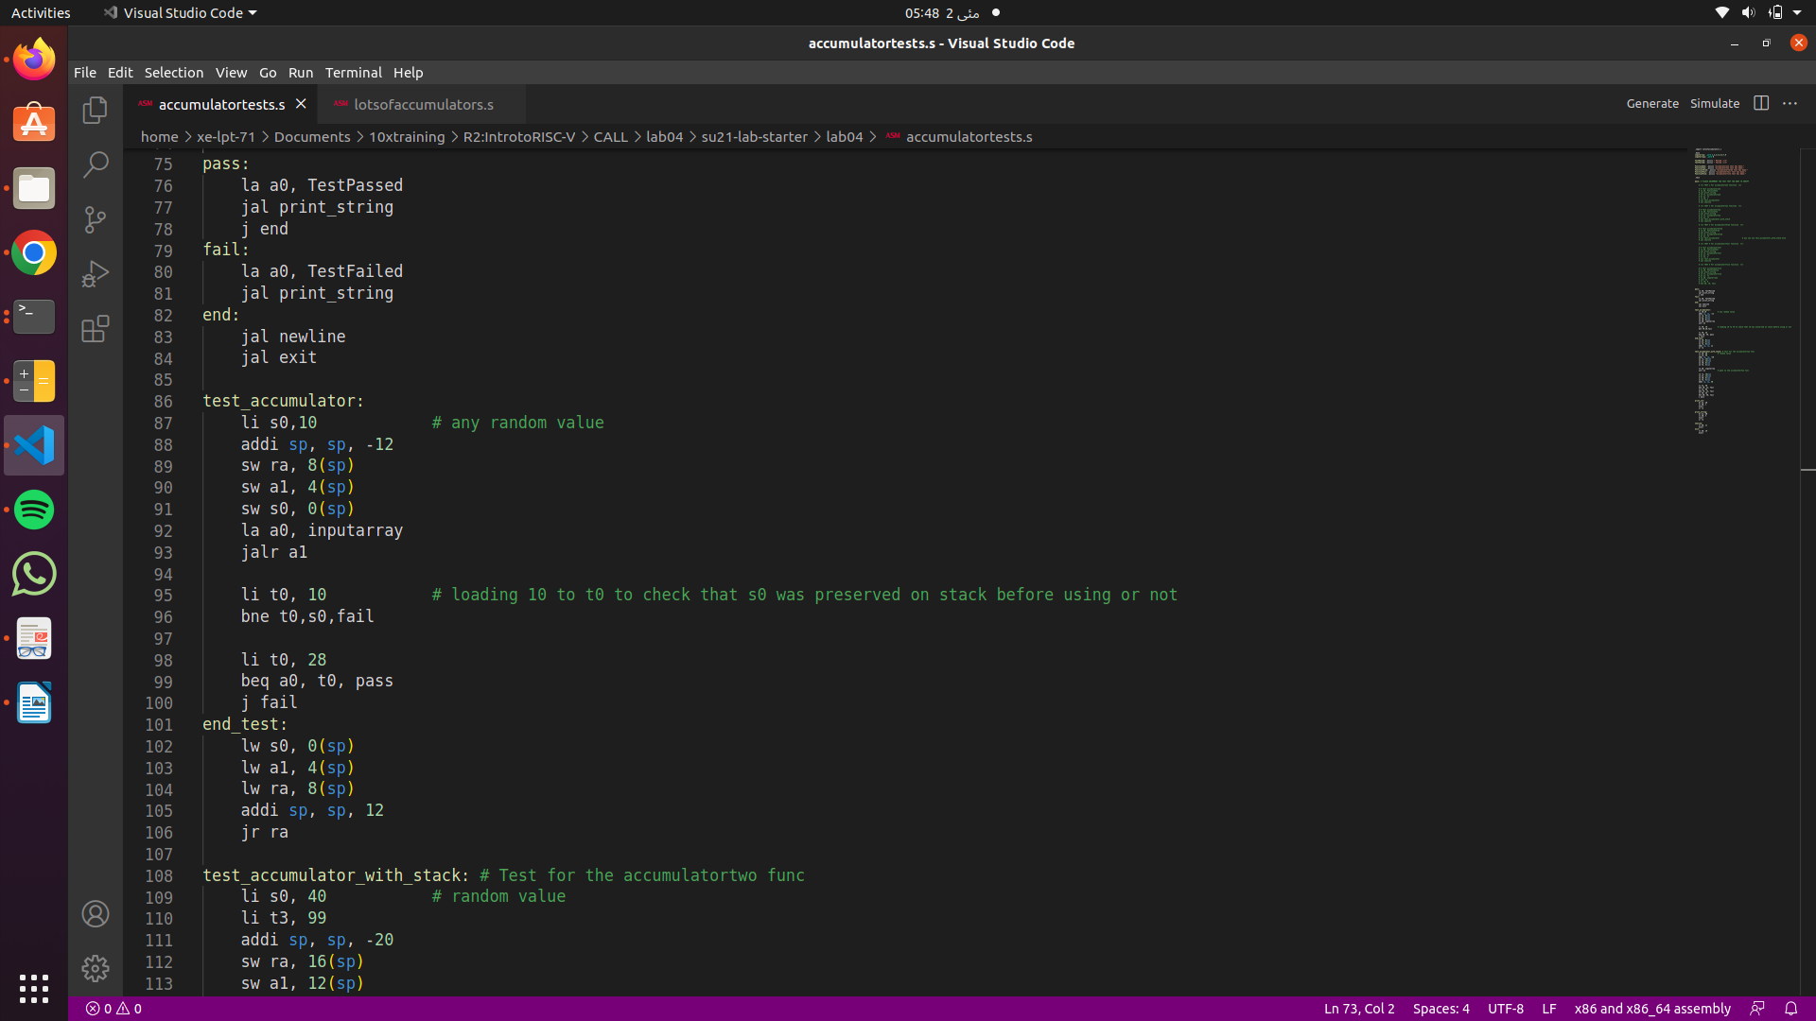

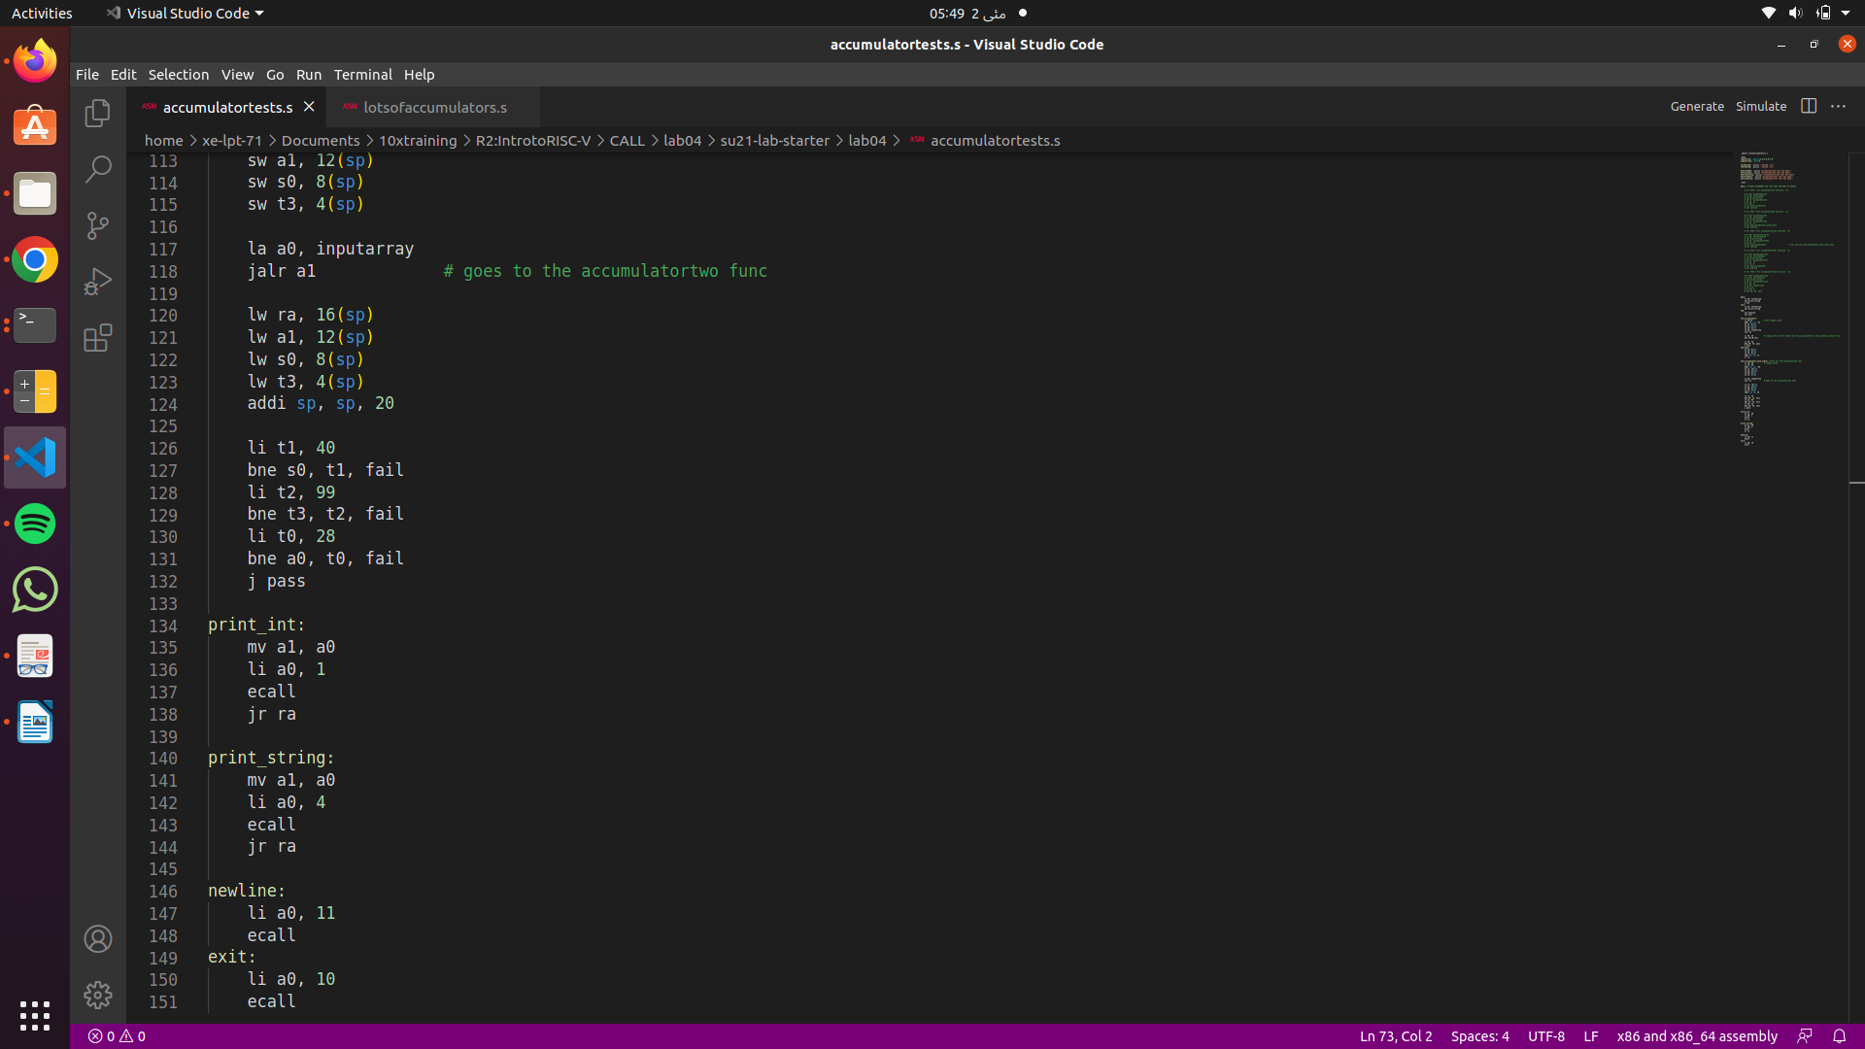

Terminal Output of the code

For the accumulatorone:

The following figure showing the output of accumulatorone function with and without -cc flag
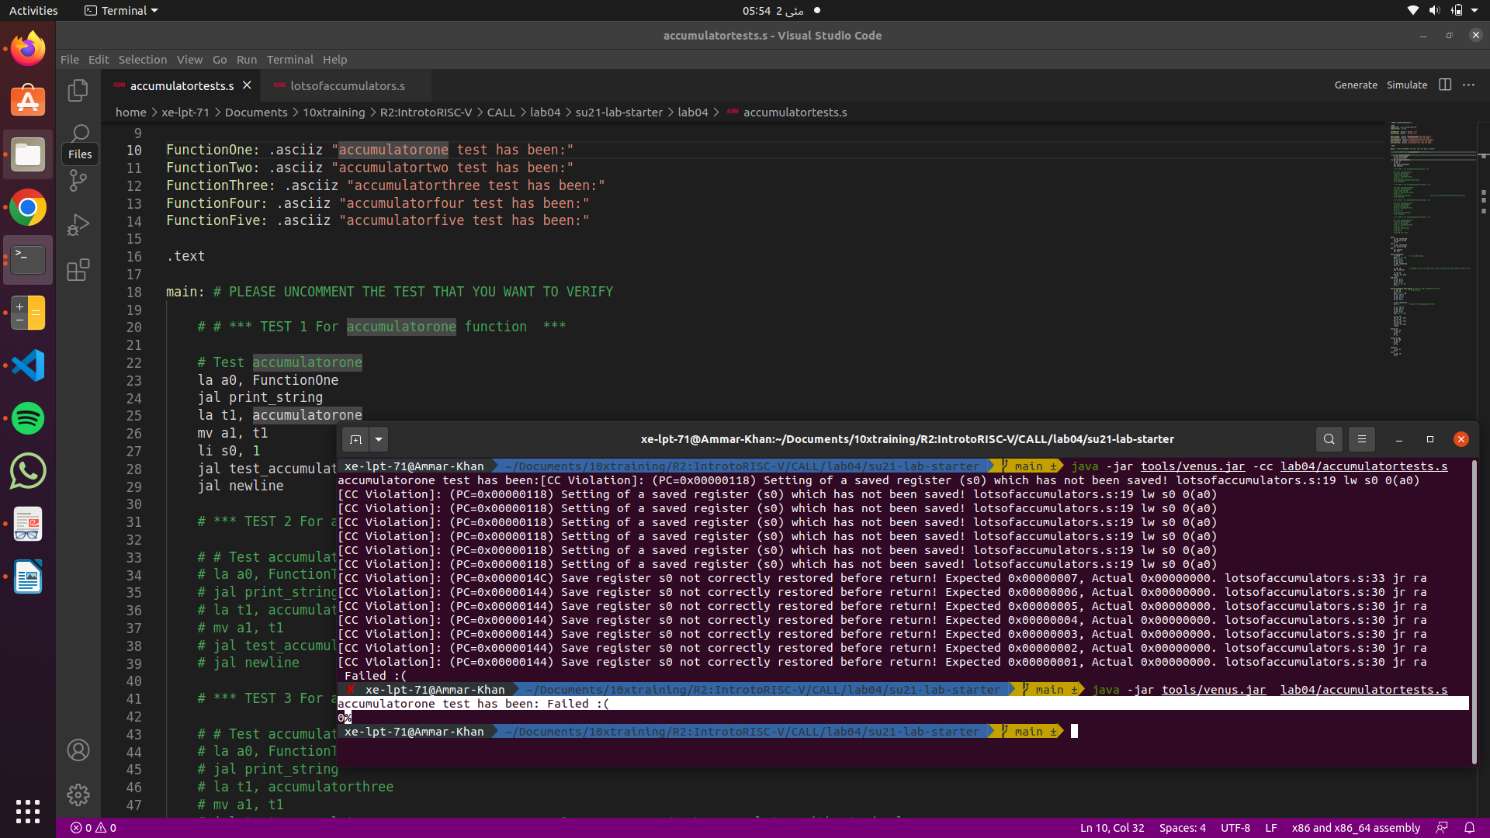

For the accumulatortwo:

The following figure showing the output of accumulatortwo function with and without -cc flag
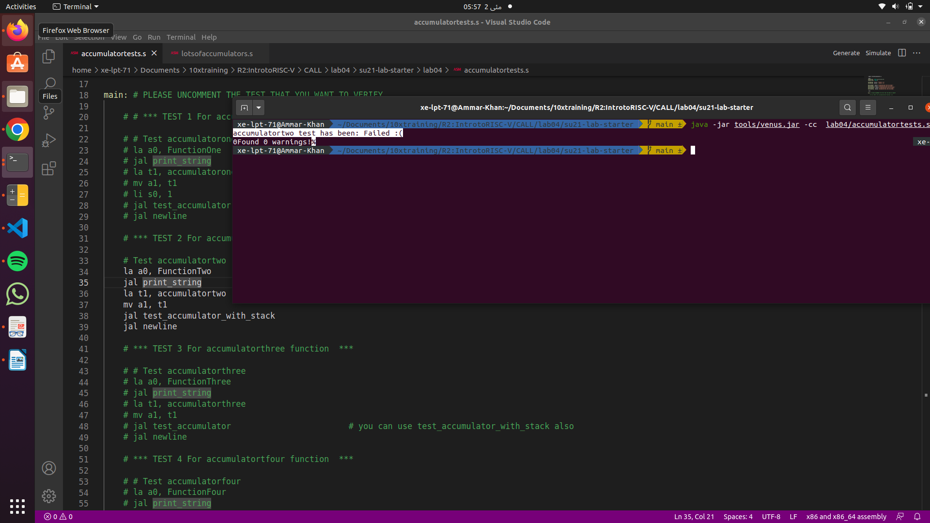

For the accumulatorthree:

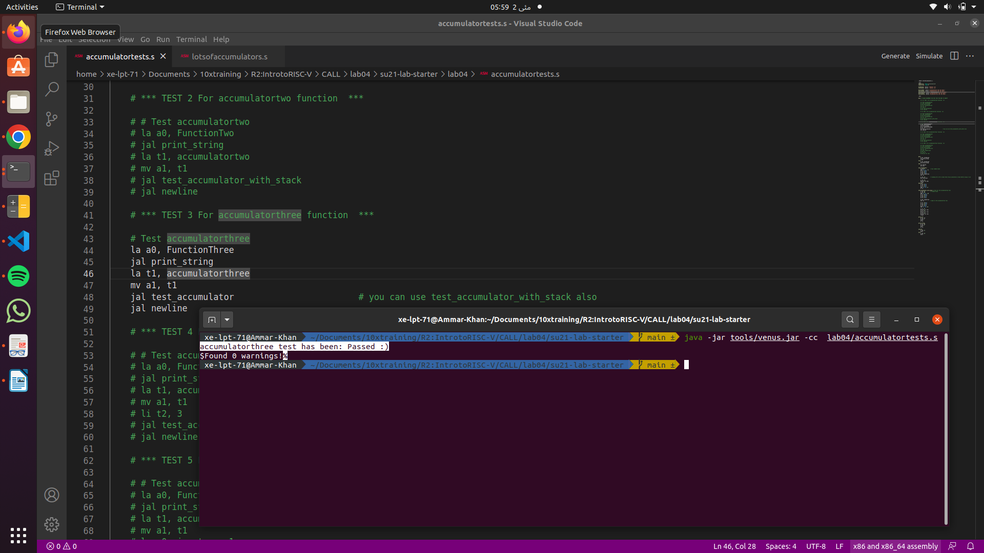
Since there were no errors the test passed status is shown below

For the accumulatorfour:

The following figure showing the output of accumulatorfour function with and without -cc flag
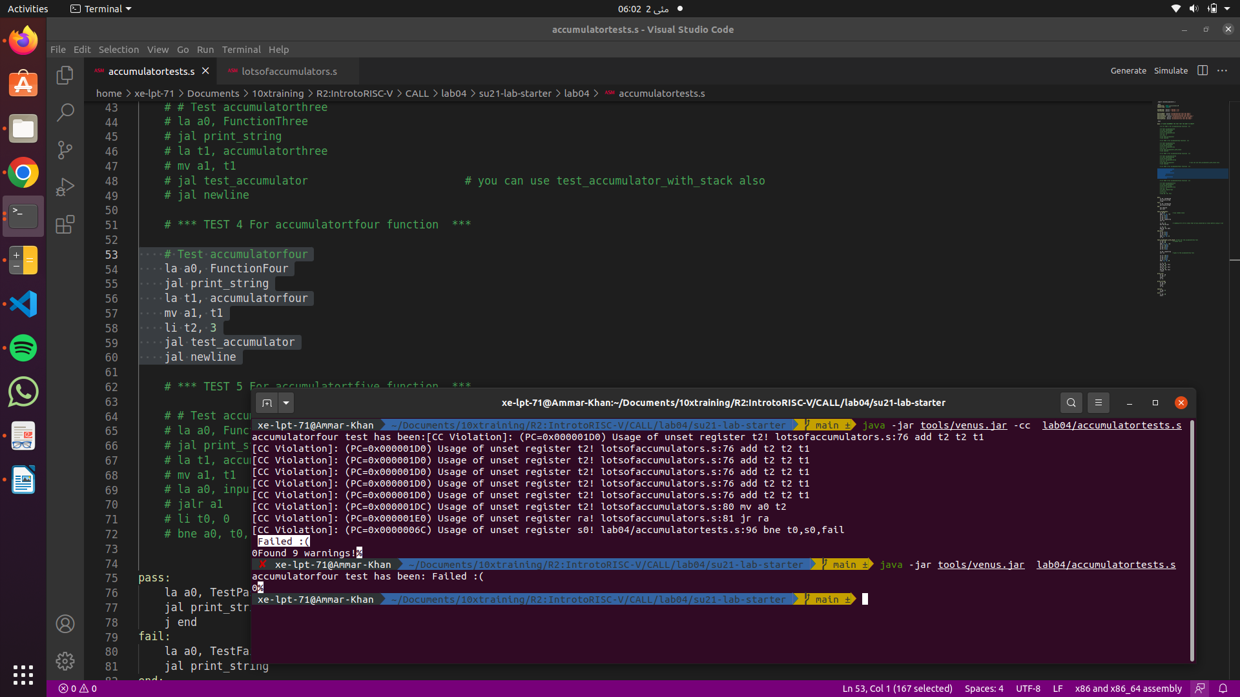
For the accumulatorfive:

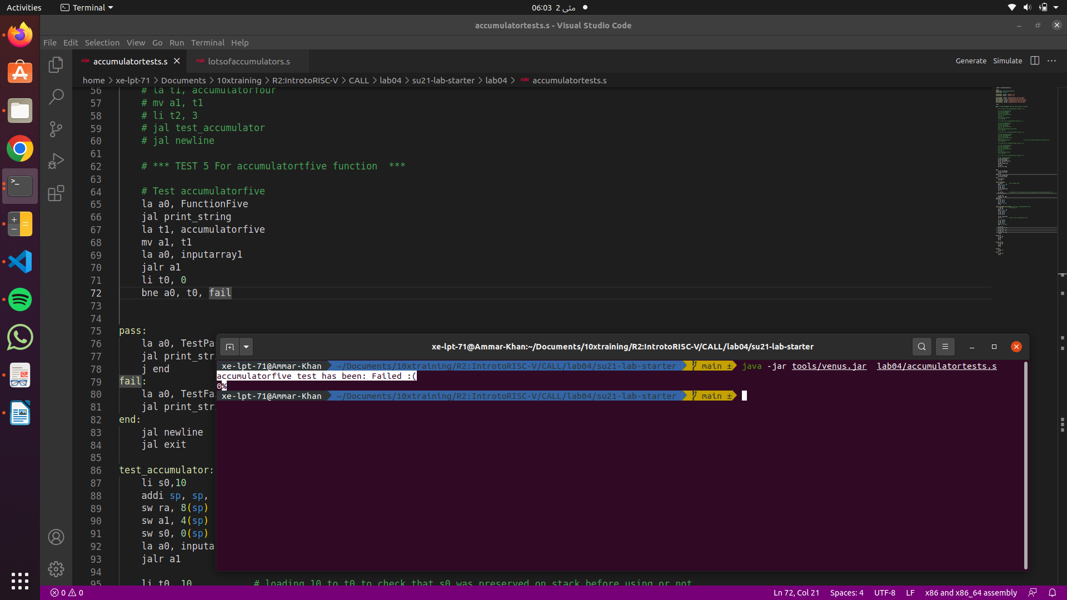
The following figure showing the output of accumulatorfour function with and without -cc flag

The github link for this lab with all the solution is as follows:

