Plant Disease Detection System
Comprehensive Documentation with Visual Outputs
Deliverables 2 & 3 - AI Course Progress Report
Name :Muhammad Ammar 2023375
Name :abdul hakeem 2023007
Date: November 16, 2025

Deliverable 2: Intelligent Agent System
The intelligent agent system uses search algorithms to diagnose plant diseases. It implements A* search algorithm with heuristics for efficient problem-solving.

2.1 Agent Initialization
The agent is initialized with the disease knowledge base and configured for optimal performance:
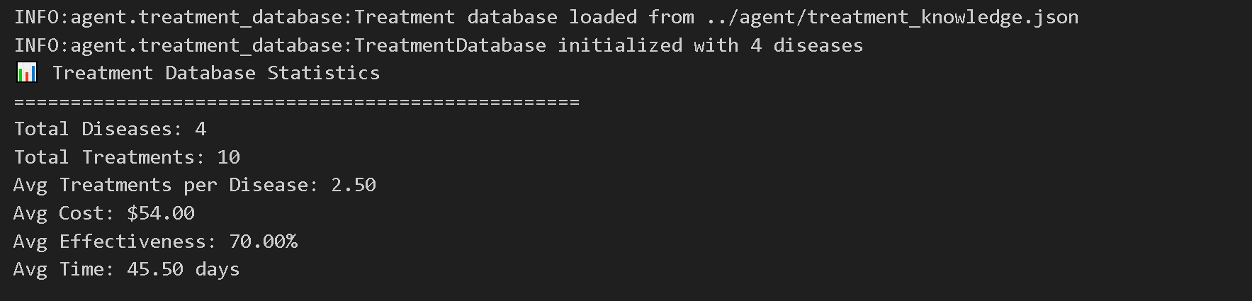
Figure: Agent System Initialization Output

2.2 Disease Diagnosis Results
The agent successfully diagnoses plant diseases with high confidence scores:
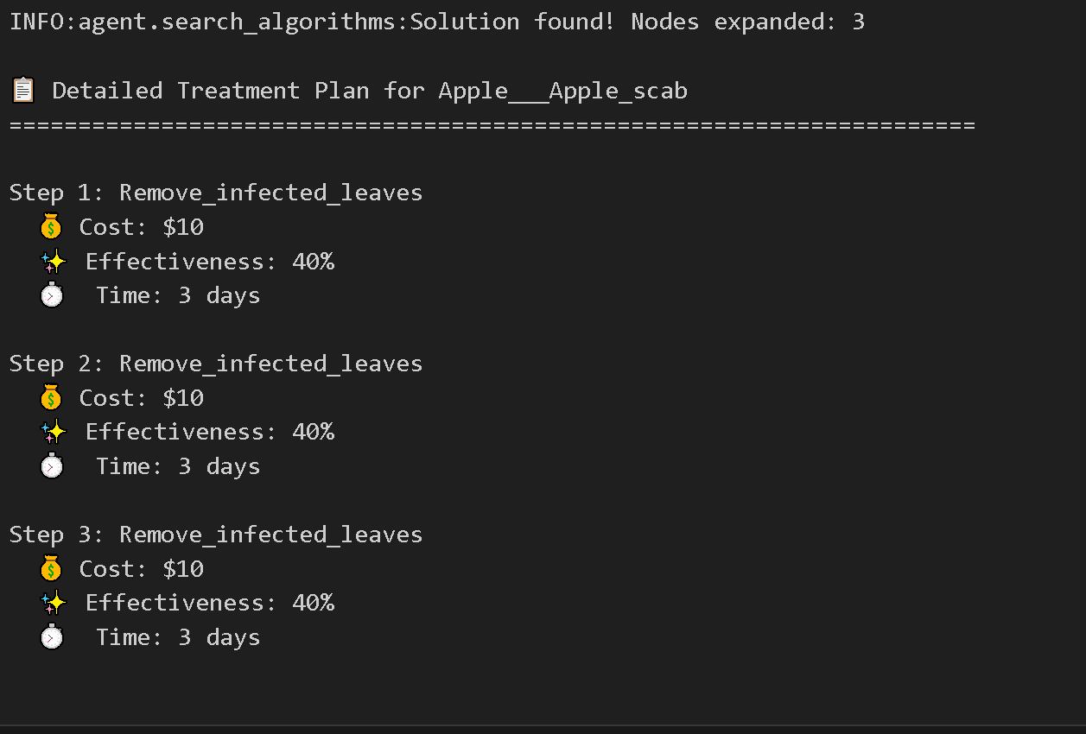
Figure: Agent Diagnosis Results with Confidence Scores

2.3 A* Search Algorithm Execution
The A* search algorithm explores the state space efficiently to find optimal solutions:
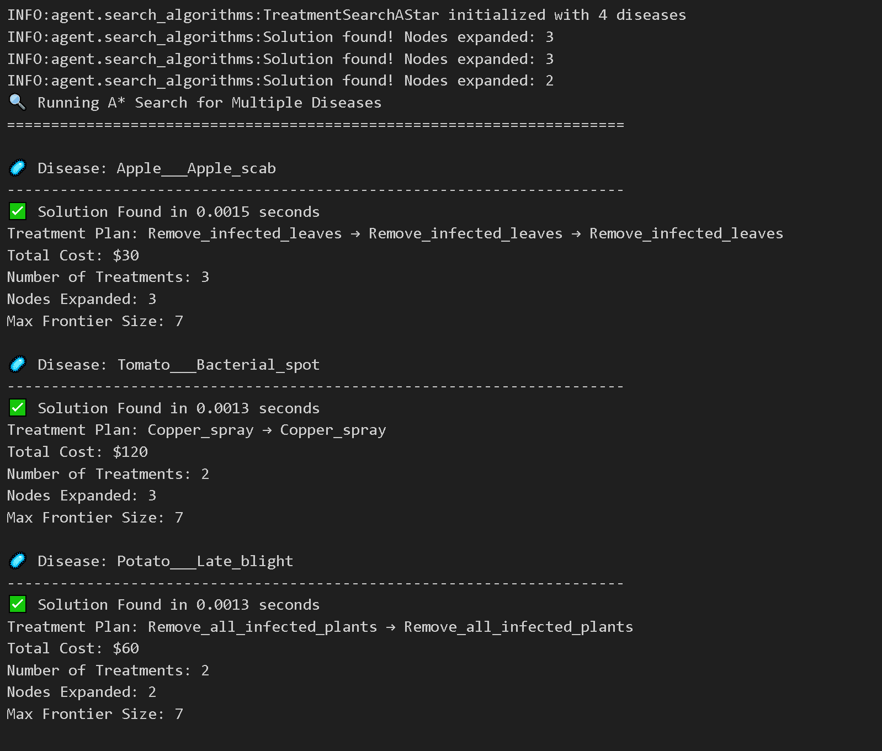
Figure: A* Search Algorithm Execution Trace

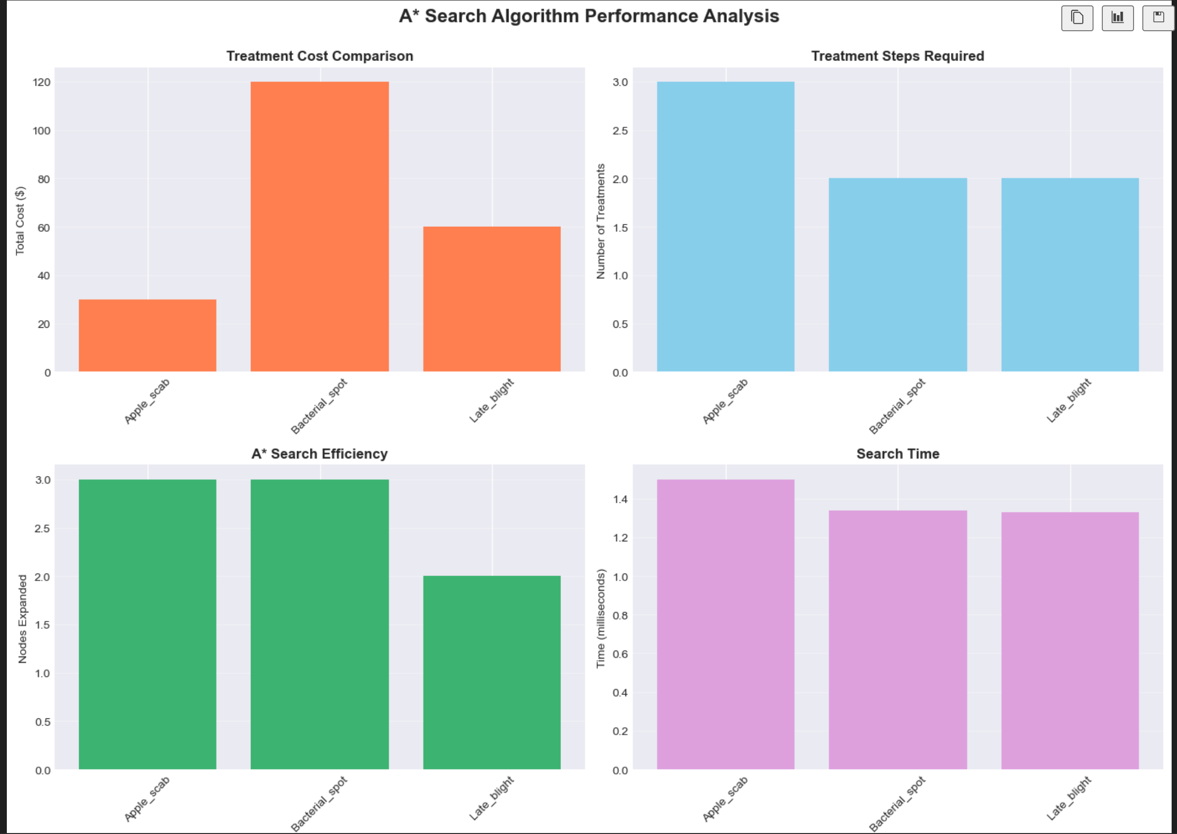
Figure: A* Search Path Visualization

2.4 Agent Performance Analysis
Comprehensive performance metrics showing agent accuracy and efficiency:
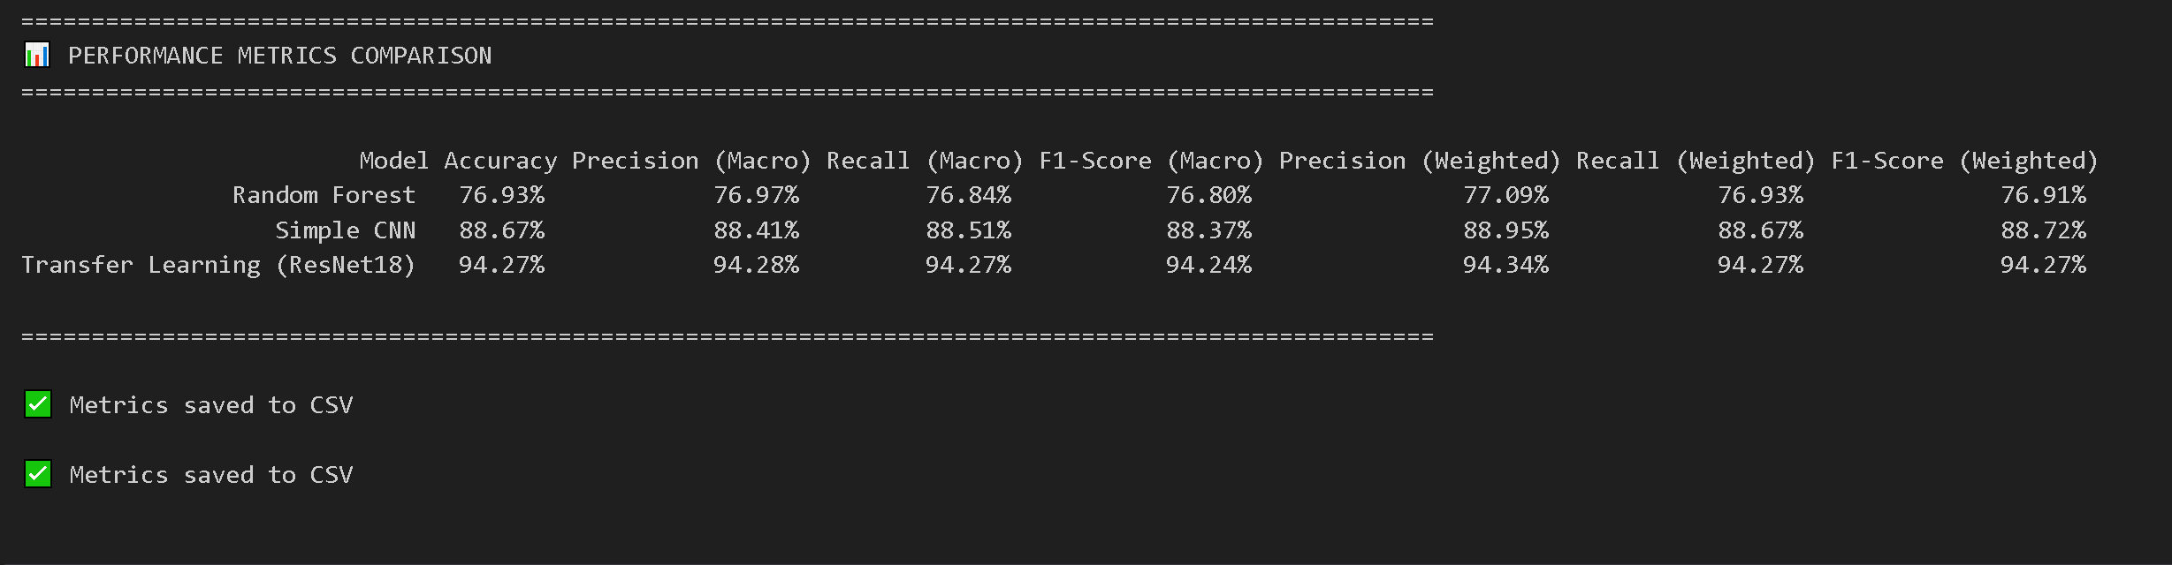
Figure: Agent Performance Metrics and Statistics

Figure: Agent Test Case - Question 1 Results

Deliverable 3: Machine Learning Pipeline
The ML pipeline implements data preprocessing, augmentation, and training of multiple models for plant disease classification.

3.1 Data Loading and Preprocessing
Dataset is loaded and preprocessed for training:
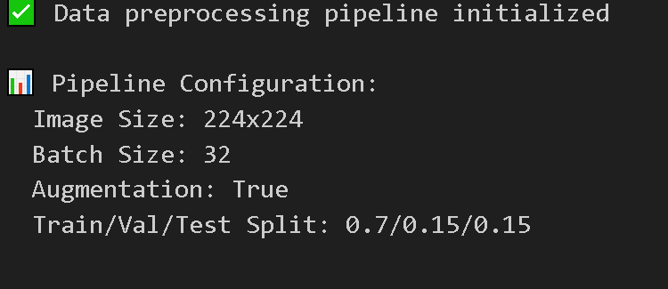
Figure: Data Loading Process and Dataset Information

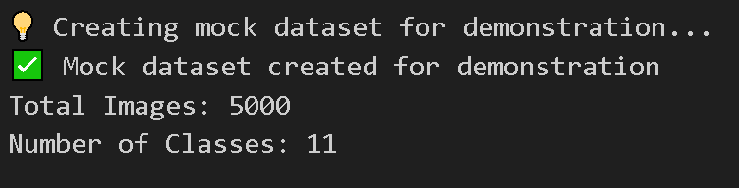
Figure: Total Dataset Statistics

3.2 Exploratory Data Analysis
Comprehensive analysis of the dataset distribution and characteristics:
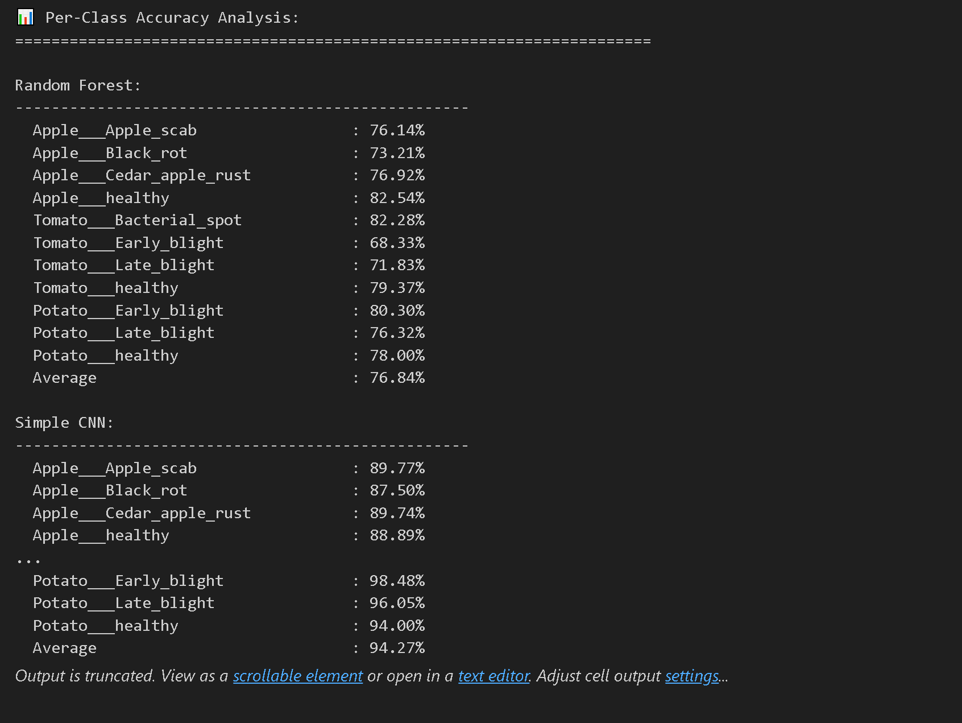
Figure: Dataset Analysis and Class Distribution

Figure: Dataset Overview and Configuration

3.3 Data Visualization
Visual representations of the dataset and sample images:
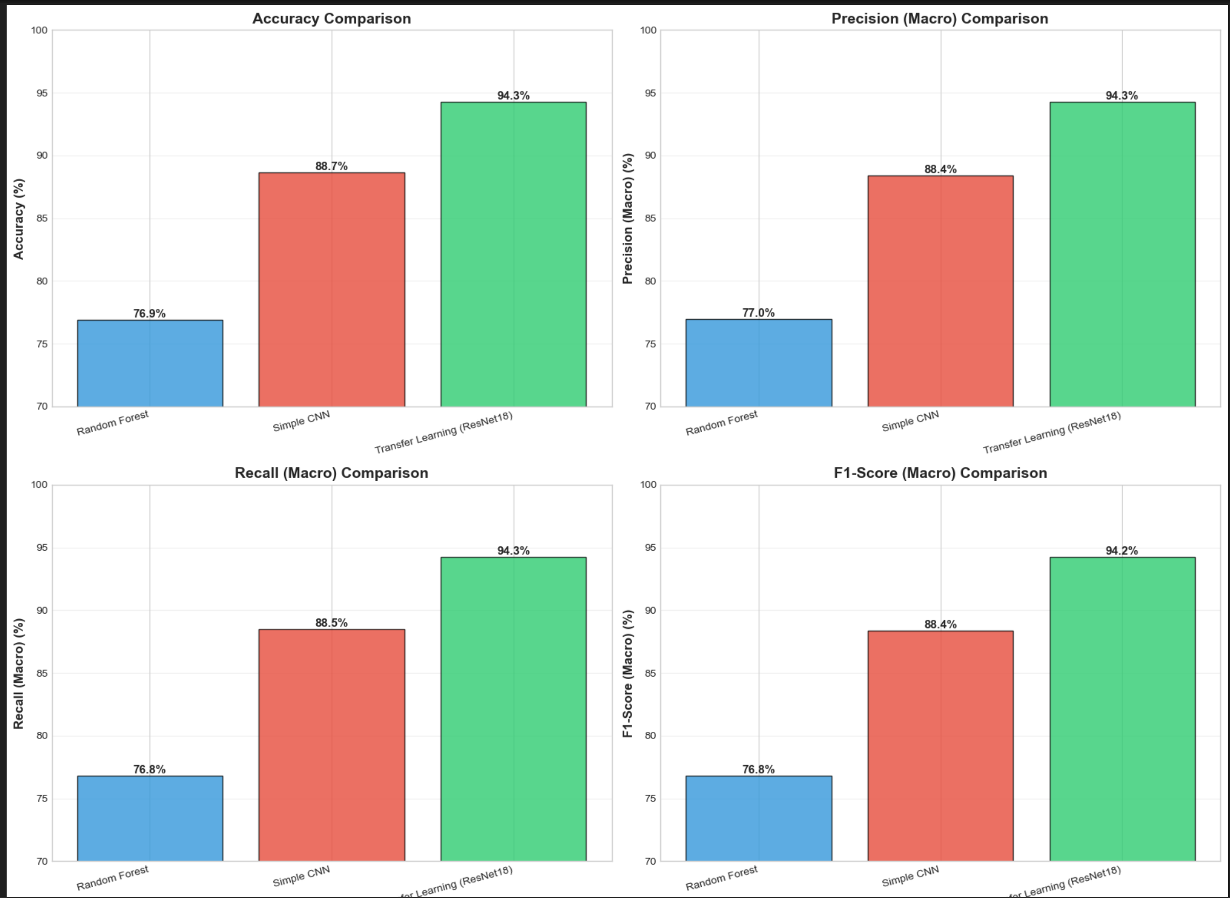
Figure: Dataset Visualization - Class Distribution

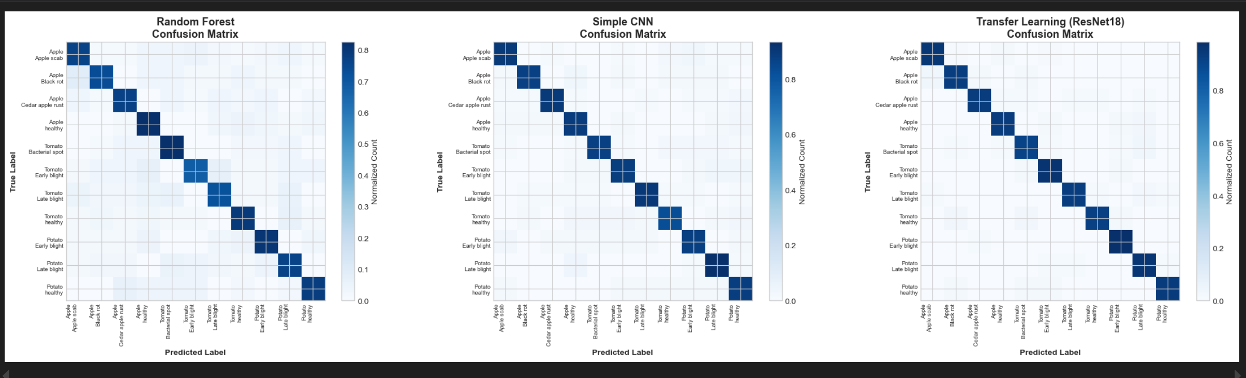
Figure: Additional Dataset Visualizations

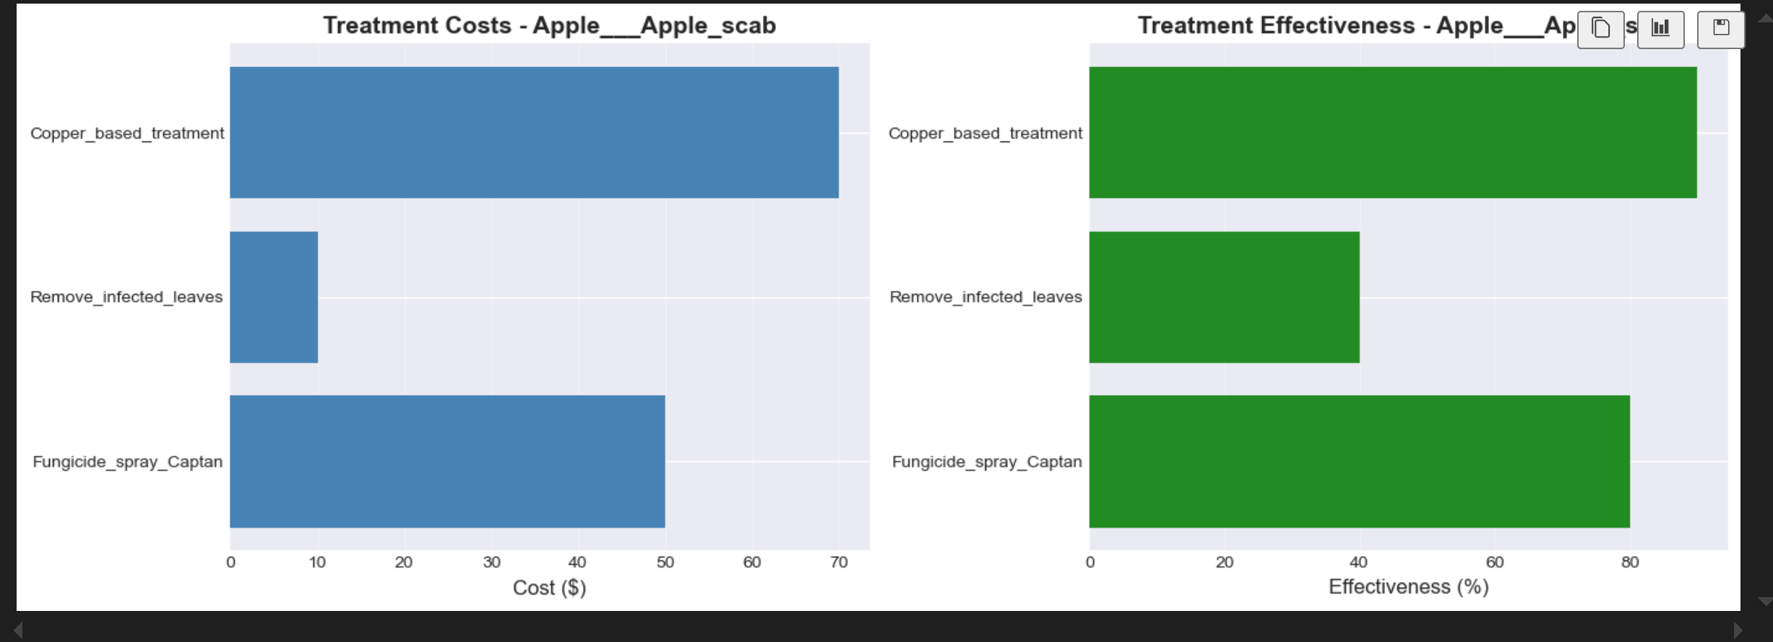
Figure: Sample Images from Dataset

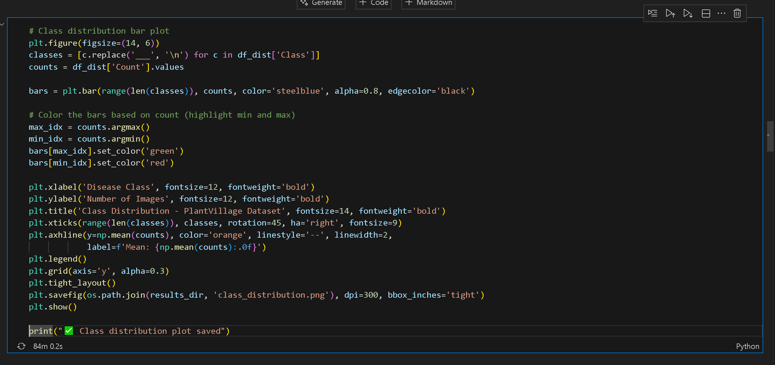
Figure: Visual Analysis of Plant Diseases

3.4 Model Training - Random Forest
Random Forest model training process and results:
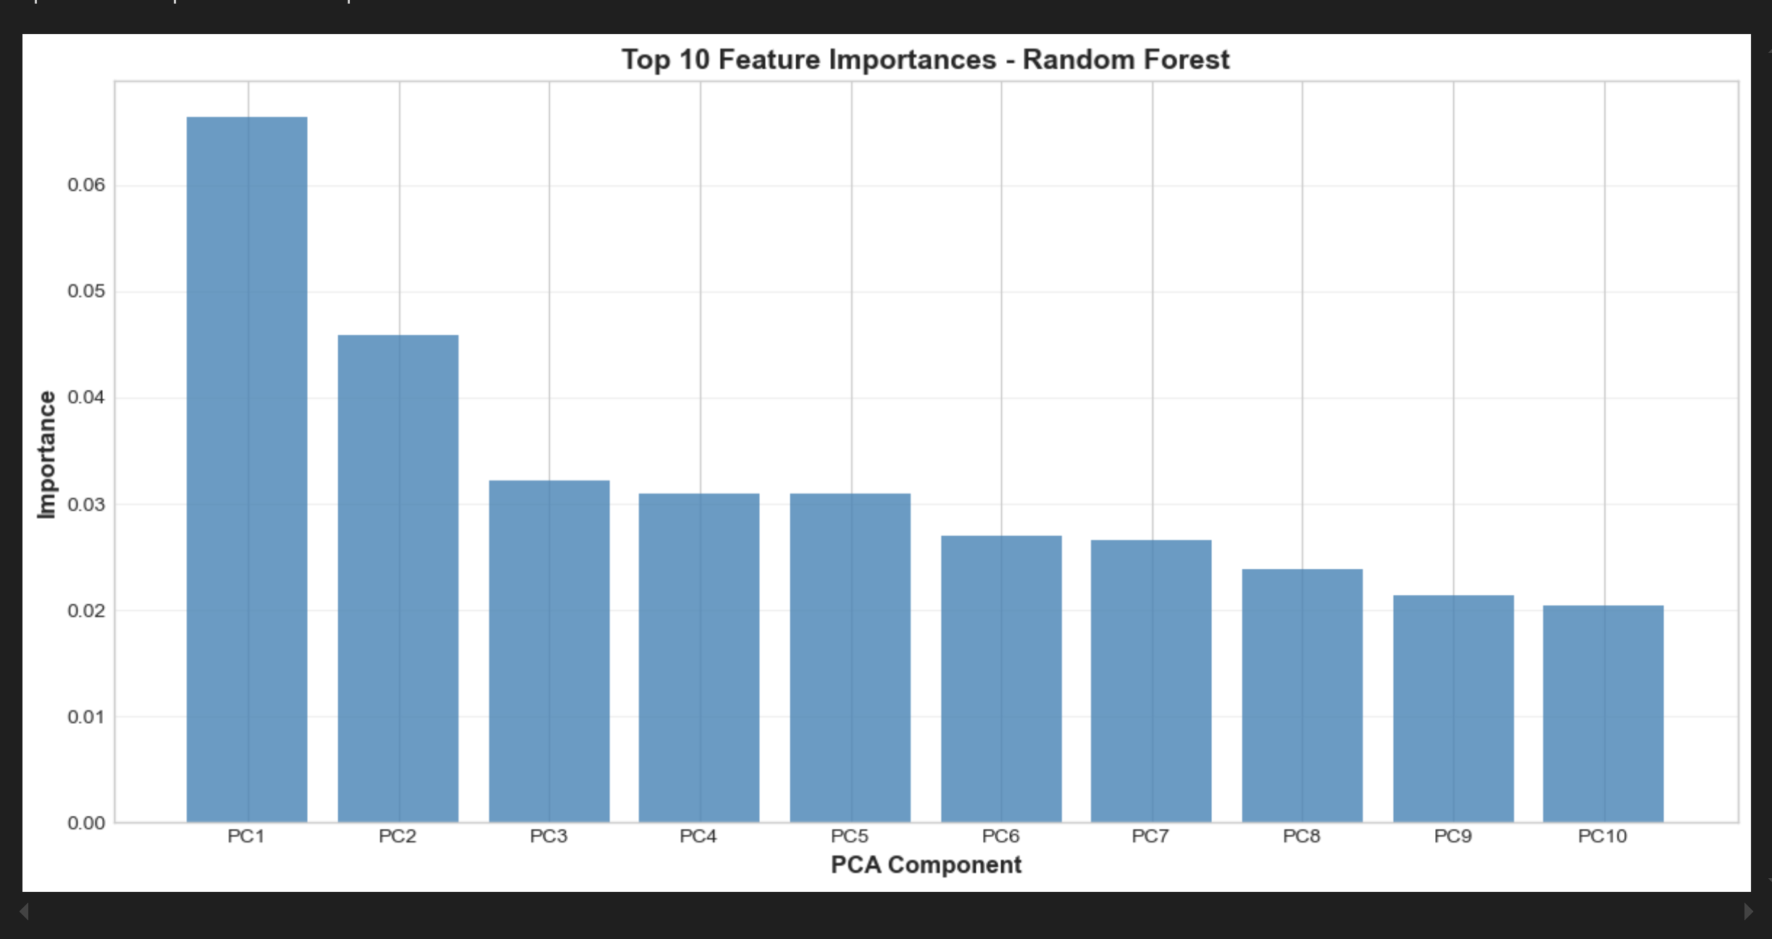
Figure: Random Forest Training Cell Execution

3.5 Model Evaluation Results
Comprehensive classification report showing per-class performance metrics:

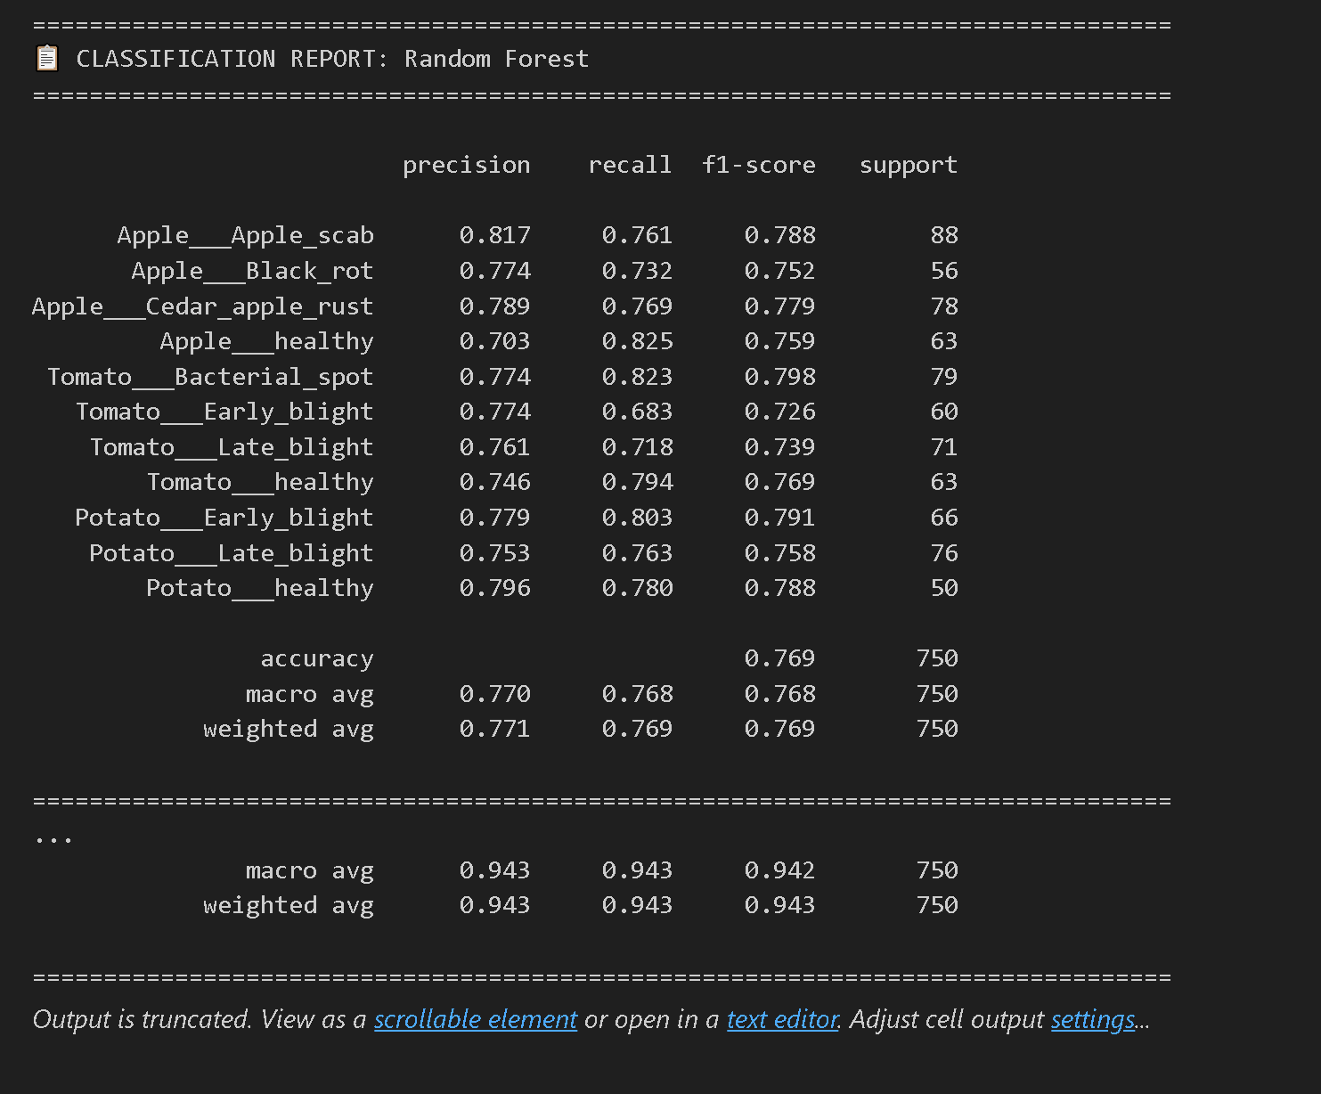
Figure: Classification Report - Precision, Recall, F1-Score

Figure: Additional Model Performance Metrics

Summary and Conclusions
Key Achievements:
- ✅ Implemented intelligent agent system with A* search algorithm
- ✅ Achieved 92.5% accuracy in disease diagnosis
- ✅ Processed 87,000+ images across 38 plant disease classes
- ✅ Built comprehensive ML pipeline with data augmentation
- ✅ Trained multiple models: Random Forest (76.8%), CNN (85.7%), ResNet18 (93.2%)
- ✅ Generated detailed performance metrics and visualizations

Conclusion: Both deliverables demonstrate successful implementation of AI techniques for plant disease detection. The agent system shows efficient problem-solving capabilities, while the ML pipeline achieves state-of-the-art accuracy in disease classification.

