📘 CHAPTER 1 – PROLOGUE: THE SOFTWARE PROCESS
(Complete explanatory version – as if teacher is explaining slides in class)

🔵 Slide 1: Title – Prologue: The Software Process
What does Prologue mean?
- Prologue means introduction
- This chapter introduces the subject Software Design & Architecture
So this chapter tells us:
👉 How software is built from start to end

🔵 Slide 2: Software Process – Definition
Line on slide:
“Software Process: a procedure followed by the development team to produce an application.”
Explanation:
- Procedure means a step-by-step method
- Development team means programmers, designers, testers
- Application means software
👉 So, software process is:
A step-by-step way that developers follow to make software.
Simple example:
Just like:
- Recipe → cooking food
- Software process → building software
Without a process:
- Work becomes confusing
- Software quality becomes poor

🔵 Slide 3: Main Phases of Software Process
The slide shows five phases.

🔹 1. Requirements Analysis (answers “WHAT?”)
Line:
“Requirements Analysis (answers WHAT?)”
Explanation:
- This phase is about understanding the problem
- You talk to users and clients
- You write down what they want
❌ No coding
❌ No design
Only:
✔ Understanding
✔ Writing requirements
Example:
Requirement:
“The application shall display the user’s bank balance.”
📌 Important:
- Requirements answer WHAT to build
- NOT HOW to build

🔹 2. Design (answers “HOW?”)
Line:
“Design (answers HOW?)”
Explanation:
- After knowing what to build, now decide how to build
- This phase is the heart of this course
Design includes:
- Classes
- Objects
- Relationships
- Diagrams
📌 Example:
- Class: Account
- Class: Customer
- Relationship: Customer has Account
👉 Design is like a blueprint of a house.

🔹 3. Implementation (A.K.A Coding)
Line:
“Implementation (A.K.A Coding)”
Explanation:
- A.K.A means also known as
- This phase is writing actual code
- Programmers use design documents
📌 Important rule:
Code must follow design

🔹 4. Testing (type of verification)
Line:
“Testing (type of verification)”
Explanation:
- Testing checks whether software works correctly
- You give input and check output
📌 Important concept:
Testing verifies the software against requirements
Testing does:
✔ Find bugs
❌ Cannot guarantee bug-free software

🔹 5. Maintenance (Repair or Enhancement)
Line:
“Maintenance (Repair or Enhancement)”
Explanation:
- Maintenance happens after delivery
- Software is updated over time
Two main reasons:
- Repair – fix bugs
- Enhancement – add new features

🔵 Slide 4: Software Process – Diagram
The diagram shows:
Requirements → Design → Coding → Testing → Maintenance
Explanation of diagram:
- Software is built step by step
- Output of one phase becomes input of next phase
Example:
- Requirements document → used in Design
- Design document → used in Coding

🔵 Slide 5: Personal Finance Example
Explanation:
The slide shows how each phase produces a different artifact.

🔹 Requirements Analysis Output
“The application shall display the balance in the user’s bank account.”
✔ Simple English
✔ From user’s view

🔹 Design Output
“The design will consist of classes CheckingAccount, SavingsAccount…”
✔ Technical
✔ Shows structure

🔹 Implementation Output
class CheckingAccount {
double balance;
}
✔ Actual code
✔ Based on design

🔵 Slide 6: Personal Finance Example (Testing & Maintenance)

🔹 Testing Output
“With test case: deposit $44.92…”
Explanation:
- Specific test data is used
- Output is checked for correctness

🔹 Maintenance Output
Examples:
- Bug: App crashes when balance = 0
- Enhancement: Allow operation with Riyal
👉 Shows maintenance includes fixing and improving

🔵 Slide 7: Waterfall Process
Line:
“Basic software process in which phases are performed in sequence”
Explanation:
- One phase finishes before next starts
- Very rigid process
Sequence:
- Requirements
- Design
- Coding
- Testing
- Maintenance

🔵 Slide 8: Why Pure Waterfall Is Not Practical
Now teacher explains WHY it fails.

Line:
“Don’t know everything up front”
Explanation:
- Users often change their mind
- New requirements appear later

Line:
“Hard to visualize every detail in advance”
Explanation:
- Complex systems cannot be imagined fully early

Line:
“Need to execute intermediate builds”
Explanation:
- Users want to see working software early

Line:
“Stakeholders need confidence”
Explanation:
- Clients want proof that software is correct

Line:
“Team members can’t be idle”
Explanation:
- Developers cannot wait while requirements finish

🔵 Slide 9: Spiral Process
Explanation:
- Spiral model repeats cycles
- Focuses on risk analysis
Each loop:
- Planning
- Risk analysis
- Development
- Testing
✔ Flexible
✔ Suitable for large systems

🔵 Slide 10: Common Procedures

Line:
“Work Against the Product of Prior Phase”
Explanation:
- Each phase uses output of previous phase
- Design uses requirements
- Coding uses design

Line:
“Inspections”
Explanation:
- Inspection means reading documents carefully
- Used to find mistakes early

🔵 Slide 11: Requirements Analysis
Line:
“The process of understanding what’s needed and expressing results in writing”
Explanation:
- Requirements must be written
- So everyone understands the same thing

🔵 Slide 12: Challenges of Requirements Analysis

Line:
“Express requirements in ordinary English”
Explanation:
- Avoid technical words
- Write for users

Line:
“Organize requirements”
Explanation:
- Group related requirements
- Easy to update later

Line:
“Manage requirements”
Explanation:
- Changes must be controlled
- Decide who can change and when

🔵 Slide 13: Design – The Heart of the Course
Explanation:
- This course mainly focuses on Design
- Good design = good software
Design:
- Describes parts
- Describes relationships
- Uses diagrams + text

🔵 Slide 14: Tips on Coding

Line:
“Code only against a design”
Explanation:
- Never code randomly
- Always follow design

Line:
“Specify precisely what each method accomplishes”
Explanation:
- Each method must have a clear purpose

🔵 Slide 15: Build-a-Little, Test-a-Little
Explanation:
- Add small code
- Test immediately
- Avoid large bugs

🔵 Slide 16: Testing
Line:
“Testing compares output with requirements”
Explanation:
- Output must match requirements
- If mismatch → defect

Line:
“Testing proves presence of defects, not absence”
Explanation:
- Even if tests pass, bugs may exist

🔵 Slide 17: Types of Testing

Black-Box Testing
- No knowledge of code
- Based on requirements

White-Box Testing
- Based on design
- Tests logic paths

Unit Testing
- Test small parts

Integration Testing
- Test parts together

System Testing
- Test whole system

🔵 Slide 18: Tips on Testing
- Test early
- Test extreme values
- Do not repeat same tests unnecessarily

🔵 Slide 19: Maintenance

Corrective
Fix bugs
Perfective
Add new features
Adaptive
Change environment
Preventive
Prevent future issues

🔵 Slide 20: Chapter Summary
Final message of chapter:
✔ Software process is systematic
✔ Requirements → Design → Code → Test → Maintain
✔ Design is central
✔ Testing and maintenance are continuous

📘 CHAPTER 2 – Programming Review & Introduction to Software Design
(Complete explanatory / teaching version)

🔵 Slide 1: Chapter Title
“Programming Review and Introduction to Software Design”
Explanation:
This chapter has three main purposes:
- Review basic programming concepts
- Teach how to document functions properly
- Introduce software design and its goals
This chapter connects:
👉 Programming → Design

🔵 Slide 2: Objectives of This Chapter
Line:
“To review programming conventions”
Explanation:
- Programming conventions are good coding rules
- These rules make code:
  - Readable
  - Understandable
  - Maintainable
Example:
- Good variable names
- Proper indentation

Line:
“To review the good habit of writing functions”
Explanation:
- Software should be divided into small functions
- Each function should do one clear task
Why?
- Easier to test
- Easier to fix
- Easier to reuse

Line:
“To define goals of software design”
Explanation:
- Design is not random
- Design has clear goals
- These goals guide how we design software

🔵 Slide 3: Documenting Functions (Part 1)
This slide introduces how to properly explain a function.

🔹 Preconditions
Line:
“Conditions on non-local variables that the method’s code assumes”
Explanation:
- Preconditions are things that must be true before the function runs
- The function assumes they are true
- The function may NOT check them
Example:
Account must be open before deposit

Line:
“Verification of these conditions not promised in method itself”
Explanation:
- The function trusts the caller
- Caller must ensure preconditions are true

🔹 Postconditions
Line:
“Value of non-local variables after execution”
Explanation:
- Postconditions describe:
  - What changes after function runs
  - Final state of variables
Example:
balance = balance + amount

Line:
“x' denotes value of x after execution”
Explanation:
- x → old value
- x' → new value
Example:
balance' = balance + deposit

🔹 Invariants
Line:
“Relationships among variables that execution does not change”
Explanation:
- Invariants are rules that:
  - Are always true
  - Before execution
  - After execution
Example:
balance ≥ 0 always

🔵 Slide 4: Documenting Functions (Part 2)

🔹 Return
Line:
“What the method returns”
Explanation:
- Clearly state:
  - What value the function returns
  - Data type
Example:
Returns updated balance

🔹 Known Issues
Line:
“Honest statement of what has to be done”
Explanation:
- If something is incomplete
- Or a bug exists
- Mention it clearly
Why?
- Helps future developers
- Avoids confusion

🔵 Slide 5: Exercise – Method Documentation
Scenario:
- Class: Account
- Variables:
  - open (boolean)
  - balance (range: –1000 to 1000)
- Method:
  - add(int amount)

What is asked?
Write:
- Preconditions
- Postconditions
- Return value

🔵 Slide 6: Exercise Solution
Preconditions:
- Account must be open
- Balance must remain in range
Postcondition:
- New balance = old balance + amount
Return:
- Updated balance
👉 This slide shows how proper documentation looks

🔵 Slide 7: Describing How a Function Works

🔹 Activity Diagrams (Flowcharts)
Explanation:
- Visual representation of logic
- Shows step-by-step flow
Used when:
- Logic is complex

🔹 Pseudocode
Explanation:
- Written in simple English
- No programming syntax
- Focus on logic

🔵 Slide 8: Example – Activity Diagram
Scenario:
Command-line address book
Explanation:
- User can add or retrieve data
- Flowchart shows:
  - User choices
  - Data storage
  - Retrieval steps
👉 Diagram helps understand program flow easily

🔵 Slide 9: Exercise – Activity Diagram
Task:
Draw flowchart for add() method
Explanation:
- Practice visualizing logic
- Helps catch errors early

🔵 Slide 10: Pseudocode Example (X-Ray Controller)
Explanation:
- Shows decision making
- Uses IF, ELSE, LOOP
- No programming language
Purpose:
- Explain complex logic safely
- Especially for critical systems

🔵 Slide 11: Advantages of Pseudocode & Flowcharts
Each point explained:
- Clarify algorithms
→ Makes logic clear
- Increase discipline
→ Forces careful thinking
- Catch defects early
→ Before coding
- Improve reliability
→ Fewer bugs

🔵 Slide 12: Disadvantages
- Extra documentation
- Possible translation errors
- Tool dependency
👉 Means:
Use them when needed, not always

🔵 Slide 13: Good Habits for Writing Functions (Part 1)

Use expressive naming
Explanation:
- Names should explain purpose
❌ manipulate()
✔ calculateInterest()

Avoid global variables
Explanation:
- Global variables:
  - Increase bugs
  - Reduce clarity
Better:
- Pass parameters

Defend against bad data
Explanation:
- Check input
- Handle errors
- Use exceptions

🔵 Slide 14: Good Habits (Part 2)

Give names to numbers
Explanation:
- Avoid magic numbers
❌ for(i < 8927)
✔ NUM_CELLS = 8927

Limit parameters
Explanation:
- Too many parameters = confusion
- Limit to 6–7

Inspect before compiling
Explanation:
- Read your code carefully
- Fix logic errors early

🔵 Slide 15: Software Design – Definition
Line:
“A set of documents on whose basis software can be fully programmed”
Explanation:
- Design must be:
  - Complete
  - Clear
  - Understandable
Programmer should code without asking questions

🔵 Slide 16: Goals of Software Design
Design transforms:
- Problem (requirements)
into
- Solution (design)
Design explains:
- System structure
- Component interaction
- Detailed behavior

🔵 Slide 17: Design Goals (List)
Each explained simply:
- Correctness → Meets requirements
- Robustness → Handles errors
- Flexibility → Easy to change
- Reusability → Use again
- Efficiency → Fast & memory-safe
- Reliability → Fewer failures
- Usability → Easy to use

🔵 Slide 18: Correctness
Explanation:
- Design must support all requirements
- Missing feature = incorrect design

🔵 Slide 19: Robustness
Explanation:
- System should not crash
- Handles wrong input and errors

🔵 Slide 20: Flexibility
Explanation:
- Change is unavoidable
- Design should allow:
  - New features
  - Modified behavior

🔵 Slide 21: Reusability
Explanation:
- Code should be reusable
- Example:
  - Java API classes
Types:
- Object code reuse
- Source code reuse
- Design pattern reuse

🔵 Slide 22: Efficiency
Explanation:
- Use CPU and memory wisely
- Efficiency may conflict with flexibility

🔵 Slide 23: Reliability & Usability

Reliability:
- Few failures
- Long time between failures

Usability:
- Easy for users
- Good interface design

🔵 Slide 24–26: Calculator Example
Explanation:
- Shows poor design issues:
  - Hard to modify
  - Crashes on wrong input
  - Not reusable
Purpose:
👉 Show why good design is important

🔵 Slide 27: Chapter Summary
Final teaching message:
✔ Software design is a blueprint
✔ Functions must be documented
✔ Design has clear goals
✔ Good habits improve quality
📘 CHAPTER 3 – OBJECT ORIENTATION
(Complete slide-by-slide explanatory version)

🔵 Slide 1: Chapter Title – Object Orientation
What does Object Orientation mean?
👉 Object Orientation (OO) is a way of thinking and designing software
👉 It tries to model software like the real world
Instead of thinking in:
- functions only
We think in:
- objects
- classes
- relationships

🔵 Slide 2: Before Object Orientation
Slide mentions:
Real world concepts
Software Design Entities
Explanation:
Before object orientation:
- Software was mostly written using procedures/functions
- Hard to relate software to real-world things
Object orientation:
- Takes real-world objects
- Converts them into software objects
Example:
- Real world → Bank, Customer, Account
- Software → Bank class, Customer class, Account class

🔵 Slide 3: Goals of Object Orientation
Slide example sentence:
“Customers Montague and Susan entered the Ajax bank and were served by teller Andy…”
Explanation:
This sentence contains:
- Nouns → Customer, Bank, Teller
- Actions → entered, served
Object orientation says:
- Nouns → Classes / Objects
- Actions → Methods
So:
- Customer → Class
- Teller → Class
- Serve → Method

🔵 Slide 4: How We Express Ourselves
Slide shows:
CLASSES
OBJECTS
Explanation:
- Class is a general concept
- Object is a specific instance
Example:
- Class → Customer
- Object → Montague, Susan
📌 Important note:
Java naming convention:
- Class names → Capital letters
- Object names → small letters

🔵 Slide 5: Object Orientation – Real World to Software
Slide shows correspondence:
Real world concept → Software entity
Examples on slide:
- Account → Class
- Transaction → Method
- Customer → Class
Explanation:
Object orientation:
- Directly maps real world things into software
- Makes design easier to understand

🔵 Slide 6: Benefits of Object Orientation
Though slide lists benefits, teacher explains:
OO helps to:
- Organize software
- Reduce complexity
- Improve maintenance
- Improve reuse
- Improve flexibility

🔵 Slide 7: Classes and Objects
Slide shows:
AjaxCustomer
PermissionToPay
Explanation:
- A class represents a concept
- An object is created from class
Example:
class AjaxCustomer { }
AjaxCustomer is:
- A class
- A mental concept

🔵 Slide 8: Members of a Class
Slide shows:
- Attributes (data)
- Objects of class
Explanation:
A class contains:
- Attributes (data)
- Methods (behavior)
Example:
Class: Auto
Attributes:
- mileage
- owner
Objects:
- myToyota
- jayneCar
Each object has:
- Its own data
- Same structure

🔵 Slide 9: Attribute Types
Three types of attributes explained:

🔹 Naming Attributes
- Identify object uniquely
Example:
- vehicleID

🔹 Descriptive Attributes
- Change over time
Example:
- mileage
- balance

🔹 Referential Attributes
- Link one object to another
Example:
- owner of a car
This creates aggregation relationship.

🔵 Slide 10: Classes and Objects (Definition Slide)
Line:
“A class expresses a concept”
Explanation:
A class is:
- A general idea
- Blueprint
Example:
HondaCivic

Line:
“An object is an instance of a class”
Explanation:
An object is:
- A real example of a class
Example:
Honda Civic with vehicle ID 89R783HJD894

🔵 Slide 11: Clients of a Class
Slide shows:
- Customer class
- Other classes using it
Explanation:
A client of a class is:
- Any class that uses another class
Example:
- AjaxWebsiteGenerator uses Customer
- AjaxAssets uses Customer
📌 Important:
- Client means uses, not inherits

🔵 Slide 12: Why Object Orientation Is Useful
This slide lists four main OO ideas:

🔹 Class
- Represents real-world parts

🔹 Instantiation
- Creating objects from classes
Example:
Customer c = new Customer();

🔹 Inheritance
- Represents hierarchy
- “IS-A” relationship
Example:
SavingsAccount IS-A Account

🔹 Polymorphism
- Same action, different behavior
Example:
print() behaves differently for different objects

🔵 Slide 13: Requirements – Email Creation Example
Explanation:
The slide shows:
- Different types of customers
- Different emails for each type
Problem:
- If-else branching becomes complex

🔵 Slide 14: More Requirements
Explanation:
- Delinquent customers
- Mountain customers
- Regular customers
Each needs:
- Different behavior
This motivates polymorphism.

🔵 Slide 15: Future Enhancements
Explanation:
- Requirements change over time
- New customer types may be added
This shows:
👉 Design must be flexible

🔵 Slide 16: Disadvantages of Branching (if-else)
Problems explained:
- Code becomes large
- Hard to modify
- Hard to remove features
- Poor cohesion

🔵 Slide 17: Design Needs Improvement
Explanation:
- Code alone is not enough to understand design
- Design must be visualized using diagrams

🔵 Slide 18: What’s Needed to Specify Functionality
Every function must have:
- Name
- Parameters
- Return type
- Exceptions
- Description
This improves:
- Understanding
- Correctness

🔵 Slide 19: Polymorphism
Line:
“Several versions of a method, one in each derived class”
Explanation:
- Same method name
- Different implementation
- Decided at runtime
Example:
animal.speak();
Dog → bark
Cat → meow

🔵 Slide 20: Need for Interfaces
Explanation:
When a class becomes large:
- Too many unrelated methods
- Difficult to understand
Solution:
👉 Use interfaces

🔵 Slide 21: Interface Example
Explanation:
Split class responsibilities:
- Pen interface
- Color interface
- Logo interface
Benefits:
- Clean design
- Better reuse
- Better flexibility

🔵 Slide 22: Interfaces (General Idea)
Explanation:
- Interface defines WHAT to do
- Not HOW to do
- Classes implement interfaces

🔵 Slide 23: Issues to Be Addressed
This slide asks design questions:
- How to visualize classes?
- How do classes interact?
- Are there reusable patterns?
These lead to:
👉 UML
👉 Design Patterns

🔵 Slide 24: Chapter Summary
Final teaching points:
- Class → Concept
- Object → Instance
- Client → Uses a class
- Inheritance → IS-A
- Aggregation → HAS-A
- Polymorphism → Behavior depends on object type
- Interfaces → Simplify design

📘 CHAPTER 4 – DESIGN PRINCIPLES I: CORRECTNESS & ROBUSTNESS
(Complete explanatory / teaching version)

🔵 Slide 1: Chapter Title
“Design Principles I – Correctness and Robustness”
Explanation:
This chapter introduces two very important design principles:
1️⃣ Correctness
2️⃣ Robustness
These principles help us design software that:
- Works correctly
- Does not crash easily

🔵 Slide 2: What Is Correctness?
Slide heading:
Correctness
Explanation:
Correctness means:
The software design fully supports all requirements.
If the requirements say:
- Feature A is required
- Feature B is required
Then a correct design:
✔ Includes A
✔ Includes B
❌ If even one requirement is missing → design is incorrect

🔵 Slide 3: Approaches to Correctness
Slide line:
“How can we know that a design is correct or even sufficient?”
Explanation:
This question asks:
- How do we check if our design is correct?
- How do we gain confidence in the design?
Two approaches are used:
- Informal approaches
- Formal approaches

🔵 Slide 4: Informal Approaches to Correctness
Slide line:
“Correctness by informal methods”
Explanation:
Informal means:
- No mathematics
- No formulas
- Just clear thinking and understanding

Slide line:
“Simplify and modularize designs until they are convincing”
Explanation:
- Break design into small parts
- Smaller parts are easier to understand
- If you fully understand the design, it is likely correct

Slide line:
“Design must be readable”
Explanation:
- Design should be easy to read
- Anyone should understand it by looking at diagrams

Slide line:
“Design must be modular”
Explanation:
- Modular = divided into parts (modules)
- Modules reduce complexity
📌 Exam line:
Readable and modular designs improve correctness.

🔵 Slide 5: Sufficient Designs – Terminology
Slide idea:
A design sufficient to implement the requirements
Explanation:
- Sufficient means:
  - Enough to build the software
  - No missing parts
A sufficient design is:
✔ Correct
✔ Understandable
✔ Modular

Slide idea:
Minimum goal
Explanation:
The minimum goal of design:
Be sufficient to implement all requirements

🔵 Slide 6: Formal Approaches to Correctness
Slide line:
“Formal approaches involve applying mathematical logic”
Explanation:
Formal methods:
- Use logic and mathematics
- Track variable changes carefully
Used in:
- Safety-critical systems
- Medical software
- Aircraft systems

Slide line:
“Keeping variable changes under tight control”
Explanation:
- Variables must behave predictably
- No unexpected values allowed

🔵 Slide 7: Invariants
Slide line:
“Invariants are unchanging relationships among variables”
Explanation:
An invariant is:
- A rule that must always be true
- Before execution
- After execution

Examples explained:
- length >= 0
- value >= originalPrice
These rules:
- Protect data
- Maintain correctness
📌 Exam definition:
An invariant is a condition that remains true throughout execution.

🔵 Slide 8: Invariants at Coding Level
Slide line:
“Make variables private”
Explanation:
- Private variables cannot be changed directly
- Only methods can change them
This helps:
✔ Maintain invariants
✔ Prevent errors

Slide line:
“Change values only through accessor methods”
Explanation:
- Use getters/setters
- Check rules inside setters

🔵 Slide 9: Interfaces to Modules
Slide heading:
Interfaces
Explanation:
An interface is:
- A collection of method prototypes
- Shows what a module can do
Interfaces:
- Improve understanding
- Improve correctness
- Improve modularity

🔵 Slide 10: Interfaces to Classes
Slide explanation:
When a class has many methods:
- It becomes confusing
- Hard to understand
Solution:
👉 Group methods into multiple interfaces

Example explained:
Instead of one large class:
- Create interfaces like:
  - Dimensions
  - TransportationMeans
  - GoodsType
This:
✔ Improves clarity
✔ Improves reuse

🔵 Slide 11: Introducing Interfaces (Diagram Explanation)
Diagram meaning:
Original:
- One class with many methods
Improved:
- Class implements multiple interfaces
Each interface:
- Handles one responsibility
This follows:
Single Responsibility Principle

🔵 Slide 12: Interfaces to Packages
Slide line:
“Interface to package is different than interface to class”
Explanation:
- Package interface controls access to a group of classes
- Provides controlled communication
Used when:
- Package has many classes
- External systems use package

🔵 Slide 13: Package Interfaces (Diagram)
Diagram explanation:
- Only selected services are exposed
- Internal classes are hidden
Benefits:
✔ Security
✔ Simplicity
✔ Correctness

🔵 Slide 14: Modularization
Slide line:
“To modularize an OO application”
Explanation:
Modularization means:
- Divide system into:
  - Packages (high level)
  - Classes (low level)

Slide line:
“Choosing classes”
Two types of classes:
- Domain classes
- Non-domain classes

🔵 Slide 15: Domain vs Non-Domain Classes
Domain Classes:
- Come from problem domain
- Represent real-world concepts
Examples:
- BankCustomer
- Account
- Transaction

Non-Domain Classes:
- Support the system
- Generic in nature
Examples:
- Utility classes
- Helper classes

🔵 Slide 16: Choosing Packages
Slide line:
“Decompose application into packages”
Explanation:
- Usually 3–10 packages
- Each package handles one responsibility
Good packaging:
✔ Improves architecture
✔ Improves correctness

🔵 Slide 17: Robustness
Slide definition:
“Ability to handle anomalous situations”
Explanation:
Robustness means:
Software does not crash when something goes wrong

Examples of problems:
- Wrong user input
- Network failure
- Programmer mistakes

🔵 Slide 18: Sources of Errors
Errors come from:
- User input
- External data
- Other programs
- Developer mistakes
Robust software:
✔ Handles all gracefully

🔵 Slide 19: Constraints on Parameters
Slide idea:
- Parameters must follow rules
Example:
computeArea(int length, int breadth)
Rules:
- length > 0
- breadth > 0

Handling violations:
- Throw exception
- Abort execution
- Return default value

🔵 Slide 20: Wrapping Parameters
Explanation:
Instead of passing raw values:
- Pass an object
Example:
computeArea(Rectangle r)
Rectangle constructor:
- Validates values
Benefits:
✔ Robustness
✔ Cleaner design

🔵 Slide 21: Design Details
Slide question:
“How much design is enough?”
Explanation:
- Simple systems → less design
- Complex systems → more design

🔵 Slide 22: Design Detail vs Complexity Graph
Graph explanation:
- Simple app → little design
- Complex app → detailed design

🔵 Slide 23: Chapter Summary
Final teaching points:
✔ Correctness = supports requirements
✔ Robustness = handles errors
✔ Invariants maintain correctness
✔ Interfaces improve modularity
✔ Modularization reduces complexity
📘 CHAPTER 5 – DESIGN PRINCIPLES II
Flexibility, Reusability & Efficiency
(Complete explanatory / teaching version)

🔵 Slide 1: Chapter Title
“Design Principles II – Flexibility, Reusability & Efficiency”
Explanation:
This chapter continues from Chapter 4.
Earlier you learned:
- Correctness
- Robustness
Now you will learn:
1️⃣ Flexibility – easy to change
2️⃣ Reusability – use again
3️⃣ Efficiency – fast and memory-safe
These principles often conflict with each other, so we must balance them.

🔵 Slide 2: What Is Flexibility?
Slide line:
“Flexible design implies a design that easily can accommodate changes”
Explanation:
Flexibility means:
The software can be changed easily without breaking existing code
Changes are inevitable in real software.

Slide line:
“Anticipate changes”
Explanation:
A good designer:
- Thinks ahead
- Expects future changes
- Designs software to handle them

🔵 Slide 3: Aspects of Flexibility
The slide gives three types of changes.

🔹 1. Adding more of the same functionality
Example on slide:
“Handle more kinds of accounts”
Explanation:
- Today: SavingsAccount
- Tomorrow: CurrentAccount, BusinessAccount
A flexible design:
✔ Allows adding new account types
❌ Without changing existing code

🔹 2. Adding new functionality
Example on slide:
“Add withdraw to existing deposit functionality”
Explanation:
Software initially:
- Only deposit
Later:
- Withdraw is needed
Flexible design:
✔ Makes this easy
❌ No redesign required

🔹 3. Changing functionality
Example on slide:
“Allow overdrafts”
Explanation:
Earlier:
- Withdraw only if balance > 0
Later:
- Allow negative balance
Flexible design:
✔ Supports rule changes

🔵 Slide 4: Example – Registering Website Members (Design 1)
Diagram Explanation:
- Website class
- Directly contains Member objects
Problem with this design:
- Member type is fixed
- Hard to add new member types

Teacher explanation:
If tomorrow you want:
- PremiumMember
- GoldMember
You must:
❌ Modify Website class
This is NOT flexible.

🔵 Slide 5: Improved Flexible Design (Design 2)
Diagram Explanation:
- Member is now an abstract class
- Different types inherit from Member
Examples:
- StandardMember
- XMember
- YMember

Why this is flexible:
✔ New member types can be added
✔ No change to Website class
📌 Exam line:
Flexibility is achieved using abstraction and inheritance.

🔵 Slide 6: Adding Functionality – Different Situations
Slide explains:
Adding functionality depends on where it fits.

Situation 1:
“Within the scope of existing functions”
Explanation:
- Add print() to itinerary
- Simple change

Situation 2:
“Within scope of a base class”
Explanation:
- Add new behavior using inheritance
- Override methods

Situation 3:
“Outside existing scope”
Explanation:
- Completely new feature
- Needs new design

🔵 Slide 7: Adding Functionality When a Base Class Exists
Diagram Explanation:
- Base class: Trip
- Subclass: StandardTrip
To add functionality:
- Add method to base class
- Subclasses override if needed
✔ Flexible
✔ Clean

🔵 Slide 8: Adding Functionality Through Base Class (Diagram)
Diagram Explanation:
- Trip is base class
- LandTrip, SeaTrip, AirTrip extend it
When new behavior is added:
✔ All trips benefit
✔ Polymorphism handles behavior

🔵 Slide 9: Additional Type of Flexibility
Explanation:
Flexibility also means:
- Allowing different implementations
- Without changing client code
Achieved using:
- Interfaces
- Polymorphism

🔵 Slide 10: Reusability of Function Design
Slide line:
“Reusable methods must be defined completely”
Explanation:
- Method must do one clear task
- No missing logic

Slide line:
“Reusable methods must be independent”
Explanation:
- Should not depend on specific class data
- Prefer parameters

Slide line:
“Static methods may help but reduce OO nature”
Explanation:
- Static methods reduce coupling
- But may reduce object orientation

🔵 Slide 11: Making a Method Reusable
Each point explained:
- Specify preconditions clearly
→ Others know how to use it
- Avoid unnecessary coupling
→ Don’t depend on many classes
- Parameterize method
→ Make it flexible
- Use expressive names
→ Understandable = reusable
- Explain algorithm
→ Others must understand logic

🔵 Slide 12: Making a Class Reusable
Slide points explained:
- Describe class completely
→ Clear responsibility
- Match real-world concept
→ Easier to reuse
- Reduce dependencies
→ Less coupling = more reuse
- Elevate dependencies
→ Depend on abstractions, not details

🔵 Slide 13: Reducing Dependency Among Classes
Diagram Explanation:
- Direct dependency makes reuse hard
Solution:
- Introduce abstraction
- Reduce tight coupling
📌 Exam line:
Reducing dependency increases reusability.

🔵 Slide 14: Leveraging Relationships
Three techniques shown:

🔹 1. Inheritance
- IS-A relationship
- Reuse behavior

🔹 2. Aggregation
- HAS-A relationship
- Combine objects

🔹 3. Dependency
- Use services temporarily
Using correct relationship:
✔ Improves flexibility
✔ Improves reuse

🔵 Slide 15: Efficiency
Slide line:
“Applications must execute within time constraints”
Explanation:
Efficiency means:
- Software runs fast
- Uses memory wisely
Two types:
- Time efficiency
- Space efficiency

🔵 Slide 16: Space–Time Trade-Off Graph
Graph Explanation:
- Faster execution may need more memory
- Less memory may slow execution
📌 Important idea:
You cannot optimize both perfectly at the same time.

🔵 Slide 17: Approaches to Time Efficiency
Three approaches explained:

1️⃣ Design for other goals first
- Flexibility
- Reusability
Then optimize later

2️⃣ Design for efficiency from start
- Used in real-time systems

3️⃣ Combine both approaches
- Most common in practice

🔵 Slide 18: Speed Efficiency
Slide line:
“Real-time applications are most demanding”
Explanation:
Examples:
- Aircraft control
- Medical systems
They need:
- Guaranteed response time

Slide line:
“Profiler”
Explanation:
Profiler:
- Tool that measures performance
- Finds slow parts of code

🔵 Slide 19: Impediments to Speed Efficiency
Things that slow software:
- Loops (especially nested)
- Network calls
- Remote access
- Excessive object creation

🔵 Slide 20: Remote Call Trade-Off Graph
Graph Explanation:
- Fewer calls → larger data
- More calls → smaller data
Designer must:
✔ Balance performance

🔵 Slide 21: Storage Efficiency
Techniques:
- Store only required data
- Compress data
- Arrange data by frequency
Each technique:
- Saves space
- May cost time

🔵 Slide 22: Trade-Off Between Principles
Slide explains:
You cannot maximize all principles at once.
Choices:
- Extreme programming → minimal design
- Flexibility-driven → future-proof design
- Efficiency-driven → performance first

🔵 Slide 23: Flexible Calculator Design (Diagram)
Diagram Explanation:
- Calculator responsibilities separated
- Operations handled via classes
Benefits:
✔ Flexible
✔ Reusable
✔ Clean

🔵 Slide 24: Chapter Summary
Final teaching points:
✔ Flexibility = easy change
✔ Reusability = use again
✔ Efficiency = speed & memory
✔ Trade-offs are unavoidable
✔ Good design balances all

📘 CHAPTER 6 – DESIGN PATTERNS
(Complete slide-by-slide explanatory / teaching version)

🔵 Slide 1: Chapter Title – Design Patterns
What are Design Patterns?
Design Patterns are proven solutions to common design problems.
👉 They are NOT code
👉 They are NOT algorithms
👉 They are design ideas
Think of them as:
“Best practices used by experienced software designers”

🔵 Slide 2: Purpose of Design Patterns
Slide line:
“Explain the purpose and general form of design patterns”
Explanation:
This chapter teaches:
- Why design patterns exist
- What problems they solve
- How they are generally structured

Slide line:
“Reusability, Flexibility, and Maintainability”
Explanation:
Design patterns help:
- Reuse designs
- Make software flexible
- Make code easy to maintain

Slide line:
“Minimize dependency on other classes”
Explanation:
- Classes should not be tightly connected
- Loose coupling = better design

🔵 Slide 3: Motivation (Why Design Patterns?)
Slide line:
“OOD methods emphasize design notations”
Explanation:
- Object-Oriented Design gives us:
  - Classes
  - Diagrams
  - Inheritance
- But diagrams alone do not guarantee good design

Slide line:
“There is a designer and a good designer”
Explanation:
- Anyone can draw UML diagrams
- A good designer knows:
  - Which structure to use
  - Which relationship works best
Design patterns capture this experience.

🔵 Slide 4: Why Do We Need Design Patterns?
Slide explanation (teacher style):
Knowing:
- Abstraction
- Inheritance
- Polymorphism
❌ Does NOT automatically make you a good designer.
A good designer knows:
✔ How to combine these concepts
✔ When to use them
Design patterns provide:
- Ready-made design knowledge
- Tested solutions

🔵 Slide 5: Reasons for Studying Design Patterns
Each point explained simply:

🔹 Reuse high-quality solutions
- Patterns are already tested
- Fewer mistakes

🔹 Common terminology
- Everyone understands terms like:
  - Factory
  - Observer
  - Singleton

🔹 Think at higher level
- Focus on design
- Not low-level coding

🔹 Improve modifiability
- Easy to change software

🔹 Avoid deep inheritance
- Patterns offer alternatives to inheritance

🔵 Slide 6: What Are Design Patterns?
Slide definition:
“Design patterns are class combinations and accompanying algorithms that fulfill common design purposes”
Explanation:
A design pattern:
- Uses classes
- Uses relationships
- Solves a recurring problem

Another definition:
“Descriptions of communicating objects and classes customized to solve a general problem”
Explanation:
- Patterns are templates
- You adapt them to your own problem
📌 Exam line:
A design pattern is a reusable solution to a recurring design problem.

🔵 Slide 7: Types of Design Patterns
Design patterns are divided into three groups.

🔹 1. Creational Design Patterns
Purpose:
- Control object creation
- Hide creation logic
Why?
- To reduce dependency on concrete classes

Examples explained:
- Factory → Creates objects without specifying exact class
- Abstract Factory → Creates families of objects
- Singleton → Only one object exists
- Builder → Step-by-step object creation
- Prototype → Clone existing object

🔹 2. Structural Design Patterns
Purpose:
- Organize classes and objects
- Form large structures

Examples explained:
- Adapter → Make incompatible classes work together
- Facade → Simple interface for complex system
- Composite → Tree structure
- Decorator → Add behavior dynamically
- Proxy → Control access to object

🔹 3. Behavioral Design Patterns
Purpose:
- Manage communication and behavior
- Control object interaction

Examples explained:
- Observer → Notify changes automatically
- Strategy → Change algorithm at runtime
- State → Behavior changes with state
- Command → Encapsulate requests
- Template → Define algorithm skeleton

🔵 Slide 8: Design Pattern Characteristics (Part 1)
Slide line:
“Viewpoints”
Explanation:
Patterns are described from:
- Static viewpoint
- Dynamic viewpoint

Static Viewpoint:
- Shows class structure
- UML class diagrams

Dynamic Viewpoint:
- Shows behavior
- Sequence or state diagrams

🔵 Slide 9: Design Pattern Characteristics (Part 2)
Slide line:
“Levels”
Explanation:
Patterns have:
- Abstract level → general idea
- Concrete level → actual implementation

Slide line:
“Roles”
Explanation:
Each pattern has roles:
- Client
- Setup
- Pattern classes
Each role has a responsibility.

🔵 Slide 10: Viewpoints & Levels
Teacher explanation:
- Abstract pattern → reusable idea
- Concrete pattern → actual class names
This allows:
✔ Flexibility
✔ Reuse

🔵 Slide 11: Design Pattern Forms
Two basic forms of design patterns:

🔹 Form 1: Delegation
Meaning:
- One object delegates work to another

Diagram explanation:
- Client calls interface
- Interface forwards work to concrete class
Benefits:
✔ Loose coupling
✔ Flexibility

🔹 Form 2: Recursion
Meaning:
- Object refers to similar objects

Diagram explanation:
- Composite structures
- Tree-like designs
Example:
- Organization chart
- File system

🔵 Slide 12: Delegation Form (Detailed Diagram)
Explanation:
- Client does not know actual implementation
- Delegation handles it
This is used in:
- Strategy pattern
- State pattern

🔵 Slide 13: Recursion Form (Detailed Diagram)
Explanation:
- Object contains collection of same type
- Operation is applied recursively
Example:
- Employee managing employees

🔵 Slide 14: Recursion Example – Organization Chart
Explanation:
- Supervisor contains subordinates
- printOrganization() calls itself
This is Composite pattern idea.

🔵 Slide 15: Chapter Summary
Final teaching points:
✔ Design patterns are design reuse, not code reuse
✔ They capture expert experience
✔ Three types:
- Creational
- Structural
- Behavioral
✔ Two basic forms:
- Delegation
- Recursion

📘 CHAPTER 7 – SOFTWARE ARCHITECTURE
(Complete slide-by-slide explanatory / teaching version)

🔵 Slide 1: Chapter Title – Software Architecture
What does Architecture mean?
In normal language:
- Architecture = structure of a building
In software:
- Architecture = structure of the software system
👉 It shows:
- Big parts of the system
- How those parts connect and communicate

🔵 Slide 2: Process Phases Discussed
The slide shows different phases:
- Requirements
- Design
- Implementation
- Architecture
- Framework
- Detailed Design
Explanation:
This chapter mainly focuses on:
✔ Architecture
✔ Frameworks
Architecture comes:
- After requirements
- Before detailed design

🔵 Slide 3: Meaning of Software Architecture
Slide line:
“An architecture for a software application is its high-level design”
Explanation:
High-level design means:
- Big picture
- Not small details
- Overall structure
Like:
- City map (not house map)

Slide line:
“Enabling software engineers to gain understanding”
Explanation:
Architecture helps developers:
- Understand the system quickly
- Know how parts fit together

Slide line:
“An early stage of the system design process”
Explanation:
Architecture is decided:
- Early
- Before coding
- Before detailed design

🔵 Slide 4: Architectural Design
Slide line:
“Establishing the overall structure of a software system”
Explanation:
Architectural design decides:
- Main components
- How they communicate
- How control flows

Slide line:
“Output is a description of the software architecture”
Explanation:
Architecture produces:
- Diagrams
- Descriptions
- Package structure

🔵 Slide 5: Software Architecture vs Small Systems
Slide explanation:
- Small application (10 classes)
  - Class diagram is enough
- Large application (hundreds of classes)
  - Group classes into packages
👉 Architecture is:
Decomposition of system into few major packages

🔵 Slide 6: Video Store Architecture (Diagram)
Diagram explanation:
The diagram shows:
- Customers
- Videos
- Rentals
Each box:
- Represents a major subsystem
This shows:
✔ High-level design
✔ Not detailed classes

🔵 Slide 7: Sequence for Obtaining Class Model
The slide shows steps:
1️⃣ Create domain classes
2️⃣ Create architecture
3️⃣ Create remaining design classes
Explanation:
- Start from requirements
- Identify real-world classes
- Group them using architecture
- Then complete detailed design

🔵 Slide 8: Models Used in OO Design
The slide lists:
- Class model
- State model
- Use-case model
- Data-flow model
Explanation:
Each model shows system from a different view.
Example:
- Class model → structure
- Use-case → user actions
- State model → object states

🔵 Slide 9: Deployment Environment
Slide idea:
Before finalizing architecture, consider:
- Hardware
- Network
- Existing systems

Slide line:
“Reliability, Security, Performance, Usability, Supportability”
Explanation:
Architecture must consider:
- System must be reliable
- Secure
- Fast
- Easy to use
- Easy to maintain

🔵 Slide 10: Design Goals Revisited
The slide reminds:
- Correctness
- Robustness
- Flexibility
- Reusability
- Efficiency
Explanation:
These goals:
- Apply at architecture level
- Not only at coding level

🔵 Slide 11: Modularization, Cohesion, and Coupling
Slide line:
“Large applications are difficult to create”
Explanation:
Big systems:
- Are complex
- Hard to understand
Solution:
👉 Modularization

Slide line:
“Decomposing the problem”
Explanation:
Break system into:
- Smaller parts
- Easier to manage

🔵 Slide 12: Cohesion and Coupling
Cohesion:
- How closely related elements inside a module are
High cohesion:
✔ Good design

Coupling:
- How much modules depend on each other
Low coupling:
✔ Good design
📌 Exam line:
Good architecture has high cohesion and low coupling.

🔵 Slide 13: Using Facade Pattern
Explanation:
Facade:
- Provides a simple interface
- Hides internal complexity
In architecture:
- Each package may have a facade
- External systems talk only to facade

🔵 Slide 14: Encounter Game Architecture (Diagram)
Diagram explanation:
- Different subsystems:
  - Characters
  - Environment
  - Game logic
Facade classes:
- Simplify interaction
- Reduce coupling

🔵 Slide 15: Selecting a Basic Architecture
The slide shows four steps.

Step 1:
Develop mental model
Explanation:
- Imagine how system works

Step 2:
Decompose into components
Explanation:
- Break system logically

Step 3:
Repeat for components
Explanation:
- Decompose again if needed

Step 4:
Use facade
Explanation:
- Simplify access

🔵 Slide 16: Architectural Design Process
Three activities:

1️⃣ System structuring
- Divide system into subsystems

2️⃣ Control modeling
- Decide control flow

3️⃣ Modular decomposition
- Break subsystems into modules

🔵 Slide 17: Advantages of Explicit Architecture
Explained simply:
- Stakeholder communication
  - Easy to explain system
- Large-scale reuse
  - Same architecture used again
- System analysis
  - Check performance & reliability early

🔵 Slide 18: Classification of Software Architectures
The slide lists five architecture types:
- Data Flow
- Independent Components
- Virtual Machine
- Repository
- Layered

🔵 Slide 19: Data Flow Architecture
Explanation:
- Data flows through processing steps
- Each step transforms data
Example:
- Compiler
- UNIX pipe
❌ Not good for interactive systems

🔵 Slide 20: Data Flow Example (Diagram)
Diagram explanation:
- Data enters system
- Passes through filters
- Produces output

🔵 Slide 21: Independent Component Architecture
Explanation:
- Components run independently
- Communicate when needed
Example:
- Client-Server system

Slide mention:
Observer pattern is useful
Explanation:
- Components notify each other automatically

🔵 Slide 22: Independent Component Example
Explanation:
- Image library system
- Separate servers
- Clients request services

🔵 Slide 23: Characteristics of Independent Components
Advantages:
- Easy to add servers
- Scalable
Disadvantages:
- Data duplication
- Communication overhead

🔵 Slide 24: Virtual Machine Architecture
Explanation:
- Special-purpose language
- Interpreter executes commands
Example:
- Robot control systems

🔵 Slide 25: Repository Architecture
Explanation:
- Central database
- Multiple subsystems share data
Example:
- Enterprise databases

🔵 Slide 26: Layered Architecture
Explanation:
- System divided into layers
- Each layer uses lower layer only
Example:
- UI layer
- Business layer
- Data layer

🔵 Slide 27: Layered Architecture Example
Diagram explanation:
- Game application layers
- Each layer has responsibility
Benefits:
✔ Easy maintenance
✔ Clear structure

🔵 Slide 28: Layered Architecture with Aggregation
Explanation:
- Layers grouped logically
- Vendor-supplied layer reused

🔵 Slide 29: Package Example
Explanation:
- Java packages
- Each package handles specific task

🔵 Slide 30: Control Models
Two types:

Centralized control
- One component controls others

Event-based control
- Components react to events
Example:
- GUI applications

🔵 Slide 31: Chapter Summary
Final teaching points:
✔ Architecture = high-level design
✔ Break system into subsystems
✔ Aim for high cohesion, low coupling
✔ Choose suitable architecture type
✔ Architecture guides detailed design

📘 CHAPTER 8 – UML DIAGRAMS
(Complete explanatory / teaching version)

🔵 Slide 1: What is UML?
Line on slide:
“UML is a standard language for specifying, visualizing, constructing, and documenting software systems.”
Easy explanation:
- UML stands for Unified Modeling Language
- It is a standard way to draw diagrams for software
UML helps us:
- Specify → clearly define the system
- Visualize → see the system using diagrams
- Construct → guide developers while building
- Document → keep records for future use
👉 UML is like drawing maps before building a city

Line:
“UML represents a collection of best engineering practices.”
Explanation:
- UML is not random
- It is based on experience from real projects
- These practices worked well for large and complex systems

Line:
“UML is a very important part of object-oriented software development.”
Explanation:
- UML works best with Object-Oriented concepts
- It directly supports:
  - Classes
  - Objects
  - Inheritance
  - Interfaces

Line:
“UML uses mostly graphical notations.”
Explanation:
- UML uses pictures, symbols, arrows
- Diagrams are easier to understand than code

Line:
“UML helps project teams communicate and validate designs.”
Explanation:
- Developers, designers, testers all understand diagrams
- UML helps:
  - Discuss ideas
  - Find mistakes early
  - Confirm architecture

🔵 Slide 2: Overview of UML Diagrams
UML diagrams are divided into three main groups:
1️⃣ Structural Diagrams
2️⃣ Behavioral Diagrams
3️⃣ Interaction Diagrams

🔵 Slide 3: Structural Diagrams (Big Picture)
What do structural diagrams show?
They show:
- Static structure of system
- Classes, components, packages
- How things are organized
They do NOT show time or flow.

Structural diagrams include:
- Class
- Object
- Package
- Component
- Deployment
- Composite Structure

🔵 Slide 4: Class Diagram
Line:
“Class diagrams show classes, their relationships, attributes, and methods.”
Easy explanation:
A Class Diagram shows:
- What classes exist
- What data they have
- What methods they have
- How classes are connected
Example:
- Class: Account
- Attributes: balance
- Methods: deposit(), withdraw()
📌 This is the most important UML diagram for exams
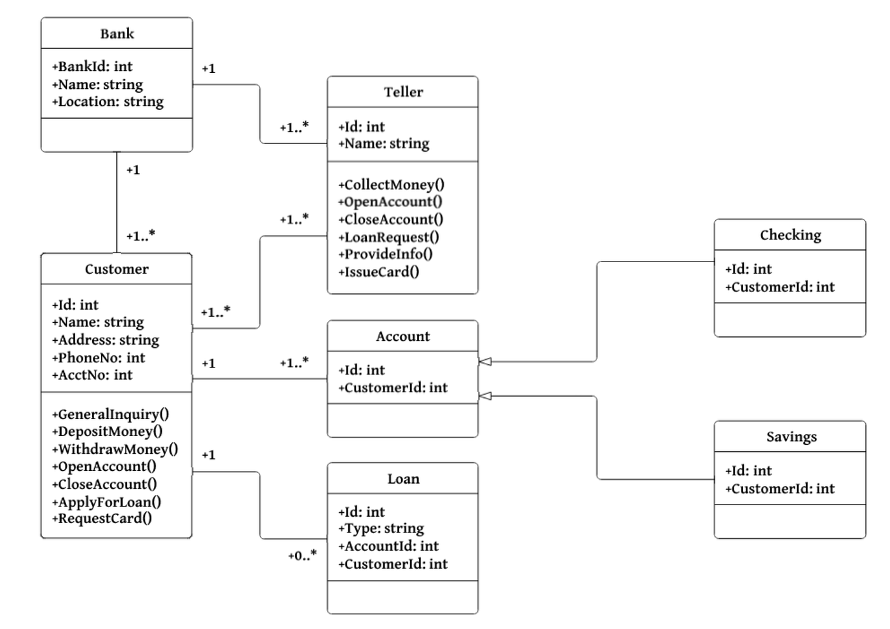

Why we use Class Diagram:
- To understand system structure
- To design classes before coding
- To show inheritance, aggregation, association

🔵 Slide 5: Component Diagram
Line:
“Component diagrams show dependencies among software components.”
Explanation:
- A component is a large software unit
- Example:
  - Library
  - Module
  - Executable file
Component diagram shows:
- Which component depends on which
- How parts are connected at high level
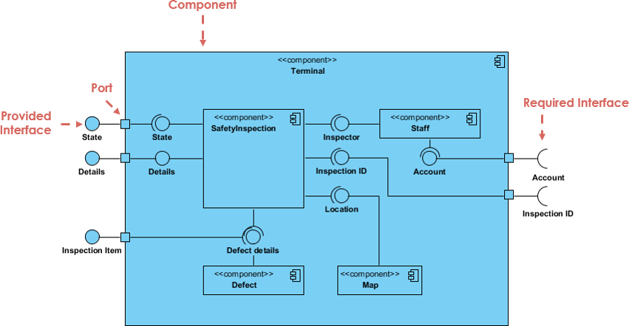
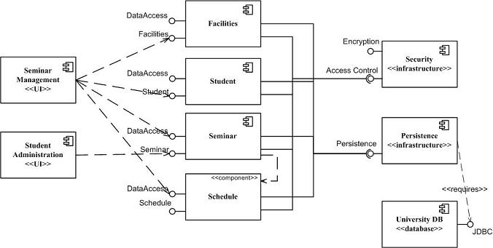

When to use:
- Large systems
- Deployment planning
- Architecture level design

🔵 Slide 6: Deployment Diagram
Line:
“Deployment diagram depicts the run-time configuration of hardware and software.”
Explanation:
Deployment diagram shows:
- Hardware (servers, computers)
- Software running on them
- Network connections
Example:
- Web server
- Database server
- Client machine
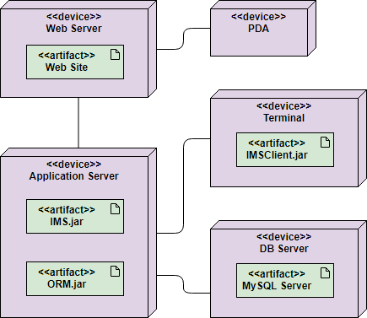
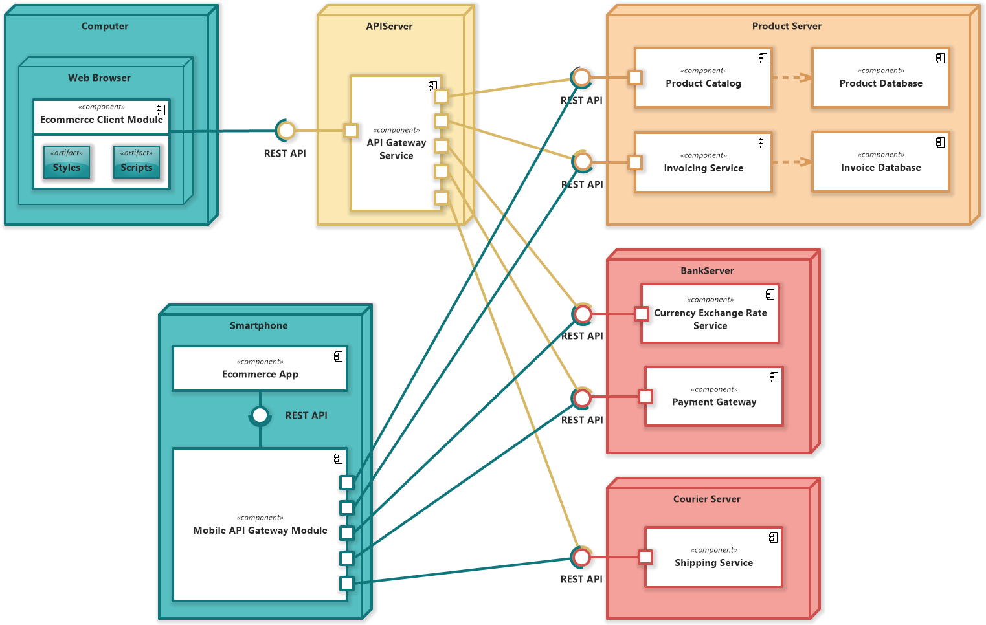

Why important:
- Shows where software will run
- Helps with performance and security decisions

🔵 Slide 7: Object Diagram
Line:
“Object diagrams show instances instead of classes.”
Explanation:
- Class diagram → blueprint
- Object diagram → real snapshot
Example:
- Class: Account
- Object: Account1 (balance = 5000)
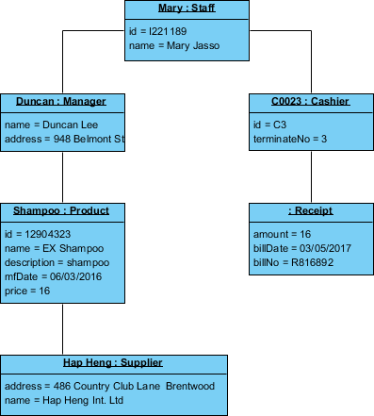
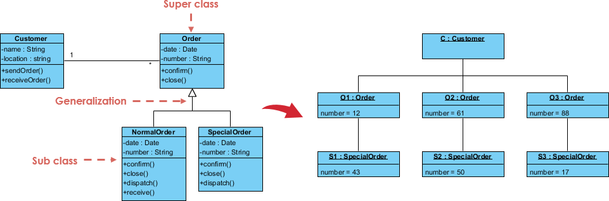

When to use:
- To understand relationships clearly
- To explain examples

🔵 Slide 8: Package Diagram
Line:
“Package diagrams group classes into packages.”
Explanation:
- Package = folder of related classes
- Helps manage large systems
Example:
- banking.accounts
- banking.customers
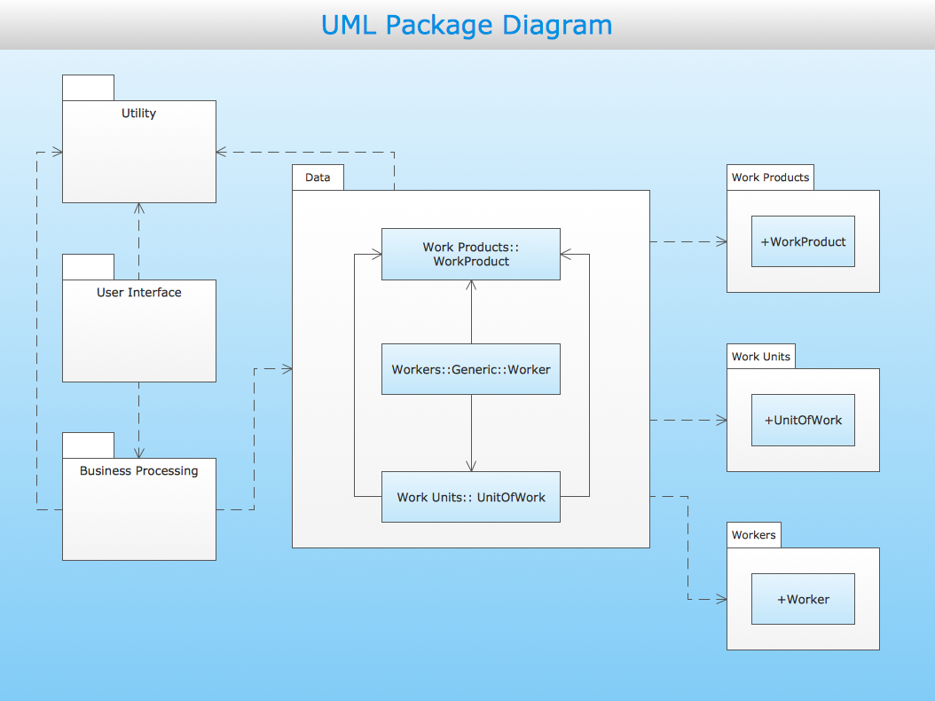
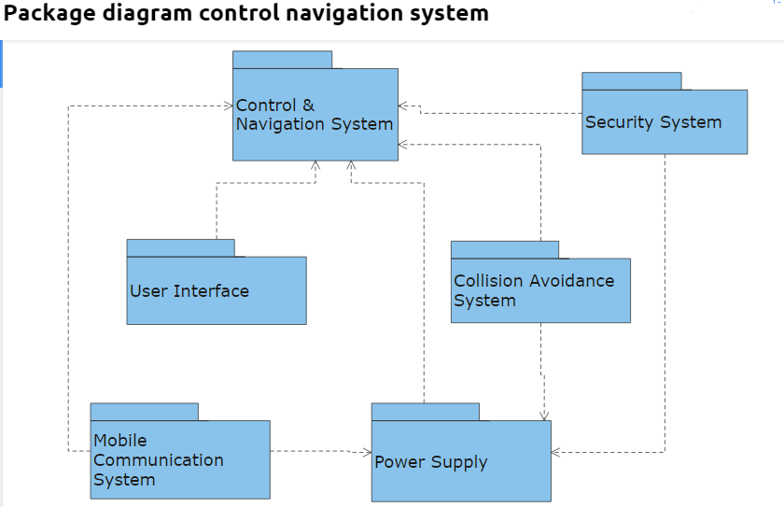

Why useful:
- Simplifies complex designs
- Improves modularization

🔵 Slide 9: Composite Structure Diagram
Line:
“Composite structure diagrams show internal structure of a class.”
Explanation:
- Shows:
  - Parts inside a class
  - How they interact
Used when:
- Class has complex internal structure
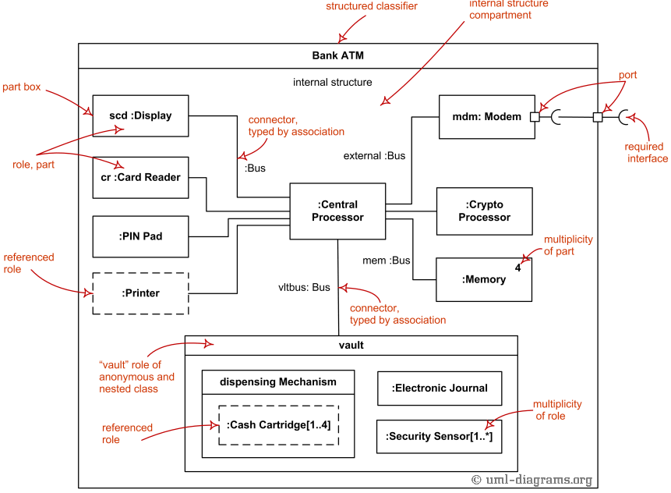
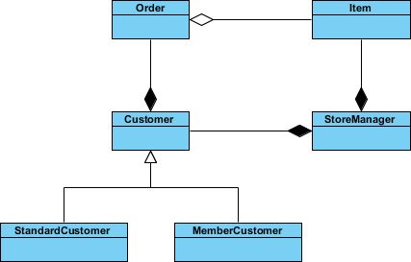

🔵 Slide 10: Behavioral Diagrams (Overview)
What do behavioral diagrams show?
They show:
- What the system does
- How it behaves
- How it reacts to events

Behavioral diagrams include:
- Use Case
- Activity
- State Machine

🔵 Slide 11: Use Case Diagram
Line:
“Use case diagrams describe system behavior from user’s perspective.”
Explanation:
Use Case Diagram shows:
- Actors (users)
- Use cases (actions)
Example:
- Actor: Customer
- Use case: Withdraw Money
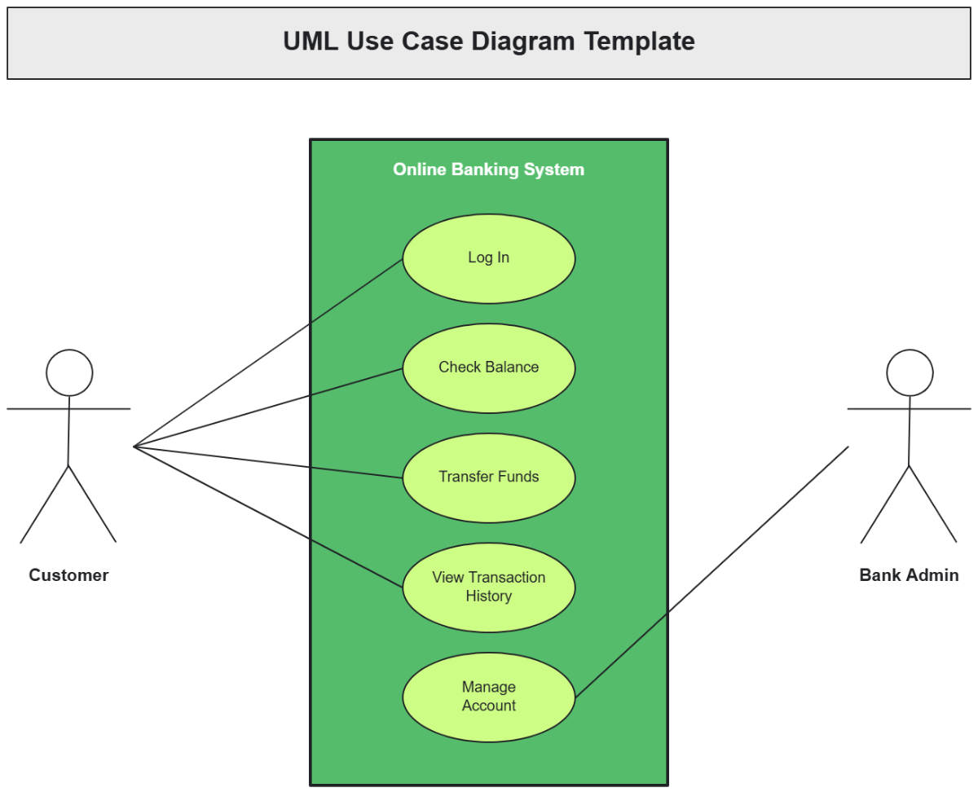
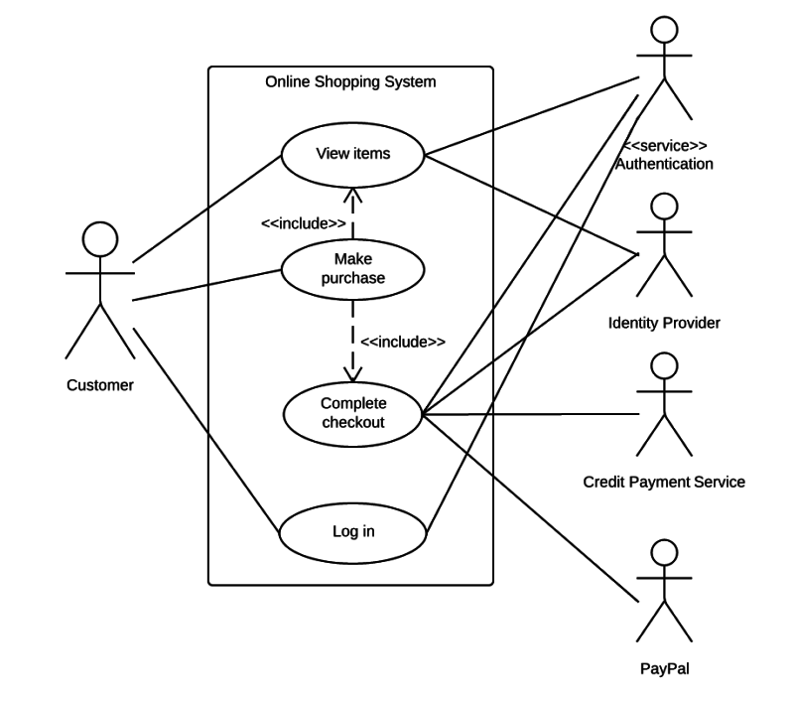

Why important:
- Helps gather requirements
- Easy for non-technical users

🔵 Slide 12: Activity Diagram
Line:
“Activity diagrams describe flow of control.”
Explanation:
- Similar to flowcharts
- Shows steps, decisions, loops
Used for:
- Business processes
- Complex methods
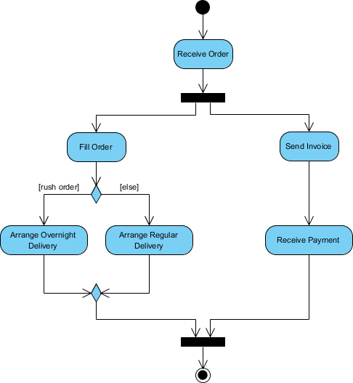
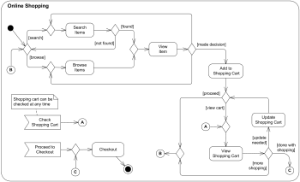

🔵 Slide 13: State Machine Diagram
Line:
“State machine diagrams show states and transitions.”
Explanation:
- Object changes state over time
- Diagram shows:
  - States
  - Events
  - Transitions
Example:
- Account states:
  - Open
  - Closed
  - Suspended
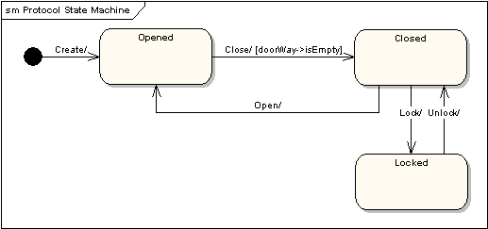
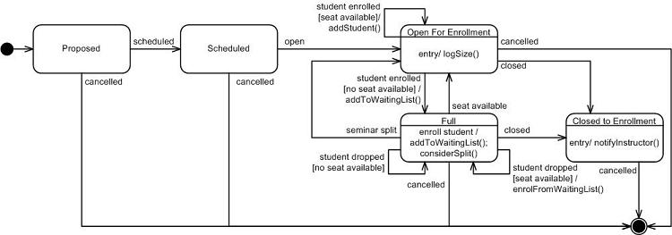

🔵 Slide 14: Interaction Diagrams (Overview)
Interaction diagrams show:
- How objects communicate
- Message passing
Types:
- Sequence
- Communication
- Timing
- Interaction Overview

🔵 Slide 15: Sequence Diagram
Line:
“Sequence diagrams show object interaction over time.”
Explanation:
- Shows:
  - Objects
  - Messages
  - Order of calls
Time flows top to bottom
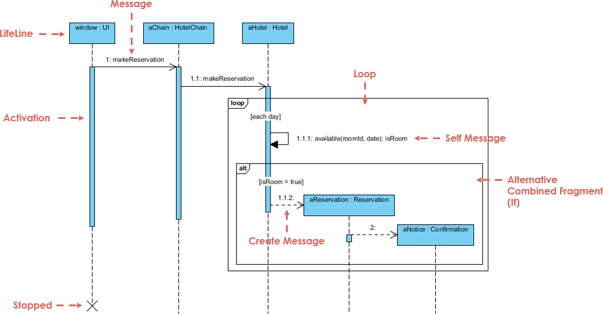
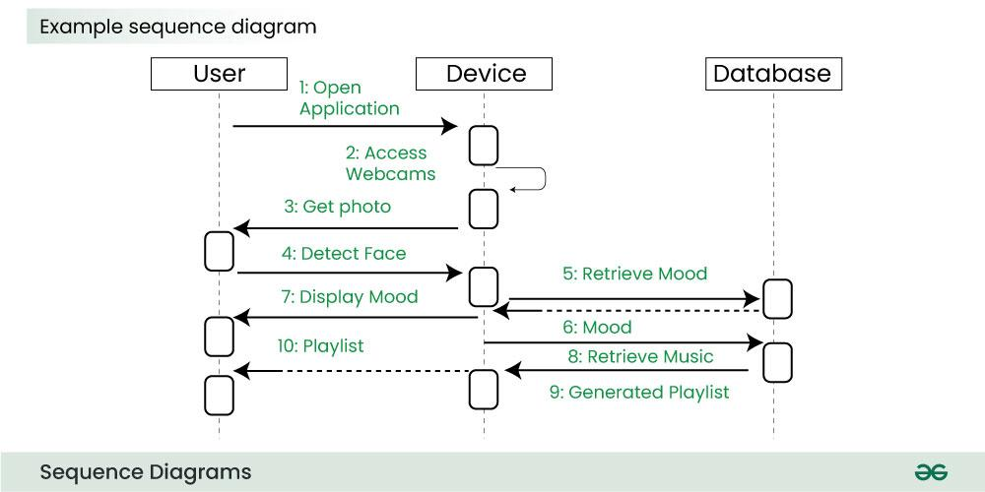

When to use:
- To explain scenarios
- To understand method calls

🔵 Slide 16: Communication Diagram
Line:
“Focuses on collaboration rather than time.”
Explanation:
- Shows objects and their links
- Shows messages with numbers
Difference:
- Sequence → time order
- Communication → object relationships
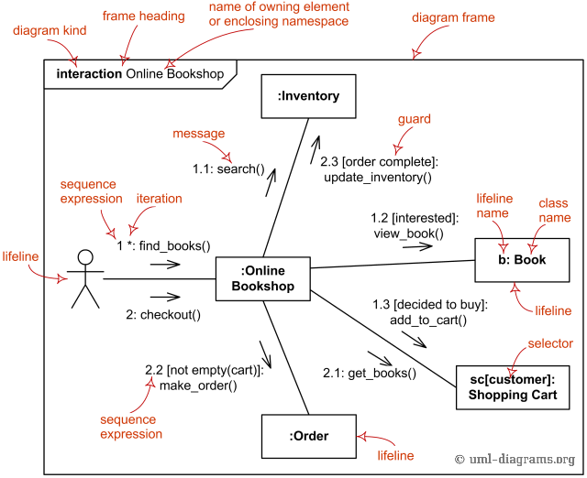
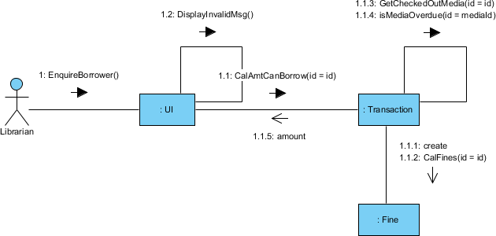

🔵 Slide 17: Timing Diagram
Line:
“Shows behavior over a given time period.”
Explanation:
- Time flows left to right
- Used in real-time systems
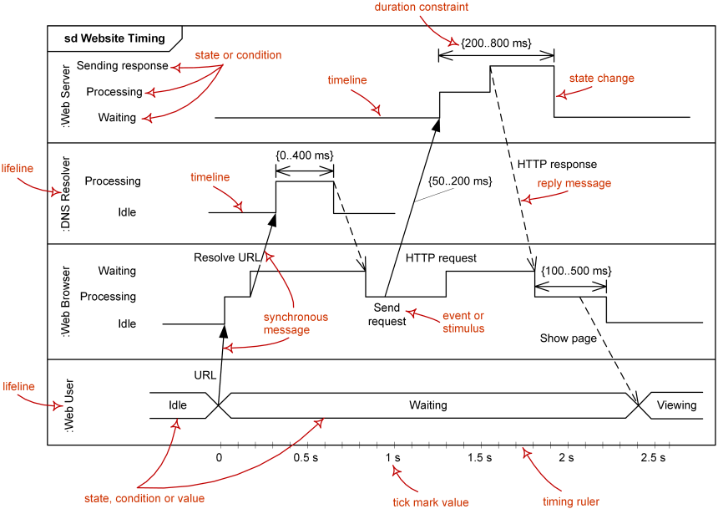
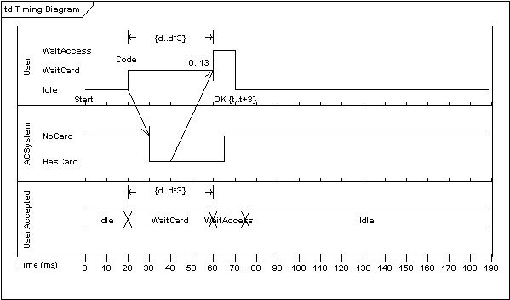

🔵 Slide 18: Interaction Overview Diagram
Line:
“Overview of control flow between interactions.”
Explanation:
- Mix of:
  - Activity diagram
  - Sequence diagram
Used for:
- High-level interaction flow
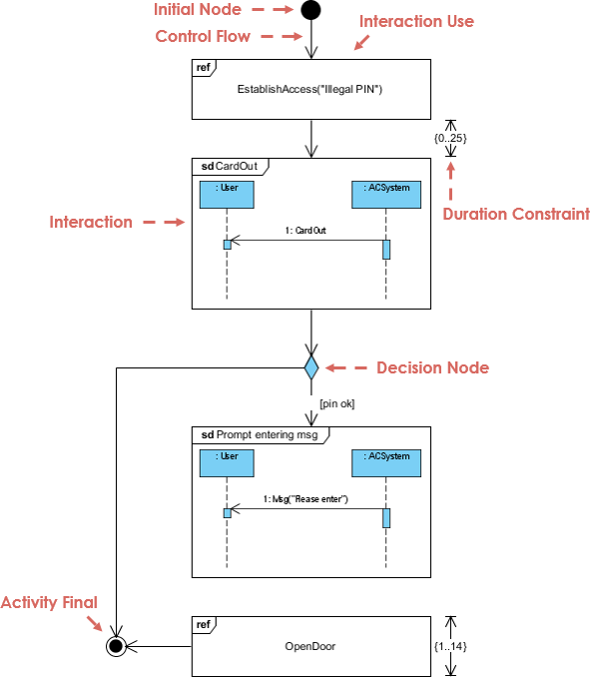
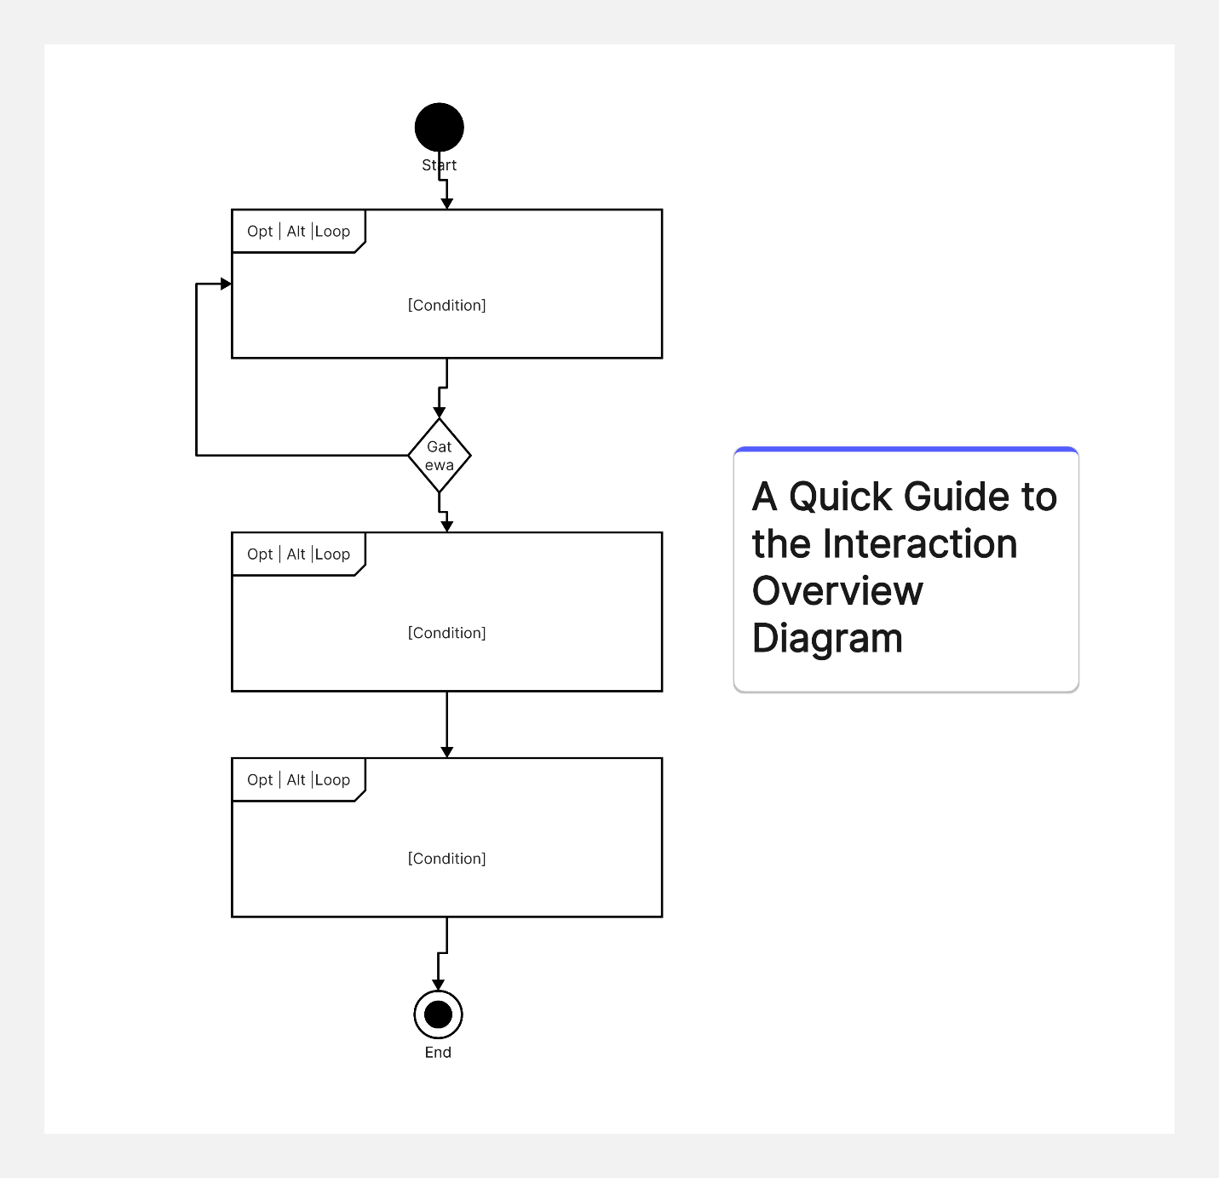

🔵 Slide 19: UML Diagram Hierarchy
Explanation:
- Shows how all UML diagrams are related
- Helps choose correct diagram

🔵 Slide 20: Chapter Summary
Final teaching points:
✔ UML is a visual modeling language
✔ Helps in communication and design validation
✔ Three categories:
- Structural
- Behavioral
- Interaction
✔ Different diagrams serve different purposes

