Introduction to Linux
=>Developed by Linus Torvalds in 1991, a 21 year old student.
*Freely distributed Operating System that manages
=>Manages hardware resources (HDD, I/O Devices and Memory etc .. )
=>Provides common services for efficient execution to various application software
=>Unlike other OS, it is released for free on the Internet under GNU (GNU's Not Unix) Project's GPL (General Public License).
=>Linux is a free source of operating system. When it comes to windows it should get paid
=>Linux finds its application in Computer hardware, Phones, Tablets, Cars, Games and many other gadgets.
=>Linux is available in many distributions- popular ones are Ubuntu, Fedora etc.
=>In Linux we can have source code which means we’ll be able to make changes to OS as how it can be suits for user description which cannot be done it with windows for free.
Operating System
An operating system is system software that manages computer hardware and software resources, and provides common services for applications.
It acts as a bridge between the user and the hardware. For example, it handles process scheduling, memory allocation, file management, and device control.
Popular operating systems include Windows, Linux, and macOS.
Kernal
The Linux kernel is the core part of the Linux operating system. It directly interacts with hardware and manages system resources like memory, CPU, and devices. It acts as a bridge between applications and the physical components of the computer.

Features of Linux
=>Multi user and Multi tasking =>Multi Processor
=>Multi threading =>Highly Customizable & Flexible
=>Secure =>Network Friendly
=>Compatible =>Hierarchical File system

Linux Distributions
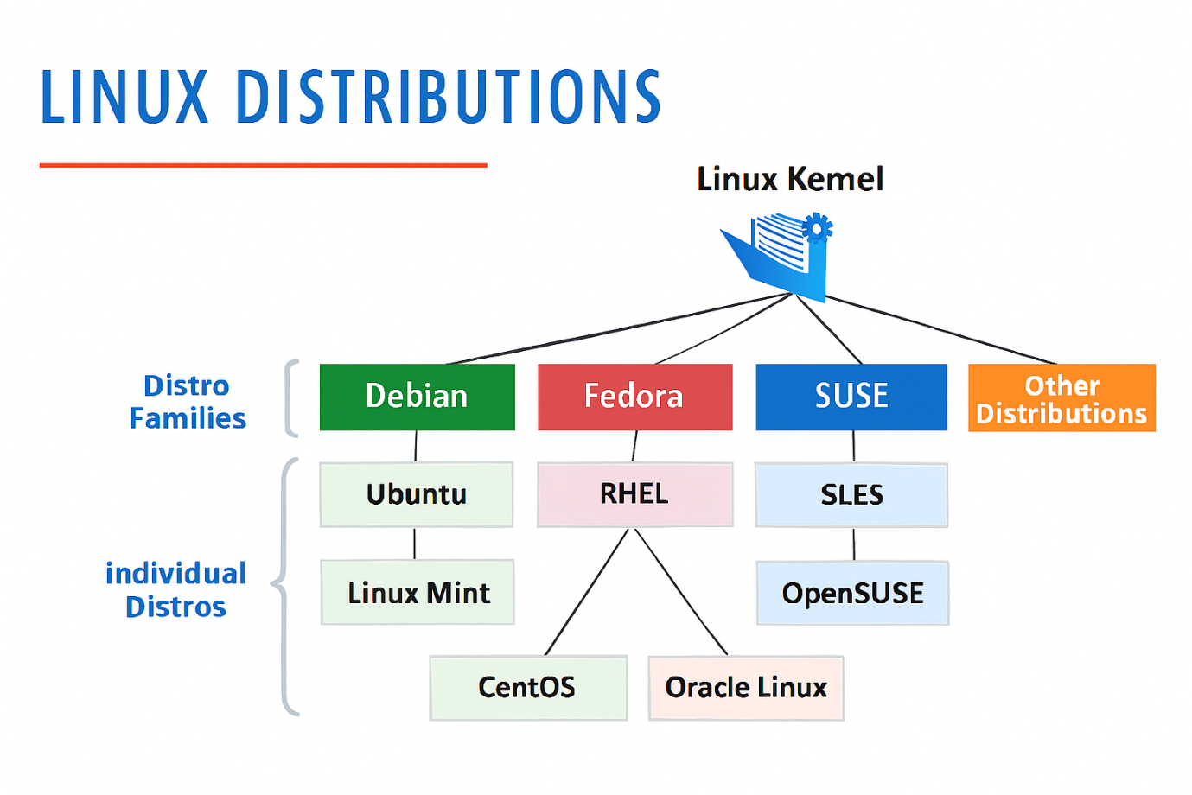
Desktop Virtualization
- VirtualBox is open-source software for virtualizinthe x86 computing architecture.
- It acts as a hypervisor, creating a VM (virtual machine)where the user can run another OS (operating system)
- Hypervisor is software which will create a virtual environment for creating virtual machine
- By using virtual box we can have more than a one virtual machine in a single laptop.
- Desktop virtualization is a technology that allows users to run a virtual version of a desktop operating system on any device, by separating the desktop environment from the physical hardware. It enables secure, flexible access to desktops from anywhere.
