**PROJECT 1:**

**Working with IAM Roles with S3 and bootstrapping with EC2**

**Task1 - Creating a bootstrapped instance:**

1. Edit user data

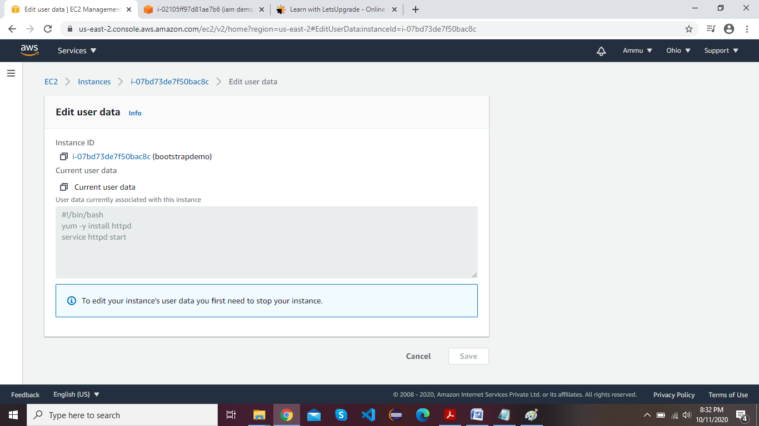

1. EC2 instance page with Details

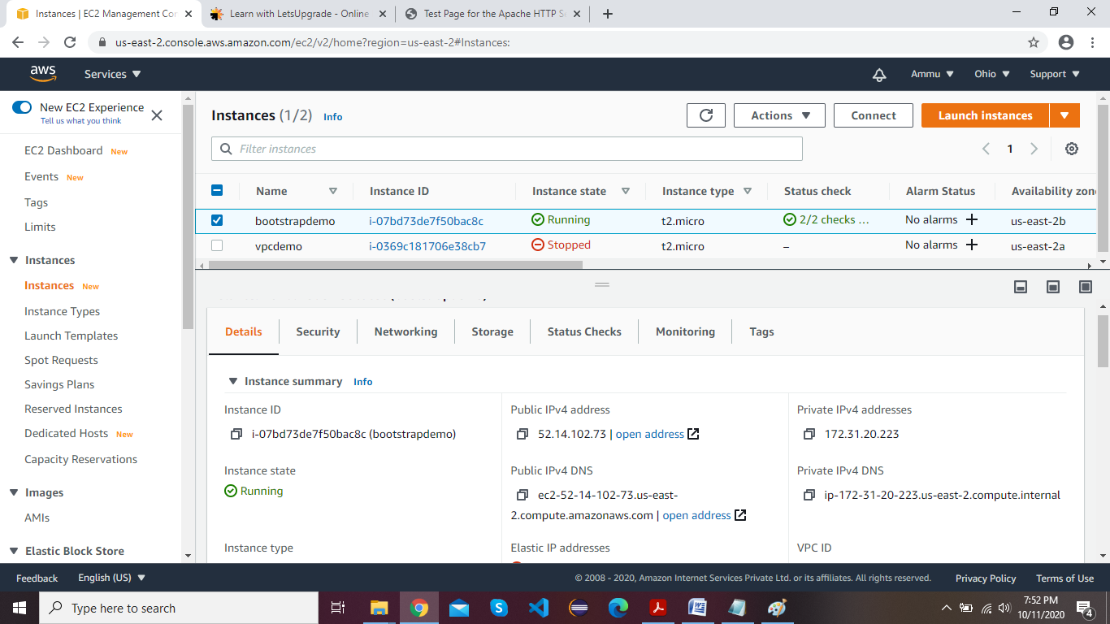

1. Test page (copy the ipv4 address and paste into browser)

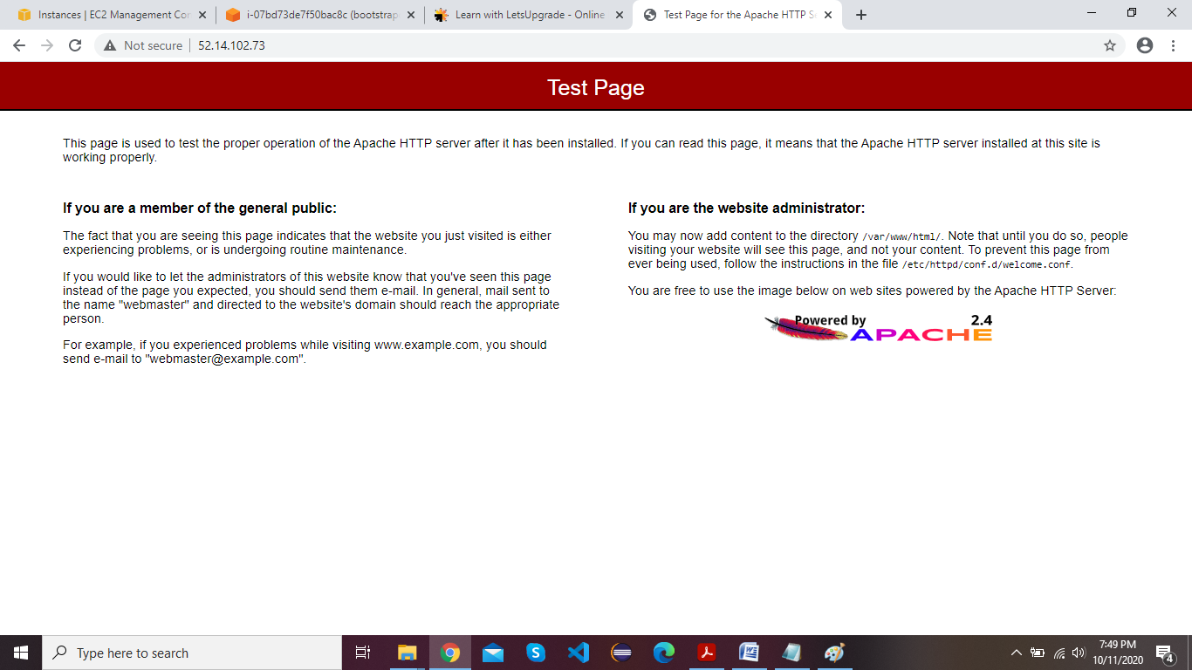

**Task 2 - Checking bucket list and creating a new bucket from EC2 using IAM Roles**

Linux instance and Details:

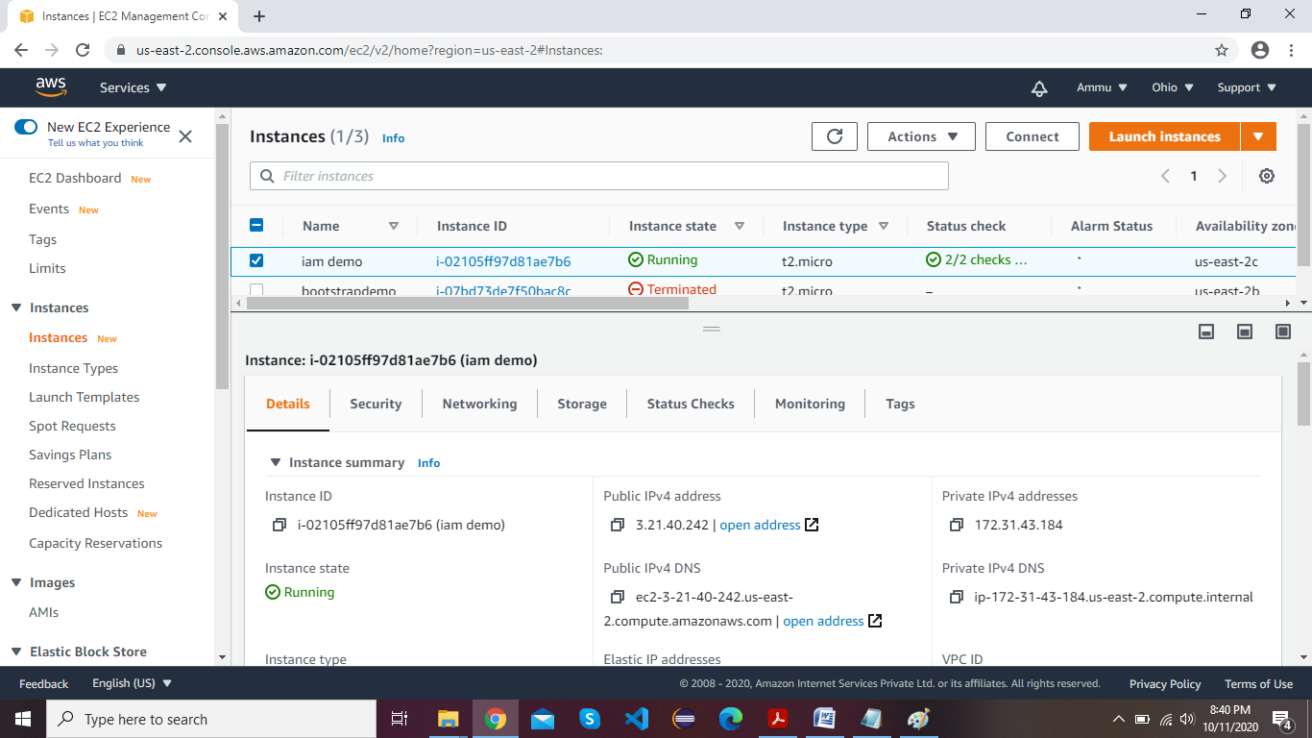

List Of Buckets: (By using Commands)

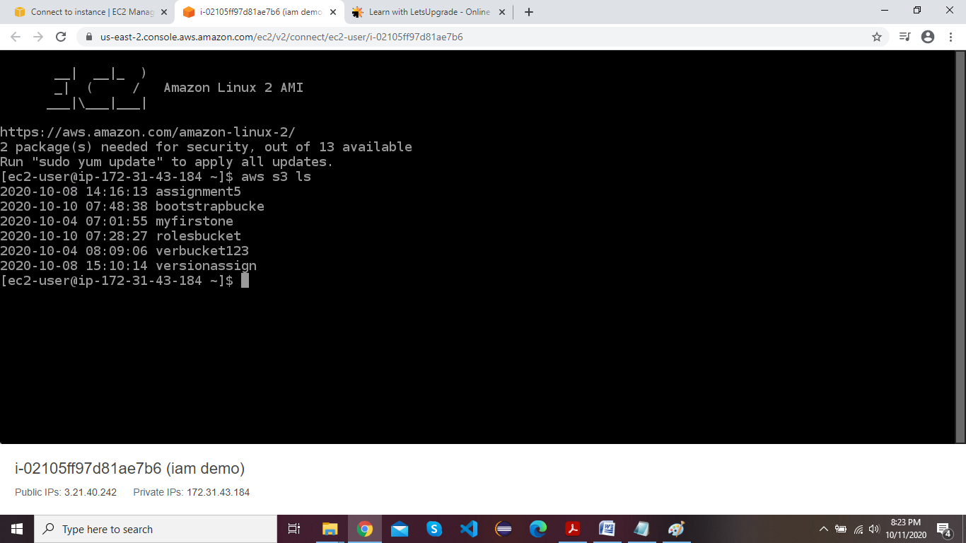

List Of Buckets in AWS Console:

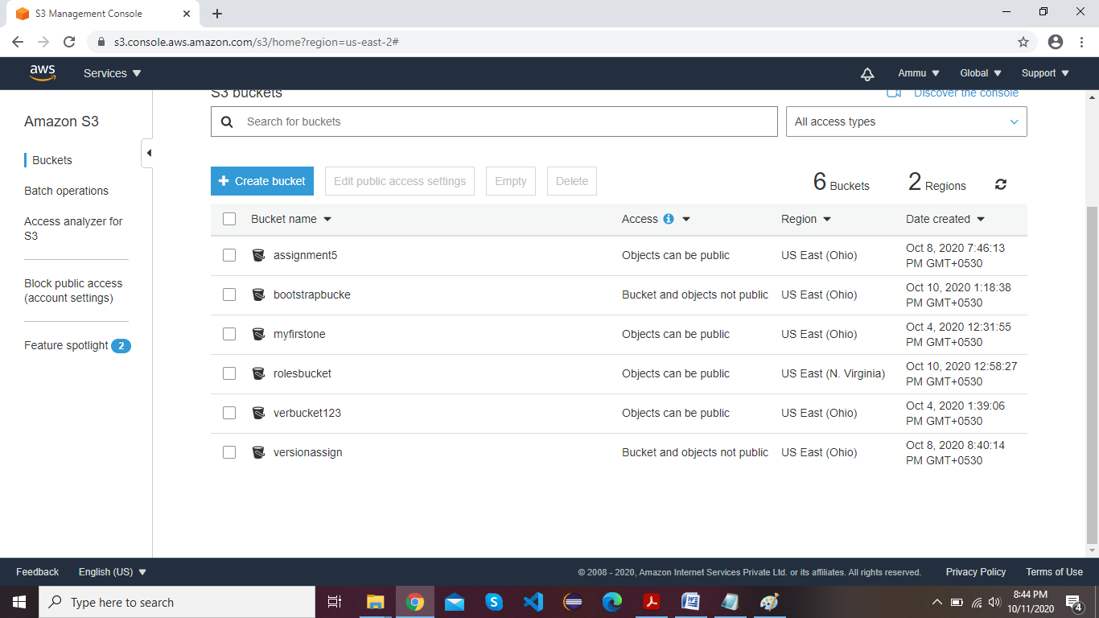

Creating bucket using Instance:

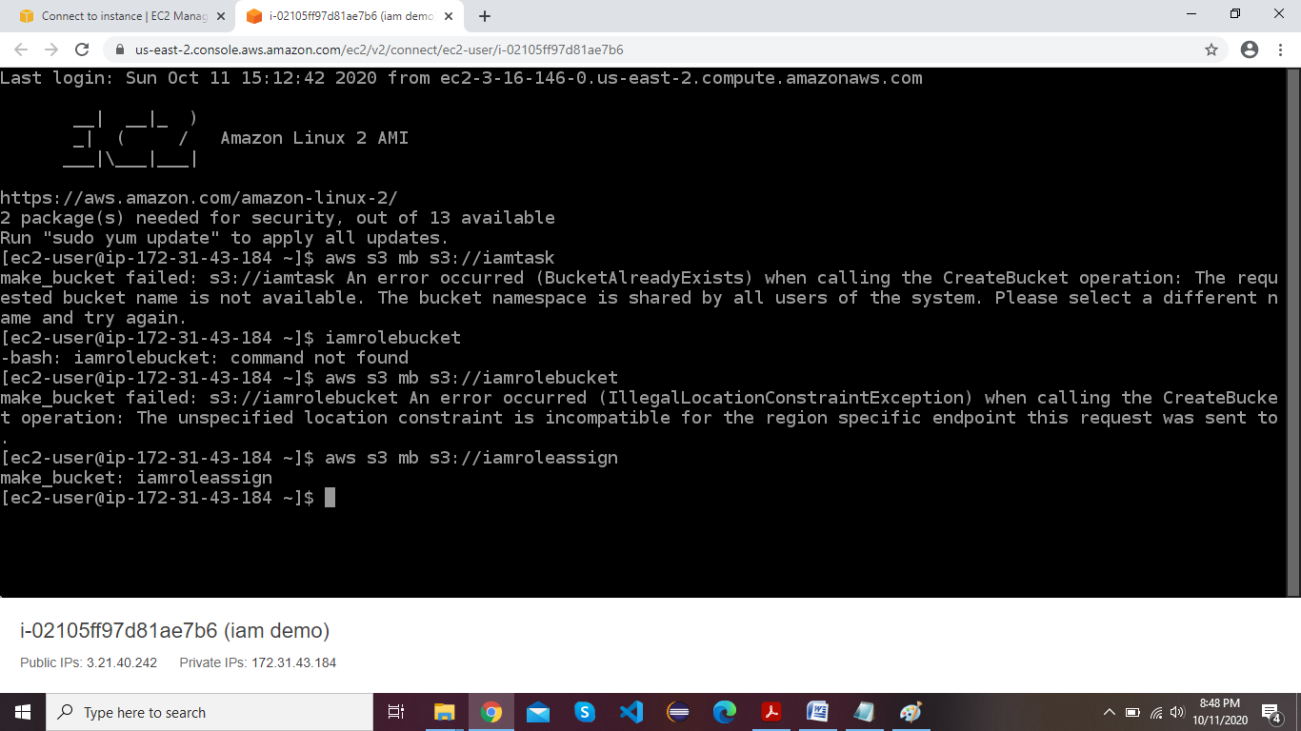

List of Buckets page after creating bucket using instance:

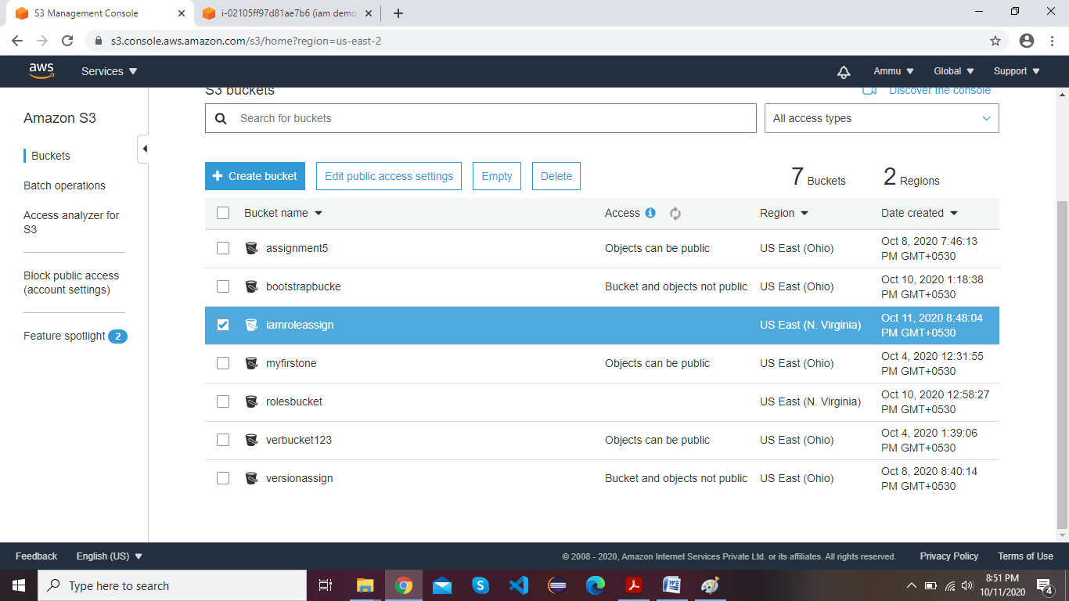

**Task 3:Hosting a webpage using the bootstrap script on ec2:**

User Data Page:

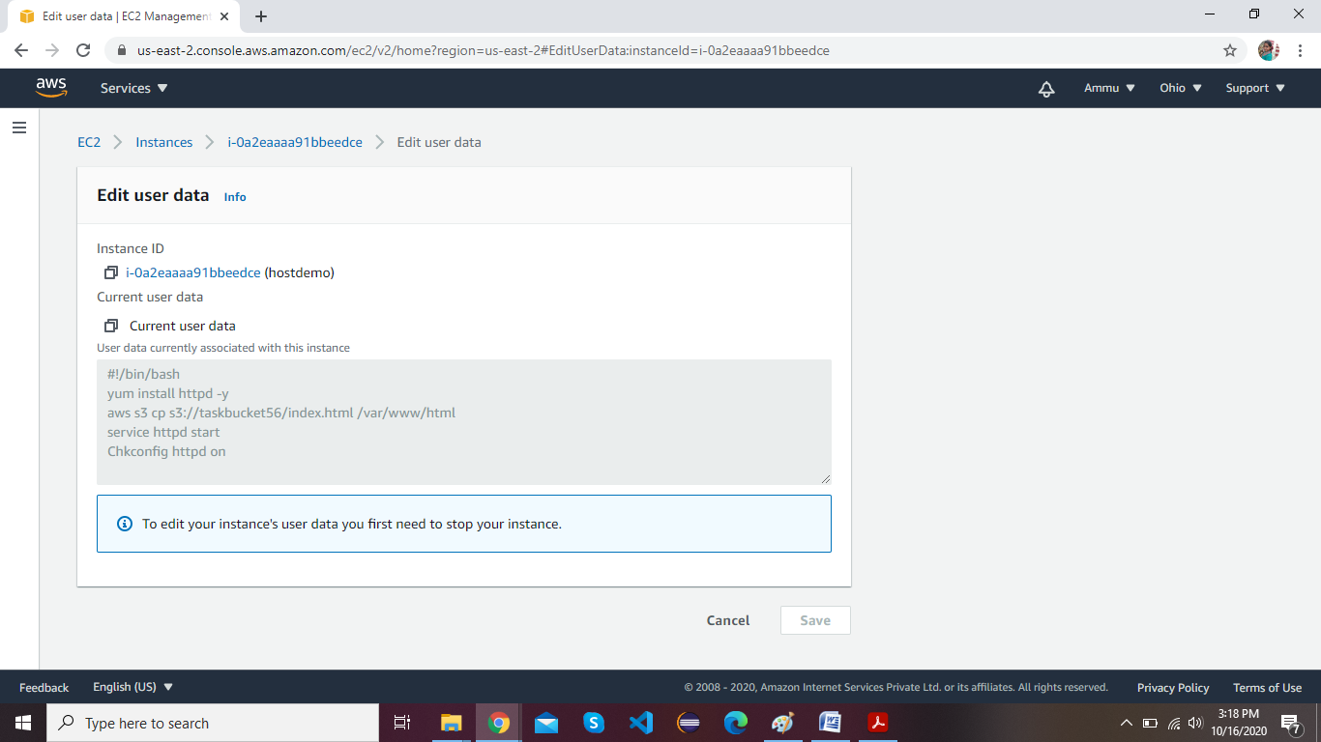

File uploaded in Bucket:

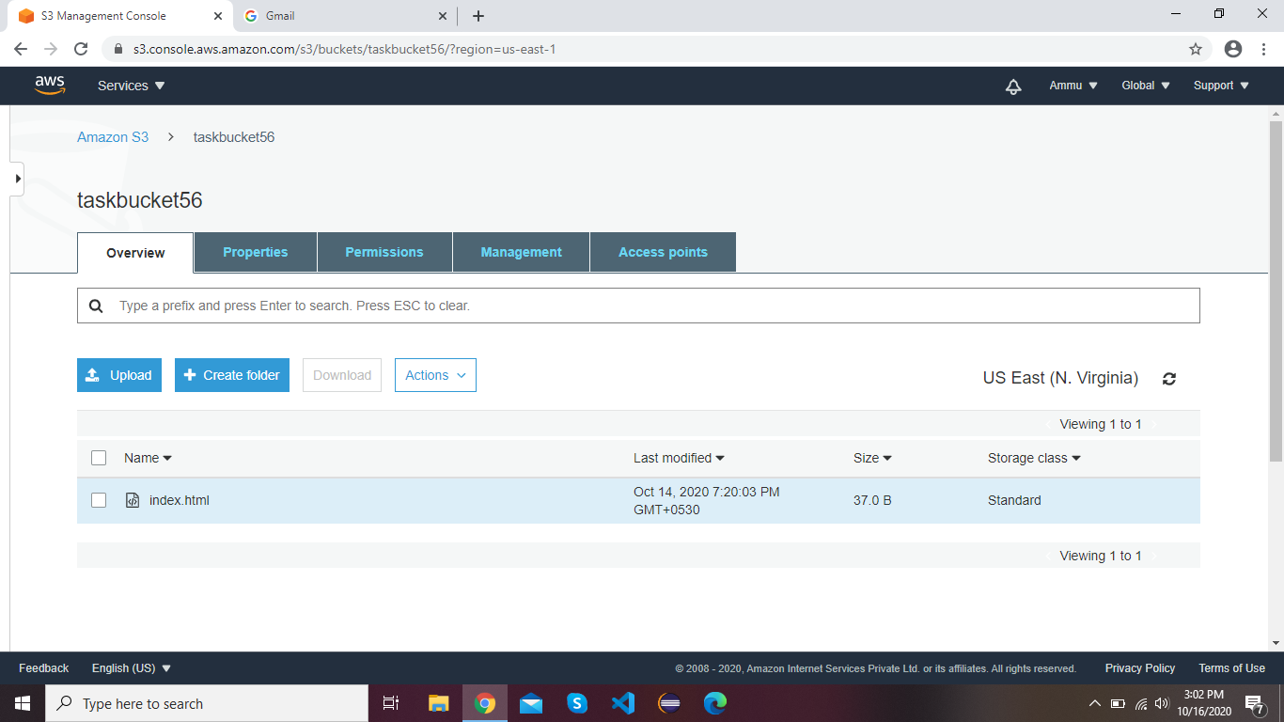

Console Page of Linux Instance:

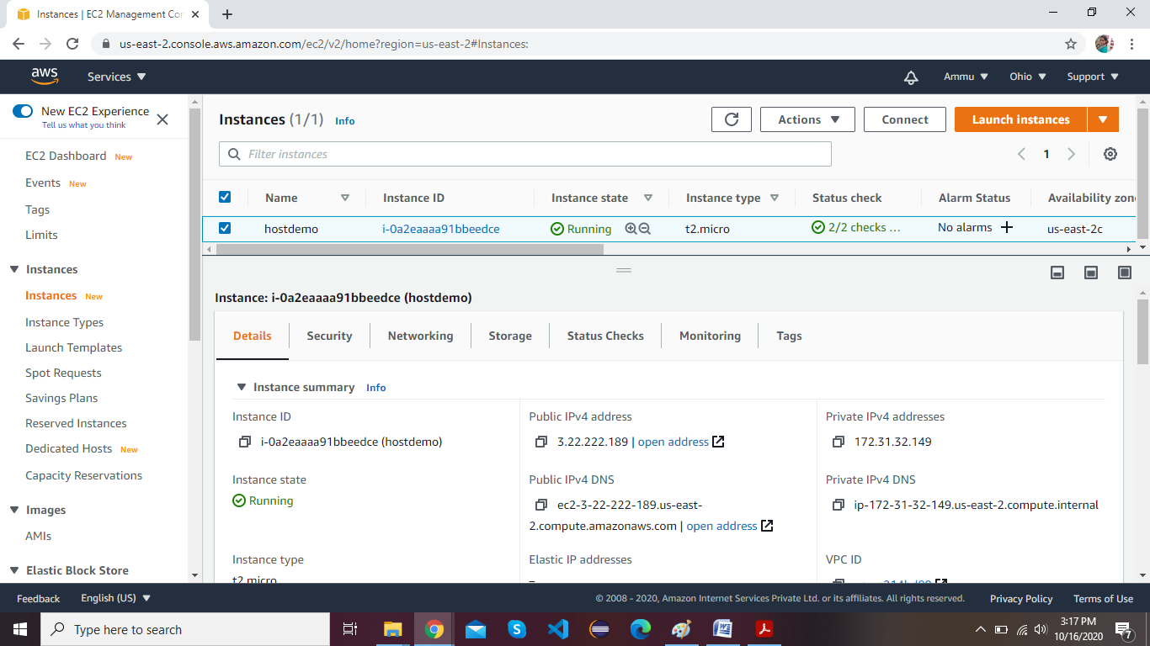

**PROJECT 2:**

**Creating an EC2 instance in custom VPC**

VPC Creation and Details Page:

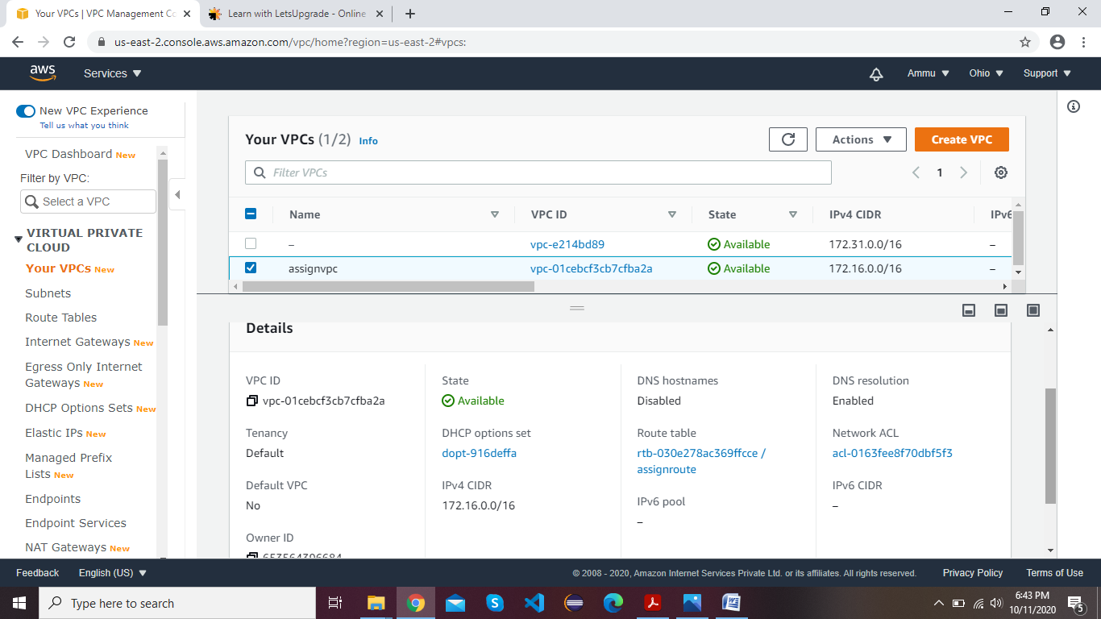

Gateway Creation and Attaching VPC to Gateway:

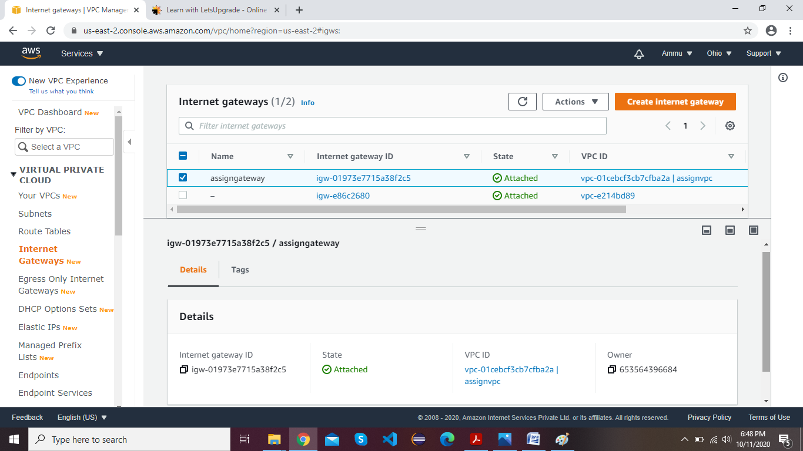

Creation of Route table and Summary Page:

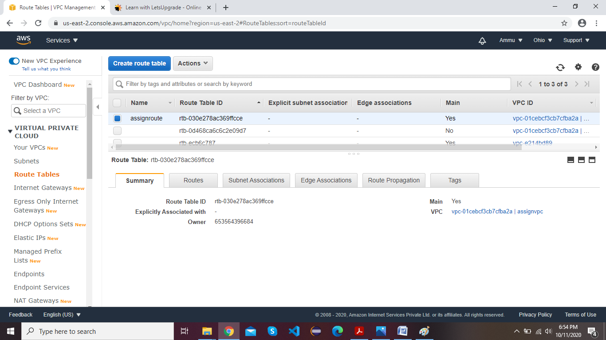

Creating Subnet and Description Page:

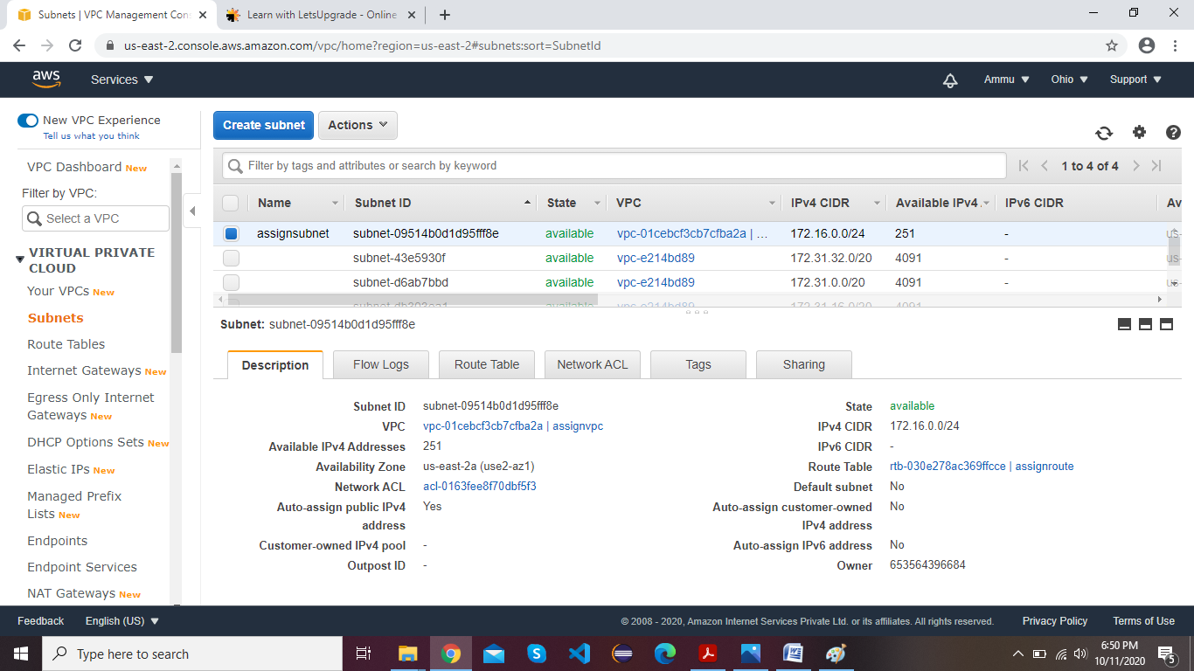

Creating EC2 Windows Instance:

1. Adding created VPC and Subnet

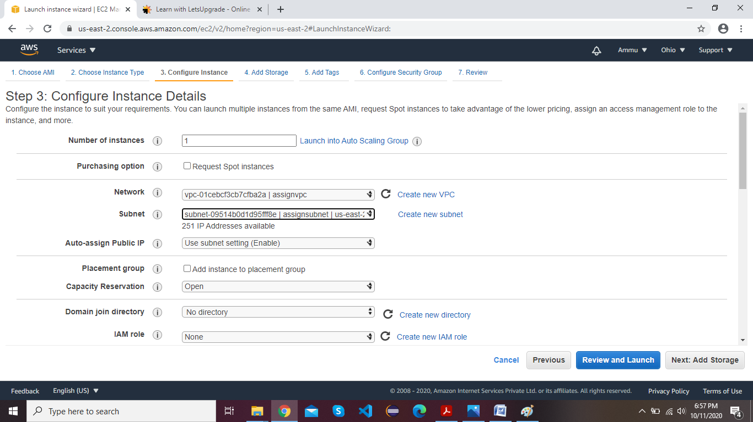

1. Ec2 instance page with Summary page

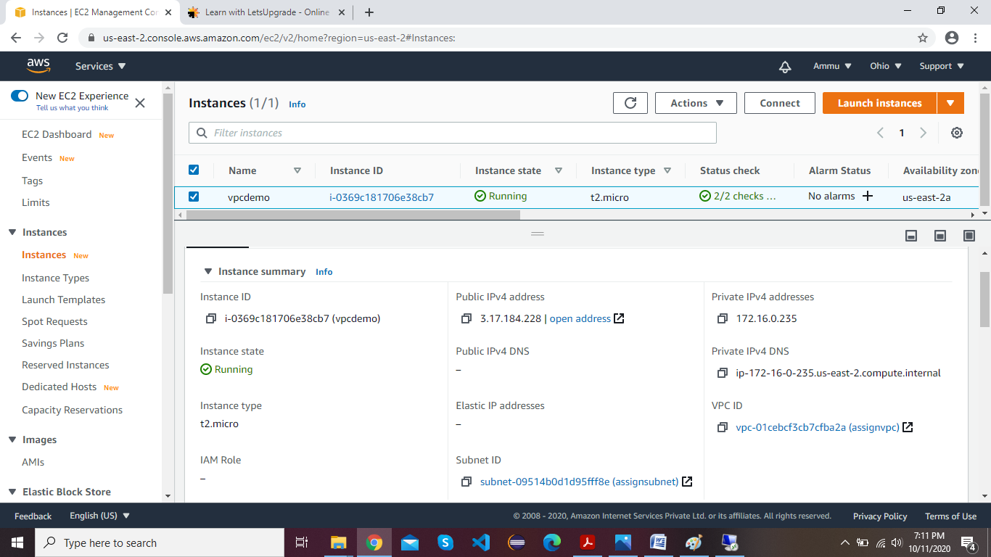

(c)RDP Launch Page

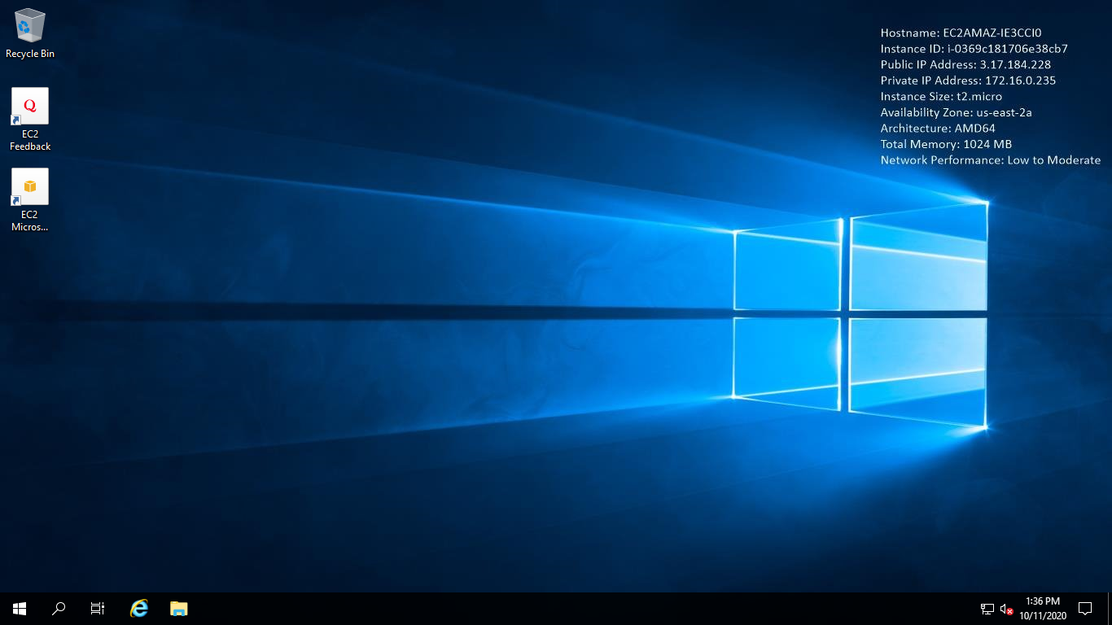

1. Ipconfig command

