**PROJECT 1:VPC peering**

VPC’s List:

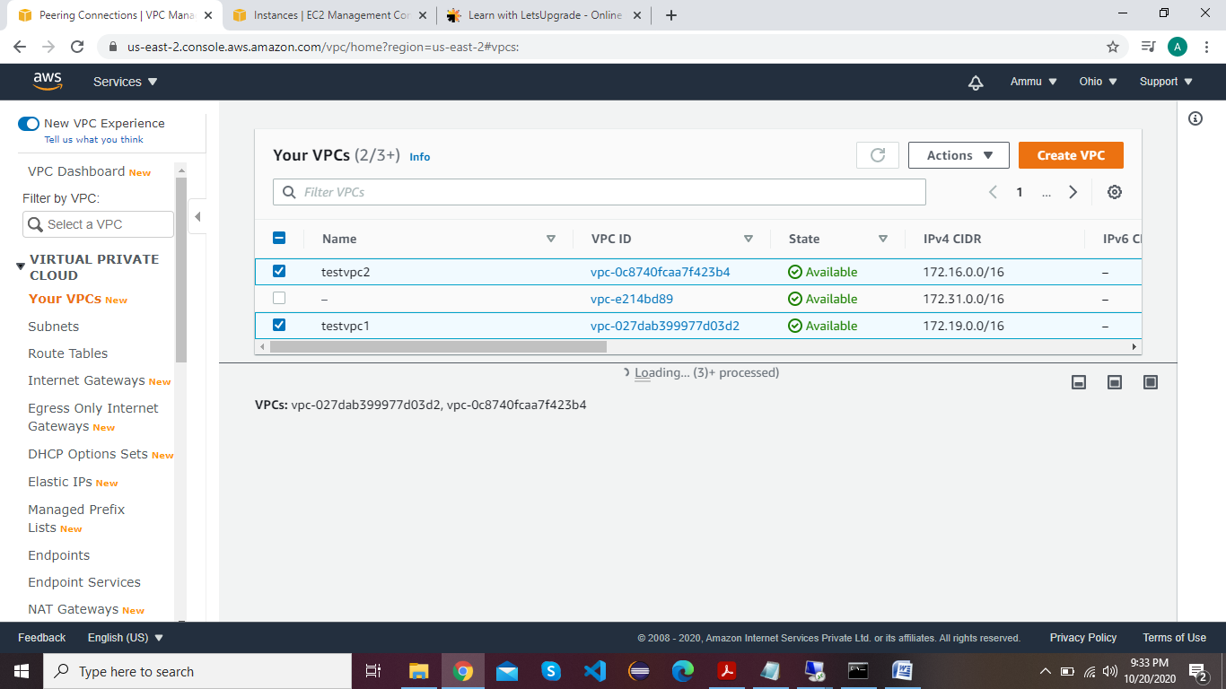

Internet Gateway’s and attached to VPC’s:

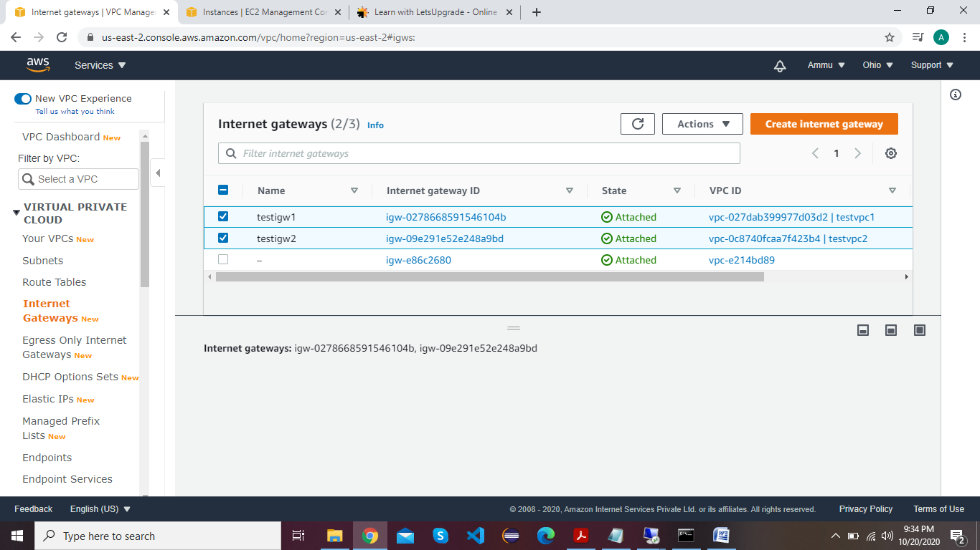

Route Tables List:

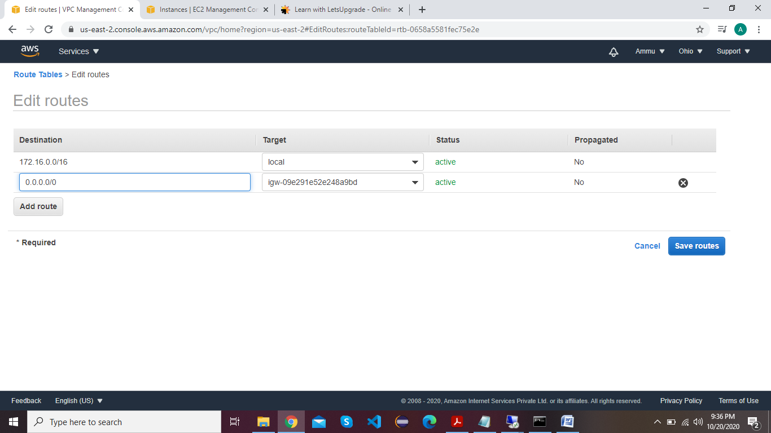

Subnets List:

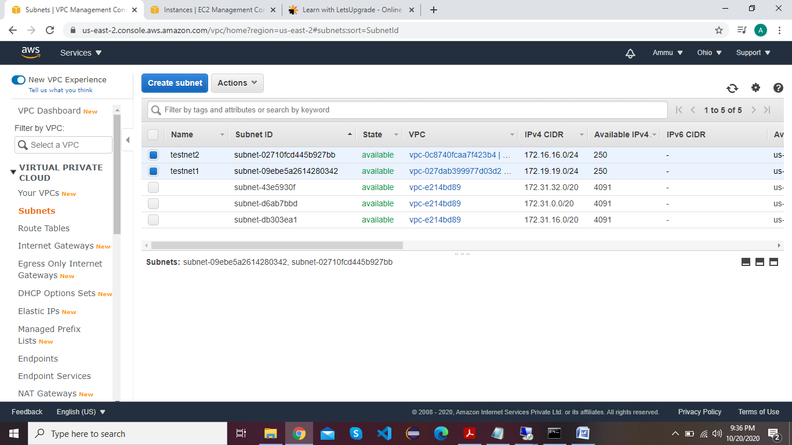

Instance Details :

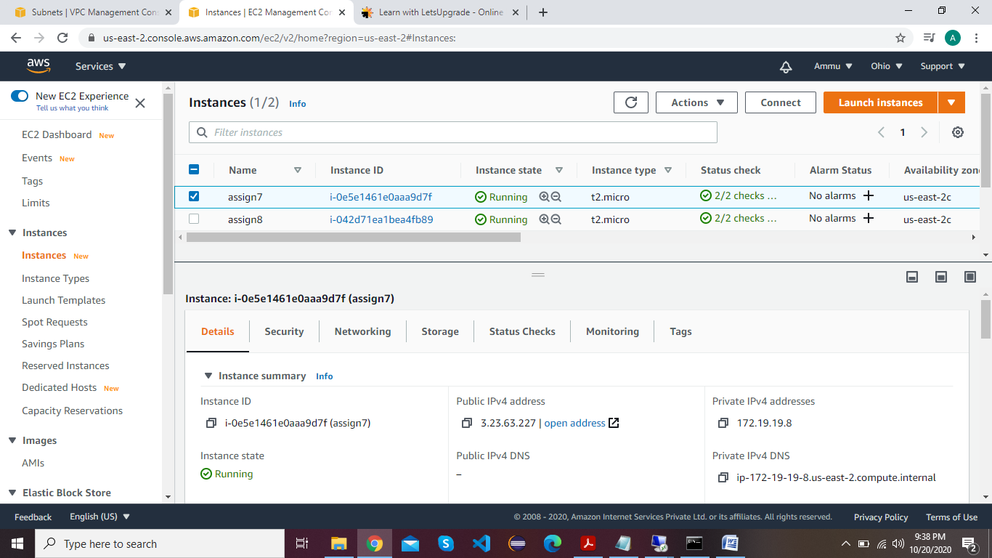

Public ip Success and Private ip Request time out:

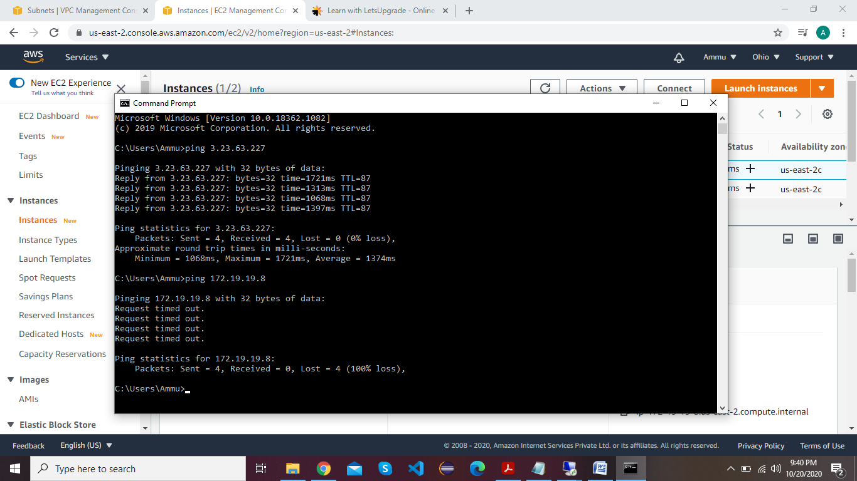

Peer Connection with Requestor & Acceptor:

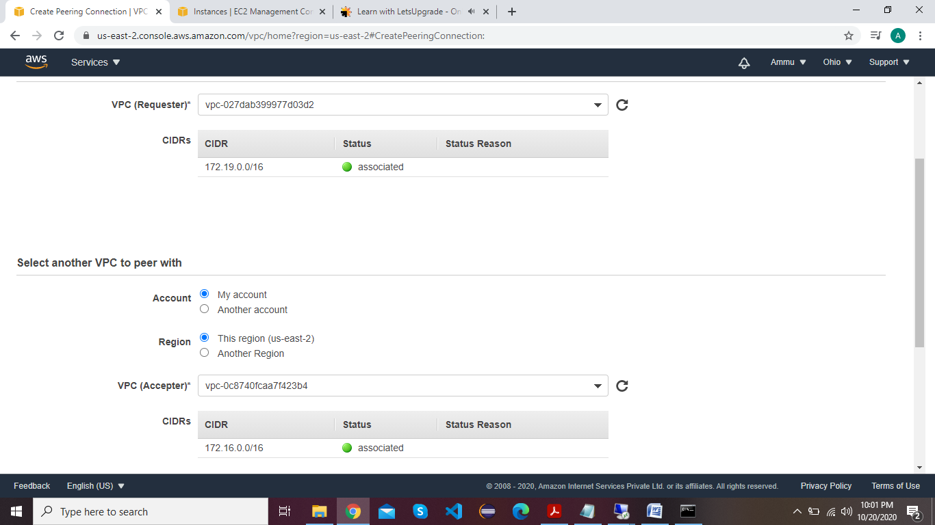

Success Private list:

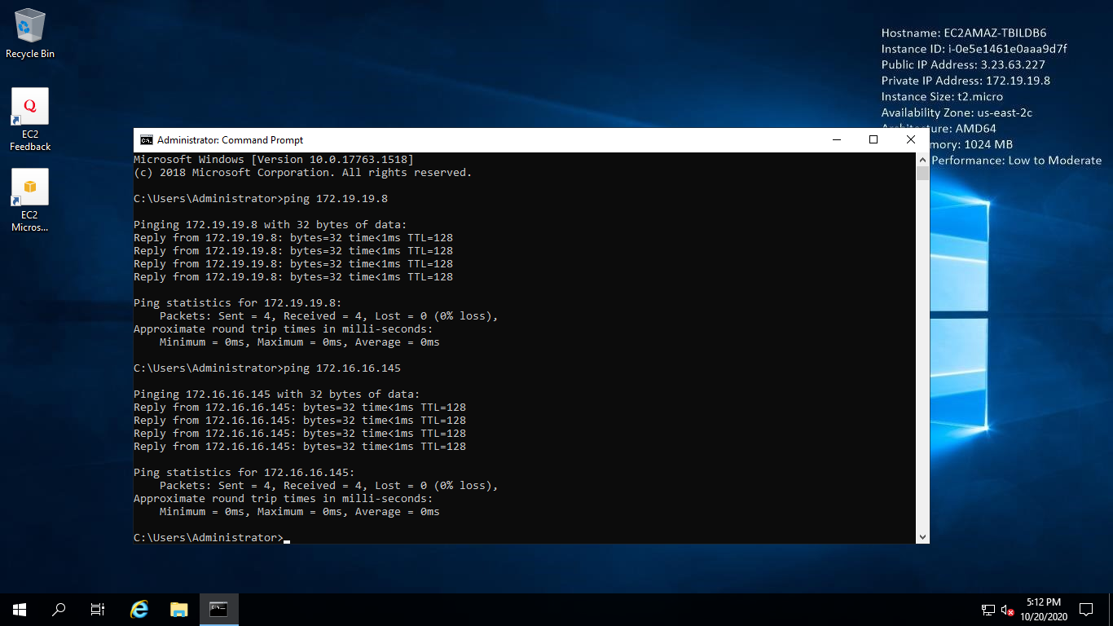

**Project 2 : IAM**

**Task 1:Creating users without permissions-IAM password policy check:**

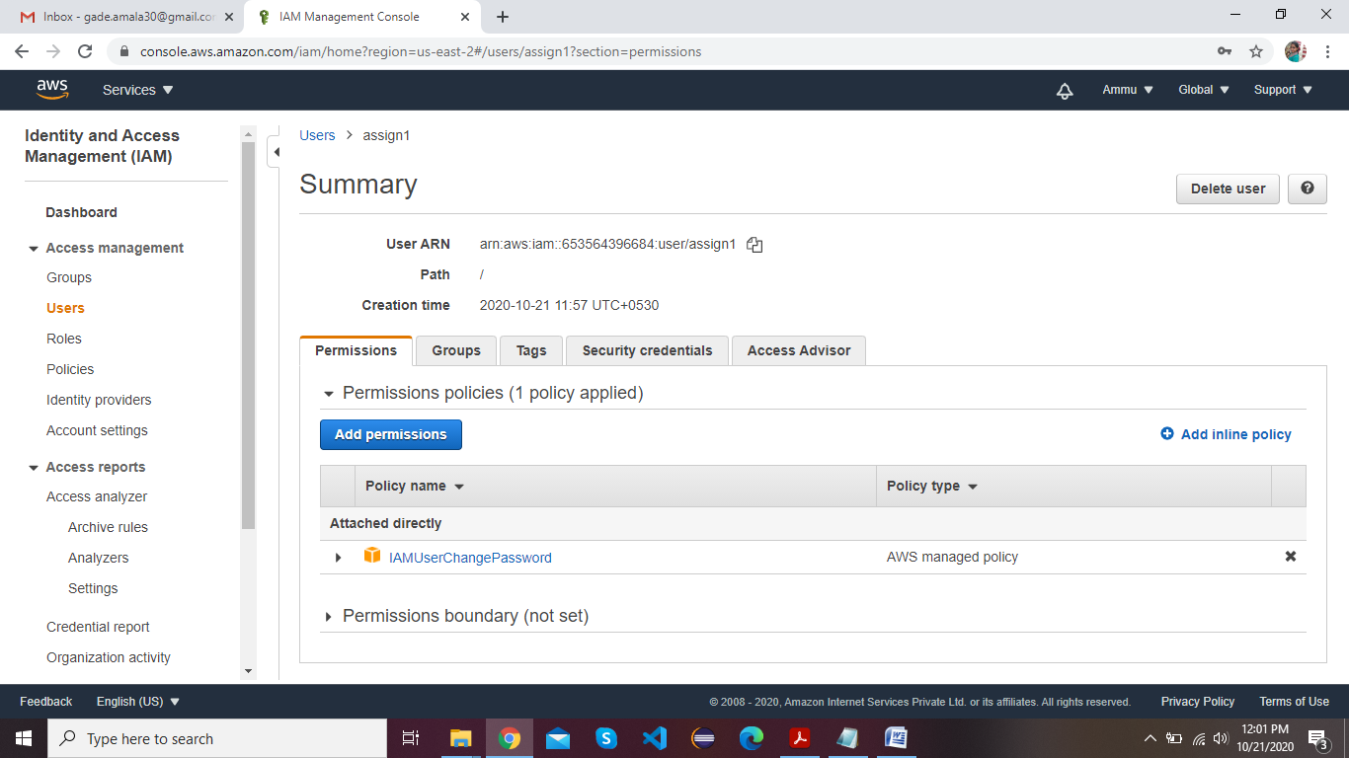

**Task 2:Creating users without the IAM password policy:**

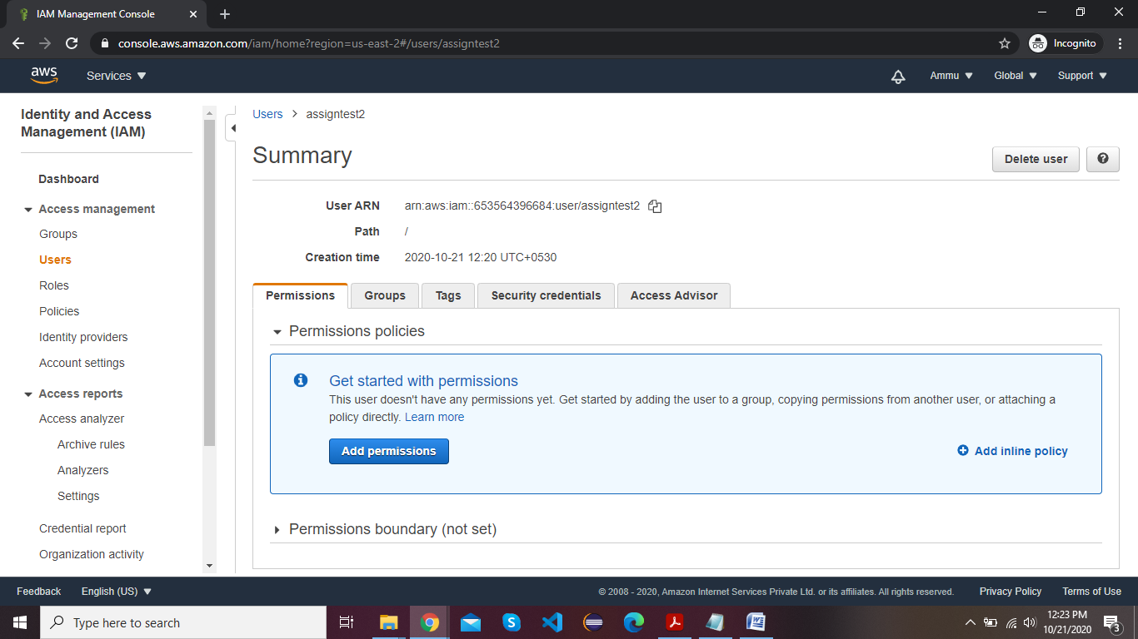

**Task 3:Create a user with S3 full access:**

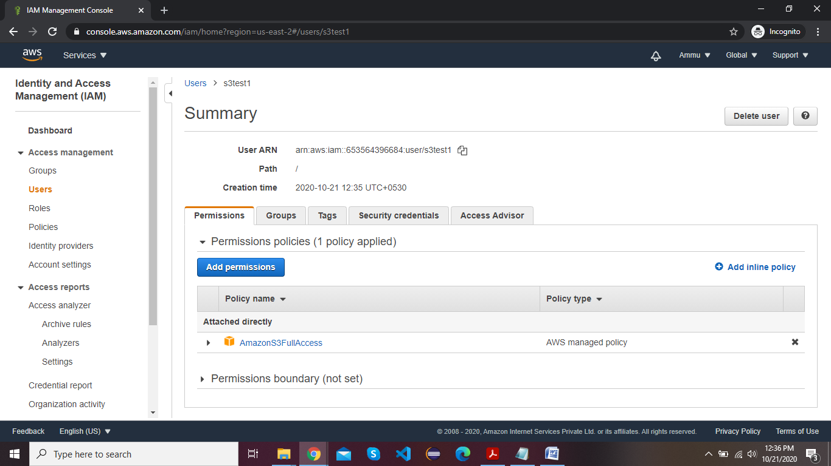

**Task4: Create a group with ec2 full access:**

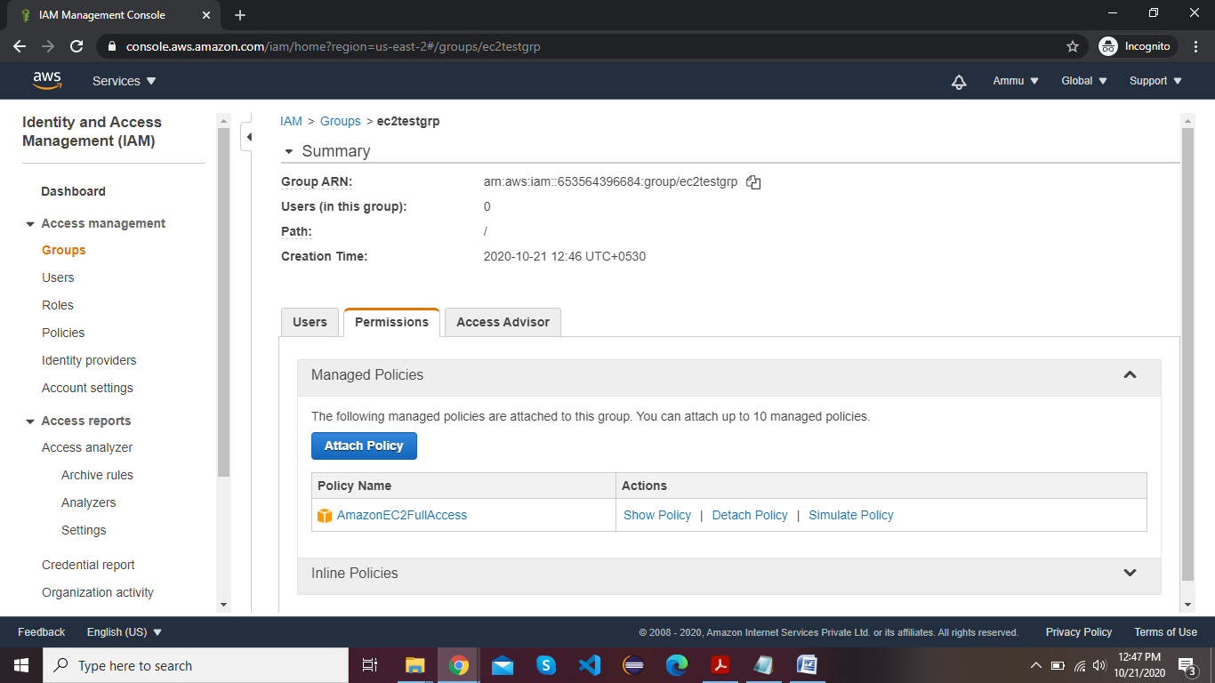

**Task 5:Add user to a group and check if user policy and the group policy is reflecting on the user:**

(a)User Summary with permission

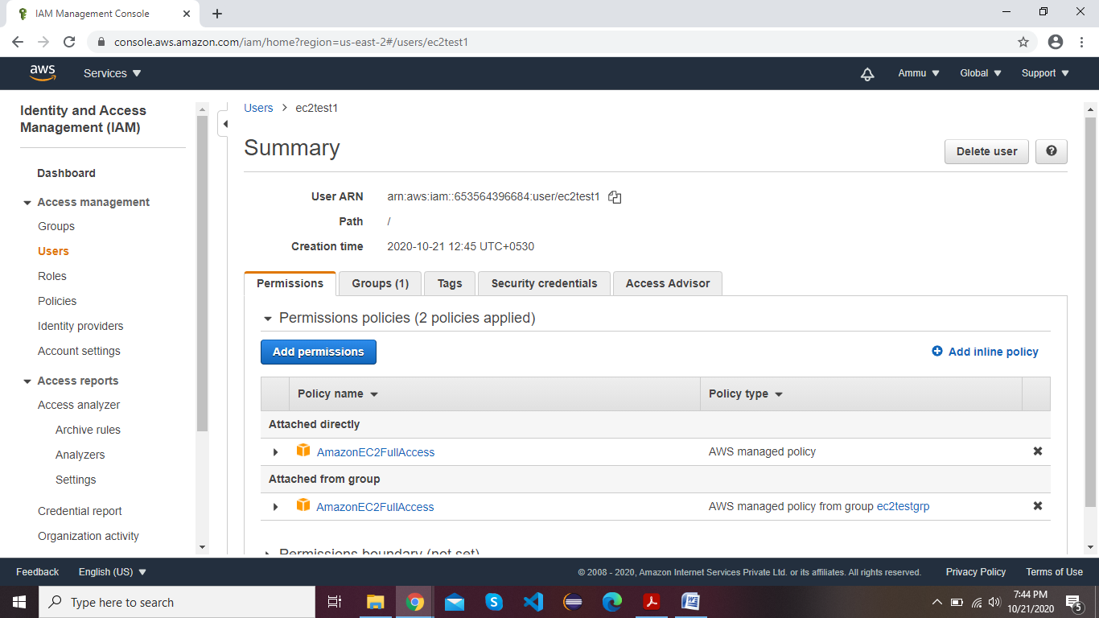

(b) login as the IAM user show that this policy is in effect

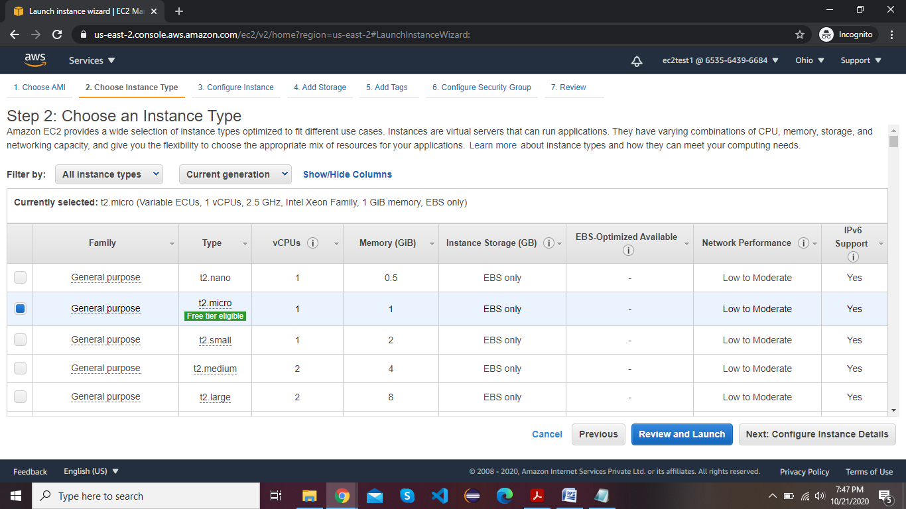

**Task 6:Copy policies from the existing user:**

1. attach user summary of the user from which you create a new user

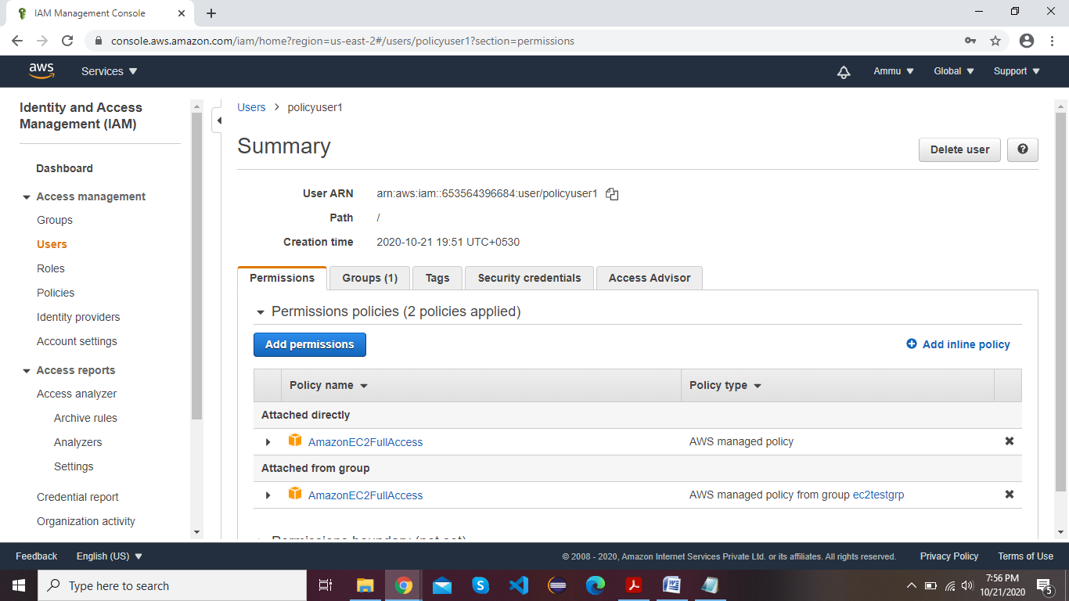

1. login as the IAM user show that this policy is in effect

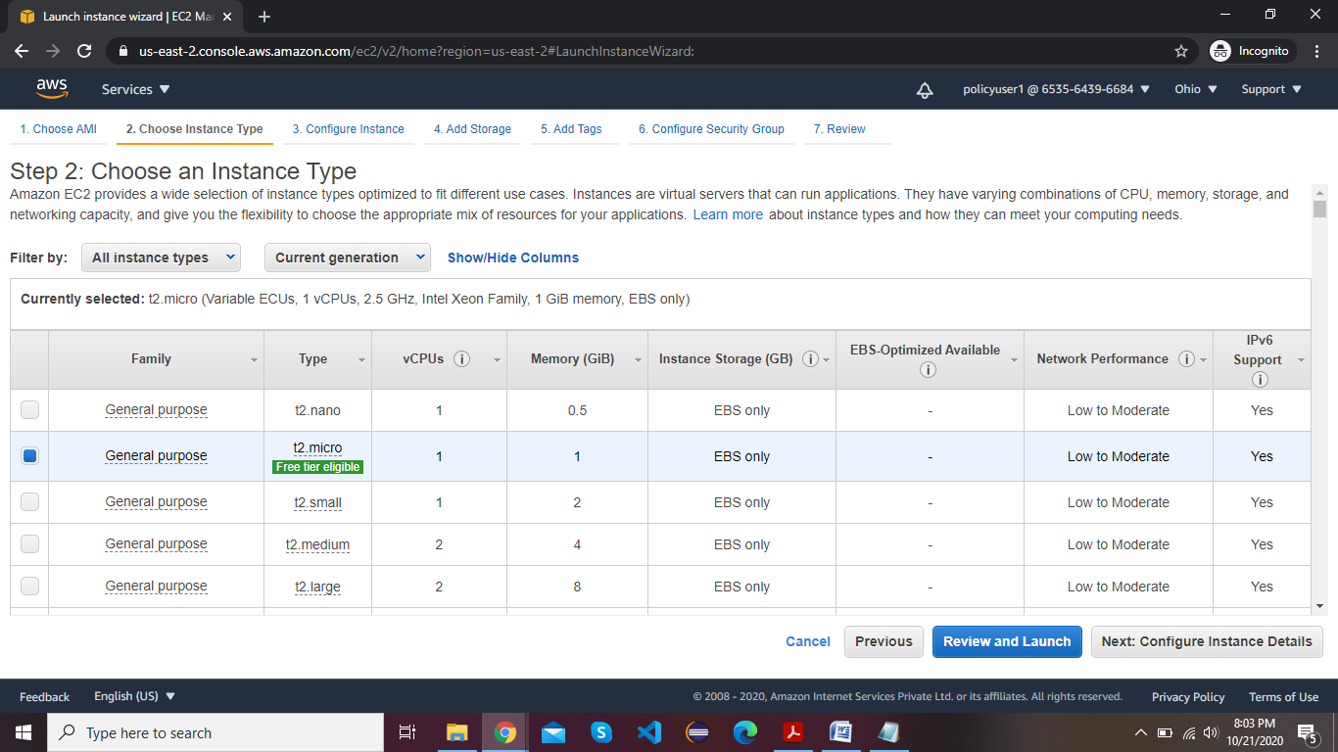

**Task 7:Add user to a group in the process of creating a user:**

(a)Created group while creating user

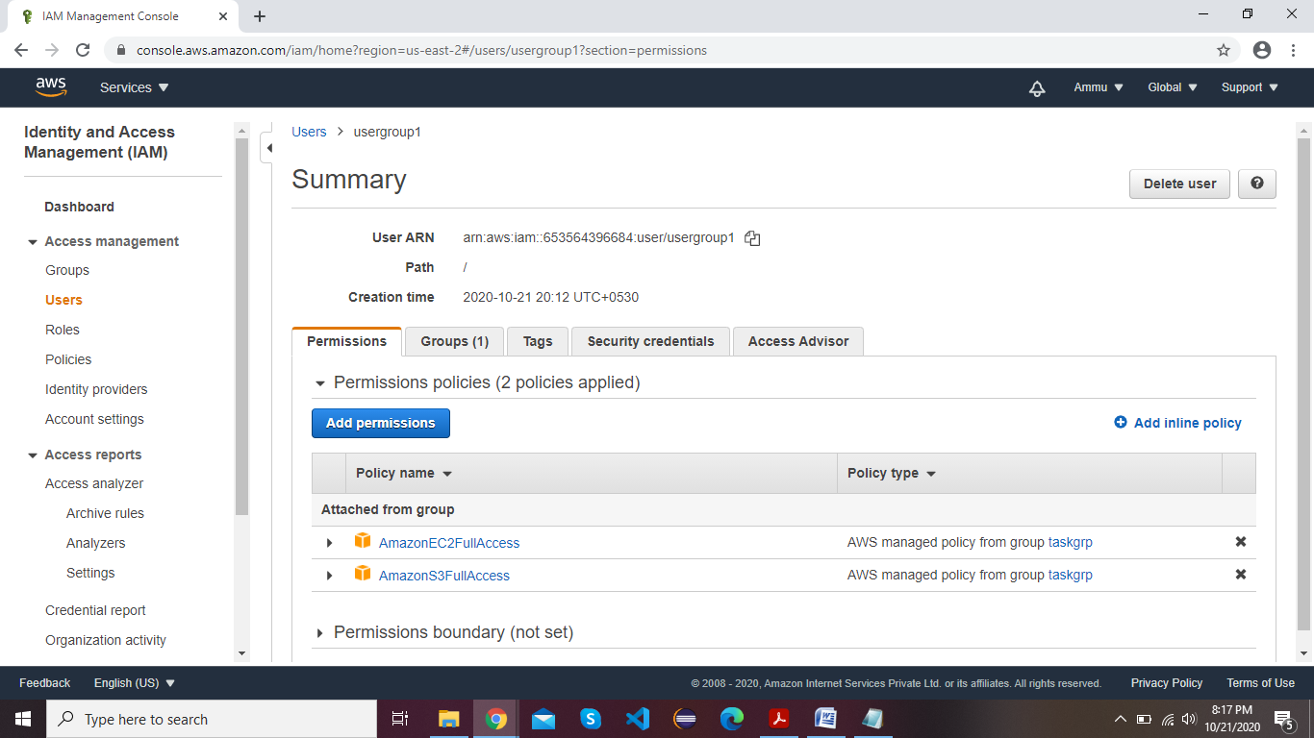

(b)Reflecting policies for Created IAM User For ec2

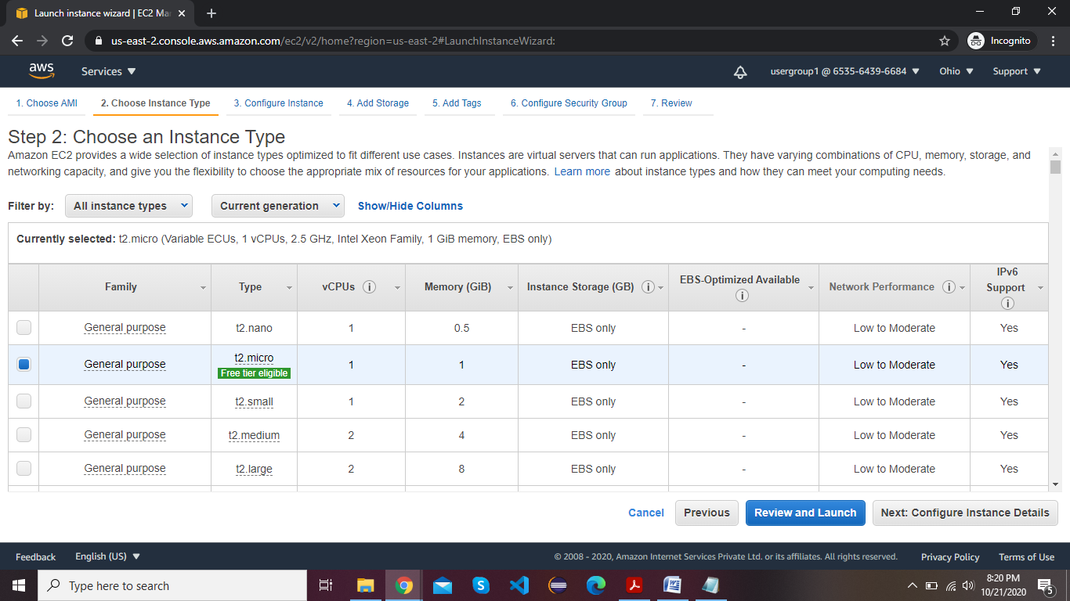

(c)Reflecting policies for Created IAM User For S3

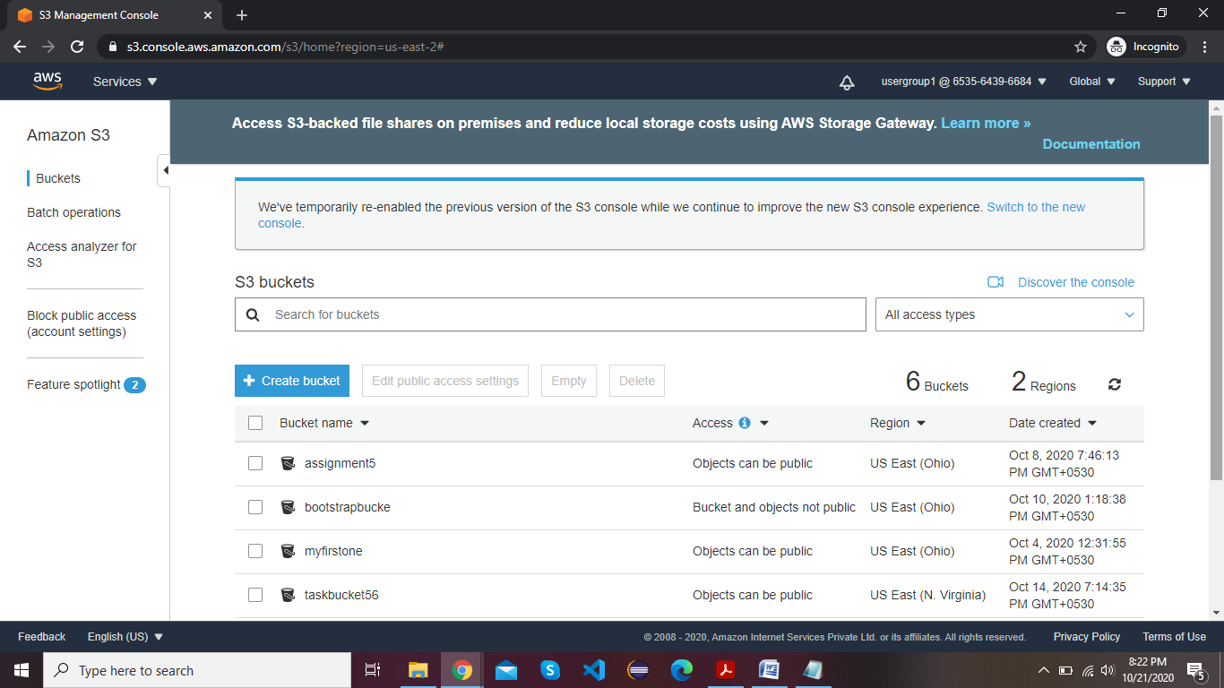

**Task8: setting a password policy:**

1. Password Policy Screen

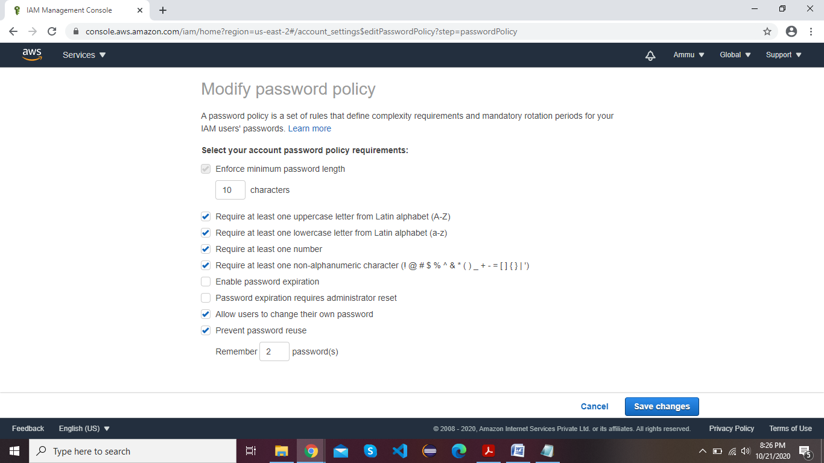

1. login as the user and show password incompatibility error

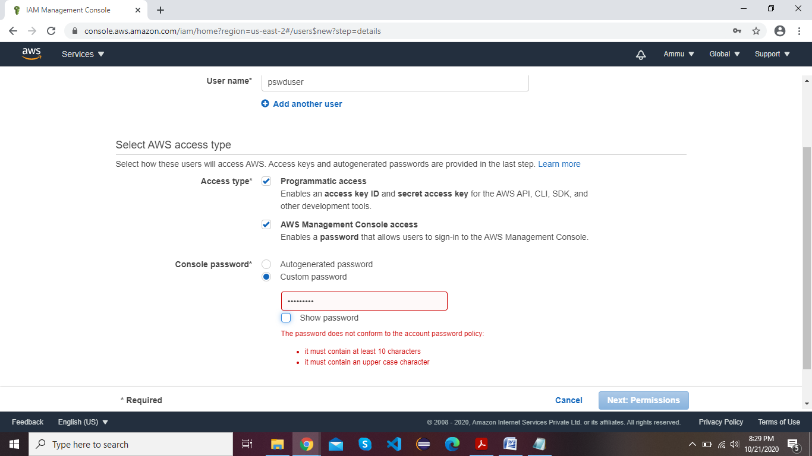

**Task 9:Enabling MFA and using an MFA device**

1. Enable MFA

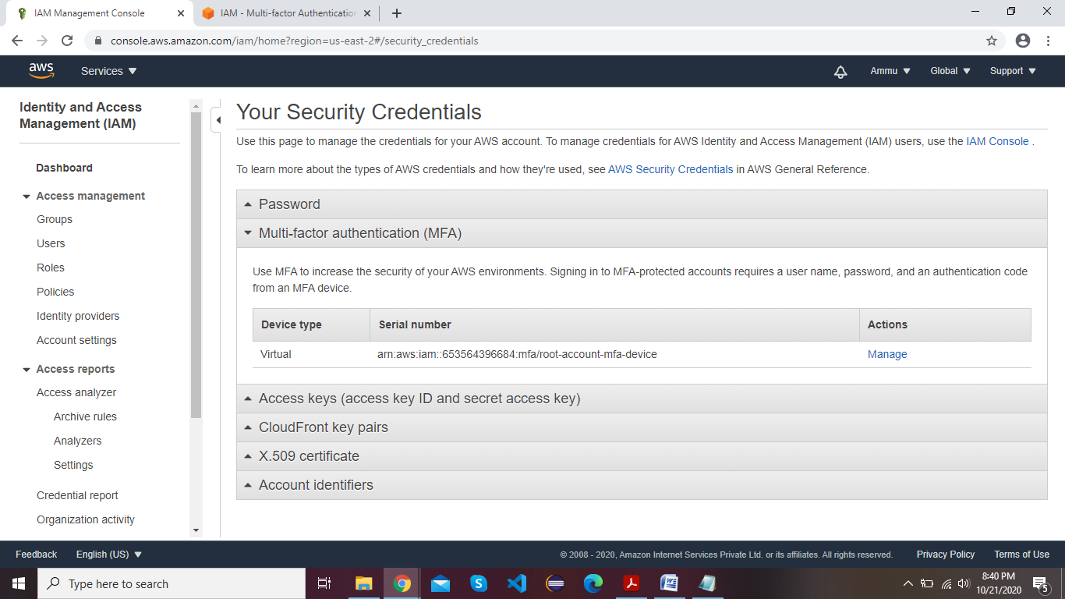

**(b**)Login screen for MFA for root user

