Howard University
College of Engineering and Architecture
Department of Electrical Engineering & Computer Science

Large Scale Programming
Fall 2024

Midterm Exam – Part I
October 17, 2024

Part I: 50 pts. (essay questions)

Instructions:
- Submit completed exam to your github repository under package org.howard.edu.lsp.midterm

Verify that the commit(s) completed successfully

- OPEN BOOK, OPEN NOTES. THERE IS NO COLLABORATION ON THIS EXAM
- Site any and ALL references for anything obtained off the internet.

Question 1. (10 pts.)

You are reviewing the following class in a Fitness Tracking System. The class is intended to manage various aspects of a user’s fitness activities.

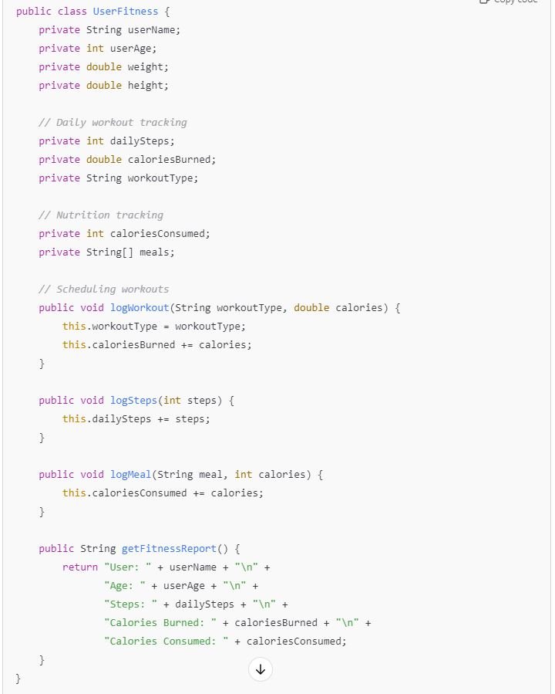

Tasks:
- Analyze the UserFitness class. Explain why this class has low cohesion. (5 pts.)

The class has low cohesion because it is attempting to manage user information, workout logging and nutrition tracking all at the same time. They are all distinct tasks and thusly should not be grouped together as it violates the Single Responsibility Principle, thus making the class harder to maintain, extend and debug which in turn reduces its cohesion.

- Describe, in general, how you would split the UserFitness class into more cohesive classes. Your answer should not be a complete design. (5 pts.)

The larger UserFitness class can instead be split into more cohesive classes, each handling a specific responsibility. For example:
- UserProfile which stores user details (name, age, weight, height).
- WorkoutTracker which tracks workout activities (steps, calories burned, workout type).
- NutritionTracker which logs meals and calories consumed.
- FitnessReport which brings together the data from trackers for generating reports.

Question 2. (5 pts.)
Given the following, answer the below questions.

A university manages its students using a program that has a class Student with subclasses FirstYear, SecondYear, and ThirdYear for year-specific state and behaviors. The program has a List that contains all Students.

Should Student be a class, an abstract class or an interface? Explain your answer

Student should be an abstract class because it serves as a base type for FirstYear, SecondYear, and ThirdYear and thus it likely contains shared data (like name, school id) and methods common to all students. An abstract class allows for these shared behaviors and states to be implemented once, while specific behaviors can be customized in the subclasses. Therefore, Student fits best as an abstract class to provide both structure and flexibility.

- At the end of each year, the third-year students graduate and must be removed. This is done by passing the list to the following method:

void removeThirdYears(List<Students> students) {
for (Student student : students) {
try {
ThirdYear = (ThirdYear) student;
students.remove(thirdyear);
}
}
}

Why is the above method flawed? Hint: Another Arthur Riel heuristic (5 pts.)

The method is flawed that it modifies the list while iterating through it, which will therefore cause an exception. The issue arises because the for-each loop doesn’t expect the collection to change during iteration, which breaks the internal structure used to track elements.

Question 3. (5 pts.)
Given the following, answer the below questions.

public class BankAccount {
public String accountHolderName;
public String accountNumber;
public double balance;
public double interestRate;

public BankAccount(
String accountHolderName,
String accountNumber,
double initialDeposit,
double interestRate) {
this.accountHolderName = accountHolderName;
this.accountNumber = accountNumber;
this.balance = initialDeposit;
this.interestRate = interestRate;
}

// Exposed implementation for adding interest
public void addInterest() {
double interest = balance * (interestRate / 100);
balance += interest;
}

// Exposed implementation for deposits
public void deposit(double amount) {
balance += amount;
}

// Exposed implementation for withdrawals
public void withdraw(double amount) {
balance -= amount;
}
}

- Is BankAccount well-encapsulated? Why or why not? If so, describe what changes you would make to the class. Otherwise, state nothing. (5 pts.)

The BankAccount class is not well-encapsulated. This can be seen in its use of public fields, where all fields (accountHolderName, accountNumber, balance, and interestRate) are declared as public, meaning they can be accessed and modified directly from outside the class. This goes against the principle of encapsulation, which requires the internal state to be hidden and only modifiable through specific methods. Furthermore, since the fields are public, there is no way to enforce validation or control changes. I would fix this by changing all the public fields to private so that they can only be accessed through methods within the class.

Question 4. (10 pts.)
Given the following, answer the below questions.

Given:
A car manufacturer uses Java software to track current vehicles being built. The UML diagram below shows an excerpt of the current software structure. You should assume the presence of other appropriate fields and methods

Car
getTrimLevel()
Engine
accelerate()
getFuelLevel()
Base
Sports
Luxury
Electric
Petrol

Each car can be built to one of three trim levels: Base, Luxury or Sport. They can also be configured with an electric or petrol engine. At various points in the manufacturing process the customer can choose to change the trim level.

Task:
- Explain in detail why the current structure does not support this. (5 pts.)
In the given UML structure, the Car class is directly associated with specific trim levels using inheritance. This structure shows that a car object is locked into a single trim level for its entire lifetime. Once a car is created as a particular trim, it cannot switch to another trim level without creating a new instance of a different subclass. This is because inheritance defines a “is-a” relationship, meaning a Sports car is a distinct type of car from a Base car.

- Describe how to refactor the structure to allow trim-level change for a car to dynamically change. Hint: How would you modify Car to use composition to solve the problem? (5 pts.)

To refactor the structure and allow dynamic trim-level changes, we can replace inheritance with composition. Instead of creating subclasses for each trim level, we define a TrimLevel interface with a common method, such as getTrimLevel(), and implement it in concrete classes like Base, Sports, and Luxury. The Car class then holds a reference to a TrimLevel object rather than inheriting from a specific trim-level class. This allows the trim level to be changed at runtime using a setter method, setTrimLevel(). When the trim level needs to be modified, we simply assign a new TrimLevel instance to the car object, making it possible to switch trims without recreating the object. This design enables greater flexibility and aligns with real-world manufacturing processes where customers may change their preferences during production.

Question 5. (5 pts.)
Suppose you are about to code a particular class and find that you have written another class with nearly the functionality that you now are developing. This means that the two classes in large parts contain the same code, but in smaller parts have different code. Explain in detail why this may be a problem and how to solve it. Give your answer in terms of Arthur Riel’s design heuristics.

Having two classes with overlapping functionality creates code duplication, which violates the Don’t Repeat Yourself principle and Arthur Riel’s heuristic of high cohesion and low coupling. Duplicated code makes maintenance difficult and increases the risk of inconsistent updates and bugs.

To solve this, refactor the common code into a superclass if the two classes share an “is-a” relationship, allowing both to inherit the shared behavior. If inheritance is not suitable, use composition or delegation by extracting shared functionality into a utility class or module that both classes can reference. This ensures better maintainability, reduces bugs, and follows good design practices.

Question 6. (5 pts.)
Suppose we need to store instances of the classes Car and BankAccount in a database. To obtain low coupling it may seem as if the functionality to save an instance should be in precisely those classes, since they have the information that shall be saved. Why is it unwise to place the database calls there?

Placing database calls inside the Car and BankAccount classes would violate the principle of separation of concerns and low coupling. These classes should focus only on representing the state and behavior of their objects, not handling persistence logic. Including database operations directly within them leads to tight coupling between the business logic and the database layer, making the system harder to maintain and modify. For example, any change to the database structure would require updates in multiple places across the codebase.

To maintain low coupling, database operations should be handled by separate classes like repositories or data access objects (DAOs). These components will handle the persistence logic, allowing the Car and BankAccount classes to remain focused on their core responsibilities. This design improves maintainability, testability, and flexibility, following good object-oriented practices.

Question 7. (5 pts.)
Given a set of requirements, what conditions must be met to make it appropriate to create a new class hierarchy using inheritance? Neither superclass nor subclass exist before, the question is about designing a new class hierarchy.
A new class hierarchy using inheritance is appropriate when certain conditions are met. There must be a natural “is-a” relationship between the objects, where the subclass is a specialized version of the superclass. Additionally, the classes should share common behavior or attributes that can be defined in the superclass to avoid code duplication. Inheritance is also suitable when polymorphism is needed, allowing different subclasses to be treated uniformly while providing their own implementations of superclass methods. This approach works best when the hierarchy is stable and unlikely to change frequently, as inheritance creates tight coupling. Furthermore, if extensibility is a requirement, inheritance allows new subclasses to be added without modifying the existing structure. If these conditions are not met, composition might be a better alternative for greater flexibility.

Question 8. (2.5 pts.)
Describe the difference between inheritance and composition why would you choose one over the other.
The difference between inheritance and composition is in how they achieve code reuse. Inheritance creates an “is-a” relationship, where a subclass inherits behavior from a superclass, leading to tight coupling. Composition establishes a “has-a” relationship, where objects contain other objects, promoting loose coupling and flexibility. Inheritance is best for stable, hierarchical relationships and when polymorphism is needed. Composition is preferred for flexibility, as it allows behavior to be changed at runtime. Generally, composition is favored over inheritance for more maintainable and adaptable designs.

Question 9. (2.5 pts.)
Explain the meaning of cohesion and describe whether low or high cohesion is better.

Cohesion refers to how closely related and focused the responsibilities of a class or module are. High cohesion means that a class has a well-defined purpose, with all its methods and data closely related to that purpose. Low cohesion occurs when a class handles multiple unrelated tasks, making it harder to maintain and understand.

High cohesion is better because it improves maintainability, readability, and reusability of code. It ensures that each class or module is responsible for a specific task, reducing complexity and making the system easier to update. Low cohesion, on the other hand, can lead to fragile code that is harder to debug and extend.

